**What is Machine Learning**

Machine learning is a branch of artificial intelligence that enables algorithms to uncover hidden patterns within datasets. It allows them to predict new, similar data without explicit programming for each task. Machine learning finds applications in diverse fields such as image and speech recognition, natural language processing, recommendation systems, fraud detection, portfolio optimization, and automating tasks.

Machine learning’s impact extends to autonomous vehicles, drones, and robots, enhancing their adaptability in dynamic environments. This approach marks a breakthrough where machines learn from data examples to generate accurate outcomes, closely intertwined with data mining and data science.

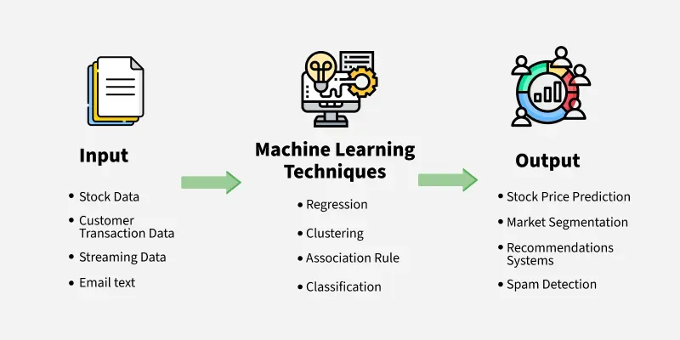

**Need for Machine Learning**

Machine learning is important because it allows computers to learn from data and improve their performance on specific tasks without being explicitly programmed. This ability to learn from data and adapt to new situations makes machine learning particularly useful for tasks that involve large amounts of data, complex decision-making, and dynamic environments.

Here are some specific areas where machine learning is being used:

* [**Predictive modeling**](https://www.geeksforgeeks.org/what-is-predictive-modeling/)**:**Machine learning can be used to build predictive models that can help businesses make better decisions. For example, machine learning can be used to predict which customers are most likely to buy a particular product, or which patients are most likely to develop a certain disease.
* [**Natural language processing**](https://www.geeksforgeeks.org/natural-language-processing-overview/)**:**Machine learning is used to build systems that can understand and interpret human language. This is important for applications such as voice recognition, chatbots, and language translation.
* [**Computer vision**](https://www.geeksforgeeks.org/computer-vision-introduction/)**:**Machine learning is used to build systems that can recognize and interpret images and videos. This is important for applications such as self-driving cars, surveillance systems, and medical imaging.
* [**Fraud detection**](https://www.geeksforgeeks.org/detecting-frauds-with-ml-and-ai/)**:** Machine learning can be used to detect fraudulent behavior in financial transactions, online advertising, and other areas.
* [**Recommendation systems**](https://www.geeksforgeeks.org/what-are-recommender-systems/)**:** Machine learning can be used to build recommendation systems that suggest products, services, or content to users based on their past behavior and preferences.

Overall, machine learning has become an essential tool for many businesses and industries, as it enables them to make better use of data, improve their decision-making processes, and deliver more personalized experiences to their customers.

**Supervised Machine Learning**

**Supervised machine learning** is a fundamental approach for machine learning and artificial intelligence. It involves training a model using labeled data, where each input comes with a corresponding correct output. The process is like a teacher guiding a student—hence the term “supervised” learning. In this article, we’ll explore the key components of supervised learning, the different types of supervised machine learning algorithms used, and some practical examples of how it works.

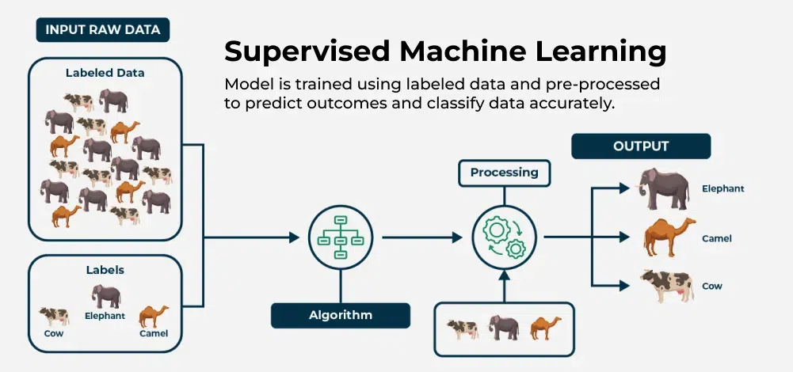

*Supervised Machine Learning*

**What is Supervised Machine Learning?**

As we explained before, **supervised learning** is a type of machine learning where a model is trained on labeled data—meaning each input is paired with the correct output. the model learns by comparing its predictions with the actual answers provided in the training data. Over time, it adjusts itself to minimize errors and improve accuracy. The goal of supervised learning is to make accurate predictions when given new, unseen data. For example, if a model is trained to recognize handwritten digits, it will use what it learned to correctly identify new numbers it hasn’t seen before.

Supervised learning can be applied in various forms, includingsupervised learning classification and supervised learning regression, making it a crucial technique in the field of artificial intelligence and supervised data mining.

A fundamental concept in supervised machine learning is learning a class from examples. This involves providing the model with examples where the correct label is known, such as learning to classify images of cats and dogs by being shown labeled examples of both. The model then learns the distinguishing features of each class and applies this knowledge to classify new images.

**How Supervised Machine Learning Works?**

Where **supervised learning algorithm** consists of input features and corresponding output labels. The process works through:

* **Training Data:**The model is provided with a training dataset that includes input data (features) and corresponding output data (labels or target variables).
* **Learning Process:**The algorithm processes the training data, learning the relationships between the input features and the output labels. This is achieved by adjusting the model’s parameters to minimize the difference between its predictions and the actual labels.

After training, the model is evaluated using a [test dataset](https://www.geeksforgeeks.org/what-is-test-dataset-in-machine-learning/) to measure its accuracy and performance. Then the model’s performance is optimized by adjusting parameters and using techniques like [cross-validation](https://www.geeksforgeeks.org/cross-validation-machine-learning/) to [balance bias and variance](https://www.geeksforgeeks.org/ml-bias-variance-trade-off/). This ensures the model generalizes well to new, unseen data.

***In summary, supervised machine learning involves training a model on labeled data to learn patterns and relationships, which it then uses to make accurate predictions on new data.***

Let’s learn how a supervised machine learning model is trained on a dataset to learn a mapping function between input and output, and then with learned function is used to make predictions on new data:

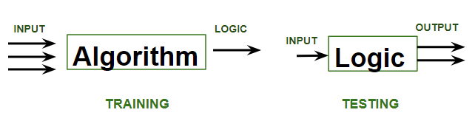

In the image above,

* **Training**phase involves feeding the algorithm labeled data, where each data point is paired with its correct output. The algorithm learns to identify patterns and relationships between the input and output data.
* **Testing**phase involves feeding the algorithm new, unseen data and evaluating its ability to predict the correct output based on the learned patterns.

**Types of Supervised Learning in Machine Learning**

Now, Supervised learning can be applied to two main types of problems:

* [Classification](https://www.geeksforgeeks.org/getting-started-with-classification/): Where the output is a categorical variable (e.g., spam vs. non-spam emails, yes vs. no).
* [Regression](https://www.geeksforgeeks.org/regression-in-machine-learning/): Where the output is a continuous variable (e.g., predicting house prices, stock prices).

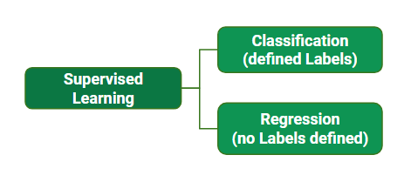

While training the model, data is usually [split in the ratio of 80:20](https://www.geeksforgeeks.org/splitting-data-for-machine-learning-models/) i.e. 80% as training data and the rest as testing data. In training data, we feed input as well as output for 80% of data. The model learns from training data only. We use different**supervised learning algorithms** (which we will discuss in detail in the next section) to build our model. Let’s first understand the classification and regression data through the table below:

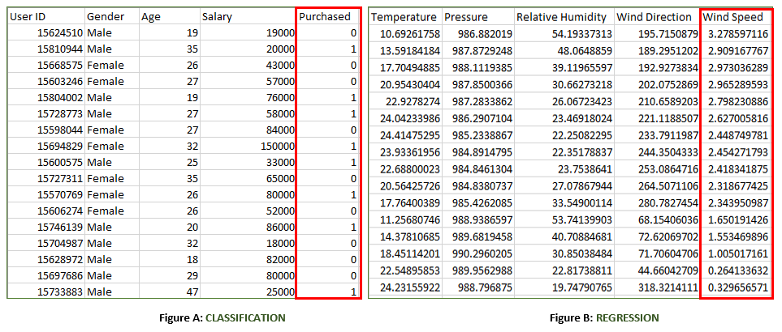

Both the above figures have labelled data set as follows:

* **Figure A:**It is a dataset of a shopping store that is useful in predicting whether a customer will purchase a particular product under consideration or not based on his/ her gender, age, and salary.  
  **Input:**Gender, Age, Salary  
  **Output:**Purchased i.e. 0 or 1; 1 means yes the customer will purchase and 0 means that the customer won’t purchase it.
* **Figure B:**It is a Meteorological dataset that serves the purpose of predicting wind speed based on different parameters.  
  **Input:**Dew Point, Temperature, Pressure, Relative Humidity, Wind Direction  
  **Output:**Wind Speed

***Refer to this article for more information of*** [***Types of Machine Learning***](https://www.geeksforgeeks.org/types-of-machine-learning/)

**Practical Examples of Supervised learning**

Few practical examples of supervised machine learning across various industries:

* [**Fraud Detection in Banking**](https://www.geeksforgeeks.org/online-payment-fraud-detection-using-machine-learning-in-python/)**:** Utilizes supervised learning algorithms on historical transaction data, training models with labeled datasets of legitimate and fraudulent transactions to accurately predict fraud patterns.
* [**Parkinson Disease Prediction:**](https://www.geeksforgeeks.org/parkinson-disease-prediction-using-machine-learning-python/?ref=lbp)Parkinson’s disease is a progressive disorder that affects the nervous system and the parts of the body controlled by the nerves.
* [**Customer Churn Prediction**](https://www.geeksforgeeks.org/python-customer-churn-analysis-prediction/)**:** Uses supervised learning techniques to analyze historical customer data, identifying features associated with churn rates to predict customer retention effectively.
* [**Cancer cell classification:**](https://www.geeksforgeeks.org/ml-cancer-cell-classification-using-scikit-learn/?ref=lbp)Implements supervised learning for cancer cells based on their features, and identifying them if they are ‘malignant’ or ‘benign.
* [**Stock Price Prediction:**](https://www.geeksforgeeks.org/stock-price-prediction-using-machine-learning-in-python/) Applies supervised learning to predict a signal that indicates whether buying a particular stock will be helpful or not.

**Supervised Machine Learning Algorithms**

**Supervised learning** can be further divided into several different types, each with its own unique characteristics and applications. Here are some of the most common types of supervised learning algorithms:

* [**Linear Regression**](https://www.geeksforgeeks.org/ml-linear-regression/): Linear regression is a type of supervised learning regression algorithm that is used to predict a continuous output value. It is one of the simplest and most widely used algorithms in supervised learning.
* [**Logistic Regression**](https://www.geeksforgeeks.org/understanding-logistic-regression/): Logistic regression is a type of supervised learning classification algorithm that is used to predict a binary output variable.
* [**Decision Trees**](https://www.geeksforgeeks.org/decision-tree/): Decision tree is a tree-like structure that is used to model decisions and their possible consequences. Each internal node in the tree represents a decision, while each leaf node represents a possible outcome.
* [**Random Forests**](https://www.geeksforgeeks.org/random-forest-regression-in-python/): Random forests again are made up of multiple decision trees that work together to make predictions. Each tree in the forest is trained on a different subset of the input features and data. The final prediction is made by aggregating the predictions of all the trees in the forest.
* [**Support Vector Machine(SVM)**](https://www.geeksforgeeks.org/support-vector-machine-algorithm/): The SVM algorithm creates a hyperplane to segregate n-dimensional space into classes and identify the correct category of new data points. The extreme cases that help create the hyperplane are called support vectors, hence the name Support Vector Machine.
* [**K-Nearest Neighbors**](https://www.geeksforgeeks.org/k-nearest-neighbours/)**(KNN) :**KNN works by finding k training examples closest to a given input and then predicts the class or value based on the majority class or average value of these neighbors. The performance of KNN can be influenced by the choice of k and the distance metric used to measure proximity.
* [**Gradient Boosting**](https://www.geeksforgeeks.org/ml-gradient-boosting/): Gradient Boosting combines weak learners, like [decision trees](https://www.geeksforgeeks.org/decision-tree/), to create a strong model. It iteratively builds new models that correct errors made by previous ones.
* [**Naive Bayes Algorithm**](https://www.geeksforgeeks.org/naive-bayes-classifiers/): The Naive Bayes algorithm is a supervised machine learning algorithm based on applying [Bayes’ Theorem](https://www.geeksforgeeks.org/bayes-theorem/) with the “naive” assumption that features are independent of each other given the class label.