MONGODB ASSIGNMENT-C

db.students.insertMany([{student_id:1,name:"Amit",age:20,marks:85,department:"CSE",subjects:["DBMS","OS","CN"],email:"amit@gmail.com"},{student_id:2,name:"Neha",age:22,marks:72,department:"ECE",subjects:["Signals","VLSI"],email:null},{student_id:3,name:"Rahul",age:19,marks:90,department:"CSE",subjects:["DBMS","AI","ML"]},{student_id:4,name:"Sneha",age:21,marks:65,department:"IT",subjects:["Web","DBMS"],email:"sneha@gmail.com"},{student_id:5,name:"Karan”,age:23,marks:78,department:"CSE”,subjects:["CN","OS"],email:"karan@gmail.com"}])
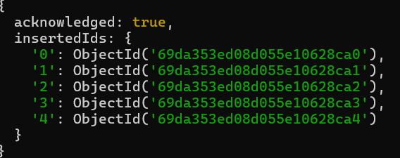

1.Find students with marks greater than 80.

db.students.find({marks:{$gt:80}})
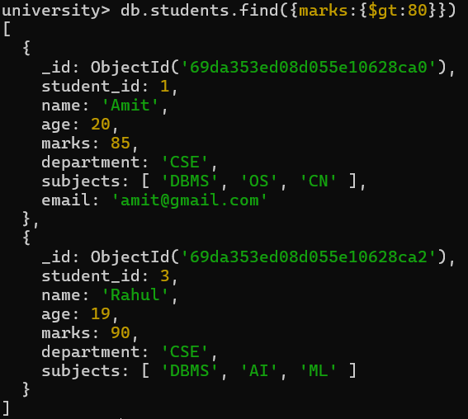
2.Find students aged less than or equal to 20.

db.students.find({age:{$lte:20}})

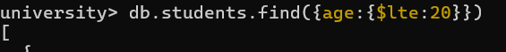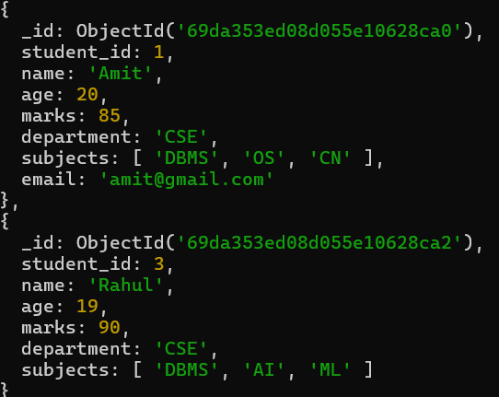
3.Find students with marks between 70 and 85.

db.students.find({marks:{$gte:70,$lte:85}})

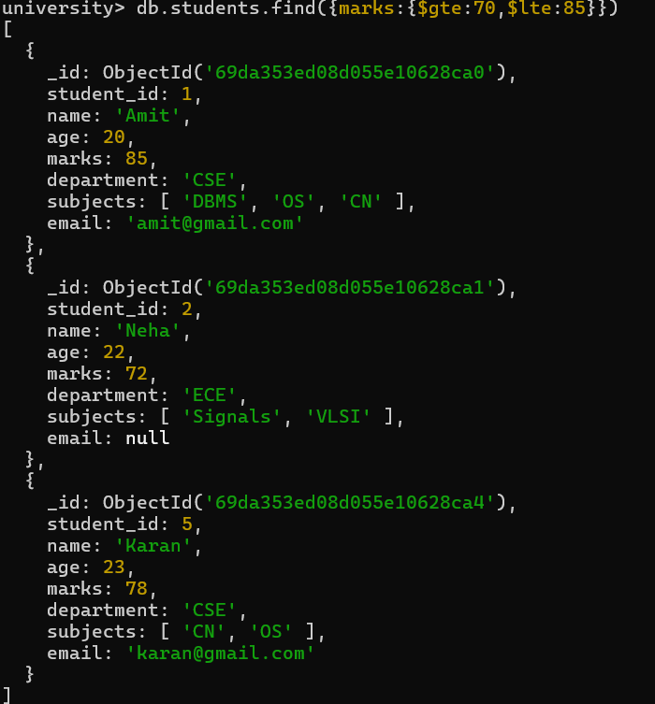
4.Find students not belonging to CSE department.

db.students.find({department:{$ne:”CSE”}})

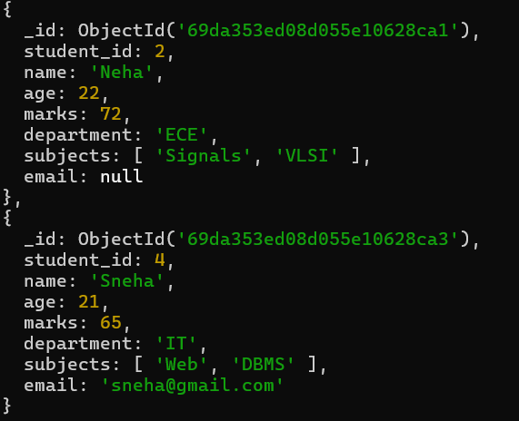

5.Find students whose age is exactly 21.

db.students.find({age:21})

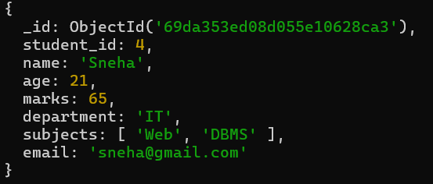

6.Find students with marks less than 75.

db.students.find({marks:{$lt:75}})

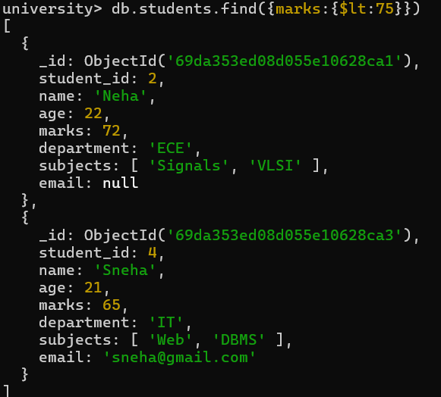

7.Find students whose department is either CSE or IT.

db.students.find({department:{$in:[“CSE”,”IT”]}})
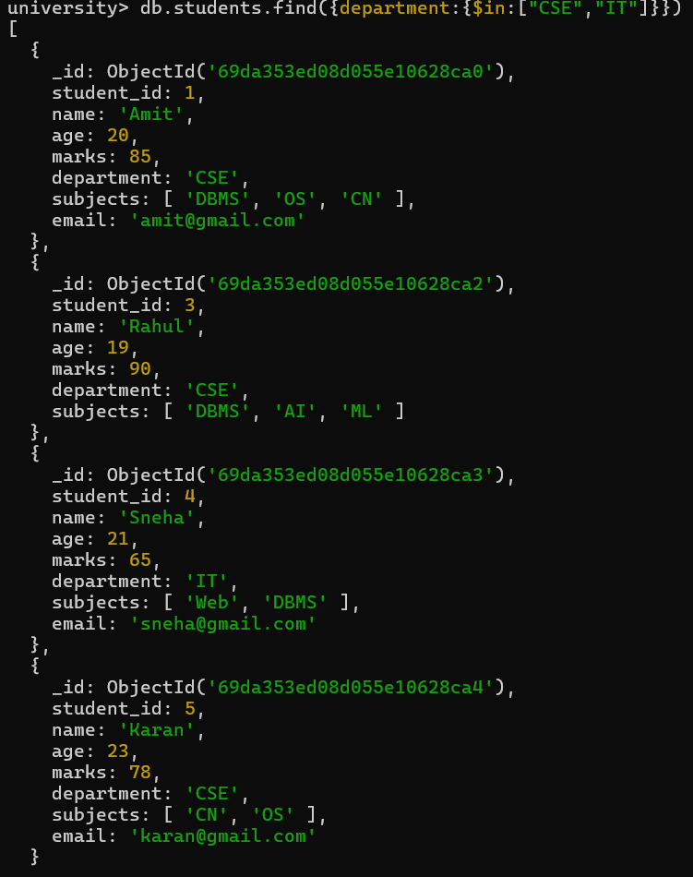

8.Find CSE students with marks above 80.
db.students.find({department:”CSE”,marks:{$gt:80}})

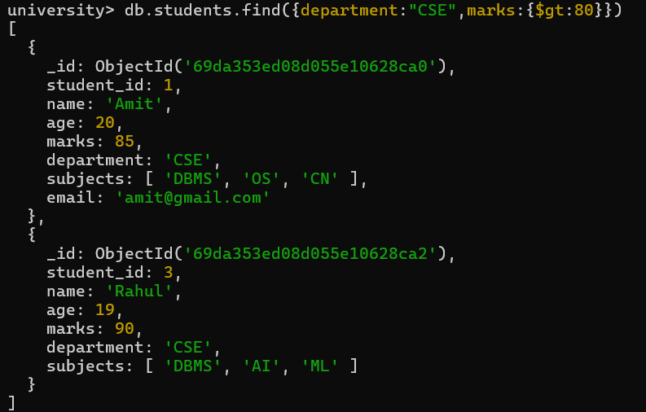

9.Find students who are in CSE or have marks above 85.

db.students.find({$or:[{department:”CSE”},{marks:{$gt:85}}]})

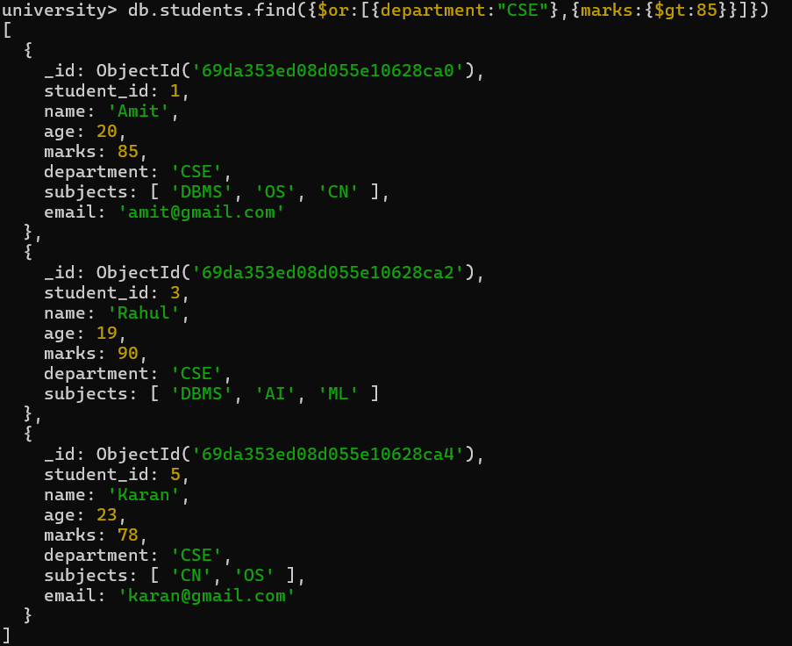

10.Find students who are NOT in IT department.

db.students.find({department:{$ne:”IT”}})

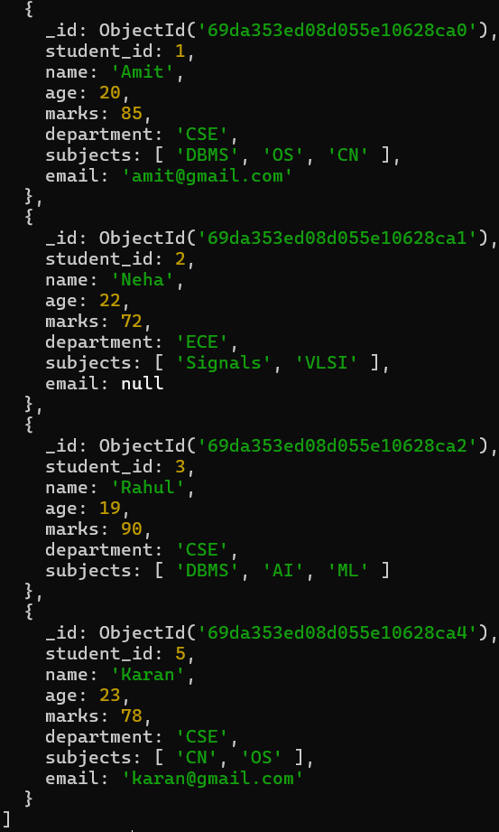
11.Find students with marks not between 70 and 85.

db.students.find({$or:[{marks:{$lt:70}},{marks:{$gt:85}}]})
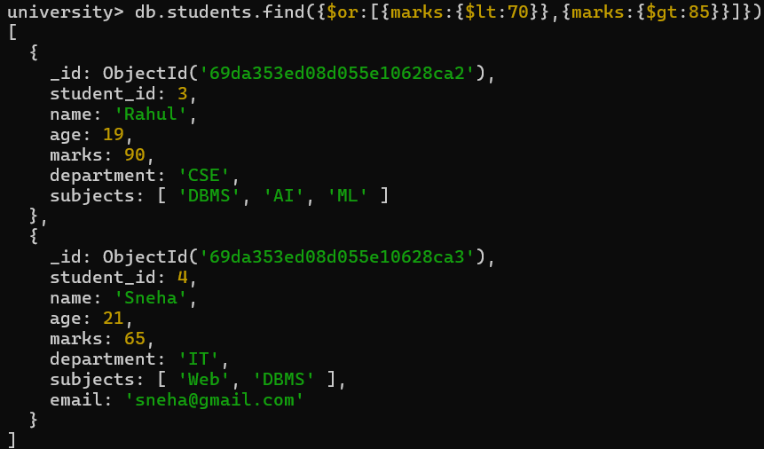
12.Find students aged above 20 and not in ECE.

db.students.find({age:{$gt:20},department:{$ne:”ECE”}})

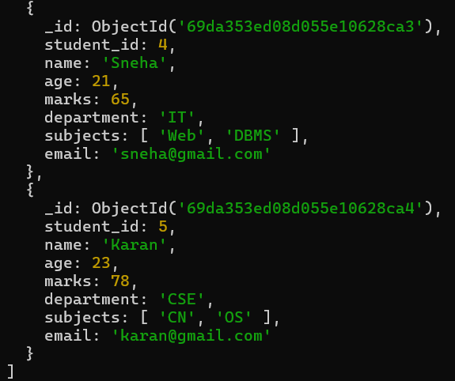
13.Find students who are either IT students or have marks less than 70.

db.students.find({$or:[{department:”IT”},{marks:{$lt:70}}]})

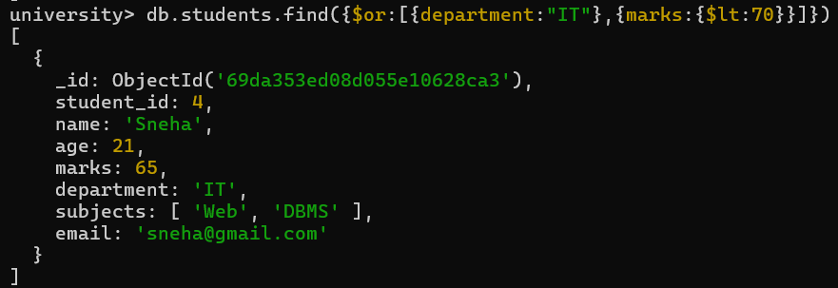
14.Find students who are not CSE and not IT.

db.students.find({department:{$nin:[“CSE”,”IT”]}})

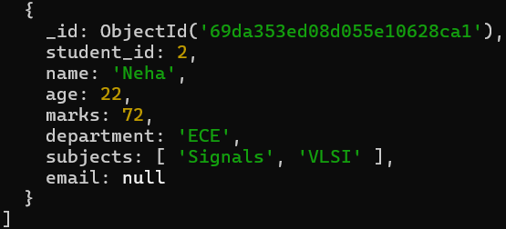

15.Find students who have an email field.

db.students.find({email:{$exists:true}})

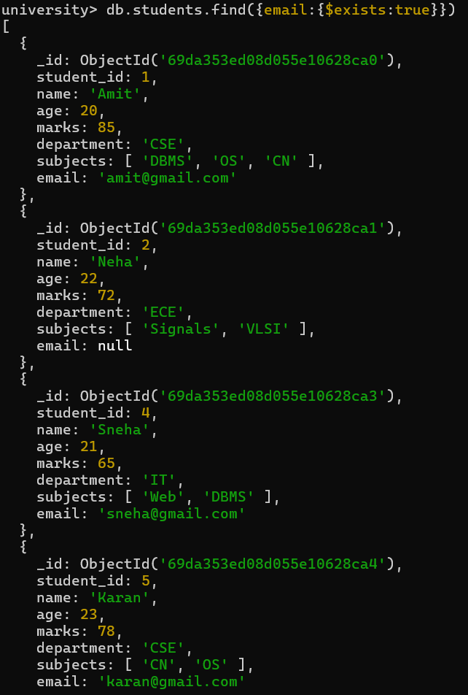

16.Find students who do not have an email field.

db.students.find({email:{$exists:false}})

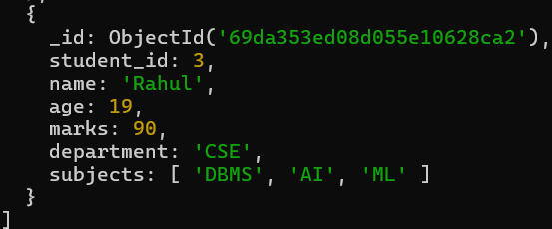

17.Find students whose email value is null.

db.students.find({email:null})

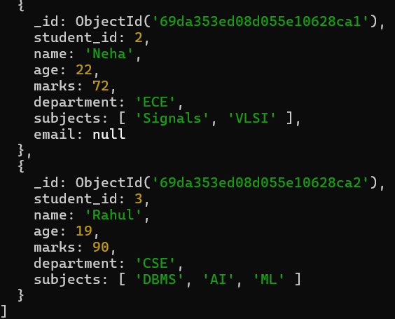

18.Find students whose marks field is of type integer.

db.students.find({marks:{$type:”int”}})
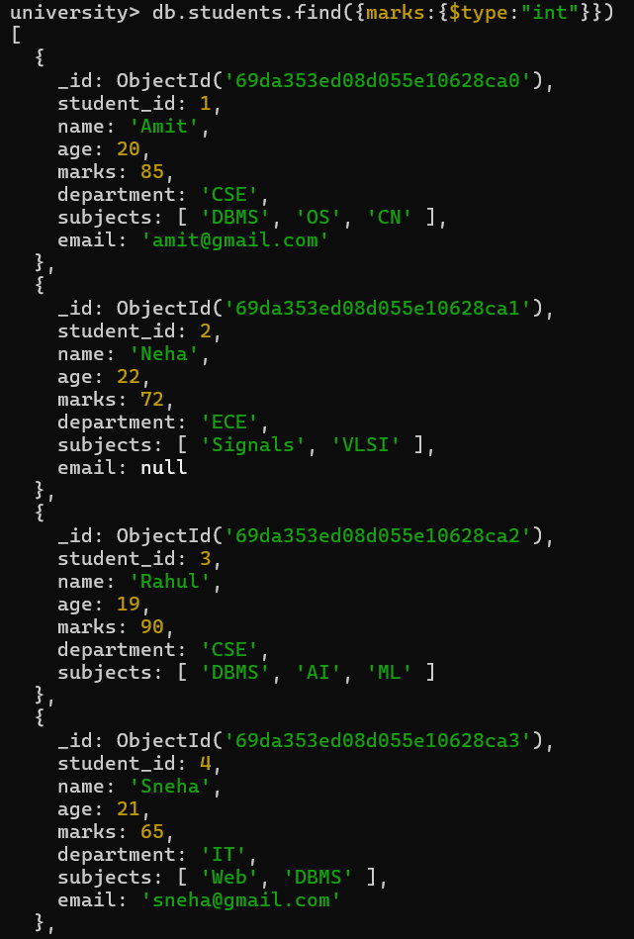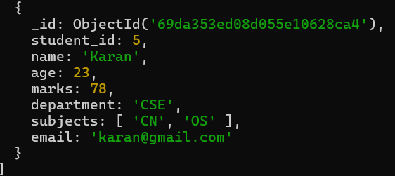

19.Find students who have subjects’ field.

db.students.find({subjects:{$exists:true}})

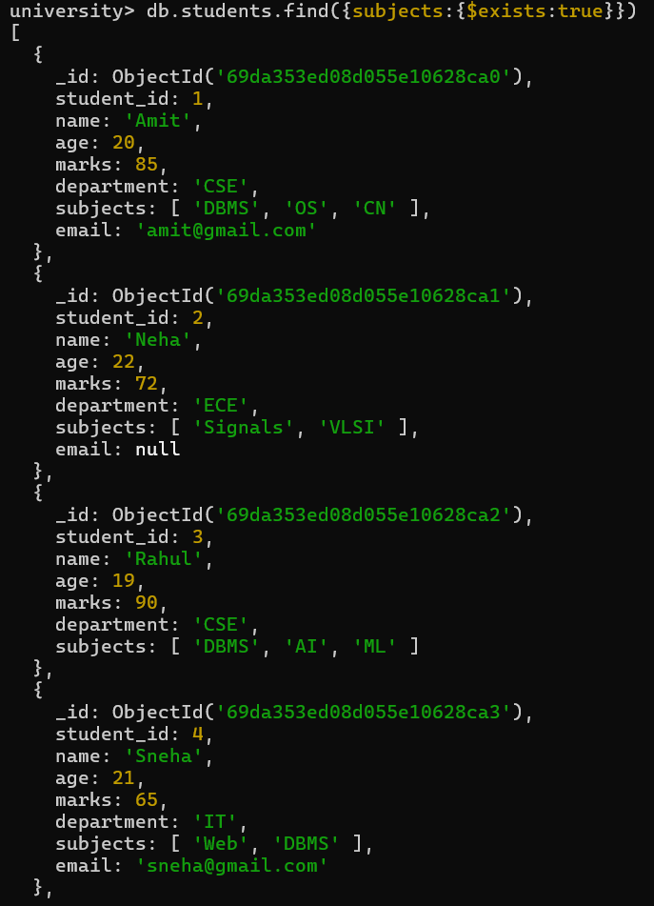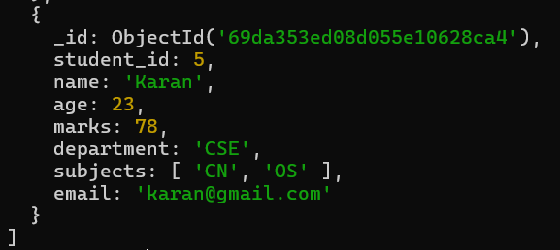

20.Find students whose age field is missing.

db.students.find({age:{$exists:false}})

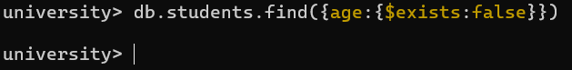

21.Find students where marks modulo 5 equals 0.

db.students.find({marks:{$mod:[5,0]}})

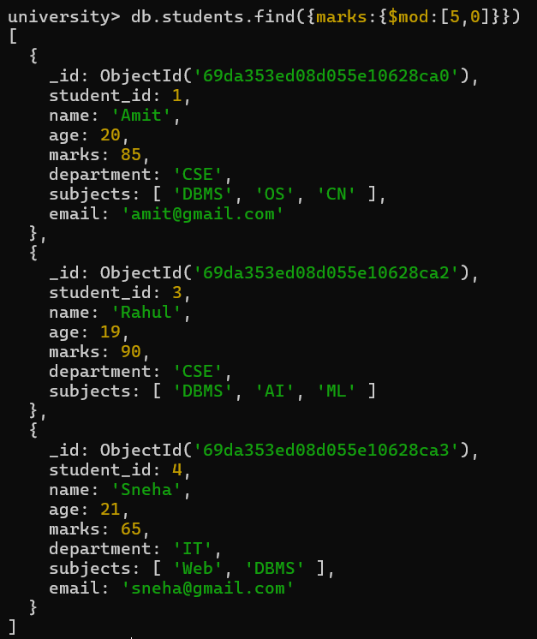
22.Find students whose name starts with letter “A”.

db.students.find({name:{$regex:”^A”}})
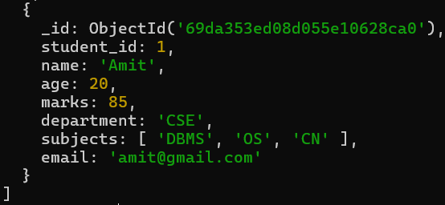

23.Find students whose email ends with gmail.com.

db.students.find({email:{$regex:/gmail\.com$/}})

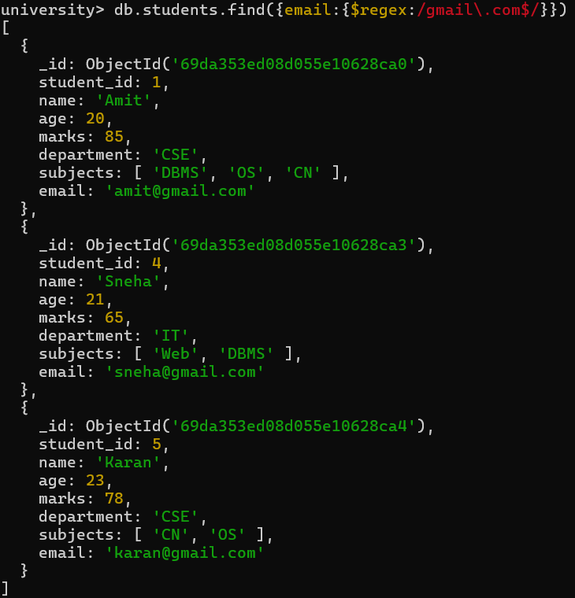

24.Find students who have more than 2 subjects.

db.students.find({$expr:{$gt:[{$size:”subjects”},2]}})

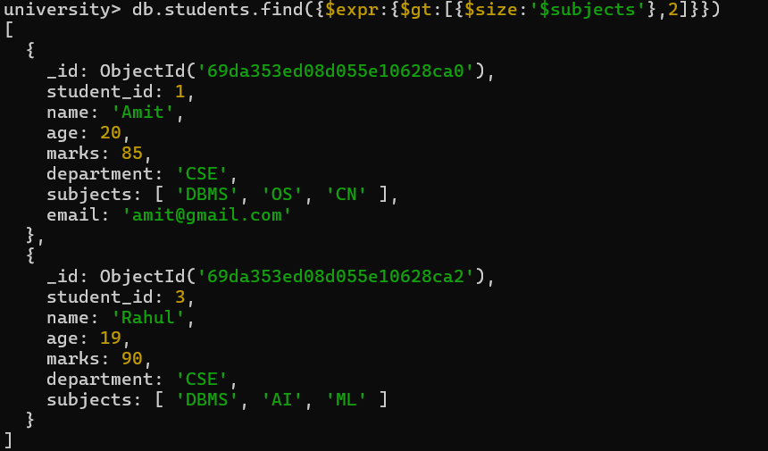

25.Find students whose marks are greater than their age × 3.

db.students.find({$expr:{$gt:[“$marks”,{$multiply:[“$age”,3]}]}})
