Task 1.1

Write a Python Program to implement your own myreduce() function which works exactly like

Python's built-in function reduce()

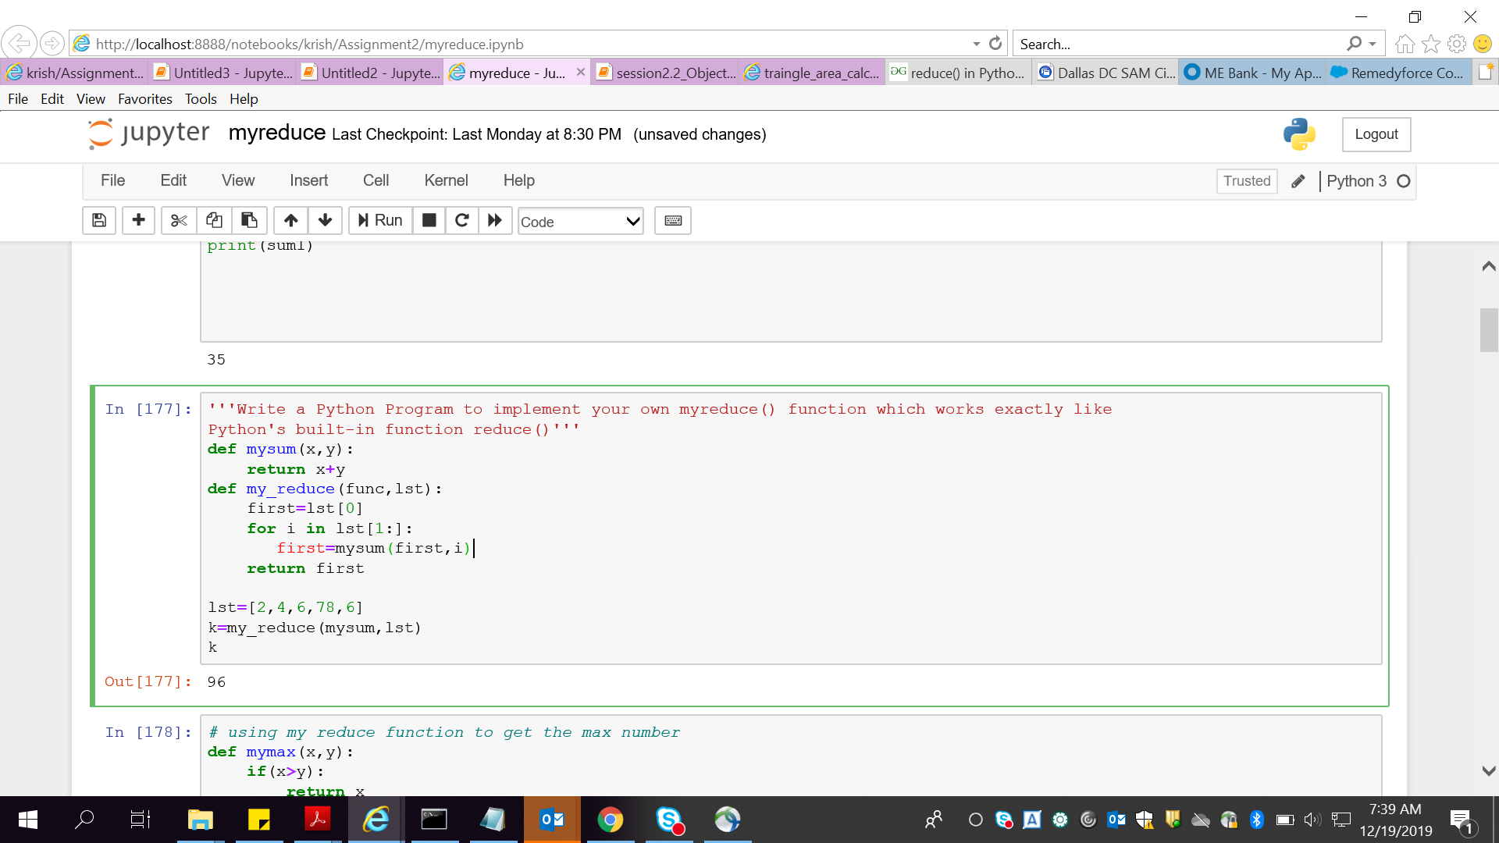

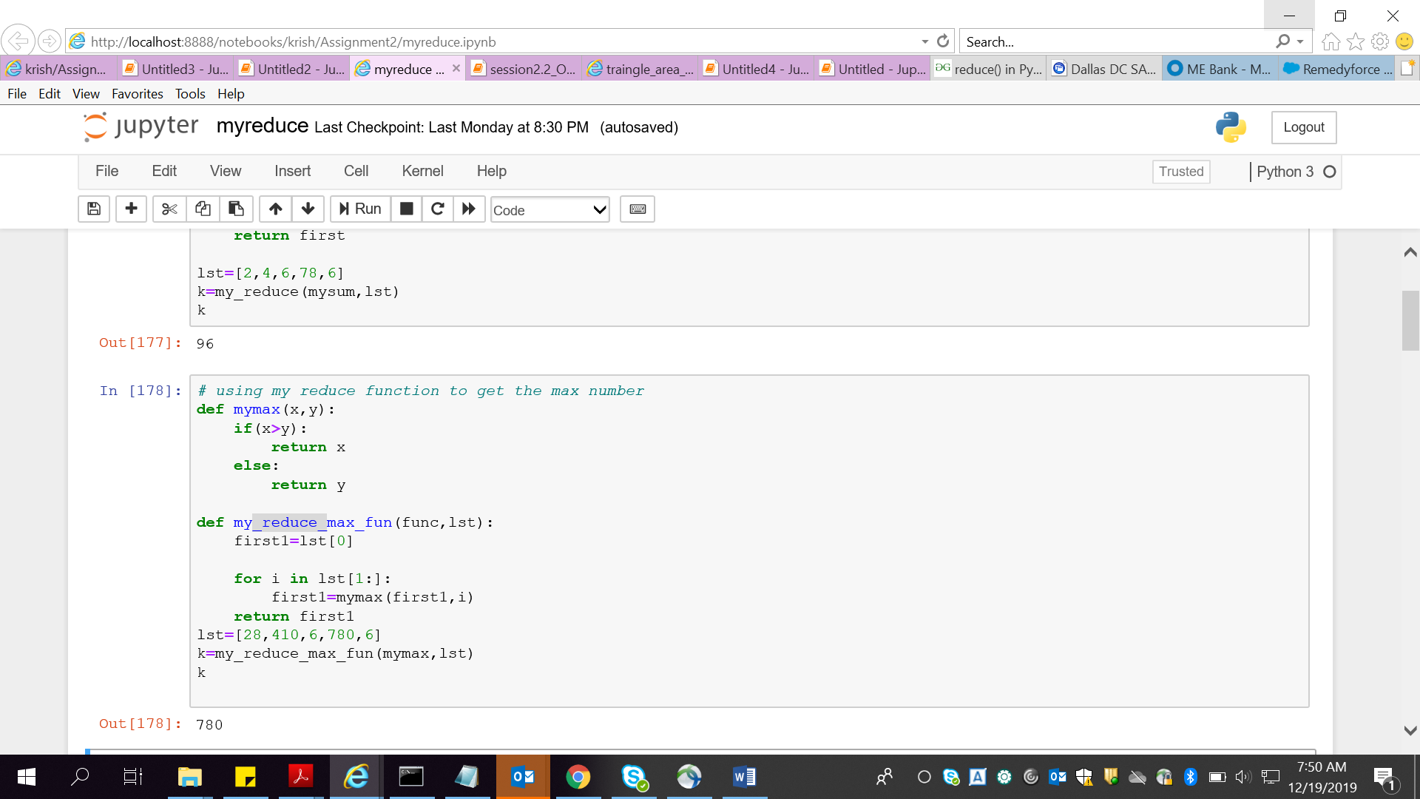

Task 1.2

Write a Python program to implement your own myfilter() function which works exactly like

Python's built-in function filter()

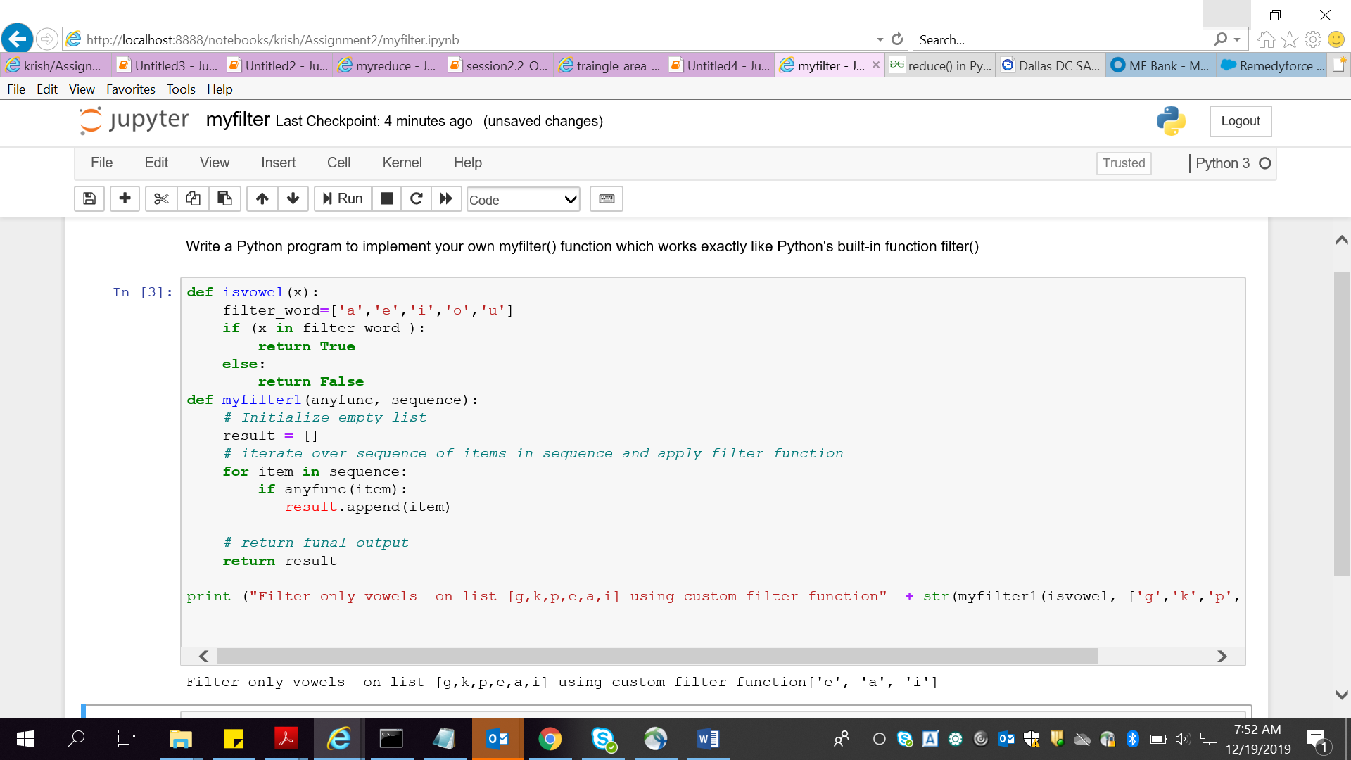

Task 2

Implement List comprehensions to produce the following lists.

Write List comprehensions to produce the following Lists

['A', 'C', 'A', 'D', 'G', 'I', ’L’, ‘ D’]

['x', 'xx', 'xxx', 'xxxx', 'y', 'yy', 'yyy', 'yyyy', 'z', 'zz', 'zzz', 'zzzz']

['x', 'y', 'z', 'xx', 'yy', 'zz', 'xx', 'yy', 'zz', 'xxxx', 'yyyy', 'zzzz']

[[2], [3], [4], [3], [4], [5], [4], [5], [6]]

[[2, 3, 4, 5], [3, 4, 5, 6], [4, 5, 6, 7], [5, 6, 7, 8]]

[(1, 1), (2, 1), (3, 1), (1, 2), (2, 2), (3, 2), (1, 3), (2, 3), (3, 3)]

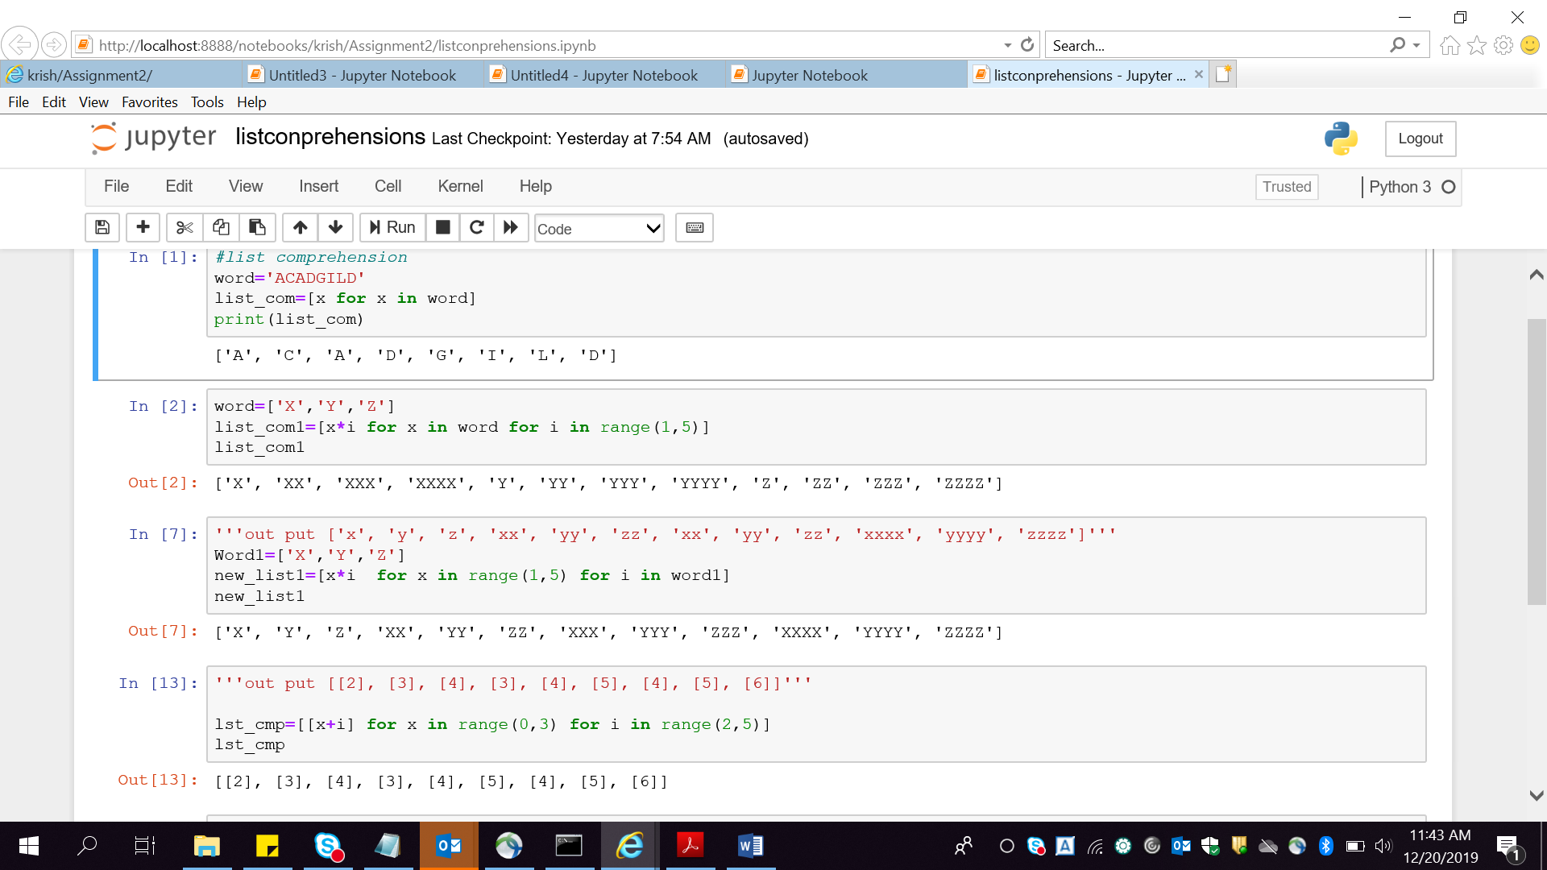

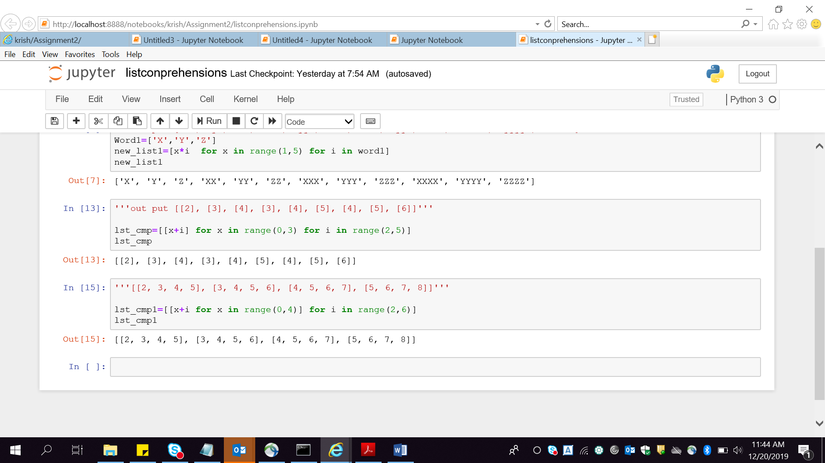

Longest word

Task 3

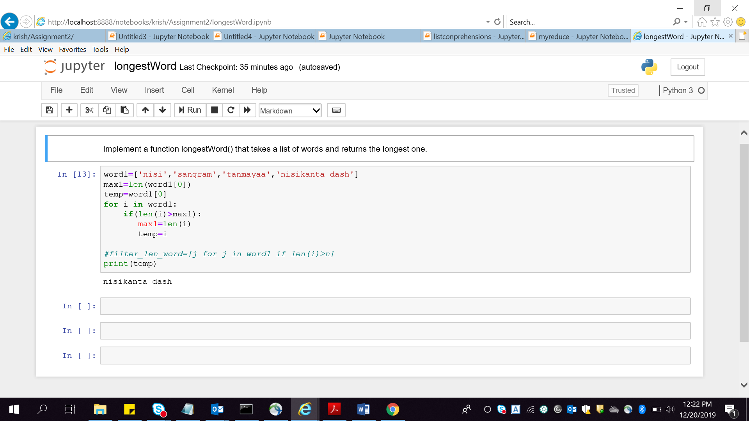

Area of a traingle

