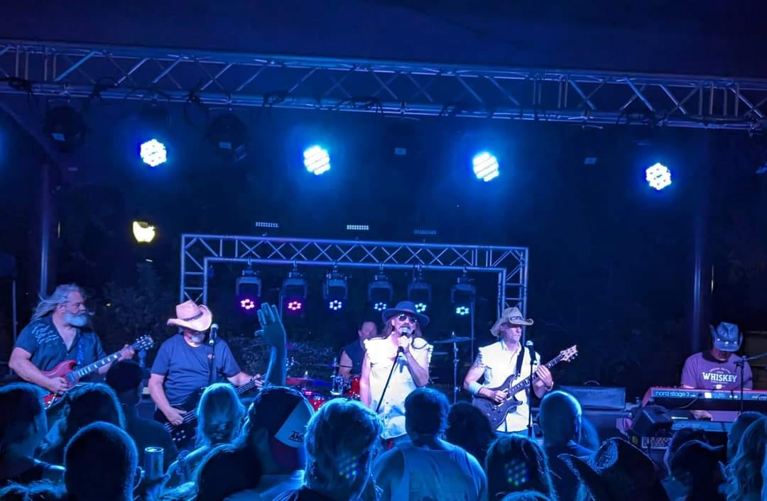


Booking Info: Michael Shreiber 916.804.0723 / Rusty@SB916.com
facebook.com/Southbound6

Southbound is Northern California’s premier Southern Rock Revue. The band features a wide variety of Southern Rock from artists such as the Allman Brothers, Lynyrd Skynyrd, .38 Special, Marshall Tucker Band, Molly Hatchet and others. The sound is energetic, danceable and features a lively stage show. Members have been together for many years and are always reliable and professional.

Southbound performs regularly at many area venues, festivals and events as well as private parties and corporate affairs. The shows are high energy, fun and suitable for all ages and all types of events.
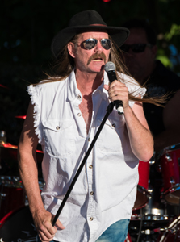 | Scott Baxter - Lead Vocals  Scott Baxter is a multi-instrumentalist and veteran of hundreds of shows along the Texas Gulf coast, including gigs with rock and roll pioneer Bo Diddley and South Texas blues legend Rocky Benton. Scott has been the face of Southbound since 2023.
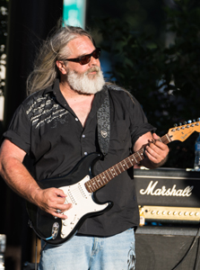 | Dean Fisher – Guitars & Vocals  It was the release of Freebird nearly 50 years ago that triggered Deans desire to pick up the guitar. That was the beginning of a musical journey that has allowed Dean to play with some amazing musicians and form a brotherhood much like any MC! To be able to play music and ride with your brothers is Dean's idea of living the dream! And Southbound represents this because everyone in the band loves doing it.
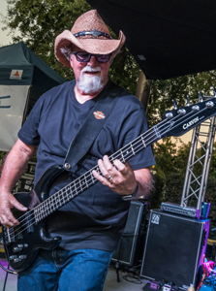 | Mike Cochran – Bass Guitar & Vocals  Mike decided at age 15 he was going to play bass guitar and began jamming with a couple of buddies. Ten years later, he and Dean Fisher started playing guitar together at backyard BBQs and campouts. Eventually a few other musicians joined the fray and they formed Savannah Blue; Nor Cals premier Southern Rock Review. 28 years later, Mike and Dean have been able to morph many of those Southern Rock influences into Southbound. "I been very fortunate to have played with a lot of incredible musicians and learned so much from every one of them."
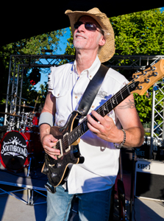 | Rusty Chain - Guitar & Vocals  Growing up outside of Washington DC, Rusty found himself amid a vibrant Blues/Rock scene that included such artists as Danny Gatton, Jimmy Thackery & the Nighthawks, the Road Ducks and others. Armed with these early influences, he soon found himself gigging regularly throughout the Maryland, DC and Virginia area playing a mix of classic rock and blues. After relocating to Sacramento in the late 90’s, he formed the Chain-Lightning Band and later, regional favorite, the Bad Catz. Today, Rusty's gritty, blues-soaked guitar riffs help fill out the Southbound sound.
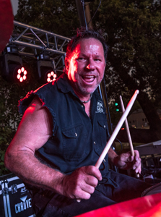 | Tony Vivilacqua – Drums & Vocals  At age 11 Tony received his first pair of wood sticks, some of his mothers empty Folgers Coffee cans with lids and a radio. After putting all that together, he realized drums was his thing. Shorty after, Tony's mom bought him his first pearl white drums set for $25.00 from the Auburn Journal's classifieds. Playing along with all the great classic rock KZAP had to offer, and a few lessons here and there, Tony became a drummer, playing professionally at age 16. Cutting his teeth on music by Lynyrd Skynyrd, the Alman Brothers, Molly Hatchet and others, gave him the chops needed to play in a band such as Southbound!
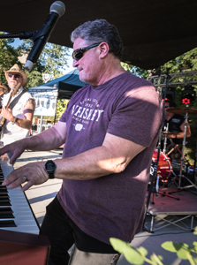 | Larry Audino – Keyboards, Guitar & Vocals  Larry began playing piano when he was 10 and began playing with friends almost immediately. Larry found he couldn't haul his piano around so he picked up guitar. By the age of 19, keyboard technology had improved tremendously and Larry began playing in various bands. Southern Rock has always been a favorite genre and Larry was an integral part of Savannah Blue... and now Southbound.

