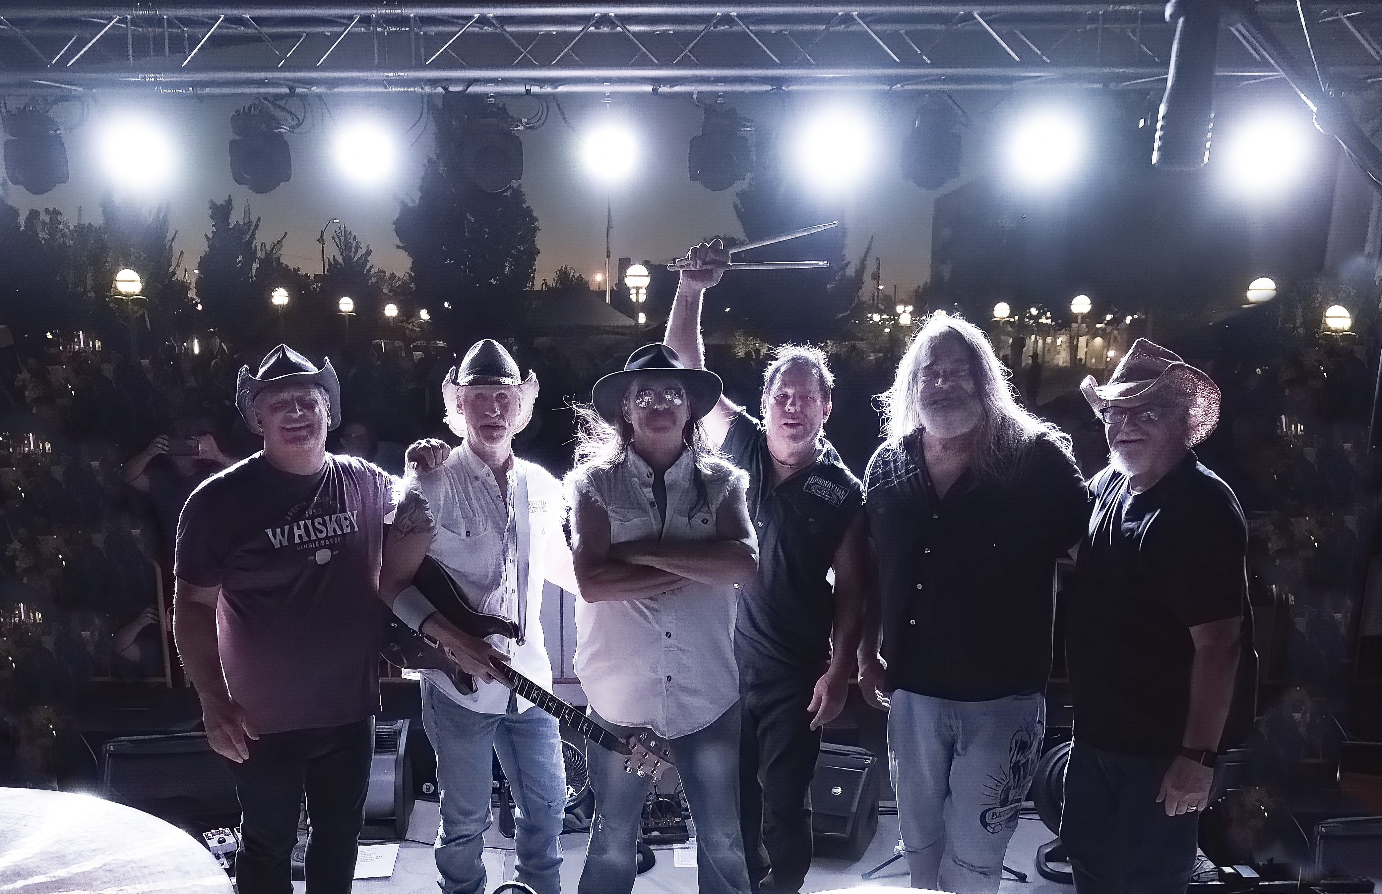
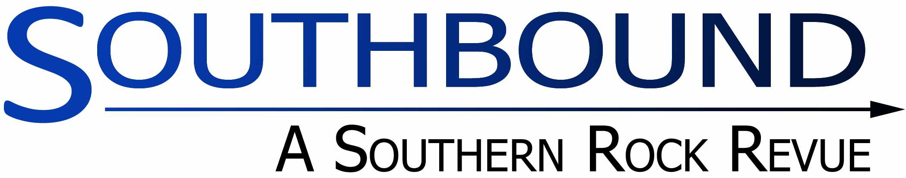

Booking Info: Tony Vivilacqua 916.997.1176 - SouthboundEmail@Gmail.com
facebook.com/Southbound6

Dear Talent Booker,

We are Southbound, Northern California’s premier Southern Rock Revue. We have performed regularly throughout the Northern California area since 2018. We play a wide range of Southern Rock classics with a lively stage show and an upbeat sound; perfect for dancing. Our music is suitable for all ages and appeals to a wide audience; young and old alike. It includes covers by artists such as the Allman Brothers, Lynyrd Skynyrd, ZZ Top, Marshall Tucker Band and others.

We are a professional act and are accustomed to playing to large audiences. We are regular participants in many local music festivals and public events in the Greater Sacramento/Sierra area including:

Roseville Concert in the Park | Carmichael Park Concerts in the Park
Vacaville Tomato & Vine Festival | Numerous clubs and live music venues

We would be pleased to perform for you and your audience at this year’s event. See the links below for video.
Please feel free to contact me for additional information.

Southbound Promotional Video: Southbound on YouTube
Additional material can be viewed at: www.youtube.com/@southbound2102

Regards,

Tony
Southbound

