

American International University-Bangladesh (AIUB)  
**Department of Computer Science and Engineering   
Faculty of Science &Technology (FST)  
SUMMER-2021  
CSC 00191- Object Oriented Analysis And Design (OOAD)**

**Section: C**

**Project Title: TRAVEL MANAGEMENT SYSTEM**

**Submitted by:**

|  |  |
| --- | --- |
| **Name** | **ID** |
| **NISMA HOSSAIN** | **20-41982-1** |
| **LAMIA** | **20-42063-1** |
| **MOMOTAZ RAHMAN OUISHY** | **20-43098-1** |
| **MD ANAS KHAN** | **20-43091-1** |

**Submitted to:**

**MD. ANWARUL KABIR**

**Sr. Assistant Professor**

**Department of Computer Science**

# 1. Project Title: TRAVEL MANAGEMENT SYSTEM

# 2. Project Overview:

In this travel management system, 2 types of users can be a part of it. Customers and travel agencies. Customer can view their possible transportation options, vacant tickets, schedule. Travel agencies can offer their services. Transport includes bus, train, airplane, rent car and others. Customers can also book tickets. This website offers a platform where customers and travel agencies can interact each other easily. Also travel agencies can get an overview about their competitors and service.

3. Justification:

* Customers can travel from one place to another easily
* The booking system is pretty neat so it isn’t a hassle to book tickets
* If there is a travel management system then there will be no need to worry about the booking and travelling process
* When there’ll be the registration process, the customer will know the required price and details about his/her destination

4. Overall Use Case of the project:

**Scenario:** In this travel management system, a customer can view all the possible options of travelling to their desired destination according to their preferences. customer can search for possible options. They can search by destination name or search by transport name. To know about vacancy of somewhere they want to go First, he/she have to select destination. Then he/she have to select the preferable date and time. After selecting, the admin can check if there is any vacant transportation available at that particular time and let the customer know about vacancy. If customer wants to book tickets, first he/she has to login/register. After logging in, first he has to select transport by which they want to go to the destination. There might be different categories of seats like economy or business class, chair coach etc. After selecting preferable seat type and transport, the admin of the server will show the amount to pay. If the customer wants to confirm the ticket, he/she have to pay the bill. To pay the amount the customer will enter the credit card info and verify it. After verifying the customer will pay the bill and purchase the ticket.

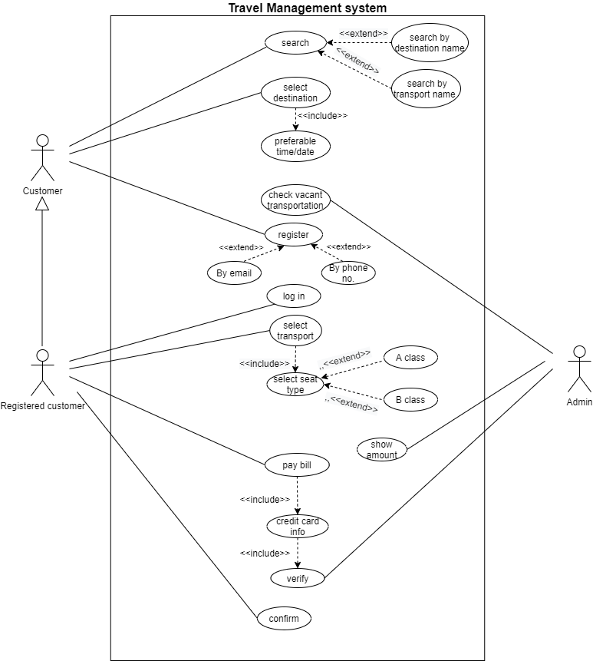

5. Class diagram of the project:

Scenario: In travel management system customer can search for transport and also search for destination. Each destination and transport has many number of customers. For booking tickets customer has to be registered customer first then they can book tickets. Registered customer can book ticket for many . After booking tickets registered customer has to pay the bill and admin will approve the payment. There can be many registered customers but system can have only one admin.

|  |
| --- |
| Destination  -destinationname:string  -preferabletime:string  -preferabledate:string |
| +setdestinationname(name:string)  +setpreferabletime(time:string)  +setpreferabledate(date:string)  +getdestinationname(name:string)  +getpreferabletime(time:string)  +getpreferabledate(date:string) |

|  |
| --- |
| Customer  -customerName:string  -customerId:int  -customerNumber:int |
| +setcustomerName()  +setcustomerId()  +setcustomerNumber()  +getcustomerName()  +getcustomerId()  +getcustomerNumber() |

|  |
| --- |
| Registered customer  -registeredcustName:string  -registeredcustId:int  -registeredcustNumber:int  -login:string |
| +setregisteredcustName(name:string)  + getregisteredcustName():string  + setregisteredcustId(id:int)  + getregisteredcustId():int  +setregisteredcustNumber(number:int)  +getregisteredcustNumber():int  +setlogin(login:string)  +getlogin():string |

|  |
| --- |
| Bookticket  -ticketid:int  -seattype:char |
| +setticketid(id:int)  +setseattype(seattype:char)  +getticketid():int  +getseattype():char |

|  |  |  |
| --- | --- | --- |
| |  | | --- | | Payment  -creditcardinfo:string  -paybill:string | | +setcreditcardinfo(info:string)  +setpaybill (bill:string)  +getcreditcardinfo ():string  +getpaybill ():string | |
|  |

|  |
| --- |
| Transport  -transportname:string  -transporttype:string |
| +settransportname(name:string)  +settransporttype(type:string)  +gettransportname():string  +gettransporttype():string |

|  |
| --- |
| Admin  -adminid:int  -adminname:string  -vacanttransport:string  -varify:string  -showamount:long |
| +setadminid(id:int)  +getadminid():int  +setadminname(name:string)  +getadminname():string  +setvacanttransport(transport:string)  +getvacanttransport():string  +setvarify(verify:string)  +getvarify():string  +setshowamount(amount:long)  +getshowamount():long |

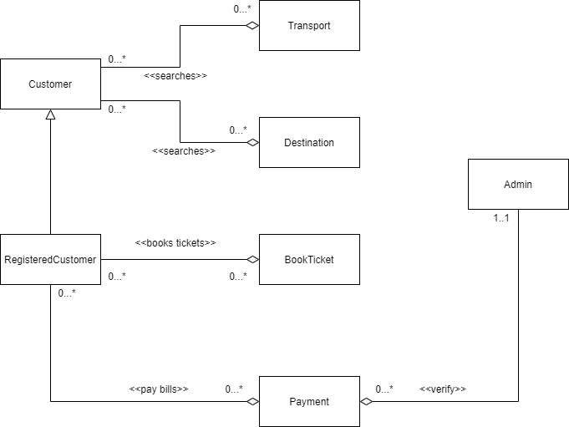

6. Activity Diagram of the project:

Scenario: In travel management system a customer can search for possible travel options. He/she can search by destination or transport. Then they have to select preferable date and time. After that the admin will check vacancy and show the customer available transport.

To purchase or book ticket the customer has to register first. Registration can be done by email or phone no. After providing information the admin will confirm registration and customer will be registered customer.

A registered customer can select transport. After selecting transport, a customer has to select seat type. There are 2 types of seats. A class and B class. After selecting seat type the admin will show the amount to be paid. If the customer wants to pay bill, he or she has to provide credit card info. The admin will verify the credit card info. If the credit card info is invalid the admin will ask the user to give the customer to provide current credit card info. If the credit card info is correct admin will ask the user for confirmation. After the customer confirms the ticket will be purchased successfully.

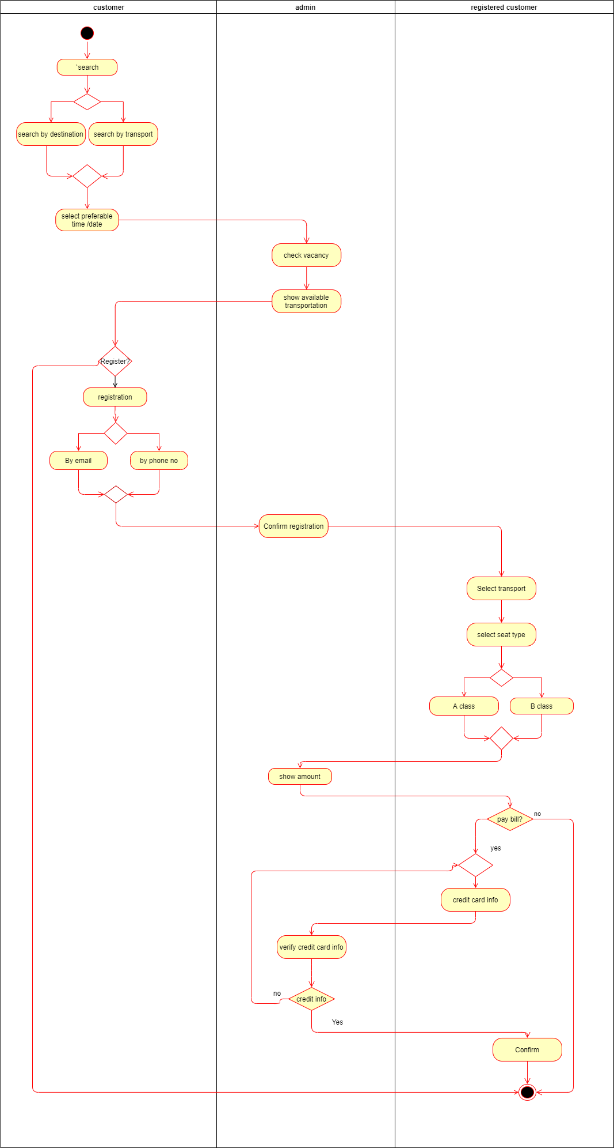

7. Sequence Diagram of the project

**Scenario**: In a transport management system, the customer first must login into the system before he books any transportation. The data system will take his login info from database and check whether it is authentic or not. If the system does not find the authenticity, it’ll return the message login is unsuccessful. After a successful login, customer will select destination and time from admin and the admin will check the availability from the database. If the destination and time is not available, the system will show destination and time not available. If the destination and times are available, the system will ask the customer to select transport and seat type. After selecting transport and seat type the system will request the admin for approval. After admin approves the request, the system will show the customer the amount he/she needs to pay. To make the payment, system will ask the customer for card info. After providing the card info, the system will check the validity of the card. If the card is invalid, the system will return booking unsuccessful and if the card is valid the system will confirm the booking.

DIAGRAM OF SEQUENCE GIVEN BELOW:

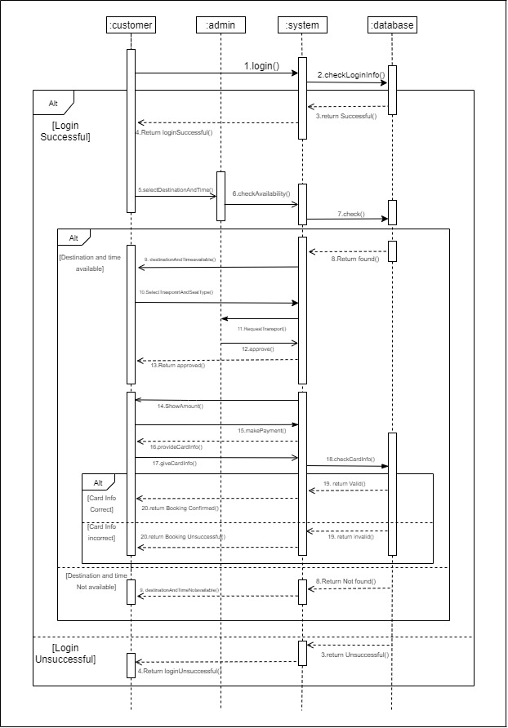

8. State chart Diagram

Scenario: In this travel management system customer can search for destination or transport. For going somewhere, he/she have to select the destination first and pick preferable date and time. After that admin checks for the vacancy. If there any vacant transport available for the particular date and time the admin notifies the customer. Then the customer can start the ticket booking process. First, he/she has to login then select transport and seat type. After that the admin shows the payable amount for the ticket. Then the customer has to give credit card info. Then the admin verifies the info. The customer pays the bill and confirms the ticket.

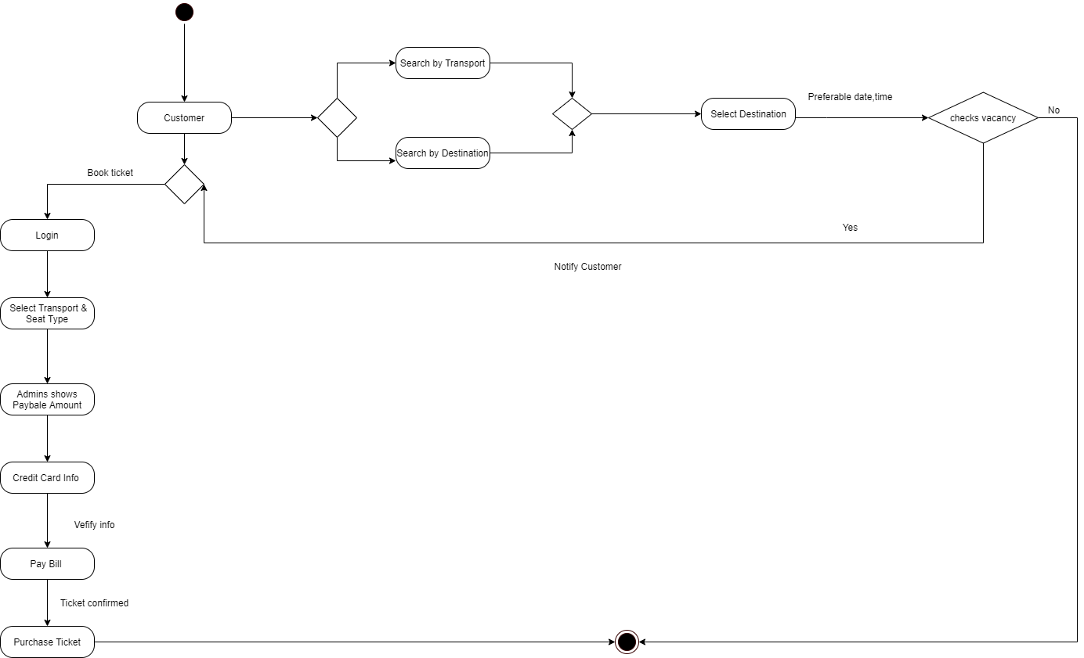

9. Conclusion:

By using this software, customers can have an experience of the whole travel management system. They can easily book tickets staying at home and do not need to go to the ticket counters for booking tickets.