MISTRAL Transport Model

# Deliverables for the Fast-Track Working Prototype of NISMOD v2.0.0

#### Milan Lovric, Simon Blainey

###### University of Southampton

#### Date: 31 October 2016

## Task 1: Agree Upon the Scope of a Case Study

The case study focuses on road traffic within a small region consisting of four local authority districts (Southampton, Eastleigh, New Forest and Isle of Wight). Selected zones have different geographical sizes and different (major) road densities; they include an island zone (Isle of Wight) which requires a ferry line to connect to the rest of the road network; and they also include one port (Southampton) and one airport (Southampton). As such, the chosen region encompasses many modelling challenges that are also relevant for the full-scale model.

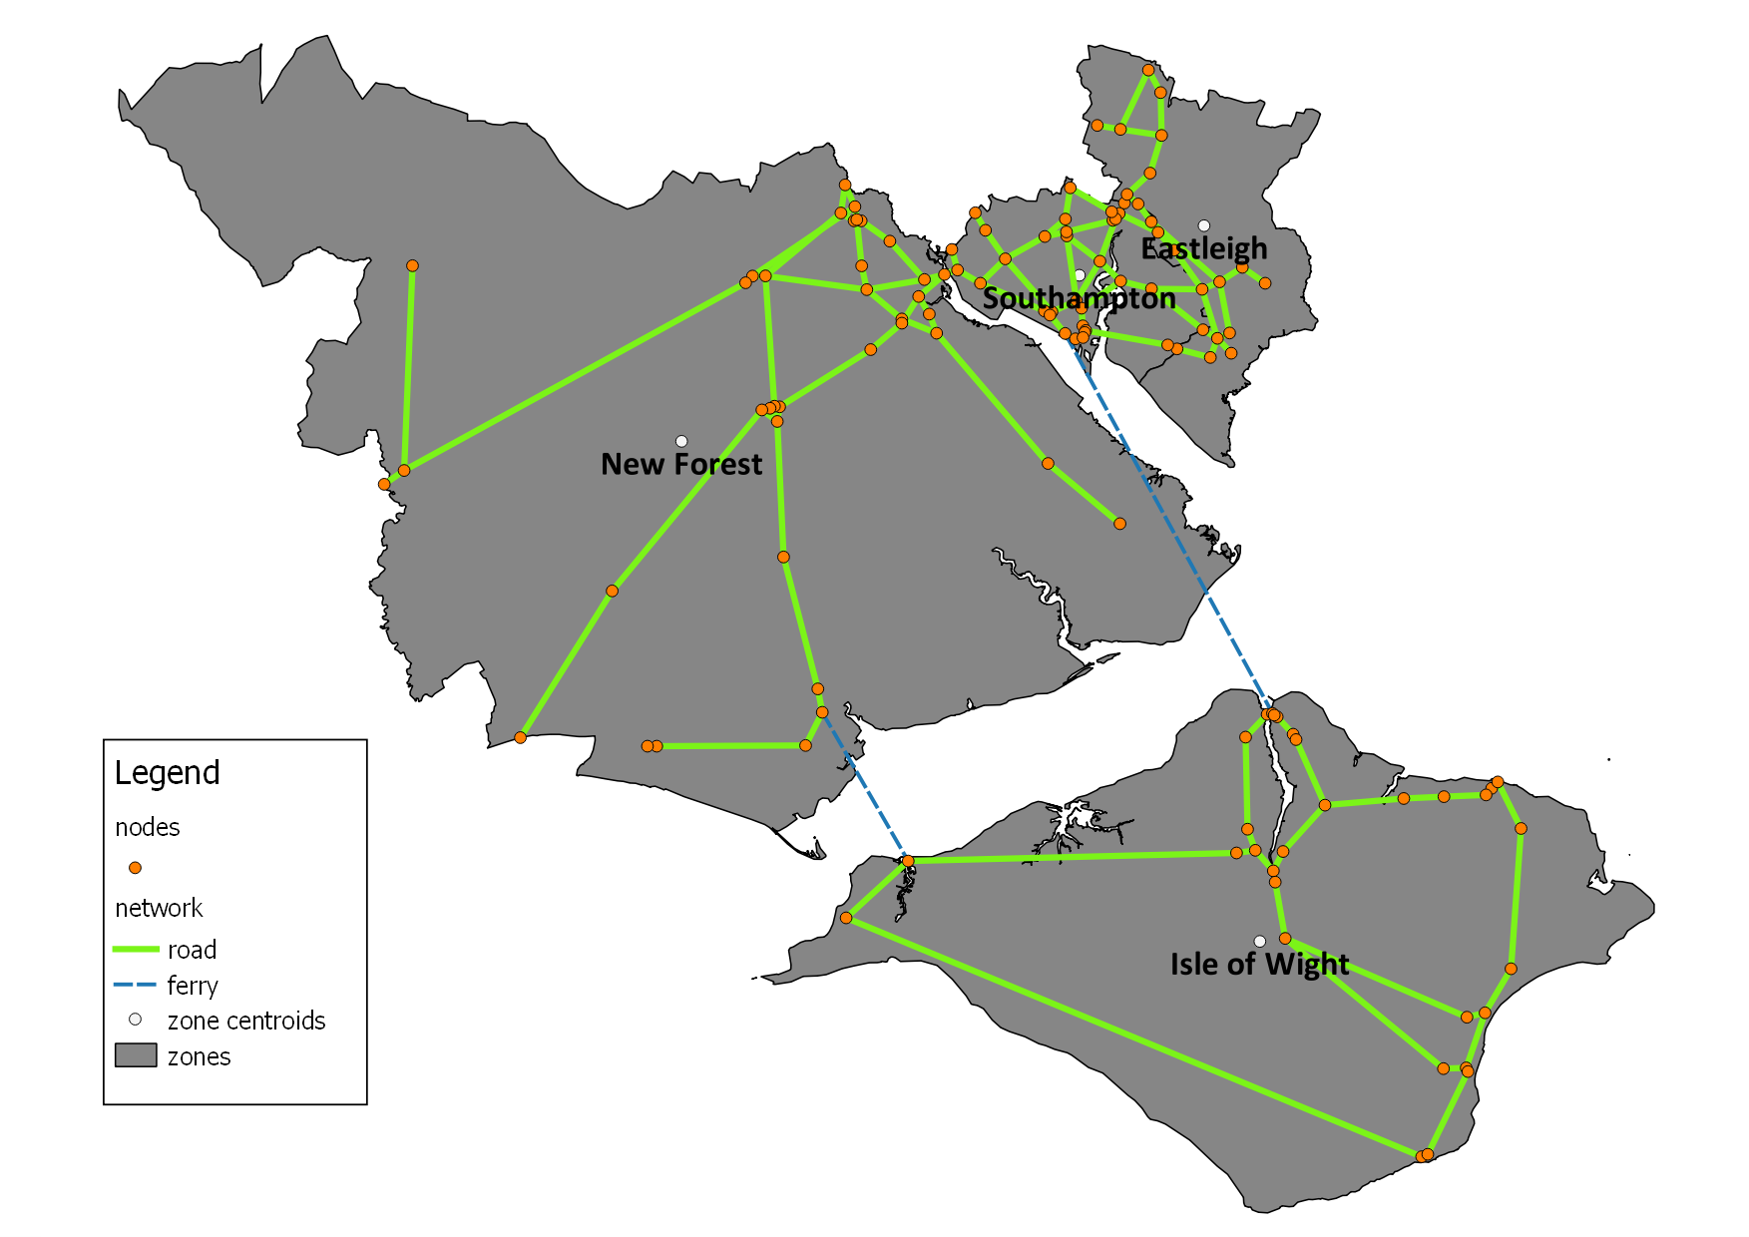

Figure – Case study region and road network

Starting with the base-year (2015) demand, the model will predict future transport demand using an elasticity-based simulation approach, the details of which will be fully specified in the Deliverable 3. The focus of this case study is on one transport mode (road traffic) and on passenger demand. Other modes (e.g. rail) and freight demand will be added in later extensions.

The case study will incorporate one cross-sectoral dependency, namely with the energy sector:

* The fuel price from the energy sector will be used in the traffic flow prediction.
* The transport model will provide information about fuel consumption to the energy sector.

## Task 2: Define Sectoral Case Study Test Data-Set and Schema

### Inputs:

* Zones
  + Local authority districts.
  + These are provided as a shapefile with the attribute table consisting of the zone code (primary key) and the name of the zone. The coding system is devised by the Government Statistical Service (GSS).
* Road network
  + The road network for this case study is based on the major road network from the GB Road Traffic Counts dataset by the Department for Transport (DfT):

<https://data.gov.uk/dataset/gb-road-traffic-counts>

* + The shapefile of the test network contains:
    - 158 road links (5 of which are detected as duplicate links by the topology checker).
    - 2 ferry links (these have been added to create a fully connected road network).
  + 122 nodes have been extracted from the road network using:
    - QGIS *Vector → Geometry Tools → Extract Nodes* and the MMQGIS plugin *Modify → Remove Duplicate Geometries* to remove duplicate nodes.
    - These nodes represent either junctions or points where links are split into multiple segments (each with its own traffic count point).
    - These nodes will serve as trip start and end points for route-choice (e.g. fastest path) calculations during the traffic assignment, and may also be weighted using additional data inputs (e.g. population size). The purpose is to distribute trips from an origin zone to a destination zone in a more realistic way than assigning all the traffic to the zone centroids.
  + Annual Average Traffic Counts (AADF) data is provided as a .csv or a .shp file containing:
    - CP (a unique identifier for the AADF count point and the associated road link).
    - CP location.
    - Traffic counts (the number of passing vehicles) for various types of vehicles (bicycle, motorcycle, car/taxi, bus/coach, LGVs, different types of HGVs) and all combined.
    - The actual physical length of the associated road link.
    - Road name and the road category of the road link.
    - Other attributes as described in the metadata file:

<http://data.dft.gov.uk/gb-traffic-matrix/all-traffic-data-metadata.pdf>

* + - Two version of AADFs exist: combined (sum of both directions) and directed.

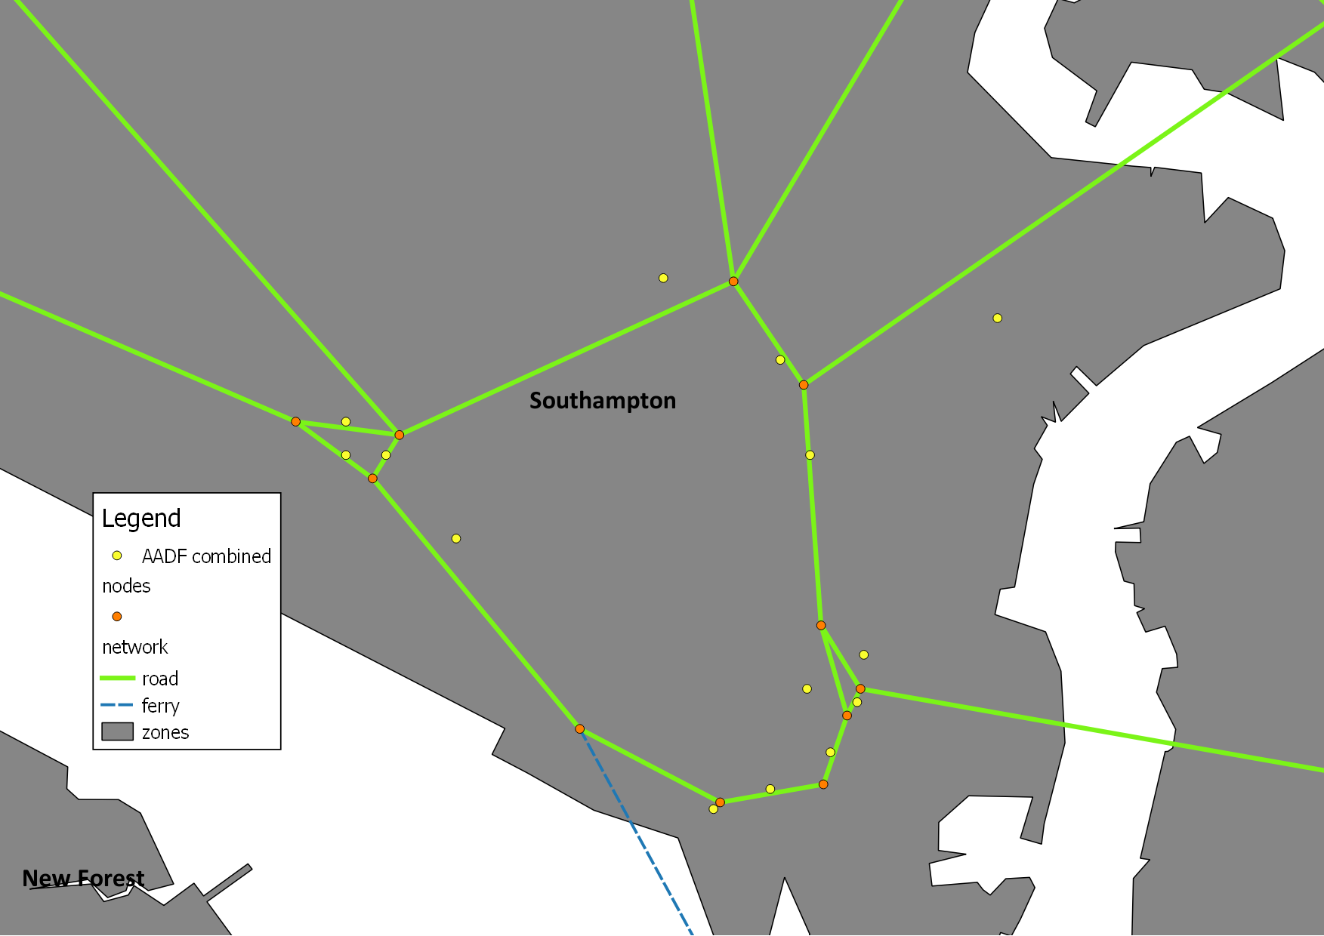

Figure - AADF count points on the road network

* + For each link in the network the following information is required:
    - Link ID (should be different from CP as new links without counts may be added. CP should be a foreign key in this table).
    - Link length - from the count point data.
    - Road category - from the count point data.
    - Number of lanes - assumed from the road category until better data is available.
    - Maximum free-flow speed - assumed from the road category until better data is available.
    - Link travel time:
      * Free-flow travel times will be calculated from the link length and the maximum free-flow speed.
      * Congested travel times will be calculated during the traffic assignment (which may need to be iterated several times to reach a quasi-equilibrium).
    - Additional parameters to model link capacities.
  + For each node in the network the following information is required:
    - Node ID.
    - Zone (local authority district) to which the node belongs (zone code as a foreign key).
    - Population size that gravitates to this node.
* A base-year (2015) **origin-destination (OD) matrix** for the (passenger) road traffic:
  + A square matrix with passenger flows (number of trips) between local authority districts.
  + In future extensions, an OD matrix will also be introduced for freight.
  + A notional example of daily flows (to obtain yearly flows multiply by the number of days in the year):

|  |  |  |  |  |
| --- | --- | --- | --- | --- |
| Destination  Origin | E06000045 (Southampton) | E07000086 (Eastleigh) | E07000091 (New Forest) | E06000046 (Isle of Wight) |
| E06000045 (Southampton) | 5000 | 5500 | 2750 | 150 |
| E07000086 (Eastleigh) | 6500 | 5500 | 900 | 120 |
| E07000091 (New Forest) | 4560 | 1400 | 6000 | 100 |
| E06000046 (Isle of Wight) | 200 | 150 | 90 | 1000 |

* A base-year (2015) **skim matrix** for the road traffic:
  + A square matrix with average travel times between local authority districts.
  + A notional example is given bellow (in minutes):

|  |  |  |  |  |
| --- | --- | --- | --- | --- |
| Destination  Origin | E06000045 (Southampton) | E07000086 (Eastleigh) | E07000091 (New Forest) | E06000046 (Isle of Wight) |
| E06000045 (Southampton) | 11 | 18 | 28 | 155 |
| E07000086 (Eastleigh) | 16 | 13 | 30 | 119 |
| E07000091 (New Forest) | 27 | 28 | 20 | 109 |
| E06000046 (Isle of Wight) | 114 | 113 | 107 | 16 |

* Socio-demographic variables:
  + Population size in each zone.
  + GVA in each zone.
* Cross-sectoral inputs:
  + Fuel price from the energy sector.
* Elasticity parameters:
  + Taken from previous studies.

### Outputs:

* Predicted (next-year) link travel times
  + Obtained after several iterations of traffic assignment.
* Predicted (next-year) skim matrix
  + Intra-zonal travel times calculated by aggregating link travel times for several paths between each origin and destination.
* Predicted (next-year) OD matrix
  + New demand (flows between each origin and destination) produced by the elasticity-based simulation.
* Capacity utilisation of the road network
  + In terms of vehicles per lane kilometres.