**ERGA LABS :**

**Introduction**:

The Smart City Environmental Sentinel monitors air quality, noise, temperature, and humidity using IoT sensors, enhances public safety with fire detection, and promotes energy efficiency through solar power. It collects and analyzes data in real-time, providing insights on a web-based dashboard for informed urban planning. This system benefits cities by improving environmental sustainability, enhancing public safety, reducing energy costs, and supporting data-driven decision-making for a more livable and resilient urban environment.

1. **Complete PCB Layout**

A complete PCB layout in KiCad involves arranging components and routing traces to create a functional and manufacturable circuit board

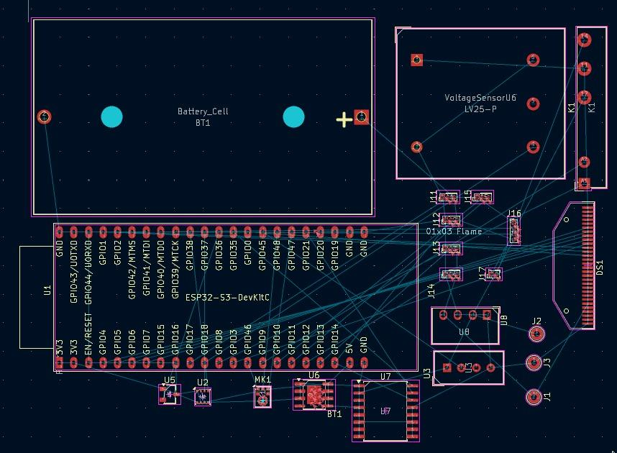

1. **Front Copper Layer**

The Front Copper Layer in KiCad represents the top side of the PCB, where copper traces are routed to connect components and provide electrical pathways.

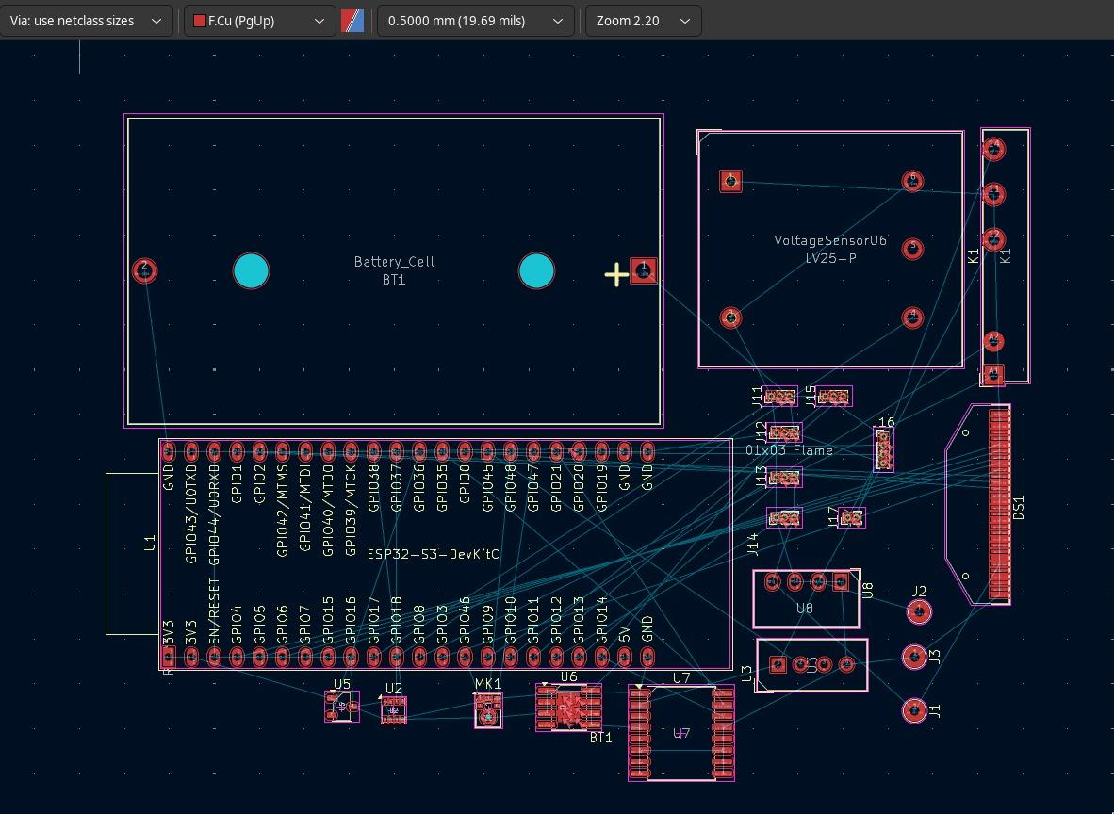

1. **Back Copper Layer**

The Back Copper Layer in KiCad represents the bottom side of the PCB, used for routing additional copper traces and electrical connections.

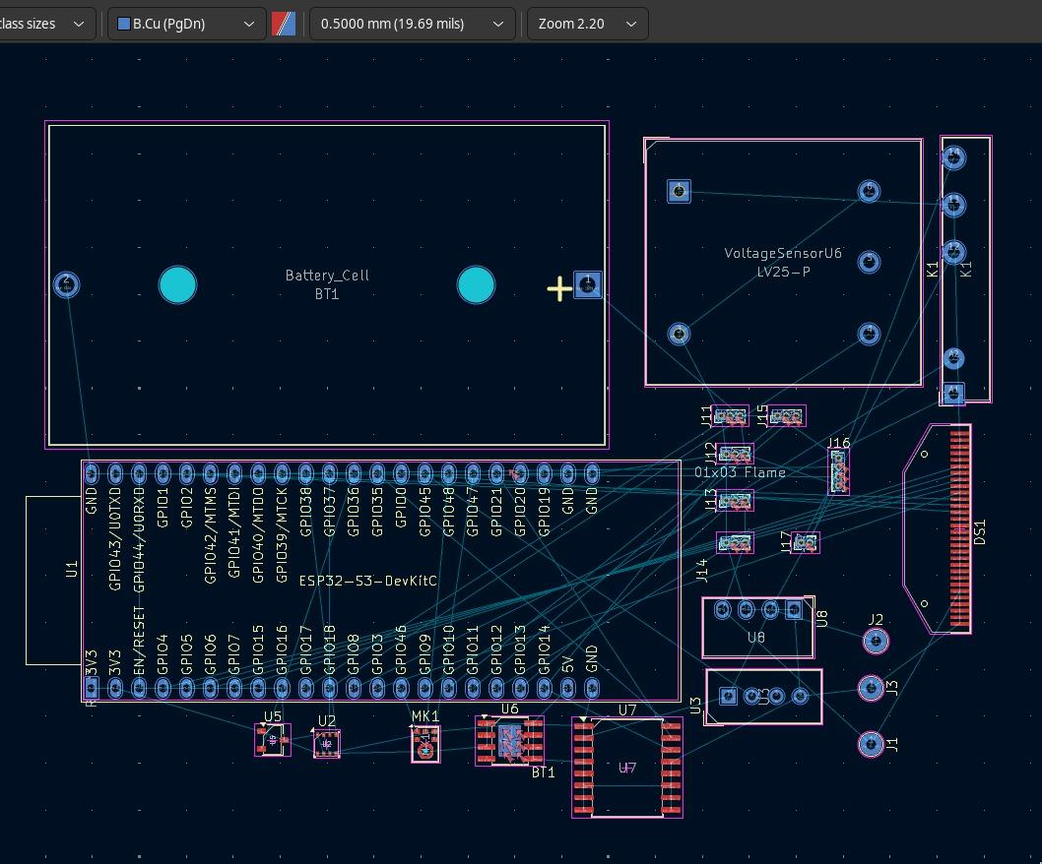

1. **3D Rendered image of PCB**

A 3D rendered image of the PCB in KiCad provides a visual representation of the board's physical appearance, including component placement and layer stack-up, for better design verification.

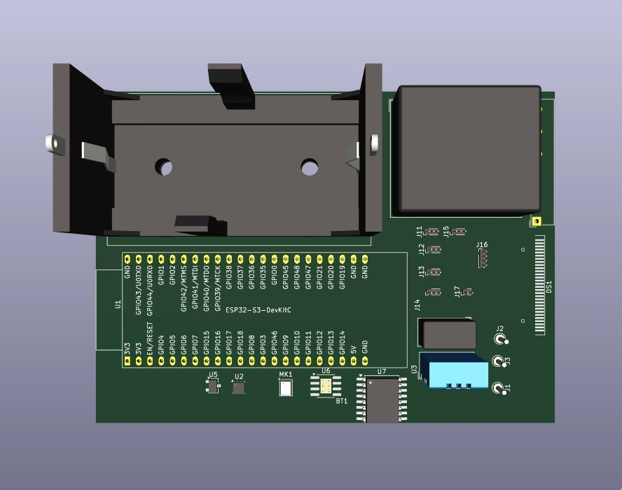

1. **Schematic Diagram**

A Schematic Diagram screenshot in KiCad displays the electrical connections between components, showing the logical design of the circuit before creating the PCB layout

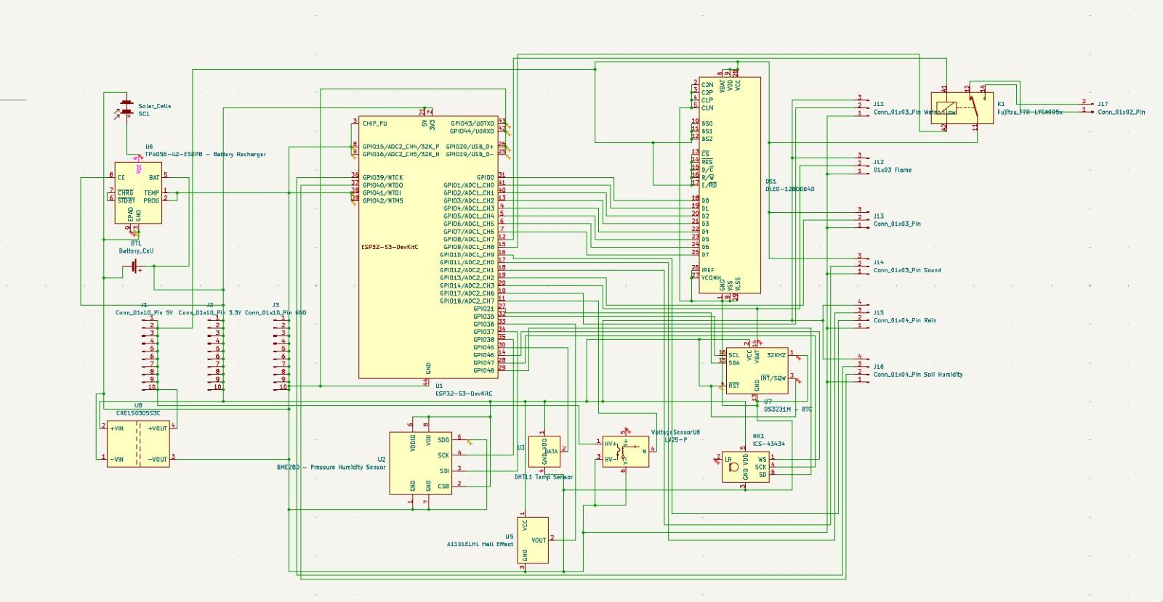

1. Electrical Rule Checker

Electrical Rule Checker (ERC) in KiCad is a tool that automatically checks the schematic for electrical errors, such as unconnected pins, incorrect power connections, or violations of design constraints, ensuring the circuit is electrically sound before moving to the PCB layout stage

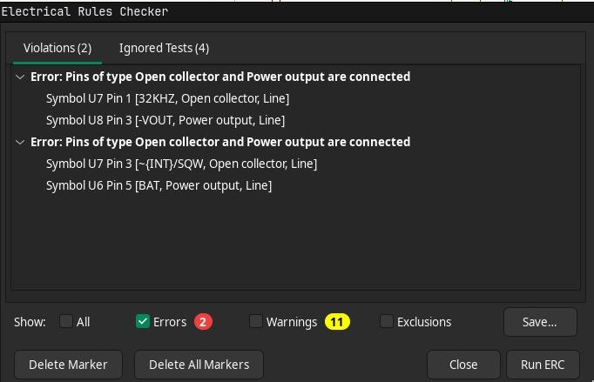

1. Ruler Checker:

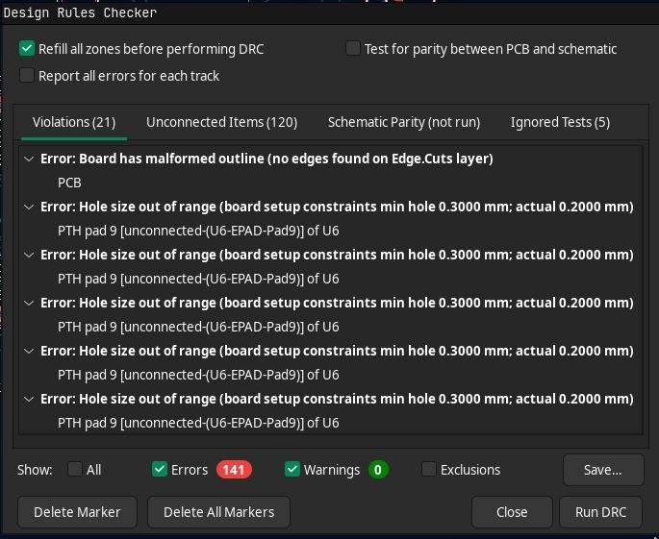

1. 3D Model:

