SleepMix
ERD
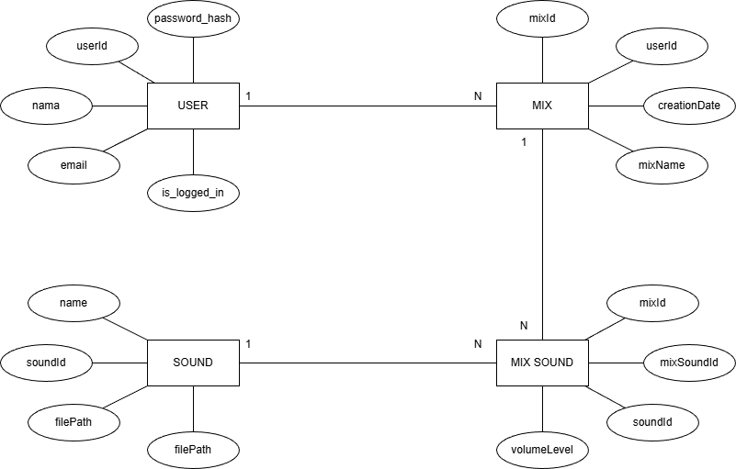
RAT
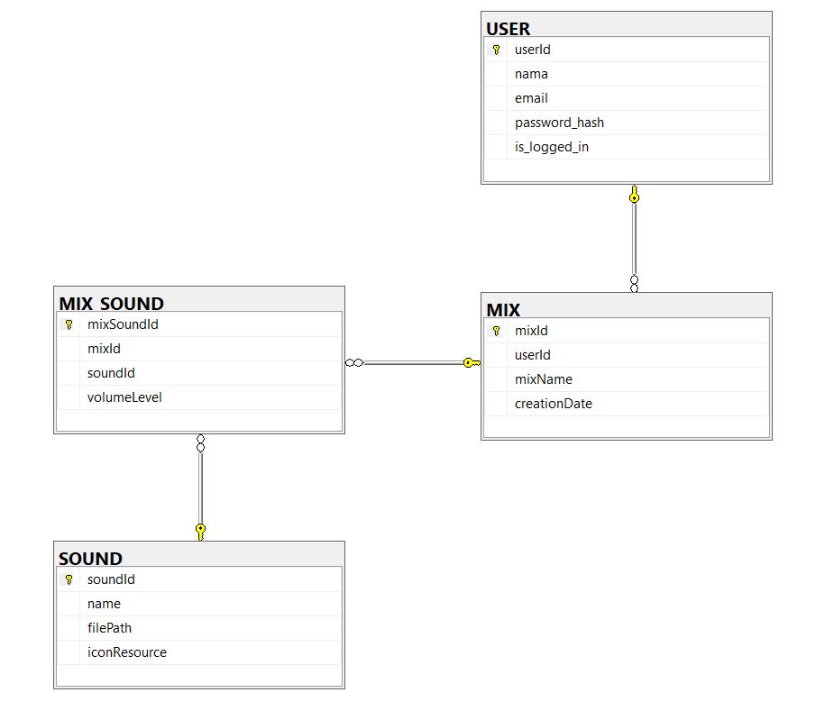
FLOWCHART
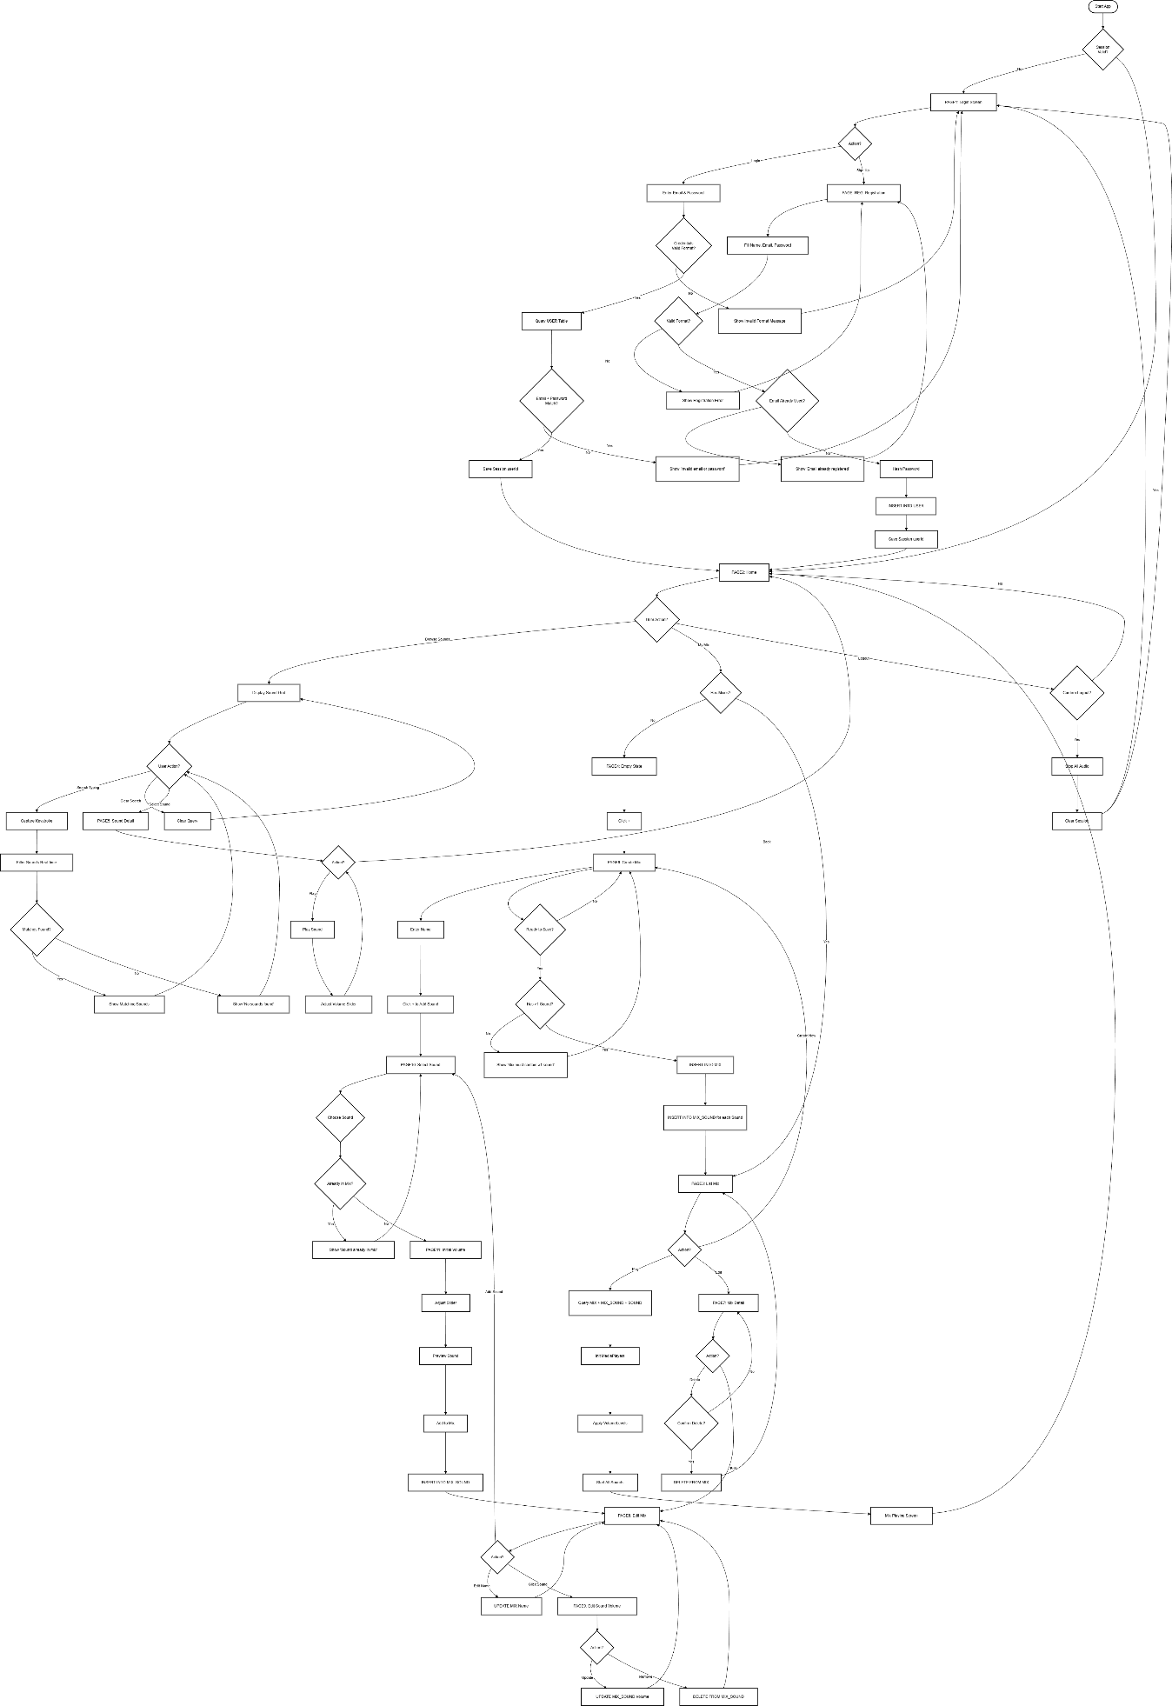
https://www.mermaidchart.com/d/3c0d5dd6-5c93-459a-adf9-3cc41a3c2daa
ACTIVITY DIAGRAM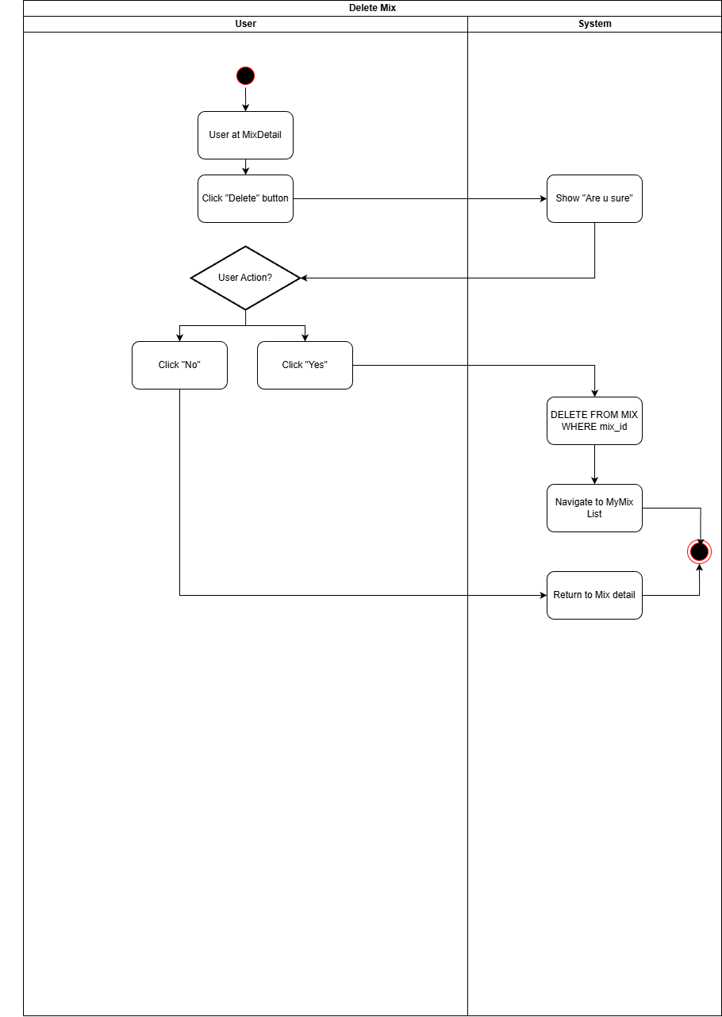
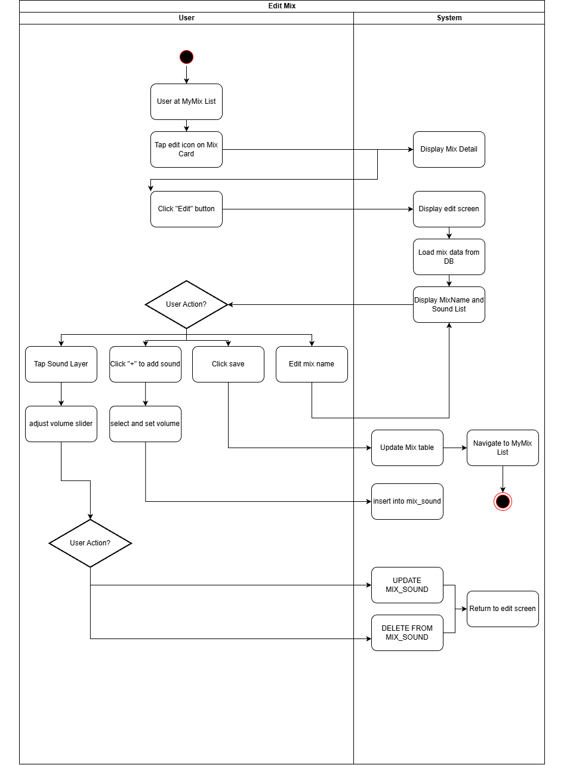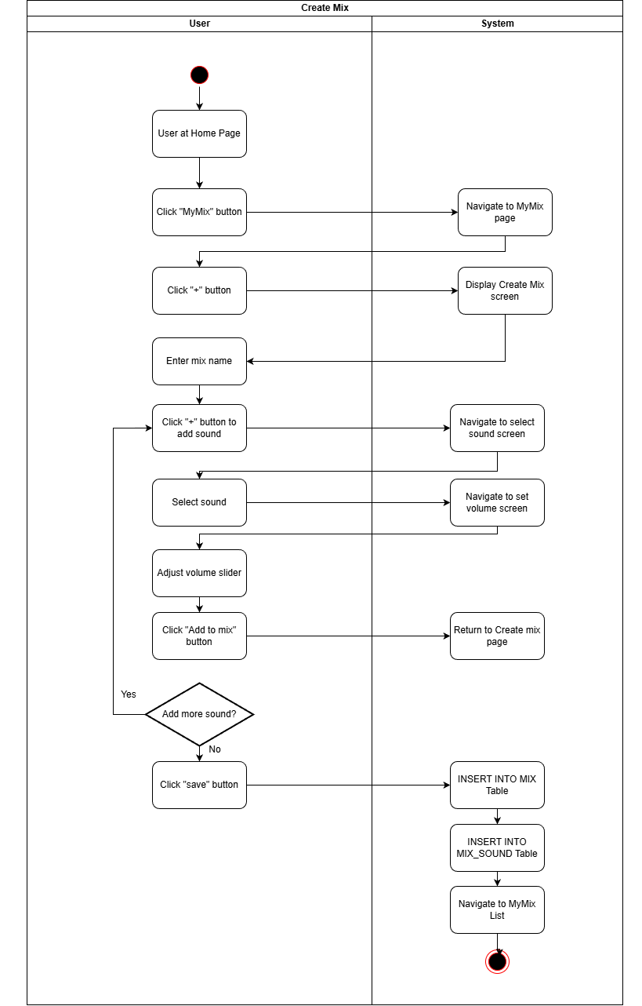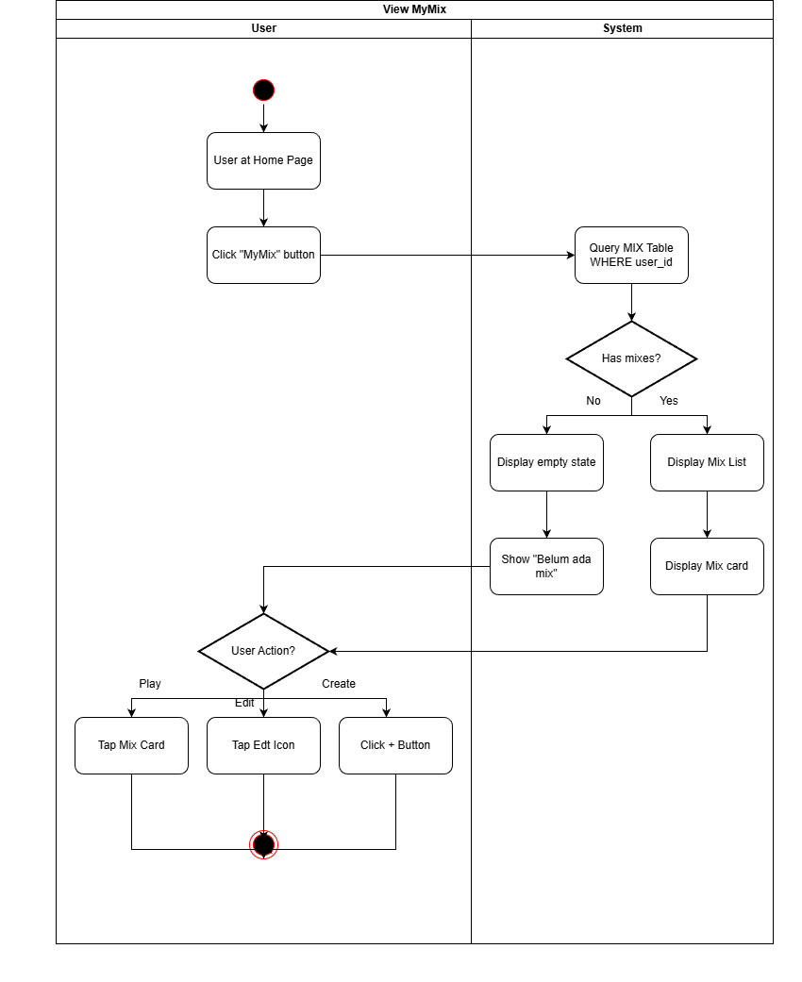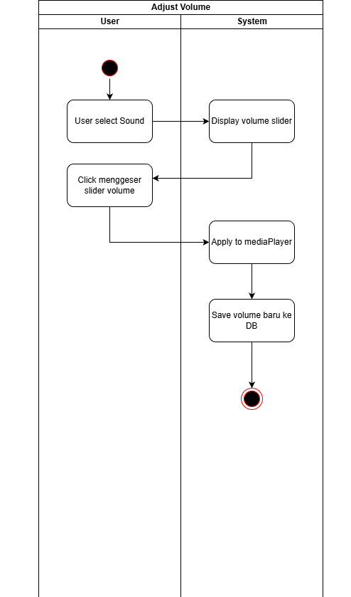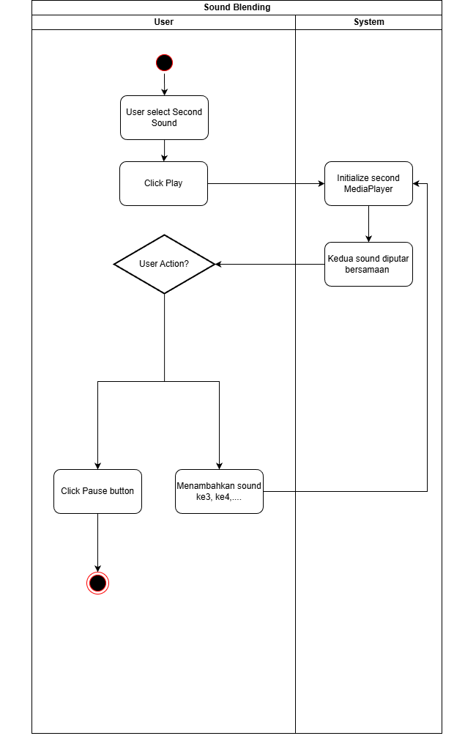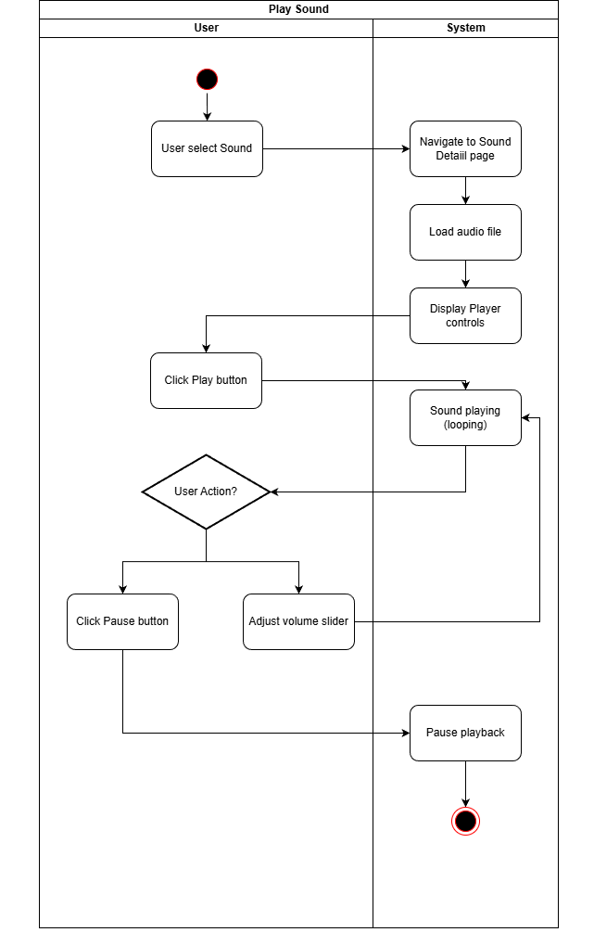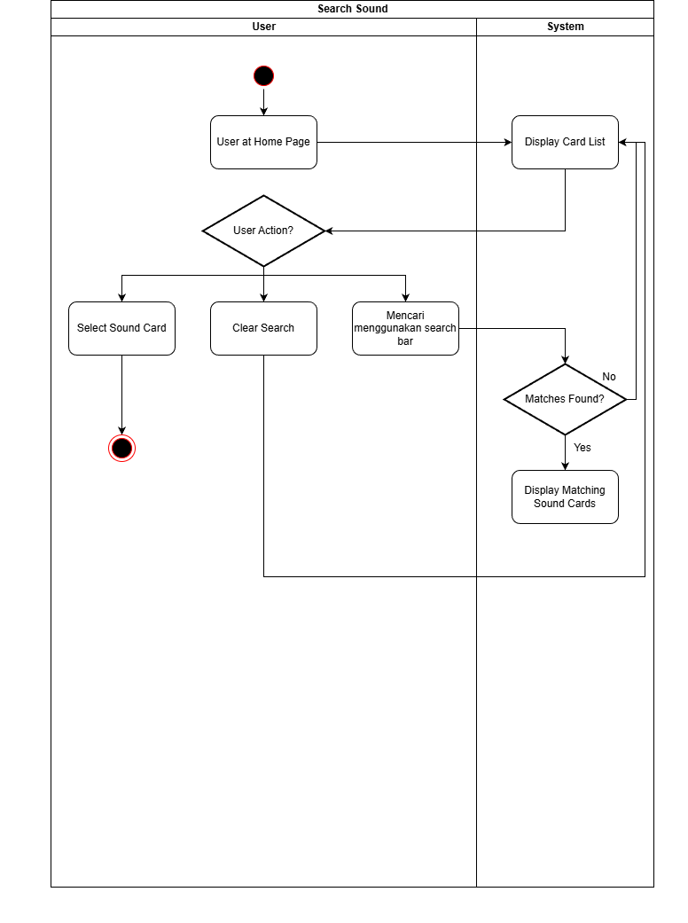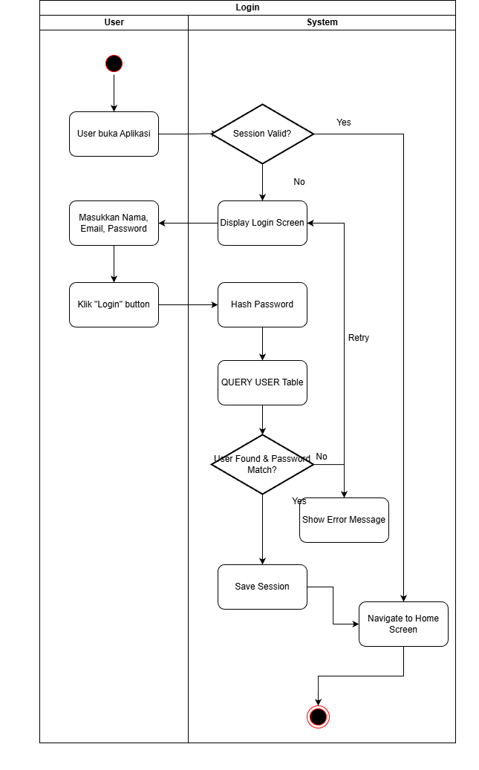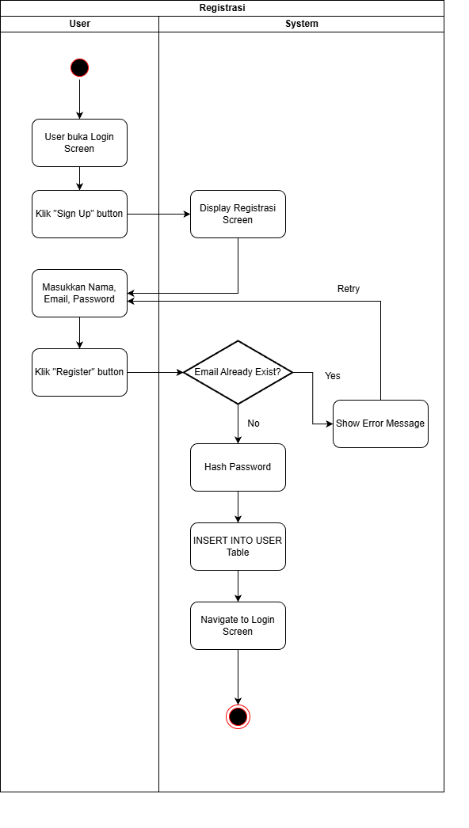
KAMUS DATA
- Tabel USER
Nama Atribut | Tipe Data | Panjang | Keterangan
userId | INT | - | Primary Key, auto increment
nama | TEXT | 100 | Nama user
email | TEXT | 255 | Email user (unique)
password_hash | TEXT | 64 | Hash password
is_logged_in | INT(0/1) | 1 | Status login user

- Tabel SOUND
Nama Atribut | Tipe Data | Panjang | Keterangan
soundId | INTEGER | - | Primary Key
name | TEXT | 100 | Nama sound (Rain, Wind, Ocean…)
filePath | TEXT | 255 | Lokasi file audio di internal storage
iconResource | TEXT | 100 | Nama atau lokasi icon untuk grid UI

- Tabel MIX
Nama Atribut | Tipe Data | Panjang | Keterangan
mixId | INTEGER | - | Primary Key
userId | INTEGER | - | Foreign Key → USER.userId
mixName | TEXT | 100 | Nama mix dari user
creationDate | TEXT (ISO 8601) | 20 | Tanggal pembuatan mix

- Tabel MIX_SOUND
Nama Atribut | Tipe Data | Panjang | Keterangan
mixSoundId | INTEGER | - | Primary Key
mixId | INTEGER | - | Foreign Key → MIX.mixId
soundId | INTEGER | - | Foreign Key → SOUND.soundId
volumeLevel | REAL (float) | - | Level volume (0.0 – 1.0)

