LAB ASSIGNMENT V : HUERISTIC EVALUATION
SYSTEM EVALUATED : Punjab National Bank (PNB) Homepage - Hi-Fi Interactive Prototype (Figma)
Groups members NAME : …………Nisarg Ghule…………….
**Evaluation to be done by other Group
PART I : HUERISTIC EVALUATION BASED ON NIELSEN'S 10 GENERAL PRINCIPLES FOR INTERACTION DESIGN. (0 is lowest and 10 is highest)
S.No. | Heuristic Evaluation Parameter | Mention Violation if any | Severity 0-10 (0- minimum and 10 is maximum) | Ways to improve
1 | User Control: Interface will allow the user to perceive that they are in control | The site has a 'Home' back button on the Login and Dashboard pages, an X to close the search box and the chat, and a Sign out button, so the user feels in control. But the Quick Access carousel has no way to pause it, and the Login page does not tell what Step 2 is. | 2 / 10 | Add a pause button on the carousel and write what Step 2 is (for example 'Step 2 of 2: Enter OTP').
2 | Human Limitations: Interface will not overload the users cognitive, auditory and motor skills | The menu is short (5 items) and the page has a lot of white space, so it is easy on the user. But the dashboard has many things on one page (3 account cards, quick actions, long table). The carousel dots are very small and the side cards are cut off. | 3 / 10 | Make the dots bigger, show the side cards fully, and keep the dashboard to the most important things at the top.
3 | Accommodation: The interface will fit the way each user group works and thinks (personas) | There are High contrast, Dark theme and Hindi options, which is good. But there are only 2 languages and no special entry for different users like senior citizens, NRIs or students, even though the heading says 'for every generation'. | 3 / 10 | Add more regional languages and a text size option. Add quick links for different types of users.
4 | Linguistic Clarity: Interface will communicate as efficiently as possible | Most words are simple ('Show balance', 'Transfer money', 'Calculate EMI'). Problems: 'Explore demo dashboard' can confuse a real customer, 'Continue securely' does not say what happens next, and 'Step 1 of 2' does not say what Step 2 is. | 3 / 10 | Change the button to 'View sample dashboard', use 'Next' or 'Login' on the button, and name the steps.
5 | Aesthetic Integrity :The interface will have an attractive and appropriate design | Maroon and cream colours are used everywhere and look like a bank. The photo is friendly and the cards are neat. Small issues: the 'Open an account' buttons touch the Quick Access box, and in Dark theme the pink text 'Banking for every generation' is hard to read on the pink tag. | 2 / 10 | Add some space between the buttons and the Quick Access box and use brighter text on the tag in Dark theme.
6 | Simplicity: The interface will have a simple design | The design is clean with plenty of space and one main message. The top part of the home page is slightly crowded because the heading, two buttons and the Quick Access box are very close together. The dashboard page is long. | 2 / 10 | Add more gap in the top part and move less-used items (like the full transaction list) further down.
7 | Predictability :The interface will behave in such a manner that the user can accurately predict what will happen next | Search has a proper magnifier icon and the results show icons and one-line help, so it is easy to guess. But it is not clear if the faded side cards in the carousel can be clicked. The nav items 'Dashboard' and 'Login' button do not tell what happens before login. | 3 / 10 | Show a hand cursor or hover effect on the side cards, and ask the user to log in first if they click Dashboard.
8 | Accuracy: Interface will be free from errors | Mostly correct, but a few small errors: in the chat box the suggestion button text is cut ('Calculate home loar'), the chat box covers part of the menu (Dashboard and Login), and the dashboard dates are not in order (22/06, 20/06, 17/06, 24/06, 18/06). | 3 / 10 | Make the chat chips wrap to the next line, keep the chat box below the menu, and sort the dates properly.
9 | Technical Clarity: Interface will have the highest possible fidelity. | The prototype works like a real website: pages open, buttons work, chat and search are usable. I only checked it on a desktop screen, so I could not see how it looks on a phone. The floating 'Ask PNB' button also covers some content at the bottom right. | 3 / 10 | Test on phone and tablet sizes and leave some space so the Ask PNB button does not cover text.
10 | Fulfillment : The interface will provide a satisfying user experience | The site helps users finish tasks: Quick actions (Transfer money, Calculate EMI, Locate branch, Open account), balance hiding, search of transactions and Download button. The first impression is friendly and trustworthy. | 2 / 10 | Add one or two more common tasks like 'Pay bills' and 'Check balance' in Quick actions on the home page.
11 | Consistency: Interface will be consistent | The header, footer, colours, fonts and buttons are the same on all pages, so it feels like one website. Small differences: 'Login' in the menu but 'Continue securely' on the form, and 'Open account' is a filled button on the home page but an outlined button on the dashboard. | 2 / 10 | Use the same button style and the same words for the same action everywhere.
12 | User Support: Interface will provide additional assistance as needed or requested | Good help is available: 'Ask PNB' chat on every page, FAQ section, customer care number 1800 1800 / 2021, email care, 'Forgot password?', and a 'Secure session' note. Missing: tooltips on icons and small hints inside the search box. | 2 / 10 | Add tooltips for the icons and a short hint like 'Try: EMI calculator' in the search box.
13 | Precision: The interface will allow the users to perform a task exactly | Buttons and the search box are large and easy to click, and the filter buttons (All, Credit, Debit) are clear. But the carousel dots are tiny and hard to hit, and the 'All' filter is the only thing that shows which option is active. | 3 / 10 | Make the dots bigger and show the active menu item and active slide more clearly.
14 | Forgiveness: Interface will make action recoverable | The user can recover from mistakes: 'Forgot password?', Show password eye icon, 'Remember my customer ID', close buttons and 'Home' button. But I could not see any error screens (wrong password, wrong ID) or a message after an action is done. | 3 / 10 | Add error messages under the fields, a 'Please wait' message and a success message after actions like transfer.
15 | Responsiveness: The interface will inform users about the results of their actions and their interface status | The site shows the status well: 'Completed' and 'Pending' tags with icons, 'Step 1 of 2', the selected filter turns maroon and the active carousel card is bigger. Missing: the current menu item is not highlighted (for example on Dashboard) and I did not see a loading or typing sign in the chat. | 3 / 10 | Highlight the current page in the menu and show a loading sign and 'typing...' in the chat.
 | Total Score | Overall usability rating: about 7.4 / 10 (the average problem score is 2.6 / 10, and lower problem score is better). Total = sum of all 15 scores. | 39 / 150 | Biggest problems (3/10): only 2 languages, unclear Step 2 on login, tiny carousel dots, no error screens and no phone view. Smallest problems (2/10): Aesthetics, Simplicity, Fulfillment, Consistency and User Support. The site is easy to use and looks like a real bank site.

**Attach Screenshots
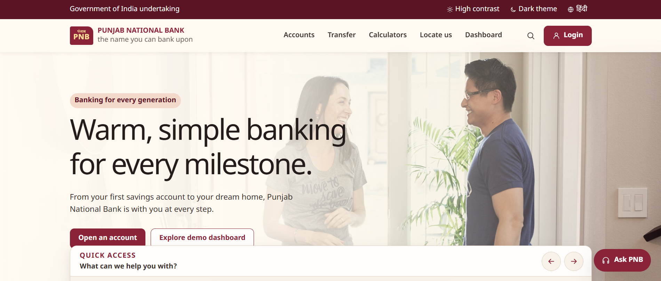
Fig 1: Home page (hero, Open an account, Quick Access)
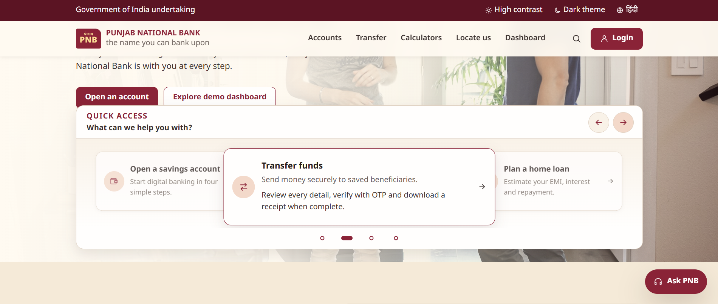
Fig 2: Quick Access carousel with arrows and dots
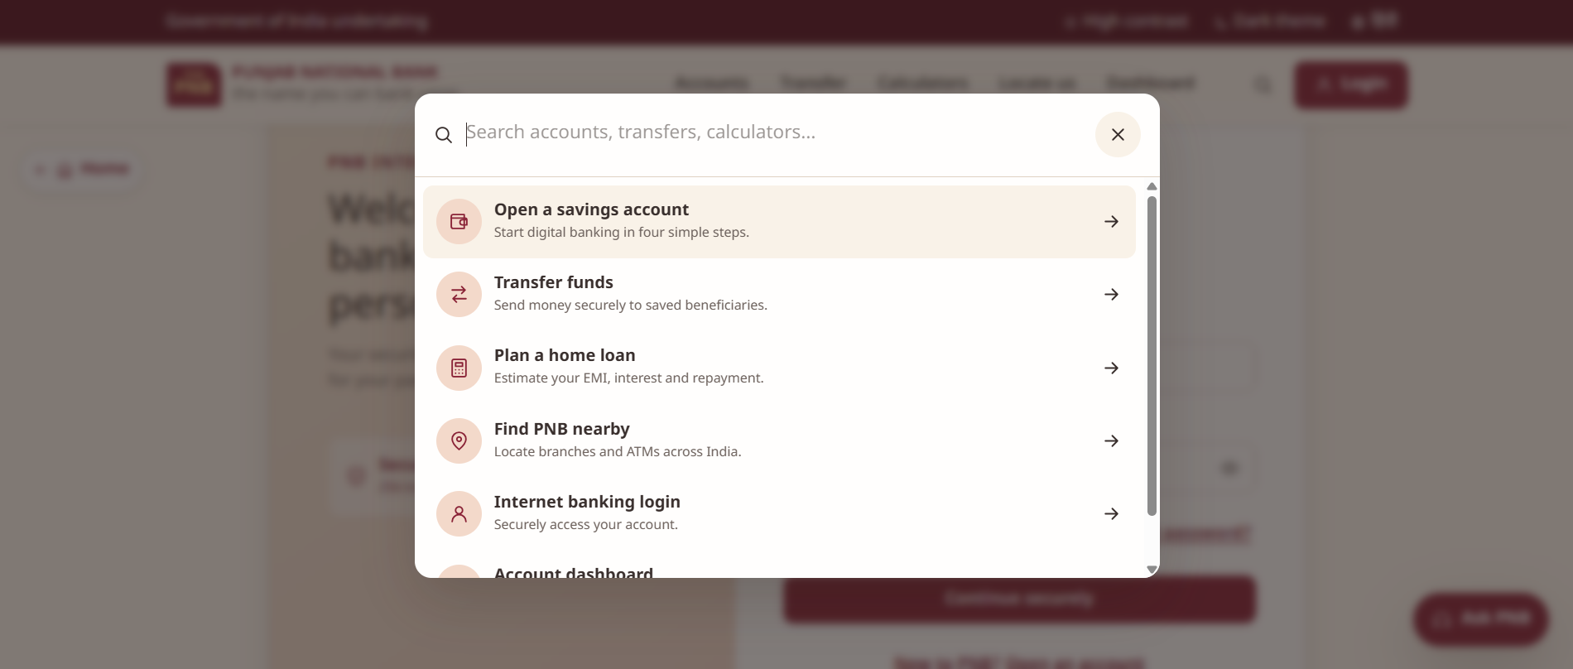
Fig 3: Search box with suggestions
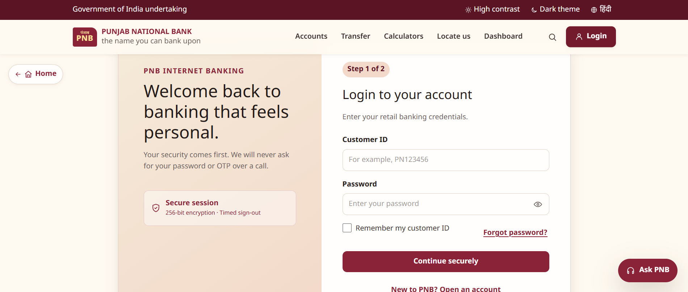
Fig 4: Login page (Step 1 of 2)
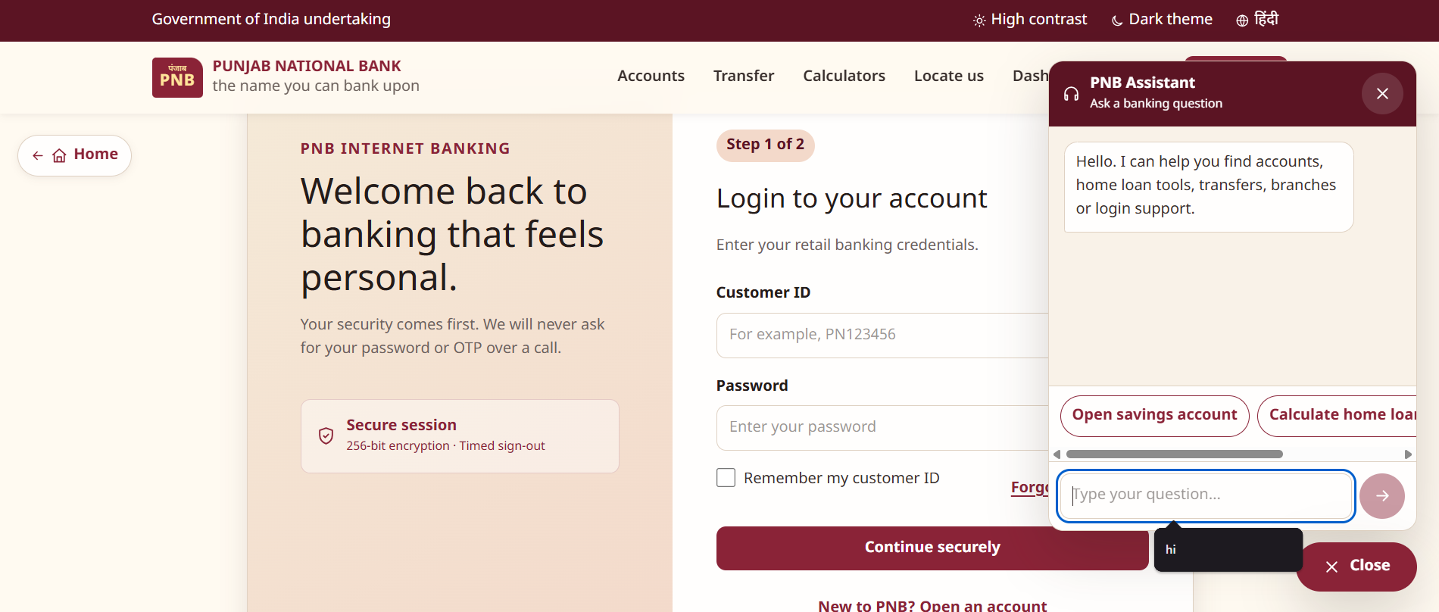
Fig 5: Ask PNB chat box (covers part of the menu)
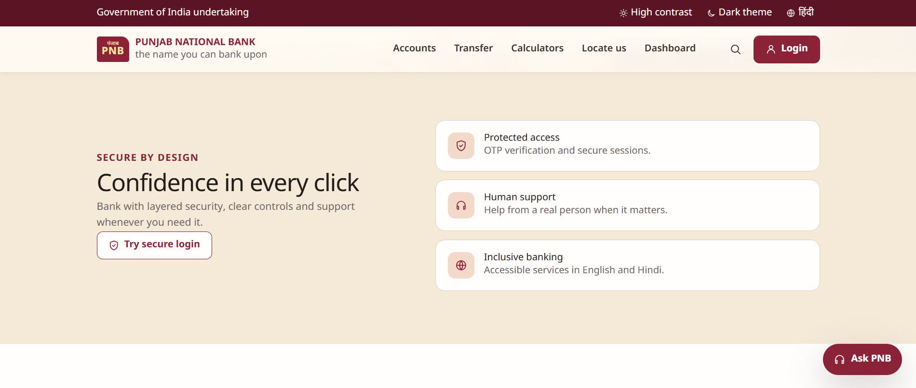
Fig 6: Secure by design section
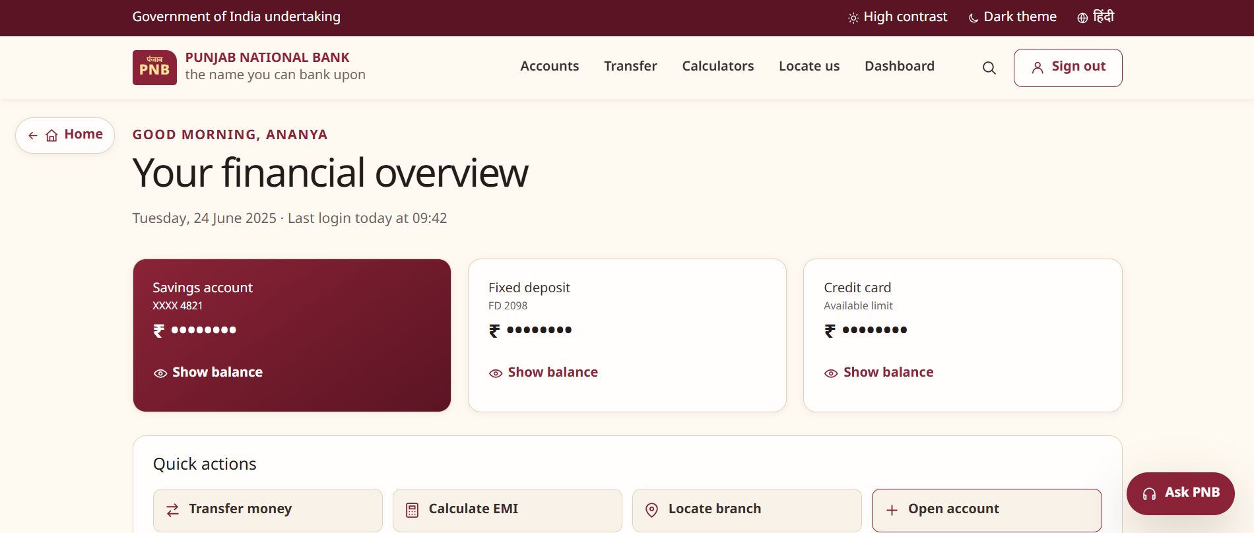
Fig 7: Dashboard (account cards and quick actions)
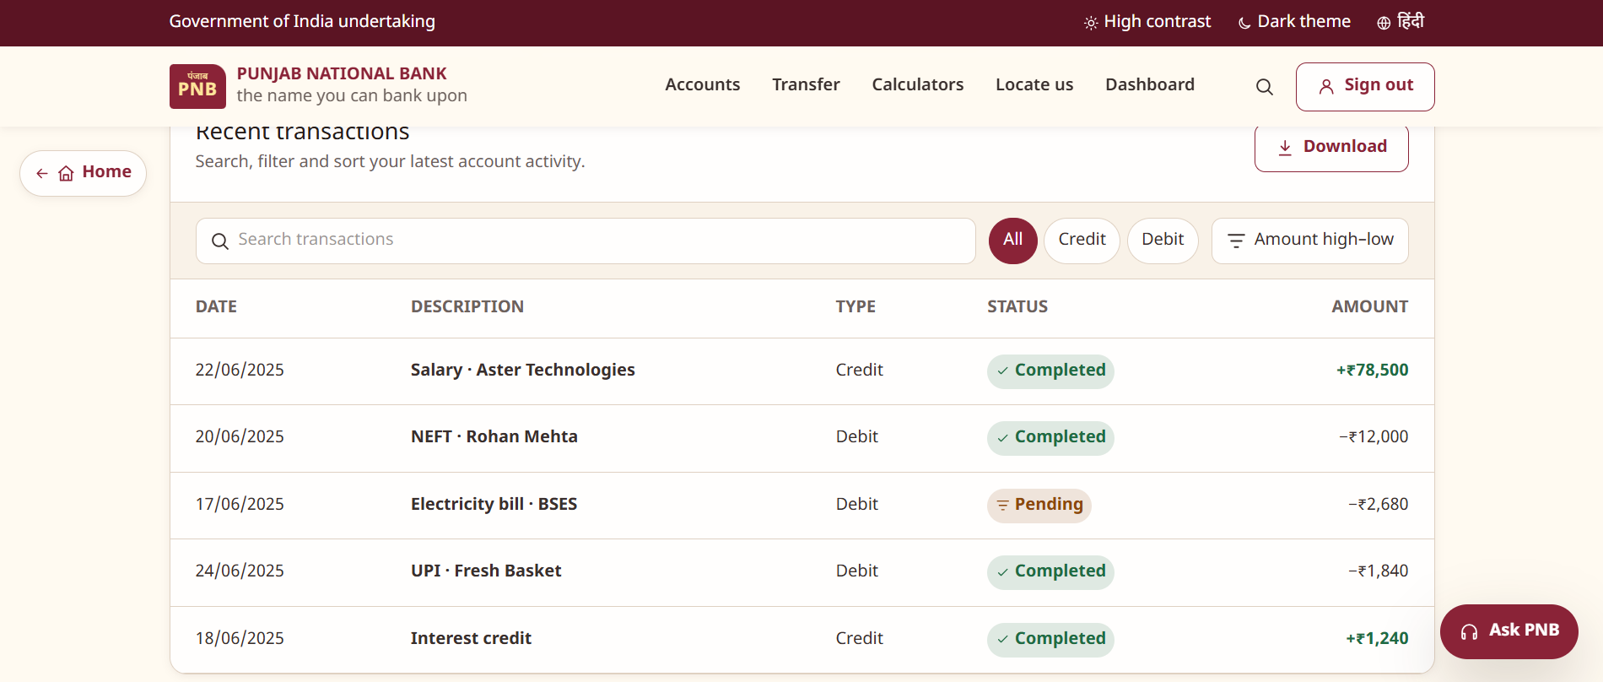
Fig 8: Recent transactions table
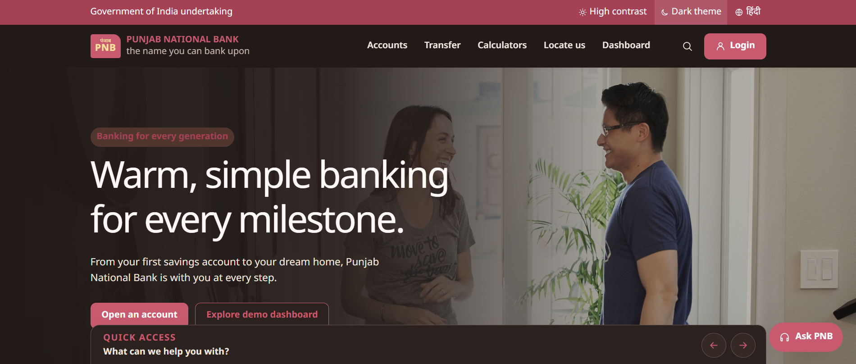
Fig 9: Dark theme (pink tag text is hard to read)
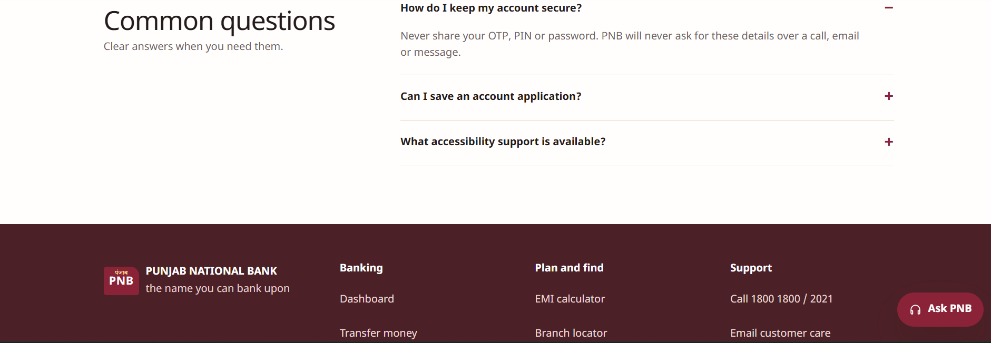
Fig 10: FAQ and footer

PART II : List out any other points that you may have missed out . (Other than Nielsen’s Principles)

S.NO | OBSERVATIONS | COMMENTS
1 | Accessibility | The site has High contrast and Dark theme buttons and a Hindi option, which is very good. But only English and Hindi are given, there is no text size option, and the pink text in Dark theme is hard to read.
2 | Phone and tablet | I could only check the desktop screen. Many people in India use banking on their phones, so phone and tablet screens should also be shown and tested.
3 | Trust and safety | The site gives clear safety messages: 'Secure session', 'We will never ask for your password or OTP over a call', the OTP note in 'Secure by design' and a FAQ on keeping the account safe. A padlock icon in the browser style and a virtual keyboard could be added.
4 | Information | The home page has Quick Access, 'Secure by design', a FAQ (Common questions) and a full footer with Banking, Plan and find, and Support links. Products are shown in a small carousel with only 4 items, so users may miss other products like loans or cards.
5 | Dashboard page | The dashboard is nice: it greets the user, hides balances until 'Show balance' is clicked, and has quick actions and a transaction list with search, filters, sorting and Download. The page date is fixed to 24 June 2025 and the transaction dates are not in order.
6 | Login page | The Login page is simple with a clear example in the Customer ID box. Still needed: error messages for wrong ID or password, a loading state, the OTP page (Step 2) and a phone version.

Students Evaluation Team : group that is evaluation ………………………………………………………………………………..

