IS 733 - Lab 11
Due Monday 11/25 4:30 pm (Before class)

Part I: Distributional Hypothesis
Please use the Distributional Hypothesis Concept to find the solution, show your work step by step
Example 1
- A piece of ______ is on the plate.
- Everyone enjoys eating ______.
- You can cut ______ with a knife.
- We make ______ from milk.
Potential Answers: "cheese," "cake," or "butter"

Example 2
- The ______ is parked in the driveway.
- He bought a new ______ for his birthday.
- ______ can drive really fast.
- People often wash their ______ on the weekends.
Potential Answers: "car," "truck," or "motorcycle"

Example 3
- I read an interesting ______ last night.
- Many people enjoy a good ______ before bed.
- ______ often has chapters and a cover.
- You can borrow a ______ from the library.
Potential Answers: "book," "novel," or "story" – these terms appear in contexts related to reading and library usage.

Part II: Practice the NLP model to classify data stories
Link to dataset
Show = level 1; Tell = Level 2 and 3
You will be asked to replicate the results from this paper (Figure 6 zero shot results, cross-validation and leave one-plot out); feature extraction steps are as follows:
For each sentence
- we converted it into lowercase
- removed punctuation
- The sentences were then split into tokens, and stop words were removed
- Tokenization and lemmatization
- feature extraction was performed using TF-IDF vectorization
You will apply ML classification models such as logistic regression, Support Vector Machine (SVM), or Random Forest(RF)
Bonus: Try additional representations/embedding methods, and compare with the current result
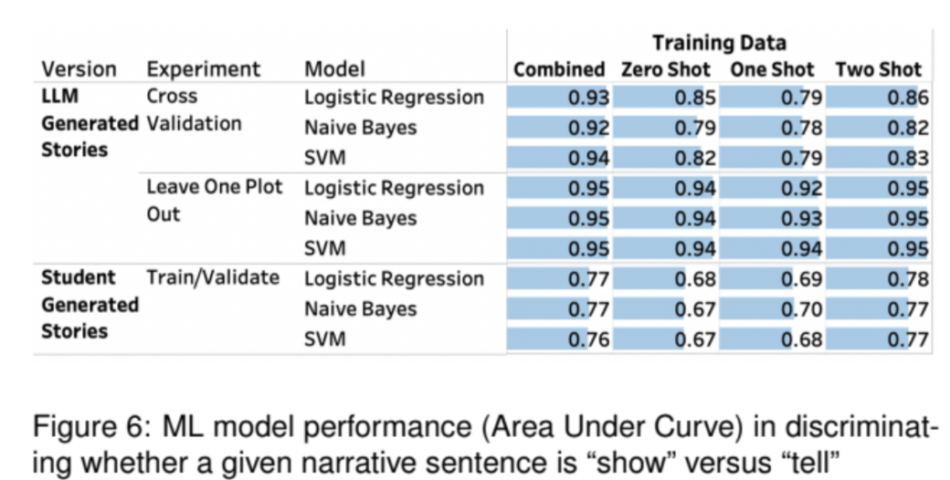

Submission:
Part I: solution + steps
Part I: a small paragraph summarizing your finding + GPT statement + Python Notebook

