Homework 2
Due 10/28/2024

Part 1. Reflections on Homework 1 (10 points)
I learned the importance of profiling to dive further into the dataset and get an overview of data and initial idea how we can solve problems from a given dataset and determine important preprocessing steps. I learned the importance of checking and handling missing values carefully, as even a small amount of missing data in critical columns, like location, affected the spatial analysis of crime patterns. Creating the dashboard was challenging but rewarding, as it helped me understand the importance of interactive tools for exploring complex datasets.

Part 2. Create a model card (30 points)
Model Card
Property | Decision Tree | Naive Bayes | K-Nearest Neighbour | Logistic Regression | Support Vector Machine (SVM)
1. Parametric/Non-parametric | Non-parametric | Parametric | Non-parametric | Parametric | Both
2. Input | Both | Discrete | Both | Continuous | Both
3. Output | Discrete | Discrete | Discrete | Discrete | Discrete
4. Handle Missing Value | No | No | No | No | No
5. Model Representation | Tree structure | Probabilistic | Distance-based | Linear equation
  Hyper-plane
6. Model Parameters | Tree depth, splitting criteria | X | K-value | Coefficients | Kernel, C
7. Make the Model More Complex | Increase tree depth | X | Increase K | Add polynomial features | Use more complex kernel
8. Make the Model less Complex | Prune tree | X | Reduce K | Regularization (L1, L2) | Linear kernel
9. Interpretability/Transparency | High | Moderate | Moderate | HIgh | Moderate to low

Part 3. Wine-Tasting Machine
1.
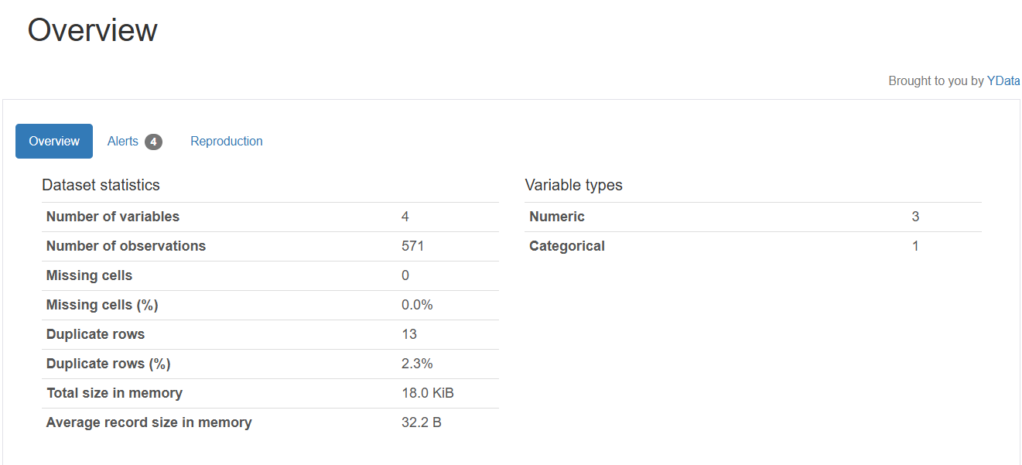
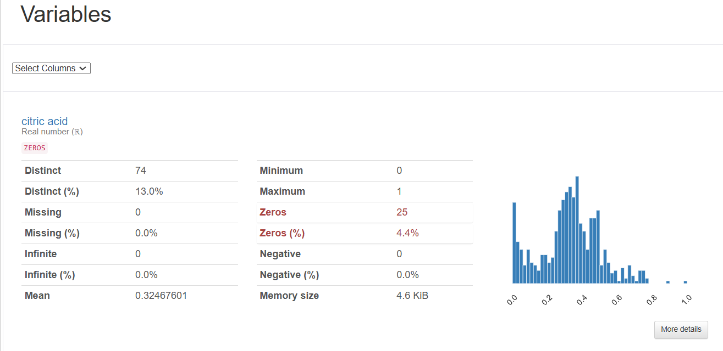
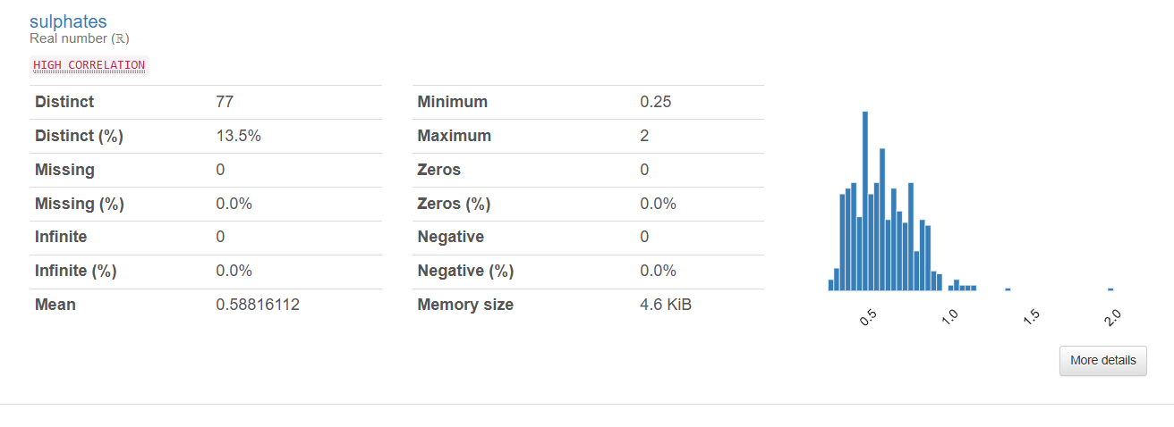
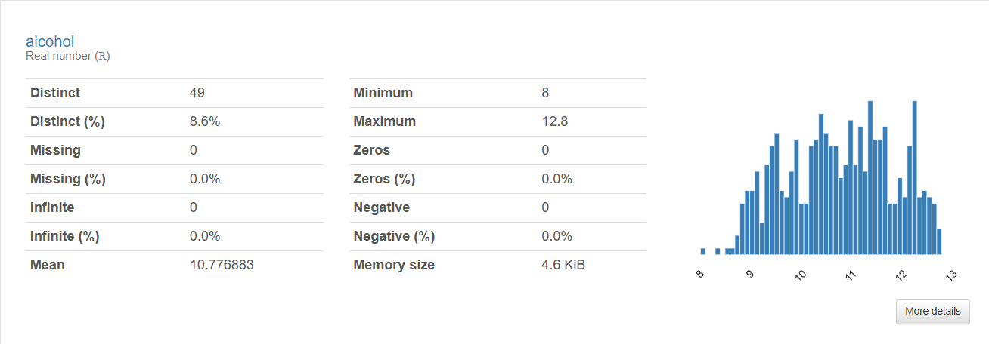
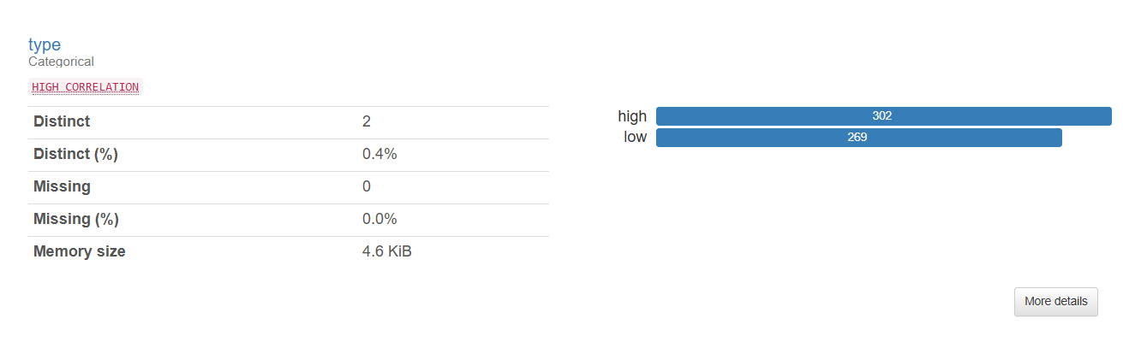
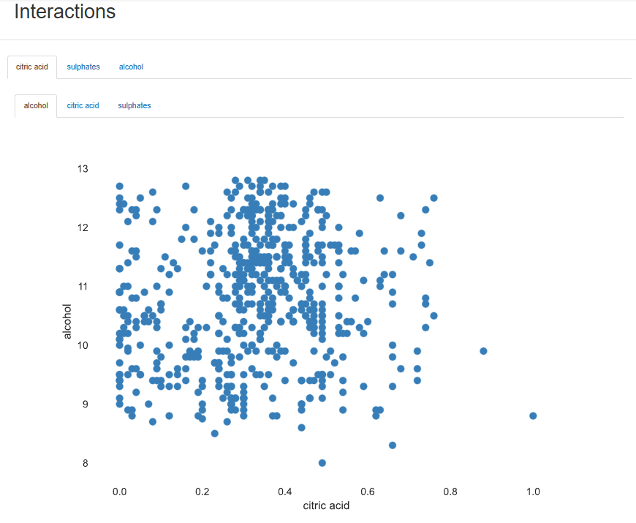
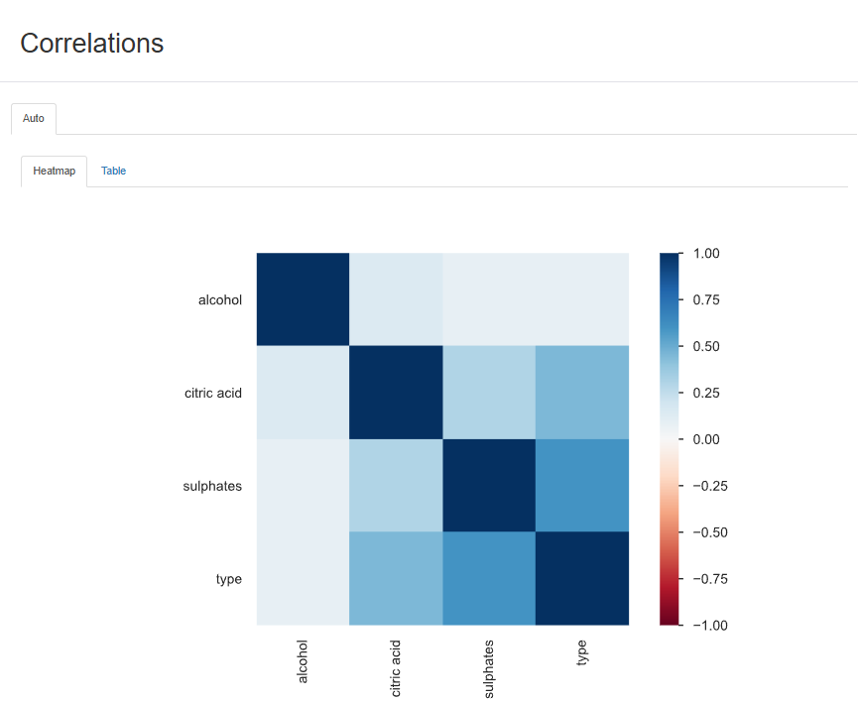
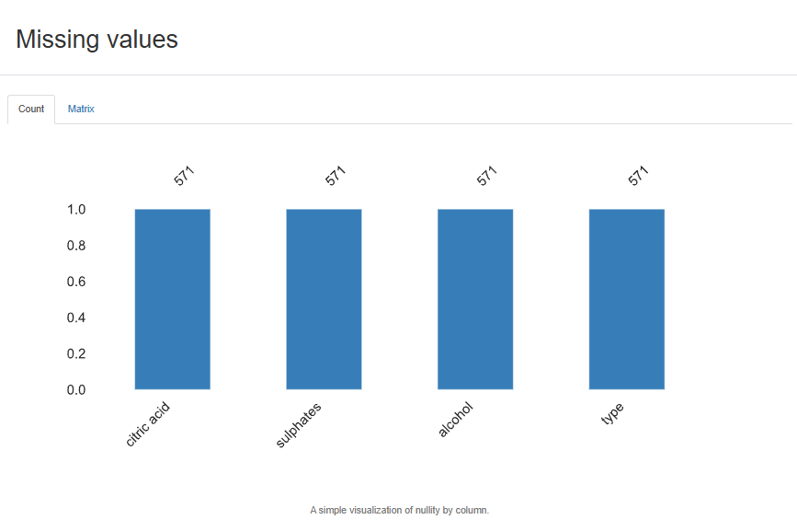
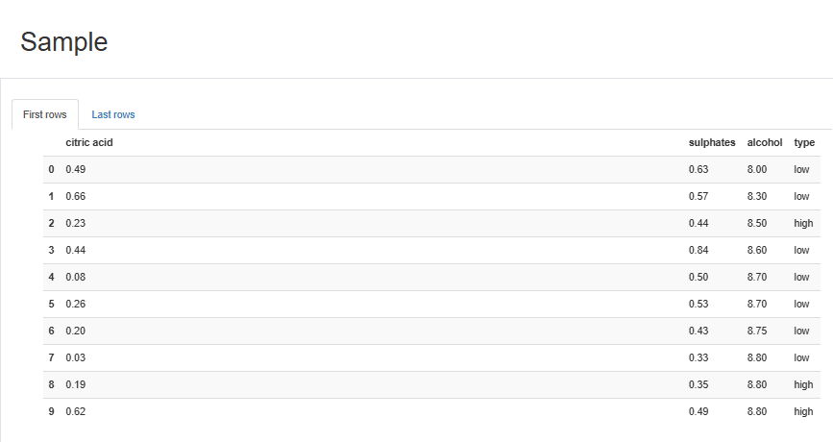
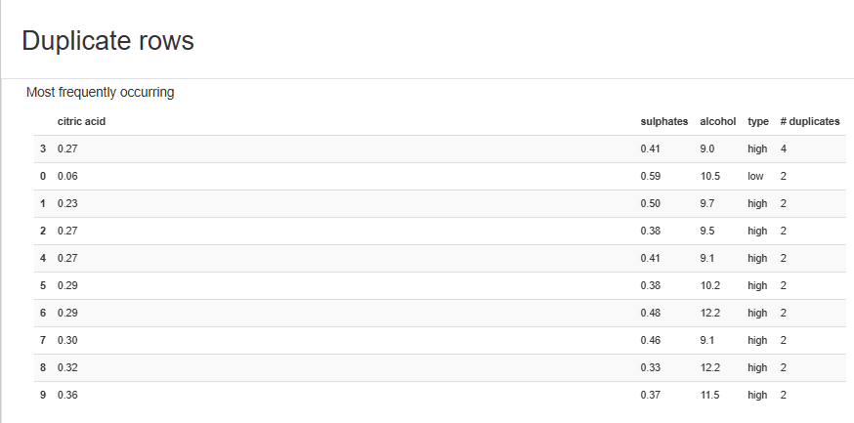
2.
Model | Baseline | Logistic Regression | Naive Bayes | Decision Tree | SVM-Linear | SVM-RBF | Random Forest
AUC | 0.500 | 0.8799019697944429 | 0.8954078975584352 | 0.7546388199614007 | 0.8814885274025059 | 0.8689201360169102 | 0.8894087553227339
Accuracy | 0.528887 | 0.7847852389594676 | 0.8216273442226255 | 0.7532667876588022 | 0.7918632788868724 | 0.5358439201451907 | 0.8039927404718693

3. Plot the ROC curve of the Random Forest classifier from the Python package, and paste a screenshot of your ROC curve here (10 points)
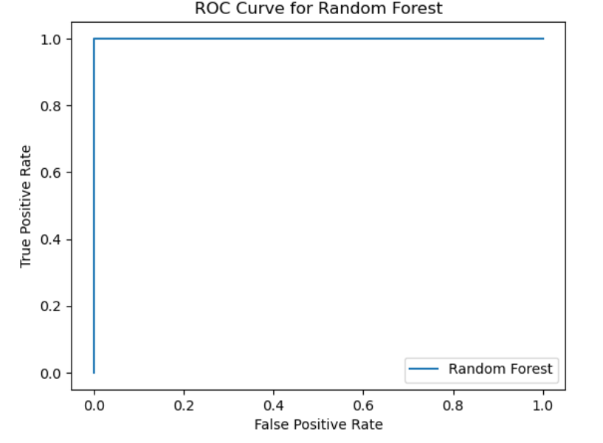
4. Using the best model obtained above in Q2 (according to AUC), running the model on white-wine.csv, and reporting the AUC score, comment on the performance. (5 points)
AUC on White Wine Data: 0.95
Naive Bayes - Accuracy: 0.8216273442226255, AUC: 0.8954078975584352 - Red Wine

The Naive Bayes model achieved an AUC score of 0.89 on the red_wine.csv dataset and 0.95 on the white_wine.csv dataset. This indicates that the model performs better at distinguishing between high and low-quality wine samples in the white wine dataset compared to the red wine dataset. The higher AUC for the white wine data suggests that the model can more accurately predict wine quality for white wine samples. This difference could be due to variations in the feature distributions between red and white wines, making the characteristics of white wines easier for the Naive Bayes model to classify accurately. However, further analysis would be needed to understand the specific reasons for this performance gap.

5. Suppose all the models have comparable performance. Which model would you prefer if the wine-tasting experts would like to gain some insights into the model? Note: there could be multiple model types fitting this criterion. (5 points)

If we compare all models we can see NB shows highest Accuracy and AUC but Given that the wine-tasting experts seek insights into how the model makes predictions, the Decision Tree model would be the most suitable choice. Decision Trees are highly interpretable, as they create a flowchart-like structure that allows users to see the decision paths and understand how different features contribute to the classification of wine quality. This transparency makes it easier for experts to trust and validate the model's predictions. Alternatively, Logistic Regression could also be considered, as it provides coefficients that show the weight of each feature in the decision-making process, offering a straightforward understanding of how changes in features affect the predictions.

Python file Github link
https://github.com/niss10/IS-733-Data-Mining/blob/IS-733-HW2/HW2/Nisarg_Patel_HW2.ipynb

GPT Usage:
I have used GPT for assistance in the coding part and debugging purpose.

GPT Link:
https://chatgpt.com/share/671d4ca5-d6c4-8005-abb4-2efb24cc81bd

