FINANCIAL DISTRESS EARLY-WARNING SYSTEM
A Small-Sample Proof of Concept
An explainable, ratio-based early-warning model for corporate financial distress — built and evaluated honestly on a small (50-company) dataset.
Prepared as a Big Data Analytics + Finance portfolio project
Data science pipeline · Machine learning · Risk analytics · Dashboard
Read this first
This project is a methodology demonstration, not a production credit model. The core model was trained on only 49 reliable examples (13 distressed). Every number in this report is real and reproducible, but should be read as a proof of concept, not a certified risk rating.

Table of Contents
1. Executive Summary
2. Business Problem
3. Datasets Used
4. Data Quality Audit
5. Building the Early-Warning Target
6. Financial Ratios Used
7. Exploratory Data Analysis
8. Modeling Methodology
9. Model Comparison Results
10. Threshold Optimization
11. Explainable AI (SHAP)
12. Risk Scoring & Early-Warning Alerts
13. Dashboard Walkthrough
14. Key Findings
15. Honest Limitations
16. Future Improvements
17. How to Run This Project

1. Executive Summary
This project builds a small early-warning system that looks at a company's financial statements and estimates how likely it is to fall into financial distress the following year. It covers the full pipeline: data cleaning, financial ratio calculation, machine learning, explainability (SHAP), a 0-100 risk score, and an interactive dashboard.
The honest headline: the dataset is small. Out of 149 company-year records, only 49 could be used to reliably train and test the "predict next year" model, because the label data for 2025 turned out to be incomplete (explained in Section 5). This is disclosed openly throughout the project instead of being hidden.

What the project demonstrates well
- A clean, reproducible, tested data pipeline with no invented values and no silent fixes.
- Correct handling of financial edge cases (negative equity, divide-by-zero, missing data) without fabricating numbers.
- A properly time-shifted early-warning target (financial data at Year T predicting distress at Year T+1) instead of just re-labeling the present.
- Explainable predictions using SHAP, so every risk score comes with a "why."
- A working, interactive 6-page dashboard.

What the project does NOT demonstrate
- A statistically trustworthy predictive model — 49 rows and 13 positive cases is too small to generalize with confidence.
- A model that discovers hidden risk patterns — many of the model's top features (leverage, cash flow, coverage) closely mirror the very criteria used to write the original distress labels.
- An industry-level analysis — most industries have only 1-3 companies, so those comparisons are illustrative, not statistical.
In short: treat this as a demonstration of correct methodology on a limited dataset, not as a ready-to-trust prediction engine.

2. Business Problem
Investors, lenders, and company management want to know when a company is heading toward financial trouble before it becomes obvious — not after a bankruptcy filing or a debt default makes headlines. A useful early-warning system should:
- Use only information that was actually available at the time (no hindsight).
- Predict FORWARD — this year's numbers predicting next year's risk, not just restating current-year status.
- Explain WHY a company is flagged, so it's actionable, not just a black-box score.
- Be honest about its own confidence, especially when trained on limited data.
This project attempts all four, at small scale.

3. Datasets Used

3.1 50-companies-financial.csv
Financial statement data for 50 companies across 2023-2025 (149 rows — one company, FUBO, is missing its 2025 row).
Group | Columns
Company Info | Company Name, Ticker, Industry, Year
Income Statement | Revenue, Cost of Sales / COGS, Gross Profit, Operating Profit / EBIT, EBITDA, Interest Expense, Net Income
Balance Sheet | Cash & Cash Equivalents, Accounts Receivable, Inventory, Current Assets, Total Assets, Current Liabilities, Total Liabilities, Short-Term Debt, Long-Term Debt, Total Debt, Total Equity
Cash Flow Statement | Operating Cash Flow, Investing Cash Flow, Financing Cash Flow, Capital Expenditure

3.2 distress_labels.csv
150 rows, giving a Distress Status (0 or 1) for each company-year, plus the specific event and the year that event occurred.
Column | Meaning
Company Name / Ticker | Company identifier
Year | The year this label applies to
Distress Status | 0 = not distressed, 1 = distressed
Distress Event | Plain-text description of what happened (e.g. "Severe Debt Restructuring")
Distress Event Year | The year the underlying event actually occurred

4. Data Quality Audit
Before touching any model, every file was checked for consistency. Nothing was silently fixed — issues were flagged and documented instead.

4.1 What we found
Check | Result
Rows in financial file | 149 (FUBO is missing its 2025 row — left missing, not invented)
Duplicate rows | 0
Companies matched between both files | 49 of 50
Ticker in labels but not financials | SATS (EchoStar) — dropped, no financial data to predict from
Ticker in financials but not labels | GME (GameStop) — kept, marked as "label unknown", never guessed
Total Debt = ST Debt + LT Debt | Passes 100% of rows
Gross Profit = Revenue − COGS | Passes ~99% (2 rows off by ~$100K, rounding, not an error)
Assets = Liabilities + Equity | Off by >2% in 11 rows — real-world reporting gaps (e.g. non-controlling interests), not corrected
Negative Total Equity | 19 rows — a real financial signal (over-leveraged companies), kept as-is
Negative EBIT | 48 rows — real signal (many growth/struggling companies), kept as-is

4.2 What we deliberately did NOT do
- Did not delete any company or row for having an unusual number.
- Did not fill in missing values with guesses — ratios that need a missing number are simply left blank.
- Did not invent a 2025 row for FUBO or a label for GameStop.
- Did not change any reported financial figure.

5. Building the Early-Warning Target
The goal was to predict distress ONE YEAR AHEAD: use Year T financial data to predict Year T+1 distress status. This is what makes it an "early-warning" system rather than a same-year classifier.
Critical problem found in the data
Every single company shows Distress Status = 0 in 2025 — even ones that were clearly struggling in 2023/2024, such as American Airlines, AMC, BlackBerry, and Rivian. This almost certainly means the label file had not yet recorded any new 2025 distress events at the time it was assembled — not that all these companies suddenly became healthy.

Because of this, the "2024 data → predict 2025" pairing is not trustworthy: every one of those 48 rows has target = 0 with zero exceptions, so a model trained on it would just learn to always predict "safe". We excluded that pairing from training.
What remained usable: the "2023 data → predict 2024" pairing. This gives:
- 49 usable rows in total
- 13 rows where the company became / stayed distressed the following year
- 36 rows where the company stayed healthy
We also discovered that year-over-year trend features (like Revenue Growth) cannot be calculated for 2023 rows, because there is no 2022 data to compare against — and 2023 is our only trustworthy training year. So the final model uses snapshot ratios only (this year's Current Ratio, ROA, Debt-to-Equity, etc.), not trend changes. Trend features are still calculated and shown on the dashboard for 2024/2025, just not used to train the model.

5.1 Why not a normal chronological train/validate/test split
The original plan was: train on 2023, validate on 2024, test on 2025. After removing the untrustworthy 2025 target, only one year of usable target data remained (2023), so there was nothing left to chronologically split. Instead, Stratified 5-Fold Cross-Validation was used — splitting the 49 rows into 5 balanced groups, training on 4 and testing on the 1 left out, five times over, so every row gets tested exactly once.

6. Financial Ratios Used
Raw dollar figures were converted into ratios so companies of very different sizes could be compared fairly. Every ratio returns "missing" instead of a fake huge number when a safe division isn't possible (e.g. dividing by zero).

Liquidity — can the company pay short-term bills?
- Current Ratio = Current Assets / Current Liabilities
- Quick Ratio = (Current Assets − Inventory) / Current Liabilities
- Cash Ratio = Cash / Current Liabilities

Profitability — is the company making money?
- Net Profit Margin = Net Income / Revenue
- EBIT Margin = EBIT / Revenue
- ROA = Net Income / Total Assets
- ROE = Net Income / Total Equity (flagged as unreliable when Equity is negative)

Leverage — how much debt does the company carry?
- Debt-to-Equity = Total Debt / Total Equity
- Debt Ratio = Total Debt / Total Assets
- Interest Coverage = EBIT / Interest Expense

Efficiency — how well are assets being used?
- Asset Turnover = Revenue / Total Assets
- Inventory Turnover = COGS / Average Inventory
- Receivables Turnover = Revenue / Average Accounts Receivable

Cash Flow Risk — is cash actually coming in?
- Operating Cash Flow Ratio = Operating Cash Flow / Current Liabilities
- CFO to Debt = Operating Cash Flow / Total Debt
- Free Cash Flow = Operating Cash Flow − Capital Expenditure

7. Exploratory Data Analysis
Before modeling, healthy and distressed companies were compared visually across the key ratios.

7.1 Class balance
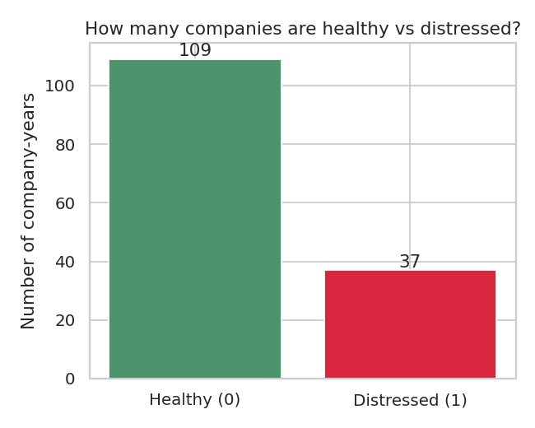
Figure 1 — Company-years labeled healthy vs. distressed (all years, all 149 rows).

7.2 Ratio comparisons: healthy vs. distressed
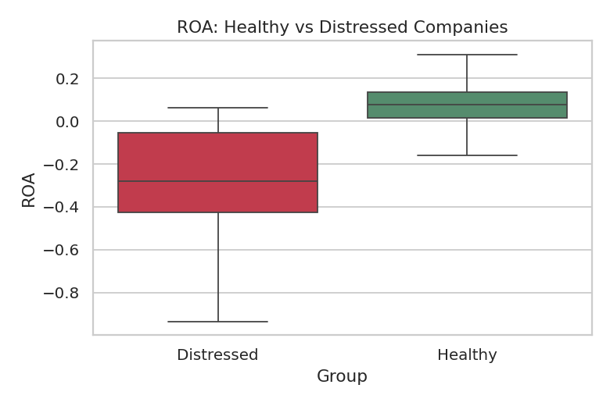
Figure 2 — ROA (profitability) is visibly lower for distressed companies.
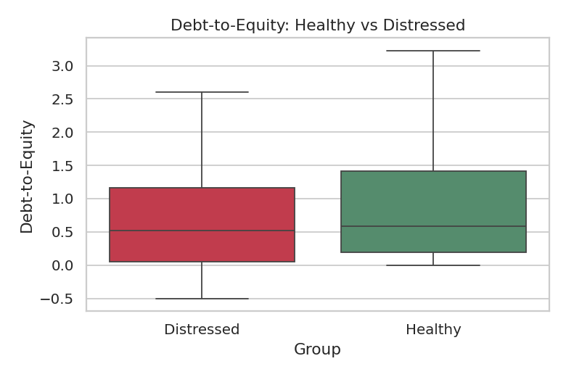
Figure 3 — Debt-to-Equity comparison (note: skewed by negative-equity outliers).
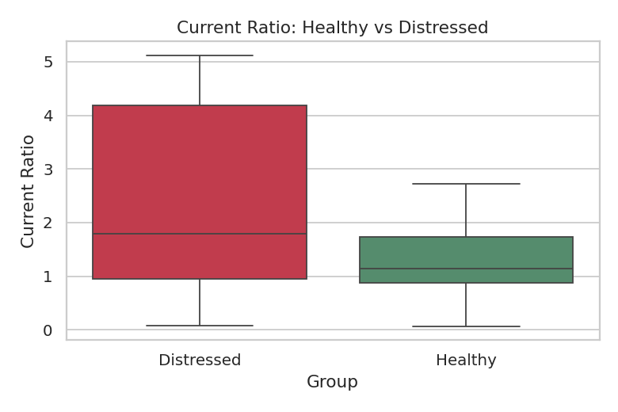
Figure 4 — Current Ratio (liquidity) comparison.
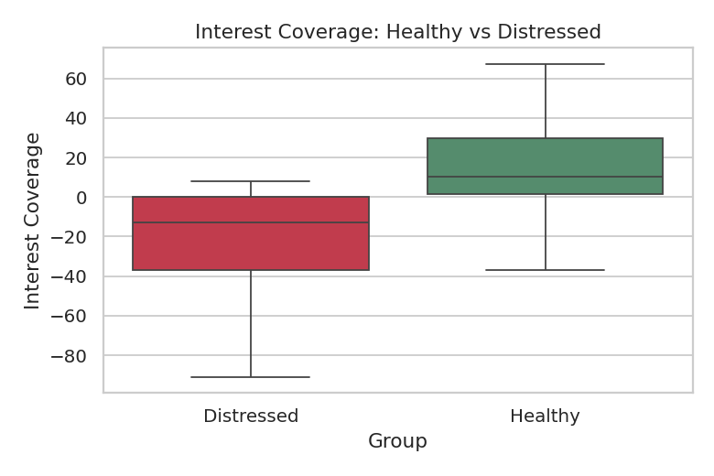
Figure 5 — Interest Coverage comparison.
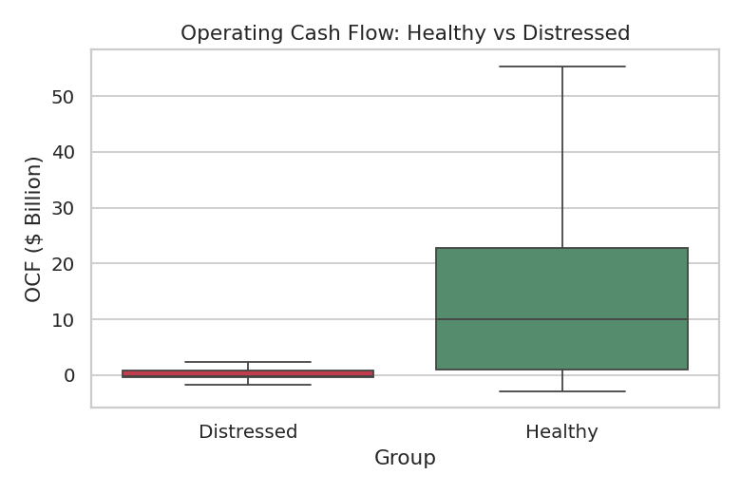
Figure 6 — Operating Cash Flow comparison.
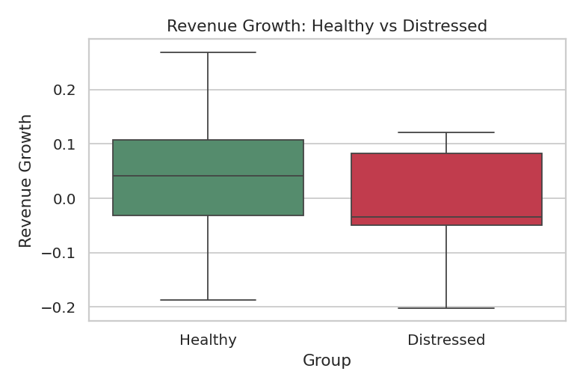
Figure 7 — Revenue growth comparison.

7.3 Trends over time
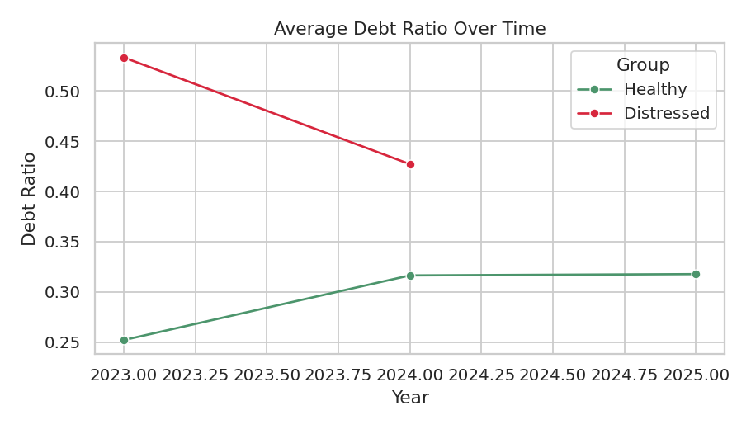
Figure 8 — Average Debt Ratio over time, healthy vs. distressed.
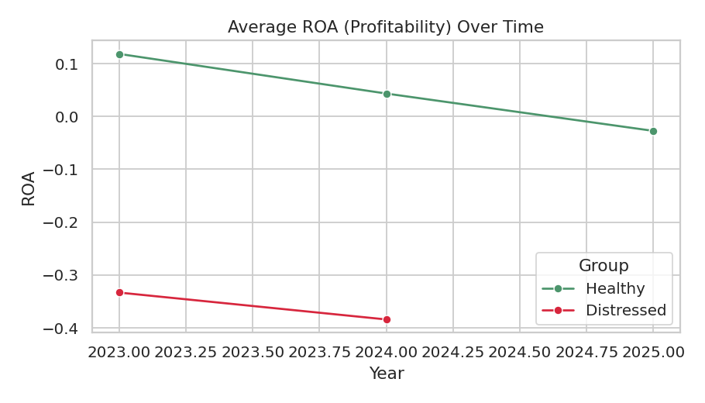
Figure 9 — Average ROA over time, healthy vs. distressed.

7.4 Industry-level distress rate
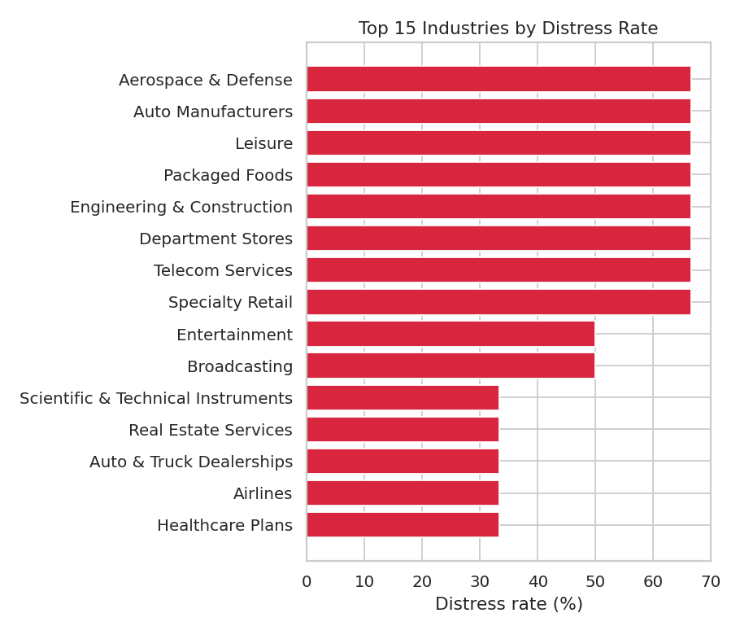
Figure 10 — Top 15 industries by distress rate. Most industries have only 1-3 companies — read as illustrative, not statistically robust.

8. Modeling Methodology
Four models were compared: Logistic Regression, Decision Tree, Random Forest, and XGBoost. All used the same 17 snapshot financial ratios as features — no raw dollar amounts (so company size doesn't bias the prediction) and nothing derived from the label file itself (to avoid leaking the answer).

8.1 Features used
Current Ratio, Quick Ratio, Cash Ratio, Net Profit Margin, EBIT Margin, ROA, ROE, Debt-to-Equity, Debt Ratio, Liabilities-to-Assets, Interest Coverage, Asset Turnover, Inventory Turnover, Receivables Turnover, Operating Cash Flow Ratio, CFO to Debt, CFO to Net Income.

8.2 Evaluation approach
Because only 49 rows were trustworthy, a single train/test split would be unreliable — it could look artificially good or bad purely by chance. Stratified 5-Fold Cross-Validation was used instead: the data is split into 5 balanced groups, the model trains on 4 and is tested on the 1 left out, five times over, so every row is tested exactly once. Results are averaged across the 5 folds.

8.3 Evaluation priorities
For an early-warning system, missing a company that actually becomes distressed (a false negative) is a worse mistake than raising a false alarm on a healthy company (a false positive). Metrics were therefore prioritized in this order:
- 1. Recall (catch as many real distress cases as possible)
- 2. F1 (balance of recall and precision)
- 3. ROC-AUC (overall separation between risky and safe companies)
- 4. Precision
- 5. Accuracy (least useful here — a model that always guesses "healthy" already scores ~73%)

9. Model Comparison Results
Model | Accuracy | Precision | Recall | F1 | ROC-AUC
Logistic Regression | 0.836 | 0.733 | 0.700 | 0.708 | 0.786
Decision Tree | 0.793 | 0.650 | 0.733 | 0.651 | 0.815
Random Forest | 0.773 | 0.567 | 0.700 | 0.621 | 0.888
XGBoost (chosen) | 0.773 | 0.567 | 0.767 | 0.640 | 0.911

XGBoost was chosen as the main model — it has the best Recall (catches ~77% of real distress cases) and the best ROC-AUC (0.911, meaning it separates risky from safe companies well overall). Logistic Regression had the best Precision and F1, and is worth keeping as a simple, transparent sanity-check model.
Honest caveat on these numbers
With cross-validation folds of roughly 10 rows each (2-3 positive cases per fold), these metrics carry real statistical noise. A different random seed could shift ROC-AUC by several points. Treat the ranking between models as directional, not definitive.

10. Threshold Optimization
By default, a model flags a company as "risky" only above a 50% probability. Several thresholds were tested instead, since catching real distress cases matters more than avoiding false alarms in this context.
Threshold | Precision | Recall | F1 | Flagged High Risk | Actually Distressed
0.30 | 0.556 | 0.769 | 0.645 | 18 | 13
0.40 | 0.556 | 0.769 | 0.645 | 18 | 13
0.50 | 0.556 | 0.769 | 0.645 | 18 | 13
0.60 | 0.588 | 0.769 | 0.667 | 17 | 13
0.70 | 0.562 | 0.692 | 0.621 | 16 | 13

Recall stays constant (0.769) from 0.30 through 0.60, and only drops at 0.70. A threshold of 0.40 was chosen for the dashboard — it keeps recall high while being slightly more cautious than the 0.50 default, matching the early-warning goal of raising a flag sooner rather than later.

11. Explainable AI (SHAP)
Every prediction can be explained using SHAP (SHapley Additive exPlanations), which shows how much each ratio pushed a specific company's risk prediction up or down compared to an average company.
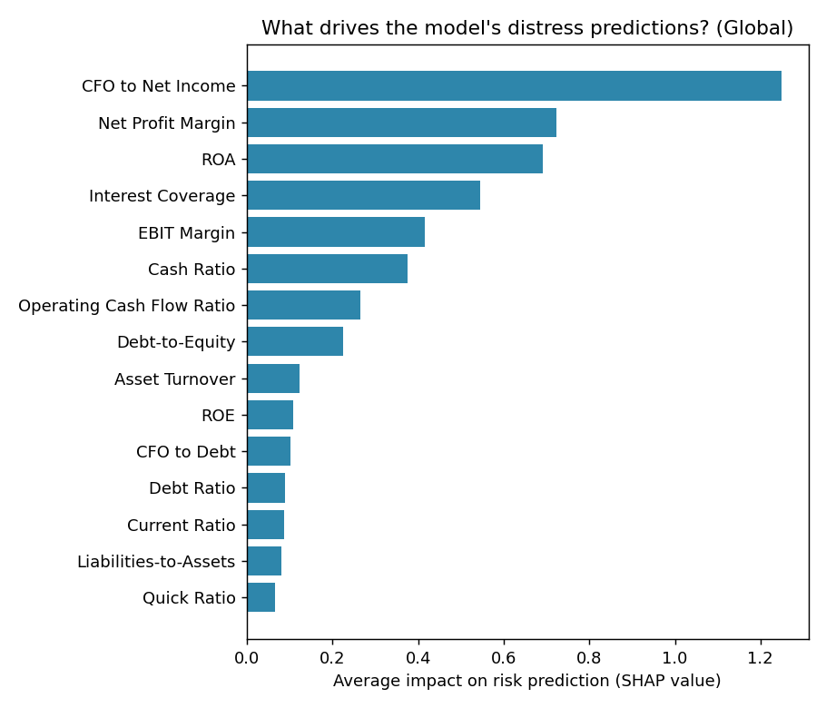
Figure 11 — Global feature importance: which ratios matter most to the model overall.
The top global risk drivers found by the model:
- 1. CFO to Net Income (cash flow quality — is reported profit backed by real cash?)
- 2. Net Profit Margin
- 3. ROA
- 4. Interest Coverage
- 5. EBIT Margin
A limitation worth naming directly
Several of the model's top features (leverage, cash flow, coverage ratios) closely mirror the language used in the original distress event descriptions (e.g. "Excessive Leverage", "Operating Cash Deficit"). This means the model is largely re-deriving the same criteria a human used to write the label, rather than discovering a hidden pattern. That has real value — automating the check — but it's a more modest achievement than "predicting the unpredictable".

12. Risk Scoring & Early-Warning Alerts
The model's raw probability (0.0 to 1.0) is converted into an easy-to-read 0-100 score, called an Internal Financial Distress Risk Score — explicitly not an official credit rating.
Score Range | Category
0 - 20 | Very Low Risk
21 - 40 | Low Risk
41 - 60 | Moderate Risk
61 - 80 | High Risk
81 - 100 | Critical Risk

12.1 Rule-based early-warning alerts
- Liquidity warning — Current Ratio below 1
- Leverage warning — Debt-to-Equity rising quickly year over year
- Interest warning — Interest Coverage below 1.5x
- Cash-flow warning — Operating Cash Flow negative
- Profitability warning — ROA negative
These are configurable rules of thumb, not universal accounting laws — clearly labeled as such throughout the project.

12.2 Management recommendations
Every flagged company gets specific, evidence-based recommendations tied to its actual numbers (e.g. "Debt-to-Equity = 3.2 → review debt restructuring options") rather than generic advice.

13. Dashboard Walkthrough
A 6-page interactive Streamlit dashboard was built to present the results. Screenshots below.

13.1 Executive Overview
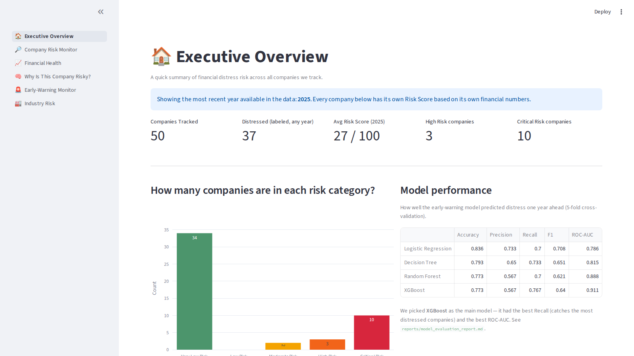
Company counts, risk category distribution, and model performance summary.

13.2 Company Risk Monitor
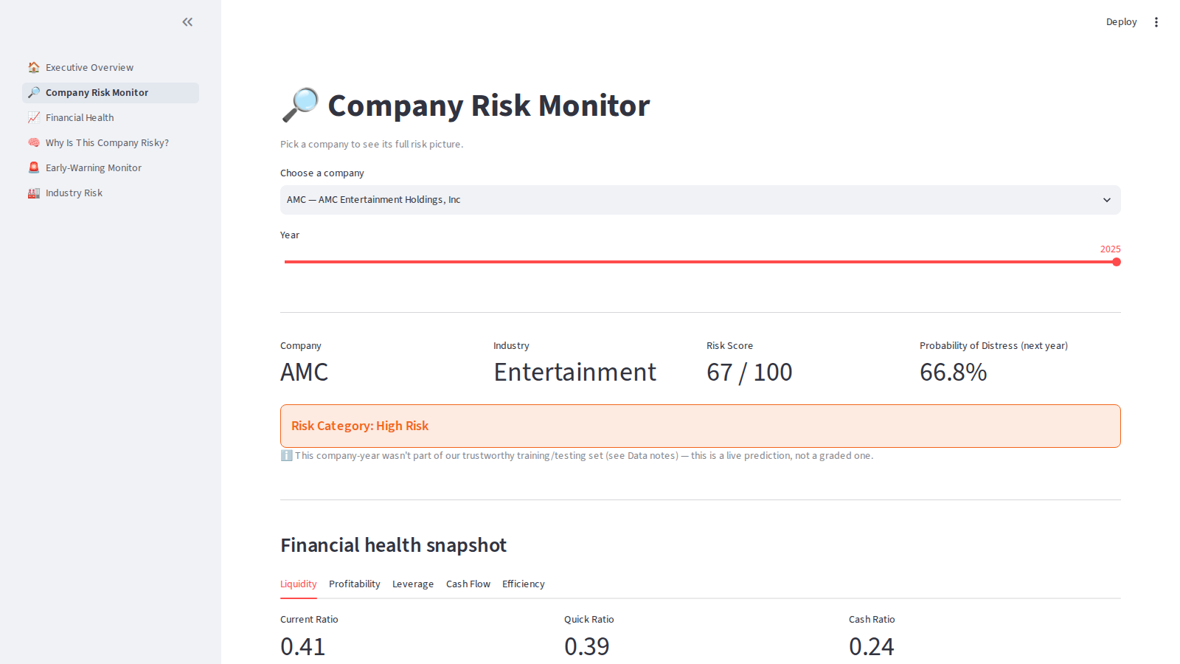
Pick any company and year to see its full ratio breakdown, risk score, alerts, and recommendations.

13.3 Financial Health
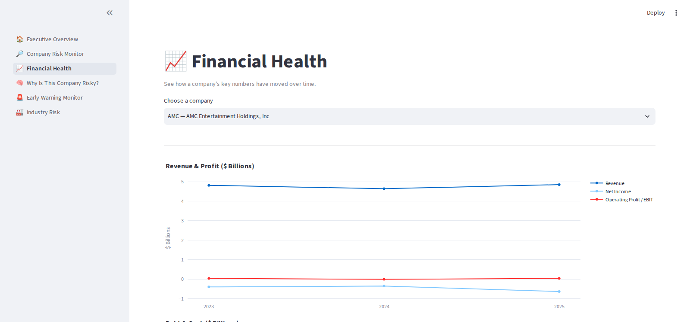
Revenue, profit, debt, and cash flow trends over time for a selected company.

13.4 Why Is This Company Risky?
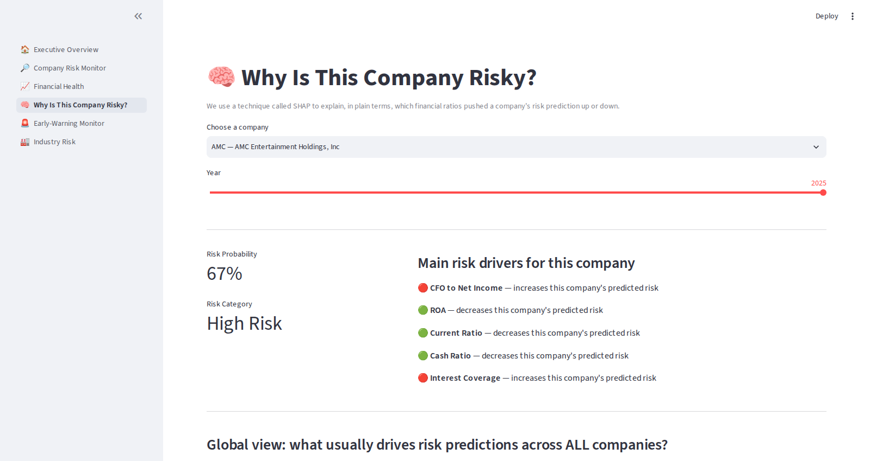
Per-company SHAP explanation, alongside the global feature importance chart.

13.5 Early-Warning Monitor
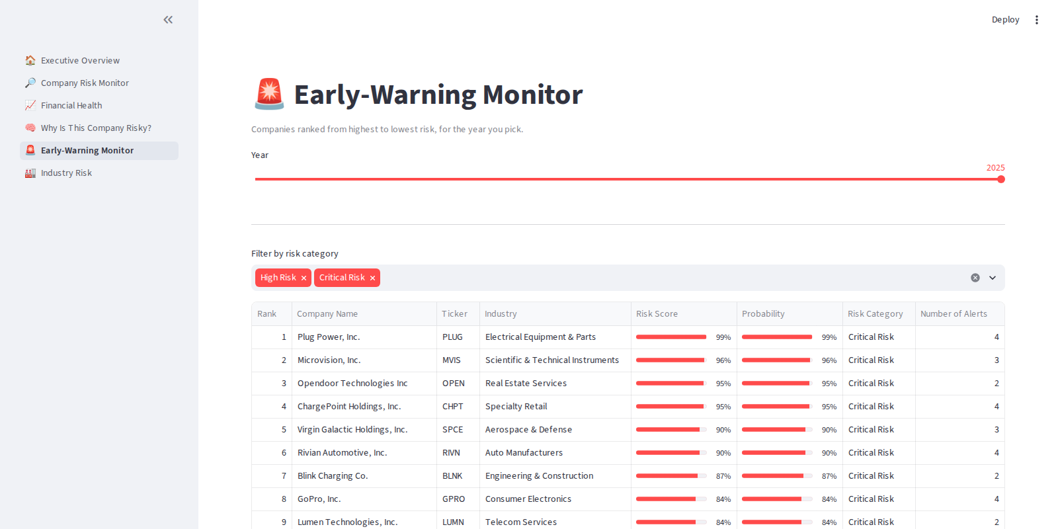
All companies ranked by risk score, filterable by risk category.

13.6 Industry Risk
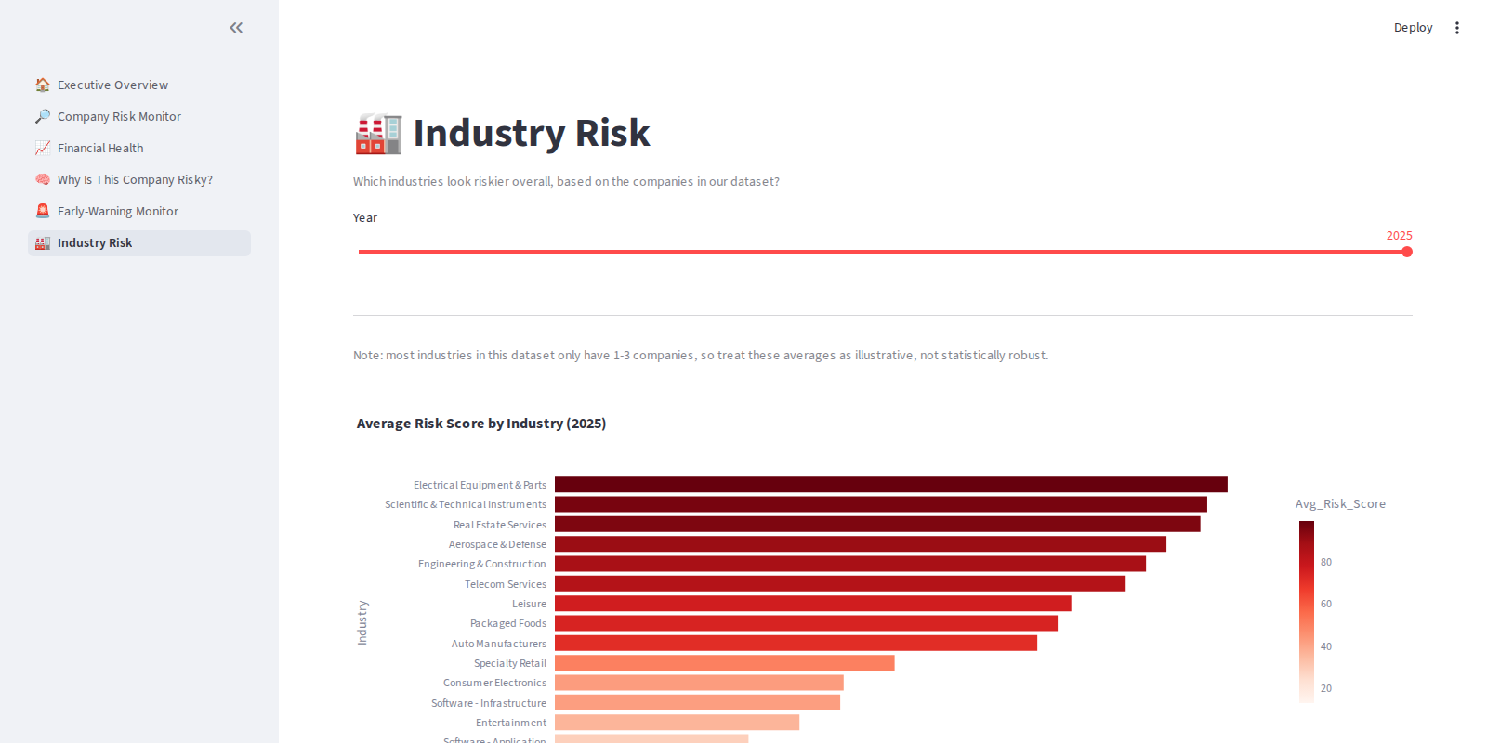
Average risk score and distress rate by industry (illustrative given small per-industry counts).

14. Key Findings
- The dataset is small: 149 total company-years, only 49 with a trustworthy next-year label.
- XGBoost performed best on the stated priorities (Recall 0.767, ROC-AUC 0.911), though the margin over other models is within the noise expected from such a small sample.
- Companies flagged highest-risk in the most recent data include Rivian, Plug Power, Beyond Meat, Peloton, BlackBerry, and ChargePoint — all showing negative operating cash flow, weak interest coverage, and/or negative profitability.
- Cash flow quality (CFO relative to Net Income) and core profitability (Net Profit Margin, ROA) were stronger predictors than raw debt levels alone.
- Most industries in this dataset have only 1-3 companies, so industry-level averages should be read as illustrative, not statistically robust.

15. Honest Limitations
This section is deliberately blunt, because a portfolio project is more credible when its limits are stated plainly rather than buried.

1. Sample size
49 training rows with 13 positive cases is not enough to draw statistically confident conclusions. Cross-validation folds have roughly 10 rows each — individual fold results can swing significantly by chance.

2. The 2025 label problem
Every company shows "not distressed" in 2025, most likely because the label file hadn't caught up with 2025 events at the time it was built — not because every company became healthy. This removed half of the theoretically available training pairs.

3. No trend features in the model
The one trustworthy training year (2023) has no prior year (2022) to compare against, so momentum/trend signals (which are often the most predictive in real distress models) could not be used for training — only for display.

4. Feature circularity
Several of the model's top predictive features closely mirror the wording of the original distress event labels (leverage, cash deficits, coverage). The model is substantially re-deriving the labeling criteria rather than finding an independent signal.

5. Industry analysis is thin
With 1-3 companies per industry in most cases, the "Industry Risk" page is closer to restating individual company scores than performing real statistical comparison.

6. This is not a credit rating
The Risk Score is an internal, simplified estimate for educational purposes. It should not be used for real investment or lending decisions.

7. Balance sheet identity gaps
11 rows don't perfectly satisfy Assets = Liabilities + Equity, likely due to missing balance-sheet lines (e.g. non-controlling interests) not present in this dataset. These were flagged, not corrected.

16. Future Improvements
- Add more years of history so trend features and a true chronological train/validate/test split become possible.
- Add more companies per industry so industry-level comparisons become statistically meaningful.
- Keep distress labels updated going forward so the 2025+ "predict next year" pairing becomes trustworthy.
- Test model stability across multiple random seeds to quantify how much the current rankings are due to chance.
- Add an external, larger benchmark dataset (e.g. historical bankruptcy datasets) to validate whether the model generalizes beyond these 50 companies.

17. How to Run This Project
Full source code, data, models, tests, and the dashboard are included in the accompanying project folder. Quick start:
pip install -r requirements.txt
python src/data_cleaning.py
python src/merge_data.py
python src/financial_ratios.py
python src/feature_engineering.py
python src/eda.py
python src/train.py
PYTHONPATH=src python src/threshold_optimization.py
PYTHONPATH=src python src/explainability.py
PYTHONPATH=src python src/risk_scoring.py
python src/recommendations.py
pytest tests/
streamlit run dashboard/app.py
See the project's README.md for the complete folder structure, data dictionary, and methodology notes.

