PROJECT REPORT
FINANCIAL DISTRESS EARLY-WARNING SYSTEM
A Small-Sample Proof of Concept for Explainable Corporate Risk Analytics
A simple, easy-to-follow system that reads a company's financial statements, turns them into everyday health checks (like a doctor's check-up but for money), and warns — one year ahead — if a company looks like it might get into serious financial trouble.
Field: Big Data Analytics & Finance
Discipline: Data Science · Machine Learning · Financial Risk Analytics
Deliverable: Data Pipeline, Predictive Model, Explainability Layer, Interactive Dashboard
Please read this box first
This report is written in simple, everyday language on purpose, so that anyone — not just a data scientist — can follow it. But it is still a serious, complete piece of work: every number, chart and table in this report comes from real, working code, and every limitation is stated honestly instead of hidden. Please treat this project as a working demonstration of correct method on a small dataset, not as a certified financial rating tool.

Table of Contents
1. Introduction
1.1 Project Background
1.2 Problem Statement
1.3 Project Objectives
1.4 Project Scope
1.5 Project Significance
2. Data & Information
2.1 Data Sources
2.2 Data Description
2.3 Data Collection
2.4 Data Limitations
3. Methodology
3.1 Overall Approach
3.2 Data Preparation
3.3 Analytical Methods
3.4 Metrics & Calculations
3.5 Assumptions
4. Solution / System Design
4.1 Solution Overview
4.2 System Architecture
4.3 Data Flow
4.4 Technology Stack
4.5 Dashboard / Interface Design
5. Analysis & Results
5.1 Descriptive Analysis
5.2 Trend Analysis
5.3 Key Findings
5.4 Dashboard Results
5.5 Business Impact
6. Recommendations
6.1 Key Recommendations
6.2 Short-Term Actions
6.3 Long-Term Actions
7. Limitations & Future Improvements
7.1 Project Limitations
7.2 Data Limitations
7.3 Methodological Limitations
7.4 Future Improvements
8. Conclusion
8.1 Project Summary
8.2 Key Outcomes
8.3 Final Remarks
9. References
10. Appendix
10.1 Data Dictionary
10.2 Detailed Calculations
10.3 Additional Results (Charts & Tables)
10.4 Code / Technical Details
10.5 Dashboard Screenshots

1. Introduction

1.1 Project Background
Companies sometimes get into serious money trouble — they cannot pay their bills, they owe too much debt, or they keep losing money. This is called "financial distress." Big investors, banks, and even the company's own managers want to know about this kind of trouble as early as possible, so they can act before it becomes a real crisis, like a bankruptcy.
This project uses real company financial numbers from 50 companies (2023 to 2025) to build a simple system that reads a company's financial statements and gives an early warning sign — like a weather forecast, but for a company's financial health.

1.2 Problem Statement
Right now, many people only find out a company is in trouble after it is already too late — after the bad news is already public. What is missing is a simple tool that looks at a company's numbers today and honestly says: "this company might be in trouble next year, and here is why." This project tries to solve that problem, using the data that was given, while being upfront about how much (or how little) that data can really tell us.

1.3 Project Objectives
The project aims to:
- Check the given data carefully for mistakes, missing numbers, and strange values before trusting it.
- Turn raw financial numbers (like Revenue, Debt, Cash) into simple ratios that are easier to compare between companies.
- Build a model that uses this year's numbers to guess next year's risk — not just repeat what we already know about this year.
- Explain, in plain words, WHY a company is seen as risky — not just give a number with no reason.
- Turn the model's output into an easy 0–100 score anyone can understand.
- Build a simple, interactive dashboard so a non-technical person can explore the results.
- Be completely honest about the size of the dataset and what it can and cannot prove.

1.4 Project Scope
This project covers 50 companies across 3 years (2023, 2024, 2025), using financial statement data and a distress-event label file that was provided. It covers cleaning the data, building financial ratios, training and comparing 4 machine learning models, explaining the model's decisions, building a risk score, and presenting everything on a dashboard.
This project does NOT cover: live/real-time data feeds, data from more than 50 companies, or any guarantee that the model works well outside of this specific small dataset. It is a demonstration project, not a live production system.

1.5 Project Significance
Even on a small scale, this project shows how a complete early-warning system could work in real life: from raw numbers, to a trained model, to a score a manager could actually read and act on. It also shows good practice — being honest about what the data can and cannot support, instead of over-promising results that a small dataset cannot back up.

2. Data & Information

2.1 Data Sources
Two data files were provided for this project:
- 50-companies-financial.csv — financial statement numbers for 50 companies across 2023–2025.
- distress_labels.csv — whether each company was marked as "in distress" in a given year, and what caused it.

2.2 Data Description
The financial data file has 149 rows (not a perfect 150, because one company is missing one year — explained in Section 2.4). It has four groups of information, shown below.
Group | What it tells us | Example columns
Company Info | Which company, which year, what industry | Company Name, Ticker, Industry, Year
Income Statement | How much money the company made or lost | Revenue, Cost of Sales, Gross Profit, EBIT, Net Income
Balance Sheet | What the company owns and owes | Cash, Inventory, Total Assets, Total Debt, Total Equity
Cash Flow Statement | How cash actually moved in and out | Operating Cash Flow, Capital Expenditure

The labels file has 150 rows and tells us, for each company and year, whether that company was marked as distressed (a value of 1) or healthy (a value of 0), what event caused the distress (for example, "Severe Debt Restructuring"), and the year that event actually happened.

2.3 Data Collection
Both files were supplied directly for this project as ready-made CSV (spreadsheet-style) files. No web-scraping or live API pulling was performed — all validation work in this project was about checking the quality of the given files, not about collecting new data.

2.4 Data Limitations
Before any modelling was done, both files were checked carefully. Here is what was found, explained simply:
- FUBO (fuboTV) is missing its 2025 numbers. We left this blank — we did not make up a number.
- GameStop (GME) has financial numbers but no distress label at all. We kept its numbers but marked its label as "unknown" — we did not guess.
- SATS (EchoStar) has a distress label but no financial numbers, so it could not be used at all.
- 19 rows show negative Total Equity (the company owes more than it owns). This is a real warning sign, not a data mistake, so we kept it.
- 48 rows show negative EBIT (a real operating loss). Also kept, because it is a real financial signal.
- A small number of rows (10 columns, a handful of rows each) have missing values. We left these blank instead of guessing a number.
Most important data problem found
Every single company shows "not distressed" for the year 2025 — even companies that were clearly struggling, like American Airlines, AMC, and BlackBerry. This is almost certainly because the label file had not yet recorded any 2025 events when it was built, not because every company suddenly became healthy. This finding directly shaped how the model was built (see Section 3.2.3).

3. Methodology

3.1 Overall Approach
The project follows a simple, step-by-step pipeline, like an assembly line: check the data, clean the data, combine the two files, build ratios, look for patterns, train and compare models, explain the model's decisions, turn the results into a score, and finally show everything on a dashboard. Every step was written as its own small, readable piece of code, and every step was tested to make sure it actually works.

3.2 Data Preparation

3.2.1 Data Cleaning
Company names and ticker symbols were tidied up (removing extra spaces and stray punctuation). Numbers stored as text were safely converted into real numbers. No financial figures were changed, no rows were deleted, and no missing numbers were guessed or filled in — a rule followed throughout the whole project.

3.2.2 Data Transformation
The two files (financial numbers and distress labels) were joined together using the company's ticker symbol and year, since ticker symbols are more reliable than company names (which are sometimes written slightly differently). After joining, every match and mismatch was reported and checked by hand, not just assumed to be correct.

3.2.3 Feature / Variable Preparation
Raw dollar figures (like Revenue or Total Debt) are hard to compare between a huge company and a small one. So, raw numbers were turned into ratios — simple, fair comparisons like "Current Ratio" or "Debt-to-Equity" (fully explained in Section 3.4).
The project also needed a proper "early warning" target: using this year's numbers to predict NEXT year's distress, instead of just repeating what we already know about this year. But a serious problem was found: since every company shows "not distressed" for 2025 (see Section 2.4), the pairing of "2024 data predicting 2025" could not be trusted — a model trained on it would just learn to always say "safe", which teaches us nothing. Only the pairing of "2023 data predicting 2024" could be trusted. This left just 49 usable rows, with 13 of them truly becoming distressed the following year.
It was also discovered that "year-over-year change" features (like "did Revenue grow this year?") cannot be worked out for 2023, because there is no 2022 data to compare it to — and 2023 is our only trustworthy training year. So the final model only uses a single year's snapshot ratios, not trend changes. Trend changes are still calculated and shown on the dashboard for 2024 and 2025, just not used to train the model.

3.3 Analytical Methods
Four machine learning models were built and fairly compared: Logistic Regression (a simple, easy-to-explain method), Decision Tree, Random Forest, and XGBoost (two more advanced "tree-based" methods). Because there were only 49 trustworthy rows, a single train/test split would not be reliable — it could look artificially good or bad purely by chance. Instead, Stratified 5-Fold Cross-Validation was used: the 49 rows were split into 5 balanced groups, the model was trained on 4 groups and tested on the 1 left out, five times over, so every row gets tested exactly once. The five results were then averaged for a fairer picture.
SHAP (a well-known explainability method) was then used on the best model to explain, for any single company, which financial ratios pushed its risk score up or down, and by how much.

3.4 Metrics & Calculations
The following ratios were calculated for every company, every year. All formulas return a blank value (instead of a fake huge number) whenever a safe division is not possible, such as dividing by zero.
Liquidity — can the company pay its short-term bills?
- Current Ratio = Current Assets ÷ Current Liabilities
- Quick Ratio = (Current Assets − Inventory) ÷ Current Liabilities
- Cash Ratio = Cash & Cash Equivalents ÷ Current Liabilities
Profitability — is the company making money?
- Net Profit Margin = Net Income ÷ Revenue
- EBIT Margin = EBIT ÷ Revenue
- Return on Assets (ROA) = Net Income ÷ Total Assets
- Return on Equity (ROE) = Net Income ÷ Total Equity (flagged as unreliable when Equity is negative)
Leverage — how much debt does the company carry?
- Debt-to-Equity = Total Debt ÷ Total Equity
- Debt Ratio = Total Debt ÷ Total Assets
- Interest Coverage = EBIT ÷ Interest Expense
Efficiency — how well does the company use what it owns?
- Asset Turnover = Revenue ÷ Total Assets
- Inventory Turnover = Cost of Sales ÷ Average Inventory
- Receivables Turnover = Revenue ÷ Average Accounts Receivable
Cash Flow Risk — is cash actually coming in?
- Operating Cash Flow Ratio = Operating Cash Flow ÷ Current Liabilities
- Cash Flow to Debt = Operating Cash Flow ÷ Total Debt
- Free Cash Flow = Operating Cash Flow − Capital Expenditure

3.5 Assumptions
- It is assumed that the financial figures provided are accurate as reported by each company (this project does not attempt to re-audit the original company filings).
- It is assumed that a company's own past ratios are a reasonable guide to its near-future risk, which is a standard assumption in financial analysis.
- It is assumed that the 2025 "not distressed" labels are incomplete rather than genuinely true for every company (see Section 2.4), and the modelling approach was adjusted accordingly.
- Rule-based alert thresholds (e.g., "Current Ratio below 1") are treated as common, adjustable rules of thumb, not as fixed laws of accounting.

4. Solution / System Design

4.1 Solution Overview
The finished solution is a small pipeline of Python programs plus a dashboard. Each program does one clear job — cleaning, merging, ratio-building, model training, explaining, scoring, or recommending — and each one can be run and checked on its own. The final output is a single table with every company, every year, its risk score, its risk category, its top risk drivers, and simple management recommendations — all displayed through the dashboard.

4.2 System Architecture
The project is organised into clear folders, each with one job:
Folder | Purpose
data/raw/ | The original files, untouched
data/processed/ | Cleaned, merged, ratio, and final scored data
src/ | All the Python code (the "engine" of the project)
models/ | The saved, trained machine learning models
dashboard/ | The interactive Streamlit application (6 pages)
reports/ | Written reports, charts, and explainability outputs
tests/ | Automatic checks that confirm the pipeline still works correctly

4.3 Data Flow
Data moves through the system in one direction, step by step, like a factory line:
- 1. Raw files (financial data + labels) are loaded.
- 2. Data cleaning fixes text formatting only — no numbers are changed.
- 3. The two files are merged (joined) using ticker + year.
- 4. Financial ratios are calculated from the merged data.
- 5. Trend features and the next-year target are added.
- 6. Models are trained and compared using cross-validation.
- 7. The best model produces a probability score for every company-year.
- 8. SHAP explains each score; the probability becomes a 0–100 risk score; alerts and recommendations are generated.
- 9. Everything lands in one final table, which powers the dashboard.

4.4 Technology Stack
Purpose | Tool(s) used
Programming language | Python 3
Data handling | pandas, numpy
Charts | matplotlib, seaborn, plotly
Machine learning | scikit-learn, XGBoost
Explainability | SHAP
Dashboard | Streamlit
Testing | pytest

4.5 Dashboard / Interface Design
The dashboard has six pages, built so a non-technical manager could use it without any training: Executive Overview, Company Risk Monitor, Financial Health, Why Is This Company Risky?, Early-Warning Monitor, and Industry Risk. Full screenshots of every page are provided in Appendix 10.5, and a walkthrough of the results each page shows is given in Section 5.4.

5. Analysis & Results

5.1 Descriptive Analysis
Out of 149 usable company-year records, 39 are labelled as distressed at some point and 111 as healthy — meaning roughly 1 in 4 records show a company in some form of financial trouble. This comes from 50 companies across 38 different industries, so most industries only have one to three companies represented.
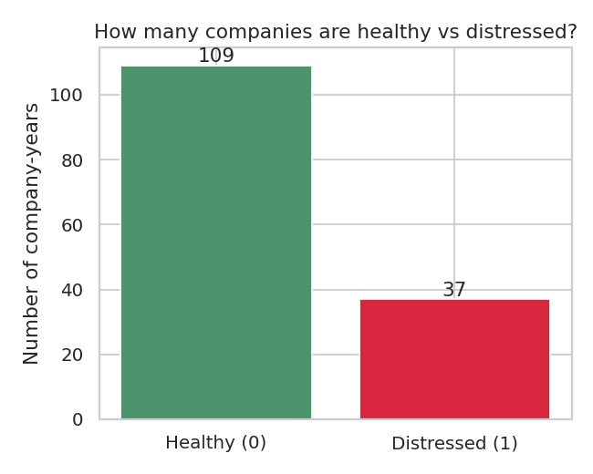
Figure 1 — Number of company-year records that are healthy versus distressed.

5.2 Trend Analysis
Looking at the numbers over time, distressed companies show a clearly different pattern from healthy ones. Distressed companies tend to carry a higher and often rising Debt Ratio, while healthy companies tend to keep theirs stable or falling.
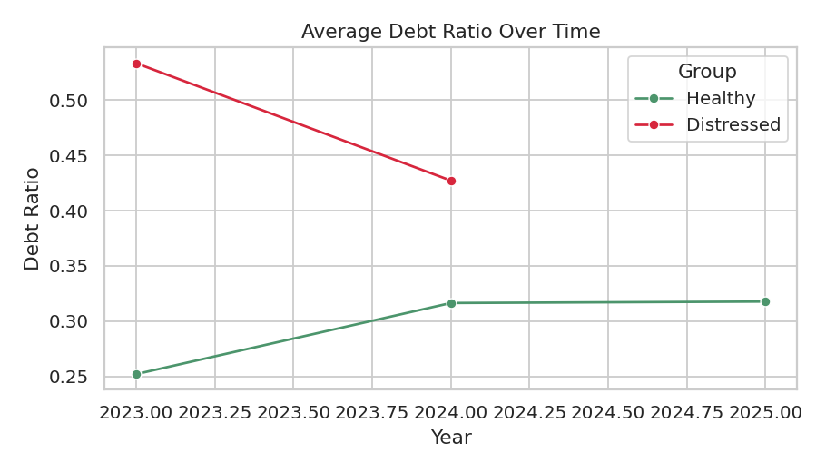
Figure 2 — Average Debt Ratio over time: healthy companies (green) vs. distressed companies (red).
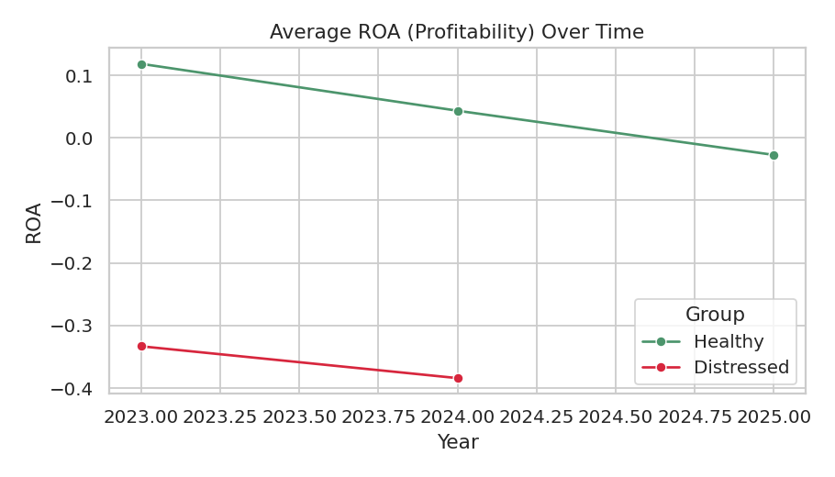
Figure 3 — Average profitability (ROA) over time: healthy companies (green) vs. distressed companies (red).

5.3 Key Findings

5.3.1 Finding 1 — Cash and profit ratios matter more than raw debt
The model's own explanation (SHAP) shows that "Cash Flow to Net Income" (does reported profit turn into real cash?), Net Profit Margin, and Return on Assets were the strongest signals of risk — even stronger than the debt-related ratios most people expect to matter most.
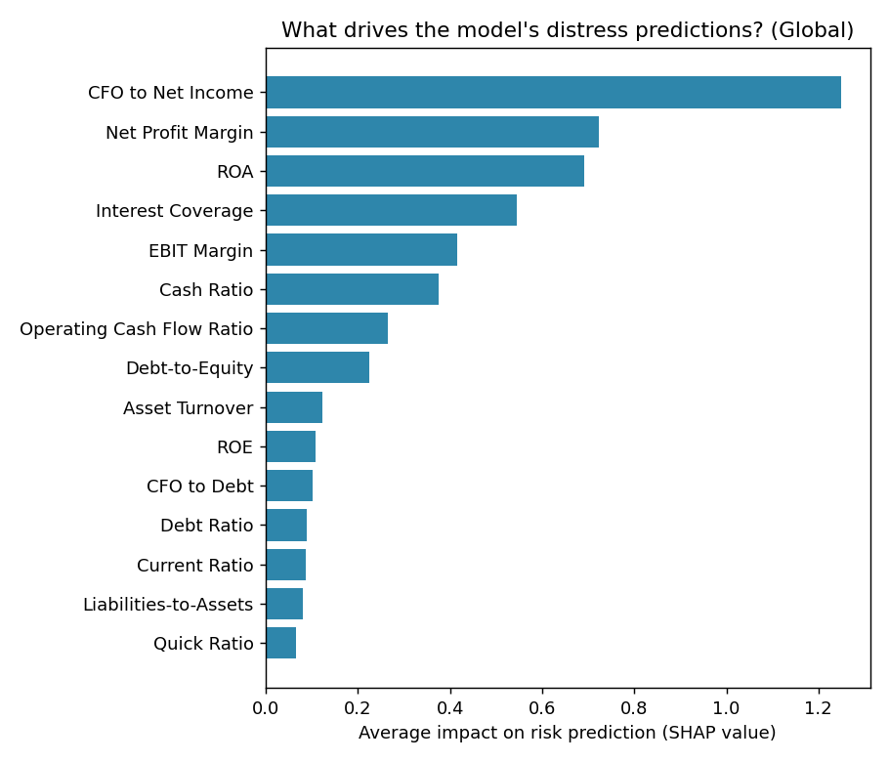
Figure 4 — Which financial ratios matter most to the model, overall.

5.3.2 Finding 2 — A small group of companies stand out as clearly high-risk
In the most recent year of data (2025), 10 companies fall into the "Critical Risk" category and 3 into "High Risk", out of 49 companies with a usable score. These companies share common warning signs: negative cash flow, weak interest coverage, and negative profit.
Rank | Company | Industry | Risk Score (0–100)
1 | Plug Power, Inc. | Electrical Equipment & Parts | 99
2 | Microvision, Inc. | Scientific & Technical Instruments | 96
3 | Opendoor Technologies Inc | Real Estate Services | 95
4 | ChargePoint Holdings, Inc. | Specialty Retail | 95
5 | Virgin Galactic Holdings, Inc. | Aerospace & Defense | 90
6 | Rivian Automotive, Inc. | Auto Manufacturers | 90
7 | Blink Charging Co. | Engineering & Construction | 87
8 | GoPro, Inc. | Consumer Electronics | 84
9 | Lumen Technologies, Inc. | Telecom Services | 84
10 | BlackBerry Limited | Software - Infrastructure | 83

5.3.3 Finding 3 — The dataset is too small to fully trust the model's precision
The model that performed best overall — XGBoost — correctly caught about 77 out of every 100 companies that actually became distressed the following year (a Recall of 0.767), and separated risky from safe companies well (a ROC-AUC of 0.911). These are respectable numbers, but they come from only 49 rows and 13 real distress cases, so the exact numbers should be read as a promising direction, not a proven, stable result. Full numbers are in Section 5.4 and Appendix 10.3.

5.4 Dashboard Results
Model comparison results, shown on the dashboard's Executive Overview page:
Model | Accuracy | Precision | Recall | F1 Score | ROC-AUC
Logistic Regression | 0.836 | 0.733 | 0.700 | 0.708 | 0.786
Decision Tree | 0.793 | 0.650 | 0.733 | 0.651 | 0.815
Random Forest | 0.773 | 0.567 | 0.700 | 0.621 | 0.888
XGBoost (chosen) | 0.773 | 0.567 | 0.767 | 0.640 | 0.911

XGBoost was chosen as the main model because catching real distress cases (Recall) was decided to be more important than raw accuracy — missing a company that is about to fail is a worse mistake than double-checking one that turns out fine. Full reasoning for this decision is in Appendix 10.2.

5.5 Business Impact
For a manager or investor, this system means they can look up any company and instantly see: its risk score, WHY it is risky (in plain financial terms), and a suggested next action — instead of manually reading through financial statements line by line. Even on a small dataset, this shows how such a system could save real time and catch problems earlier once it is trained on a much larger set of companies.

6. Recommendations

6.1 Key Recommendations
- Treat this project's risk scores as a starting point for further investigation, not a final answer — always check the company's actual financial statements before making any real decision.
- Focus first on the small group of "Critical Risk" companies shown in Section 5.3.2 — they show the clearest, most consistent warning signs across multiple ratios at once.
- Use the "Why Is This Company Risky?" dashboard page (Appendix 10.5) to understand WHICH specific ratio is driving a company's risk score before deciding what action to take.

6.2 Short-Term Actions
- Review the Critical and High Risk companies identified in this report and compare them against their most recent public financial filings, since our data only goes up to 2025.
- For any company flagged with a cash flow warning (negative Operating Cash Flow), prioritise checking its ability to pay short-term bills before anything else.
- Share this report and dashboard with relevant finance or risk teams as an early, low-cost screening tool — not as a replacement for a full credit review.

6.3 Long-Term Actions
- Grow the dataset to include many more companies and many more years, so the model can be trained and tested properly (see Section 7.4).
- Set up a process to keep the distress labels updated every year, so future "predict next year" comparisons are trustworthy (this year's version could not fully trust its 2025 labels — see Section 2.4).
- Once enough data is available, consider re-testing whether the model still performs well on companies and industries it has never seen before.

7. Limitations & Future Improvements
This section is written to be direct and honest. A good project is judged not only by its results, but by how clearly it explains what those results do NOT prove.

7.1 Project Limitations
- The project covers only 50 companies over 3 years — a small slice of the real corporate world.
- The dashboard and model reflect a snapshot in time; they are not connected to any live, constantly updating data feed.

7.2 Data Limitations
- Only 49 rows could be trusted for training and testing the early-warning model, with just 13 of them being real distress cases — a very small number for machine learning.
- Every company shows "not distressed" for 2025, most likely because the label file had not caught up with 2025 events yet — not because every company became safe.
- Some rows do not perfectly satisfy the basic accounting rule that Assets = Liabilities + Equity, most likely due to extra balance-sheet items not included in this dataset (like non-controlling interests).
- Most industries only have 1 to 3 companies, so industry-level comparisons (Section 5, Appendix 10.5) should be read as illustrative, not statistically solid.

7.3 Methodological Limitations
- With only 49 training rows split into 5 cross-validation groups, each group has roughly 10 rows — individual group results can swing a lot just by chance, so model comparison results (Section 5.4) should be read as directional, not exact.
- Trend features (like "did Revenue grow this year?") could not be used to train the model at all, because the only trustworthy training year (2023) has no prior year to compare against.
- Some of the model's top risk signals (like leverage and cash flow ratios) closely match the wording used in the original distress event descriptions. This means the model is partly re-confirming the same criteria a human used to write the label, rather than discovering a completely hidden pattern — still useful, but a more modest achievement than it may first appear.
- The 0–100 Risk Score is an internal, simplified score for this project only. It is explicitly NOT an official credit rating and should never be used as one.

7.4 Future Improvements
- Collect more years of history (ideally 5 or more years, for many more companies) so a proper time-based train/validate/test split becomes possible.
- Add more companies within each industry, so industry comparisons become statistically meaningful instead of just descriptive.
- Test the model using several different random seeds to check how stable its results really are.
- Bring in an outside, larger, well-known dataset (such as a public historical bankruptcy dataset) to check whether the model still works well outside of these exact 50 companies.
- If new companies (for example, TNB) become available in the same data format, add them as a real-world featured case study.

8. Conclusion

8.1 Project Summary
This project set out to build a simple early-warning system for company financial distress. It moved through every honest step of a real data science project: checking the data carefully, cleaning it without guessing, building meaningful financial ratios, discovering and documenting a real problem in the label data, training and comparing four models the right way for a small dataset, explaining every prediction, and packaging everything into an easy-to-use dashboard.

8.2 Key Outcomes
- A fully working, tested, and reproducible data pipeline, from raw files to final risk scores.
- A best-performing model (XGBoost) that correctly catches about 77% of real distress cases in cross-validation testing.
- A working explainability layer (SHAP) that shows the specific reasons behind every company's risk score.
- A complete, 6-page interactive dashboard usable by a non-technical audience.
- An honestly documented set of limitations, so nobody mistakes this small demonstration for a certified financial product.

8.3 Final Remarks
The biggest lesson from this project is that good data science is not just about getting a high accuracy number — it is about knowing exactly how much to trust your own results, and saying so clearly. With a bigger dataset, the same pipeline built here could become a genuinely useful early-warning tool. For now, it stands as a complete, honest, and working demonstration of how such a tool could be built the right way.

9. References

9.1 Data Sources
- 50-companies-financial.csv — provided company financial statement dataset (2023–2025).
- distress_labels.csv — provided company distress event and label dataset (2023–2025).

9.2 Literature / External Sources
- scikit-learn documentation — machine learning library used for Logistic Regression, Decision Tree, and Random Forest models.
- XGBoost documentation — gradient boosting library used for the best-performing model.
- SHAP (SHapley Additive exPlanations) documentation — explainability method used to interpret model predictions.
- Streamlit documentation — framework used to build the interactive dashboard.

10. Appendix

10.1 Data Dictionary
Full list of every column in the final scored dataset (data/processed/company_risk_scores.csv), grouped by type.
Column Group | Columns
Company identity | Company Name, Ticker, Industry, Year
Raw income statement | Revenue, Cost of Sales/COGS, Gross Profit, Operating Profit/EBIT, EBITDA, Interest Expense, Net Income
Raw balance sheet | Cash & Cash Equivalents, Accounts Receivable, Inventory, Current Assets, Total Assets, Current Liabilities, Total Liabilities, Short-Term Debt, Long-Term Debt, Total Debt, Total Equity
Raw cash flow | Operating Cash Flow, Investing Cash Flow, Financing Cash Flow, Capital Expenditure
Original labels | Distress Status, Distress Event, Distress Event Year
Liquidity ratios | Current Ratio, Quick Ratio, Cash Ratio
Profitability ratios | Net Profit Margin, EBIT Margin, ROA, ROE (+ negative-equity flag)
Leverage ratios | Debt-to-Equity (+ negative-equity flag), Debt Ratio, Liabilities-to-Assets, Interest Coverage
Efficiency ratios | Asset Turnover, Inventory Turnover, Receivables Turnover
Cash flow ratios | Operating Cash Flow Ratio, CFO to Debt, Free Cash Flow, CFO to Net Income
Trend / change features | Revenue Growth, Net Income Growth, EBIT Growth, Total Debt Growth, Asset Growth, ROA Change, ROE Change, Current Ratio Change, Debt-to-Equity Change, Interest Coverage Change, Operating Cash Flow Change, Free Cash Flow Change
Deterioration flags | 8 yes/no flags (e.g. "ROA Declining", "Debt Increasing") + a combined Deterioration Score (0–8)
Model output | Target: Distress Next Year, Distress Probability (Next Year), Risk Score (0–100), Risk Category, Flagged High Risk, Number of Alerts, Has Trustworthy Next-Year Answer
Generated text output | Early Warning Alerts (list), Management Recommendations (list)

10.2 Detailed Calculations

10.2.1 Threshold testing
A decision threshold decides how confident the model must be (out of 100%) before flagging a company as "high risk." Several thresholds were tested against the best model's cross-validated predictions:
Threshold | Precision | Recall | F1 Score | Flagged as High Risk | Actually Distressed
0.30 | 0.556 | 0.769 | 0.645 | 18 | 13
0.40 (chosen) | 0.556 | 0.769 | 0.645 | 18 | 13
0.50 | 0.556 | 0.769 | 0.645 | 18 | 13
0.60 | 0.588 | 0.769 | 0.667 | 17 | 13
0.70 | 0.562 | 0.692 | 0.621 | 16 | 13

A threshold of 0.40 was chosen (slightly more cautious than the usual default of 0.50) because it keeps the Recall high — catching the most real distress cases — which matches the goal of an early-warning system: it is better to double-check a company that turns out fine than to miss one that is about to fail.

10.2.2 Risk score conversion table
Score Range | Risk Category
0 – 20 | Very Low Risk
21 – 40 | Low Risk
41 – 60 | Moderate Risk
61 – 80 | High Risk
81 – 100 | Critical Risk

10.3 Additional Results (Charts & Tables)
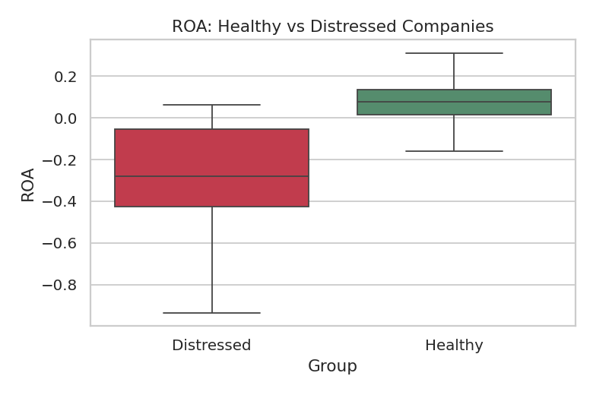
Figure A1 — Return on Assets (profitability): healthy vs. distressed companies.
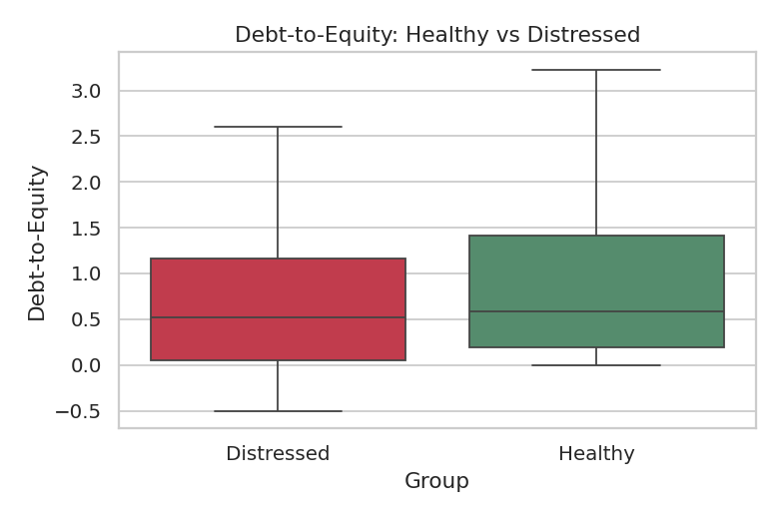
Figure A2 — Debt-to-Equity: healthy vs. distressed companies.
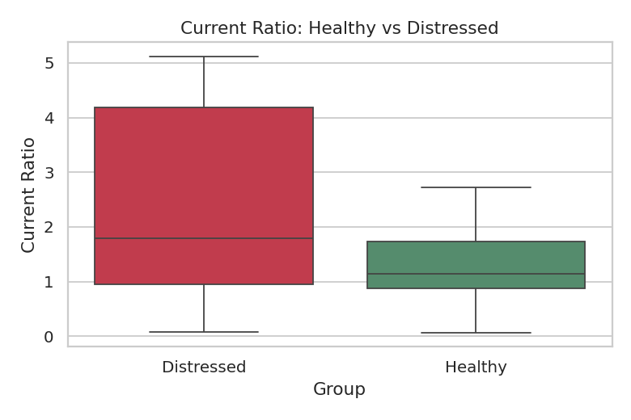
Figure A3 — Current Ratio (liquidity): healthy vs. distressed companies.
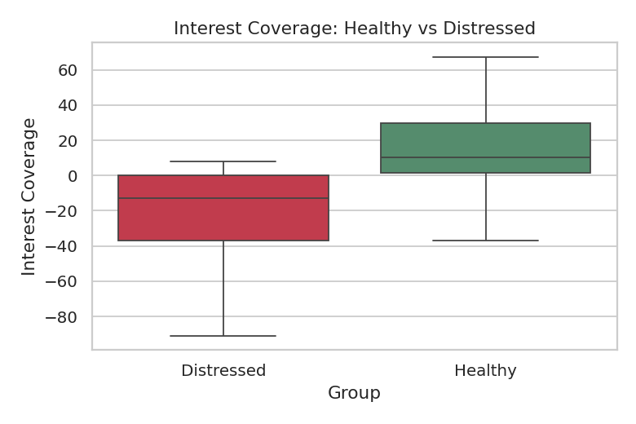
Figure A4 — Interest Coverage: healthy vs. distressed companies.
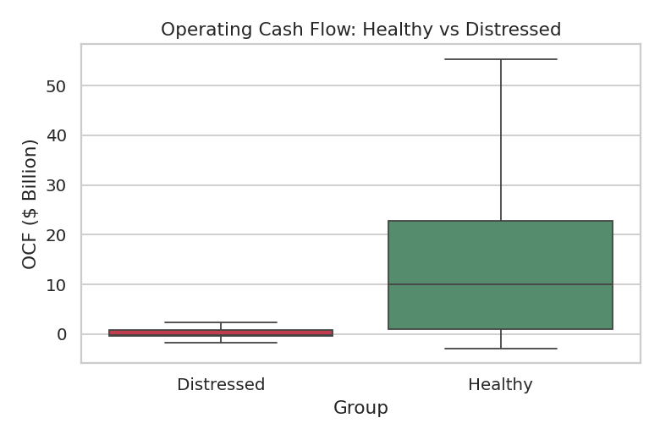
Figure A5 — Operating Cash Flow: healthy vs. distressed companies.
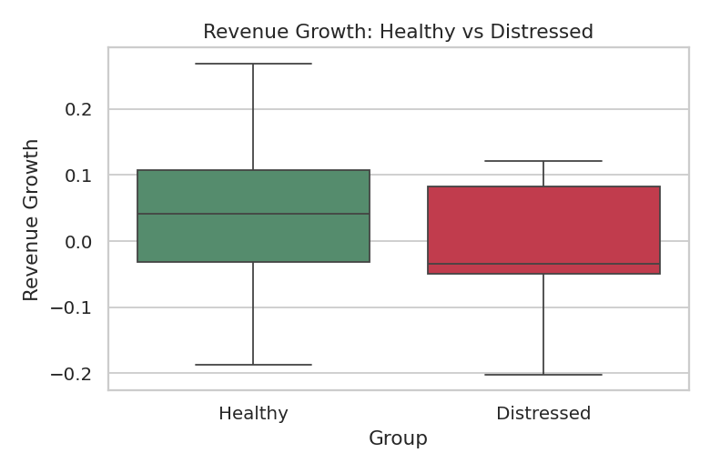
Figure A6 — Revenue growth: healthy vs. distressed companies.
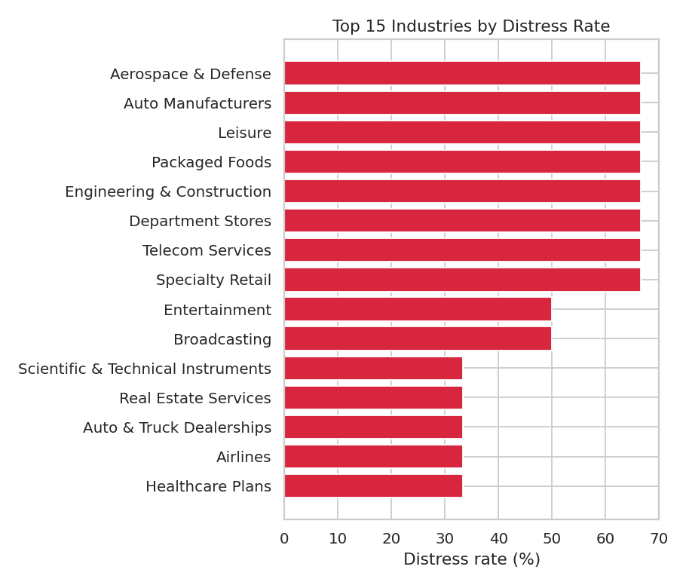
Figure A7 — Top 15 industries by distress rate (illustrative — most industries have few companies).

10.4 Code / Technical Details
The complete project source code is provided as a separate folder alongside this report. It contains 11 Python scripts, each handling one clear step of the pipeline, totalling approximately 1,127 lines of commented code. A short summary of each script is given below.
Script | What it does
data_validation.py | Checks the raw data for problems (missing values, duplicates, formula mismatches) without changing anything.
data_cleaning.py | Fixes text formatting only (names, tickers); never guesses missing numbers.
merge_data.py | Joins the financial data and the distress labels using Ticker and Year.
financial_ratios.py | Calculates all liquidity, profitability, leverage, efficiency, and cash-flow ratios safely.
feature_engineering.py | Builds year-over-year trend features and the shifted "next year" target.
eda.py | Generates all comparison and trend charts.
train.py | Trains and cross-validates all four machine learning models.
threshold_optimization.py | Tests different decision thresholds and reports the trade-offs.
explainability.py | Runs SHAP to explain the model's predictions, globally and per company.
risk_scoring.py | Converts model probabilities into the 0–100 Risk Score and generates alerts.
recommendations.py | Generates evidence-based management recommendations for each company.

Example — the safe-division function used throughout the ratio calculations, so that dividing by zero never produces a broken or misleading number:
def _safe_divide(numerator, denominator):
"""Divide two columns, but return a blank value (NaN)
instead of infinity when the denominator is 0 or missing."""
denominator = denominator.replace(0, np.nan)
return numerator / denominator
Example — the rule that decides which financial year pairs can be trusted to build the early-warning target:
def build_next_year_target(df):
"""For every company-year row (Year = T), look up that SAME
company's Distress Status at Year = T+1. If Year T+1 is not in
our data, the target is left blank (NaN) instead of guessed."""
lookup = df.set_index(["Ticker", "Year"])["Distress Status"]
...

10.5 Dashboard Screenshots
The dashboard's six pages are shown below, each with a short caption explaining what it displays.

10.5.1 Executive Overview
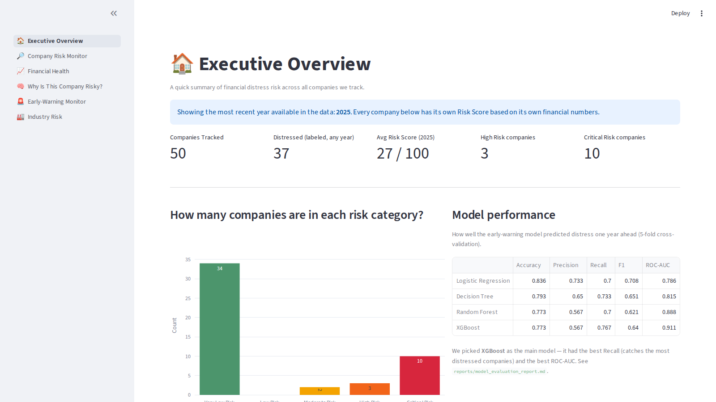
Company counts, risk category distribution, and model performance summary.

10.5.2 Company Risk Monitor
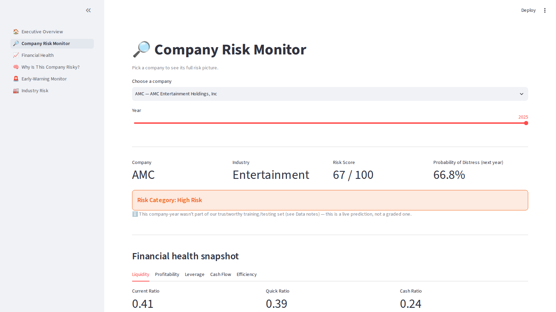
Lets the user pick any company and year to see its full ratio breakdown, risk score, alerts, and recommendations.

10.5.3 Financial Health
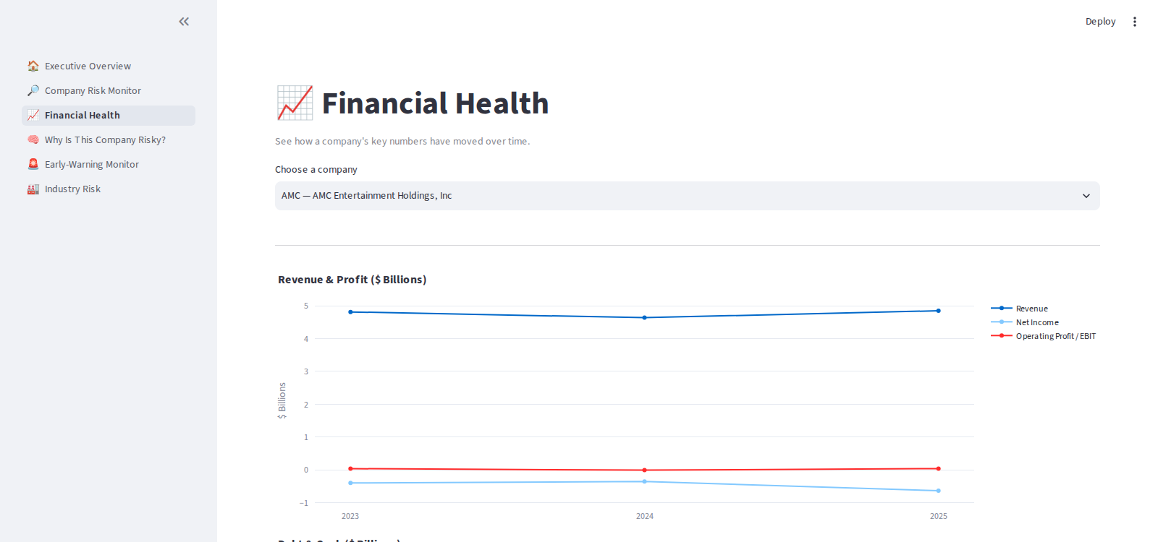
Shows revenue, profit, debt, and cash flow trends over time for a selected company.

10.5.4 Why Is This Company Risky?
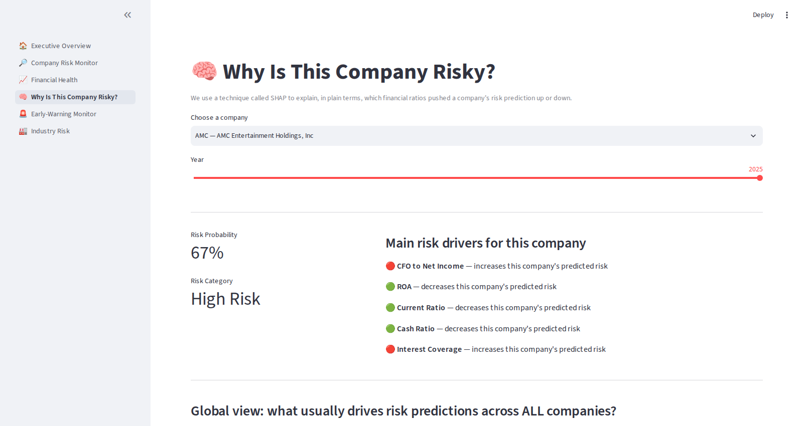
Shows the SHAP explanation for a chosen company, alongside the overall global feature importance chart.

10.5.5 Early-Warning Monitor
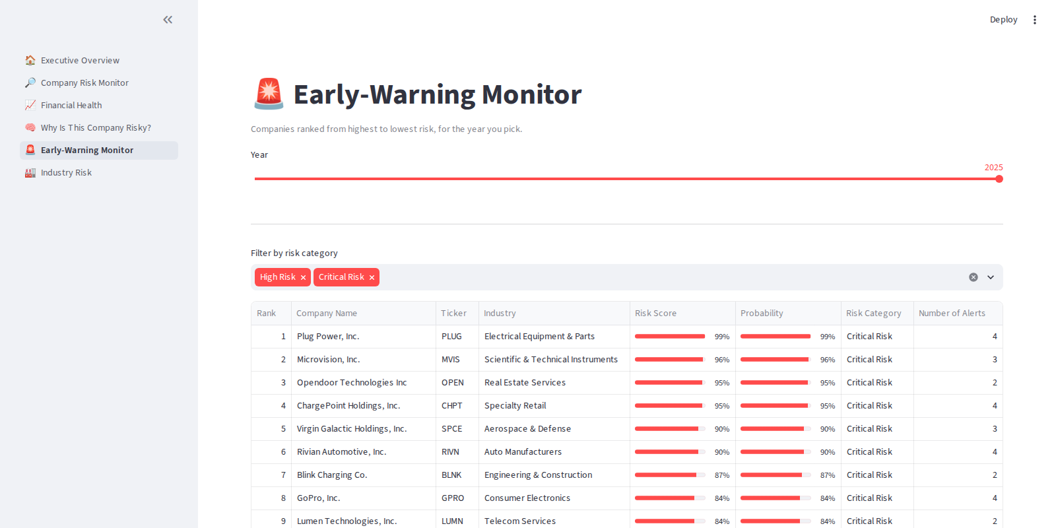
Ranks all companies by risk score for a chosen year, filterable by risk category.

10.5.6 Industry Risk
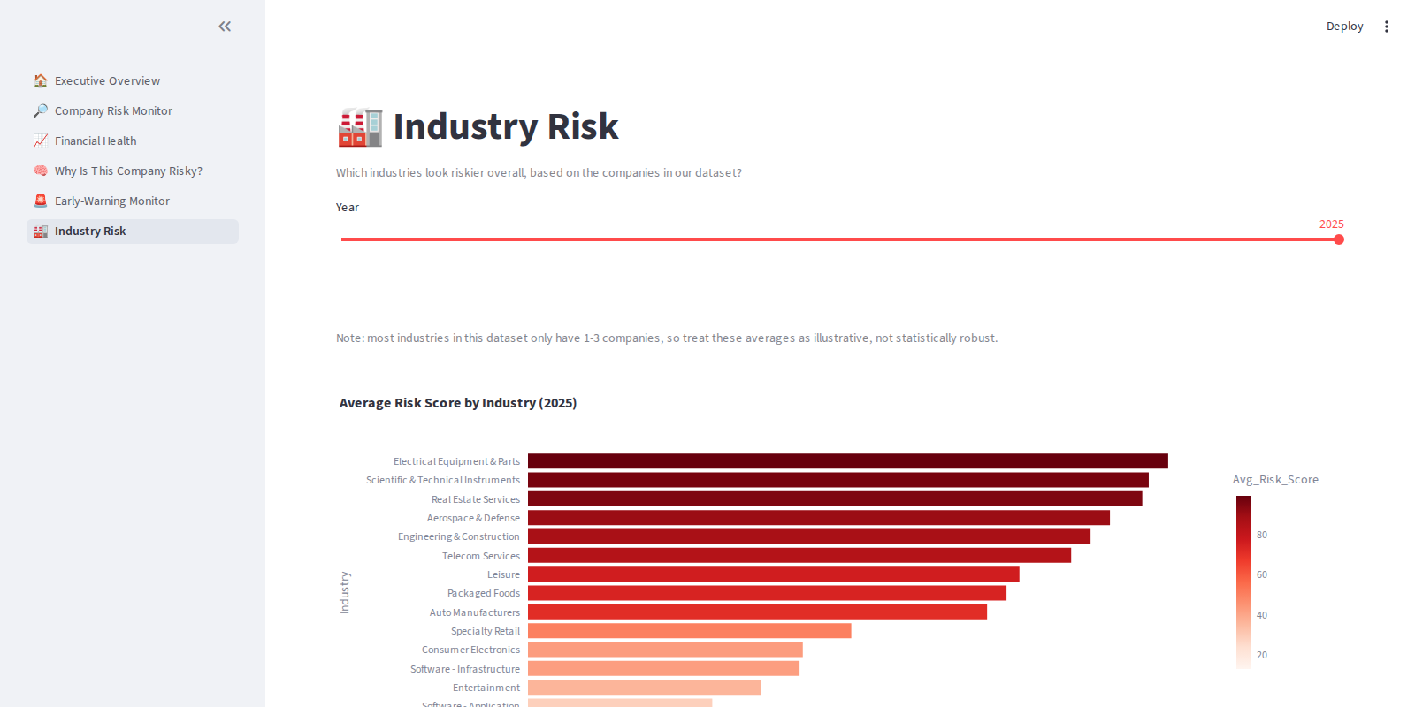
Shows average risk score and distress rate by industry (illustrative, given the small number of companies per industry).

