PROJECT SUMMARY FOR RESUME & PORTFOLIO
Financial Distress Early-Warning System
A one-stop reference for describing this project on a resume, LinkedIn, or in an interview — covering the full tool stack, the skills it demonstrates, and ready-to-use bullet points.

1. Project Overview (Elevator Pitch)
A short version you can say out loud in an interview:
30-second version
“I built an early-warning system that predicts, one year in advance, whether a company is likely to face financial distress. I cleaned and audited real financial statement data, engineered financial ratios, trained and compared four machine learning models, used SHAP to explain every prediction, and built both a Streamlit dashboard and a Power BI report so the results are usable by both technical and non-technical stakeholders.”

A longer version for a portfolio page or cover letter:
This project analyzes corporate financial statements to identify early warning signs of financial distress — before the distress becomes public knowledge. It goes beyond a simple pass/fail prediction: it audits the data for quality issues first, builds a forward-looking prediction target (this year's numbers predicting next year's risk), compares multiple machine learning models using proper cross-validation, explains every prediction with SHAP, and presents the results through both an interactive Streamlit dashboard and a Power BI report for business-side reporting. Every limitation of the small dataset used is documented transparently rather than hidden behind an inflated accuracy score.

2. Tools & Technologies Used
Category | Tools / Libraries
Programming | Python
Data Handling | pandas, numpy
Machine Learning | scikit-learn (Logistic Regression, Decision Tree, Random Forest), XGBoost
Explainable AI | SHAP (SHapley Additive exPlanations)
Data Visualization | matplotlib, seaborn, Plotly
Interactive Dashboard | Streamlit
Business Intelligence / Reporting | Power BI (data modeling, DAX measures, Power Query, interactive report pages)
Testing | pytest
Version Control & Workflow | Git-style modular project structure (src/, data/, models/, reports/)
Documentation | Markdown, Word (docx) reporting

3. Skills Gained / Demonstrated

3.1 Data & Analytics Skills
- Data quality auditing — systematically checking for missing values, duplicates, inconsistent formulas, and impossible values before trusting a dataset.
- Data cleaning without data fabrication — fixing formatting issues while leaving genuinely missing or unusual values flagged rather than guessed.
- Financial ratio analysis — liquidity, profitability, leverage, efficiency, and cash-flow ratios, with correct handling of edge cases (e.g. negative equity, divide-by-zero).
- Feature engineering — building year-over-year trend features and correctly identifying when they can and can't be used, given data constraints.
- Exploratory data analysis (EDA) — comparing distributions and trends across groups using statistical visualizations.

3.2 Machine Learning Skills
- Supervised classification — training and tuning Logistic Regression, Decision Tree, Random Forest, and XGBoost models.
- Proper evaluation methodology — using Stratified K-Fold Cross-Validation instead of a single train/test split when data is limited.
- Avoiding data leakage — building a genuinely forward-looking prediction target (T → T+1) instead of predicting the present.
- Metric selection for business context — prioritizing Recall over Accuracy when false negatives are more costly than false positives.
- Threshold optimization — tuning the decision threshold based on a precision/recall trade-off instead of defaulting to 0.5.
- Explainable AI — using SHAP to produce both global (model-level) and local (per-prediction) explanations.

3.3 Business Intelligence & Reporting Skills
- Power BI report design — building interactive report pages (executive summary, company drill-down, risk ranking, industry comparison).
- Data modeling for BI — structuring cleaned/scored data into a model suitable for slicers, drill-downs, and cross-filtering.
- DAX measures — calculating KPIs such as average risk score, count of high-risk companies, and industry-level distress rate.
- Translating a data science output into a business-facing dashboard — turning model probabilities into an intuitive 0-100 risk score and risk category that non-technical stakeholders can act on.

3.4 Software Engineering & Project Skills
- Modular pipeline design — splitting a project into independent, testable stages (cleaning → merging → feature engineering → modeling → scoring).
- Automated testing — writing pytest sanity checks for data integrity, ratio correctness, and model output ranges.
- Reproducibility — building a pipeline that produces identical results on every re-run.
- Technical documentation — writing a full methodology report, data dictionary, and limitations section for a non-technical audience.

3.5 Analytical & Communication Skills
- Critical thinking about data — identifying a hidden labeling problem in the dataset (an entire year's labels were unusable) instead of accepting the data at face value.
- Honest, evidence-based reporting — separating what a small-sample model can responsibly claim from what it can't.
- Financial domain literacy — applying real accounting relationships and financial statement analysis, not just generic ML on numeric columns.
- Translating technical results into plain language for management-style recommendations.

4. Ready-to-Use Resume Bullet Points
Pick 3-5 depending on the role you're applying for. Data Science / ML roles should lean on section 4.1; BI / Analyst roles should lean on section 4.2.

4.1 For Data Science / Machine Learning roles
- Built an end-to-end financial distress early-warning system in Python, engineering 17+ financial ratios from raw statement data and training/comparing 4 ML models (Logistic Regression, Random Forest, XGBoost) with Stratified K-Fold Cross-Validation.
- Designed a forward-looking (T → T+1) prediction target to avoid data leakage, and identified a critical labeling defect in the source data that would have silently invalidated 48% of the training set.
- Implemented SHAP-based explainability to generate both global and per-company risk explanations, turning black-box model output into actionable, auditable insights.
- Optimized decision thresholds based on a Recall-first evaluation framework appropriate for imbalanced, cost-asymmetric classification problems.
- Delivered results through an interactive Streamlit dashboard (6 pages) and a complementary Power BI report for business stakeholders.

4.2 For Business Intelligence / Data Analyst roles
- Audited and cleaned a 50-company financial dataset, documenting data quality issues (missing records, inconsistent labels, accounting mismatches) instead of silently correcting them.
- Built a 0-100 risk-scoring model and translated it into a Power BI report with drill-down company views, industry comparisons, and KPI cards for executive reporting.
- Designed DAX measures and a data model supporting interactive filtering by company, year, industry, and risk category.
- Created a rule-based early-warning alert system (liquidity, leverage, cash-flow, profitability flags) tied to specific, explainable financial thresholds.
- Presented complex financial and model output in plain language for non-technical audiences, including limitations and appropriate use caveats.

4.3 One-line summary (for a resume header / LinkedIn “Featured” caption)
Built a Python + Power BI financial distress early-warning system that predicts company risk one year ahead, explains every prediction with SHAP, and flags data quality issues most projects would miss.

5. Streamlit Dashboard Screenshots
Screenshots of the interactive dashboard built for this project — useful to attach directly to a portfolio page or LinkedIn post alongside the write-up.

5.1 Executive Overview
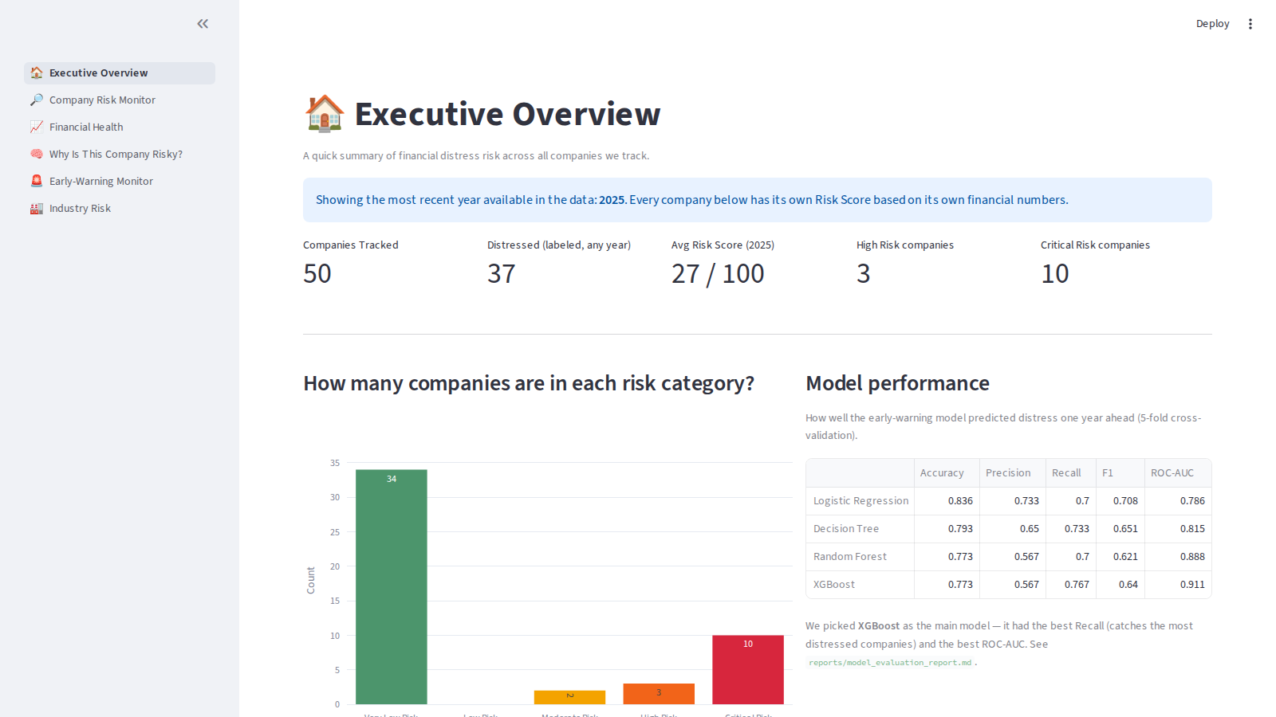
Company counts, risk category distribution, and model performance summary.

5.2 Company Risk Monitor
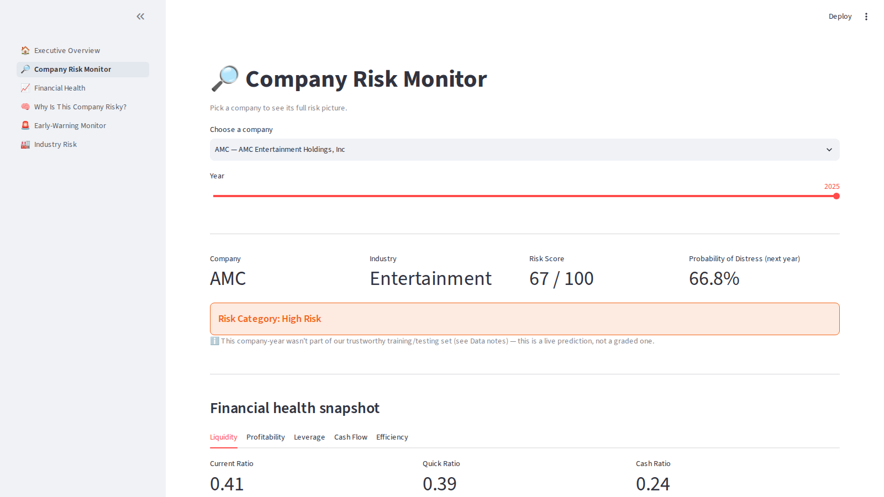
Pick any company and year to see its full ratio breakdown, risk score, alerts, and recommendations.

5.3 Financial Health
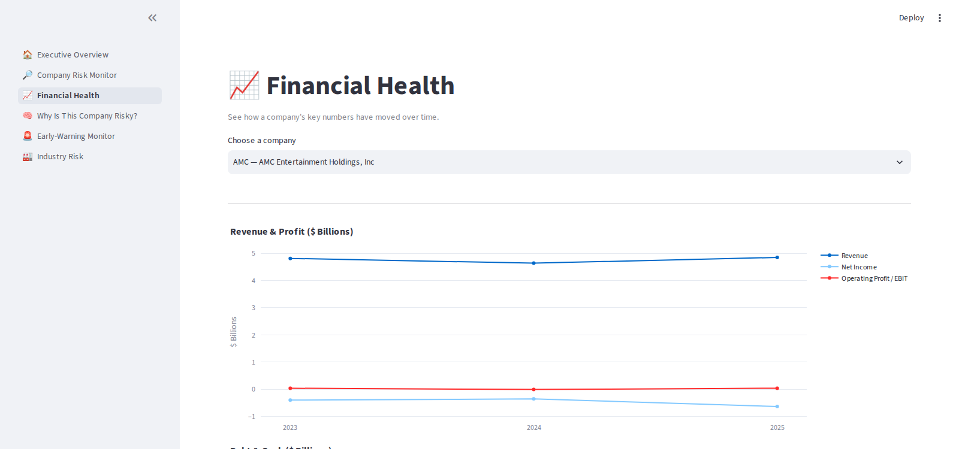
Revenue, profit, debt, and cash flow trends over time for a selected company.

5.4 Why Is This Company Risky?
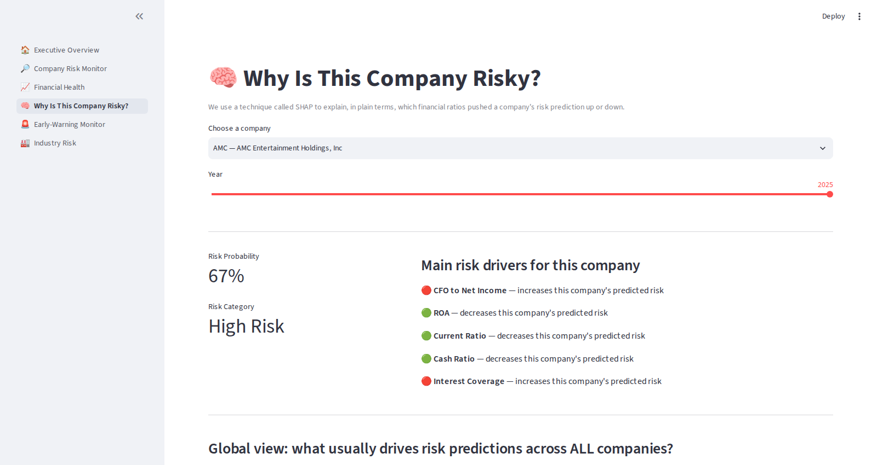
Per-company SHAP explanation, alongside the global feature importance chart.

5.5 Early-Warning Monitor
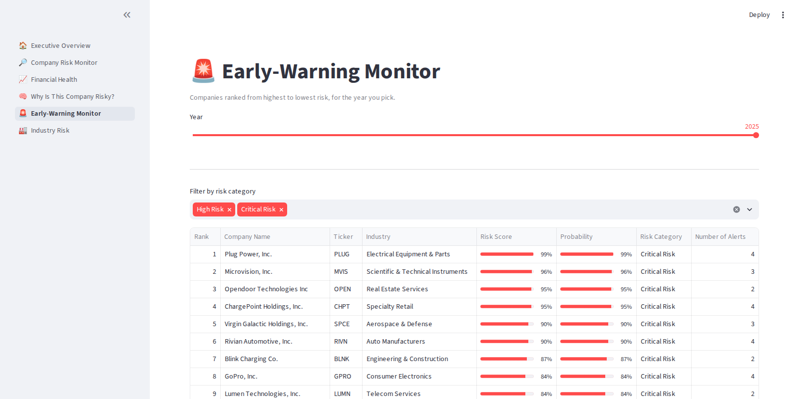
All companies ranked by risk score, filterable by risk category.

5.6 Industry Risk
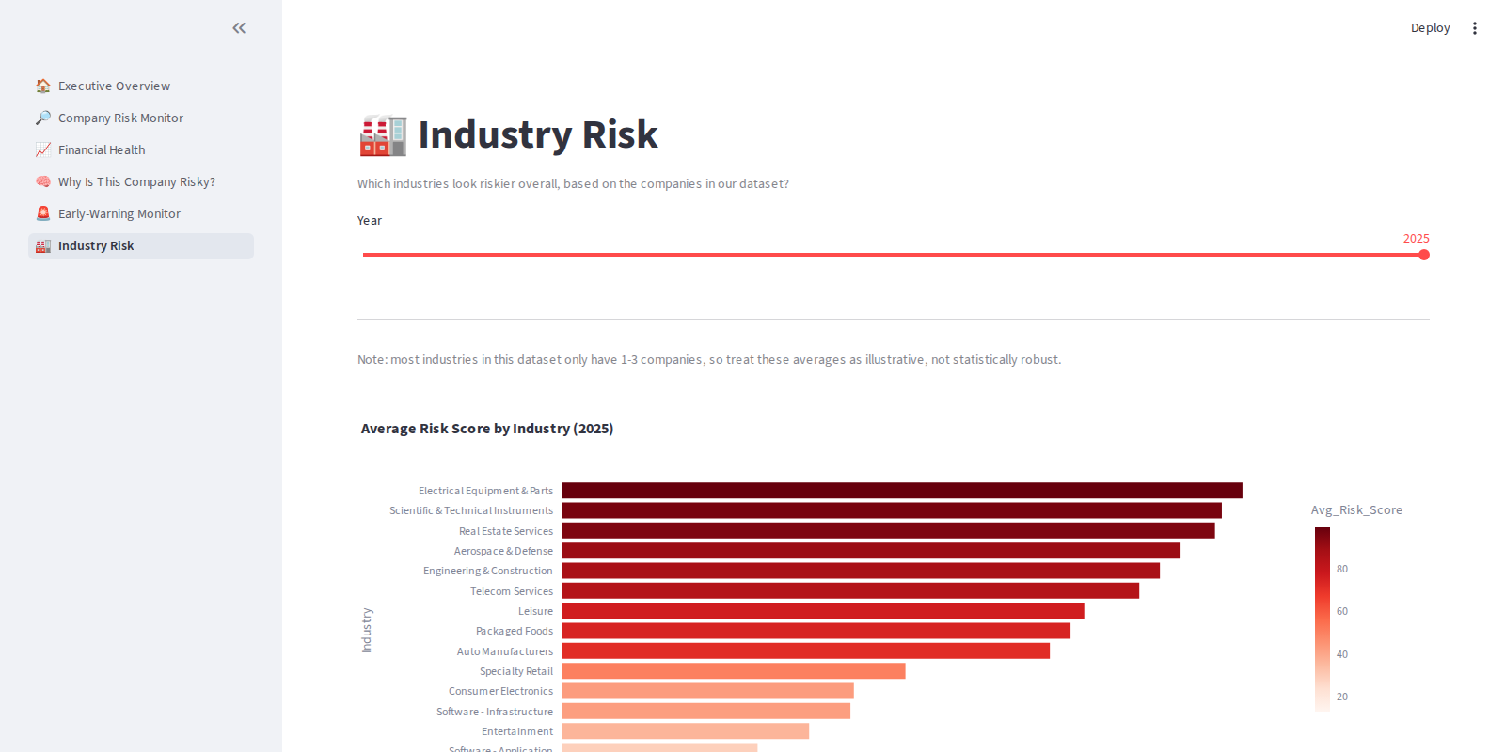
Average risk score and distress rate by industry.

6. Interview Talking Points
Questions you might get, and the honest, strong answers this project supports:

“Walk me through a project you're proud of.”
Use the elevator pitch in Section 1, then pivot to the labeling defect you caught (Section 3.5) — this is the strongest “critical thinking” story in the project.

“How did you handle a small dataset?”
Explain the choice of Stratified 5-Fold Cross-Validation over a single train/test split, and why you prioritized Recall over Accuracy given the cost asymmetry of missing a real distress case.

“How do you make sure your model isn't a black box?”
Talk about SHAP — both global feature importance and per-company local explanations — and how that feeds into the dashboard's “Why is this company risky?” page.

“What would you do differently with more time/data?”
Reference the Future Improvements section of the main report: more years of history for a true chronological split, more companies per industry, and testing model stability across random seeds.

“Why both Streamlit and Power BI?”
Streamlit was used for a fully custom, code-driven interactive tool with SHAP explanations built in; Power BI was used to demonstrate the same results in a format familiar to business stakeholders and finance teams who work in BI tools day-to-day — showing range across both a developer-facing and a business-facing delivery format.

