A cross-study knowledge graph of 1,085 human liver biopsies resolves fibrosis progression into stage-specific gene programmes
[Author list to be completed]
[Affiliations to be completed]
[Corresponding author and e-mail to be completed]
[ DRAFT v1. Written from the committed outputs in Paper1_Results. Discussion and Conclusion are deliberately left blank for the supervisor. References are not yet inserted; citation markers read [REF]. Line numbering is on to make commenting easier. ]

Abstract
Fibrosis stage is the strongest predictor of liver-related outcome in metabolic dysfunction-associated steatotic liver disease, yet the molecular events that separate one stage from the next remain poorly resolved [REF]. Individual transcriptomic cohorts are small, stage distributions are uneven, and each study records severity on its own scale, so findings have been difficult to compare or combine. Here we assembled eight public human liver transcriptome studies comprising 1,085 biopsies from 1,027 patients into a single property graph of 126,244 nodes and 35,091,066 relationships, in which per-sample measurement and curated biological knowledge are queryable together. Gene identifiers were mapped to one canonical namespace and clinical labels were harmonised onto two explicitly separate ladders: fibrosis stage F0-F4, and disease group from control through NAFL to NASH. Correlating expression with ladder position within each study and combining across studies, rather than pooling patients, identified 4,692 progression-associated genes, of which 1,953 tracked fibrosis only, 1,047 inflammation only and 1,692 both. Clustering the 3,645 fibrosis-associated genes by the shape of their F0-F4 curve resolved five reproducible trajectories, including an early immune activation programme and a late matrix-remodelling programme. Testing every stage transition at patient level under a power-matched design showed that the transition into cirrhosis, F3 to F4, carries by far the largest transcriptional change: a median of 311 substantially changing genes against 0-2 for earlier transitions, with effect sizes roughly twice as large. Enrichment against the 14,794 genes eligible for cross-study analysis assigned distinct biology to each group: loss of xenobiotic, fatty-acid and bile-acid metabolism among down-regulated genes, and extracellular matrix formation, epithelial-mesenchymal transition and TNF-NF-kB signalling among genes shared by both ladders. The resulting stage-resolved map provides a reproducible foundation for staging models and for therapeutic target prioritisation.

Keywords: liver fibrosis; MASLD/NAFLD; disease progression; knowledge graph; transcriptomics; cross-study integration; stage transition

1. Introduction
Metabolic dysfunction-associated steatotic liver disease affects a substantial fraction of the adult population worldwide and is now a leading indication for liver transplantation [REF]. Its clinical course is governed less by the presence of steatosis than by the degree of fibrosis: among all histological features scored on biopsy, fibrosis stage is the feature most consistently associated with liver-related morbidity and mortality [REF]. Staging therefore sits at the centre of both prognosis and trial eligibility. It nonetheless still depends on needle biopsy, an invasive procedure subject to sampling variability and inter-observer disagreement, and one that returns a single ordinal label rather than any account of the molecular processes that carried the tissue from one stage to the next [REF].
Transcriptomic profiling of staged biopsies offers a route to that account, and many such cohorts are now public. In practice, however, they have proved difficult to use collectively. Individual studies enrol tens to a few hundred patients, and advanced stages are systematically under-represented because patients with cirrhosis are biopsied less often. Each cohort differs in sequencing platform, depth and centre, so absolute expression values are not comparable across studies. Severity is recorded on study-specific scales, with the same biological state written variously as "4", "F4" or a free-text description, so a naive query against a merged table silently returns an incomplete group rather than an error. Analyses that pool patients across cohorts without addressing these differences risk reporting cohort structure as biology.
Knowledge graphs have become a common substrate for integrating heterogeneous biomedical evidence, linking genes to diseases, pathways, phenotypes and drugs in a single queryable structure [REF]. Existing resources of this kind are, however, built almost entirely from curated literature assertions: they encode what is already known about a gene, but contain no patient-level measurement, and therefore cannot by themselves say how a gene behaves as a particular disease advances. Conversely, differential-expression analyses produce exactly that measurement but discard the surrounding biological context. The two halves are rarely held in the same structure.
This study was designed around that gap, and differs from previous work in several respects that we consider essential rather than incidental. First, measurement and curated knowledge are placed in one graph, so that a gene's behaviour across 1,085 biopsies and its established pathway, disease and drug associations are reachable in a single query; the patient-derived edges linking genes to fibrosis and inflammation are themselves a contribution to the graph rather than an import from an existing database. Second, both the gene axis and the patient axis are harmonised, and every clinical translation is additive, leaving the original study-specific fields untouched so that each mapping remains auditable. Third, fibrosis and inflammation are treated as two separate ladders rather than one severity score, because they are scored separately by pathologists, differ in reversibility, and dissociate in real patients: 40 patients in this cohort have steatohepatitis at fibrosis stage 0, a state that is invisible on the fibrosis ladder alone. Fourth, genes are selected by agreement across independent studies rather than by pooling patients, so that a gene behaving atypically in a single cohort cannot enter the result. Fifth, enrichment is tested against the genes actually eligible for cross-study analysis rather than the whole genome, which materially changes which terms reach significance. Finally, each result is reported with the stability or power analysis that bounds it, so that the distinction between what the data support and what they merely suggest is visible in the output itself.
We report here the construction of that resource and four analyses built on it: the division of progression-associated genes into fibrosis-specific, inflammation-specific and shared programmes; the shapes those genes trace across stages F0 to F4; the stage transition at which the largest transcriptional change occurs; and the biological processes enriched in each group. Together these define a stage-resolved molecular map of fibrosis progression, intended both as a basis for staging models and as the evidence layer for downstream therapeutic target prioritisation.

2. Results

2.1 A harmonised eight-study resource linking measurement to curated knowledge
We assembled eight public human liver transcriptome studies (Table 1), together comprising 1,085 samples from 1,027 patients; the difference reflects 58 patients in GSE193066 who were biopsied twice. Expression files were converted to a common long format, and gene identifiers from all studies were mapped to canonical Ensembl identifiers, yielding 53,993 genes. Because studies differ in platform and depth, expression was standardised per gene within each study (value_z); this within-study standardisation is what makes the eight cohorts comparable at all, and all subsequent analyses use it.
Clinical labels were harmonised onto two ladders. Fibrosis stage was recorded as "0"-"4" in four studies, "F0"-"F4" in another, and in one case as free text; disease state was recorded with four different vocabularies. Harmonised fibrosis_stage and disease_group fields were added alongside, never replacing, the original values, so that every translation remains auditable. Where a label could not be established with confidence it was left blank rather than inferred: one apparently informative field in GSE193066 was tested and rejected because the group it produced was more fibrotic yet expressed less COL1A1 than its comparator, contradicting that study's own staging and the direction seen in every other cohort. After harmonisation, 668 samples carry a fibrosis stage (F0 152, F1 168, F2 186, F3 127, F4 35) and the imbalance at F4 is carried explicitly through every subsequent analysis.
The harmonised data were loaded into a Neo4j property graph of 126,244 nodes and 35,091,066 relationships (Figure 1). Sample-to-gene EXPRESSES edges constitute 32,471,042 of these and represent measurement; curated nodes and edges for diseases, pathways, biological processes, phenotypes and drugs were attached from OptimusKG, restricted to associations with an evidence score of at least 0.1 to prevent the weakest literature co-mentions from connecting everything to everything. Each gene node additionally records n_datasets, the number of studies in which it was measured; 39,199 genes are absent from at least one study and 10,621 appear in exactly one, so this field is required before any cross-gene comparison.
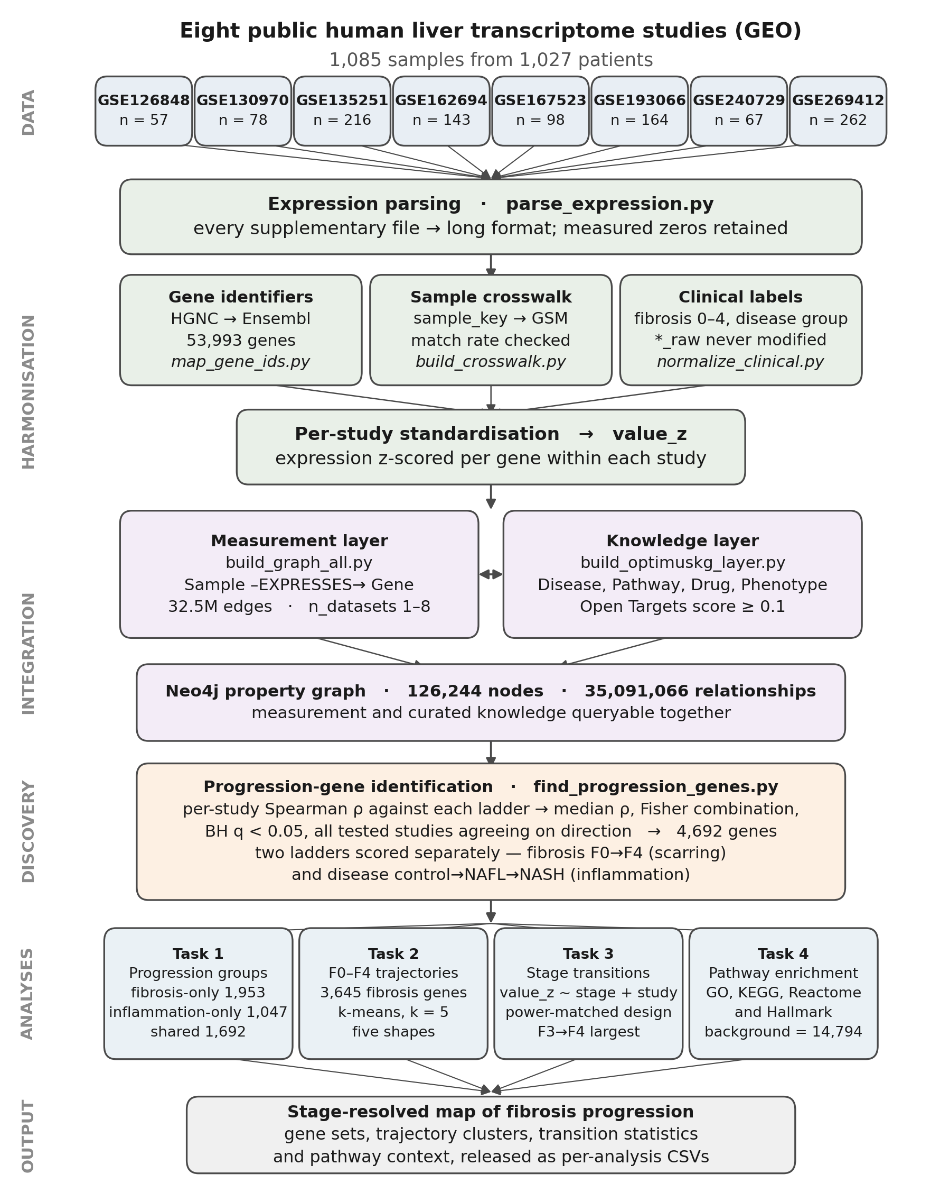
Figure 1. Study design and analysis pipeline. Eight public GEO liver transcriptome studies were parsed to a common long format, harmonised on both the gene axis (identifier mapping to Ensembl) and the patient axis (fibrosis stage, disease group, patient identity), standardised within study, and loaded into a Neo4j property graph together with a curated knowledge layer. Progression-associated genes were identified by per-study Spearman correlation against each ladder, combined across studies, and then analysed in four steps corresponding to Sections 2.2-2.5. Counts shown are the final values reported in this paper.
Table 1. Studies included. Patients differ from samples only in GSE193066, where 58 patients were biopsied twice; repeat biopsies are collapsed to one observation per patient before any statistical test. "derived" indicates diagnosis reconstructed from the study's own Kleiner component scores using the standard NASH-CRN definition, flagged in the data and removable with a single filter.
Study | Samples | Patients | Fibrosis staged | Disease labelled
GSE126848 | 57 | 57 | no | yes
GSE130970 | 78 | 78 | yes | derived
GSE135251 | 216 | 216 | yes | yes
GSE162694 | 143 | 143 | yes | yes
GSE167523 | 98 | 98 | no | yes
GSE193066 | 164 | 106 | yes | no
GSE240729 | 67 | 67 | yes | no
GSE269412 | 262 | 262 | no | no
Total | 1085 | 1027 | 668 samples | -

2.2 Progression-associated genes separate into fibrosis-specific, inflammation-specific and shared programmes
For each gene we computed Spearman correlations against ladder position within each study separately, then combined the per-study coefficients by their median and the per-study p-values by Fisher's method. Genes were retained only when the false-discovery rate was below 0.05 and every study in which the gene was testable agreed on the direction of effect. This requirement is deliberately strict: a gene that rises convincingly in one cohort but is flat in the others is excluded, because such behaviour is more readily explained by cohort composition than by disease biology. Repeat biopsies were collapsed to one observation per patient before testing, so that the 58 twice-biopsied patients in GSE193066 could not receive double weight.
This procedure identified 4,692 progression-associated genes. Partitioning them by ladder (Table 2) showed that 1,953 genes (41.6%) tracked fibrosis only, 1,047 (22.3%) tracked inflammation only, and 1,692 (36.1%) tracked both. The shared group is strikingly coherent in direction: 1,335 genes rise on both ladders and 356 fall on both, while a single gene (GPD1) moves in opposite directions. Across shared genes the two correlation coefficients agree closely (Spearman rho = 0.725, p = 2.9e-276), although this figure is inflated by the separation between the up and down clouds; computed within direction the agreement is more modest but still clear (rho = 0.453 among rising genes, rho = 0.354 among falling genes).
The genes most strongly associated with fibrosis stage include NALCN (rho = 0.580), STMN2 (0.574), LAMC3 (0.538), CCL20 (0.526), IL32 (0.522) and THBS2 (0.514), each of which also tracks inflammation. The most strongly negative associations are dominated by hepatocyte metabolic and sinusoidal genes, among them CLEC4M, ANXA10 and OAT. That the positive end is populated by matrix and immune genes while the negative end is populated by differentiated hepatocyte functions is the expected signature of progressive fibrosis, and provides a first check that the harmonisation has not distorted direction.
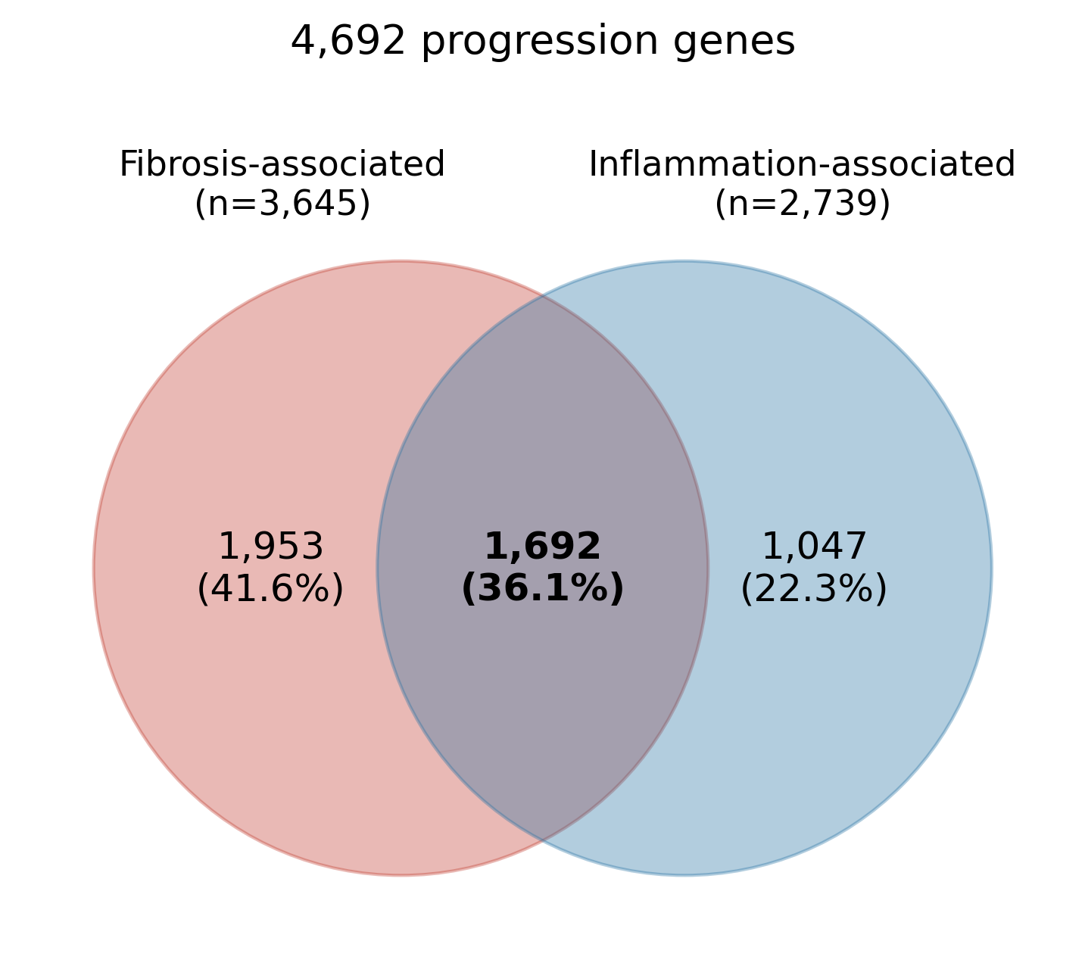
Figure 2. Overlap between the two progression ladders. Genes significantly associated with fibrosis stage and with disease group, showing the fibrosis-only, inflammation-only and shared partitions used throughout this paper.
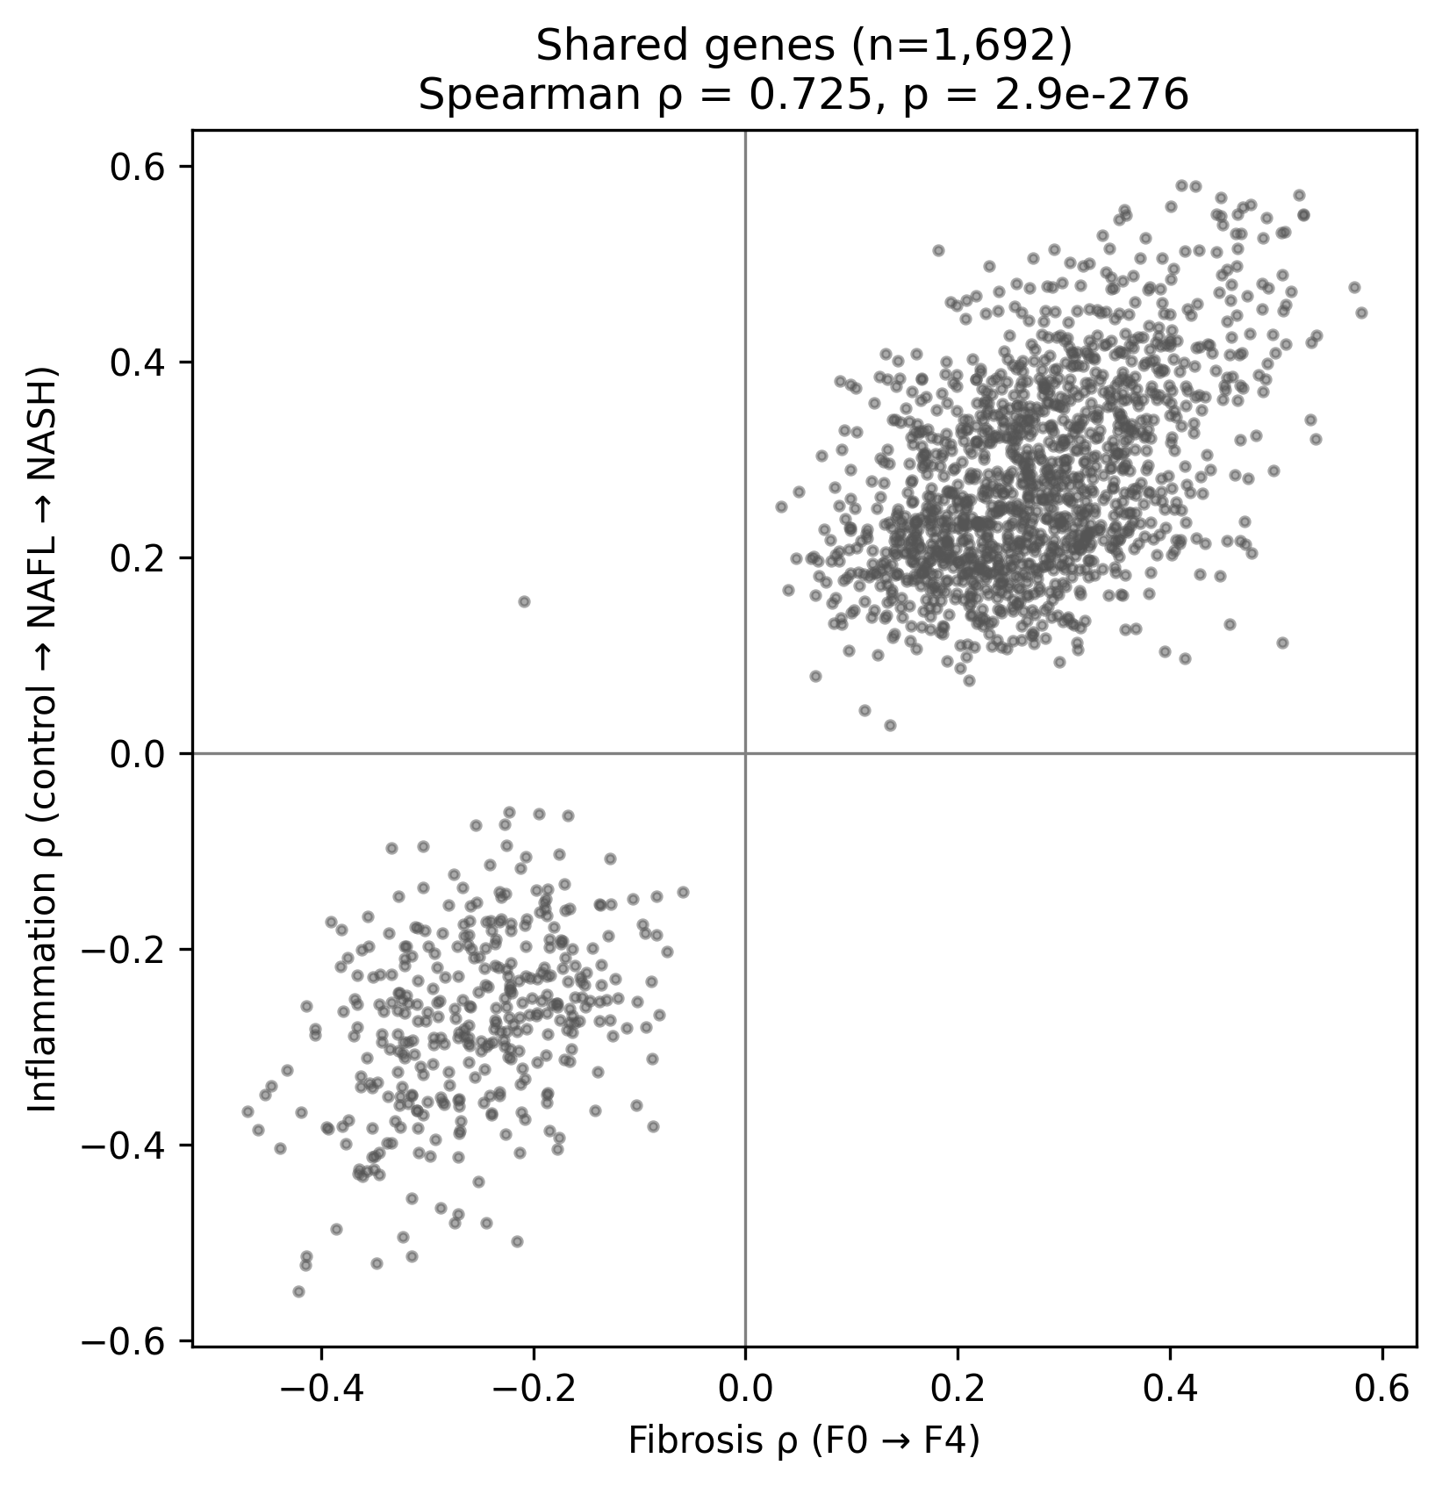
Figure 3. Agreement between ladders among shared genes. Fibrosis correlation plotted against inflammation correlation for the 1,692 shared genes. The two clouds correspond to concordantly rising and concordantly falling genes; only one gene is discordant.
Table 2. Progression-associated genes by ladder and direction. Rising indicates expression increasing with severity. One shared gene (GPD1) is discordant between ladders and is excluded from the rising and falling columns.
Group | Genes | % of 4,692 | Rising | Falling
Fibrosis only | 1,953 | 41.6 | 1,301 | 652
Inflammation only | 1,047 | 22.3 | 597 | 450
Shared | 1,692 | 36.1 | 1,335 | 356
Total | 4,692 | 100.0 | 3,233 | 1,458

2.3 Fibrosis-associated genes follow five reproducible trajectories across F0-F4
To ask how fibrosis-associated genes behave across stages rather than merely whether they correlate with stage, we took the 3,645 genes associated with fibrosis (fibrosis-only plus shared), computed their mean expression at each stage from the 668 staged samples, and z-scored each gene across its own five stage means so that genes would group by the shape of their curve rather than its amplitude. K-means clustering was applied for k = 3 to 8 and the number of clusters chosen by stability rather than by silhouette score alone: for each k we reclustered 50 random 80% subsets of genes and 50 patient-level bootstraps, and selected the largest k whose gene-subsample adjusted Rand index remained at or above 0.95, giving k = 5. Clusters were named only after clustering, from their average curves; no gene was assigned to a pattern by hand.
The five trajectories are an early increase beginning at F0-F1 and continuing (927 genes), a late increase largest at F3-F4 (1,514 genes), an early rise followed by a plateau (197 genes), a mid decrease largest at F1-F2 (309 genes), and a late decrease largest at F3-F4 (698 genes). Representative members are SAE1, LAIR1 and CD52 for the early increase; SLC51B, CCN2 and KRT23 for the late increase; ANLN, ASPM and RRM2 for the early rise and plateau; and SLC27A2, ADH6 and PDK4 for the late decrease.
The shapes themselves are robust. Across 100 patient bootstraps each shape was recovered with a median correlation of 0.97 to 0.997 to the original, and re-estimating stage profiles with study included as a covariate produced per-gene profiles correlating at 0.998 with the plain stage means, so the shapes are not an artefact of which studies contributed to which stage. The membership of individual genes is less certain: under bootstrap, genes move most often between the three increasing clusters, which differ only in timing. We therefore report a per-gene membership confidence and recommend that statements about specific genes within a cluster be restricted to high-confidence members, of which the late-increase and late-decrease clusters have large stable cores (841 and 423 genes) while the early-increase cluster has only 47.
One cluster was renamed as a direct consequence of the next analysis. Cluster 3 was initially described as rising to F3 and then reversing, on the basis of its stage means. Patient-level testing of the F3-F4 transition (Section 2.4) found no significant decrease for any of its 197 genes, so the apparent reversal is not supported and the cluster is described here as an early rise followed by a plateau. Its core members are cell-cycle genes, consistent with a proliferative response that stops increasing rather than one that reverses.
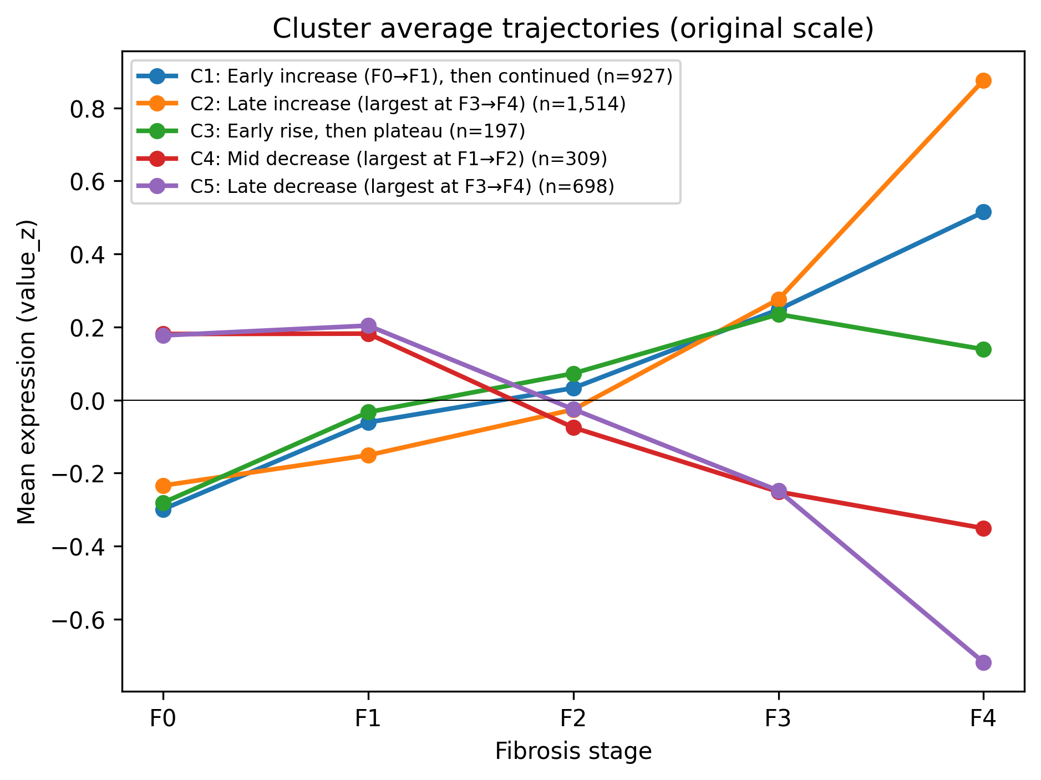
Figure 4. The five fibrosis trajectory shapes. Mean standardised expression of each cluster at fibrosis stages F0 to F4. Cluster names were assigned after clustering from these curves.
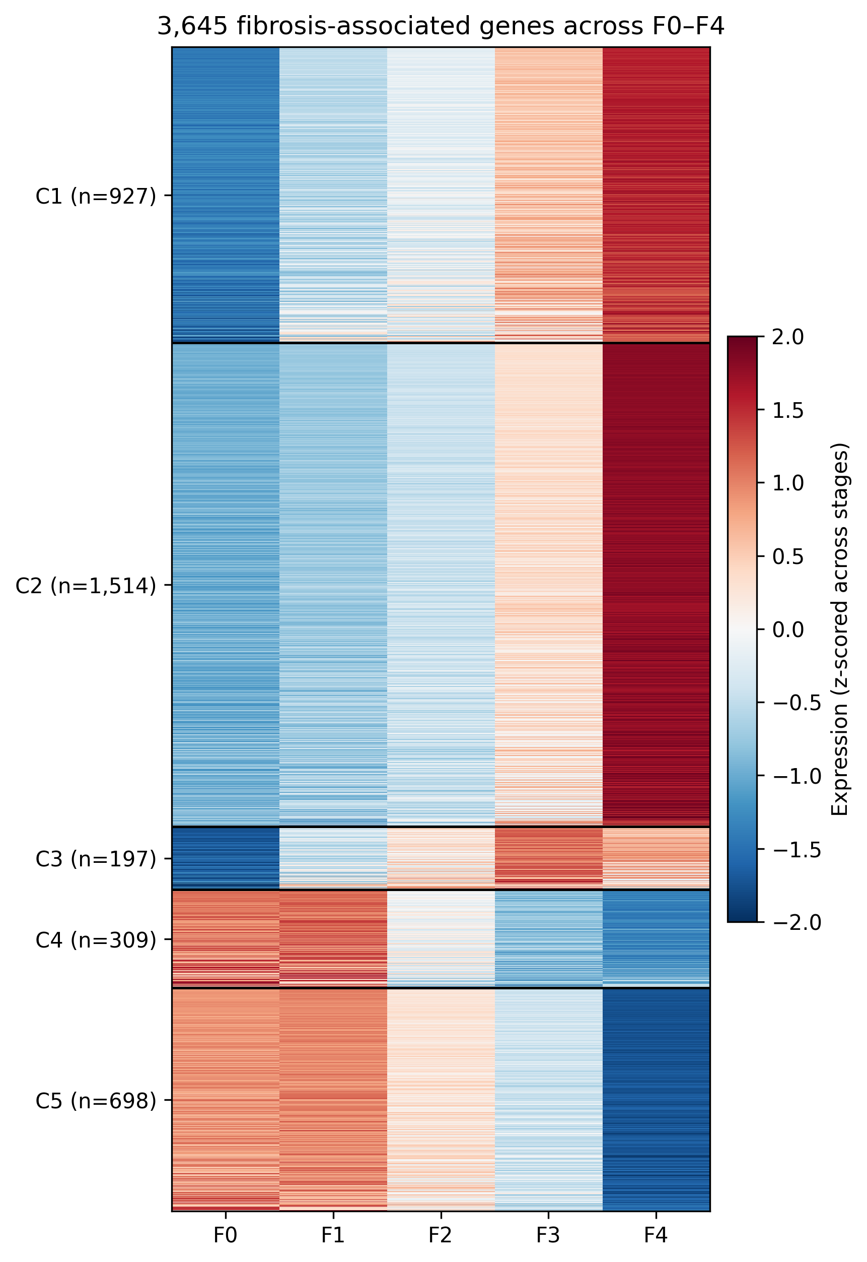
Figure 5. Stage profiles of all 3,645 fibrosis-associated genes. Genes in rows, grouped by cluster; stages F0-F4 in columns. Values are mean standardised expression per stage.
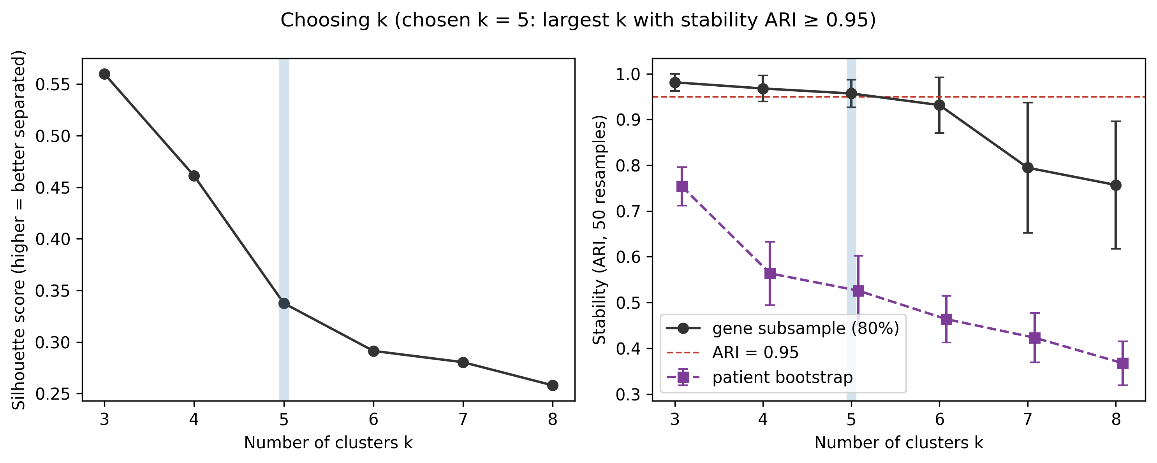
Figure 6. Choice of cluster number. Silhouette score, gene-subsample stability and patient-bootstrap stability for k = 3 to 8. k = 5 is the largest k retaining a gene-subsample adjusted Rand index of at least 0.95.

2.4 The largest transcriptional change occurs at the transition into cirrhosis
Stage means describe where genes sit, not whether the difference between adjacent stages is real. We therefore tested every one of the 3,645 fibrosis-associated genes at each of the four transitions (F0-F1, F1-F2, F2-F3, F3-F4) at patient level, fitting value_z as a function of stage with study included as a covariate so that stages are compared within study and differences in stage composition between studies cannot create an apparent change. Patients contribute once: repeat biopsies at the same stage were averaged, and for the 24 patients biopsied on both sides of a transition one sample was retained at random under a fixed seed. Genes were called substantially changing at a false-discovery rate below 0.05 together with an absolute standardised effect of at least 0.2.
On the full data the four transitions appear broadly similar, with 1,165, 1,175, 1,117 and 936 substantially changing genes respectively (Table 3). This comparison is, however, confounded by sample size: the F3-F4 transition rests on only 34 patients with cirrhosis. We therefore refitted every transition 50 times on an identical study-balanced design of 30 patients per stage, equalising statistical power across all four. Under this design the ordering changes decisively: the median number of substantially changing genes is 0 at F0-F1, 0 at F1-F2 and 2 at F2-F3, against 311 at F3-F4. The typical effect size shows the same pattern, with a median absolute standardised effect of 0.378 at F3-F4 against 0.188 to 0.221 earlier.
The two views are complementary rather than contradictory. Earlier transitions involve many small and consistent changes that are detectable only with large samples; the transition into cirrhosis involves fewer but much larger ones. Direction also shifts across the disease course: the first transition is almost entirely composed of increases (1,135 rising against 30 falling), whereas decreases appear in quantity from F1-F2 onward (528 falling). Among the genes changing most sharply at F3-F4 are STC1, KRT23, MMP7 and PLVAP, while CYP2E1, SLC22A1 and CMBL fall, a pattern consistent with matrix remodelling and ductular reaction replacing hepatocyte metabolic capacity.
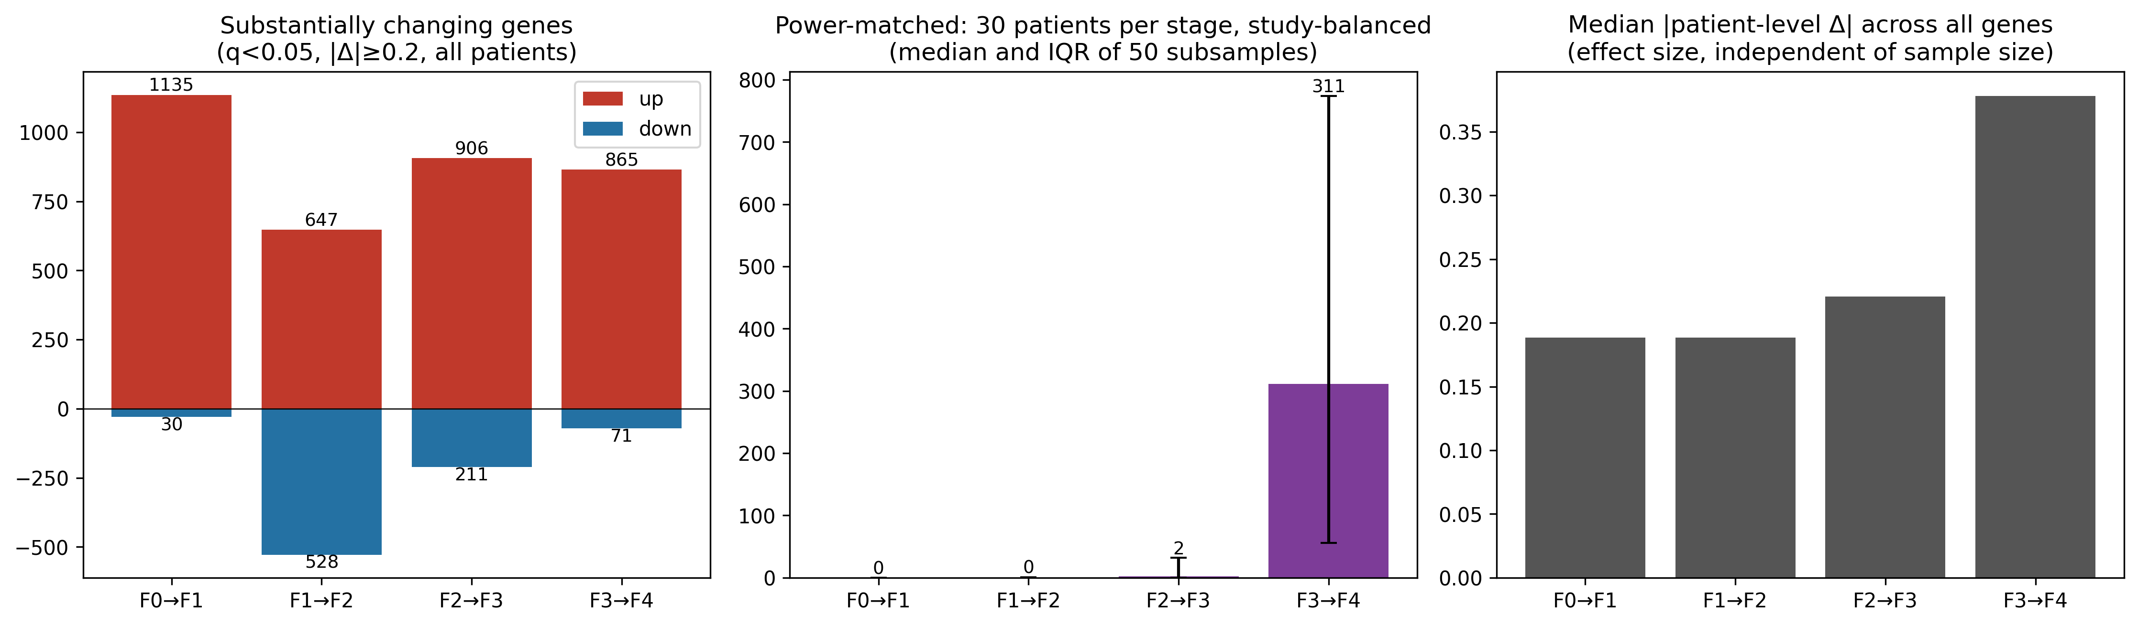
Figure 7. Comparison of the four stage transitions. Numbers of substantially changing genes on the full data, the same counts under the power-matched design of 30 patients per stage, and the distribution of effect sizes. Equalising power isolates F3-F4 as the transition carrying the largest transcriptional change.
Table 3. Transcriptional change at each fibrosis stage transition. Substantial genes are those with false-discovery rate below 0.05 and an absolute standardised effect of at least 0.2, from a model including study as a covariate. The power-matched column gives the median across 50 refits on a fixed study-balanced design of 30 patients per stage.
Transition | Patients (a / b) | Substantial genes | Rising | Falling | Median |effect| | Power-matched median
F0 - F1 | 152 / 166 | 1,165 | 1,135 | 30 | 0.188 | 0
F1 - F2 | 160 / 165 | 1,175 | 647 | 528 | 0.189 | 0
F2 - F3 | 165 / 109 | 1,117 | 906 | 211 | 0.221 | 2
F3 - F4 | 118 / 34 | 936 | 865 | 71 | 0.378 | 311

2.5 Each programme carries distinct biology
Gene sets were tested for over-representation of GO Biological Process, KEGG, Reactome and Hallmark terms, each group separately and never all 4,692 genes together. The background was the 14,794 genes eligible for the cross-study analysis, that is, those measured in every study, rather than the whole genome; using the full genome would overstate enrichment for any term whose members are preferentially well measured, and this choice materially changes which terms reach significance.
The resulting assignments are biologically coherent. Genes rising with fibrosis only are enriched for immune cell activation, including myeloid and T-cell programmes, IL6-JAK-STAT3 signalling and inflammatory response. Genes falling with fibrosis only are enriched for xenobiotic, fatty-acid and bile-acid metabolism and for peroxisomal function, representing the progressive loss of normal hepatocyte metabolism. Genes rising on both ladders give the strongest signal of any group and describe the core fibrogenic programme: extracellular matrix and collagen formation, epithelial-mesenchymal transition, TNF-NF-kB signalling, apoptosis, p53 and angiogenesis. Genes falling on both ladders are enriched for amino-acid and organic-acid catabolism and coagulation. The inflammation-only groups are notably weak, with only interferon-alpha response and G2/M reaching significance among rising genes and nothing at all among falling genes, indicating that most interpretable inflammatory biology in these data is shared with the fibrosis ladder rather than specific to inflammation.
Mapping enrichment onto the trajectory clusters orders this biology in time. The early-increase cluster is enriched for adaptive immunity, T-cell activation and interferon-gamma response, so immune activation is already established at the earliest stage transition. The late-increase cluster is enriched for epithelial-mesenchymal transition, matrix organisation, cell migration, hypoxia and TGF-beta signalling, indicating that scarring accelerates late. The early-rise-then-plateau cluster is dominated by cell-cycle terms (E2F targets, G2/M checkpoint, chromosome segregation). The late-decrease cluster recapitulates metabolic failure, with bile-acid, fatty-acid and xenobiotic metabolism and peroxisomal terms. The mid-decrease cluster yields few terms and no clear theme. Repeating every cluster analysis using only high-confidence cluster members confirmed the late-increase, early-rise and late-decrease conclusions, partially confirmed the early-increase cluster at the level of immune activation, and left the mid-decrease cluster uninterpretable; statements in this paper are restricted accordingly.
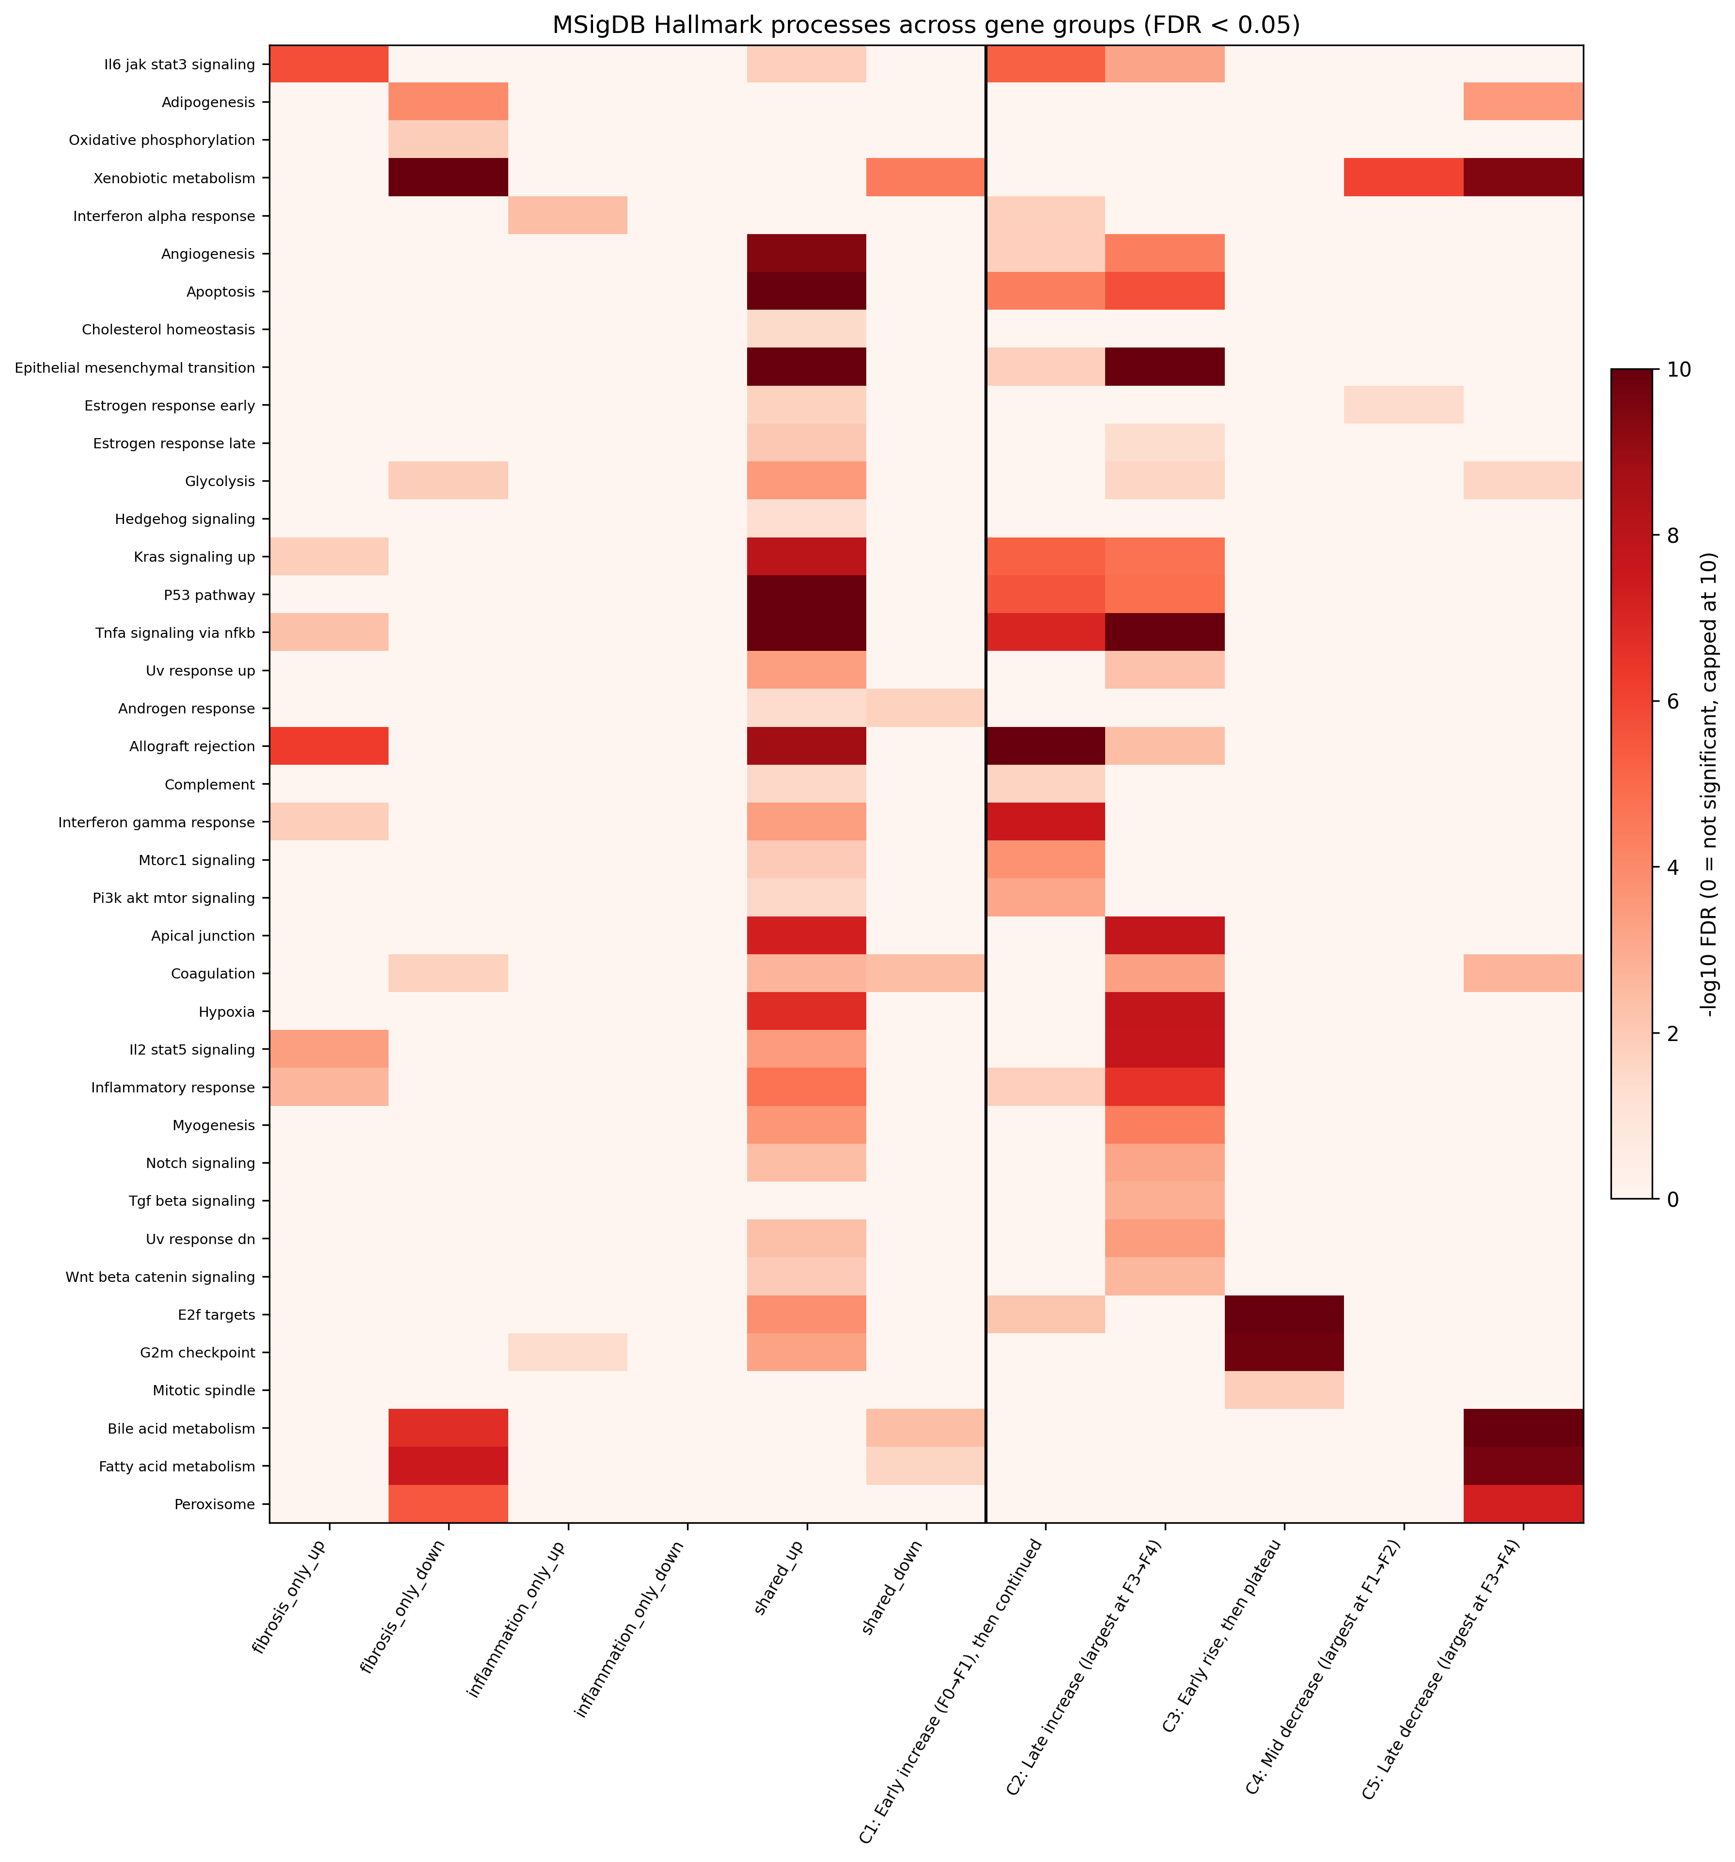
Figure 8. Hallmark process enrichment across groups and clusters. All significantly enriched Hallmark processes (false-discovery rate below 0.05) by gene group and trajectory cluster, tested against the 14,794-gene eligible background.
Table 4. Significantly enriched terms per group. Counts of terms at false-discovery rate below 0.05 in each database, tested against the 14,794-gene eligible background with gene sets restricted to 10-500 background genes.
Group | Genes | GO BP | KEGG | Reactome | Hallmark
Fibrosis only, rising | 1,301 | 234 | 35 | 18 | 7
Fibrosis only, falling | 652 | 106 | 26 | 33 | 8
Inflammation only, rising | 597 | 2 | 1 | 30 | 2
Inflammation only, falling | 450 | 0 | 0 | 0 | 0
Shared, rising | 1,335 | 446 | 27 | 71 | 30
Shared, falling | 356 | 62 | 22 | 19 | 5
C1 early increase | 927 | 348 | 47 | 50 | 15
C2 late increase | 1,514 | 542 | 20 | 48 | 21
C3 early rise, plateau | 197 | 85 | 3 | 29 | 3
C4 mid decrease | 309 | 5 | 1 | 2 | 2
C5 late decrease | 698 | 159 | 35 | 38 | 7

3. Discussion
[ TO BE WRITTEN BY THE SUPERVISOR, as agreed. Material available to draw on: the ordering of immune activation before matrix remodelling; the F3-F4 result and what it implies for staging models and trial endpoints; the dissociation of the two ladders and the 40 patients with NASH at fibrosis stage 0; and the handover of these gene sets to the drug-prioritisation analysis. ]

4. Conclusion
[ TO BE WRITTEN BY THE SUPERVISOR, as agreed. ]

5. Methods

5.1 Data sources
Eight human liver transcriptome studies were obtained from the Gene Expression Omnibus: GSE126848 (57 samples), GSE130970 (78), GSE135251 (216), GSE162694 (143), GSE167523 (98), GSE193066 (164), GSE240729 (67) and GSE269412 (262), giving 1,085 samples from 1,027 patients. For each study both the supplementary expression files and the series matrix were retrieved, the latter providing per-sample clinical characteristics. No new human data were generated; all analyses use existing public data, so no sample-size calculation or randomisation applies and the available sample size is reported as a constraint rather than a design choice.

5.2 Expression parsing
Supplementary expression files differ in layout between studies. Each was parsed into a single long-format table with columns for dataset, sample key, raw gene identifier, identifier type, value and unit. Measured values of zero were retained throughout. This is a consequential choice: a zero recorded by the assay is evidence that a gene was not detected in that biopsy, and discarding such values removes precisely the switching-on behaviour that distinguishes stages. Retaining them added approximately 9.1 million measurements and 514 additional progression genes relative to an earlier run in which they were dropped.

5.3 Gene identifier harmonisation
Every gene identifier was translated to a canonical Ensembl gene identifier with version suffixes removed, using the HGNC complete set as the dictionary. Mapping was performed on the unique identifiers of each dataset and then joined back to the measurement table, rather than row by row. Identifiers that failed to map were written to a separate report rather than silently discarded. Rows corresponding to pseudoautosomal duplicates (_PAR_Y) were removed, and where two raw identifiers collapsed onto a single Ensembl identifier their values were summed. This produced 53,993 genes.

5.4 Sample crosswalk
Expression files label their columns differently from the GEO sample accessions used in the series matrices, so a per-study rule was derived to map each expression column to its GSM accession. Rules were not trusted blindly: each was applied and then verified against the sample keys actually present in the expression files, and the per-study match rate was reported, so that a rule correct for the first few samples but wrong for the rest would be detected rather than produce a partially connected graph.

5.5 Clinical label harmonisation
Clinical severity was recorded on study-specific scales. Four studies recorded fibrosis as "0" to "4", one as "F0" to "F4", and one used a free-text description for normal histology; disease state was recorded with four distinct vocabularies. Harmonised fields (fibrosis_stage as an integer 0-4; disease_group as control, obese, NAFL, NASH or NAFLD) were added alongside the original *_raw fields, which were never modified, so that every translation remains auditable. Patient identity and biopsy number were also derived, because the 164 samples of GSE193066 come from 106 patients, 58 of whom were biopsied twice. For GSE162694 the diagnosis encoded in sample titles was recovered after cross-checking against the recorded fibrosis stage for all 143 samples. For GSE130970, which states no diagnosis but reports full Kleiner component scores, diagnosis was derived using the standard NASH-CRN definition (steatosis 0 as control; ballooning at least 1 as NASH; steatosis of at least 1 with no ballooning as NAFL) and flagged as derived so that it can be excluded with a single filter. Four studies were deliberately left unlabelled where no defensible join existed; one candidate field in GSE193066 was tested and rejected because the groups it produced contradicted that study's own fibrosis staging.

5.6 Expression standardisation
Because studies differ in platform, depth and centre, raw values are not comparable across cohorts. Expression was therefore standardised per gene within each study (value_z), so that a value expresses how far a sample sits from that study's own mean for that gene. All downstream analyses use value_z.

5.7 Graph construction
The harmonised measurements were written as Neo4j-ready CSVs and loaded into a Neo4j property graph with uniqueness constraints created before loading. The graph contains 126,244 nodes (Gene 53,993; Disease 36,044; BioProcess 12,203; Drug 12,025; Phenotype 8,666; Pathway 2,220; Sample 1,085; Dataset 8) and 35,091,066 relationships. Sample-gene EXPRESSES edges account for 32,471,042 of these. No gene filter was applied at load time; instead each Gene node records n_datasets, the number of studies in which it was measured, so that filtering decisions are made at query time and remain visible in the analysis rather than being fixed in the data.

5.8 Knowledge layer
Curated biological knowledge was attached from OptimusKG, which identifies genes by Ensembl identifier and so joins directly to the measurement layer (50,725 of 53,993 genes match, 94%). Gene-disease associations were restricted to an evidence score of at least 0.1 and the score was stored on every edge, so queries may tighten the threshold without reloading; without this restriction the resource contributes over nine million gene-disease links with a median score of 0.026, connecting a third of the genome to NAFLD and leaving the graph too densely connected to support inference. Drug-gene edges retain their reported mode of action. Drug-drug interaction, anatomy-gene and environmental exposure slices were excluded as not relevant to disease mechanism.

5.9 Identification of progression-associated genes
Two ladders were analysed separately: fibrosis stage (0 to 4) and disease group (control, NAFL, NASH, coded 0 to 2). Only genes measured in all eight studies were tested. Within each study, each gene's value_z was correlated with ladder position by Spearman's rho, chosen because stages are ordered ranks whose spacing is not meaningful. Studies contributing fewer than 25 labelled patients for an axis were skipped for that axis, and a gene had to be testable in at least three studies. Per-study coefficients were combined by their median and per-study p-values by Fisher's method, with Benjamini-Hochberg correction. Genes were retained at a false-discovery rate below 0.05 and only when every study in which they were testable agreed on the direction of effect. Samples were collapsed to one observation per patient per study before any statistic was computed. Combining per-study results rather than pooling patients is deliberate: pooling allows a gene that behaves atypically in one cohort to dominate, whereas requiring cross-study agreement makes cohort-specific behaviour a reason for exclusion.

5.10 Assignment to progression groups
Genes significant on the fibrosis ladder only, on the disease ladder only, or on both were assigned to the fibrosis-only, inflammation-only and shared groups respectively, and each group was further split by the sign of its median correlation. Agreement between ladders among shared genes was quantified by Spearman correlation of the two coefficients, computed overall and separately within the rising and falling subsets, the latter being the more conservative estimate.

5.11 Trajectory clustering
The 3,645 fibrosis-associated genes (fibrosis-only plus shared) were summarised by their mean value_z at each fibrosis stage, computed from the 668 staged samples. Each gene's five stage means were z-scored across stages so that clustering would respond to curve shape rather than amplitude. K-means was run with 50 random initialisations for k = 3 to 8. The number of clusters was selected by stability: for each k, 50 random 80% subsets of genes and 50 patient-level bootstraps (resampling patients within study, with replacement, and recomputing stage means) were reclustered and compared to the full-data solution by adjusted Rand index. The largest k retaining a gene-subsample index of at least 0.95 was chosen, giving k = 5; silhouette score alone would have favoured k = 3, which visibly merges distinct shapes. Clusters were named after clustering from their average curves. A per-gene membership confidence was recorded as the fraction of 100 bootstraps in which the gene remained in its assigned cluster, and the sensitivity of the solution to study composition was assessed by re-estimating stage profiles from a model including study as a covariate.

5.12 Stage transition analysis
For each fibrosis-associated gene and each adjacent-stage transition, value_z was modelled as a function of stage with study as a covariate, fitted only on patients at the two stages concerned, so that stages are compared within study; studies lacking either stage were excluded from that transition. Patients contribute once: repeat biopsies at the same stage were averaged (28 patients) and, for patients biopsied on either side of a transition (24 patients), one sample was retained at random under a fixed seed. Coefficients were tested by t-test with Benjamini-Hochberg correction within each transition, and a gene was called substantially changing at a false-discovery rate below 0.05 together with an absolute coefficient of at least 0.2 standard deviations. Because the number of patients differs sharply between transitions, and F4 in particular is represented by only 34 patients, every transition was additionally refitted 50 times on an identical study-balanced design of 30 patients per stage, equalising power across transitions.

5.13 Pathway enrichment
Over-representation was tested for GO Biological Process, KEGG, Reactome and Hallmark gene sets (MSigDB v2024.1, human symbols) using one-sided hypergeometric tests with Benjamini-Hochberg correction within each group and database, calling terms significant below a false-discovery rate of 0.05. The background was the 14,794 genes eligible for the cross-study analysis, not the whole genome; every gene set was first restricted to these genes and retained only if 10 to 500 of them remained, leaving 4,853 GO BP, 183 KEGG, 1,279 Reactome and 50 Hallmark sets. Each group was tested separately. Cluster analyses were repeated using only genes with a bootstrap membership confidence of at least 0.8, and conclusions are reported only where they survive that check.

5.14 Software and availability
Analyses were performed in Python using pandas, NumPy, SciPy, scikit-learn and gseapy, with the graph held in Neo4j. All analysis code, the per-step rationale and the complete result tables are available in the project repository; each analysis directory carries a README recording its method, its chosen thresholds and its limitations.
[ Insert the repository URL or data-availability statement required by the target journal, and confirm package versions. ]

6. Limitations
Four limitations bound the interpretation of these results and are stated here rather than left to inference. First, the genes analysed in Sections 2.3 to 2.5 were selected because they correlate with fibrosis stage in these same data, so absolute counts of significant genes are inflated by selection; comparisons between transitions remain fair because all four use the same gene set, but the counts themselves should not be read as unbiased estimates. Second, stage F4 is represented by only 34 to 35 patients, and although the power-matched design addresses the resulting imbalance in statistical power, estimates for the F3-F4 transition remain the least precise in the study. Third, cluster membership for individual genes is less stable than the cluster shapes, particularly among the three increasing clusters, which is why per-gene membership confidence is reported and gene-level claims are restricted to high-confidence members. Fourth, demographic coverage is partial: age and sex are recorded by five of the eight studies and only three of those also stage fibrosis, so any analysis combining stage with age or sex rests on 385 samples rather than the full cohort, and every output file carries its own sample count so that this limit remains visible.

References
[ To be inserted. Citation markers in the text read [REF] and mark the places where a reference is required: disease burden and transplantation; fibrosis stage as the dominant prognostic feature; biopsy sampling variability and inter-observer agreement; and biomedical knowledge graphs. Format according to the target journal. ]

