**Task Manager with Running Unused Programs**

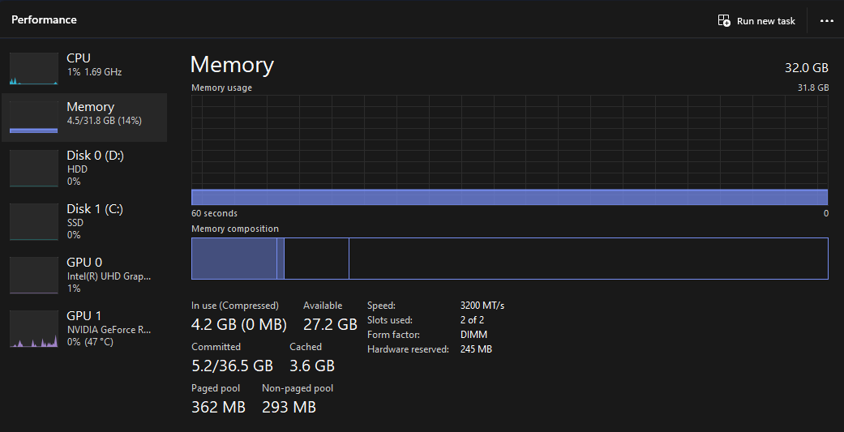

**Task Manager after executing the Resource Allocation**

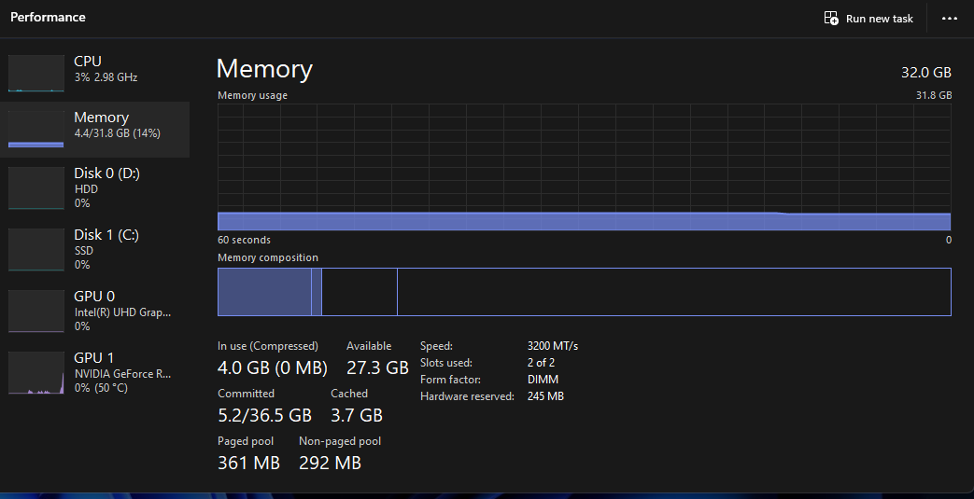

**Reflection on the Activity**

The activity is all about the Resource Allocation and Management on Windows. The student was able to noticed the high usage of CPU, Memory, and Disk and it results to lagging, and slow response of certain application. The student was able to observe in the task Manager the high usage of noted and Microsoft edge since the both of them are automatically starting up whenever the computer opens up (Task Manager with Running Unused Programs). The student was able to follow the steps on how to terminate the unused applications and programs, the student was able to kill the process of the Microsoft edge and notepad (Task Manager after executing the Resource Allocation). This results with more efficiency in CPU usage and the computer was able to perform at a greater speed.

In this lab, I explored managing system resources on a Windows computer, using tools like Task Manager, Resource Monitor, and Command Prompt, with a focus on Microsoft Edge. I began by opening Task Manager to observe the overall CPU, memory, and disk usage and count the number of active processes. Using Resource Monitor, I identified which processes were consuming the most resources, focusing on Edge, which was one of the more resource-intensive applications running.

Next, I used Command Prompt to control the resource usage of Microsoft Edge specifically. After finding its process ID (PID), I adjusted its CPU priority to "low," which limited its processing power. This exercise helped me understand how changing a process’s priority can impact the system’s overall performance. I also checked how much memory Edge was using, getting insights into how much memory intensive applications require.

To further analyze performance, I opened additional applications like a media player and a web browser to observe how multiple active applications affected CPU and memory usage. Task Manager showed significant spikes, especially with Edge open alongside other applications. I then used Performance Monitor to generate a report over a 60-second period, which highlighted the impact of running multiple applications on system resources.

Finally, I practiced resource cleanup by terminating Microsoft Edge through Command Prompt and confirmed its termination in Task Manager. This allowed me to compare system performance before and after closing Edge, where I observed an improvement in CPU and memory availability. Overall, this lab gave me a practical understanding of how to monitor and control resource allocation on Windows, using Edge as an example of managing a high-resource application effectively.