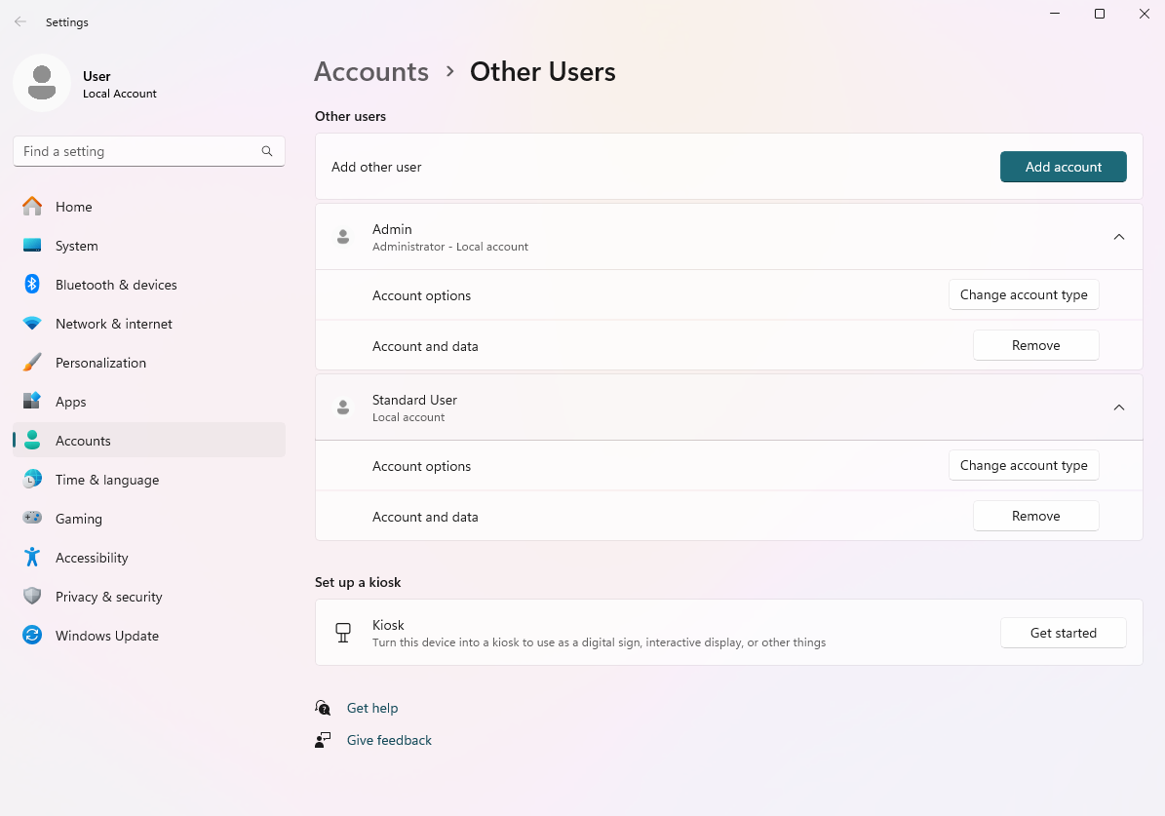

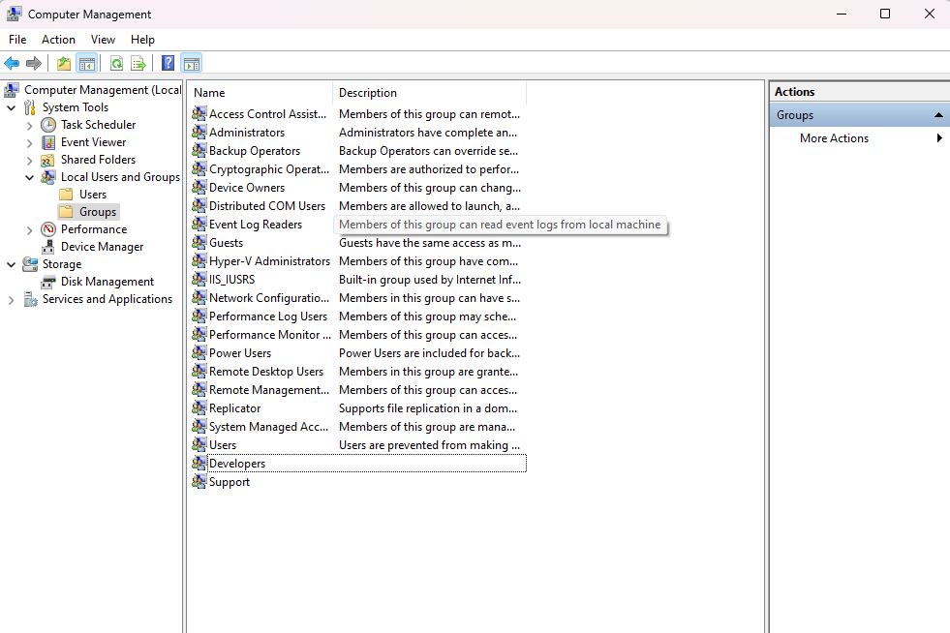

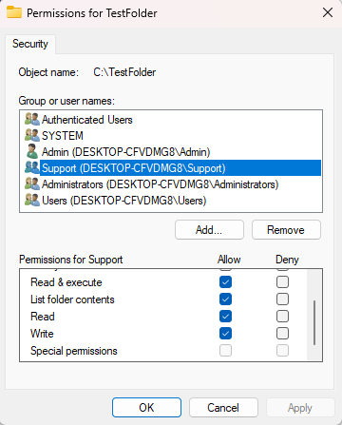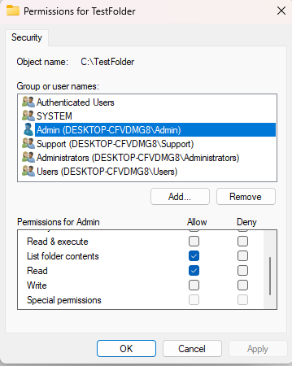

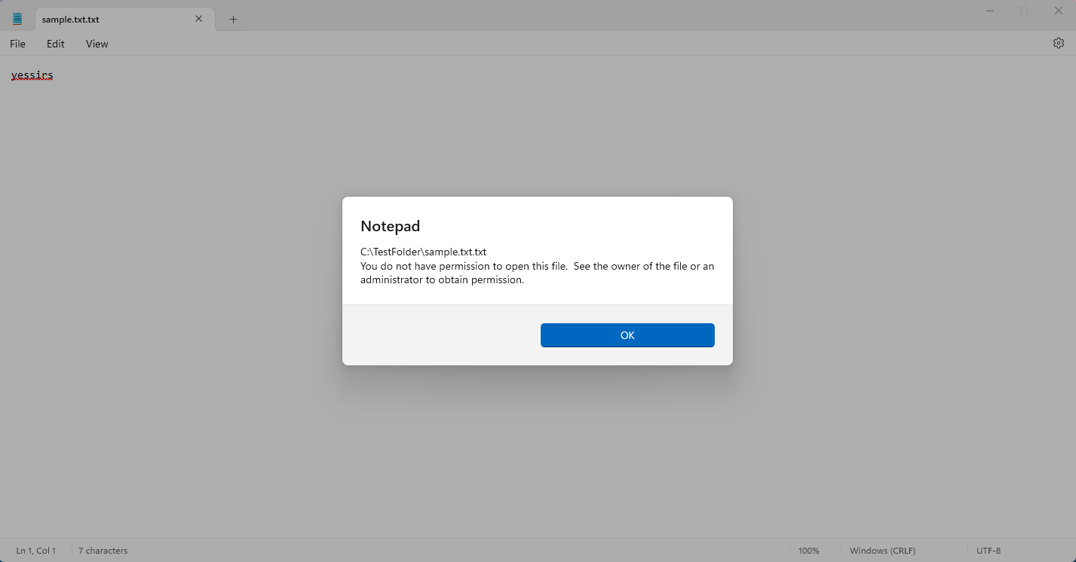

### 1. Benefits of Assigning Permissions Through Groups

* **Efficiency**: Managing permissions through groups allows administrators to assign rights to multiple users simultaneously, reducing the time and effort required for individual configurations.
* **Consistency**: Group-based permissions ensure that users with similar roles or responsibilities have the same access levels, promoting uniformity in access controls.
* **Simplified Management**: Changes to permissions can be made at the group level, automatically affecting all users within that group, making it easier to manage large teams.
* **Reduced Risk of Errors**: By limiting direct changes to individual users, the chance of accidentally misconfiguring permissions for a single account is minimized.

**2. Risks of Granting Administrator Privileges to Standard User Accounts**

* **Increased Vulnerability**: If a standard user account is compromised, the attacker gains full control over the system, leading to potential data breaches or system damage.
* **Unintentional Changes**: Users with admin privileges may inadvertently alter critical system settings or delete important files, disrupting system stability and security.
* **Malware Risk**: Malware can exploit elevated permissions, allowing it to install itself or modify system files, which could lead to widespread infections or data loss.
* **Loss of Accountability**: Tracking changes becomes difficult when multiple users have admin rights, complicating audits and incident response.

**3. Contribution of Access Permissions to System Security**

* **Principle of Least Privilege**: Access permissions help enforce the principle of least privilege, ensuring users have only the rights necessary for their role, which minimizes potential damage from misuse or compromise.
* **Segregation of Duties**: By restricting access based on roles, organizations can prevent conflicts of interest and reduce the risk of fraud or abuse.
* **Audit and Compliance**: Well-defined access permissions facilitate auditing and monitoring, making it easier to track user actions and ensure compliance with regulations.
* **Incident Containment**: In the event of a security breach, restricted permissions can help contain the damage by limiting what an attacker can access or modify within the system.