Supermarket Sales Analysis
_{Methods in Empirical Analysis}
_{Sayed Khushal Shah}

_{By}
Nissi Sharon Pidathala
Yashwanth Chowdary Venigalla
Yashwanth Kirla
Sai Praneeth Kankanala
Nitin Reddy Dhamana

Abstract— The project involves a thorough analysis of a supermarket's sales data using Python. The goal is to utilize Python's data analysis and visualization libraries to derive meaningful insights from the sales dataset. The process includes cleaning and formatting raw sales data using Pandas, followed by exploratory data analysis (EDA) using Matplotlib and Seaborn for visualization. Time-series analysis is incorporated for assessing sales trends, and machine learning techniques, possibly using Scikit-learn, may be applied for predictive analysis. The entire analysis is documented in a Jupyter notebook, demonstrating Python's effectiveness in retail data analysis for informed decision-making.

Introduction

A supermarket is a large retail store operating on a self-service model, offering a wide range of food products and household items. Unlike traditional grocery stores, supermarkets are known for their extensive selection. For businesses collecting substantial customer data, the challenge lies in extracting meaningful insights from vast databases. Market basket analysis, extensively studied in academic literature, focuses on understanding customer interest profiles and preferences for individual products. This analysis proves valuable for one-to-one marketing, enabling the customization of strategies based on individual customer behaviour.
In a retail setting with multiple stores, companies commonly utilize purchasing patterns identified through market basket analysis. This method reveals product associations, forming the foundation for a retailer's promotion strategy. By harnessing this data, businesses can make informed decisions regarding product placement, pricing, promotions, and overall profitability. Moreover, market basket analysis uncovers successful products that may not have apparent connections, allowing companies to optimize their strategies. Ultimately, this analytical approach streamlines the identification of similar products, facilitating strategic placement and cross-selling opportunities. It proves invaluable for companies aiming for a competitive edge through data-driven decision-making in the ever-evolving retail landscape. In summary, the primary objective of this analysis is to examine consumer data, predict future sales trends, and enable supermarkets to enhance their operations through informed, data-driven decisions. This analysis is crucial in the industry as it provides insights into how a company manages its workforce, cash flow, and resources.

BACKGROUND
Understanding market segmentation is crucial for any business. It involves gaining insights into customer behavior and needs, which is essential for the smooth operation of the company. Analyzing data from supermarket customers can serve as valuable information for stakeholders, including branch heads and marketing teams.

The goal is to develop effective marketing strategies that boost product sales and help achieve sales targets. By delving into customer data, businesses can tailor their approaches to better align with the preferences and demands of their target audience. This strategic analysis becomes a reference point for making informed decisions and driving overall success in the competitive market.

Goals and Objectives:
Motivation:
Market basket analysis is a critical strategic tool for supermarkets, offering transformative impacts on both short-term profitability and long-term sustainability. By uncovering hidden patterns, identifying growth opportunities, and mitigating risks, this analysis empowers supermarkets to strategically boost revenue and minimize costs. It fosters a deeper understanding of customer needs, enabling personalized marketing and informed decision-making regarding product assortment, pricing, and promotions. In essence, market basket analysis plays a pivotal role in enhancing the efficiency, profitability, and adaptability of supermarkets in a dynamic retail landscape.
Significance:
The importance of this analysis cannot be emphasized enough. It serves as a strategic tool, enabling supermarkets to uncover hidden patterns, spot avenues for growth, and proactively address potential risks. Whether it's enhancing income and reducing costs or gaining a profound insight into customer preferences, the real value lies in its transformative impact on both immediate profitability and enduring sustainability.
Objectives:
Create visual representations to understand how factors such as Branch, Customer segment, Gender, Product category, and ship mode influence the study variable, which is sales. Evaluate the primary effects as well as the interactions among the explanatory variables (Branch, Customer type, Gender, Product line, and Payment type) on the study variable (sales). Apply a suitable Time Series Model to analyze and interpret the study variable, sales. This involves fitting a model that considers the temporal aspects of the data, providing insights into patterns and trends over time.
Features:
Our supermarket sales analysis features are crafted to offer a comprehensive understanding of the business landscape. Ranging from detailed sales trend analysis and product performance metrics to customer segmentation and real-time inventory insights, our approach seamlessly blends analytical rigor with practical applicability. Visualizations and reports serve to simplify intricate data, providing actionable insights for more informed decision-making. As we immerse ourselves in the supermarket sales analysis, we're not just examining the past and present; we're strategically shaping the future. Subsequent sections will unveil layers of data, exposing growth opportunities, areas for enhancement, and the roadmap to enduring success in the ever-evolving world of supermarket retail.

DATA

Data Collection:
We utilized secondary data for our analysis. The supermarket sales data was sourced from the Kaggle website. The data span from 2010, to 2013. Our supermarket analysis is conducted exclusively based on these secondary data.
Kaggle Website:
Kaggle originated in 2010, initially focusing on machine learning competitions and has since expanded its services. It now offers a public data platform, a cloud-based workbench for data science, and provides education in artificial intelligence. Founded by Anthony Goldbloom and Jeremy Howard, with Nicholas Gruen as the founding chair, later succeeded by Max Levchin. In 2011, the company raised equity, reaching a valuation of $25 million. Notably, on March 8, 2017, Google announced the acquisition of Kaggle. Kaggle, now a subsidiary of Google LLC, functions as an online community connecting data scientists and machine learning practitioners. It facilitates data set discovery and publication, model exploration and building in a web-based environment, collaboration with peers, and participation in data science competitions to address various challenges.
Size: 9994 rows and 13 columns
Link:https://www.kaggle.com/datasets/bravehart101/sample-supermarket-dataset/code
Github link: https://github.com/nissisha/EMPRICAL-ANALYSIS

Dataset Attributes:
Ship Mode: Mode of shipping used for shipment delivery
Segment: Customer segment product was shipped to
Country: Country in which the shipment was delivered.
City: City in which shipment was delivered
State: State in which the shipment was delivered.
Postal Code: Postal code the shipment was delivered to.
Region: Country Region
Category: The category product belongs to
Sub Category: Sub-category of the product.
Price: Sale made in USD
Quantity: Product Quantity
Discount: Reflects the discount applied to the order.
Profit: Profit or sale made on the sale.

DaTa Manipulation
Data Cleaning and Manipulation:
Python is the tool that have chosen to use for this project. Pandas libraries provide efficient cleaning tools and visualizations in order to gain quick insights. This csv file contains 9427 rows and 24 columns.
The columns are Row ID, Order Priority, Discount, Unit Price, Shipping Cost, Customer ID, Customer Name, Ship Mode, Customer Segment, Product Category, Product Sub-Category, Product Container, Product Name, Product Base, Margin, Region, State or Province, City, Postal Code, Order, Date, Ship Date, Profit, Quantity, ordered, new Sales, Order ID.
Graphical Representation:
Charts are vital for understanding collected data, serving as a potent tool for visualization. They efficiently convey information from large datasets through graphical representation, revealing the inherent structure. Compared to text or numbers, visual charts provide a swift and intuitive comprehension.
Pie Charts:
Also referred to as "angular charts," pie charts visually represent data by dividing a circle into segments. Each segment corresponds to the relative frequency or percentage of different categories, collectively forming a full circle (360 degrees).
Line Charts:
Line charts are useful for illustrating changes over time. Whether tracking the growth of a child, stock prices, or a country's GDP, these charts effectively portray trends and patterns in a straightforward manner.

ANALYSIS

Analysis:
Data analysis involves various techniques, including univariate analysis (examining a single variable) and multivariate analysis (analyzing multiple variables simultaneously). Data is ubiquitous, found in spreadsheets, social media platforms, and other sources. The process of cleaning, transforming, interpreting, analyzing, and visualizing this data for valuable insights is known as Data Analysis.
There are six types of data analysis:
Exploratory Analysis
Descriptive Analysis
Inferential Analysis
Predictive Analysis
Causal Analysis
Mechanistic Analysis

This article focuses on Exploratory Analysis, which is the preliminary examination of data to discover relationships, trends, and patterns using statistics and visualization tools. Exploratory data analysis includes graphical or non-graphical methods and is further classified as univariate, bivariate, or multivariate.

Univariate analysis:
In Exploratory Analysis, univariate analysis examines a single dependent variable, aiming to derive, define, and summarize data patterns. This covers both categorical and numerical variables, identifying patterns such as central tendency (mean, mode, median), dispersion (range, variance), quartiles (interquartile range), and standard deviation.
Univariate Hypothesis Testing:
Tests are based on the null hypothesis LB = 0, where L is the contrast coefficients matrix, and B is the parameter vector.
SPSS creates an L matrix for specified contrasts, adjusting columns to ensure estimability.
Output includes F statistics and Bonferroni-type simultaneous confidence intervals for contrast differences based on Student's t distribution.
Design of Experiment - One-Way ANOVA:
Examines differences between multiple explanatory samples. Used with a categorical explanatory variable having two or more categories and a normally distributed interval or ratio dependent variable.
Experimental Designs for ANOVA:
Completely Randomized Design:
One explanatory variable with two or more levels, comparing mean scores of populations.
Randomized Block Design:
One explanatory variable with two or more levels, with control over a blocking variable.
Factorial Design:
Two or more explanatory level variables, studying each level of one variable for each level of the remaining variables. Examines simultaneous impact of two or more explanatory variables. Two-Way ANOVA is used if there are two explanatory variables.
Time Series Analysis:
A time series is a collection of observations obtained by regularly measuring a single variable over a period of time. For instance, in inventory data, these observations could represent daily inventory levels across several months. Market share data might consist of weekly measurements taken over a span of years, and total sales figures could involve monthly observations for an extended period. What ties these examples together is the systematic recording of a variable at known intervals over a defined timeframe. Essentially, a time series is a structured sequence of observations, each corresponding to measurements taken consistently over regular intervals.
Data that evolves or varies with time is referred to as time-dependent data. Analyzing this type of data allows us to examine the past to make predictions about the future. Predictions based on time-dependent data consider time as a variable, and the output is expected to vary with time. Time-dependent data analysis helps identify recurring patterns over time. A Time Series is a specific type of data collection consisting of observations gathered at regular intervals of time. When visualized, a Time Series plot typically has time represented on one of its axes.
Components of Time Series Analysis:
Trend:
Represents data variation with time or frequency. Shows how data increases, decreases, or remains stable over time.
Examples: Population trends, stock market fluctuations, production levels in a company.
Seasonality:
Captures variations at regular time intervals.
Examples: Fluctuations related to festivals, conventions, or seasons. Predictable variations occurring around the same time period.
Irregularity:
Represents random fluctuations not aligned with trend or seasonality.
Examples: Unforeseeable circumstances like natural calamities affecting data.
Cyclic:
Refers to time series oscillations lasting more than a year. May or may not be periodic.
Stationary:
Describes a time series with consistent statistical properties. Requires constant mean, variance, and covariance. Crucial for effective time-series analysis.

Implementation
Implementation:
Using Jupiter notebook, the first step is importing the pandas.

Finding out number of rows and columns.

Printing out top 5 data in the excel file
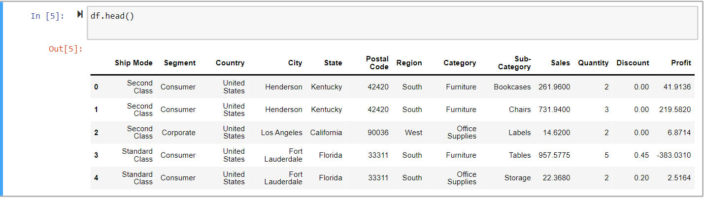

Data Cleaning:

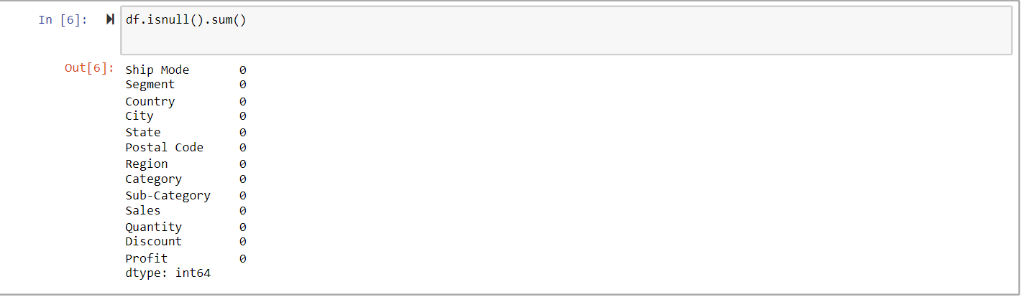

Checking information of dataset:

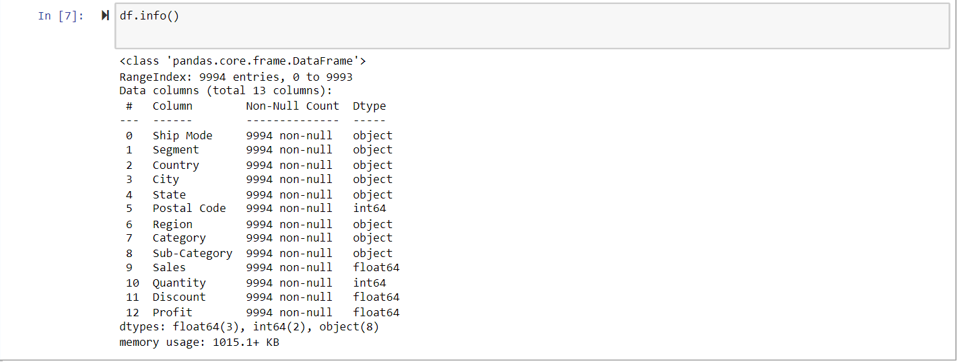

Descriptive statistics of dataset:

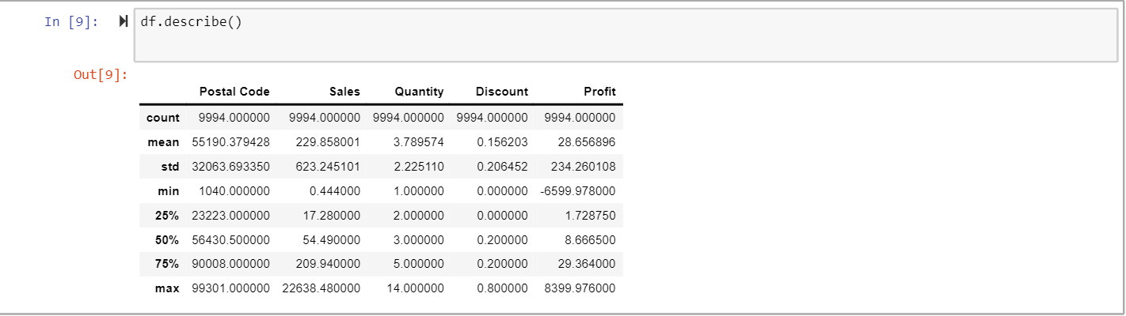

Duplicate Values:

Exploratory Data Analysis:

Which is the most popular product category used by customers?

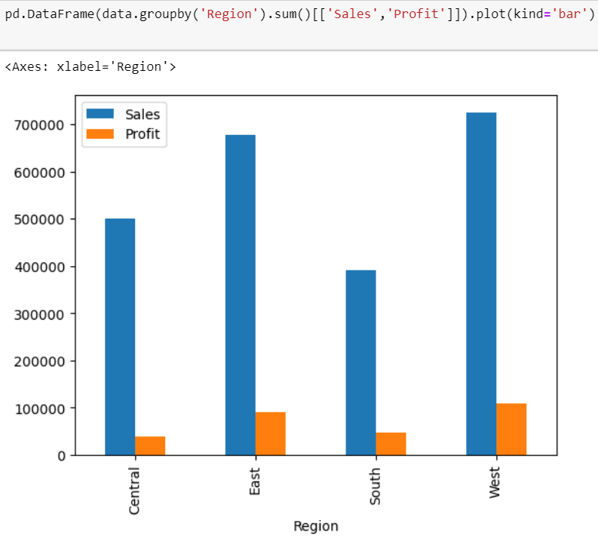

Both Western and Eastern regions exhibit superior sales and profit performance compared to the Southern and Central regions.
Central region has higher sales than the Southern region but it has shown lower profit gains between the two of them.

Analyzing the sales with profit using Scatter Plot

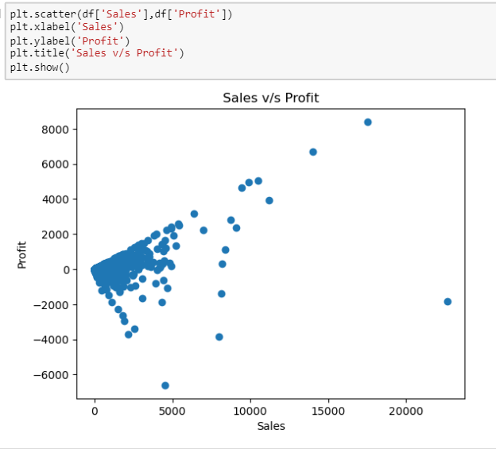

When sales are low, a business either gets profit or loss. But, when the sales are high, a business mostly gets profit.

Correlation Check:

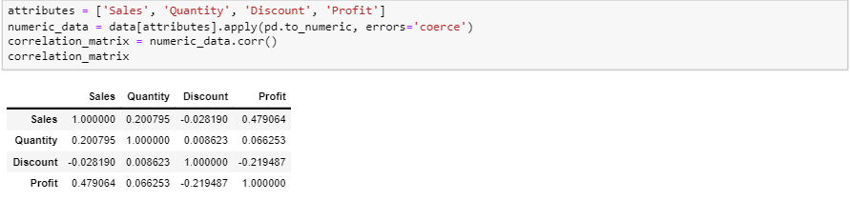

Correlation Matrix:

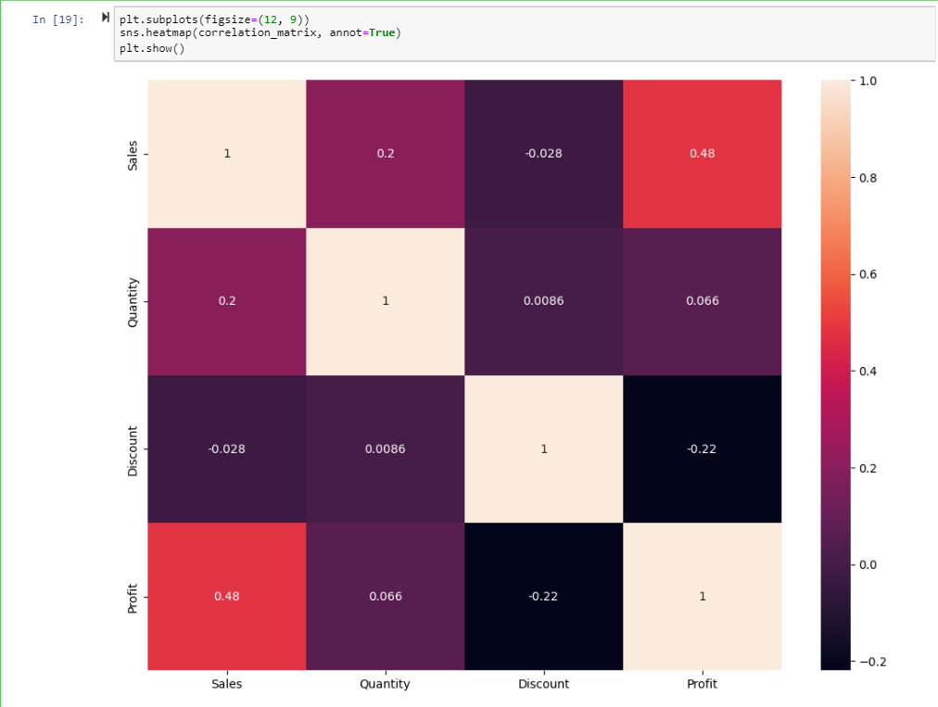

State having highest number of Sales:

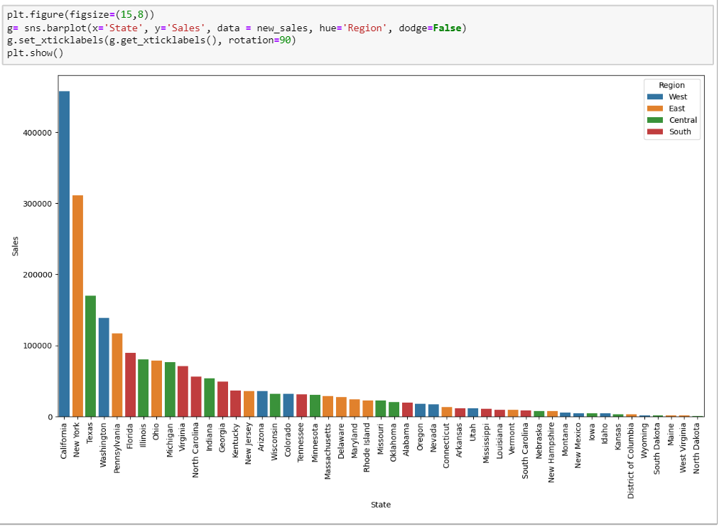

- The company has highest sales in the state of California which is around 450k.
- New York is the state that constitutes the second highest sales for the company of around 300k

TRAINING AND TESTING:
Data Splitting:
Splitting the dataset into training and testing sets. The training test is used to train the model and the testing set is used to evaluate the performance.

Splitting into 80 and 20 ratio

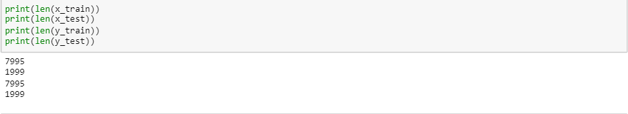

IX. MODELS
ARIMA:
Building an ARIMA model using the auto_arima function in Python.
Important parameters in ARIMA model are
Time-series Data:
The actual time series data that you want to model and forecast.
start_p:
This parameter represents the starting value for the order of the auto-regressive (AR) model (p). It must be a positive integer.
start_q:
This parameter represents the starting value for the order of the moving-average (MA) model (q). It must be a positive integer.
d:
The order of differencing. This parameter determines how many times the data needs to be differenced to achieve stationarity. If set to None, it is automatically selected based on the results of the Augmented Dickey-Fuller (ADF) test.
test:
The type of unit root test used to detect stationarity if stationary is False and d is None. In this case, the Augmented Dickey-Fuller (ADF) test is used.
Filling null values with average values:
By using the SimpleImputer class from scikit-learn to impute missing values in your training data (x_train). The strategy='mean' parameter indicates that you want to replace missing values with the mean of the non-missing values for each feature.
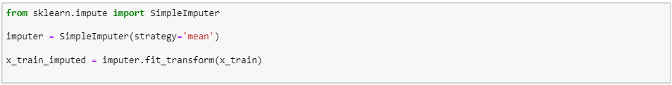
The first step is to import the pmdarima library that contains the auto_arima function.
The second step is to define a function that takes in the time series array and returns the auto-arima model.
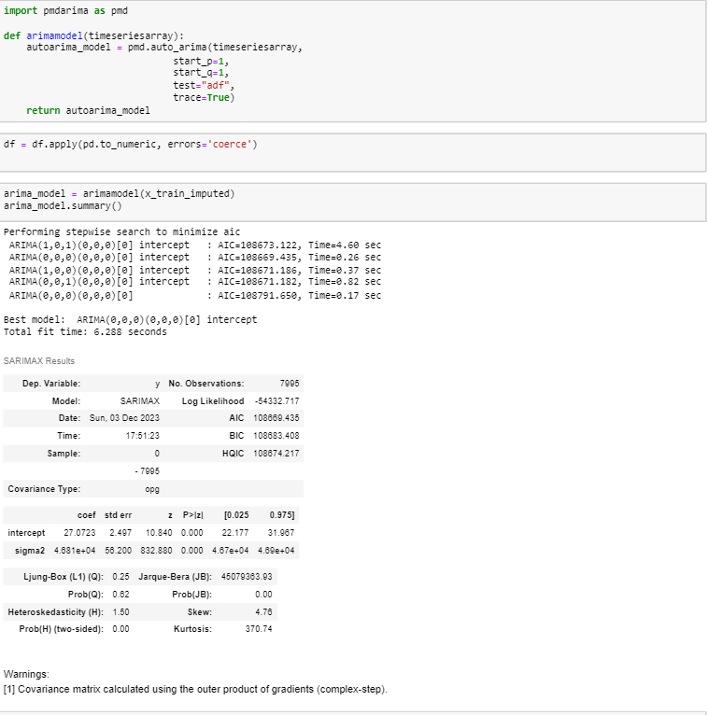
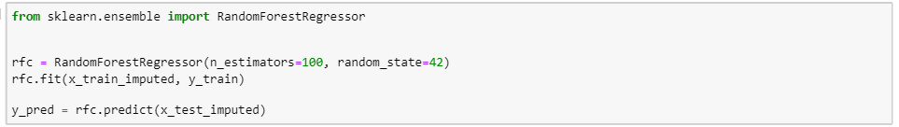

Arima (0,0,0)(0,0,0) intercept is the best fit.
Random Forest:
Random Forest Regression is a powerful machine learning algorithm used for both classification and regression tasks.
In the context of supermarket sales analysis, you can use a Random Forest Regression model to predict sales based on various features.
Making predictions:
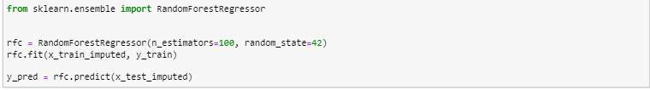
Interpreting model using MSE And R2
The Mean Squared Error (MSE) measures the average squared difference between the actual and predicted values. R-squared (R2) provides a measure of how well the predicted values match the actual values, with a higher R-squared indicating a better fit.
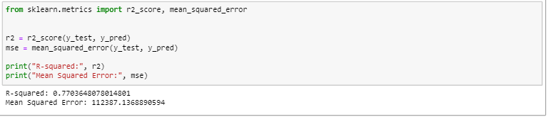
An R-squared of 0.77 suggests that approximately 77% of the variability in sales can be explained by the independent variables included in your model. In other words, your model accounts for a significant portion of the variance in the sales data.
Decision Regressor:
In the context of supermarket sales analysis, it can be employed to predict sales based on various features such as time, promotions, discounts, or other relevant factors.
Creating a decision tree regressor and fitting model to the dataset.
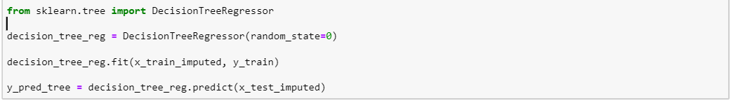
Comparing predicted values with actual values:
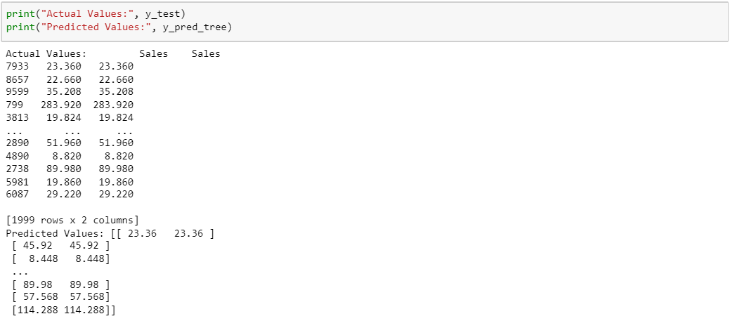
Interpreting model using MSE And R2:
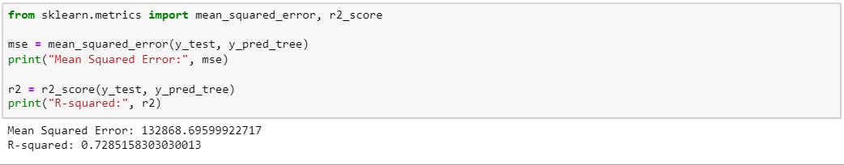
The R-squared value of 0.73 suggests that the model explains 73% of the variance in supermarket sales. This is a relatively good fit, but the interpretation should consider the specific context of your analysis.
These result based on the specifics of your supermarket sales analysis, considering factors like the business objectives, the nature of the data, and potential insights gained from the model.
X.CONCLUSIONS
The models Random Forest and Decision Regressor, based on the provided features, explains a significant portion of the variance in supermarket sales.
The Mean Squared Error, while not exceptionally low, is reasonable, indicating decent predictive performance.
The R-squared value suggests that the model is fairly effective in explaining and predicting variations in sales.

XI.CONTRIBUTION&TASKS
- 11714665- Nitin Reddy Dhamana -He has completed description part of Introduction and Goals and objectives along with data set cleaning
Percentage- 20%
- 11651255- Yashwanth Chowdary Venigalla - He has completed description about dataset and various analysis used in the python for the dataset
Percentage- 20%
- 11704960- Yashwanth Kirla- He installed Jupiter notebook and read excel files and made some analysis using various plots, and also prepared visual and return content for presentations and publications.
Percentage- 20%
- 11702995- Sai Praneeth Kankanala - He performed analysis of reasearch questions and provided screenshots of that and ipynb file.
Percentage- 20%
- 11717379- Nissi Sharon Pidathala- She provided the project’s methodology, findings and results and created detailed and understandable reports.
Percentage- 20%

XII.REFERENCES
- Suresh Kumar Mukhiya, ‎Usman Ahmed, Hands on Exploratory data analysis with Python(2020)
- Meni Koslowsky, Univariate and Multivariate Analysis of Categorical Variables, (1979), Springer
- Shaun McQuitty, The Purposes of Multivariate Data Analysis Methods: an Applied Commentary (13 Sep 2017), Journal of African Business
- Chris Chatfield, Exploratory data analysis,(Jan 1986), European Journal of Operational Research,Volume 23, Issue 1

