Title1
The quick brown fox
 | EXAMPLE OF TABLE
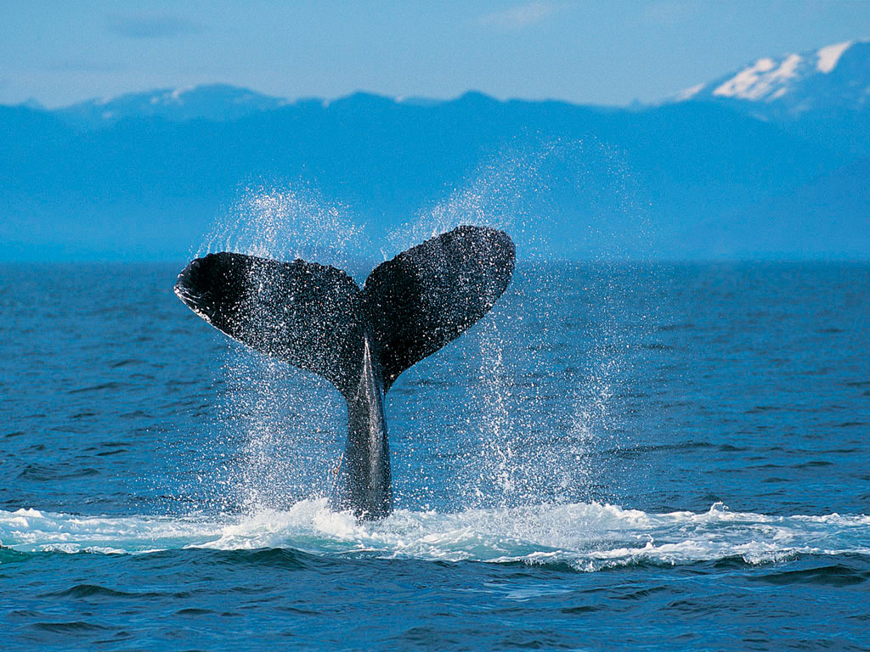 |  | only text

