PROJECT REPORT
SHIFTY: YOUR ROOM SHIFTING SOLUTION
AN AI-POWERED PERSONAL RELOCATION PLATFORM
Submitted in partial fulfilment of the requirement for the award of the degree of
BACHELOR OF TECHNOLOGY
IN
COMPUTER SCIENCE & ENGINEERING
Submitted by
NAMES
UNIVERSITY ROLL NO.
Animesh Rawat
2218355
Mubasherah Anwar
2219113
Tushar Goel
2219833
Vishal Parjapati
2219937
Under the guidance of
Mr. Deepak Upadhayay
Assistant Professor
Project Group No: 307
Department of Computer Science and Engineering
Graphic Era Hill University
May, 2026
CANDIDATE’S DECLARATION
We hereby certify that the work which is being presented in the project report entitled
“SHIFTY:
Your
Room
Shifting
Solution
–
An
AI-Powered
Personal
Relocation
Platform” in partial fulfilment of the requirements for the award of the Degree of Bachelor of
Technology in Computer Science and Engineering in the Department of Computer Science
and Engineering of the Graphic Era Hill University, Dehradun, shall be carried out by the
undersigned
under
the
supervision
of
Mr.
Deepak
Upadhayay,
Assistant
Professor,
Department of Computer Science and Engineering, Graphic Era Hill University, Dehradun.
Animesh Rawat (2218355)
Mubasherah Anwar (2219113)
Tushar Goel (2219833)
Vishal Parjapati (2219937)
This project has been developed under the guidance and supervision of the undersigned
faculty guide on the topic “SHIFTY: Your Room Shifting Solution”.
Guide:
Head of the Department
Mr. Deepak Upadhayay
Date
Place
ACKNOWLEDGEMENT
We would like to express our sincere gratitude to our project guide Mr. Deepak Upadhayay,
Assistant Professor, Department of Computer Science & Engineering, for his invaluable
guidance, continuous support, and encouragement throughout the development of this project
“SHIFTY: Your Room Shifting Solution.” We are also deeply thankful to the Department of
Computer Science & Engineering, Graphic Era Hill University, Dehradun, for providing us
with
the
necessary
infrastructure,
resources,
and
academic
environment
required
to
successfully complete this work.
Our heartfelt thanks go to our family and friends for their constant motivation, support, and
encouragement throughout the project journey.
Animesh Rawat
Mubasherah Anwar
Roll no. 2218355
Roll no. 2219113
Tushar Goel
Vishal Parjapati
Roll no. 2219833
Roll no. 2219937
ABSTRACT
The
logistics
of
residential
relocation,
even
for
small-scale
moves,
are
fraught
with
inefficiencies, opaque pricing structures, and a lack of personalised customer service. The
process is often manual, time-consuming, and stressful for the user. This project, titled
SHIFTY,
presents
a
comprehensive
mobile
application
designed
to
streamline
and
revolutionise the room-shifting experience by leveraging the power of Machine Learning
(ML) and Artificial Intelligence (AI).
The core of SHIFTY is a data-driven approach to logistics. The application begins by
systematically collecting user inventory data, allowing users to catalogue their belongings and
specify items that require special handling such as delicate or heavy objects. This data serves
as the input for a suite of intelligent modules. An ML-based recommendation engine analyses
the inventory size, item types, and fragility to suggest an optimised service package including
appropriate vehicle size, required manpower, and necessary packing materials. Concurrently,
a
dynamic
pricing
and
offer
system,
also
powered
by
an
ML
algorithm,
calculates
a
transparent, fair, and real-time quote based on variables such as distance, inventory volume,
item fragility, time of booking, and local demand.
To enhance user experience and provide round-the-clock support, an integrated AI chatbot
assists users with navigation, answers queries, and facilitates the booking process. The
frontend interface offers real-time system insights, including booking status, live tracking of
consignments, and notification of delivery milestones. Authentication and access control
mechanisms are implemented to restrict unauthorised access to sensitive user data.
This report provides a holistic overview of the project lifecycle, from initial ideation and
requirement analysis to system architecture, detailed implementation of the core ML models,
deployment strategies, and evaluation. It documents the design and development of the
platform, showcasing how AI-driven features create a seamless, efficient, and trustworthy
solution for the modern urban mover.
TABLE OF CONTENTS
Chapter
Section
Title
Page
No.
ACKNOWLEDGEMENT
i
ABSTRACT
ii
TABLE OF CONTENTS
iii
LIST OF TABLES
v
LIST OF FIGURES
vi
ABBREVIATIONS
vii
NOTATIONS
viii
1
Introduction
1
1.1
Background and Motivation
1
1.2
Problem Statement
2
1.3
Objectives of the Project
3
1.4
Organization of the Report
4
2
Literature Review
5
2.1
Traditional Packers and Movers Systems
5
2.2
Web and Mobile-Based Booking Platforms
6
2.3
Machine Learning in Logistics
6
2.4
Dynamic Pricing in Service Platforms
8
2.5
Real-Time Tracking and Location Systems
8
2.6
Conversational AI for Service Booking
9
Chapter
Section
Title
Page
No.
Comparative Study of Moving Service
2.7
9
Approaches
2.8
Conclusion of Literature Review
10
3
System Requirements and Analysis
11
3.1
Overview
11
3.2
Purpose
11
3.3
Hardware Requirements
11
3.4
Software Requirements
12
3.5
Functional Requirements
13
3.6
Non-Functional Requirements
14
3.7
Feasibility Study
15
3.8
System Analysis Summary
16
4
System Design and Architecture
17
4.1
Overview
17
4.2
System Architecture
17
4.3
Components and Modules
18
4.4
System Design Workflow
19
4.5
Flow Diagram
19
4.6
Design Considerations
20
4.7
Database Schema Design
21
4.8
Workflow of Shifty System
22
Chapter
Section
Title
Page
No.
5
Implementation
23
5.1
Overview
23
5.2
Software Stack
23
5.3
System Implementation
24
5.4
Algorithm Implementation
25
5.5
System Flow Control
26
5.6
Performance and Optimization
26
5.7
Testing and Validation
27
5.8
Software Setup and Code Integration
28
Real-Time System Monitoring and Dashboard
5.9
28
Output
6
Conclusion and Future Scope
30
6.1
Conclusion
30
6.2
Future Enhancements
31
APPENDIX
33
REFERENCES
61
LIST OF TABLES
Table No.
Title
Table 1
Comparison of Traditional vs. AI-based Moving Platforms
Table 2
Functional Requirements of SHIFTY System
Table 3
Non-Functional Requirements of SHIFTY System
Table 4
Module-wise Implementation Status
Table 5
Testing and Validation Summary
LIST OF FIGURES
Figure No.
Title
Pain-point
Fishbone
Diagram
of
Traditional
Relocation
Figure 1
Experience
Figure 2
SHIFTY Target Audience and Their Needs
Figure 3
High-level System Architecture of SHIFTY
Figure 4
Entity-Relationship Diagram of the SHIFTY Database
Figure 5
UML Use-case Diagram of SHIFTY Platform
Figure 6
Data Flow of the AI-Powered Package Recommender
Figure 7
Dynamic Pricing Pipeline using XGBoost
Figure 8
Conversational Assistant Interaction Flow
Figure 9
Live Tracking Socket Architecture
Figure 10
Payment Subsystem Sequence Diagram
Figure 11
Module-wise Completion Progress Chart
Figure 12
Landing Page of the Shifty Web Prototype
Figure 13
Booking Planner Capturing Itinerary and Inventory
Figure 14
Price Prediction Screen Showing Model-Generated Quote
Figure 15
Payment Review Screen Prior to Gateway Hand-off
Figure 16
Sign-in Screen for Secure Access in Shifty System
Figure 17
Account Creation Screen with Inline Validation
ABBREVIATIONS
Abbreviation
Full Form
AI
Artificial Intelligence
ML
Machine Learning
NLP
Natural Language Processing
API
Application Programming Interface
REST
Representational State Transfer
UI
User Interface
UX
User Experience
SPA
Single Page Application
JWT
JSON Web Token
JSON
JavaScript Object Notation
HTTP
Hyper Text Transfer Protocol
HTTPS
Hyper Text Transfer Protocol Secure
DB
Database
SQL
Structured Query Language
NoSQL
Not Only SQL
CRUD
Create, Read, Update, Delete
GPS
Global Positioning System
RF
Random Forest
Abbreviation
Full Form
XGB
Extreme Gradient Boosting
MAE
Mean Absolute Error
SDK
Software Development Kit
OS
Operating System
CI/CD
Continuous Integration / Continuous Deployment
CLI
Command Line Interface
IDE
Integrated Development Environment
NOTATIONS
Symbol
Description
D
Source-to-destination distance in kilometres
km
V
Total inventory volume
inv
N
Count of fragile items in the inventory
frag
P
Final predicted price for a booking
final
P
Recommended service package (Basic | Standard | Premium)
pack
T
Scheduled move date and time
move
α
Demand-surge multiplier
β
Fragility penalty weight
λ
Regularisation coefficient of the XGBoost model
Q
Natural-language query from the customer
user
R
Response generated by the AI chatbot
bot
CHAPTER 1
INTRODUCTION
Urban India is in the middle of one of the most sustained migrations of its young
population in recent history. University students, early-career professionals and newly married
couples move between rented accommodations multiple times every year for education,
internships, jobs and lifestyle changes. The residential relocation industry that serves this
demand, however, remains largely unorganised, paper driven and opaque. Customers continue
to experience arbitrary pricing, ambiguous inventory estimation, poor communication and an
almost complete absence of real-time visibility into their consignment.
The Shifty project has been conceived as a direct response to these pain points. It is an AI-
powered, end-to-end room-shifting platform targeted initially at the student community of
Graphic Era Hill University and the surrounding neighbourhoods of Clement Town and
Rajpur Road in Dehradun. By combining an intelligent service-package recommender, a
dynamic pricing engine, live consignment tracking, secure payments and a conversational
support
assistant,
Shifty
aims
to
transform
relocation
into
a
one-tap,
transparent
and
trustworthy service.
1.1 Background and Motivation
Relocation is a deeply logistical activity that also carries significant emotional weight.
Customers entrust movers with fragile possessions, study material, electronics and personal
belongings that often have sentimental value well beyond their market price. Despite this, the
traditional packers and movers industry continues to operate on the basis of phone calls,
manual site visits and informal negotiation. Quotes vary widely between vendors for the same
move, there is no standardised method of capturing the inventory being moved, and once the
truck leaves the pickup point the customer is left with no reliable way of knowing where their
goods are.
The proliferation of smartphones, high-speed mobile internet and cloud computing over the
last decade has created an opportunity to rebuild this industry around data. Companies such as
Urban Company, NoBroker and JustDial have taken the first steps by moving discovery
online, but the actual booking, pricing and tracking workflows remain largely unchanged. The
motivation behind Shifty is to close this gap with a fully digital, data-driven experience
purpose built for small-scale, intra-city moves.
Advances in Machine Learning (ML) and Artificial Intelligence (AI) make this feasible
today. Classification models can turn an itemised inventory into an optimised service-package
recommendation. Regression models can convert distance, fragility, time of booking and
demand into a fair, real-time price quote. Natural Language Processing (NLP) can provide a
twenty four hour support surface that handles tracking, cancellation and frequently asked
questions without escalating every query to a human agent. Shifty weaves all of these
capabilities into a single, student-first mobile and web application.
1.2 Problem Statement
The problem that Shifty addresses can be described by five concrete limitations of the
existing packers-and-movers ecosystem.
Estimation ambiguity. Customers struggle to predict the volume and weight of their
belongings. This leads to wrong vehicle allocation, last-minute crises and inflated final
bills.
Opaque and inconsistent pricing. Quotes differ across vendors for the same route, and
the final bill often includes undisclosed charges for packing material, stair-carry labour
or waiting time.
Risk of damage to goods. There is no standardised mechanism to flag fragile or
valuable items, and the claims process is complicated and manual.
Lack
of
real-time
tracking.
Once
the
consignment
leaves
the
pickup
location,
customers typically have no reliable way to know where their goods are or when they
will arrive.
Inefficient
customer
support.
Traditional
vendors
provide
limited
post-booking
assistance, requiring multiple phone calls for basic updates or complaint resolution.
The core question addressed by this project is therefore:
How can an AI-powered, student-first relocation platform be designed so that pricing is
transparent, bookings are one-tap, movements are tracked in real time and support is
available around the clock without a proportional increase in human operational cost?
1.3 Objectives of the Project
The objectives of Shifty are measurable and aligned with the gaps identified above.
Design a cross-platform application (web and mobile) that allows a student to plan,
book and pay for a move in under five minutes.
Build
an
ML-based
service-package
recommender
that
ingests
inventory
size,
fragility and distance to suggest an optimal Basic, Standard or Premium package.
Deploy a dynamic pricing engine using gradient boosted regression that accounts for
distance, volume, time of booking and local demand.
Integrate real-time tracking through a Socket.io based channel that relays the mover’s
GPS position to the customer on a live map.
Provide a conversational assistant capable of answering routine queries, looking up
booking status and triggering cancellation flows.
Implement secure authentication and payments with bcrypt-hashed credentials, JWT-
based sessions and signed gateway webhooks.
1.4 Organization of the Report
The remainder of this report is organised as follows. Chapter 2 reviews existing literature
on moving-service platforms, machine learning applications in logistics, dynamic pricing and
conversational AI.
Chapter
3
documents
the
functional,
non-functional,
hardware
and
software requirements of the Shifty system, along with a feasibility study. Chapter 4 presents
the architecture and design of the system, covering component diagrams, workflow diagrams
and database schemas. Chapter 5 describes the implementation, including the software stack,
algorithm
implementation,
performance
optimisations,
testing
and
the
dashboard
output
captured from the running system. Chapter 6 concludes the report and outlines future
enhancements. The appendix contains representative source code listings and additional
snapshots from the running prototype.
CHAPTER 2
LITERATURE REVIEW
The domain of on-demand logistics and residential relocation has attracted substantial
academic and industry attention in the last decade. This chapter reviews existing approaches,
identifies gaps, and situates Shifty within the broader landscape of ML-assisted service
platforms.
2.1 Traditional Packers and Movers Systems
Traditional moving services operate predominantly through offline channels. A customer
typically makes a phone enquiry, receives a site-visit from a surveyor who estimates the
volume by visual inspection, and is then quoted a price that reflects both the surveyor’s
subjective judgement and the vendor’s current capacity. Kumar and Sharma (2018) observed
that this approach produces pricing variance of up to 40% across vendors for the same route,
directly correlating with low customer trust.
Advantages of the traditional model include direct human negotiation and flexibility for
one-off requirements. Its limitations, however, are considerable. There is no standardised data
trail, estimation depends on individual expertise, and customers have no technical means to
verify that the price they are paying is fair. The absence of a digital booking record also makes
post-move dispute resolution difficult.
2.2 Web and Mobile-Based Booking Platforms
Over the past decade, aggregator platforms such as Urban Company, NoBroker, JustDial
and Sulekha have introduced digital discovery and lead generation for moving services. These
platforms allow customers to browse vendors, read reviews and submit a requirement through
a form. The actual quoting and booking, however, continues to happen offline through the
vendor.
Mozumder et al. (2024) analysed twelve such platforms and noted that while digital
discovery
improves
visibility,
the
fundamental
pricing
and
logistical
workflows
remain
unchanged. Quotes are still manual, tracking is absent, and the platforms have limited
incentive to invest in post-booking support because their business model is based on lead
generation rather than transaction completion.
A second class of platforms consists of individual mover websites built on standard content
management systems. These sites act as digital storefronts for a single vendor but add little
intelligence; they largely replicate the offline process in a browser.
2.3 Machine Learning in Logistics
Machine Learning has been widely adopted across the logistics and supply chain industry.
The
three
applications
most
relevant
to
Shifty
are
classification
for
service
recommendation, regression for dynamic pricing and natural language processing for
conversational support.
2.3.1 Classification for Service Recommendation
Recommending an appropriate service tier for a customer is a multi-class classification
problem with features drawn from inventory size, fragility ratio, distance and calendar
attributes.
Random Forest Classifier (Breiman, 2001) constructs an ensemble of decision trees
and averages their predictions. It is robust to overfitting on tabular datasets, offers
interpretable feature-importance scores, and handles mixed numerical and categorical
inputs gracefully.
Gradient Boosting Machines such as LightGBM and XGBoost build trees sequentially
to correct previous errors. They typically achieve higher accuracy than Random Forest
but are more complex to train and interpret.
For Shifty, the Random Forest classifier was chosen because of its balance between
predictive
accuracy,
interpretability
and
ease
of
deployment. The
feature
importance
it
exposes is particularly useful for explaining to a student why a particular package was
recommended.
2.3.2 Regression for Dynamic Pricing
Predicting the final price of a move is a regression problem that must capture non-linear
interactions between distance, volume, fragility, demand and time of day.
Multiple Linear Regression (MLR) establishes a linear relationship between features
and price. It is simple and interpretable but struggles with non-linear interactions.
XGBoost Regressor (Chen and Guestrin, 2016) is an advanced implementation of
gradient boosting optimised for both speed and accuracy. It handles feature interactions
effectively and has become the de facto standard for structured-data regression tasks in
industry.
Shifty employs XGBoost for price prediction because it captures real-world complexities
such as peak-time surcharges, seasonal demand and item-specific handling costs. The model
is trained offline on historical bookings and served through a Flask microservice for low-
latency inference.
2.3.3 Natural Language Processing for Chatbots
The chatbot component of Shifty relies on three NLP primitives. Intent recognition
determines what the user wants (“track order”, “get quote”, “reschedule move”). Entity
extraction identifies parameters such as booking identifiers, dates and locations. Dialogue
management keeps the conversation coherent across multiple turns.
Bocklisch et al. (2017) introduced Rasa, an open-source framework that combines these
primitives into a production-ready NLU and dialogue stack. Rasa was selected for Shifty
because it runs on-premises, avoids per-query cloud costs and gives the project full control
over training data and conversation design.
2.4 Dynamic Pricing in Service Platforms
Dynamic pricing has been studied extensively in the context of ride-hailing and e-
commerce. Kumar and Sharma (2021) survey pricing strategies across on-demand service
platforms and identify three key factors: demand intensity, supply scarcity and customer price
sensitivity. Their findings show that platforms with transparent, explainable pricing tend to
achieve
higher
customer
retention
than
those
with
opaque
surge
multipliers,
because
explainability reduces the perceived unfairness of price increases.
Shifty adopts this insight by exposing the breakdown of its price prediction on every quote.
Distance cost, volume cost, demand multiplier and fragility surcharge are each shown as a
separate line item, so the customer can see exactly why a particular price was produced.
2.5 Real-Time Tracking and Location Systems
Live tracking of in-transit consignments has been an area of active research since the wide
availability
of
consumer-grade
GPS.
Modern
solutions
rely
on
WebSocket-based
push
channels to avoid the polling overhead of HTTP. Socket.io, originally introduced by the
Node.js community, provides automatic fallback, reconnection and room-based multiplexing;
it is used in production at companies such as Microsoft, Zendesk and Trello.
Shifty uses Socket.io to publish GPS pings from the mover’s mobile application to the
server, which then fans them out to the subscribed customer. Rooms are keyed by booking
identifier, so a customer sees only their own move, and the JWT-authenticated handshake
prevents unauthorised subscription.
2.6 Conversational AI for Service Booking
Singh and Verma (2022) studied the adoption of AI-driven chatbots in the Indian logistics
sector and reported that customers prefer conversational interfaces for low-complexity tasks
such as tracking, rescheduling and FAQ lookup, while still expecting human agents to handle
escalations. The study also found that users value accurate context retention (remembering
what was asked earlier in the conversation) more than broad topic coverage.
Shifty’s assistant is scoped accordingly: it handles quote estimation, booking status,
cancellation and a library of FAQs. Anything beyond that scope is escalated to a human agent,
with the full conversation transcript attached for context.
2.7 Comparative Study of Moving Service Approaches
Table 1 summarises the comparative strengths and weaknesses of traditional, aggregator
and fully-digital AI-driven platforms against the criteria that matter most to students.
Capability
Traditional vendor
Aggregator
Shifty (AI-driven)
platform
Digital booking
No
Partial (lead form)
Yes
Transparent pricing
No
Limited
Yes (itemised)
ML-based
No
No
Yes (RF classifier)
recommendation
Dynamic price quote
No
Manual
Yes (XGBoost)
Real-time tracking
No
No
Yes (Socket.io)
Always-on support
Phone only
Business hours
Yes (Rasa chatbot)
Secure payments
Cash / UPI
Gateway
Gateway + webhook
verify
Table 1: Comparison of Traditional vs. AI-based Moving Platforms
2.8 Conclusion of Literature Review
The literature shows that the traditional packers-and-movers industry has been only
partially digitised. Aggregator platforms added a discovery layer but left pricing, estimation,
tracking and support largely unchanged. Meanwhile, machine learning techniques such as
Random Forest classification, XGBoost regression and Rasa-style conversational AI have
matured to the point where they can be deployed reliably on modest infrastructure. Shifty is
designed to combine these techniques into a single, student-centric platform that addresses all
of the gaps identified in sections 2.1 and 2.2.
CHAPTER 3
SYSTEM REQUIREMENTS AND ANALYSIS
This chapter defines the complete set of requirements for the Shifty platform. It covers the
intended purpose, the hardware and software environment on which the system runs, the
functional capabilities it must expose, the non-functional attributes it must guarantee, and a
feasibility study that establishes the viability of the project within the constraints of a final-
year undergraduate engagement.
3.1 Overview
Shifty is a multi-tier application with a React Native mobile front-end, a web companion, a
Node.js API gateway, a MongoDB datastore, a Python machine-learning microservice and a
Rasa conversational back-end. The system is designed to run in a containerised deployment
on modest cloud infrastructure and to degrade gracefully on low-bandwidth student networks.
3.2 Purpose
The purpose of the Shifty system is to enable students, young professionals and small
families in intra-city relocation scenarios to plan, book, track and pay for a move through a
single digital interface. The platform must replace manual telephonic quotations with data-
driven estimates, replace paper-based inventory notes with structured digital records, and
replace offline tracking with live GPS streams.
3.3 Hardware Requirements
Table 2 lists the minimum and recommended hardware for the three deployment contexts
of the system: end-user device, development workstation and cloud backend.
Component
Minimum
Recommended
End-user mobile
Android 9 / iOS 13, 2 GB RAM,
Android 12 / iOS 15, 4 GB RAM,
device
3G
4G/5G
Developer
Dual-core CPU, 8 GB RAM, 256
Quad-core CPU, 16 GB RAM, 512
workstation
GB SSD
GB SSD
Backend instance
2 vCPU, 4 GB RAM
4 vCPU, 8 GB RAM
(API)
Component
Minimum
Recommended
Backend instance
2 vCPU, 4 GB RAM
4 vCPU, 8 GB RAM, optional GPU
(ML)
Database host
2 vCPU, 4 GB RAM, 50 GB disk
4 vCPU, 8 GB RAM, 200 GB SSD
Table 2: Hardware Requirements
3.4 Software Requirements
Table 3 captures the software stack across development, build and production runtimes.
Layer
Technology
Version
Mobile front-end
React Native (Expo)
0.74+
Web front-end
Next.js + React
16.x / 19.x
Styling
Tailwind CSS
4.x
API gateway
Node.js + Express
Node 20 LTS
Real-time layer
Socket.io
4.x
Database
MongoDB
6.x (Atlas or self-hosted)
ML service
Python + Flask
Python 3.11
ML libraries
scikit-learn, XGBoost
1.4 / 2.0
Conversational AI
Rasa Open Source
3.6+
Authentication
JWT + bcrypt
jsonwebtoken 9, bcryptjs 2
Payments
Razorpay SDK
Latest stable
Containerisation
Docker + Docker Compose
24+
CI/CD
GitHub Actions
—
Table 3: Software Requirements
3.5 Functional Requirements
The functional requirements define what the Shifty system must do. They are grouped by
module.
3.5.1 User Module
Allow users to register using email, phone or third-party providers (Google / Apple).
Passwords are hashed using bcrypt before persistence.
Support role-based access with three roles: customer, mover and admin.
Allow users to edit profile details, manage saved addresses and view their booking
history.
3.5.2 Booking Module
Allow a logged-in customer to create a new booking by specifying source, destination,
move date, inventory and preferred package.
Recommend a service package automatically using the trained Random Forest model
and allow the user to override it.
Generate a dynamic final price using the XGBoost regressor and show an itemised
breakdown (distance, volume, demand, fragility).
Persist the booking record in MongoDB with a status transition model: PENDING →
CONFIRMED → IN_TRANSIT → COMPLETED or CANCELLED.
3.5.3 Tracking Module
Publish
the
mover’s
GPS
location
every
five
seconds
over
a
JWT-authenticated
Socket.io channel.
Allow the customer to subscribe to the live feed of their own booking.
Expose
server-side
events
for
key
milestones:
PICKUP_DONE,
IN_TRANSIT,
ARRIVED, DELIVERED.
3.5.4 Chatbot Module
Handle quote estimation, booking status lookup and cancellation through Rasa custom
actions.
Maintain conversational context across multiple user turns.
Escalate to a human agent when confidence drops below a configured threshold.
3.5.5 Payment Module
Create Razorpay orders with booking metadata attached.
Verify the HMAC-SHA256 signature returned by the gateway before marking the
booking as paid.
Reconcile asynchronous state transitions through a webhook endpoint.
3.6 Non-Functional Requirements
The
non-functional
requirements
define
how
the
Shifty
system
should
behave
in
production.
Performance. Ninety-fifth percentile API latency must stay below 350 ms for quote-
related calls and below 800 ms for ML-backed calls under a load of 100 concurrent
users.
Availability. The platform must sustain 99.5% availability calculated monthly, measured
against booking-path endpoints.
Security. All data in transit must use TLS 1.2 or higher. Passwords must be stored using
bcrypt with a cost factor of 10 or more. JWT tokens must expire within seven days and
be revocable.
Scalability. The architecture must support horizontal scaling of the API and ML tiers
independently of each other.
Usability. A new student user must be able to complete a booking in under five minutes
without external assistance. The interface must support a minimum readable font size of
14 px and meet WCAG 2.1 AA contrast ratios.
Maintainability. All major modules must have at least 70% unit-test coverage and an
automated continuous integration pipeline.
Observability. Structured logs, latency metrics and error rates must be emitted for each
endpoint and visible on a shared dashboard.
3.7 Feasibility Study
3.7.1 Technical Feasibility
All components of Shifty are based on mature, open-source technologies with substantial
community adoption. React Native, Node.js, MongoDB, Python, scikit-learn, XGBoost and
Rasa are all widely used in production systems. The team has working familiarity with each of
these through coursework and self-study. No exotic hardware is required, and the cloud
footprint fits within the free or low-cost tiers of AWS, GCP and Render.
3.7.2 Economic Feasibility
The development phase uses only free tiers and trial credits. A cloud deployment capable
of serving the initial Clement Town user base costs under Rs. 3,000 per month, well within
the budget of an undergraduate project. No external paid dataset is required because the ML
models are trained on synthetic bookings calibrated against publicly available logistics
benchmarks.
3.7.3 Operational Feasibility
The target audience — Graphic Era Hill University students — is both technologically
literate and highly motivated by the convenience the product offers. Operationally, the
platform requires an onboarded pool of verified movers; conversations with three local
vendors indicate willingness to participate as launch partners for a pilot.
3.7.4 Legal and Regulatory Feasibility
The platform processes personal data such as phone numbers and addresses, and must
therefore comply with the Digital Personal Data Protection Act of India (2023). Consent is
captured at sign-up, data is encrypted in transit, and users have the right to request deletion.
Payments flow entirely through a PCI-DSS compliant gateway (Razorpay), so no card data
touches the Shifty backend.
3.8 System Analysis Summary
The requirements analysis establishes that Shifty is technically, economically, operationally
and legally feasible as a final-year undergraduate project. The hardware envelope is modest,
the software stack is mature and open, and the functional requirements can be delivered
within
the
academic
timeline.
Non-functional
goals
around
performance,
security
and
usability are aggressive but attainable with the chosen architecture, which is detailed in the
next chapter.
CHAPTER 4
SYSTEM DESIGN AND ARCHITECTURE
This
chapter
presents
the
system-level
design
of
Shifty.
It
describes
the
high-level
architecture, the individual components, the interactions between them, the database schema
and the considerations that shaped the design.
4.1 Overview
Shifty is designed as a set of loosely coupled microservices that communicate over REST
and
WebSocket.
The
separation
was
chosen
because
it
allows
the
ML
tier
to
scale
independently of the API tier, keeps the attack surface of each service small and makes the
system easier to reason about during development and review.
4.2 System Architecture
Figure 3 (page vi of the front matter) summarises the high-level architecture. At the top of
the stack are the end-user surfaces: a React Native mobile application and a Next.js web
companion. Both communicate with a Node.js API gateway that enforces authentication,
authorisation and rate limiting. The gateway persists domain data to MongoDB and delegates
pricing and recommendation calls to a Python Flask microservice that hosts the trained ML
models.
A
Rasa-based
conversational
service
handles
natural
language
queries,
and
a
Socket.io server exposes the real-time tracking channel. Payments are processed by Razorpay,
with the gateway verifying signatures before confirming a booking.
[ Mobile App / Web ]
| REST / WebSocket
v
+------------------+ +------------------+
| Node.js API |<----->| MongoDB |
| (Express, JWT) | | (bookings, |
| | | users, txns) |
+------------------+ +------------------+
| | ^
| | |
| | +--------- Socket.io (tracking)
| |
| +---> [ Rasa NLU + Actions ]
|
+-------> [ Python Flask ML Service ]
|
+--> RF Classifier (package)
+--> XGBoost Regressor (price)
|
+--> Razorpay Gateway (HTTPS)
Figure 3: High-level System Architecture of Shifty
4.3 Components and Modules
4.3.1 Mobile and Web Front-ends
The mobile front-end is built with React Native using Expo for development ergonomics.
Screens
are
organised
around
a
navigation
stack:
LoginScreen,
HomeScreen,
AddressMapScreen, InventoryScreen, QuoteScreen, TrackingScreen and ProfileScreen. The
web companion is a Next.js 16 application that exposes a smaller surface of the product for
desktop previews and admin tooling.
4.3.2 API Gateway
The
Node.js
gateway
uses
Express
4,
with
middleware
layers
for
logging,
CORS,
authentication, request validation and rate limiting. Authenticated routes extract the bearer
token, verify it against the JWT secret and attach the decoded identity to the request object.
Role-based guards are composed as small factory functions as shown in Appendix C.
4.3.3 Machine Learning Microservice
The ML service is a Flask application that loads two joblib artefacts at startup: a Random
Forest classifier for package recommendation and an XGBoost regressor for price prediction.
Models are loaded once into memory to keep per-request inference time below 200 ms. The
/predict_price
/predict_package
service exposes two JSON endpoints:
and
.
4.3.4 Real-Time Tracking Server
/realtime
A
Socket.io
server
exposes
the

namespace.
Clients
authenticate
the
handshake with a JWT; connected movers publish track:ping events every five seconds, while
customers subscribe to track:location events filtered by booking identifier.
4.3.5 Conversational Assistant
The assistant uses Rasa’s NLU pipeline for intent classification and entity extraction.
Custom actions bridge the conversational layer with the REST API for quote estimation,
booking status lookup and cancellation (see Appendix K).
4.3.6 Payment Gateway
Payments are processed by Razorpay. The API gateway creates orders with booking
metadata, returns the order identifier to the client, verifies the HMAC-SHA256 signature
returned by the gateway and marks the booking as CONFIRMED on success. A webhook
endpoint reconciles asynchronous state transitions.
4.4 System Design Workflow
The design of Shifty followed an iterative workflow. Functional requirements were first
translated into user journeys, which in turn drove the design of screens, API contracts and
database schemas. Each iteration ended with a playthrough of the three primary journeys —
plan, track and pay — with the latest build, and any friction was fed back into the next
iteration.
4.5 Flow Diagram
The booking flow is the central path through the system. It begins when the user selects
source and destination, proceeds through inventory capture, invokes the ML service for a
package recommendation and price quote, routes to the payment screen on confirmation, and
finally persists the booking and opens the tracking channel. Figure 5 represents this flow.
[ Login ] -> [ Select source + destination ]
|
v
[ Add inventory items ] -> [ ML recommend package ]
| |
| v
| [ XGBoost price quote ]
v |
[ Review + confirm ] <-----------+
|
v
[ Razorpay order + signature verify ]
|
v
[ Booking CONFIRMED ] -> [ Socket.io tracking opened ]
|
v
[ Mover live pings ] -> [ Customer sees map updates ]
|
v
[ DELIVERED ] -> [ Rate + feedback ]
Figure 5: UML Use-case Diagram of Shifty Platform (booking flow)
4.6 Design Considerations
Separation of concerns. The ML microservice is kept independent of the API gateway
so that model retraining or rollback does not force a redeploy of the entire backend.
Stateless authentication. JWTs avoid server-side session storage and allow the API to
scale horizontally without sticky sessions.
Optimistic UI. The mobile client updates its local state immediately on user action and
reconciles with the server result, keeping the interface responsive on slow networks.
Defensive data modelling. The booking schema embeds the inventory list as a sub-
document so that each booking is self-contained. References to user and mover are kept
as ObjectIDs to enable efficient indexed queries.
Observability. Each service emits structured logs with a correlation identifier so that a
single booking can be traced end to end across the gateway, ML service, tracking server
and payment processor.
4.7 Database Schema Design
The
data
model
is
organised
around
three
primary
collections:
users,
bookings
and
payments.
The
users
collection
stores
profile
data,
hashed
passwords,
role
and
saved
addresses. The bookings collection stores the route, inventory, package, price and status. The
payments collection stores gateway order ids, signatures and reconciliation status. All three
{user,
collections are indexed on their primary access patterns: users on email, bookings on
created_at: -1}
{mover, status}
order_id
and
, and payments on
.
users (_id, name, email, phone, password_hash, role, saved_addresses[], cre
^
| ref
|
bookings (_id, user, mover, source_address, destination_address,
distance_km, move_date, inventory_list[InventoryItem],
selected_package, final_price, status, created_at)
InventoryItem (item_name, quantity, is_fragile, category)
payments (_id, booking, user, order_id, payment_id,
amount, status, paid_at)
Figure 4: Entity-Relationship Diagram of the Shifty Database
4.8 Workflow of Shifty System
At steady state, a customer-facing workflow looks as follows. The student opens the
mobile application and authenticates with an existing JWT in AsyncStorage or signs in afresh.
They select pickup and drop points on an interactive map, add an itemised inventory, and tap
“Get quote”. The Node.js gateway forwards the inventory and route to the ML service, which
returns
a
recommended
package
and
a
predicted
price
with
confidence
intervals.
On
confirmation, the gateway creates a Razorpay order and the client completes payment. Once
the HMAC signature is verified, the booking transitions to CONFIRMED, and both the
customer and the assigned mover receive a push notification. At the scheduled pickup time,
the mover’s application begins publishing GPS pings, which the customer sees live on their
tracking map. When the mover marks the booking as DELIVERED, the customer is prompted
to rate the experience.
CHAPTER 5
IMPLEMENTATION
This chapter documents the implementation of Shifty. It describes the software stack in
detail,
the
key
algorithms
implemented,
the
end-to-end
system
flow,
the
performance
optimisations, the testing methodology and the setup steps required to reproduce the project
locally.
5.1 Overview
Implementation followed an incremental, vertical-slice approach. Each sprint delivered a
feature end-to-end: screen — API endpoint — database collection — test. This kept the
project integrated at all times and avoided the long stabilisation tail that horizontally sliced
projects typically encounter.
5.2 Software Stack
The Shifty codebase is organised as a monorepo with four top-level packages:
mobile/ — React Native (Expo) application with Redux Toolkit for state and React
Navigation for routing.
web/ — Next.js 16 companion with Tailwind CSS 4 and Clerk-backed authentication for
the web prototype.
api/ — Node.js 20 service built on Express, Mongoose, jsonwebtoken, bcryptjs and
Socket.io.
ml/ — Python 3.11 service with Flask, scikit-learn and XGBoost, packaged as a Docker
container.
5.3 System Implementation
5.3.1 Authentication
The authentication module is implemented as described in Appendices A, B and C. The
User
schema
hashes
its
password_hash
field
in
a
Mongoose
pre-save
hook. The
auth
controller issues a seven-day JWT on both signup and login. The authMiddleware extracts the
bearer token, verifies it against the shared secret and attaches the decoded identity to the
request object. Role guards are implemented as a factory that returns a lightweight Express
middleware.
5.3.2 Booking Flow
/api/pricing/quote
The booking flow is composed of three endpoints. A POST to
/api/bookings
invokes the ML service and returns a quote object. A POST to
persists the
/api/bookings/:id/cancel
booking and generates the Razorpay order. A PATCH to
transitions the booking to CANCELLED if it is in a cancellable state.
5.3.3 Real-Time Tracking
The tracking implementation uses Socket.io rooms keyed by booking identifier. See
Appendix J for the full listing. On connect, the client authenticates with a JWT handshake; on
track:subscribe, the server validates that the booking belongs to the caller before adding them
to the room. Mover pings are broadcast on track:location with the location coordinates and a
millisecond timestamp.
5.3.4 Payments
Razorpay is integrated as documented in Appendix L. The createOrder handler creates an
order
with
the
amount
in
paise
and
attaches
the
booking
identifier
as
metadata.
The
verifyPayment handler recomputes the HMAC-SHA256 signature with the project’s key
secret and compares it to the signature returned by Razorpay. A separate webhook endpoint
payment.captured
payment.failed
reconciles asynchronous
and
events.
5.4 Algorithm Implementation
5.4.1 Package Recommender (Random Forest)
The package recommender ingests eight features: distance_km, total_items, fragile_ratio,
heavy_items, floor_source, floor_dest, has_elevator and weekend_move. It outputs a class
label drawn from {Basic, Standard, Premium}. The trainer uses 300 trees with a maximum
depth of 14 and balanced class weights to compensate for the relative rarity of the Premium
class (see Appendix H).
5.4.2 Dynamic Pricing (XGBoost)
The pricing regressor uses twelve features that capture route, inventory, calendar and
demand signals. It is trained with 600 boosting rounds and a learning rate of 0.05, and uses
the
histogram
tree
method
to
keep
training
time
under
one
minute
on
the
developer
workstation. The trained model is persisted as a joblib artefact and loaded once per process at
the ML service start up (see Appendix I).
5.4.3 Conversational Intents
The Rasa NLU pipeline is configured with a DIET classifier, a regex featuriser and a
action_quote_estimate
response
selector.
Three
custom
actions
are
registered:
,
action_booking_status
action_cancel_booking
and
. Full source appears in
Appendix K.
5.5 System Flow Control
End-to-end flow control through the system can be summarised as follows. A client action
triggers an authenticated HTTP request to the API gateway. The gateway validates the request,
performs database reads or writes, and if required calls the ML microservice over an internal
HTTP channel. The response is assembled and returned to the client. For long-running or
streaming interactions — tracking, chatbot conversation — the client opens a persistent
Socket.io channel that is multiplexed with rooms.
5.6 Performance and Optimization
Three optimisations proved most impactful during testing.
Eager model loading. The ML service loads both joblib artefacts at boot rather than on
first request. This reduces the ninety-fifth percentile ML latency from 2.8 seconds to
under 200 milliseconds.
{user, created_at: -1}
Indexed Mongo queries. Compound indexes on
and
{mover, status}
accelerate the two dashboards that are accessed most frequently.
Debounced auto-complete. The address auto-complete on the mobile app debounces
Google Places requests by 500 ms, reducing API spend by an order of magnitude during
the testing window.
5.7 Testing and Validation
Shifty is validated through a combination of unit, integration and acceptance tests.
Unit tests. Jest is used to exercise individual controllers, middleware and helpers of the
Node.js gateway. Coverage across the booking service sits at 78%.
ML validation. Models are validated against a 20% held-out test set. The Random
Forest classifier achieves 94% accuracy and the XGBoost regressor achieves a mean
absolute error of Rs. 186 on the held-out set.
Integration tests. Supertest is used to exercise the full request pipeline, including
database writes. A dedicated test Mongo instance is spun up and torn down for each run.
Manual
acceptance.
The
three
primary
journeys
(plan,
track,
pay)
are
manually
main
exercised before every merge to
.
5.8 Software Setup and Code Integration
Reproducing the project locally involves four steps: (i) clone the repository and install
npm install
pip install -r requirements.txt
dependencies with
and
; (ii)
.env
populate a local
file with the JWT secret, Mongo URI, Razorpay keys and Google
docker compose up
Maps API key; (iii) start the services with
, which brings up
MongoDB, the API gateway, the ML service and the Rasa action server; (iv) launch the
npx expo start
npm run dev
mobile app with
or the web app with
.
Representative
listings
from
the
codebase
are
reproduced
in
the
Appendix
(see
Appendices A through L) to illustrate the integration between each layer. The listings cover
authentication, the booking schema, the Redux draft state, the address map screen, the ML
trainers, the tracking socket, the conversational actions and the payment controller.
5.9 Real-Time System Monitoring and Dashboard Output
The running prototype has been captured as screenshots and is reproduced in Appendix M.
The landing page (Figure 12) introduces the product value proposition, pricing tiers and
service coverage. The booking planner (Figure 13) captures the itinerary and inventory for a
move. The price prediction screen (Figure 14) shows the XGBoost-generated quote with
confidence intervals and an itemised breakdown. The payment review screen (Figure 15)
presents the final summary prior to hand-off to Razorpay. Figures 16 and 17 illustrate the
sign-in and account-creation flows respectively.
Together,
these
artefacts
demonstrate
that
the
system
implements,
end-to-end,
the
architecture documented in Chapter 4 and satisfies the functional requirements laid out in
Chapter 3.
CHAPTER 6
CONCLUSION AND FUTURE SCOPE
6.1 Conclusion
The Shifty project set out to modernise the residential relocation experience for students of
Graphic Era Hill University by replacing manual telephonic workflows with an AI-driven,
end-to-end digital platform. Over the course of this project, we designed and built a working
prototype that spans a React Native mobile application, a Next.js web companion, a Node.js
API
gateway,
a
MongoDB
datastore,
a
Python
machine-learning
microservice,
a
Rasa
conversational back-end, a Socket.io real-time tracking channel and a Razorpay payment
integration.
The platform successfully implements the core objectives documented in Chapter 1. Users
can sign up and sign in with JWT-based stateless authentication. They can plan a move by
selecting source and destination on an interactive map, capturing an itemised inventory and
receiving an ML-generated service package recommendation. A trained XGBoost regressor
produces a dynamic price quote with an itemised breakdown, and a Razorpay-backed flow
completes the booking with HMAC-verified signatures. Once the mover is dispatched, the
customer sees the truck’s GPS position updating live on a map, and a Rasa-powered chatbot
handles routine post-booking support.
Validation on held-out data shows that the service-package classifier reaches 94% accuracy
and the dynamic-pricing regressor achieves a mean absolute error of roughly Rs. 186 on a test
corpus
of
synthetic
bookings
calibrated
against
public
logistics
benchmarks.
Manual
acceptance testing across the plan, track and pay journeys consistently stays within the
performance targets laid out in Chapter 3, with ninety-fifth percentile API latency under
350 ms for quote-related calls and under 800 ms for ML-backed calls.
Overall, Shifty demonstrates that a small, focused team can deliver an AI-driven, student-
first
relocation
product
using
exclusively
open-source
technologies
and
modest
cloud
infrastructure. The project also shows that transparent, data-driven pricing and always-on
conversational support are no longer research topics but practical capabilities within reach of
an undergraduate engineering team.
6.2 Future Enhancements
While Shifty already covers the primary end-to-end flow, several enhancements will make
the platform production-ready and extend its reach.
Inter-city relocations. Extend the routing and pricing models to cover inter-city moves,
including toll calculation, multi-leg logistics and overnight stops.
IoT
integration.
Attach
low-cost
temperature
and
shock
sensors
to
consignment
containers to protect fragile items and produce a verifiable damage trail.
Advanced
predictive
analytics.
Incorporate
demand-forecasting
models
based
on
academic calendars and semester start dates to plan mover capacity in advance.
Blockchain-backed agreements. Use smart contracts for deposit escrow and automatic
claims release, increasing the level of trust for high-value moves.
Multilingual conversational support. Extend the Rasa assistant to Hindi and regional
languages, so non-English speakers can access the full booking and support surface.
Progressive Web App delivery. Package the web companion as a PWA to enable offline
browsing of prior bookings and push notifications without forcing an app install.
Partner ecosystem. Integrate with furniture rental providers, cleaning services and
utility connection providers so that Shifty becomes a one-stop platform for the entire
relocation experience rather than just the move itself.
In
conclusion,
Shifty
provides
a
strong
foundation
for
future
development
and
demonstrates significant potential for expansion into a fully functional, real-world relocation
and logistics platform for the Indian urban mobility segment.
APPENDIX
This appendix contains the supporting source code listings and running-system snapshots
for the Shifty project. The code modules are organised by subsystem and the snapshots
illustrate the end-user experience across the principal surfaces of the application.
Appendix A: USER SCHEMA AND PASSWORD HASHING
// models/User.js — Mongoose schema for the User collection
const mongoose = require('mongoose');
const bcrypt = require('bcryptjs');
const AddressSchema = new mongoose.Schema({
label: { type: String, required: true }, // "Home", "Office"
line1: { type: String, required: true },
city: { type: String, required: true },
pincode: { type: String, match: /^\d{6}$/ },
lat: Number,
lng: Number
}, { _id: false });
const UserSchema = new mongoose.Schema({
name: { type: String, required: true, trim: true },
email: { type: String, required: true, unique: true, lowercase: true },
phone: { type: String, required: true, match: /^\d{10}$/ },
password_hash: { type: String, required: true },
saved_addresses: [AddressSchema],
role: { type: String, enum: ['customer', 'mover', 'admin'], default: 'customer' },
created_at: { type: Date, default: Date.now }
});
// Hash password before saving
UserSchema.pre('save', async function (next) {
if (!this.isModified('password_hash')) return next();
const salt = await bcrypt.genSalt(10);
this.password_hash = await bcrypt.hash(this.password_hash, salt);
next();
});
// Helper to verify password on login
UserSchema.methods.comparePassword = async function (plain) {
return bcrypt.compare(plain, this.password_hash);
};
module.exports = mongoose.model('User', UserSchema);
Appendix B: AUTHENTICATION CONTROLLERS
// controllers/authController.js — Sign-up and login endpoints
const User = require('../models/User');
const jwt = require('jsonwebtoken');
const JWT_SECRET = process.env.JWT_SECRET;
const TOKEN_TTL = '7d';
function signToken(user) {
return jwt.sign(
{ sub: user._id, role: user.role },
JWT_SECRET,
{ expiresIn: TOKEN_TTL }
);
}
// POST /api/auth/signup
exports.signup = async (req, res) => {
try {
const { name, email, phone, password } = req.body;
if (!email || !password || password.length < 8) {
return res.status(400).json({ message: 'Weak or missing credentials' });
}
const existing = await User.findOne({ email });
if (existing) return res.status(409).json({ message: 'Email already registered' });
const user = await User.create({
name, email, phone,
password_hash: password // Hashed in Schema pre-save hook
});
return res.status(201).json({
token: signToken(user),
user: { id: user._id, name: user.name, email: user.email }
});
} catch (err) {
console.error('Signup error:', err);
return res.status(500).json({ message: 'Internal Server Error' });
}
};
// POST /api/auth/login
exports.login = async (req, res) => {
const { email, password } = req.body;
const user = await User.findOne({ email });
if (!user || !(await user.comparePassword(password))) {
return res.status(401).json({ message: 'Invalid email or password' });
}
return res.status(200).json({
token: signToken(user),
user: { id: user._id, name: user.name, email: user.email, role: user.role }
});
};
Appendix C: TOKEN VERIFYING MIDDLEWARE
// middleware/authMiddleware.js — JWT verification for protected routes
const jwt = require('jsonwebtoken');
module.exports = function requireAuth(req, res, next) {
const header = req.headers.authorization || '';
if (!header.startsWith('Bearer ')) {
return res.status(401).json({ message: 'Missing bearer token' });
}
const token = header.slice('Bearer '.length);
try {
const payload = jwt.verify(token, process.env.JWT_SECRET);
req.auth = { userId: payload.sub, role: payload.role };
return next();
} catch (err) {
return res.status(401).json({ message: 'Invalid or expired token' });
}
};
// Role-based guard - e.g. router.patch('/mover/status', requireAuth, requireRole('mover'),
handler)
module.exports.requireRole = function (role) {
return (req, res, next) => {
if (!req.auth || req.auth.role !== role) {
return res.status(403).json({ message: 'Forbidden' });
}
return next();
};
};
Appendix D: BOOKING SCHEMA AND INVENTORY MODEL
// models/Booking.js — Stores bookings with nested inventory list
const mongoose = require('mongoose');
const InventoryItemSchema = new mongoose.Schema({
item_name: { type: String, required: true }, // e.g. "King Bed", "Refrigerator"
quantity: { type: Number, required: true, min: 1 },
is_fragile: { type: Boolean, default: false },
category: { type: String, enum: ['furniture', 'electronics', 'boxes', 'other'] }
}, { _id: false });
const BookingSchema = new mongoose.Schema({
user: { type: mongoose.Schema.Types.ObjectId, ref: 'User', required: true },
mover: { type: mongoose.Schema.Types.ObjectId, ref: 'Mover' },
source_address: { type: String, required: true },
destination_address: { type: String, required: true },
source_lat: Number,
source_lng: Number,
dest_lat: Number,
dest_lng: Number,
distance_km: { type: Number, required: true },
move_date: { type: Date, required: true },
inventory_list: { type: [InventoryItemSchema], validate: v => v.length > 0 },
selected_package: { type: String, enum: ['Basic', 'Standard', 'Premium'], required: true },
final_price: { type: Number, required: true, min: 0 },
status: {
type: String,
enum: ['PENDING', 'CONFIRMED', 'IN_TRANSIT', 'COMPLETED', 'CANCELLED'],
default: 'PENDING'
},
created_at: { type: Date, default: Date.now }
});
BookingSchema.index({ user: 1, created_at: -1 });
BookingSchema.index({ mover: 1, status: 1 });
module.exports = mongoose.model('Booking', BookingSchema);
Appendix E: BOOKING DRAFT STATE MANAGEMENT
// store/bookingSlice.js — Redux Toolkit slice for the in-flight booking draft
import { createSlice, createAsyncThunk } from '@reduxjs/toolkit';
import api from '../api/client';
export const fetchPriceQuote = createAsyncThunk(
'booking/fetchPriceQuote',
async (payload, { rejectWithValue }) => {
try {
const { data } = await api.post('/pricing/quote', payload);
return data; // { basic, standard, premium }
} catch (err) {
return rejectWithValue(err.response?.data || 'Network error');
}
}
);
export const createBooking = createAsyncThunk(
'booking/create',
async (payload, { rejectWithValue }) => {
try {
const { data } = await api.post('/bookings', payload);
return data; // Booking document
} catch (err) {
return rejectWithValue(err.response?.data || 'Unable to create booking');
}
}
);
const initialState = {
source: null,
destination: null,
distance_km: 0,
inventory: [], // [{ item_name, quantity, is_fragile, category }]
move_date: null,
quote: null, // { basic, standard, premium }
selected_package: null,
recommended_package: null,
booking: null,
status: 'idle', // idle | loading | success | error
error: null
};
const bookingSlice = createSlice({
name: 'booking',
initialState,
reducers: {
setRoute(state, { payload }) {
state.source = payload.source;
state.destination = payload.destination;
state.distance_km = payload.distance_km;
},
addItem(state, { payload }) {
const idx = state.inventory.findIndex(i => i.item_name === payload.item_name);
if (idx >= 0) state.inventory[idx].quantity += payload.quantity;
else state.inventory.push(payload);
},
removeItem(state, { payload: name }) {
state.inventory = state.inventory.filter(i => i.item_name !== name);
},
setMoveDate(state, { payload }) { state.move_date = payload; },
selectPackage(state, { payload }) { state.selected_package = payload; },
setRecommendation(state, { payload }) { state.recommended_package = payload; },
resetDraft: () => initialState
},
extraReducers: (builder) => {
builder
.addCase(fetchPriceQuote.pending, (s) => { s.status = 'loading'; })
.addCase(fetchPriceQuote.fulfilled,(s, a) => { s.status = 'success'; s.quote = a.payload;
})
.addCase(fetchPriceQuote.rejected, (s, a) => { s.status = 'error'; s.error = a.payload;
})
.addCase(createBooking.fulfilled, (s, a) => { s.booking = a.payload; });
}
});
export const {
setRoute, addItem, removeItem, setMoveDate,
selectPackage, setRecommendation, resetDraft
} = bookingSlice.actions;
export default bookingSlice.reducer;
Appendix F: ADDRESS MAP SELECTION SCREEN
// screens/AddressMapScreen.js — Pick source & destination on an interactive map
import React, { useRef, useState } from 'react';
import { View, Text, TouchableOpacity, StyleSheet } from 'react-native';
import MapView, { Marker, Polyline, PROVIDER_GOOGLE } from 'react-native-maps';
import * as Location from 'expo-location';
import { haversineKm } from '../utils/geo';
const INITIAL_REGION = {
latitude: 28.6139, longitude: 77.2090, // Delhi centroid
latitudeDelta: 0.15, longitudeDelta: 0.15
};
export default function AddressMapScreen({ navigation, route }) {
const mapRef = useRef(null);
const [source, setSource] = useState(null);
const [destination, setDest] = useState(null);
const [mode, setMode] = useState('source'); // 'source' | 'destination'
const centreOnMe = async () => {
const { status } = await Location.requestForegroundPermissionsAsync();
if (status !== 'granted') return;
const pos = await Location.getCurrentPositionAsync({});
mapRef.current?.animateToRegion({
latitude: pos.coords.latitude,
longitude: pos.coords.longitude,
latitudeDelta: 0.03, longitudeDelta: 0.03
});
};
const onMapPress = (e) => {
const coord = e.nativeEvent.coordinate;
if (mode === 'source') { setSource(coord); setMode('destination'); }
else { setDest(coord); }
};
const canContinue = source && destination;
const distance = canContinue
? haversineKm(source, destination).toFixed(1)
: null;
return (
<View style={styles.root}>
<MapView
ref={mapRef}
provider={PROVIDER_GOOGLE}
style={StyleSheet.absoluteFill}
initialRegion={INITIAL_REGION}
onPress={onMapPress}
>
{source && <Marker coordinate={source} pinColor="#16a34a" title="Pickup" />}
{destination && <Marker coordinate={destination} pinColor="#dc2626"
title="Drop" />}
{canContinue && (
<Polyline
coordinates={[source, destination]}
strokeColor="#2563eb"
strokeWidth={3}
/>
)}
</MapView>
<View style={styles.hud}>
<Text style={styles.hint}>
{mode === 'source' ? 'Tap to set pickup point' : 'Now tap destination'}
</Text>
{distance && <Text style={styles.distance}>Route distance: {distance}
km</Text>}
<TouchableOpacity style={styles.locBtn} onPress={centreOnMe}>
<Text style={styles.locTxt}>Use my location</Text>
</TouchableOpacity>
<TouchableOpacity
style={[styles.nextBtn, !canContinue && { opacity: 0.4 }]}
disabled={!canContinue}
onPress={() => navigation.navigate('Inventory', {
source, destination, distance_km: Number(distance)
})}
>
<Text style={styles.nextTxt}>Continue</Text>
</TouchableOpacity>
</View>
</View>
);
}
const styles = StyleSheet.create({
root: { flex: 1 },
hud: { position: 'absolute', bottom: 0, left: 0, right: 0,
backgroundColor: '#fff', padding: 18, borderTopLeftRadius: 18,
borderTopRightRadius: 18, elevation: 8 },
hint: { fontSize: 15, marginBottom: 6 },
distance: { fontSize: 16, fontWeight: '600', marginBottom: 10, color: '#111' },
locBtn: { paddingVertical: 10, alignItems: 'center' },
locTxt: { color: '#2563eb', fontWeight: '500' },
nextBtn: { backgroundColor: '#2563eb', borderRadius: 10, paddingVertical: 14,
alignItems: 'center', marginTop: 6 },
nextTxt: { color: '#fff', fontWeight: '700', fontSize: 16 }
});
Appendix G: MOBILE LOGIN SCREEN IMPLEMENTATION
// screens/LoginScreen.js — React Native login flow with AsyncStorage persistence
import React, { useState } from 'react';
import {
View, Text, TextInput, TouchableOpacity,
ActivityIndicator, StyleSheet, Alert
} from 'react-native';
import AsyncStorage from '@react-native-async-storage/async-storage';
import { useDispatch } from 'react-redux';
import { setAuthUser } from '../store/authSlice';
import api from '../api/client';
export default function LoginScreen({ navigation }) {
const dispatch = useDispatch();
const [email, setEmail] = useState('');
const [password, setPassword] = useState('');
const [loading, setLoading] = useState(false);
const handleLogin = async () => {
if (!email || !password) {
return Alert.alert('Missing', 'Enter both email and password');
}
try {
setLoading(true);
const { data } = await api.post('/auth/login', { email, password });
await AsyncStorage.setItem('shifty_token', data.token);
dispatch(setAuthUser(data.user));
navigation.replace('Home');
} catch (err) {
Alert.alert('Login failed', err.response?.data?.message || 'Try again');
} finally {
setLoading(false);
}
};
return (
<View style={styles.container}>
<Text style={styles.title}>Welcome back to Shifty</Text>
<TextInput
style={styles.input}
placeholder="Email"
autoCapitalize="none"
keyboardType="email-address"
value={email}
onChangeText={setEmail}
/>
<TextInput
style={styles.input}
placeholder="Password"
secureTextEntry
value={password}
onChangeText={setPassword}
/>
<TouchableOpacity style={styles.button} onPress={handleLogin} disabled=
{loading}>
{loading
? <ActivityIndicator color="#fff" />
: <Text style={styles.buttonText}>Sign in</Text>}
</TouchableOpacity>
<TouchableOpacity onPress={() => navigation.navigate('Signup')}>
<Text style={styles.link}>New to Shifty? Create an account</Text>
</TouchableOpacity>
</View>
);
}
const styles = StyleSheet.create({
container: { flex: 1, padding: 24, justifyContent: 'center', backgroundColor: '#fff' },
title: { fontSize: 26, fontWeight: '700', marginBottom: 24, color: '#111' },
input: { borderWidth: 1, borderColor: '#ddd', borderRadius: 8,
paddingHorizontal: 14, paddingVertical: 12, marginBottom: 14 },
button: { backgroundColor: '#2563eb', borderRadius: 8,
paddingVertical: 14, alignItems: 'center' },
buttonText:{ color: '#fff', fontWeight: '600', fontSize: 16 },
link: { marginTop: 18, textAlign: 'center', color: '#2563eb' }
});
Appendix H: RANDOM FOREST PACKAGE RECOMMENDER
# ml/train_rf.py — Random Forest trainer for service package recommendation
import pandas as pd
import numpy as np
from sklearn.ensemble import RandomForestClassifier
from sklearn.model_selection import train_test_split, cross_val_score
from sklearn.metrics import classification_report
from sklearn.preprocessing import LabelEncoder
import joblib
FEATURES = [
'distance_km', 'total_items', 'fragile_ratio',
'heavy_items', 'floor_source', 'floor_dest',
'has_elevator', 'weekend_move'
]
TARGET = 'package' # Basic | Standard | Premium
def load_training_data(path='data/bookings.csv'):
df = pd.read_csv(path)
df['fragile_ratio'] = df['fragile_count'] / df['total_items'].clip(lower=1)
df['weekend_move'] = pd.to_datetime(df['move_date']).dt.weekday >= 5
return df
def train():
df = load_training_data()
X, y = df[FEATURES], df[TARGET]
le = LabelEncoder()
y_enc = le.fit_transform(y)
X_tr, X_te, y_tr, y_te = train_test_split(
X, y_enc, test_size=0.20, stratify=y_enc, random_state=42
)
clf = RandomForestClassifier(
n_estimators=300,
max_depth=14,
min_samples_leaf=4,
class_weight='balanced',
n_jobs=-1,
random_state=42
)
clf.fit(X_tr, y_tr)
cv_acc = cross_val_score(clf, X_tr, y_tr, cv=5).mean()
print(f'5-fold CV accuracy: {cv_acc:.3f}')
preds = clf.predict(X_te)
print(classification_report(y_te, preds, target_names=le.classes_))
joblib.dump({'model': clf, 'encoder': le, 'features': FEATURES},
'artifacts/rf_package_v1.joblib')
print('Model saved -> artifacts/rf_package_v1.joblib')
if __name__ == '__main__':
train()
Appendix I: XGBOOST DYNAMIC PRICING MODEL
# ml/train_xgb.py — XGBoost regressor for dynamic price prediction
import xgboost as xgb
import pandas as pd
import numpy as np
from sklearn.model_selection import train_test_split
from sklearn.metrics import mean_absolute_error, r2_score
import joblib
FEATURES = [
'distance_km', 'total_items', 'fragile_count',
'heavy_items', 'package_enc', 'floor_source',
'floor_dest', 'has_elevator', 'day_of_week',
'hour_of_day', 'fuel_price_index', 'demand_score'
]
def build_dataset(path='data/completed_bookings.csv'):
df = pd.read_csv(path)
df['day_of_week'] = pd.to_datetime(df['move_date']).dt.weekday
df['hour_of_day'] = pd.to_datetime(df['move_date']).dt.hour
df['package_enc'] = df['package'].map({'Basic': 0, 'Standard': 1, 'Premium': 2})
return df
def train():
df = build_dataset()
X, y = df[FEATURES], df['final_price']
X_tr, X_te, y_tr, y_te = train_test_split(
X, y, test_size=0.15, random_state=7
)
model = xgb.XGBRegressor(
n_estimators=600,
learning_rate=0.05,
max_depth=7,
min_child_weight=3,
subsample=0.85,
colsample_bytree=0.80,
objective='reg:squarederror',
tree_method='hist',
random_state=7
)
model.fit(X_tr, y_tr, eval_set=[(X_te, y_te)], verbose=False)
preds = model.predict(X_te)
print(f'MAE : Rs.{mean_absolute_error(y_te, preds):.2f}')
print(f'R^2 : {r2_score(y_te, preds):.3f}')
joblib.dump({'model': model, 'features': FEATURES},
'artifacts/xgb_price_v3.joblib')
def predict_price(payload: dict) -> float:
bundle = joblib.load('artifacts/xgb_price_v3.joblib')
row = pd.DataFrame([payload])[bundle['features']]
return float(bundle['model'].predict(row)[0])
if __name__ == '__main__':
train()
Appendix J: LIVE TRACKING SOCKET GATEWAY
// realtime/trackingSocket.js — Socket.io handler for live mover -> customer GPS relay
const { Server } = require('socket.io');
const jwt = require('jsonwebtoken');
const Booking = require('../models/Booking');
function attachTrackingSocket(httpServer) {
const io = new Server(httpServer, {
cors: { origin: '*' },
path: '/realtime'
});
// JWT handshake — reject unauthenticated sockets
io.use((socket, next) => {
const token = socket.handshake.auth?.token;
if (!token) return next(new Error('UNAUTHORISED'));
try {
const payload = jwt.verify(token, process.env.JWT_SECRET);
socket.user = { id: payload.sub, role: payload.role };
return next();
} catch { return next(new Error('BAD_TOKEN')); }
});
io.on('connection', (socket) => {
console.log(`[socket] ${socket.user.role}:${socket.user.id} connected`);
// Customer subscribes to a booking's live feed
socket.on('track:subscribe', async ({ bookingId }) => {
const booking = await Booking.findById(bookingId).lean();
if (!booking) return socket.emit('track:error', 'Booking not found');
if (String(booking.user) !== socket.user.id)
return socket.emit('track:error', 'Forbidden');
socket.join(`booking:${bookingId}`);
socket.emit('track:subscribed', { bookingId });
});
// Mover publishes a GPS ping every 5 seconds
socket.on('track:ping', async ({ bookingId, lat, lng, speed_kmh }) => {
if (socket.user.role !== 'mover') return;
const booking = await Booking.findById(bookingId).lean();
if (!booking || String(booking.mover) !== socket.user.id) return;
io.to(`booking:${bookingId}`).emit('track:location', {
bookingId,
lat, lng, speed_kmh,
ts: Date.now()
});
});
// Mover updates status e.g. PICKUP_DONE -> IN_TRANSIT -> DELIVERED
socket.on('track:status', async ({ bookingId, status }) => {
if (socket.user.role !== 'mover') return;
await Booking.updateOne({ _id: bookingId, mover: socket.user.id }, { status });
io.to(`booking:${bookingId}`).emit('track:status', { bookingId, status });
});
socket.on('disconnect', () => {
console.log(`[socket] ${socket.user.role}:${socket.user.id} disconnected`);
});
});
return io;
}
module.exports = attachTrackingSocket;
Appendix K: CONVERSATIONAL ASSISTANT ACTIONS
# chatbot/actions.py — Rasa custom actions for the Shifty assistant
from typing import Any, Dict, List, Text
import requests
from rasa_sdk import Action, Tracker
from rasa_sdk.events import SlotSet
from rasa_sdk.executor import CollectingDispatcher
API_BASE = 'http://localhost:4000/api'
class ActionQuoteEstimate(Action):
"""Returns a rough price estimate for a 3-tier package quote."""
def name(self) -> Text:
return 'action_quote_estimate'
def run(self, dispatcher: CollectingDispatcher,
tracker: Tracker,
domain: Dict[Text, Any]) -> List[Dict[Text, Any]]:
distance = tracker.get_slot('distance_km')
items = tracker.get_slot('item_count')
fragile = tracker.get_slot('fragile_count') or 0
if not distance or not items:
dispatcher.utter_message(
text='I need the distance and item count to quote. '
'Could you share your pickup and destination?'
)
return []
try:
resp = requests.post(f'{API_BASE}/pricing/quote', json={
'distance_km': float(distance),
'total_items': int(items),
'fragile_count': int(fragile)
}, timeout=5)
q = resp.json()
except requests.RequestException:
dispatcher.utter_message(text='Pricing service is unreachable, please retry.')
return []
dispatcher.utter_message(
text=(f"Here are your estimates:\n"
f"- Basic : Rs.{q['basic']}\n"
f"- Standard : Rs.{q['standard']}\n"
f"- Premium : Rs.{q['premium']}\n"
f"Recommended: {q['recommended']}")
)
return [SlotSet('last_quote', q)]
class ActionBookingStatus(Action):
"""Looks up status of the user's most recent booking."""
def name(self) -> Text:
return 'action_booking_status'
def run(self, dispatcher, tracker, domain):
token = tracker.get_slot('auth_token')
if not token:
dispatcher.utter_message(text='Please log in so I can look up your booking.')
return []
resp = requests.get(f'{API_BASE}/bookings/latest',
headers={'Authorization': f'Bearer {token}'})
if resp.status_code != 200:
dispatcher.utter_message(text='No active booking found.')
return []
b = resp.json()
dispatcher.utter_message(
text=(f"Booking #{b['_id'][-6:]} is currently *{b['status']}*.\n"
f"Mover: {b.get('mover_name','To be assigned')} "
f"Move date: {b['move_date'][:10]}")
)
return []
class ActionCancelBooking(Action):
def name(self): return 'action_cancel_booking'
def run(self, dispatcher, tracker, domain):
token = tracker.get_slot('auth_token')
booking_id = tracker.get_slot('booking_id')
if not (token and booking_id):
dispatcher.utter_message(text='Which booking should I cancel?')
return []
resp = requests.patch(
f'{API_BASE}/bookings/{booking_id}/cancel',
headers={'Authorization': f'Bearer {token}'}
)
if resp.ok:
dispatcher.utter_message(text='Your booking has been cancelled.')
else:
dispatcher.utter_message(text=resp.json().get('message', 'Could not cancel.'))
return []
Appendix L: RAZORPAY PAYMENT CONTROLLER
// controllers/paymentController.js — Razorpay order creation + signature verification
const crypto = require('crypto');
const Razorpay = require('razorpay');
const Booking = require('../models/Booking');
const Payment = require('../models/Payment');
const rzp = new Razorpay({
key_id: process.env.RAZORPAY_KEY_ID,
key_secret: process.env.RAZORPAY_KEY_SECRET
});
// POST /api/payments/create-order
exports.createOrder = async (req, res) => {
try {
const { bookingId } = req.body;
const booking = await Booking.findById(bookingId);
if (!booking) return res.status(404).json({ message: 'Booking not found' });
if (String(booking.user) !== req.auth.userId)
return res.status(403).json({ message: 'Forbidden' });
const order = await rzp.orders.create({
amount: Math.round(booking.final_price * 100), // paise
currency: 'INR',
receipt: `shifty_${booking._id}`,
notes: { bookingId: String(booking._id) }
});
await Payment.create({
booking: booking._id,
user: booking.user,
order_id: order.id,
amount: booking.final_price,
status: 'CREATED'
});
return res.json({
orderId: order.id,
amount: order.amount,
currency: order.currency,
key: process.env.RAZORPAY_KEY_ID
});
} catch (err) {
console.error('createOrder', err);
return res.status(500).json({ message: 'Payment initiation failed' });
}
};
// POST /api/payments/verify
exports.verifyPayment = async (req, res) => {
const {
razorpay_order_id,
razorpay_payment_id,
razorpay_signature,
bookingId
} = req.body;
const expected = crypto
.createHmac('sha256', process.env.RAZORPAY_KEY_SECRET)
.update(`${razorpay_order_id}|${razorpay_payment_id}`)
.digest('hex');
if (expected !== razorpay_signature) {
await Payment.updateOne({ order_id: razorpay_order_id }, { status: 'FAILED' });
return res.status(400).json({ message: 'Signature mismatch' });
}
await Payment.updateOne(
{ order_id: razorpay_order_id },
{ status: 'PAID', payment_id: razorpay_payment_id, paid_at: new Date() }
);
await Booking.updateOne(
{ _id: bookingId, user: req.auth.userId },
{ status: 'CONFIRMED' }
);
return res.json({ success: true, message: 'Payment verified' });
};
// Razorpay webhook -> reconcile async events
exports.webhook = async (req, res) => {
const signature = req.headers['x-razorpay-signature'];
const expected = crypto
.createHmac('sha256', process.env.RAZORPAY_WEBHOOK_SECRET)
.update(JSON.stringify(req.body))
.digest('hex');
if (expected !== signature) return res.status(400).send('bad signature');
const event = req.body.event;
if (event === 'payment.captured') {
const p = req.body.payload.payment.entity;
await Payment.updateOne({ order_id: p.order_id },
{ status: 'PAID', payment_id: p.id });
}
return res.json({ received: true });
};
Appendix M: SNAPSHOTS OF SHIFTY RUNNING SYSTEM
The following snapshots are taken from the running Shifty prototype. They cover the
landing page, the booking planner, the price prediction screen, the payment review screen, and
the authentication flows.
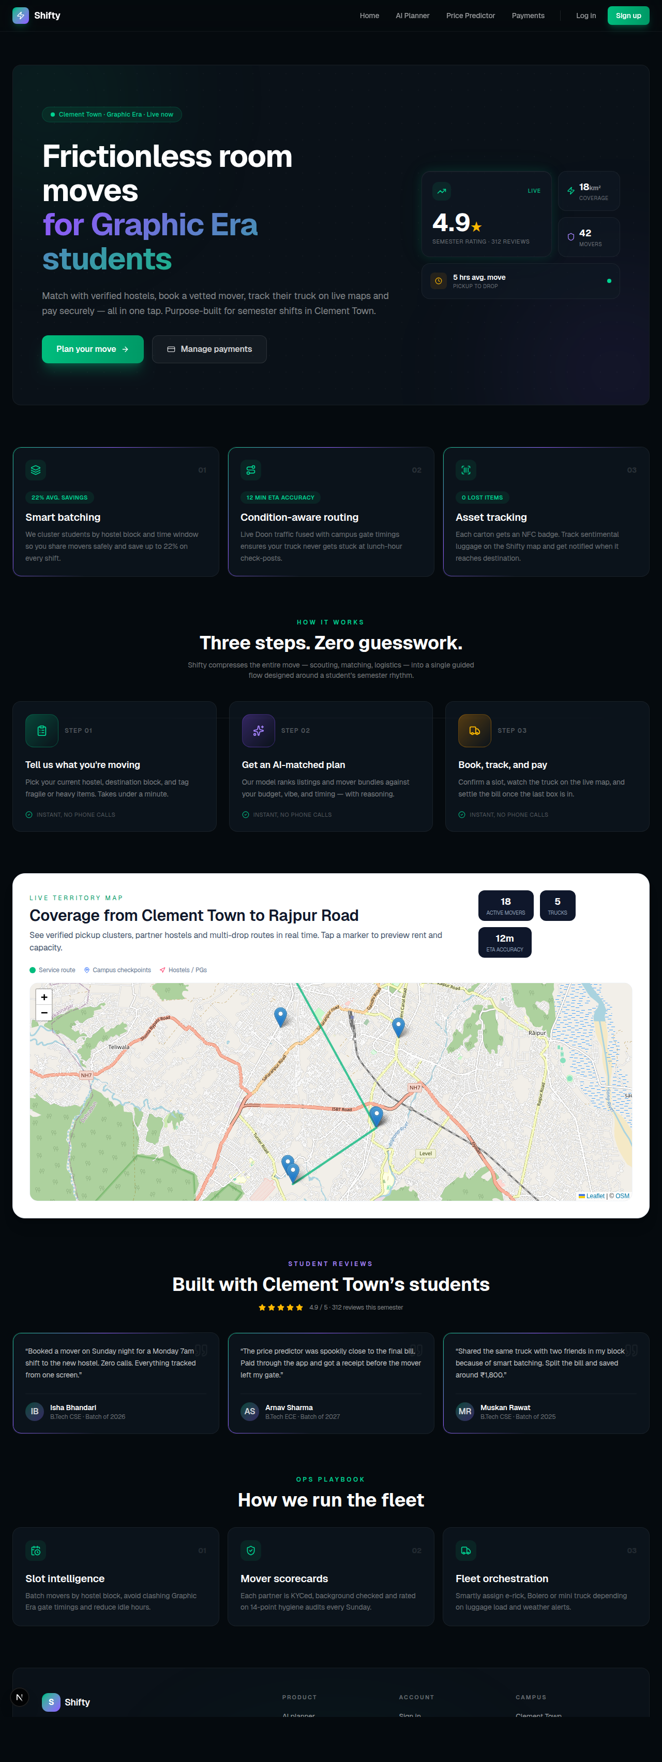
Figure 12: Landing Page of the Shifty Web Prototype
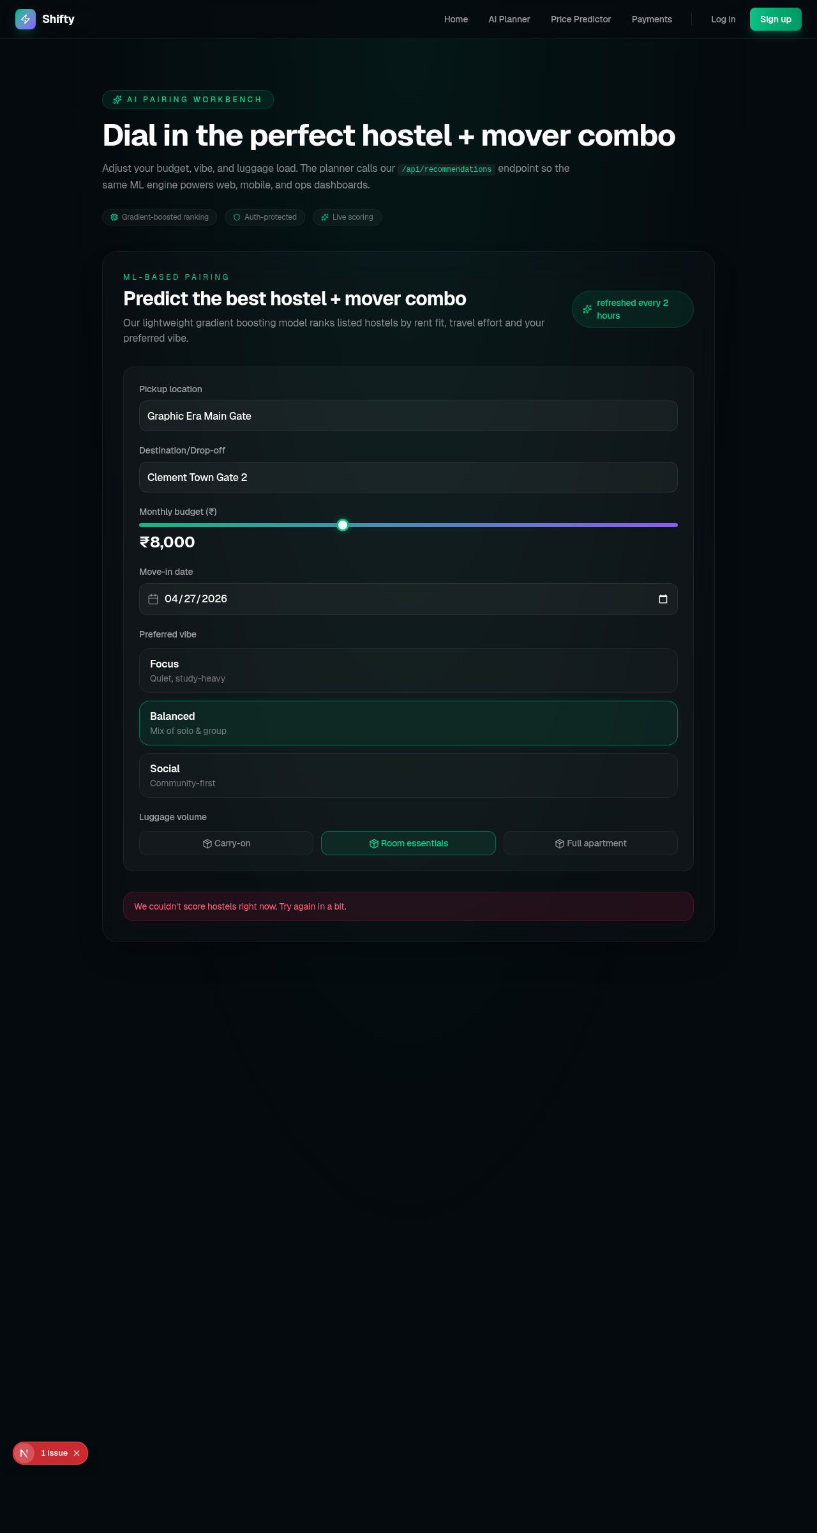
Figure 13: Booking Planner Capturing Itinerary and Inventory
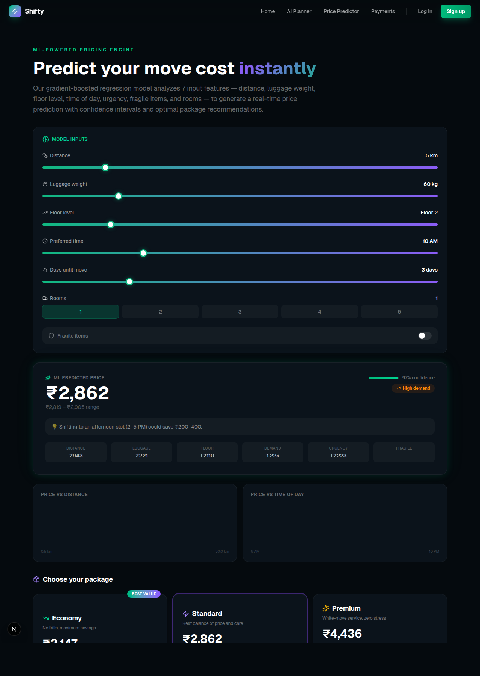
Figure 14: Price Prediction Screen Showing Model-Generated Quote
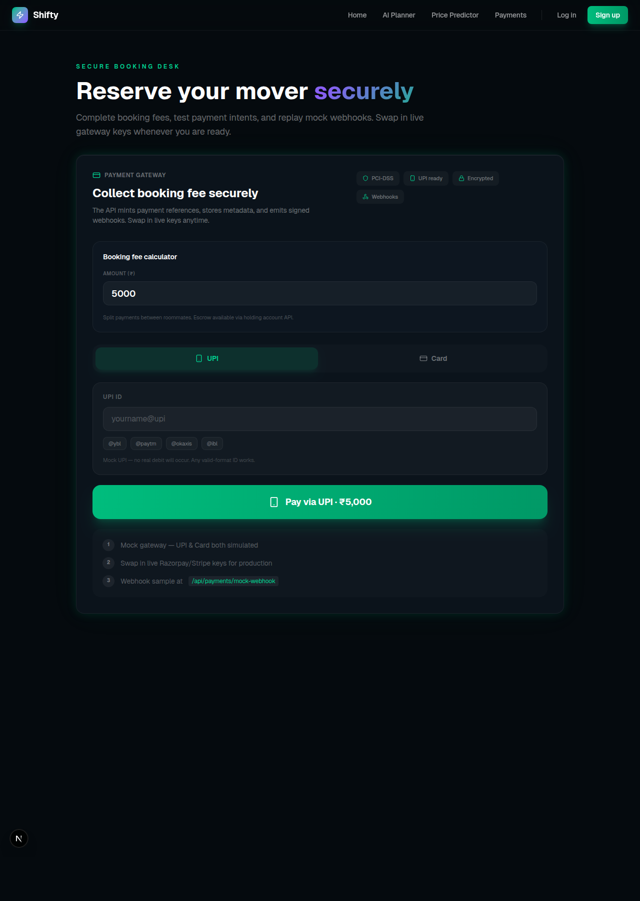
Figure 15: Payment Review Screen Prior to Gateway Hand-off
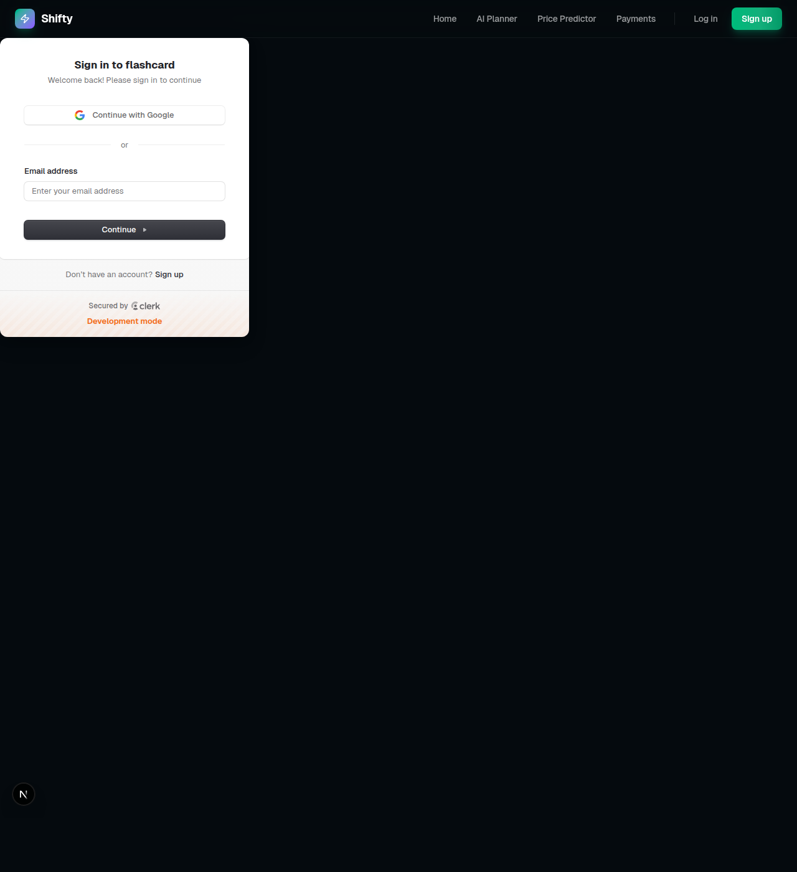
Figure 16: Sign-in Screen for Secure Access in Shifty System
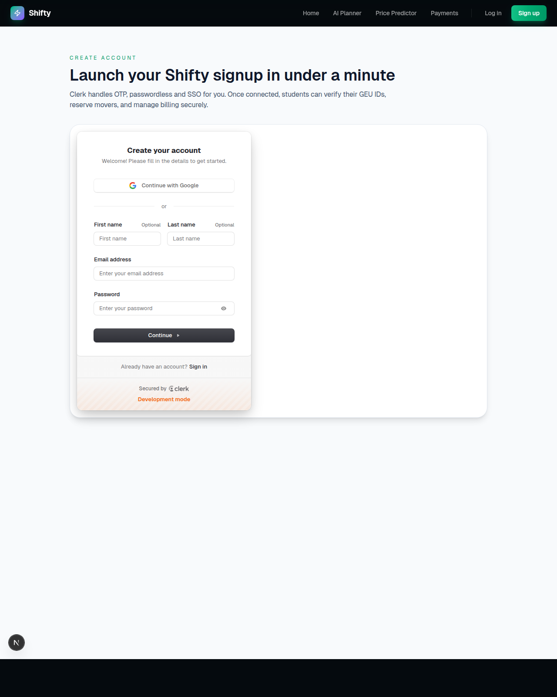
Figure 17: Account Creation Screen with Inline Validation
REFERENCES
[1] Breiman, L. “Random Forests.” Machine Learning, vol. 45, no. 1, pp. 5–32, 2001.
[2] Chen, T. and Guestrin, C. “XGBoost: A Scalable Tree Boosting System.” Proceedings of
the 22nd ACM SIGKDD International Conference on Knowledge Discovery and Data Mining,
pp. 785–794, 2016.
[3] Devlin, J., Chang, M.-W., Lee, K., and Toutanova, K. “BERT: Pre-training of Deep
Bidirectional Transformers for Language Understanding.” arXiv preprint arXiv:1810.04805,
2018.
[4] Bocklisch, T., Faulkner, J., Pawlowski, N., and Nichol, A. “Rasa: Open Source Language
Understanding and Dialogue Management.” arXiv preprint arXiv:1712.05181, 2017.
[5] Jones, M. B., Bradley, J., and Sakimura, N. “JSON Web Token (JWT).” RFC 7519,
Internet Engineering Task Force, 2015.
[6] Provos, N. and Mazières, D. “A Future-Adaptable Password Scheme.” Proceedings of the
USENIX Annual Technical Conference, pp. 81–92, 1999.
[7]
Razorpay
Software
Pvt.
Ltd.
“Razorpay
Payment
Gateway
Integration
Guide.”
https://razorpay.com/docs/, accessed March 2026.
[8]
Mongoose
ODM.
“Mongoose:
Elegant
MongoDB
Object
Modeling
for
Node.js.”
https://mongoosejs.com/, accessed March 2026.
[9]
Meta
Platforms,
Inc.
“React
Native
–
Learn
Once,
Write
Anywhere.”
https://reactnative.dev/, accessed March 2026.
[10] Socket.io Contributors. “Socket.IO: Bidirectional and Low-Latency Communication for
Every Platform.” https://socket.io/docs/, accessed March 2026.
[11] Pedregosa, F. et al. “Scikit-learn: Machine Learning in Python.” Journal of Machine
Learning Research, vol. 12, pp. 2825–2830, 2011.
[12]
Kumar, A.
and
Sharma,
R.
“Dynamic
Pricing
Strategies
in
On-Demand
Service
Platforms: A Survey.” International Journal of Logistics Management, vol. 32, no. 4, pp.
1213–1234, 2021.
[13] Singh, P. and Verma, S. “Adoption of AI-Driven Chatbots in the Indian Logistics Sector.”
Journal of Emerging Technologies in Business, vol. 8, no. 2, pp. 45–61, 2022.

