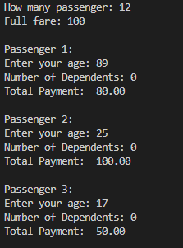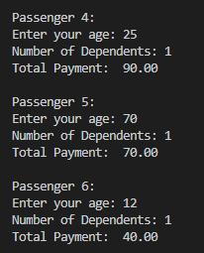

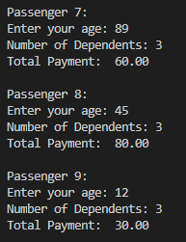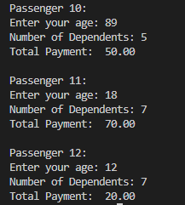

'''

DEPENDENT

0 dependent=no discount

1-2 = 10%

3-4 = 20%

5 above = 30%

#------------------------------------------

AGE

adult(18-59) full fare

senior(60+) 20% discount

children(<18) 50% discount'''

#\*\*\*\*\*\*\*\*\*\*\*\*\*\*\*\*\*\*\*\*\*\*\*\*\*\*\*\*\*\*\*\*\*\*\*\*\*\*\*\*\*\*

def fareDiscount(dependents):

    discount = 0

    while True:

        if dependents == 0:

            discount = 0

            break

        elif 1 <= dependents <= 2:

            discount = 0.10

            break

        elif 3 <= dependents <= 4:

            discount = 0.20

            break

        else:

            discount = 0.30

            break

    return discount

def ageDiscount(age):

    discount = 0

    while True:

        if age < 18:

            discount = 0.50

            break

        elif age >= 60:

            discount = 0.20

            break

        else:

            discount = 0

            break

    return discount

passengerCount = int(input("How many passenger: "))

fare = float(input("Full fare: "))

for i in range(passengerCount):

    print(f"\nPassenger {i + 1}: " )

    age = int(input("Enter your age: " ))

    dependents = int(input("Number of Dependents: " ))

    totalDiscount  =(fareDiscount(dependents) + ageDiscount(age))

    totalPayment = fare - (fare \* totalDiscount)

    print(f"Total Payment: {totalPayment: .2f}")