**Exp-12**

Term Work Project

**AIM:** Lift and Elevator Control using SCADA.

**Description:**

This project describes how a Lift and Elevator control can be done using SCADA. A total of 4 windows is used in this project. The first window is an introduction and title about the project as shown in the picture below.

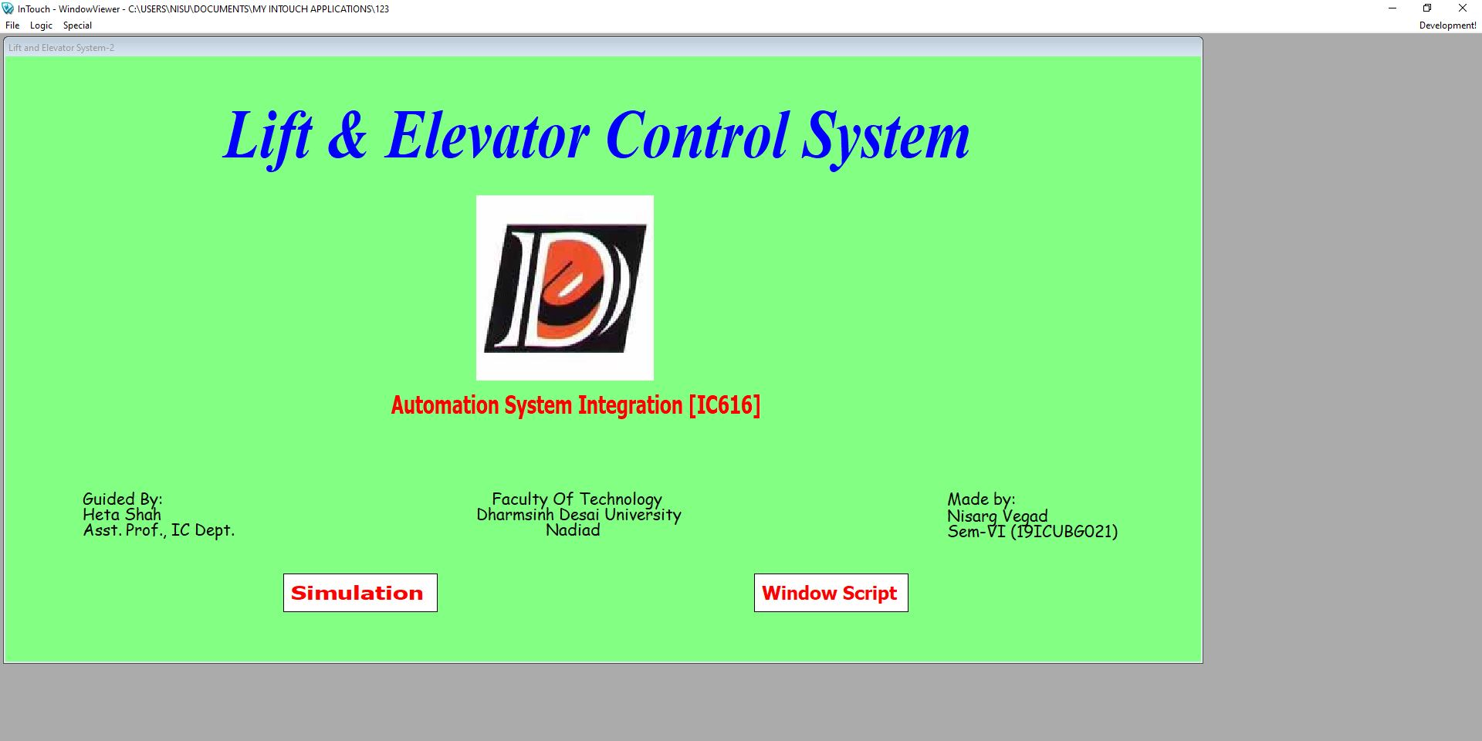

As seen from the buttons used, there are other 3 windows for Simulation, Window Script and Real Time Trend. The following photo shows the Simulation Window.

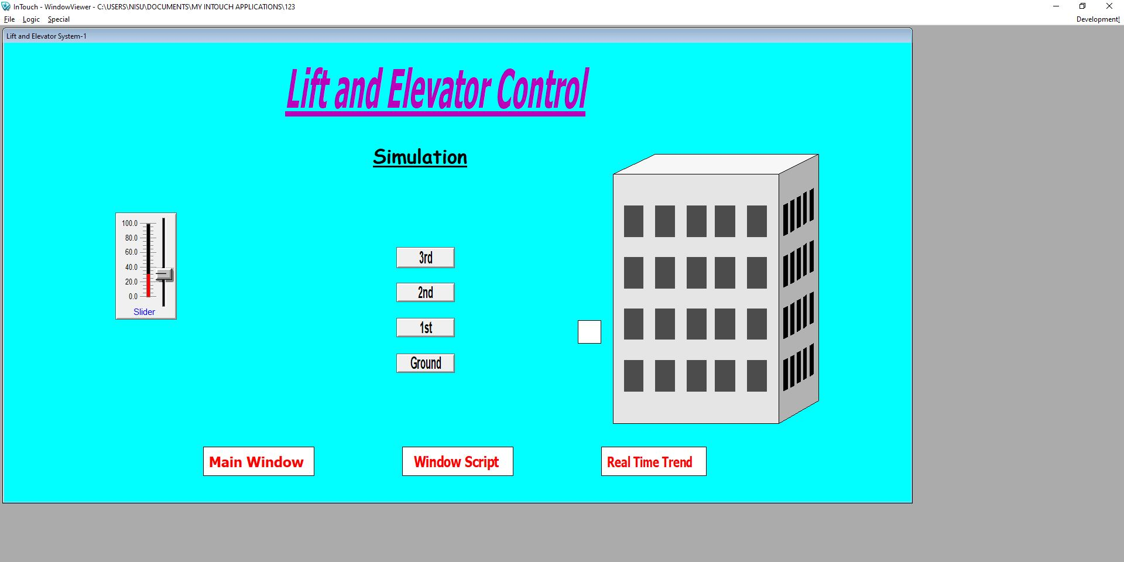

The lift is represented by the white square box besides the building. Initially the lift will be at Ground floor. As seen from the photo, currently the lift is at the first floor. The movement of the lift is associated with the slider which is placed on the left side.

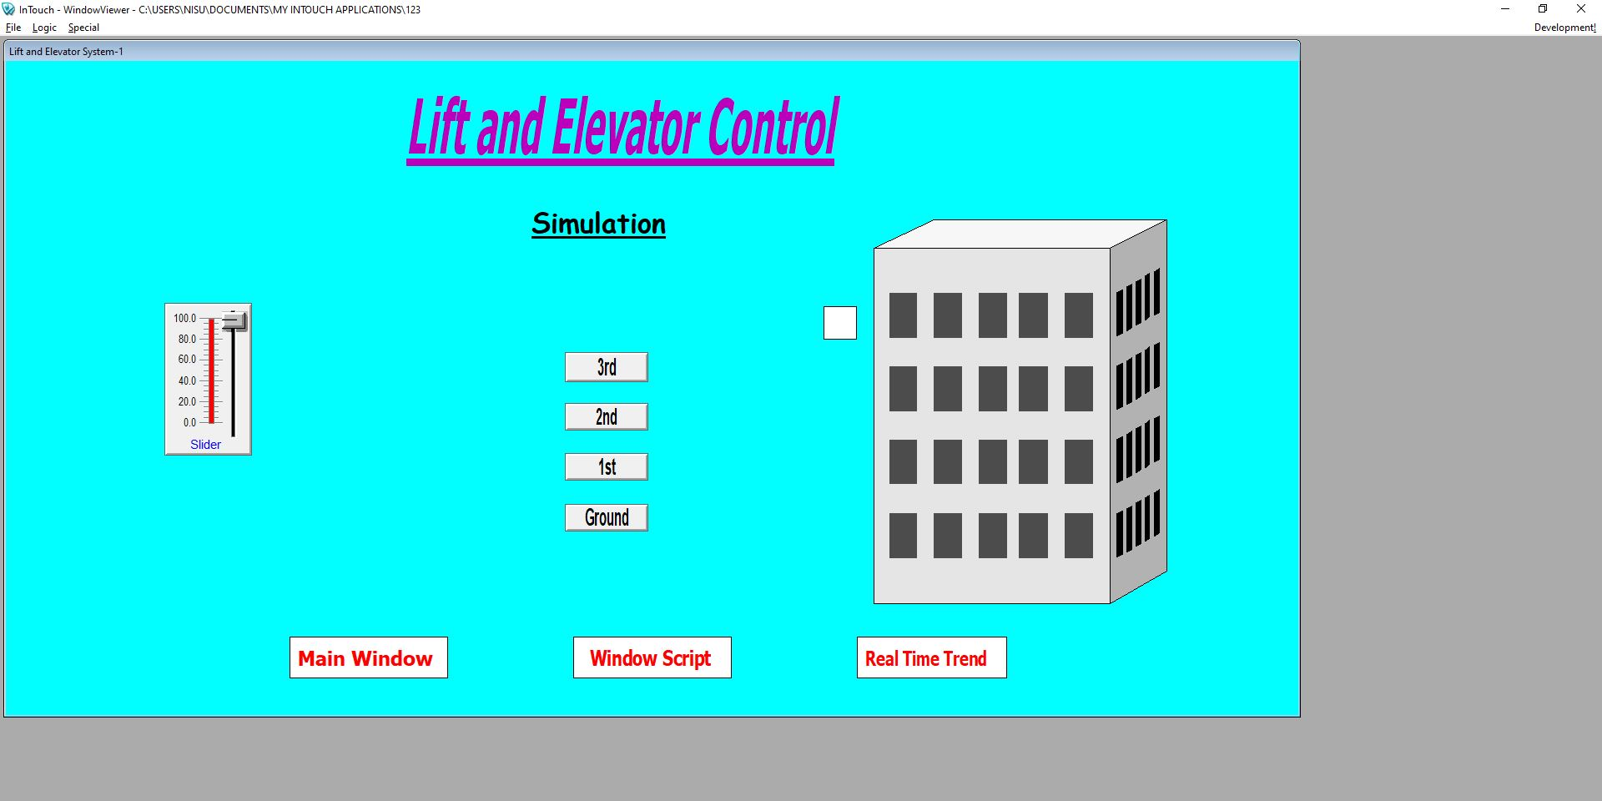

Here, the lift has been reached at third floor. For ground floor slider value will be 0, for 1st floor the slider value will be 32, for 2nd value will be 66 and for 3rd floor it will be 100.

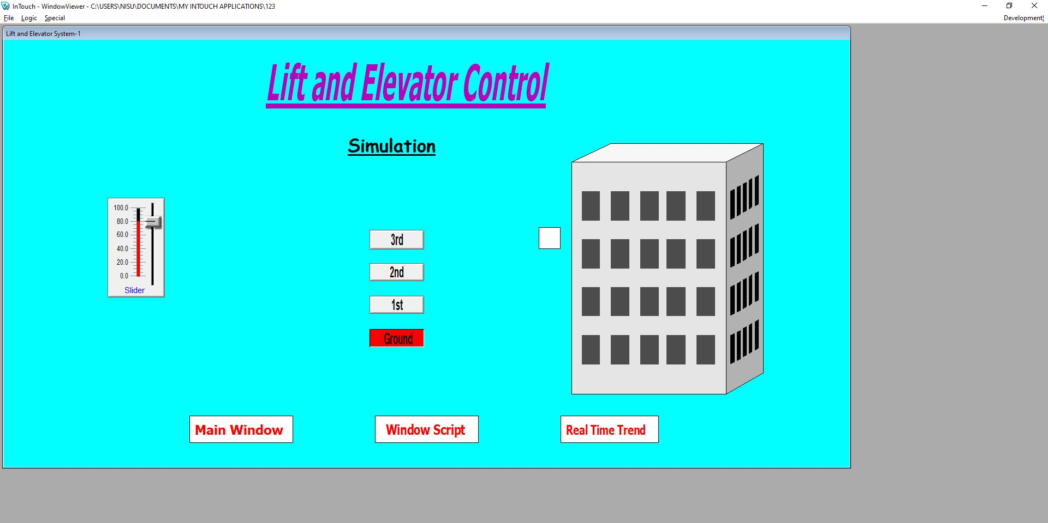

This photo shows that currently the lift is in transition from 3rd floor to Ground floor. The buttons can be used to switch the windows as per our need.

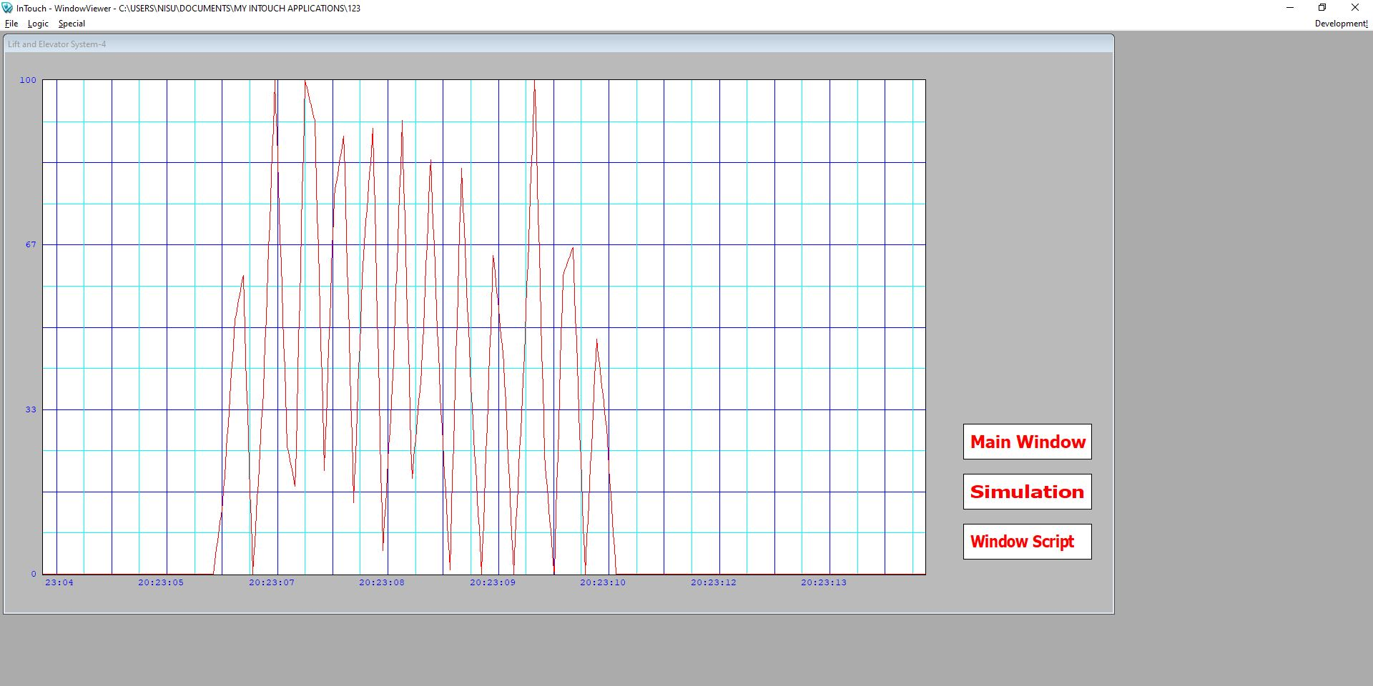

This is the Real Time Trend window. Here we are able to see the Real Time Trend of the lift. This can be used to observe where the lift will be through a graph. By the help of buttons, switching of windows can be possible.

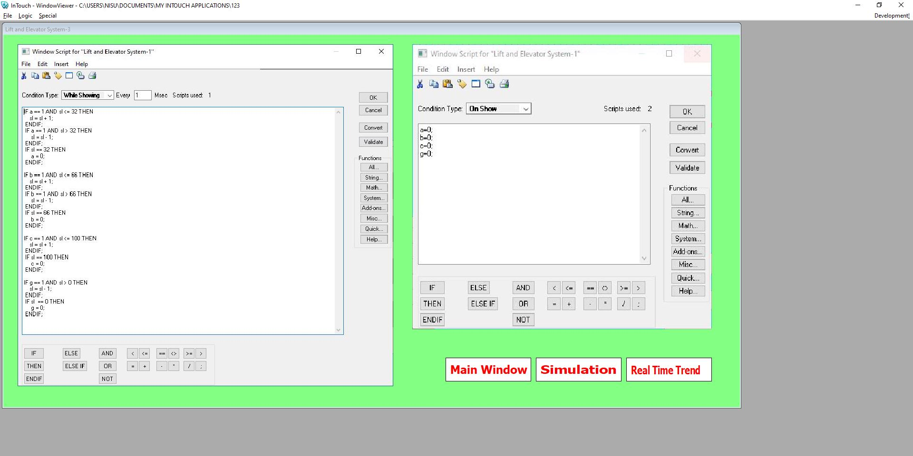

This is the last window of the project. This window shows the window script that has been used in this project.