**[Project:](https://www.campcodes.com/category/projects/) Advanced Online Voting Management System in PHP and MySQL with Source Code**

An **online voting system** is a web-based application that allows users to cast their votes through the internet. This type of system is widely used in various fields such as politics, education, and business, as it enables efficient and convenient voting processes. In this article, we will guide you through the steps of creating an online voting system in PHP, one of the most popular programming languages for web development.

**Creating an Online Voting System in PHP: A Comprehensive Guide**

**Advanced Voting Management System in PHP MySQL Free Download** is an election system that allows voters to record a secret ballot and have it tabulated electronically. Votes are stored so they can be re-counted should the need arise.

**Voting Management System** can speed up election results and lower the cost of conducting an election by significantly reducing the number of people required to operate a polling place and tabulate results. A primary concern with e-voting, however, is how to store votes so they can be recounted if required.

**What is an Online Voting System in PHP?**

An**online voting system in PHP** is a software application that enables users to cast their votes through the internet. It provides an efficient and convenient way of voting, allowing users to participate from anywhere and at any time. Online voting systems are widely used in various fields, such as political elections, school and university elections, business and corporate decision-making, and surveys.

**Features of  Advanced Online Voting  System in PHP and MySQL**

* **Vote preview**
* **Multiple votes**
* **Result tally via Horizontal Barchart**
* **Print voting result in PDF**
* **Changeable order of positions to show in ballot**
* **CRUD voters**
* **CRUD candidates**
* **CRUD positions**

**How to Create a Voting System in PHP?**

To create a voting system in PHP, you need to have a good understanding of the language’s fundamentals and web development concepts. Here are the basic steps involved in creating a voting system:

* **Define the requirements**. Define the purpose of your voting system, the type of voting method you want to use, and the security measures you need to implement.
  + The first step in creating an online voting system is designing the database schema. The database schema should include tables for storing information about voters, candidates, and the voting process. Here are some of the key tables that you should include in your database:
  + Users: This table should store information about voters, such as their name, email address, and login credentials.
  + Candidates: This table should store information about the candidates running for office, such as their name, party affiliation, and photo.
  + Votes: This table should store information about the votes cast by users, including the user ID, candidate ID, and the date and time of the vote.
* **Design the database**. Design the database schema and create the necessary tables to store user information, voting data, and other relevant information.
* **Develop the front-end**. Create a user-friendly interface for your voting system, including the ballot and voting options.
  + The next step is to develop the user interface for your online voting system. The user interface should be user-friendly and easy to navigate, allowing voters to easily find information about the candidates and cast their vote. Here are some of the key features that you should include in your user interface:
  + Candidate profiles: Each candidate should have a profile page that includes information about their background, platform, and stance on key issues.
  + Voting page: The voting page should allow users to cast their vote for their preferred candidate.
  + Results page: The results page should display the current vote count for each candidate and update in real-time as votes are cast.
* **Develop the back-end**. Develop the back-end of your voting system using PHP, including the logic for vote counting, result calculation, and data validation.
* **Test and deploy**. Test your voting system thoroughly and deploy it on a web server.

**Which Database is Best for Voting System?**

The choice of database for a voting system depends on several factors such as the size of the system, the number of users, and the complexity of the data. However, some of the most popular databases for voting systems are MySQL, PostgreSQL, and Oracle.

MySQL is a popular open-source database that is widely used in web applications. It is easy to use, scalable, and provides good performance. PostgreSQL is a powerful open-source database that provides advanced features such as transaction support, table partitioning, and data replication. Oracle is a commercial database that provides high-performance, scalability, and reliability for large-scale voting systems.

**What is the Most Common Voting System?**

The most common voting system used in political elections is the plurality voting system, also known as the first-past-the-post system. In this system, the candidate with the most votes wins the election. However, there are several other voting systems used in different contexts such as ranked choice voting, approval voting, and proportional representation.

**How to Implement Polling in PHP?**

To implement polling in PHP, you need to develop a back-end script that collects the poll data from the users, stores it in a database, and calculates the poll results. Here are the basic steps involved in implementing polling in PHP:

1. Create the poll form: Create a form that displays the poll question and the options to the user.
2. Process the poll data: Process the poll data submitted by the user and store it in a database.
3. Calculate the poll results: Calculate the poll results based on the data stored in the database and display the results to the user.

**How to Create an Authentication System in PHP?**

To create an authentication system in PHP, you need to develop a back-end script that authenticates the user’s credentials and provides access to the voting system. Here are the basic steps involved in creating an authentication system in PHP:

1. **Design the database**. Design the database schema and create the necessary tables to store user information, login credentials, and other relevant information.
2. **Develop the login form**. Develop a user-friendly login form that prompts the user to enter their login credentials.
3. **Validate the login credentials**. Validate the user’s login credentials against the information stored in the database.
4. **Set up user sessions**. Set up user sessions to maintain the user’s login state and provide access to the voting system.

**What is the Main Objective of E-Voting System?**

The main objective of an e-voting system is to provide an efficient and convenient way of voting, allowing users to participate from anywhere and at any time. E-voting systems also aim to improve the accuracy and integrity of the voting process by reducing errors, minimizing fraud, and increasing transparency. Additionally, e-voting systems can reduce the cost and time involved in traditional voting methods.

**Advanced Online Voting System in PHP and MySQL Project**

* **Name of Project:**    **Advanced Online Voting System in PHP** **Project**
* **Language**:                 PHP
* **Databases used**:     MySQL
* **Design used**:            HTML JavaScript, Ajax, JQuery, Bootstrap
* **Browser used:**          IE8, Google Chrome, Opera Mozilla
* **Software used:**         WAMP/ XAMPP/ LAMP/MAMP

**Screenshots**

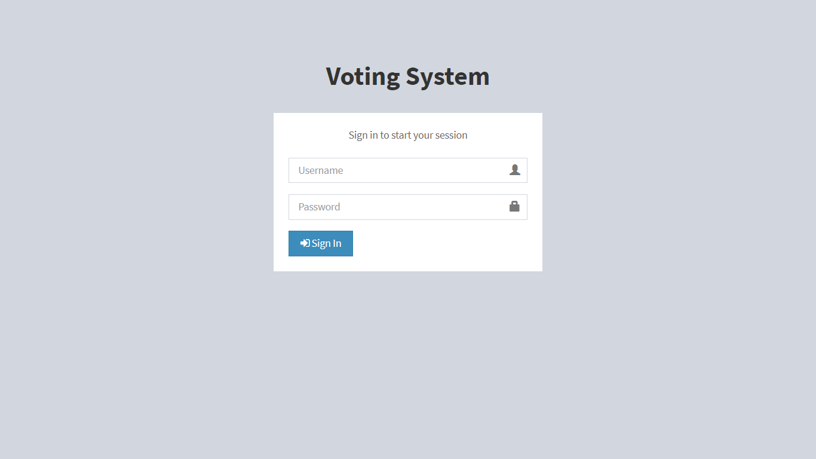

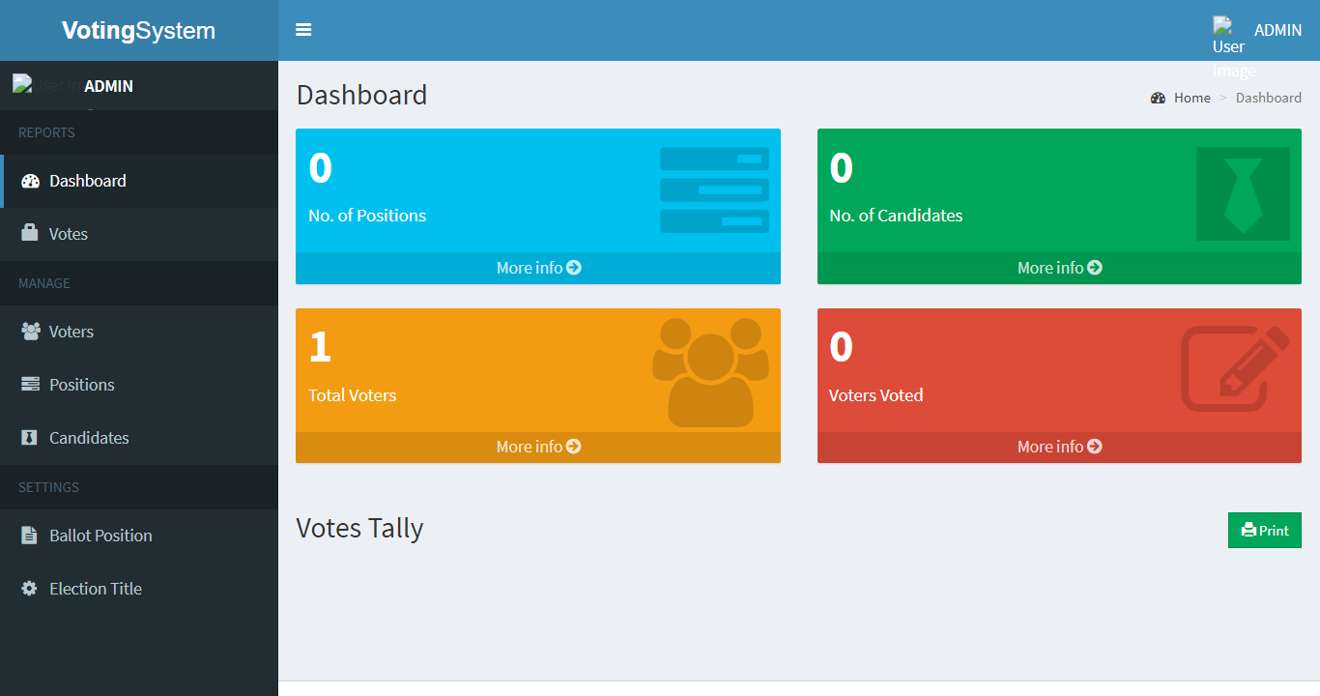

**Planning and Designing Your Online Voting System**

In this section, we’ll discuss the planning and designing stage of your online voting system. This includes determining the features and functionality of your system and designing its user interface.

**Determining the Features and Functionality of Your System**

Before you start coding your online voting system, you must first plan and conceptualize its features and functionality. Below are some questions to help you get started:

* What types of elections or contests can be created?
* What are the specifications and requirements of each election or contest?
* How many candidates or entries are allowed?
* What types of voting systems are supported?
* How can voters cast and modify their votes online?
* What types of reports and analytics are needed?
* How will the system handle errors, invalid votes, and fraud attempts?

Answering these questions can help you create a clear and concise plan for your online voting system.

**Designing the User Interface of Your System**

After you determine the features and functionality of your online voting system, the next step is to design its user interface. The user interface is the visual and functional representation of your system, and it’s crucial to make it user-friendly and accessible.

Here are some tips to consider when designing your system’s user interface:

1. Keep it simple and easy to navigate
2. Use clear and concise labels and instructions
3. Make it responsive and accessible through different devices and platforms
4. Use contrasting colors and visual hierarchies to highlight important elements
5. Test it with real users to get feedback and improve its usability

**Developing Your Online Voting System**

In this section, we’ll discuss the core functionality of your online voting system. This includes creating the login and authentication system, election/contest creation module, voting module, vote counting module, and results display module.

**Creating the Login and Authentication System**

The login and authentication system is responsible for verifying the identity of the user and granting them access to specific features or resources. Here are the steps to create one in PHP:

1. Create a login form that can accept the username and password of the user.
2. Validate the user’s credentials by checking them against the database records.
3. Store the user’s login session and permission levels in a session variable.
4. Implement a logout feature that can terminate the user’s login session.
5. Secure the login and authentication system by using encryption, password hashing, and other security measures.

**Creating the Election/Contest Creation Module**

The election/contest creation module is responsible for creating and managing elections or contests. Here are the steps to create one in PHP:

1. Create a form that can collect the necessary information for creating an election/contest, such as the title, description, start and end dates, and candidates or entries.
2. Validate the information and store it in the database.
3. Display the list of existing elections/contests and allow the user to edit or delete them.
4. H4: Creating the Voting Module
5. The voting module is responsible for allowing voters to cast and modify their votes online. Here are the steps to create one in PHP:
6. Create a form that can display the election/contest details and the candidates or entries.
7. Allow the user to select one or more candidates or entries and submit their vote.
8. Validate the vote and store it in the database.
9. Allow the user to modify their vote before the deadline.

**Creating the Vote Counting Module**

The vote counting module is responsible for tallying the votes and computing the results. Here are the steps to create one in PHP:

1. Retrieve the votes from the database and organize them according to the voting system used.
2. Apply the vote counting algorithm and compute the results.
3. Store the results in the database and display them to the users.

**Creating the Results Display Module**

The results display module is responsible for showing the election/contest results to the users. Here are the steps to create one in PHP:

1. Retrieve the results from the database and display them in a table or graph.
2. Allow the user to filter and sort the results according to different criteria.
3. Provide a summary and analysis of the results using charts or other visual aids.

**Testing, Deployment, and Maintenance of Your Online Voting System**

In this section, we’ll discuss the testing, deployment, and maintenance of your online voting system. This includes testing it for bugs, errors, and vulnerabilities, deploying it on the web, and maintaining it for updates and improvements.

**Testing Your Online Voting System in PHP and MySQL**

Testing your online voting system is crucial to ensure its security, functionality, and usability. Here are some tips to consider when testing your system:

* Use automated testing tools to check for bugs and vulnerabilities.
* Test your system on different devices, platforms, and browsers.
* Involve real users to test the system’s usability and user experience.
* Assess the system’s security using penetration testing and vulnerability scanning.

**Deploying Your Online Voting System**

Deploying your online voting system on the web requires the following steps:

1. Choose a reliable web hosting service that can support PHP, MySQL, and other web technologies.
2. Register a domain name that suits your online voting system and is easy to remember.
3. Obtain an SSL certificate to secure your system’s data transmission and communication.
4. Configure your server’s settings and database to ensure optimal performance and security.

**Maintaining Your Online Voting System in PHP**

Maintaining your online voting system involves keeping it up-to-date, fixing bugs and errors, and improving its features and functionality. Here are some tips to consider:

* Regularly update your system to the latest version of PHP, MySQL, and other web technologies.
* Fix bugs and errors promptly to ensure optimal performance and security.
* Implement user feedback and suggestions to improve your system’s usability and user experience.
* Conduct security audits and risk assessments to identify potential threats and vulnerabilities.

**How To Run this Online Voting System in PHP and MySQL?**

Above all, to run this project you must have installed a virtual server i.e [XAMPP](https://www.apachefriends.org/download_success.html) on your PC. **Advanced Online Voting System** in PHP and MySQL with source code is free to download, **Use for educational purposes only!**

*Follow the following steps after Starting Apache and MySQL in XAMPP:*

***1st Step****:* Firstly, Extract the file  
***2nd Step:*** After that, Copy the main project folder  
***3rd Step:*** So, you need to Paste in xampp/htdocs/

***Further, Now Connecting Database***

***4th Step:*** So, for now, Open a browser and go to URL “http://localhost/phpmyadmin/”  
***5th Step:*** After that, Click on the databases tab  
***6th Step:*** So, Create a database naming “votingsystem” and then click on the import tab  
***7th Step:*** Certainly, Click on browse file and select “[votingsystem.](https://www.campcodes.com/php/5163/online-shopping-system-using-php-mysql/)**[sql](https://www.campcodes.com/php/5163/online-shopping-system-using-php-mysql/)**” file which is inside the “db” folder  
***8th Step:*** Meanwhile, click on Go button.

***After Creating Database***,

***9th Step:*** Moreover, Open a browser and go to URL “http://localhost/votingsystem”

**\*\*LOGIN DETAILS\*\***

**Admin**  
user: Nurhodelta  
pass: password

**DEMO**

**Related Projects:**[Online Voting System using PHP MySQL](https://www.campcodes.com/projects/php/6360/online-voting-system-using-php-mysql/), [Online School Event Management System in PHP/MSQLi](https://www.campcodes.com/projects/php/4353/online-school-event-management-system-in-php-msqli/)

To sum up, you can download this project below. However, you need to login first to download the source code. In other words, you can only download the source code if you are a member of this site.

[**Download Here**](https://www.campcodes.com/download/advanced-voting-management-system-using-php-mysqli-source-code/)

Creating an online voting system in PHP requires technical skills, planning, and dedication. But with the right tools and knowledge, you can develop a secure, accessible, and reliable system that’s suitable for different types of elections and contests. Whether you’re a government agency, an organization, or a business, an online voting system can help you streamline your election processes and increase voter turnout. So, get started with PHP and create your online voting system today!