**Assignment_4**

1. **What exactly is []?**

[] is big bracket in which python used to store list kind of data in which we can store int type, str type, float type, boot type, complex type, dict type, tuple type, etc.

Ex - a = [ "nitesh", 7, (1,2,3, "nitesh"), {1,2,3,4,23,23}, {1:"nitesh",2: "Kumar"}]

1. **In a list of values stored in a variable called spam, how would you assign the value ‘hello’ as the third value? (Assume [2, 4, 6, 8, 10] are in spam).**

In list if we want to insert some object then we have to use list_name.insert(index_number, insert_value). As example is shown below.

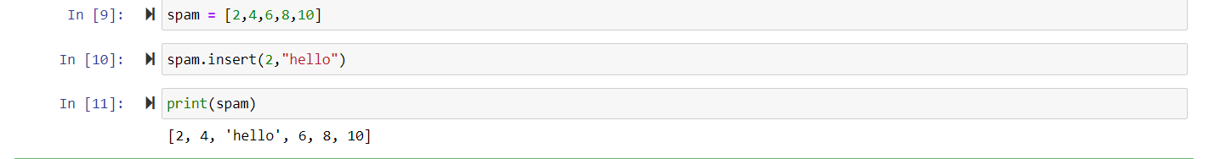

**Let’s pretend the spam includes the list [‘a’, ‘b’, ‘c’, ‘d’] for the next three queries.**

1. **What is the value of spam[int(int(‘3’*2)/11]?**

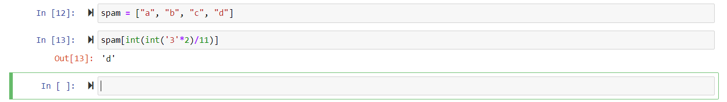

1. **What is the value of spam[-1]?**



1. **What is the value of spam[:2]?**



**Let’s pretend bacon has the list [3.14, “cat,” 11, “cat,” True] for the next three questions.**

1. **What is the value of bacon.index(“cat”)?**



1. **How does bacon.append(99) change the look of the list value in bacon?**



1. **How does bacon.remove(‘cat’) change the look of the list in bacon?**

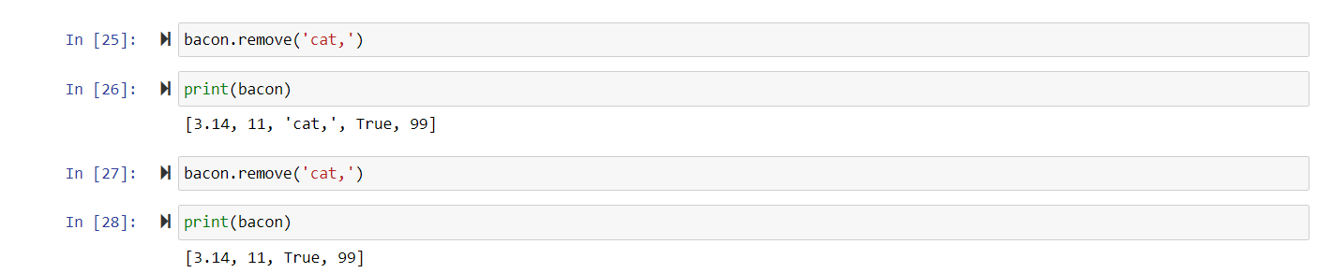

1. **What are the list concatenation and list replication operators?**

List concatenation is simply adding all the elements two or more lists in to a single list. We can do it by using ‘+’ operator.

List replication operator is ‘*’.

1. **What is difference between the list methods append() and insert()?**

* append() takes only one argument.
* append() can add a value to a list but it can’t take index of our choices. It will add new element always at the end of list.
* insert() takes two arguments one for index and another for the element to be inserted.
* Since insert() take index value also so it will be able to add element to a our choice of index.

1. **What are the two methods for removing items from a list?**

* pop()
* remove()

1. **Describe how list values and string values are identical.**

* List values can be accessed as it can be done in case of string values using slicing or indexing method.
* list and string both are subscript able.
* list and string both are mutable

1. **What’s the difference between tuples and lists?**

* Lists are stored in big bracket [].
* Lists are mutable.
* ‘list’ object support item asssigment.
* ‘tuple’ is stored in side small braces ().
* 'tuple' object does not support item assignment.
* ‘tuple’ is immutable.

1. **How do you type a tuple value that only contains the integer 42?**

if a tuple contains only one element then after that element a comma is must.

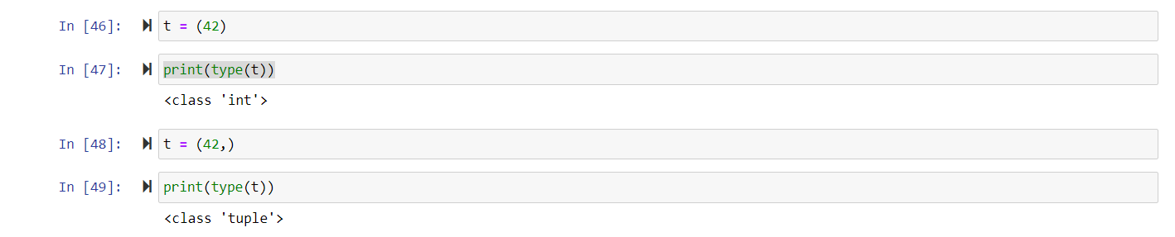

1. **How do you get a list value’s tuple form? How do you get a tuple value’s list form?**

Put the list in to tuple function to covert list values into tuple form and put the tuple in to list function to convert tuple values in to list. Example is shown below.

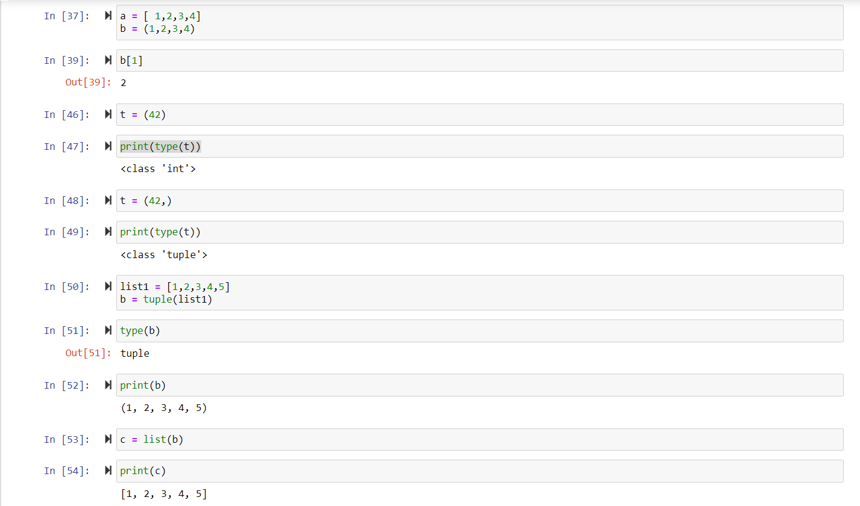

1. **Variables that “contain” list values are not necessarily lists themselves. Instead, what do they contain?**

List can contain int, bool, set, tuple, string, list itself, dictonary etc

1. **How do you distinguish between copy.copy() and copy.deepcopy()?**

copy() create reference to original object. If you change copied object - you change the original object. Deepcopy() creates new object and does real copying of original object to new one.

**THE END**