**Assignment_5**

1. **What does an empty dictionary’s code look like?**

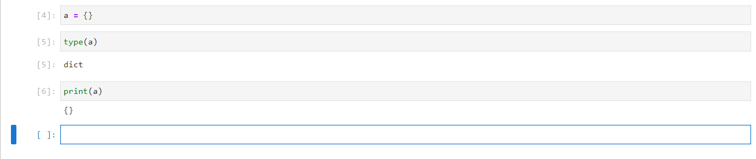

1. **What is the value of a dictionary value with the key ‘foo’ and the value 42?**

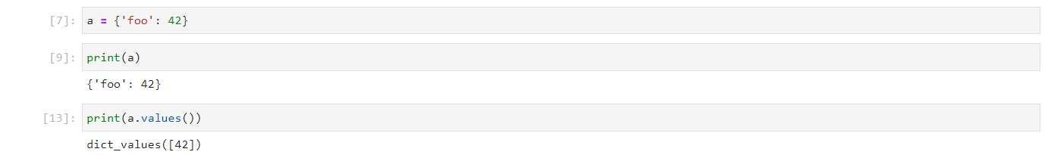

1. **What is the most significant distinction between a dictionary and a list?**

**List:** list values are enveloped in side big braces [].

**Dictionary:** Dictionary values are in available in key and value pair. And key and value are inside the curly braces {}.

1. **What happens if you try to access spam[“foo”] if spam is {“bar”: 100}?**

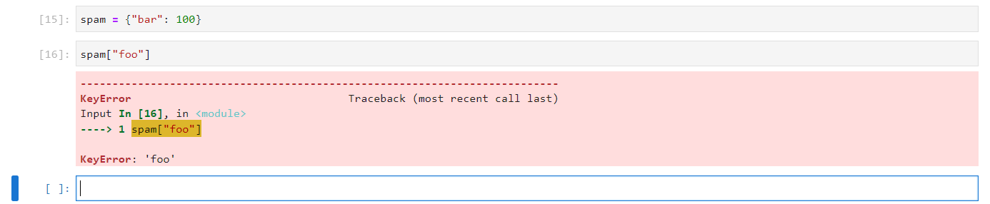

1. **If a dictionary is stored in spam, what is the difference between the expressions “cat” in spam and “cat” in spam.keys()?**

When “cat” is in the spam it is paired with it’s value but function spam.key() extract only keys of dictionary so all the keys of dictionary are available in list form.

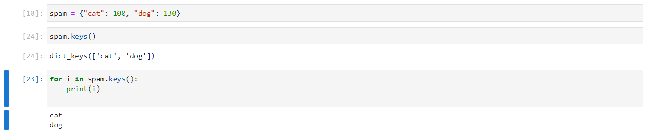

1. **If a dictionary is stored in spam, what is the difference between the expressions “cat” in spam and “cat” in spam.values()?**

When “cat” is in the spam it is paired with it’s key but function spam.values() extract only values of dictionary so all the values of dictionary are available in list form.

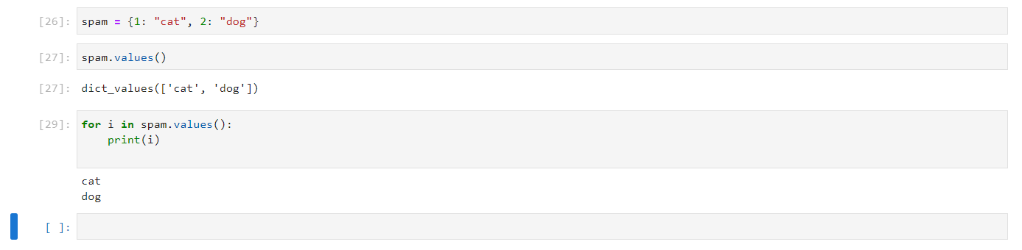

1. **What is a shortcut for the following code?**

**if “color” not in spam:**

**spam[“color”] = “black”**

No need to give if condition. Just write sapm[“color”] = “Black”, if the key “color” will be available it will overwrite the value of this key other wise it will add new key value pair in the dictionary.

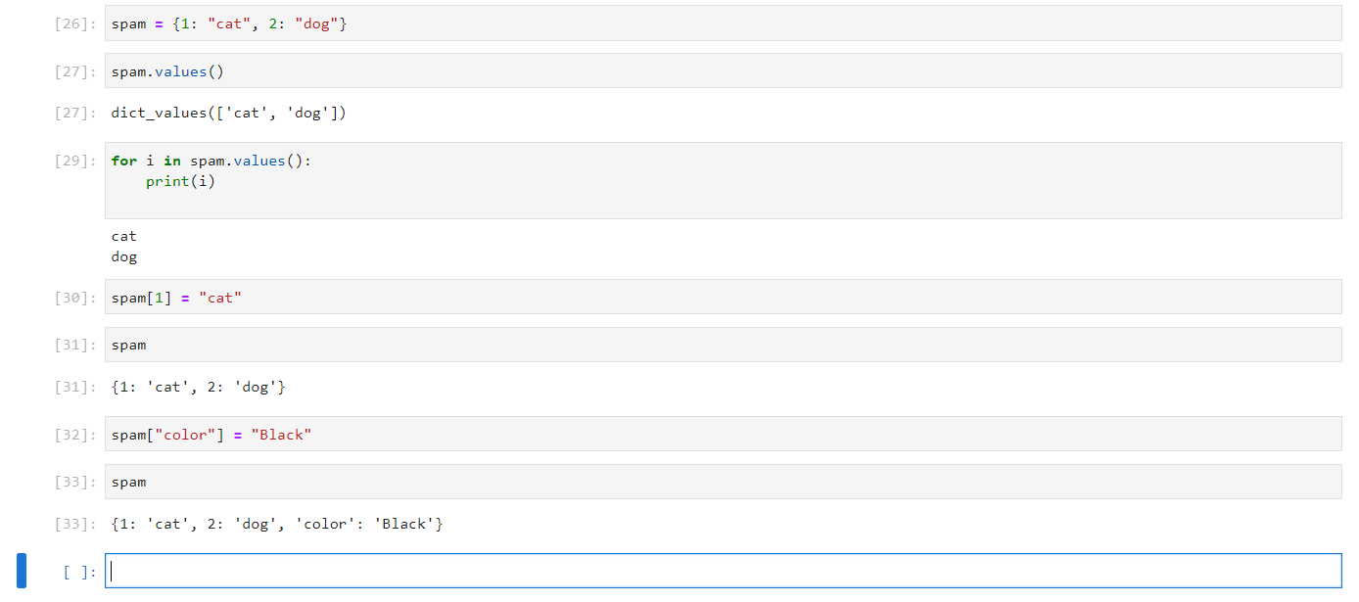

1. **How do you "pretty print” dictionary values using which module and function?**

As you can see in the below image, I have imported pprint module from pprint library. And pprint() function is used to print the data. As you must have observed that with simple print function data displayed is in single line which make the data to read little cumbersome but pprint function we can see the each key and value pair of dictionary are in different line which make the displayed data more readable.

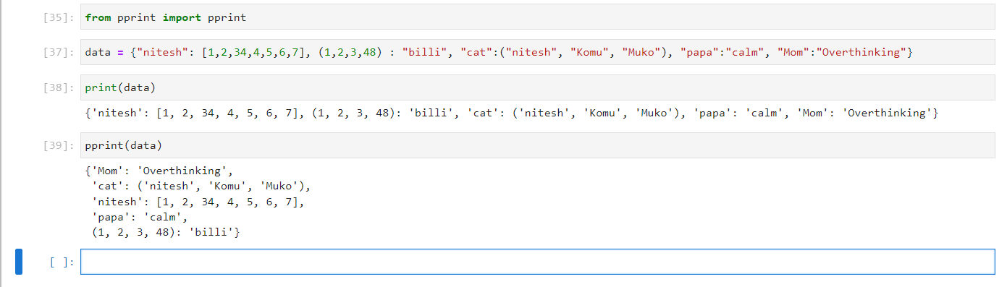

**The End**