**Assignment_6**

1. **What are escape characters, and how do you use them?**

To insert characters that are illegal in a string, use an escape character. An escape character is a backslash \ followed by the character you want to insert. An example of an illegal character is a double quote inside a string that is surrounded by double quotes.

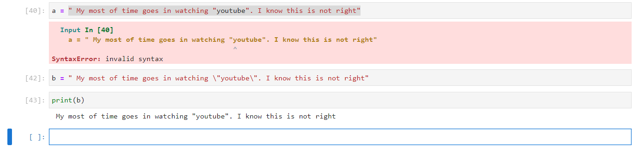

1. **What do the escape characters n and t stand for?**

“\n” and “\t” stands for new line and tab respectively.

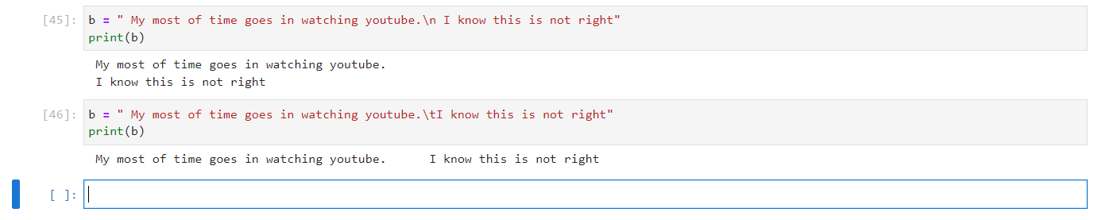

1. **What is the way to include backslash characters in a string?**

You can do this in two ways either you put two backslashes or you put only one backslash. Both way you will able to include backslash characters in a string.

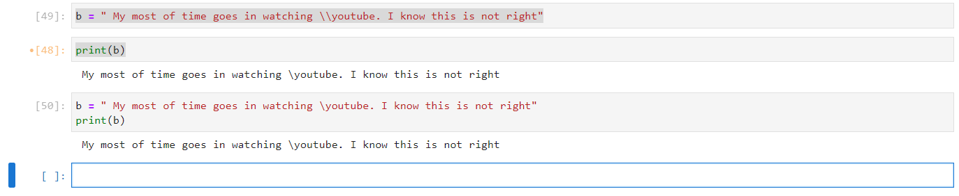

1. **The string “Howl’s Moving Castle” is a correct value. Why isn’t the single quote character in the word Howl’s not escaped a problem?**

If we enclose string with double quote then starting of literal and end of literal both should be double quote only. And if we are enclosing string with single quote at starting then compiler will look for only single quote at the end of literal.

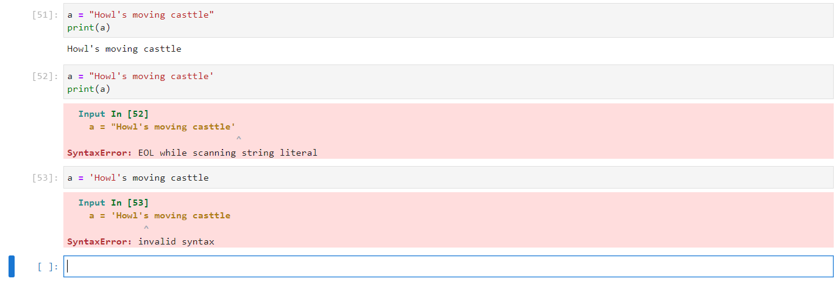

1. **How do you write a string of newlines if you don’t want to use the n character?**

If I don’t want to use n character to write a string of newlines, use another print() function.

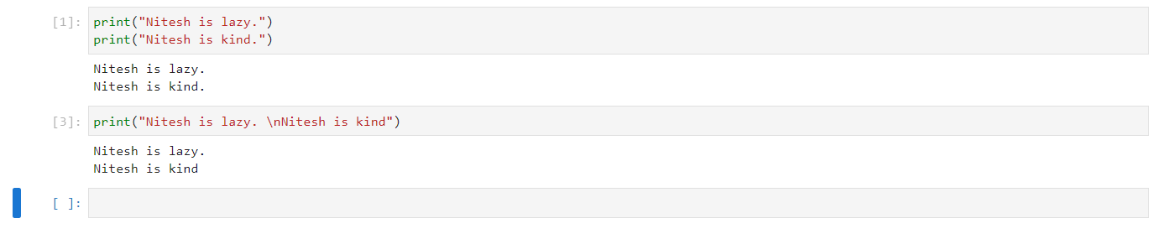

1. **What are the values of the given expressions?**

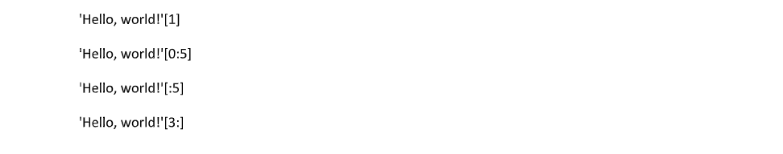 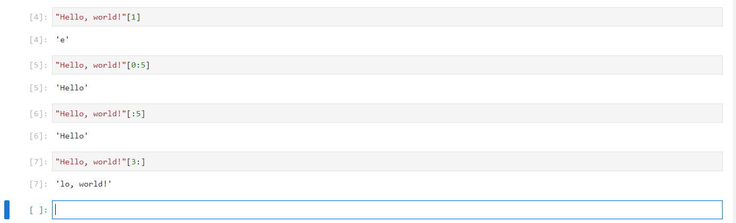

1. **What are the values of the given expressions?**

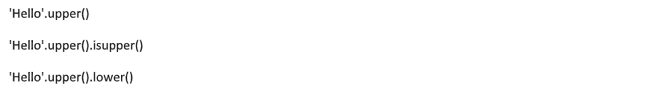

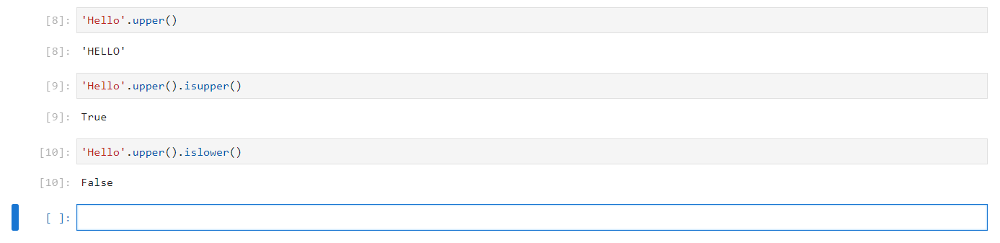

1. **What are the values of the given expressions?**



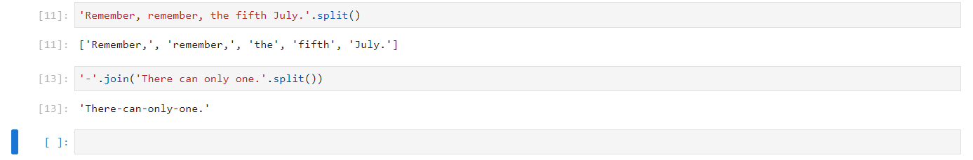

1. **What are the methods for right-justifying, left-justifying, and centring a string?**

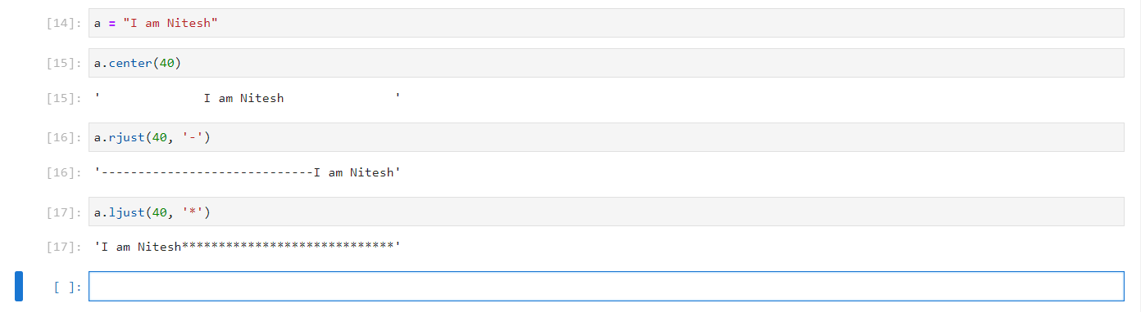

1. **What is the best way to remove whitespace characters from the start or end?**

lstrip() and rstrip() function are used to remove the white spaces form start and end of the string respectively.

**The End**