Assignment_2

1. The two value of Boolean data type are 0 and 1. We write them as False or True respectively.
2. Boolean operators are AND, OR, and NOT.

|  |  |  |  |  |
| --- | --- | --- | --- | --- |
| X | Y | X and Y | X or Y | Not X |
| True | True | True | True | False |
| True | False | False | True | False |
| False | True | False | True | True |
| False | False | False | False | True |
|  |  |  |  |  |

1. Values of following expressions given in question are given below

* (5 > 4) and (3 == 5) False
* not(5 > 4) False
* (5 > 4) or (3 == 5) True
* not((5 > 4) or (3 == 5)) False
* (True and True) and (True == False) False
* (not False) or (not True) True

1. Six comparisons operators are >= (Greater than Equal to), <=(Less than Equal to), >(Greater Than), < (Less Than), ==(equals to), and !=(Not Equals to).
2. Assignment operator and equal to operator are entirely different. Assignment operator assigns value to a variable and representer by one equal sign “=” but equal to operator is used for comparison between value and represented by two equal sign “==”.
3. Since spam = 0, code in first block and second block will not be executed. Code inside else block will be executed.

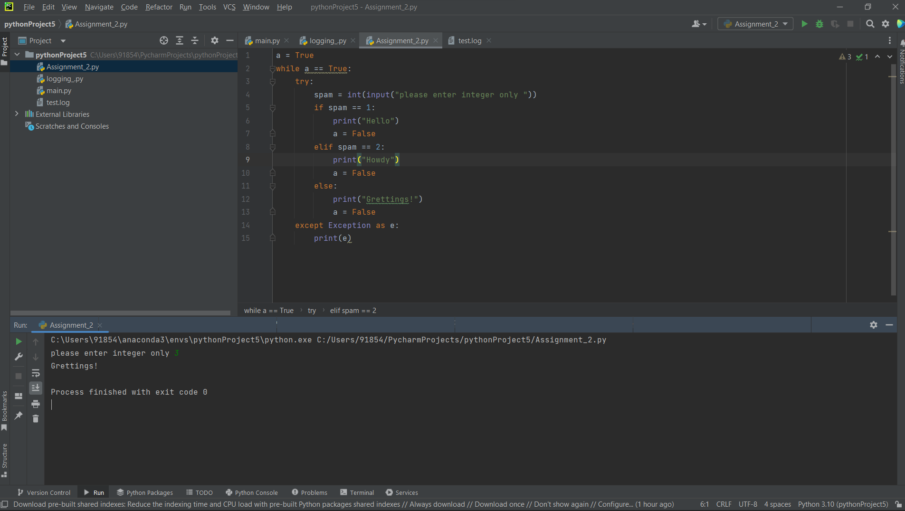

1. If my programme is stuck in endless loop in pycharm, I click stop button available at the top right most corner of python IDE. In Jupyter Notebook I restart the kernel again.
2. break helps to get out of while loop when the condition given in the code is fulfilled but continue keeps loop running.
3. There is no difference between range(10), range(0, 10), and range(0,10,1) but if we want to initialize range function with different than 0 then we will use range(initial value, final value) format and if we want a constant gap between all the element created by range function then we will use range(initial value, final value, constant gap)

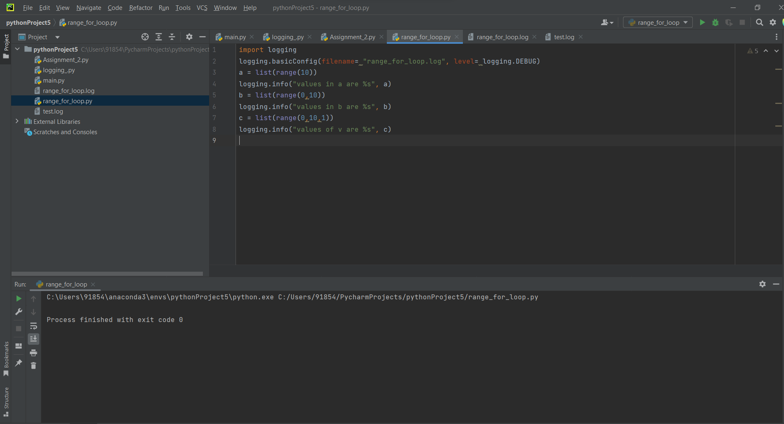

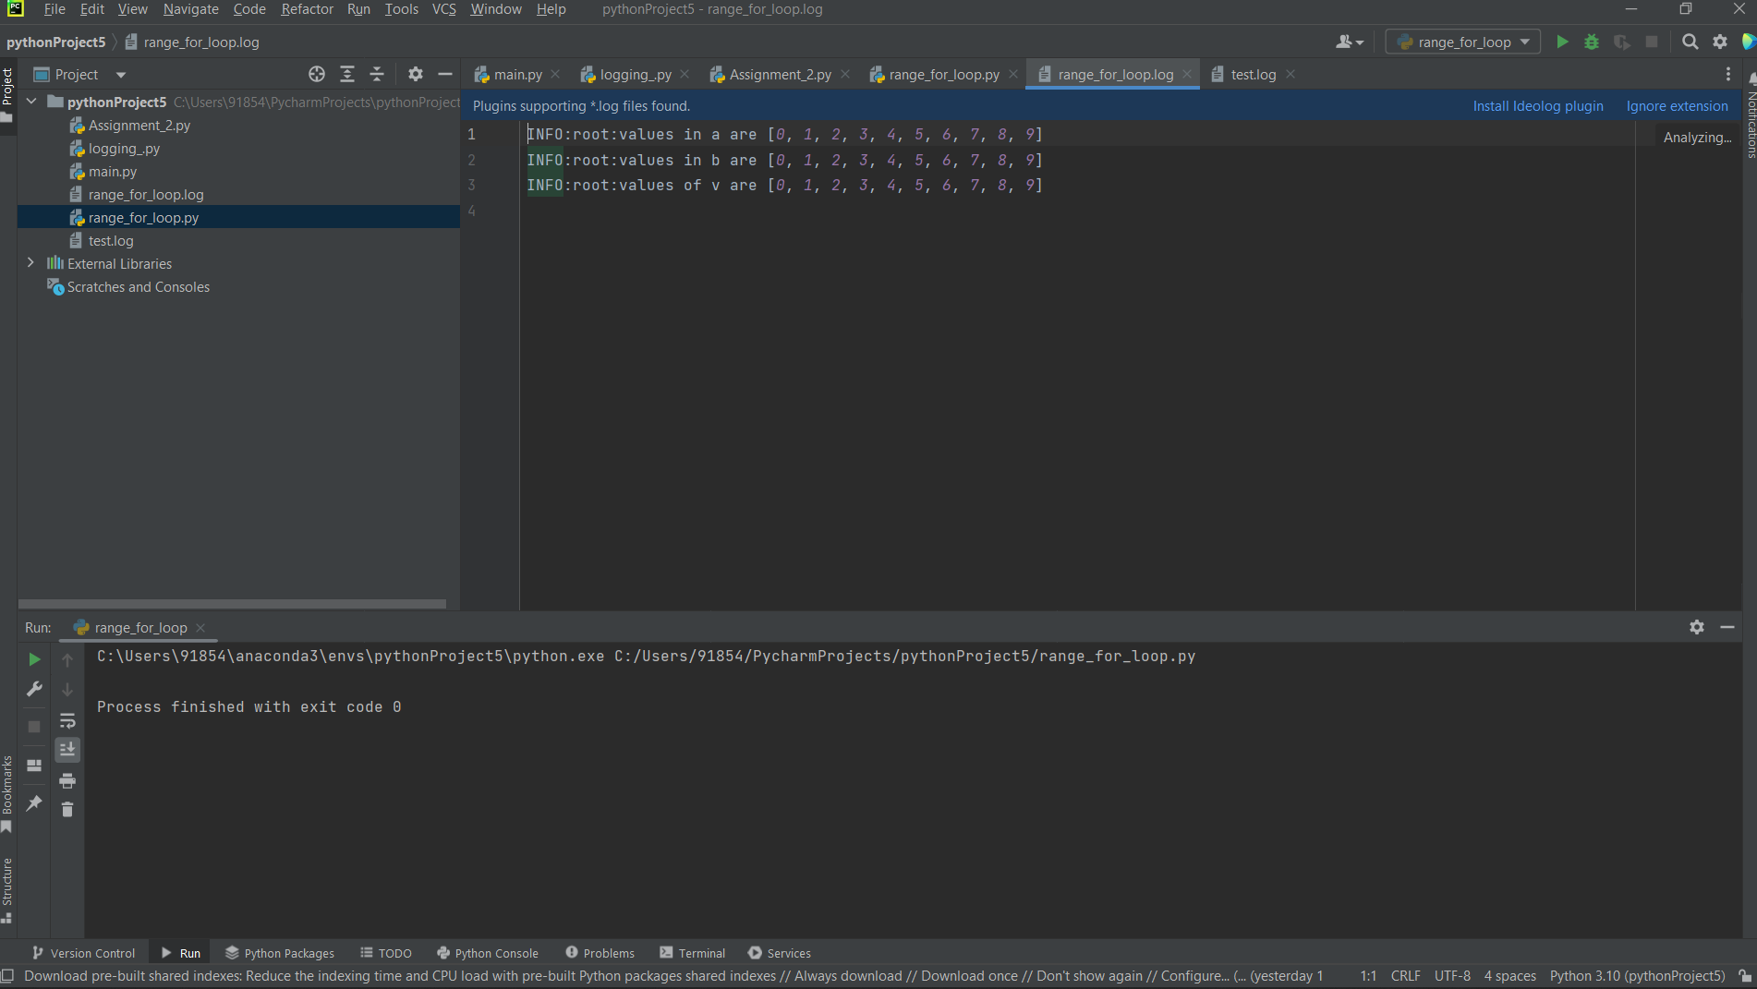



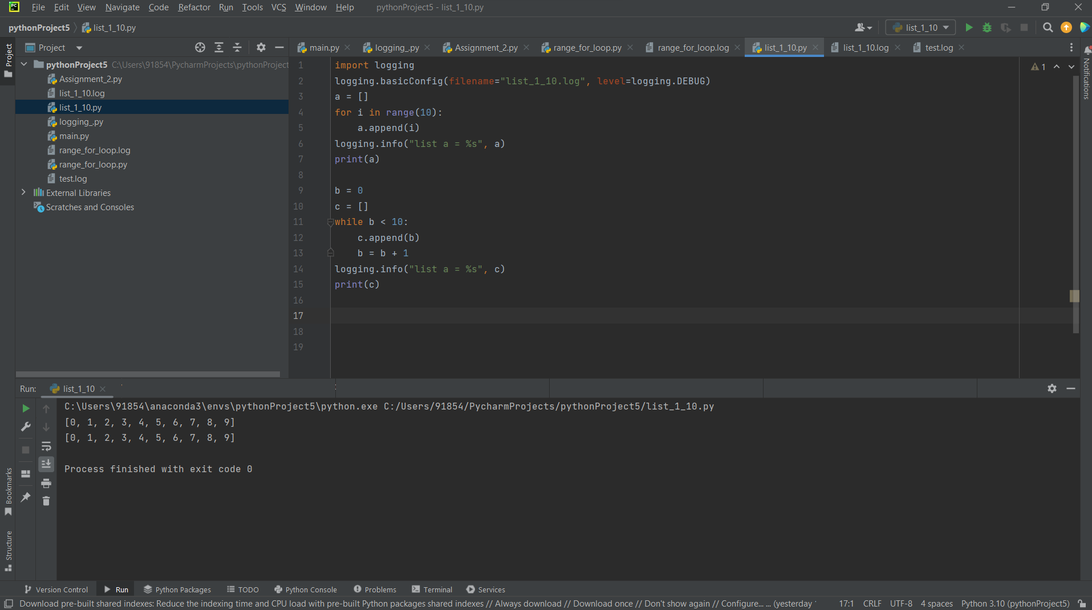

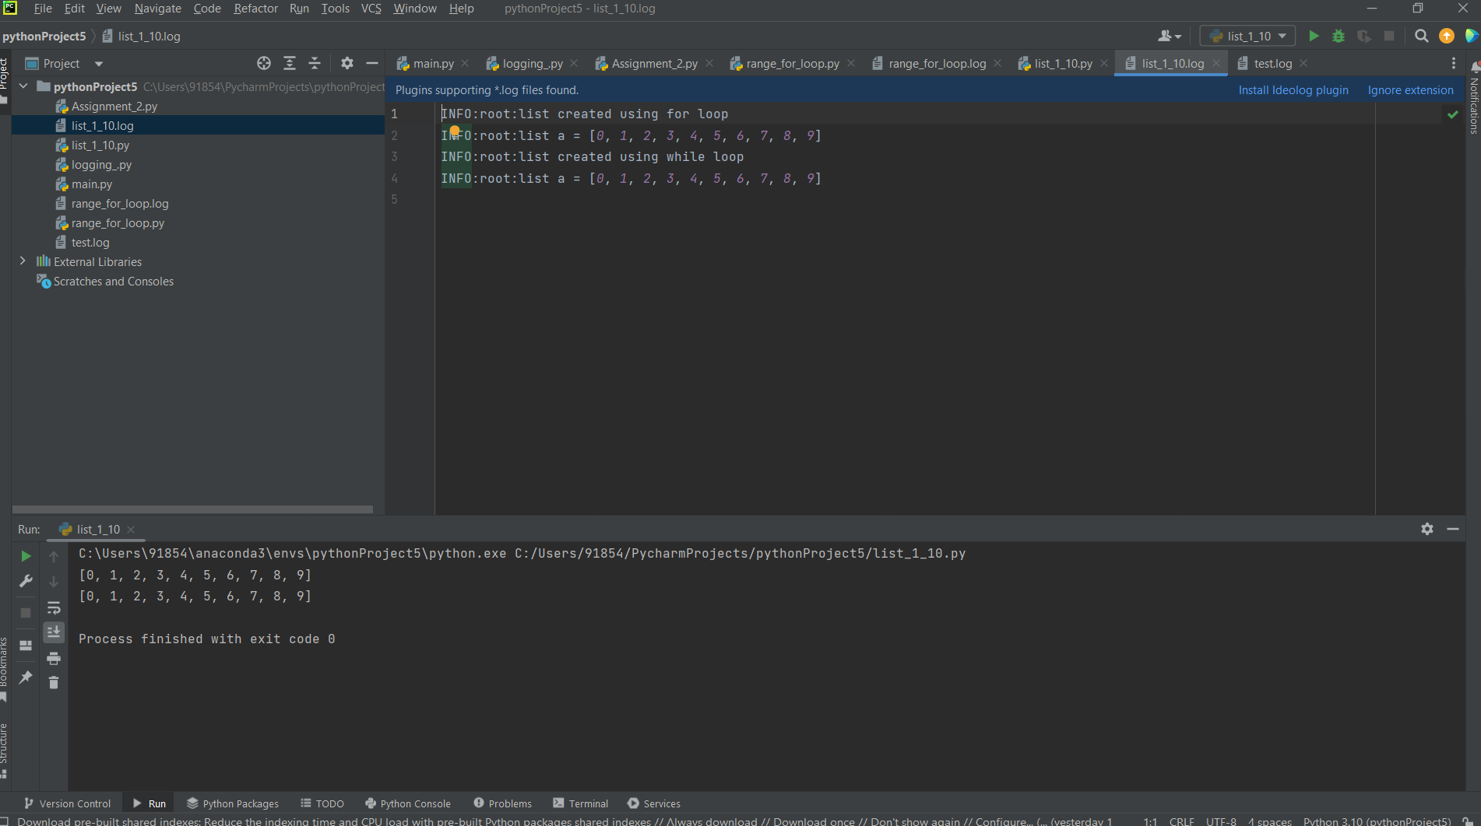

1. At first we will import module using “import spam” and then we can call bacon() function by calling this “spam.bacon()”.