Qaanita Fataar

PE17QF220497

Internet Programming 2

Formative 1 - The Pizzatorium

Table Of Contents

Planning 2

Goals 2

Objectives 2

Site Map 2

UML Diagram 2

Screen Designs 2

Login Page 2

Design Page 2

Final Page 2

Thank You Page 2

# Planning

## Goals

## Objectives

## Site Map

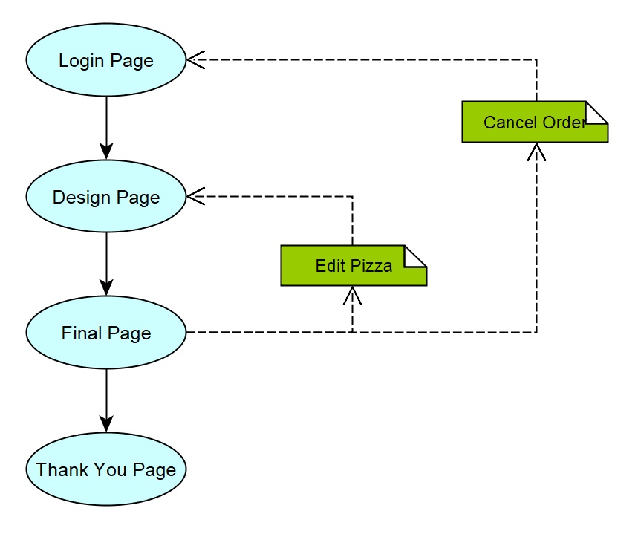

## UML Diagram

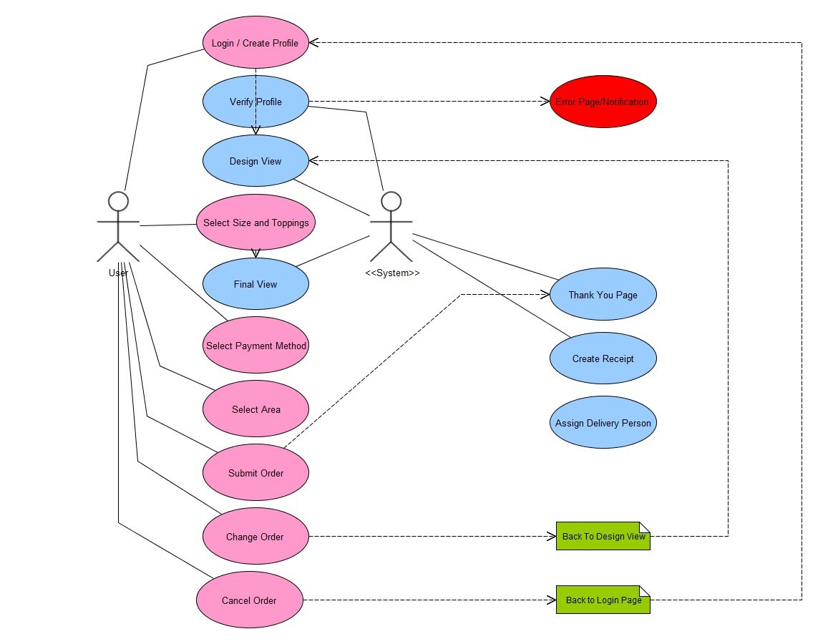

## Screen Designs

### Login Page

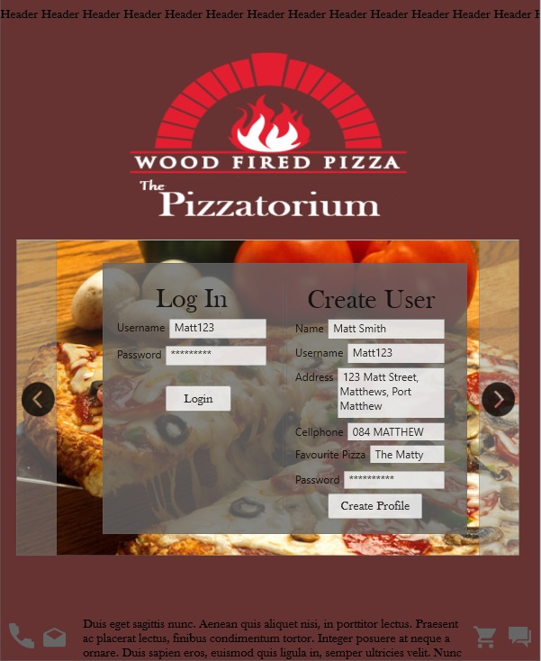

### Design Page

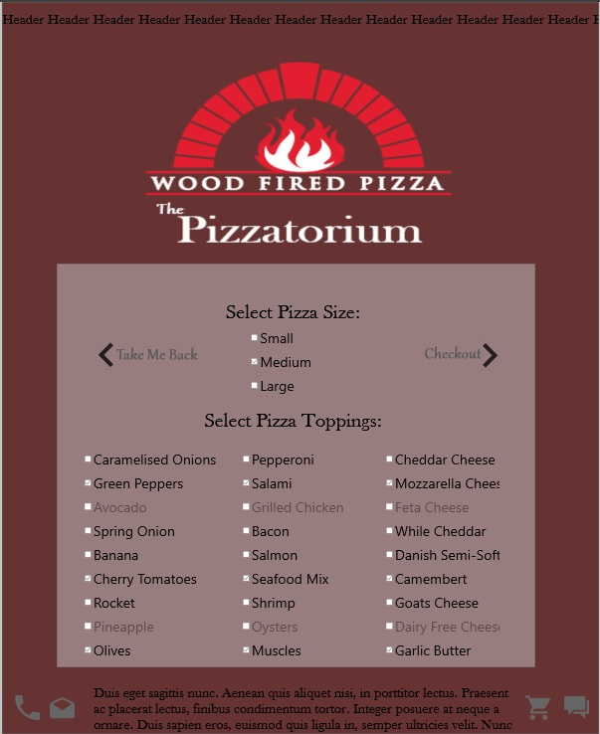

### Final Page

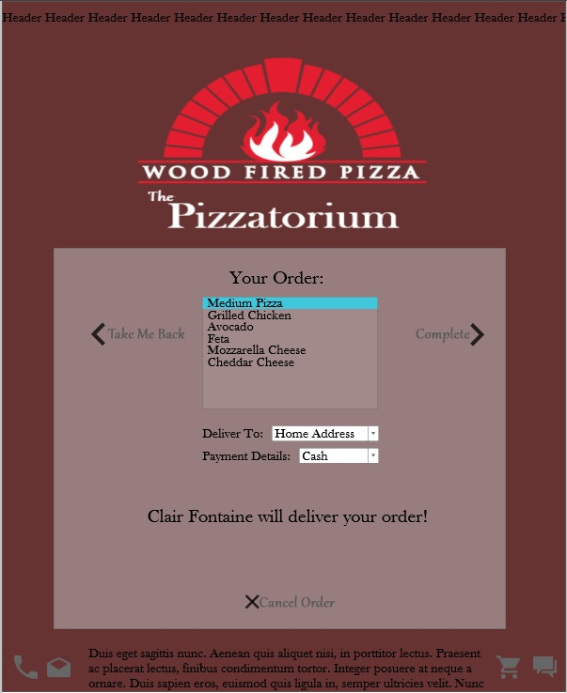

### Thank You Page

