**1**) Extract the .zip file, launch SQL Server, and right click on the **Build_db_zoo.sql** file.

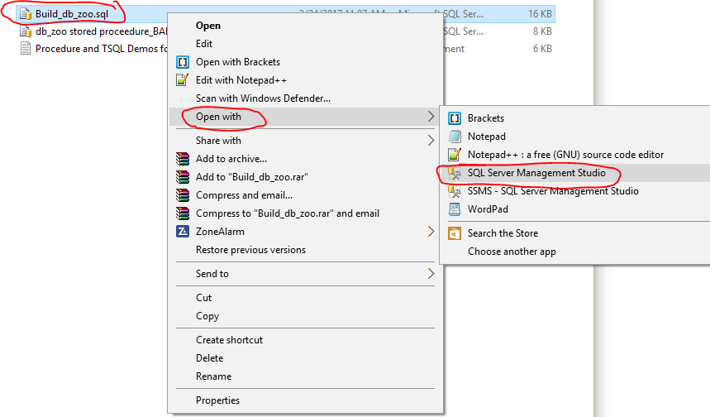

It should open a “**New Query**” window automatically and paste the code to the screen.

**2**) Click on the “**!Execute**” button:

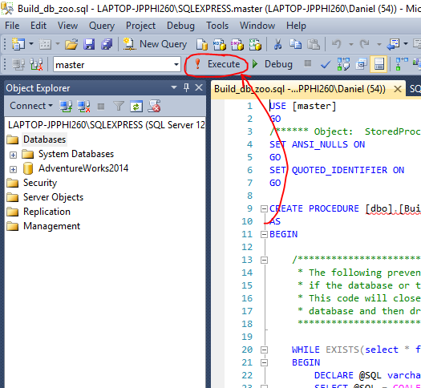

**3**) Navigate to the stored procedure file, “**dbo.Build_db_zoo**” to verify that it is present:

**Databases>System Databases>master>Programmability>Stored Procedures**

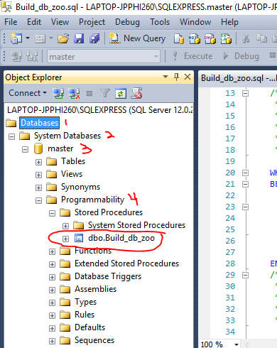

**4**) Click on the “**New Query**” button to open a blank query window and type the following command:

USE master

GO

EXEC [dbo].[Build_db_zoo]

Click on the **“!Execute**” button to execute the stored procedure that will create the empty zoo database.

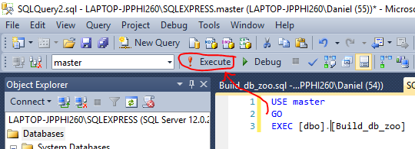

**5**) In the Object Explorer Window, Highlight “**Databases**” and click the “**Refresh**” button. The empty “**db_zoo**” database should now be present in the tree listing.

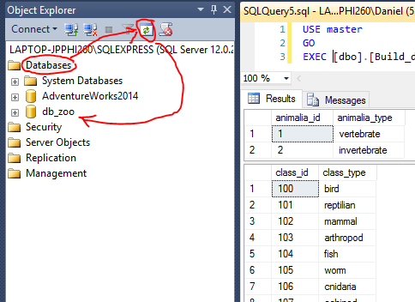

6.) Back in your windows explorer, locate the original zipped files and right click on the file named, “**Populate_db_zoo.sql**”. This should also open up a “**New Query**” window in SQL SERVER with code on screen.

7.) Click on the “**!Execute**” button to create the new procedure.

8.) Click on the “**New Query**” button one last time to get a clean environment and type the following command and click the “**!Execute**” button:

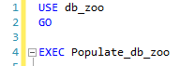

Congratulations, your new zoo database should now be created, populated with data, and ready for you to practice composing SQL statements and query the data.

************************************************************************************