**Inequality in the World State**

* Description: For this test we wanted to look at how varying levels of inequality in the initial world affect outcomes now that we have the new features since the completion of part 1. We used the same measure of inequality, the mean log deviation(MLD) of each country’s state quality. This is normalized so that an MLD of 0 represents completely equal state qualities and 1 represents only a single country having any resources at all. We ran tests over 10 rounds of the game on countries with high, limited, and no inequality.
* Test 1
  + Description: In this test case the MLD is 0, representing a completely equal initial world.
  + Parameters:
    - num_rounds = 10
    - frontier_size = 100
    - use_dynamic_solution_limit = True
    - use_dynamic_depth_limit = True
    - solution_limit = 1000
    - depth = 3
    - interventions_on = True
    - log_inequality = True
    - seed = 123456654321
    - initial_state_filename = "./input_files/no_inequality.xlsx"
    - initial_resource_filename = "./input_files/Resources.xlsx"
    - initial_interventions_filename = "./input_files/Interventions_case0.xlsx"
    - output_schedule_filename = "./output_files/ no_inequality.txt"
    - game_state_print = True
    - game_state_filename = "./game_output_files/ no_inequality.csv"
    - trade_selectivity_parameters = [0, 100, 1, 200]
  + Input:

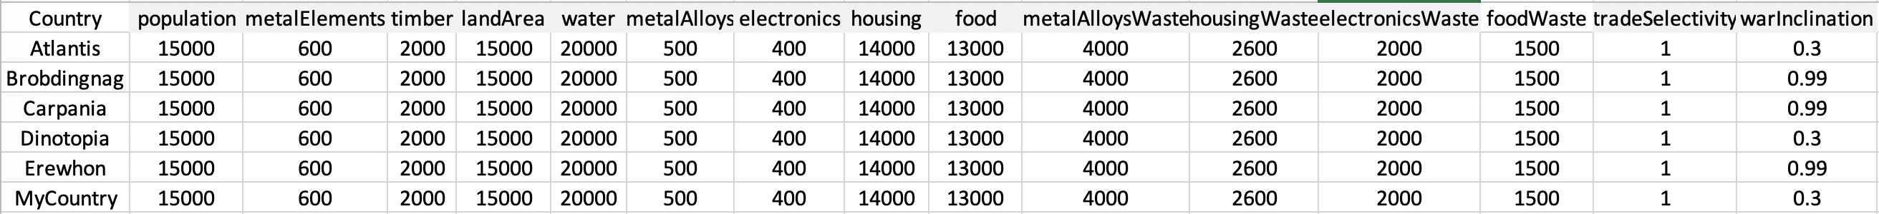

* + Output:

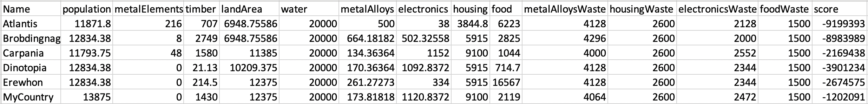

* Test 2
  + Description: In this test case the MLD is ~0.25, representing a world with limited resource inequality.
  + Parameters:
    - num_rounds = 10
    - frontier_size = 100
    - use_dynamic_solution_limit = True
    - use_dynamic_depth_limit = True
    - solution_limit = 1000
    - depth = 3
    - interventions_on = True
    - log_inequality = True
    - seed = 123456654321
    - initial_state_filename = "./input_files/low_inequality.xlsx"
    - initial_resource_filename = "./input_files/Resources.xlsx"
    - initial_interventions_filename = "./input_files/Interventions_case0.xlsx"
    - output_schedule_filename = "./output_files/ low_inequality.txt"
    - game_state_print = True
    - game_state_filename = "./game_output_files/ low_inequality.csv"
    - trade_selectivity_parameters = [0, 100, 1, 200]
  + Input:

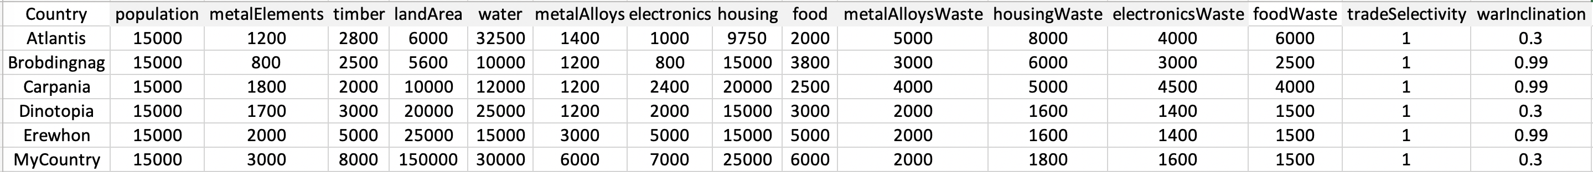

* + Output:

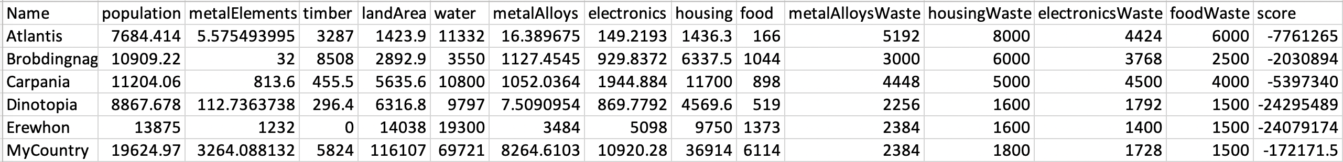

* Test 3
  + Description: In this test case the MLD is ~0.5, representing a world with high resource inequality.
  + Parameters:
    - num_rounds = 10
    - frontier_size = 100
    - use_dynamic_solution_limit = True
    - use_dynamic_depth_limit = True
    - solution_limit = 1000
    - depth = 3
    - interventions_on = True
    - log_inequality = True
    - seed = 123456654321
    - initial_state_filename = "./input_files/high_inequality.xlsx"
    - initial_resource_filename = "./input_files/Resources.xlsx"
    - initial_interventions_filename = "./input_files/Interventions_case0.xlsx"
    - output_schedule_filename = "./output_files/ high_inequality.txt"
    - game_state_print = True
    - game_state_filename = "./game_output_files/ high_inequality.csv"
    - trade_selectivity_parameters = [0, 100, 1, 200]
  + Input:

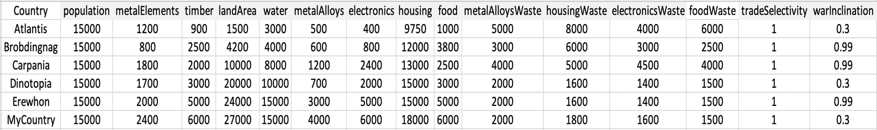

* + Output:

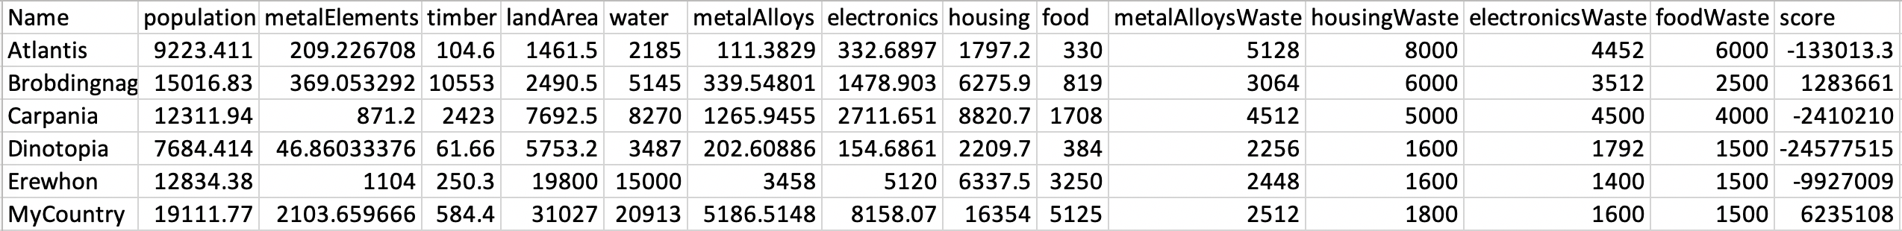

* Results and analysis:

|  |  |  |  |  |  |  |
| --- | --- | --- | --- | --- | --- | --- |
|  | Test 1 |  | Test 2 |  | Test 3 |  |
| Round | Inequality | # of wars | Inequality | # of wars | Inequality | # of wars |
| Start | 0 |  | 0.251509 |  | 0.498422 |  |
| 1 | 0.002323 | 0 | 0.294582 | 2 | 0.544651 | 2 |
| 2 | 0.004054 | 0 | 0.326407 | 2 | 0.436395 | 2 |
| 3 | 0.008479 | 0 | 0.400244 | 2 | 0.497292 | 1 |
| 4 | 0.008792 | 0 | 0.406111 | 2 | 0.491902 | 2 |
| 5 | 0.010472 | 0 | 0.436193 | 2 | 0.464207 | 1 |
| 6 | 0.004700 | 0 | 0.422146 | 2 | 0.454362 | 1 |
| 7 | 0.005740 | 0 | 0.422090 | 2 | 0.477241 | 2 |
| 8 | 0.016614 | 0 | 0.454691 | 2 | 0.513168 | 2 |
| 9 | 0.027315 | 0 | 0.463609 | 2 | 0.540466 | 2 |
| 10 | 0.038455 | 0 | 0.516405 | 3 | 0.560339 | 1 |

We see that when the countries are all equal, no one chooses to go to war as no one has an advantage so only disasters can introduce a degree of inequality. Inequality seems to rise exponentially, suggesting inequality causes greater inequality in our system. When the inequality starts higher, at 0.25, inequality grows much more quickly, then slows down, getting up to around 0.5. When the MLD starts high, at 0.5, inequality changes much less, hovering around 0.5. This suggests an equilibrium in equality. The way our simulation works and the strategies of our actors leads to unequal world states. This is realistic in that in the real world there has always been severe inequality between countries throughout history. The most wars occur in test 2, when inequality changed the most. Test 1 had little change to inequality and no wars. Test 3 was in between. We see that wars cause changes in the equality of the world.