**Varying aggressiveness in regards to war**

* Description: We wanted to observe the effect of countries having different inclinations towards going to war. We use a country resource called warAmbition for this. If this value is lower than the computed war_inclination between 2 countries, war is considered, otherwise it is not. This value is normalized such that 1 represents never going to war and 0 represents taking every war that is perceived as profitable. For each test case all that changes are the warAmbitions. The world state has high inequality to promote war and MyCountry is of average wealthto give it the most options.
* Test 1:
  + Description: All countries have a warAmbition of 1 so there are no wars.
  + Parameters:
    - num_rounds = 7
    - frontier_size = 100
    - use_dynamic_solution_limit = False
    - use_dynamic_depth_limit = False
    - solution_limit = 100
    - depth = 4
    - interventions_on = True
    - log_inequality = True
    - seed = 123456654321
    - initial_state_filename = "./input_files/war_ambition1.xlsx"
    - initial_resource_filename = "./input_files/Resources.xlsx"
    - initial_interventions_filename = "./input_files/Interventions_case0.xlsx"
    - output_schedule_filename = "./output_files/war_ambition1.txt"
    - game_state_print = True
    - game_state_filename = "./game_output_files/war_ambition1.csv"
    - trade_selectivity_parameters = [0, 100, 1, 200]
  + Input:

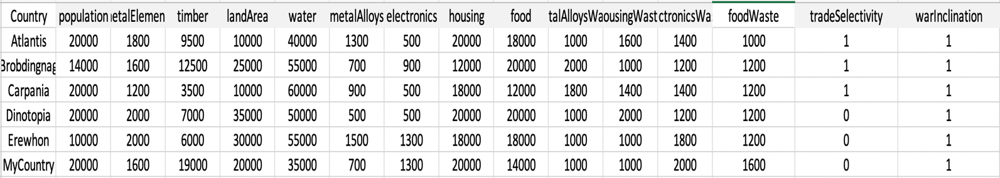

* + Output:

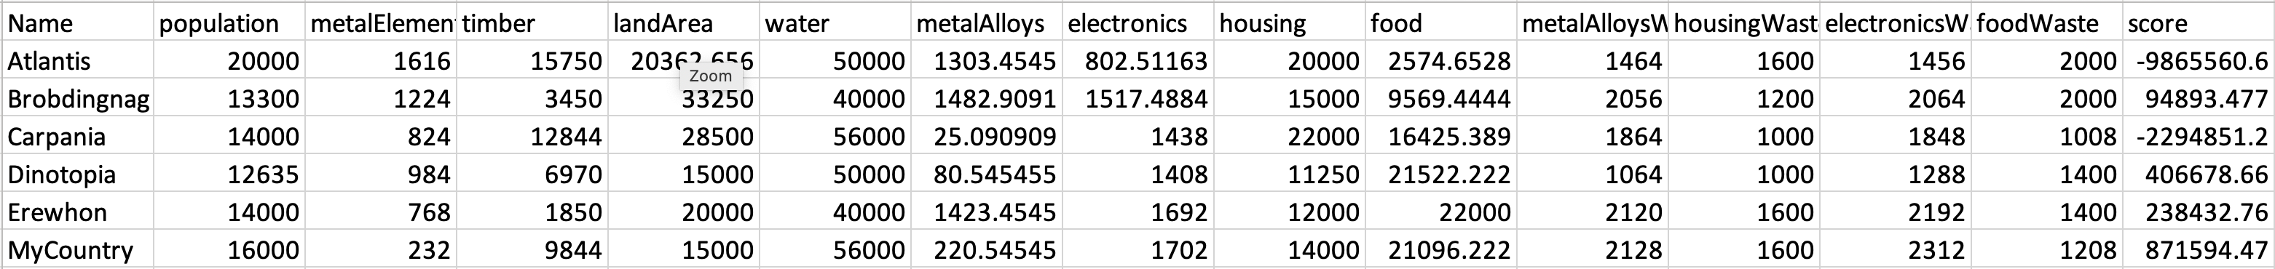

* Test 2:
  + Description: All countries have a warAmbition of 1 except MyCountry which has an ambition of 0.95, representing a strong reluctance to go to war.
  + Parameters:
    - num_rounds = 7
    - frontier_size = 100
    - use_dynamic_solution_limit = False
    - use_dynamic_depth_limit = False
    - solution_limit = 100
    - depth = 4
    - interventions_on = True
    - log_inequality = True
    - seed = 123456654321
    - initial_state_filename = "./input_files/war_ambition2.xlsx"
    - initial_resource_filename = "./input_files/Resources.xlsx"
    - initial_interventions_filename = "./input_files/Interventions_case0.xlsx"
    - output_schedule_filename = "./output_files/war_ambition2.txt"
    - game_state_print = True
    - game_state_filename = "./game_output_files/war_ambition2.csv"
    - trade_selectivity_parameters = [0, 100, 1, 200]
  + Input:

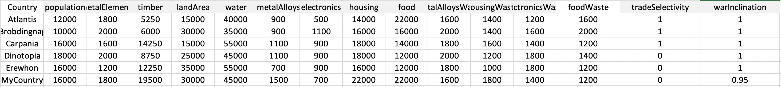

* + Output:

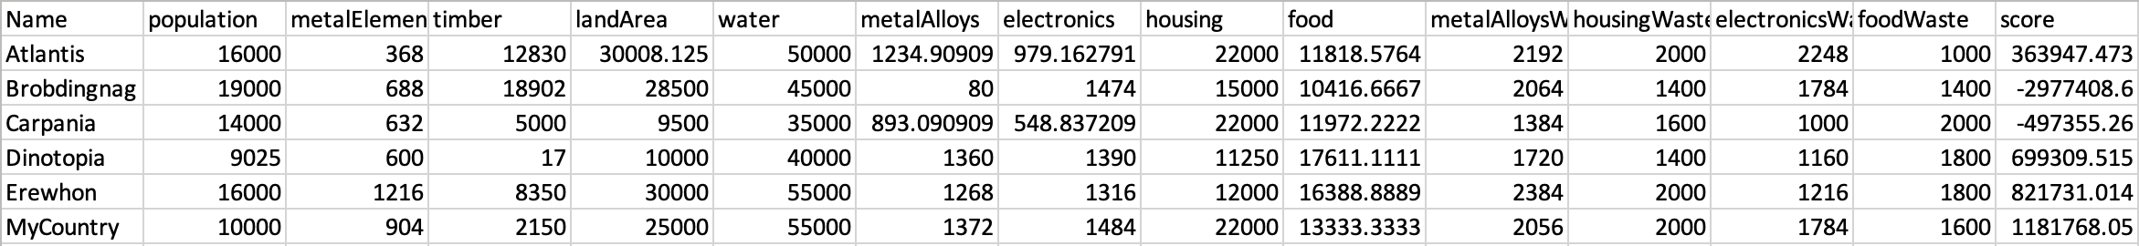

* Test 3:
  + Description: All countries have a warAmbition of 1 except MyCountry which has an ambition of 0.9, representing a weak reluctance to go to war.
  + Parameters:
    - num_rounds = 7
    - frontier_size = 100
    - use_dynamic_solution_limit = False
    - use_dynamic_depth_limit = False
    - solution_limit = 100
    - depth = 4
    - interventions_on = True
    - log_inequality = True
    - seed = 123456654321
    - initial_state_filename = "./input_files/war_ambition3.xlsx"
    - initial_resource_filename = "./input_files/Resources.xlsx"
    - initial_interventions_filename = "./input_files/Interventions_case0.xlsx"
    - output_schedule_filename = "./output_files/war_ambition3.txt"
    - game_state_print = True
    - game_state_filename = "./game_output_files/war_ambition3.csv"
    - trade_selectivity_parameters = [0, 100, 1, 200]
  + Input:

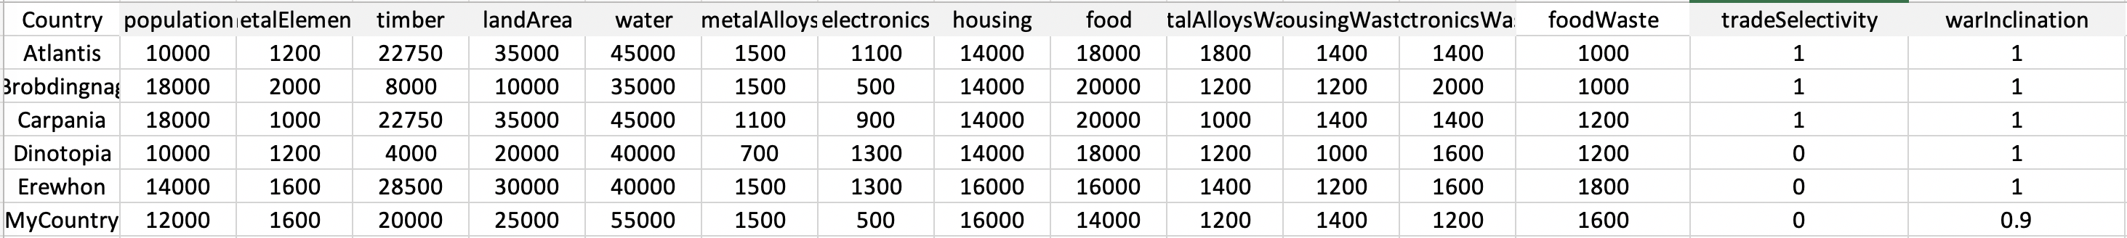

* + Output:

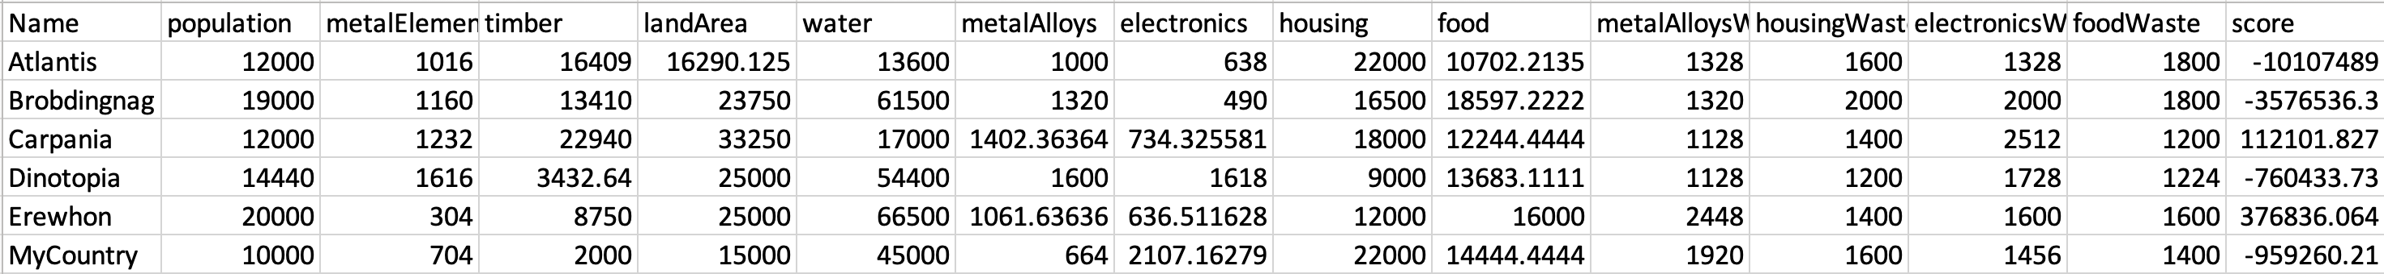

* Test 4:
  + Description: All countries have a warAmbition of 1 except MyCountry which has an ambition of 0.5, representing having interest in war.
  + Parameters:
    - num_rounds = 7
    - frontier_size = 100
    - use_dynamic_solution_limit = False
    - use_dynamic_depth_limit = False
    - solution_limit = 100
    - depth = 4
    - interventions_on = True
    - log_inequality = True
    - seed = 123456654321
    - initial_state_filename = "./input_files/war_ambition4.xlsx"
    - initial_resource_filename = "./input_files/Resources.xlsx"
    - initial_interventions_filename = "./input_files/Interventions_case0.xlsx"
    - output_schedule_filename = "./output_files/war_ambition4.txt"
    - game_state_print = True
    - game_state_filename = "./game_output_files/war_ambition4.csv"
    - trade_selectivity_parameters = [0, 100, 1, 200]
  + Input:

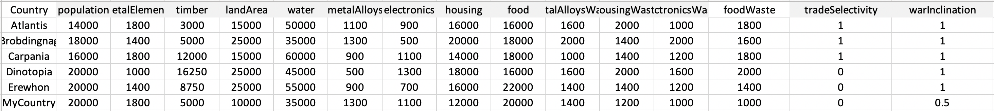

* + Output:

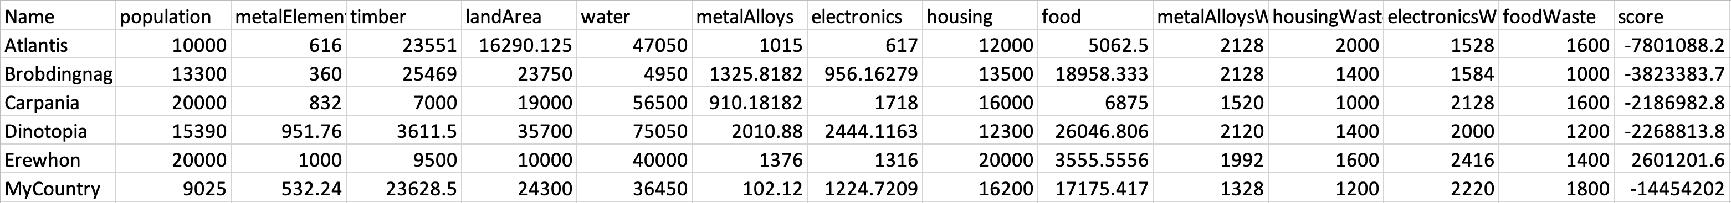

* Test 5:
  + Description: All countries have a warAmbition of 1 except MyCountry which has an ambition of 0, representing having no reservations towards war at all.
  + Parameters:
    - num_rounds = 7
    - frontier_size = 100
    - use_dynamic_solution_limit = False
    - use_dynamic_depth_limit = False
    - solution_limit = 100
    - depth = 4
    - interventions_on = True
    - log_inequality = True
    - seed = 123456654321
    - initial_state_filename = "./input_files/war_ambition5.xlsx"
    - initial_resource_filename = "./input_files/Resources.xlsx"
    - initial_interventions_filename = "./input_files/Interventions_case0.xlsx"
    - output_schedule_filename = "./output_files/war_ambition5.txt"
    - game_state_print = True
    - game_state_filename = "./game_output_files/war_ambition5.csv"
    - trade_selectivity_parameters = [0, 100, 1, 200]
  + Input:

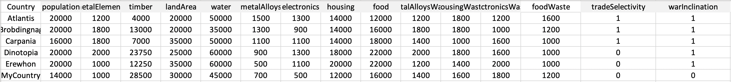

* + Output:

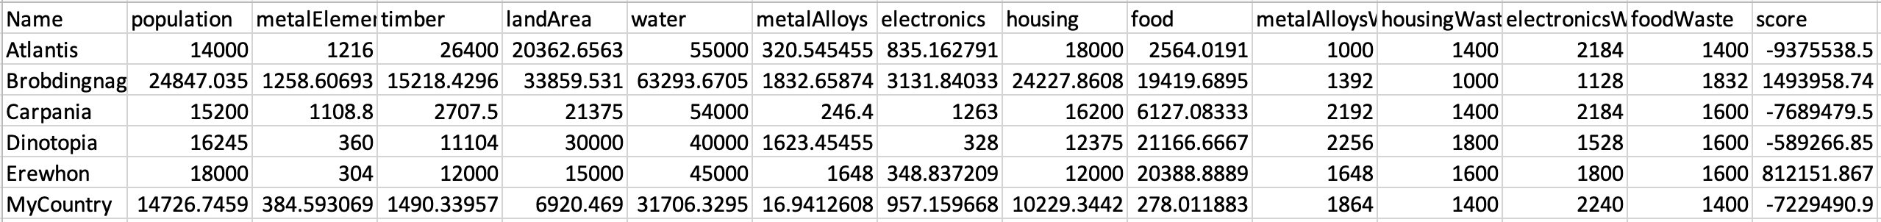

* Results and Analysis:

|  |  |  |  |  |  |
| --- | --- | --- | --- | --- | --- |
| Test case | 1 | 2 | 3 | 4 | 5 |
| Ambition | 1 | 0.95 | 0.9 | 0.5 | 0 |
| Quality change | 871,594.473 | 1,181,768.05 | -959,260.21 | -14,454,202 | -7,229,490.9 |

We can see that MyCountry performs best when it avoids war but is willing to attack if a really good opportunity comes along. Decreasing ambition(making MyCountry more aggressive) results in worse output schedules. This is because MyCountry is fighting too many wars. In the later test cases we can see that MyCountry’s population decreases significantly during the simulation. A small amount of aggression is ideal in our world.