For n=400 m=5

Maximal matching (shows best n similar points)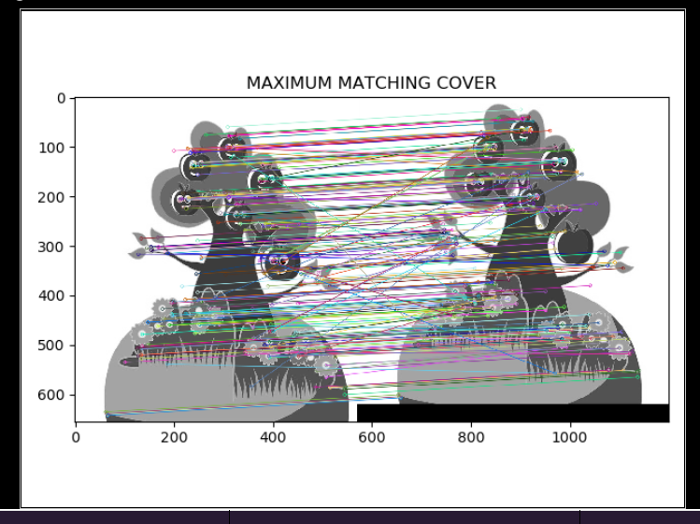

Coordinates file:   
MatchCoordinatesResults.txt

Example of the file content  
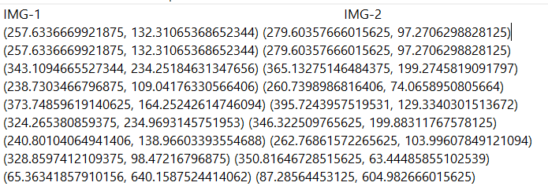

For each point:  
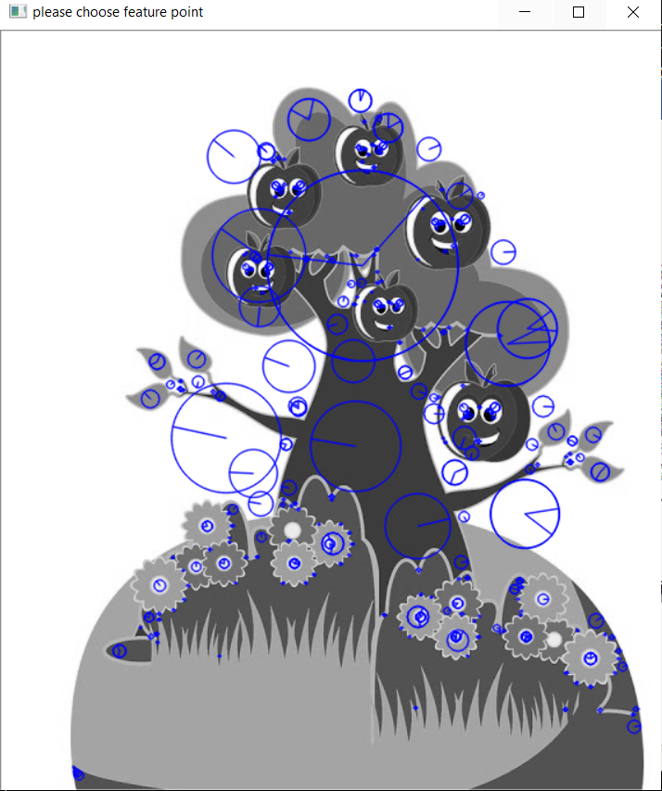

Press the needed point and you will get the m best matches

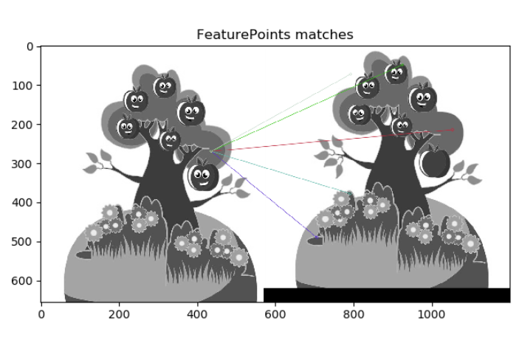another example:

