***P versus NP Problem***

* ***P (polynomial time):***

*P is a class that includes all the problems that can be solved by a reasonably fast program, like multiplication or addition.*

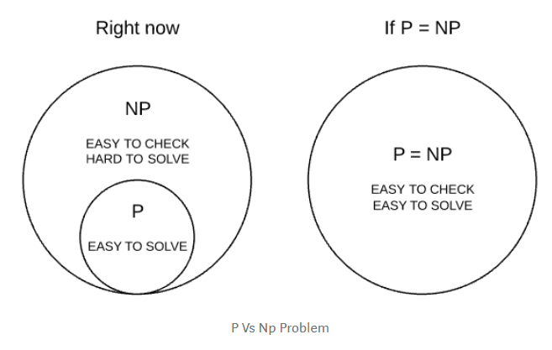

* ***NP*** *(****nondeterministic polynomial time):***

NP is a **complexity *class*** includes all the problems where if you're given a correct solution you can **at least check** it in a reasonable amount of time but computing the correct solution itself is not possible in polynomial time.

**Ex.** **Factorization** can take a long time to solve but if we already know the factors then, we can easily check it for mistakes.

NP contains lots of important problems **like** vehicle routing, scheduling, circuit design, and databases.

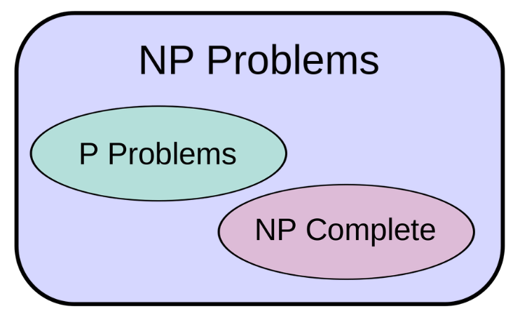

Sometimes we get lucky and find that an NP problem is actually a part of P and we'd have our fast program. But, for a lot of them that didn't seem to be happening.

* ***NP-hard:***

*A problem is NP-hard if an algorithm for solving it can be translated into one for solving any NP-problem (nondeterministic polynomial time) problem.*

*Or*

*that are at least as hard as NP problem hardest part is called "NP-hard".*

* ***NP-complete:***

*A group of problem where if a fast solution to* ***any of one*** *the problem is found we can solve a group of problem in same set of complexity with ease*

*Or*

*NP-complete means that these problems include all the really* ***hard parts*** *of every NP problem.*

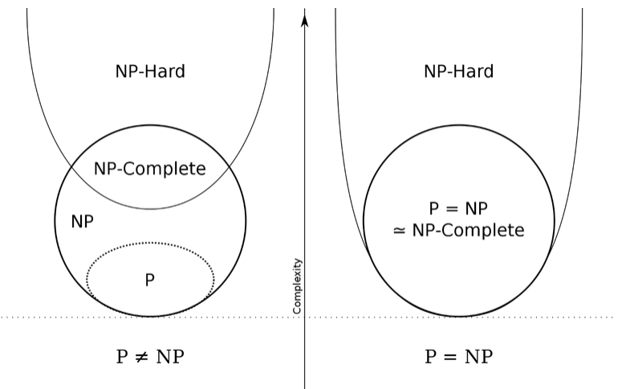

# ***The Computational Complexity:***

*Theoretically, a fast program for solving any NP-complete problem could be used to solve every problem in NP. The whole class would instantly collapse.*

***Ex.***

***Sudoku*** *is hard because it involves, literally, the same NP-complete task that makes* ***protein folding*** *hard.*

*Therefore, solving the NP-complete task of Sudoku in polynomial time would solve the fast protein folding which in turn would help us cure cancer.*

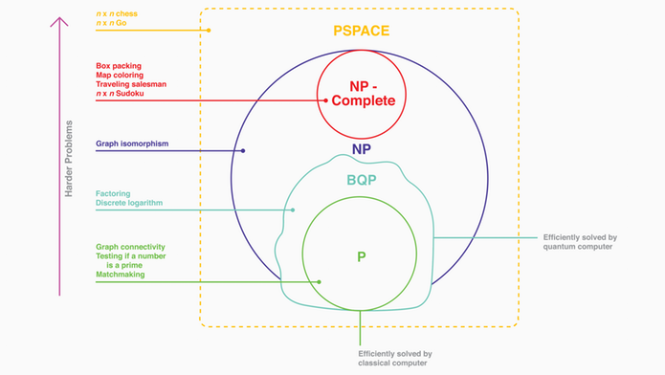

* ***"P-SPACE":***

*The class of problems that can be solved given* ***unlimited time****, but using only a polynomial amount of space for memory.*

* ***“BPP”:***

*The class of problems that can be solved* ***probabilistically*** *in polynomial time.*