

DATE: 31/07/2022

TO WHOMSOEVER IT MAY CONCERN

This is to certify that Mr. MANDAL SUDHIRKUMAR UMESH has worked with our organization from 08 *AUGUST 2021 to 30”JULY 2022 as a Sr. DESIGN Engineer.
He has resigned from the job for better prospectus.
During this tenure he was sinCere and hard working. His conduct & communication skills were good.
We w”sh him all the best for his future.


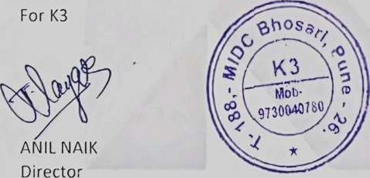

Place: Pune.

