DOE_01
Aditya Pardeshi
2025-07-12
Given this experimental setup (3 factors: Bacteria, Temp, Oxygen; and one response: Rot), this is a full factorial design with categorical predictors. Here’s how to analyze the data using R, step-by-step:

Step 1: Load and Prepare Data
# Assuming the data is in a CSV file
data <- read.csv("potato_rot_data.csv") # Or use read.table()
# Convert factors
data$Bacteria <- factor(data$Bacteria, levels = 1:3, labels = c("Low", "Medium", "High"))
data$Temp <- factor(data$Temp, levels = 1:2, labels = c("10C", "16C"))
data$Oxygen <- factor(data$Oxygen, levels = 1:3, labels = c("2%", "6%", "10%"))

Step 2: Explore the Data
summary(data)
## Bacteria Temp Oxygen Rot
## Low :18 10C:27 2% :18 Min. : 0.000
## Medium:18 16C:27 6% :18 1st Qu.: 4.000
## High :18 10%:18 Median : 8.000
## Mean : 9.407
## 3rd Qu.:14.750
## Max. :26.000
#table(data$Bacteria, data$Temp, data$Oxygen)
boxplot(Rot ~ Bacteria , data = data,
las = 2, main = "Boxplot of Rot by Bacteria")
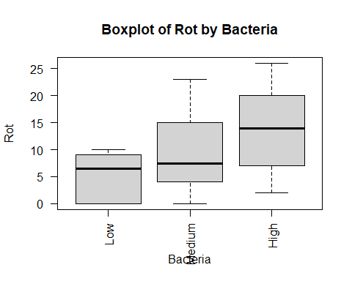
boxplot(Rot ~ Temp, data = data,
las = 2, main = "Boxplot of Rot by Temp")
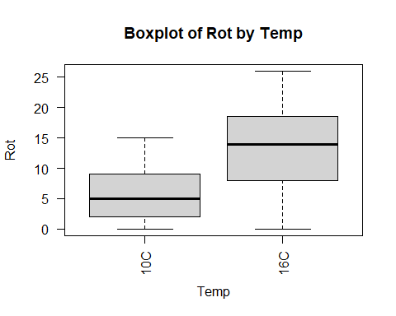
boxplot(Rot ~ Oxygen, data = data,
las = 2, main = "Boxplot of Oxygen")
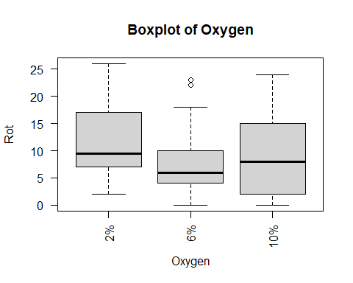

Conclusions: Write some conclusions here

Step 3: Fit Full Factorial ANOVA Model
# 3-way factorial design
model <- aov(Rot ~ Bacteria * Temp * Oxygen, data = data)
summary(model)
## Df Sum Sq Mean Sq F value Pr(>F)
## Bacteria 2 651.8 325.9 13.912 3.34e-05 ***
## Temp 1 848.1 848.1 36.202 6.60e-07 ***
## Oxygen 2 97.8 48.9 2.088 0.1387
## Bacteria:Temp 2 152.9 76.5 3.264 0.0498 *
## Bacteria:Oxygen 4 30.1 7.5 0.321 0.8621
## Temp:Oxygen 2 1.6 0.8 0.034 0.9666
## Bacteria:Temp:Oxygen 4 81.4 20.4 0.869 0.4921
## Residuals 36 843.3 23.4
## ---
## Signif. codes: 0 '***' 0.001 '**' 0.01 '*' 0.05 '.' 0.1 ' ' 1

Conclusions: Write some conclusions here

Step 4: Check Assumptions
# Residual diagnostics
par(mfrow = c(2, 2))
plot(model)
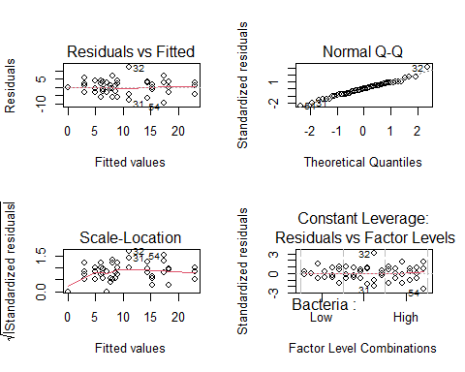
# Normality test
shapiro.test(residuals(model))
##
## Shapiro-Wilk normality test
##
## data: residuals(model)
## W = 0.98401, p-value = 0.6845
# Homogeneity of variances
library(car)
## Loading required package: carData
leveneTest(Rot ~ Bacteria * Temp * Oxygen, data = data)
## Levene's Test for Homogeneity of Variance (center = median)
## Df F value Pr(>F)
## group 17 0.5682 0.8933
## 36

Conclusions: Write some conclusions here

Step 5: Interpret Significant Effects
# Use interaction plots to visualize interactions
interaction.plot(data$Bacteria, data$Temp, data$Rot, col = c("red", "blue"))
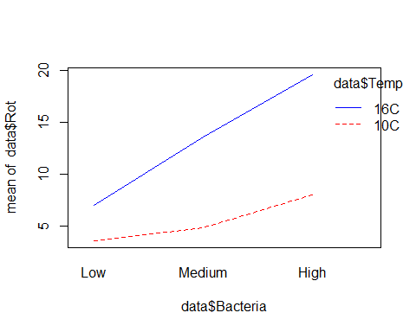
interaction.plot(data$Oxygen, data$Temp, data$Rot, col = c("green", "orange", "purple"))
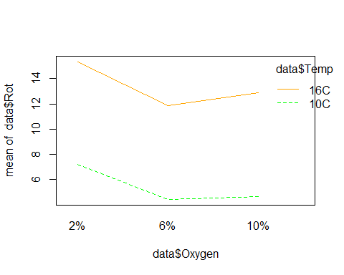
# If needed, do post-hoc comparisons
# library(emmeans)
# emmeans(model, pairwise ~ Bacteria | Temp * Oxygen)

Conclusions: Write some conclusions here

Step 6: Simplify Model (if interactions are not significant)
# Fit reduced model if interactions are not significant
model_reduced <- aov(Rot ~ Bacteria + Temp + Oxygen, data = data)
summary(model_reduced)
## Df Sum Sq Mean Sq F value Pr(>F)
## Bacteria 2 651.8 325.9 14.102 1.52e-05 ***
## Temp 1 848.1 848.1 36.696 2.05e-07 ***
## Oxygen 2 97.8 48.9 2.116 0.132
## Residuals 48 1109.3 23.1
## ---
## Signif. codes: 0 '***' 0.001 '**' 0.01 '*' 0.05 '.' 0.1 ' ' 1
# Compare models
anova(model_reduced, model)
## Analysis of Variance Table
##
## Model 1: Rot ~ Bacteria + Temp + Oxygen
## Model 2: Rot ~ Bacteria * Temp * Oxygen
## Res.Df RSS Df Sum of Sq F Pr(>F)
## 1 48 1109.33
## 2 36 843.33 12 266 0.9462 0.5144

Step 7: Report Final Model
# Final model summary and estimated effects
summary(model)
## Df Sum Sq Mean Sq F value Pr(>F)
## Bacteria 2 651.8 325.9 13.912 3.34e-05 ***
## Temp 1 848.1 848.1 36.202 6.60e-07 ***
## Oxygen 2 97.8 48.9 2.088 0.1387
## Bacteria:Temp 2 152.9 76.5 3.264 0.0498 *
## Bacteria:Oxygen 4 30.1 7.5 0.321 0.8621
## Temp:Oxygen 2 1.6 0.8 0.034 0.9666
## Bacteria:Temp:Oxygen 4 81.4 20.4 0.869 0.4921
## Residuals 36 843.3 23.4
## ---
## Signif. codes: 0 '***' 0.001 '**' 0.01 '*' 0.05 '.' 0.1 ' ' 1

Conclusions: Write some conclusions here
📌 Notes:
- You are performing a 3 × 2 × 3 factorial ANOVA.
- If sample sizes are equal (54 total = 3 × 2 × 3 × 3 replicates), then standard ANOVA is valid.
- Post-hoc tests help understand where differences lie if main effects or interactions are significant.
If you provide your dataset file or sample rows, I can help with exact plots and interpretation.

