1. **INTRODUCTION**
   1. **OBJECTIVES OF PROJECT**

The primary objective of the project is to develop a model that can help to manage the traffic and in short make life much more easier. Traffic congestion is one of the major problem of every metro city in the world. And it reaches it's peak during the offices hours in the morning and in the evening when they get back. Its real annoyance and can only can understood by someone faces it on daily basis. So a solution to the problem like this is a must and this is what exactly we are doing through this project.

A lot of thinking goes into how to reduce the traffic even its by a minute factor. There are infact some solutions that people have thought of are and in place in various parts of the world (discussed in future sections). But not to forget that those are highly area specific solutions and can never be implemented in a country like India. With its vast population and traffic arrangements it needs it own traffic management system that takes into account all these factors.

And the solution we are proposing clearly does that. Moreover, as we unfold our hypothesis in upcoming sections, it will be more clear what else these other implementations lack compared to our model.

* 1. **HISTORICAL BACKGROUND**

The history of traffic signals and signal systems begins with the busy intersection of Bloor Street and Yonge Street. It was home to Toronto’s first traffic signal in 1925. The following year saw the installation of signals at many more intersections.

The introduction of computers into the realm of traffic control was pioneered in Toronto in 1959. Metro Council has concluded that improvements to traffic signal control were needed to complement the rapid expansion of the arterial road network. Metro Council authorized a small-scale pilot study to examine the practicality of introducing a new traffic signal system which could be centrally controlled through the use of an electronic computer.

At the time, only specialized analog type equipment was available in the industry, and this would result in huge costs to replace signal controller hardware, with limited opportunity to introduce innovative strategies in either the theory or practice of traffic control. A research report suggested that if a general purpose digital computer was operated in real time, it could take in traffic information from a large number of vehicle detectors, select timings and offsets, and optimize these for overall system efficiency. Although this suggestion appeared attractive, some doubts were expressed concerning the ability of a digital computer to perform in the required manner. Therefore, a network of 15 signals was controlled in various ways ranging from pre-timed to fully traffic responsive to test the feasibility. This proved to be so successful that it was decided to proceed with the full scale system.

Metro proceeded with the installation of the world’s first full-scale, real-time, automatic traffic control computer in June 1963. A key to success was that the Metro Roads and Traffic Department had been granted authority over all existing or new signals within the then Metropolitan Toronto. The first phase of the system required the installation of 1,000 vehicle detectors, and the connection of each controller through leased telephone lines to the computer, which was located on the main floor of the Old City Hall. In a comparative sense, it was the second largest on-line control system in the world, exceeded only by the North American Air Defense Command (NORAD) installation.

Initially the system was responsible for 500 signals, but as Metropolitan Toronto grew, so did the number of signalized intersections that were to be controlled. Unfortunately the original traffic computer was capable of controlling only 1,164 intersections, and Toronto soon surpassed that figure as the city experienced rapid growth. In 1978 it was decided that a replacement system was necessary. This new traffic control center was located underground as part of the Sheppard subway station on the Yonge Line. It became operational in the early 1980s.

By the mid-1980s, the capacity of the Gardiner/Lake Shore corridor had reached its limit. A feasibility study confirmed the benefits of installing a corridor traffic management system (CTMS). Construction of the CTMS was approved in 1987 by Metro Council. However, around the same time it was becoming apparent that Toronto could benefit from the development of an Integrated Traffic Control Centre (ITCC) which would combine the operation of the corridor system with the traffic signal control system. The implementation of this ITCC was subsequently approved in 1989.

**1.3. RELEVANCE**

The development of traffic control systems for urban streets has paralleled the development and use of the automobile. After World War I, rapid growth in automobile traffic led to requirements for special personnel, signals and systems to address the problem.

In typical urban areas, approximately two-thirds of all vehicle-miles of travel, and even a higher percentage of vehicle-hours of travel, take place on facilities controlled by traffic signals [1]. To a major extent, therefore, the quality of traffic signal operation determines urban vehicular traffic flow quality.

Traffic signals originated with signaling system technology developed for railroads. In 1914 [2], Cleveland, Ohio installed the first electric traffic signal in the United States. In 1917, Salt Lake City introduced an interconnected signal system that involved manually controlling six intersections as a single system [3]. In 1922, in Houston, Texas, 12 intersections were controlled as a simultaneous system from a central traffic tower. This system proved unique in its use of an automatic electric timer.

The year 1928 saw the introduction of a flexible-progressive pretimed system. Municipalities quickly accepted these pretimed systems and widespread installation followed in virtually every U.S. city.

However, early pretimed systems had limited flexibility. They could respond only to predicted traffic changes via preset changes on a time clock. But predicting traffic conditions proved difficult because of the needed data collection efforts. Agencies usually avoided timing changes because of the staffing and time resources required to make changes at each local intersection controller.

Traffic-actuated local controllers using pressure detectors became available during the period 1928-1930. These controllers proved a first step toward traffic-actuated control but applied only to isolated intersections.

In 1952, Denver, Colorado advanced the state-of-the-art of traffic control systems by developing and installing an analog computer control system. This system applied some actuated isolated intersection control concepts to signalized networks. Sampling detectors input traffic flow data, and the system adjusted its timing on a demand rather than time-of-day (TOD) basis. Over one hundred systems of this type were installed in the United States in the period 1952-1962.

In 1960, Toronto conducted a pilot study using a digital computer to perform centralized control functions [4]. The amount of traffic data available from this form of control proved a fortunate by-product. While the computer used for the test was archaic by today's standards - an IBM 650 with about 2,000 words of drum memory - the success of this control system approach encouraged Toronto to proceed with full-scale implementation. The city placed 20 intersections under computer control in 1963, and later expanded the system to 885 intersections by 1973.

International Business Machines (IBM) began a cooperative development in 1964 with the City of San Jose, California, to further develop a computer traffic control system [5]. The project used an IBM 1710 computer. Control concepts developed and implemented proved successful in significantly reducing stops, delays, and accidents.

Beginning in 1965, the City of Wichita Falls, Texas, contracted for the delivery of an IBM 1800 process control computer for traffic control. This system was placed in daily operation in 1966, controlling 56 intersections in the central business district. It was later expanded to include 78 intersections. San Jose, California, shortly thereafter made a transition to an IBM 1800 computer, and similar systems were installed in Austin and Garland, Texas; Portland, Oregon; Fort Wayne, Indiana and New York City. In these systems, traffic signals were controlled by using stored timing plans developed off-line.

In 1967, the Bureau of Public Roads, currently the Federal Highway Administration (FHWA), began to develop the Urban Traffic Control System (UTCS) Project. The system was installed in Washington, D.C., to develop, test, and evaluate advanced traffic control strategies [6]. Completed in 1972, it contained 512 vehicle detectors whose outputs determined signal timing at 113 intersections. Extensive data processing, communications, and display capabilities were made available to support traffic control strategy research. Later efforts produced the Extended and Enhanced versions of the software package that implemented these concepts.

The 1970s also saw continuing research and development of software packages and models for digital computer and microprocessor based traffic control systems. The Transport and Road Research Laboratory (TRRL) in Great Britain developed the advanced centrally controlled traffic system, Split, Cycle and Offset Optimization Technique (SCOOT), in the 1970s with implementation taking place in Glasgow and other cities in the 1980s. SCOOT has been installed in several North American cities including Toronto, ON. Another advanced system, Sydney Coordinated Adaptive Traffic System (SCATS), developed in Australia, has been implemented in many cities throughout the world. SCOOT and SCATS initiated the deployment of responsive control systems. Adaptive control techniques, represented by Optimized Policies for Adaptive Control (OPAC) and RHODES, have also begun to be implemented.

**2. LITERATURE SURVEY**

**2.1 INTRODUCTION**

**2.1.1 INTERNATIONAL STATUS -** Current Computer Traffic Signal Systems in Toronto.

Computerized traffic control signal systems are used to view and manage current traffic conditions, diagnose signal system problems and implement/modify signal timings remotely. The City of Toronto operates the following two computerized traffic control signal systems:

1. TransSuite Traffic Control System (TransSuite TCS) – TransSuite TCS is a hybrid traffic control system that relies on second-by-second communication to monitor signal operations but relies on field equipment to maintain coordination (i.e. the field equipment can maintain signal coordination for about 24 hours if there is a loss of communication). TransSuite TCS does not directly control signal movements but commands each intersection controller to follow a timing plan that resides within its local database. TransSuite then verifies that the controller adheres to the commanded timing plan. Intersection controllers are monitored and controlled through a user interface. TransSuite TCS supports a variety of phase-based controllers.

2. Split Cycle Offset Optimization Technique/Urban Traffic Control (SCOOT/UTC) – SCOOT is an adaptive traffic control system that determines its traffic timing plans based on real-time information received from vehicle detectors located on the approaches to signalized intersections. Like MTSS, SCOOT relies on telephone communication to maintain signal coordination. UTC is a traffic control system that operates in tandem with SCOOT; it also relies on telephone communications. UTC provides pre-determined signal timing plans and is used as a stopgap measure if SCOOT is not available. SCOOT signals are sometimes called "smart" signals.

**2.1.2 NATIONAL STATUS - T**he Diamond City(Surat), which is witnessing tremendous growth in vehicular traffic, is gearing up for a smart traffic control system. All the traffic intersections, be it small or big, will soon have adaptive traffic control system (ATCS) based on sensors to regulate the flow of traffic.

An advanced signaling system used in several European countries as well as in China, the ITMS is being modified to suit Indian traffic conditions. A Thiruvananthapuram-based company has bagged the tender for installing ATCS in the city.

The civic body has identified around 267 traffic junctions where the smart sensors will be installed along with 398 high-density CCTV cameras. The virtual loop cameras of this intelligent traffic signal system would constantly read the density of traffic and adjust the green/red light duration accordingly to ensure there is more of red light on directions which have lesser vehicular density and more of green for routes having a greater number of vehicles.

At present, the traffic signals are controlled with fixed timers of 120 seconds. The commuters on the traffic signals have to stop for 120 seconds compulsorily, whether there is traffic or no traffic.

An integrated computer-based sensor system will control the duration of the red or green light at the traffic junctions, depending on the density of the vehicular traffic. These smart traffic signals will allow the free flow of vehicular traffic from one junction to another.

For the first time, this system would also ensure red lights on all directions to facilitate movement of pedestrians. The other type of facility is that pedestrians will cross half of the road while traffic flows on the other side. A 'hooter' will alert the pedestrians to cross in 10 to 20 seconds time when the pedestrian signal would turn green.

As per Regional Transport Office (RTO) figures, the city has around 29 lakh vehicles plying on the city roads. Every year, around 1.7 lakh vehicles are added onto the city roads.

**3.BLOCK DIAGRAM**

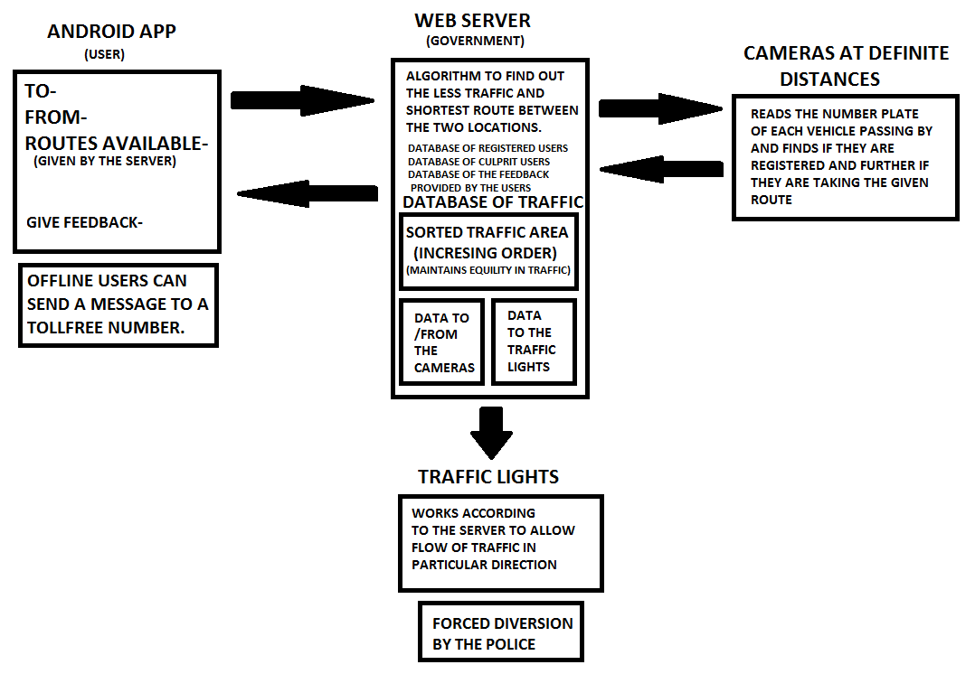

Fig 1: Complete Block Diagram

**4. METHODOLOGY**

Many solutions have been proposed to solve the traffic related issues but the uniqueness of this model is that it predicts the traffic that is going to be in next 15 minutes, and accordingly we can manage the traffic.

An android app will be installed in the user’s phone (as 90% of the population that creates traffic have an android phone, this will not be an issue). Every user will be uniquely identified by his ID card i.e. Adhaar Card, PAN card, Driving license. During registration, the user has to mention the vehicle plate number.

Before going to a journey,15 minutes prior to the journey he will enter his journey details i.e. initial location, final location, two/four wheeler. This data will be handled by the government and according to the traffic that is going to be next 15 minutes, they will provide a suitable route for the user. If the server detects that major traffic is going to be in particular route, then the server can manually operate the traffic lights that are in between them and allow the respective flow of traffic. After user will get the route provided by the server. The various cameras (connected with a microcontroller) that will be installed at various places will get the vehicle plate numbers that are going to pass. If unknown plate number is detected (using image processing) then there are three possibilities -

1. Vehicle plate number is not registered.

2. Vehicle plate number is registered, but the user has not filled in the details prior to the journey.

3. Vehicle plate number is registered, but the user is not following the required path.

Unknown number plates will be scanned and pushed to the server. Where proper actions can be taken against them. It will alarm as soon as this kind of vehicles is passed so that police can catch them. Also, it will be a good idea to replace the hard copy driving license to an android app. So at regular intervals traffic police can check who all have installed an app at the same time it will be easy for the user to carry.

Nowadays a lot of cases came into picture related to the traffic police taking the bribe. If we implement this app license concept we can totally overcome this problem. As there will be a record of a number of culprit vehicle plate number on the server, so corruption can be decreased to a great extent.

After the user is reached to its required destination, the data will be popped out of the database. By this model, we can reach to every individual person for any information.

**5. EXPERIMENTATION**

Users android phone which is acting as an interface between the cloud and user-end will have a simple elemental-UI asking for route and vehicle option i.e. 2-wheeler or 4-wheeler. For the new users, we will ask them to register using AADHAR UID to uniquely identify everyone. Later On, after registration Users have to add there Driving license by doing this user can directly show the DL on the app. Fine and other penalties can be done digitally without any fraud.

Accordingly, the data will be pushed to the cloud where we will update the database and other journey details. Starting and end of the journey will act as two nodes in our graph where weights on the edges will be updated according to the number of people in between the two locations i.e. in between two nodes.

We will have smart traffic lights where we will install Beaglebone-Black. Beaglebone will dynamically change the timing setting of the traffic light for smooth traffic flow.

Beaglebone will also be connected to the camera that will continuously scan the live traffic density within a particular area. Timing setting will depend on the image processing output from the camera. We will keep track of this data with there timestamps to do analysis via machine learning. So that we can find out which routes have higher traffic and at what duration of the day.

Using these data we can forcefully diverge the traffic to some other route at a certain instance of the day. These servers and traffic light components authentications will be given to police to facilitates its working.

After we get data from the user onto the server further processing as we have discussed will occur and the server will send the required route to the users android app.

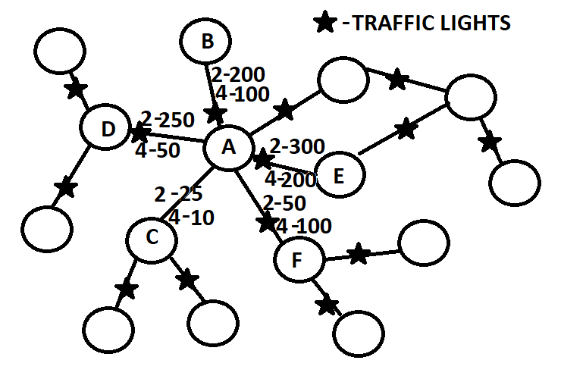Fig 2: Traffic Structure

If we consider the above graph where each node represents an individual place and weights on the edges represents the number of two-wheelers and four-wheeler between two places. According to these weights, we can change the traffic lights settings accordingly. From the machine learning analysis, we can analyze where more number of traffic police are required.

We can also provide the feedback column in the Android app, where the user can give his query related to faulty roads and other related problems. This will be directly managed by the government so it will be easy to solve the problems. We can also provide emergency services in case of accident or robbery during the journey. We can design our system such that only specific number of trucks, cars, and motorbikes are there at any given instant, and if they are more in number we can even request the user to delay his journey for few minutes.We can even provide SMS service for the users who don’t have internet access.

**6. PROJECT SCHEDULE**

