<https://www.youtube.com/watch?v=7xngnjfIlK4&t=1480s>

Terraform:

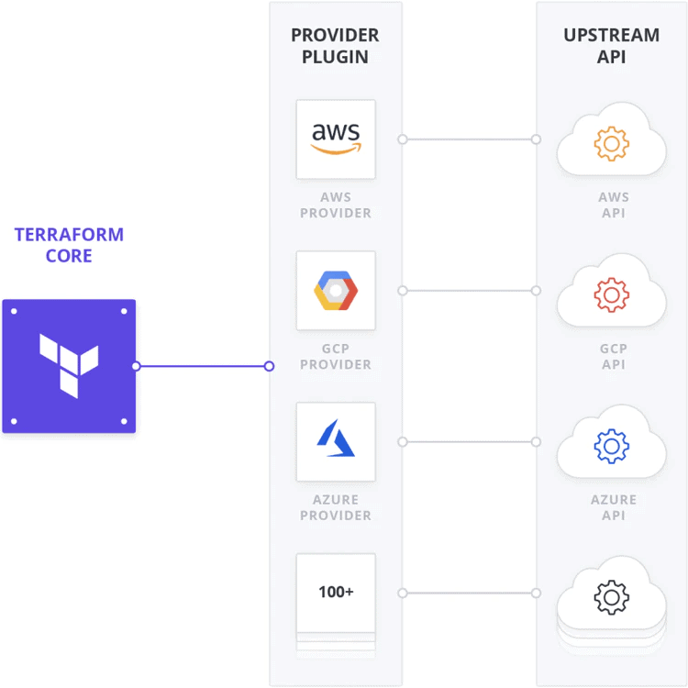

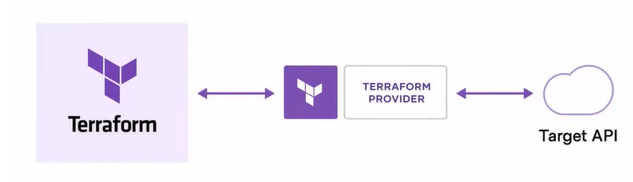

Cloud infrastructure is provisioned by

* Gui
* Cli / api
* Iac

Workspace:

It is the working env from the single main terraform file like pro, dev etc

* terraform workspace list -> list all the ws
* terraform workspace show -> list the current working ws
* terraform workspace new <ws-name> -> create new ws