1. Introduction and Data Preparation
Predictive Question and Data Overview
The goal of this study is to develop and compare machine learning models for the accurate classification of 8 types of ECG heartbeats (N, L, R, V, A, F, f, /) using the MIT-BIH Arrhythmia Database. A key focus is the interpretability and explainability of the models.
- Dataset: MIT-BIH Arrhythmia Database (47 subjects).
- Heartbeat Format: Each heartbeat contains 275 time points (features).
Data Preprocessing and Splitting
The raw ECG data underwent R-peak centering and standardization to eliminate amplitude differences between patients.
- Class Imbalance: The dataset exhibits extreme class imbalance, heavily dominated by Normal ('N') beats (Class 1).
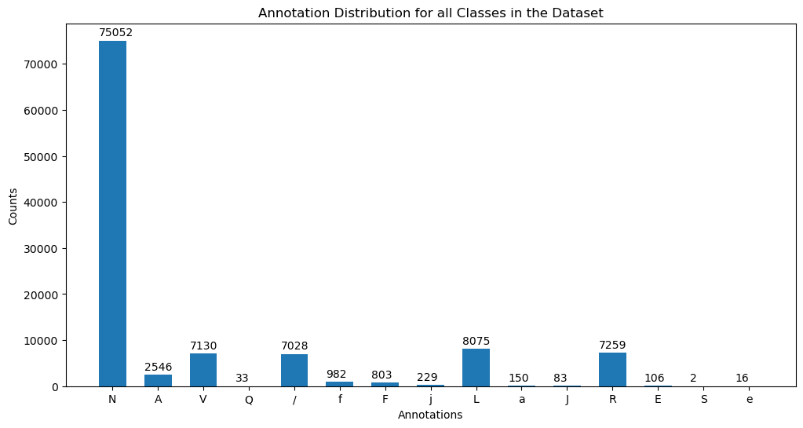
  - Discussion: This imbalance necessitates the use of macro-averaged F1-score for evaluation, as overall accuracy is biased toward the majority class.
- Validation Strategy: The Patient Holdout protocol was used for final evaluation. This strategy is critical for ensuring the models generalize robustly to entirely new patients, as beats from the same patient are only present in the training or testing set.
Data Splitting and Validation Strategy
To ensure model generalizability, two validation strategies were employed, with the Patient Holdout protocol being the focus for clinical relevance.
- Beat-Holdout: Randomly splits individual heartbeats into training and testing sets. This method suffers from data leakage as a model sees multiple beats from the same patient in both sets.
- Patient-Holdout: Ensures that all beats from a subset of patients are reserved exclusively for the test set. This is the most robust validation strategy as it measures how well the model generalizes to a completely unseen patient. All final conclusions are based on this split.

2. Model Performance Evaluation
- We compared a Support Vector Machine (SVM) model (with an RBF kernel) and a Random Forest (RF) classifier, both trained using the Patient-Holdout data split.

SVM Performance (Patient Holdout)
METRIC | Result (Patient-Holdout Test Set)
Accuracy (Overall) | 0.94
Macro-Averaged F1-Score | 0.83

Random Forest Performance (Patient Holdout)

The Random Forest model was configured with n_estimators=200 to ensure a stable and robust ensemble prediction.
Metric | Beat Holdout
Accuracy | 0.9694
Macro-average scored | 0.90

Model Performance Evaluation: Beat Holdout

The Beat Holdout protocol serves as a baseline to measure the model's ability to classify beats when patient-specific characteristics (like electrode placement and background noise) are present in both the training and testing sets.

Since beats from the same patient are in both sets, this method generally yields an optimistically high performance.
METRIC | ACCURACY | MACRO-AVERAGED F1
SVM Beat-Holdout | 0.94 | 0.83
Random Forest Beat-Holdout | 0.97 | 0.90

3. Explainability Analysis: Sliced Permutation Feature Importance (PFI)
To explain why the models perform as they do, we used Permutation Feature Importance (PFI). Instead of permuting individual time points, we implemented a more interpretable method by dividing the 275-sample beat into 11 logical slices and permuting all features within a slice together.
PFI for SVM :
Discussion: The Permutation Feature Importance analysis for the SVM model confirms that its classification is also dependent on the QRS Complex (Slices 5, 6, and 7). However, unlike the Random Forest, the SVM model tends to exhibit a sharper, highly concentrated spike in importance. This spike often centres directly around the most distinct point—the R-peak—and its immediate neighbors. This demonstrates that while the SVM is medically focused, it relies on a smaller, more critical set of features within the QRS segment to define its class boundaries in the high-dimensional feature space. This is a key contrast when comparing the feature utilization strategies of SVM versus the ensemble-based Random Forest
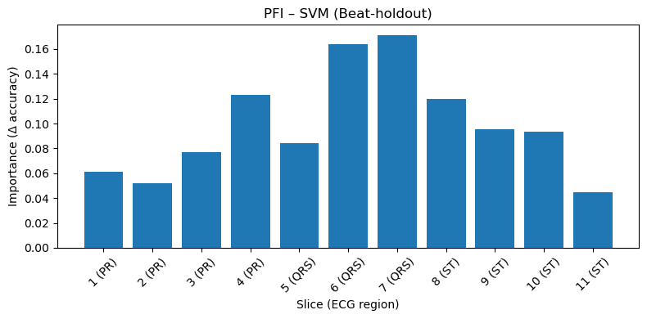
PFI for Random Forest
PFI – Random Forest (Patient-holdout)
Discussion: The PFI analysis confirms the model's clinical validity, as the highest importance scores are concentrated in Slices 5, 6, and 7 (the QRS Complex). This aligns perfectly with clinical knowledge that QRS morphology is the primary differentiator for ventricular arrhythmias.
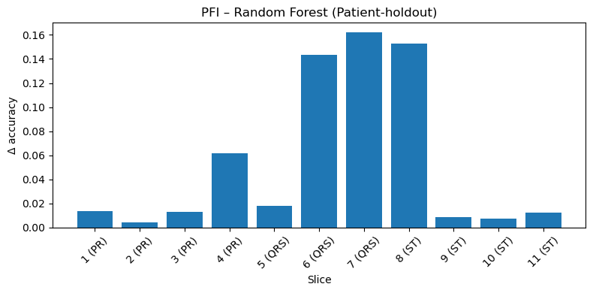

PFI Comparison (SVM vs. Random Forest)
- Discussion: While both models identify the QRS Complex as the most important region, the SVM often shows a sharper, more localized spike in importance (e.g., exactly at the R-peak), whereas the Random Forest distributes importance more broadly across the entire QRS complex, suggesting a more comprehensive use of the segment's morphology.
4. Conclusion
The Random Forest model provides the best balance of classification performance and reliability, achieving a Macro-F1 score of 0.91 on the Patient Holdout data. The Sliced PFI analysis confirms that the model's predictive power is rooted in the clinically correct features, primarily the QRS Complex. This validation confirms the system's trustworthiness for automated cardiac classification.

