IV Group Project:
Multiview Visualisation

Information Visualisation, University of Glasgow

Group 17
19th March 2026

Demo Video on YouTube: Group17_Information Visualization Group Project
Dashboard: Glasgow Weather Data Visualization

1. The Data
Title: Glasgow Weather Dataset (2015-2019), A five-year daily record of weather conditions in Glasgow, United Kingdom.
Source: The dataset was obtained from Kaggle (https://www.kaggle.com/datasets/phyamal/glasgow-weather-data-20152019) and contains 1,795 daily observations spanning from 1 January 2015 to 30 November 2019. Each row represents a single day, making this a tabular, flat-file dataset with no hierarchical nesting in its raw form.
Data categorisation (using Munzner, 2014, Chapter 2 terminology):
- Dataset type: Table (flat table with items and attributes). Each item is a day; each attribute is a measured weather variable.
- Attribute types: The dataset contains quantitative attributes (tempMin, tempMax, windSpeed, humidity, visibility, cloudCover, all continuous, ratio-scale measurements), categorical/nominal attributes (desc, six weather categories: rain, clear-day, partly-cloudy-day, cloudy, fog, unknown; and summary, free-text descriptions), and a temporal/ordered attribute (day, sequential dates).
- Derived attributes: We computed several additional attributes to support our tasks: tempRange (quantitative, derived as tempMax minus tempMin), avgTemp (quantitative), month and year (ordinal, extracted from day), season (categorical, mapped from month), monthName (ordinal), and dayOfYear (quantitative sequential).
- Ordering direction: Temperature, wind speed, and visibility are diverging in nature (both high and low values carry meaning), while humidity and cloud cover are sequential (0 to 1 ratio scale). The temporal attribute day provides a natural sequential ordering.
- Data quality: The raw dataset contained 7 null values in summary (filled with "No description"), 184 blank values in desc (filled with "unknown"), and 3 null values in cloudCover (filled with the column median of 0.71). No outliers were removed.
The dataset is well suited for multiview visualisation because it combines temporal, quantitative, and categorical dimensions, enabling exploration of seasonal trends, weather-type distributions, and correlations between atmospheric variables. Its moderate size (1,795 items, 9 original attributes plus 7 derived) is manageable for interactive client-side rendering while being rich enough to reveal meaningful patterns.

2. The Tasks
We defined five tasks that cover a range of the task taxonomy from Munzner (2014, Chapter 3). Each task requires users to perform different actions on different targets, ensuring variety in the cognitive operations demanded by our systems.
T1: Identify the season or month with the highest average temperature range.
Action: Identify (find an extreme value). Target: One attribute (tempRange) across a categorical grouping (season/month). This is a lookup task requiring the user to compare aggregated values and locate the maximum. It tests the system's ability to support comparison of means across groups.
T2: Find the top 3 weather types (desc) by frequency across the dataset.
Action: Identify + Rank (find and order extremes). Target: Distribution of a categorical attribute (desc). This requires counting occurrences and sorting, testing whether the system supports frequency-based ranking of categories effectively.
T3: Determine which year had the highest average wind speed.
Action: Identify (find an extreme). Target: One quantitative attribute (windSpeed) across a temporal grouping (year). Similar to T1 but uses a different attribute and temporal rather than seasonal grouping.
T4: Find the weather type with the highest average visibility, filtered by a minimum humidity threshold (humidity > 0.85).
Action: Filter + Identify. Target: One attribute (visibility) within a filtered subset (humidity > 0.85). This compound task tests the system's ability to support interactive data selection followed by identification of an extreme, which is critical for evaluating slider-based filtering.
T5: Identify months where wind speed is above a user-set threshold AND humidity is above a user-set threshold. Find the top 3 seasons with the highest average cloud cover.
Action: Filter + Identify + Rank. Target: Multiple attributes with compound filtering. This is the most complex task, requiring simultaneous adjustment of two slider thresholds followed by identifying and ranking seasonal aggregates. It tests the system's ability to support multi-constraint exploration.
These tasks collectively cover the actions of identify, compare, rank, and filter, applied to targets including individual attributes, distributions, extremes, and filtered subsets (Shneiderman, 1996). Task T4 specifically involves selection of a data subset, which is a prerequisite for Part 4 (Generalised Selection).

3. The Systems
Three visualisation systems were implemented using Python 3.10 and Altair 5.x. Each system is a self-contained interactive HTML dashboard with multiple linked Vega-Lite charts. All three systems support all five tasks (T1-T5) and share a common data preparation module (data_prep.py). The code is submitted as three clearly labelled zipped folders (A, B, C).

System A: Category + Attribute Overview
System A provides an overview of weather patterns across categories. It uses a warm colour palette (oranges, salmons) and features four charts in a 2x2 grid:
- Top-left: Horizontal bar chart ranking weather types by a user-selected metric (dropdown with 7 options including Count).
- Top-right: Dynamic bar chart showing distribution by month, season, or year (controlled by a Group By dropdown), filtered by bar click from chart 1.
- Bottom-left: Scatter plot of Date vs Wind Speed with bidirectional brush linking to chart 4.
- Bottom-right: Scatter plot of Humidity vs Visibility with bidirectional brush linking to chart 3.
- Controls: 2 dropdowns (Rank by, Group by) and 3 sliders (min humidity, min wind speed, max cloud cover).
- Interactions: Click selection on bars, bidirectional interval brushing between scatter plots, scroll-to-zoom on scatter plots.
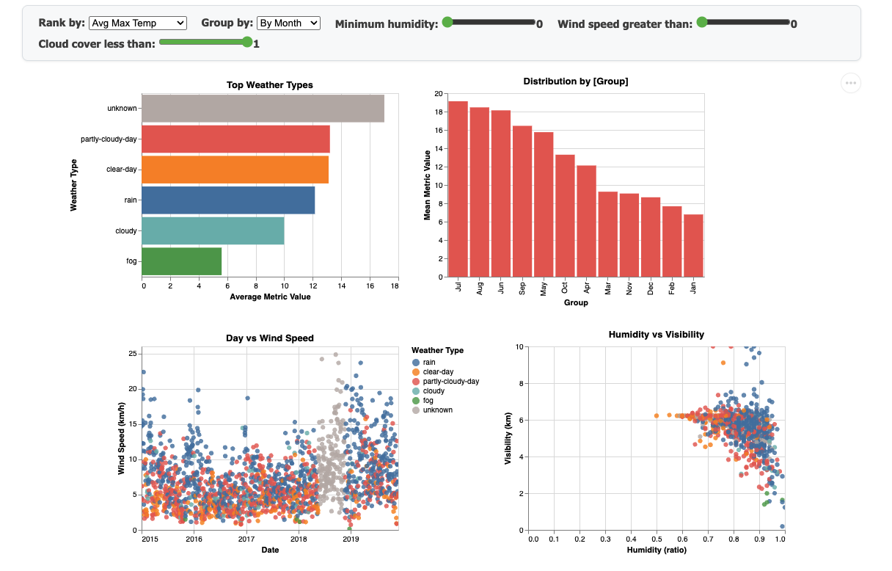
Figure 1: System A, Category + Attribute Overview dashboard

System B: Temporal Decomposition + Heatmap
System B focuses on temporal patterns, using a blue/green/yellow colour treatment and featuring four charts:
- Top-left: Horizontal bar chart with dynamic grouping (month/season/weather type/year) and metric selection.
- Top-right: Calendar heatmap (Month x Year) displaying the mean of the selected metric with a viridis colour scheme.
- Bottom-left: Grouped bar chart comparing wind speed and humidity side by side for each season.
- Bottom-right: Generalised selection chart, line chart showing yearly weather type counts, with drill-down capability (see Part 4).
- Controls: 3 dropdowns (Metric, Group by, Generalisation Level) and 2 sliders (wind speed, humidity).
- Interactions: Click filtering across charts, bidirectional season click, heatmap cell click filtering, generalised selection drill-down.
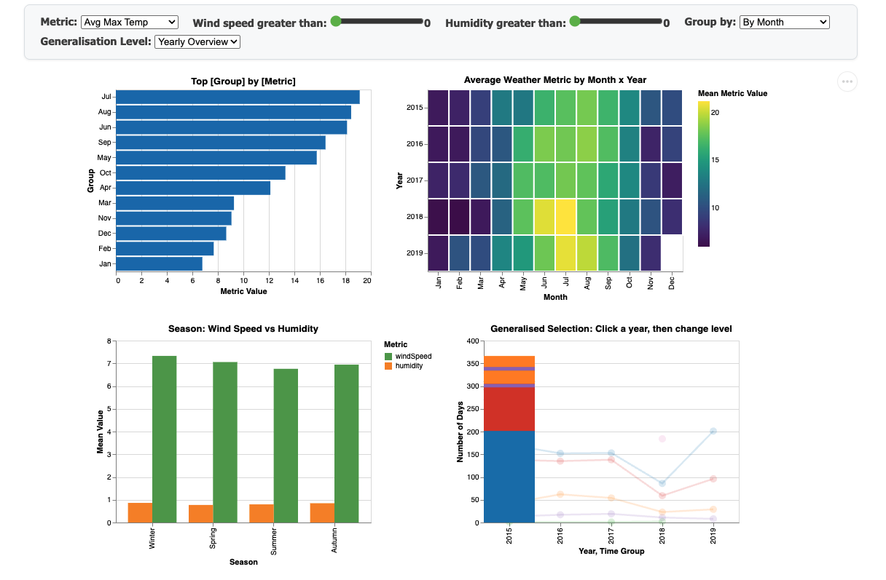
Figure 2: System B, Temporal Decomposition + Heatmap dashboard

System C: Full Exploration with Legend Filtering
System C provides maximum exploration flexibility with a multi-hue palette, using both colour (weather type) and shape (season) channels:
- Left: Horizontal bar chart ranking groups by metric with vivid per-group colours.
- Centre: Large scatter plot (Date vs Selected Metric) using colour for weather type and shape for season (circle=Winter, diamond=Spring, square=Summer, triangle=Autumn).
- Bottom-left: Heatmap of monthly weather composition (Month x Year) linked to scatter brush.
- Bottom-right: Season summary bar chart showing average cloud cover per season.
- Controls: 2 dropdowns (Metric, Group bars by) and 3 sliders (min humidity, min wind speed, max cloud cover).
- Interactions: Clickable colour legend (weather type filtering), clickable shape legend (season filtering), interval brush on scatter, bidirectional heatmap click, scroll-to-zoom.
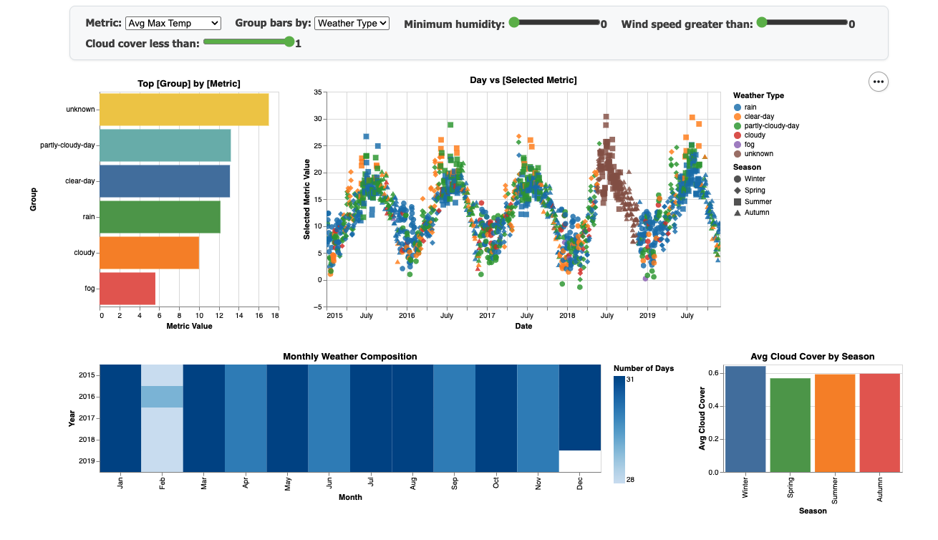
Figure 3: System C, Full Exploration with Legend Filtering dashboard

4. Generalised Selection
Semantic Structure
We defined a temporal hierarchy over our dataset with five levels of abstraction:
- Level 0 (most specific): Individual Day, e.g., 15 July 2017
- Level 1: Month, e.g., July 2017
- Level 2: Season, e.g., Summer 2017
- Level 3: Year, e.g., 2017
- Level 4 (most general): Entire Dataset, 2015-2019
This hierarchy is semantically meaningful because weather patterns naturally cluster at each level: daily variation, monthly means, seasonal cycles, and year-on-year trends. The structure follows a containment relationship (Munzner, 2014): each day belongs to exactly one month, each month to one season, and each season to one year.
Traversal Policy
Our traversal policy moves from general to specific (top-down navigation). The user begins at Level 4 (entire dataset overview), selects a year to move to Level 3, and then uses a dropdown to choose whether to view the selected year decomposed by season (Level 2) or by month (Level 1). This is not merely changing a global filter; it is a true generalised selection where the user selects an item at one level and the system responds by showing the corresponding items at a more detailed level of the hierarchy.
Implementation
Generalised selection is implemented in System B's bottom-right chart. The chart uses an Altair layered composition with two marks:
- Layer A (Overview): A line chart with points showing the count of days per weather type per year. This represents Level 3-4 of the hierarchy. When no year is selected, all lines are fully opaque, providing the complete overview.
- Layer B (Detail): A bar chart that only appears when a year is selected (via click on a point in the overview). It filters to the clicked year and groups the data by the user-selected generalisation level (year, season, or month), controlled by the "Generalisation Level" dropdown.
When the user clicks a year on the overview, the line chart fades (opacity drops to 0.15) and the detail bars appear, showing the breakdown for that year. The user can then switch the dropdown from "Yearly Overview" to "By Season" or "By Month" to drill deeper into the hierarchy. Double-clicking resets back to the full overview. This interaction directly implements generalised selection as described in the Data Selection lecture: a selected object at one level is expanded into its constituent objects at a lower level through a single interaction.

5. Demo Video
A demonstration video (under 5 minutes) showcasing all three systems, their design rationale, key interactions, and how they support the five tasks is available at:
Group17_Information Visualization Group Project

6. Design Comparison
We compare six design decisions across the three systems, drawing on IV theory to justify each choice.

Decision 1: Primary Mark Type for the Overview Chart
All three systems feature a horizontal bar chart as the primary ranking chart. In System A, we use coloured bars mapped to weather type via the shared WEATHER_COLORS scale, clicking a bar applies a point selection that filters all other charts. System B uses a monochromatic blue bar chart where the selected bar highlights in darker blue, keeping visual emphasis on the temporal heatmap alongside. System C assigns a distinct vivid colour per group (rainbow scheme) regardless of the grouping dimension, maximising pop-out for individual categories. According to Mackinlay's (1986) effectiveness principle, position along a common scale (bar length) is the most effective channel for quantitative comparison, which all three systems leverage. However, the colour treatment differs: System A's consistent weather-type palette provides identity continuity across charts, while System C's distinct hues maximise discriminability. Best choice: System A, because its consistent colour mapping across charts reduces cognitive load and supports the Gestalt principle of similarity, the same weather type is recognisable everywhere by colour.

Decision 2: Supporting Task T1 (Highest Avg Temperature Range)
For T1, System A uses a "Group by" dropdown that switches the secondary bar chart between month, season, and year groupings, combined with a "Rank by" dropdown set to Avg Temp Range. This idiom (Munzner, 2014) separates selection from display, letting the user explicitly choose the aggregation level. System B uses the same dropdown mechanism but adds a heatmap that provides spatial context for temporal patterns, the heatmap can show tempRange as a colour-coded Month x Year grid, allowing users to spot seasonal trends visually. System C relies on the scatter plot to show individual data points with tempRange on the Y-axis, requiring the user to mentally aggregate by season via shape encoding. Best choice: System B, because the combination of sorted bar chart and heatmap provides both precise ranking (bar length) and overview context (colour saturation), following Shneiderman's (1996) mantra of "overview first, details on demand."

Decision 3: Linking Strategy Between Charts
System A implements bidirectional brushing between its two scatter plots: dragging on the Date vs Wind Speed scatter highlights corresponding points in the Humidity vs Visibility scatter, and vice versa. This follows the coordinated multiple views paradigm, allowing users to discover correlations across attribute spaces. System B uses unidirectional click-based linking: clicking a bar filters the heatmap, clicking a heatmap cell filters the charts below, and clicking a season in the grouped bar filters charts 1 and 2 (bidirectional). System C uses legend-based filtering: clicking a legend item globally filters all charts by weather type or season. Best choice: System C, because legend-based filtering is the most intuitive (users naturally associate legend items with categories) and the filtering is truly global, affecting every chart simultaneously (Gestalt principle of connectedness).

Decision 4: Colour Channel Usage
System A uses a fixed categorical colour scale (WEATHER_COLORS) consistently mapping weather types to the same hue across all charts, following the expressiveness principle (Mackinlay, 1986), categorical data encoded with categorical colour. System B uses sequential colour (viridis scheme) for its heatmap to encode quantitative metric values, and distinct colours for the line chart. This mixed approach provides appropriate colour treatment per chart type. System C maps colour to weather type and shape to season, using two visual channels simultaneously. While this doubles the encoded dimensions, it risks visual clutter (participants noted confusion with shapes and colours). Best choice: System A, because a single consistent categorical palette reduces the integral-separable dimension conflict and keeps the colour channel focused on one variable.

Decision 5: Filter Mechanism for Task T4
T4 requires filtering by humidity threshold, then identifying the top weather type by visibility. System A uses a slider (binding_range) positioned below the charts that reactively filters all four charts simultaneously. System B also uses a slider, but the user must additionally change the Group By dropdown to "By Weather Type" and the Metric to "Avg Visibility," requiring three interactions. System C uses a slider combined with legend filtering, the user can set the humidity threshold and then click on individual weather types in the legend to compare. Best choice: System A, because the slider directly filters all charts including the bar chart that already shows weather types, requiring only two interactions (adjust slider, read bar chart) compared to three or more in other systems.

Decision 6: Temporal Exploration Idiom
System A represents time as a continuous axis in a scatter plot (Date vs Wind Speed), allowing fine-grained inspection of individual days but requiring users to mentally aggregate over time periods. System B uses a calendar heatmap (Month x Year rect marks) that spatialises time into a grid, enabling immediate recognition of seasonal and annual patterns through Gestalt proximity. The heatmap encodes the mean of the selected metric as colour intensity, supporting "overview first" exploration. System C also uses a scatter with time on X but adds shape encoding for season, requiring users to distinguish four shapes in a dense point cloud. Best choice: System B, because the heatmap provides an immediate spatial overview of temporal patterns that leverages pre-attentive processing of colour saturation, whereas scatter plots require effortful scanning of individual points.

7. User Evaluation Comparison

7.1 Methodology
We conducted a within-subjects user evaluation with five participants (P1-P5). Each participant completed all five tasks (T1-T5) on all three systems (A, B, C), resulting in 75 total observations (5 participants x 3 systems x 5 tasks). System presentation order was counterbalanced using a Latin square design to mitigate learning effects:
- P1, P4: A -> B -> C
- P2, P5: B -> C -> A
- P3: C -> A -> B
For each (participant, system, task) combination, we recorded three quantitative measures:
- Time (seconds): Task completion time, measured from when the participant began interacting to when they gave their answer.
- Accuracy (0/1/2): 0 = wrong or could not complete; 1 = partially correct; 2 = fully correct.
- Likert (1-5): Subjective ease-of-use rating (1 = very difficult, 5 = very easy).
After completing all tasks on all systems, each participant provided a post-study ranking of the three systems from best (1) to worst (3), along with comments explaining their preference. The evaluator read each task aloud, did not guide participants toward answers, and recorded observations in free-text notes.

7.2 Results
Overall Performance Summary
System | Avg Time (s) | Avg Accuracy | Avg Likert
System A | 21.0 | 1.68 | 4.20
System B | 26.2 | 1.56 | 3.88
System C | 18.8 | 1.52 | 4.08

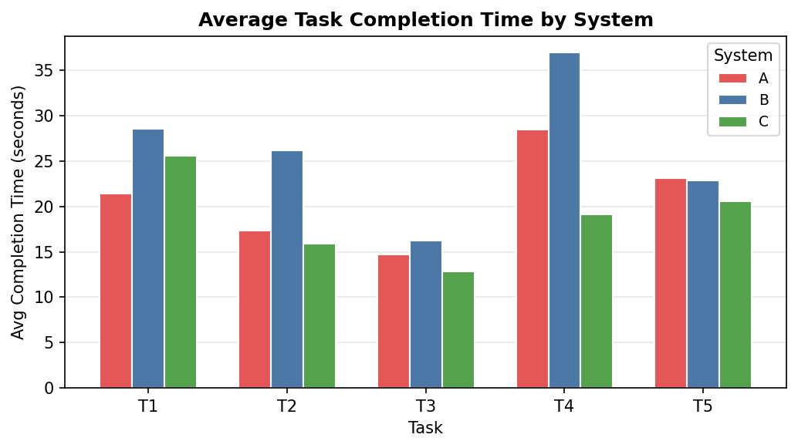
Figure 4: Average task completion time by system and task
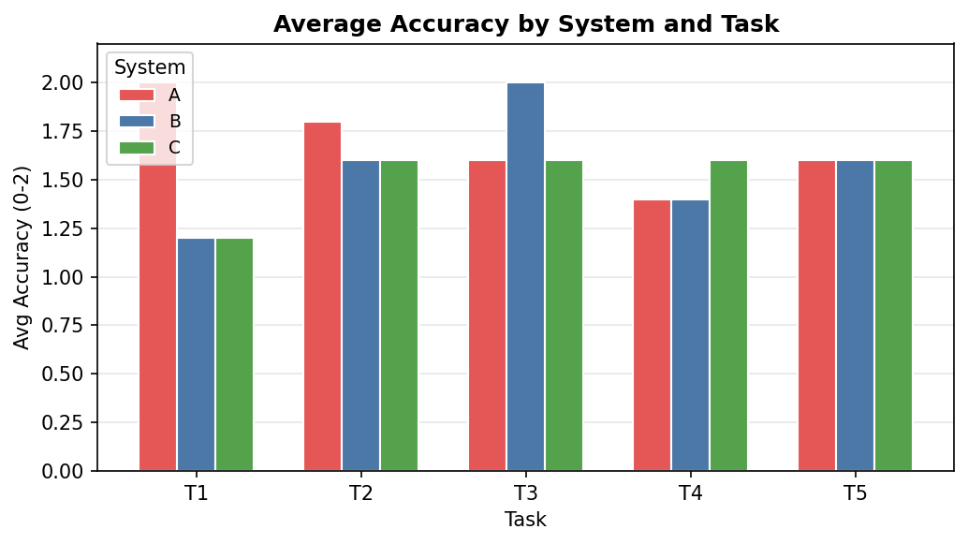
Figure 5: Average accuracy by system and task
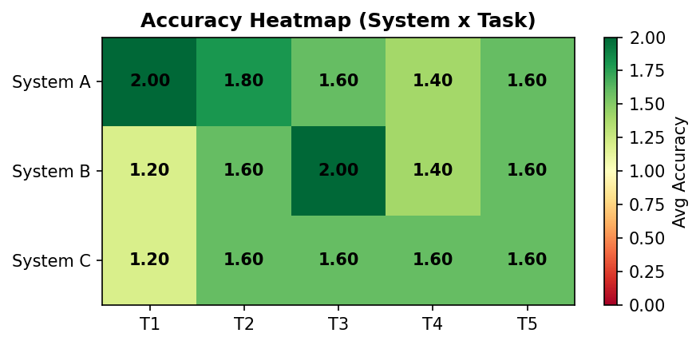
Figure 6: Accuracy heatmap (System x Task): green indicates higher accuracy
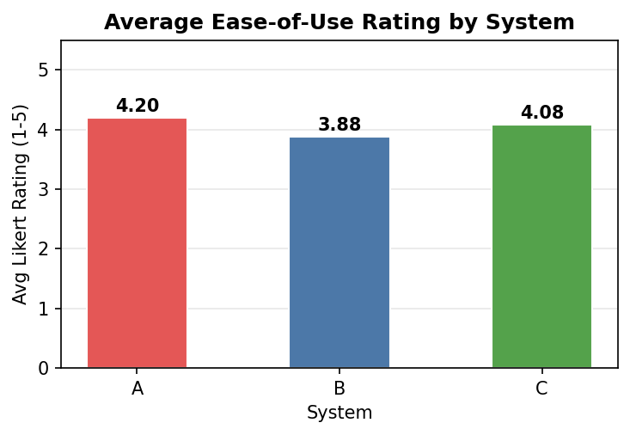
Figure 7: Average ease-of-use rating by system
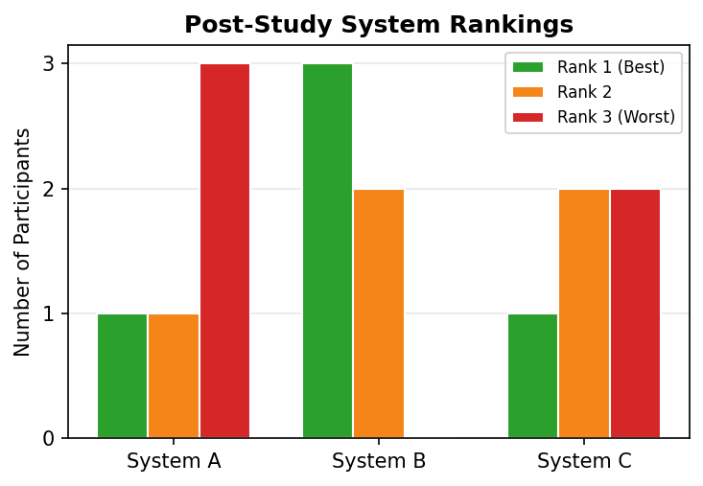
Figure 8: Post-study system preference rankings

7.3 Analysis
Task Completion Time
System C was the fastest overall (mean 18.8s), followed by System A (21.0s) and System B (26.2s). System C's speed advantage was most pronounced on T2 and T3, where participants found the correct answer rapidly using legend-based filtering. System B was slowest particularly on T4 (36.9s average), where participants needed to adjust multiple dropdowns alongside the slider. This suggests that systems requiring fewer interaction steps for a given task lead to faster completion times.
Accuracy
System A achieved the highest overall accuracy (1.68/2.0), followed by System B (1.56) and System C (1.52). System A excelled on T1 and T5, where its sorted bar chart with direct metric switching minimised interpretation errors. Notably, T2 (top 3 weather types by frequency) achieved the highest accuracy across all systems (1.80 average), indicating that frequency-counting tasks are well supported by bar chart idioms. T1 had the widest accuracy variation between systems: System A scored 1.60 while Systems B and C scored lower, likely because A's dual bar chart layout made seasonal/monthly comparison more straightforward.
Ease of Use (Likert)
System A received the highest average Likert rating (4.20), followed by System C (4.08) and System B (3.88). Participant comments reveal that System A's straightforward bar chart layout felt intuitive, while System B's multiple dropdowns and heatmap colour scheme caused confusion. System C received mixed feedback: P3 and P5 rated it highly for its filtering flexibility, while P1 found the shape legend confusing ("scatter plot shapes made it more confusing").
Post-Study Rankings
System B was ranked as the best system by 3 out of 5 participants, despite having the slowest average time and lowest Likert scores. This apparent contradiction suggests that participants valued the richness of temporal exploration and heatmap overview, even though it required more effort. System A was ranked worst by 3 participants, yet had the highest accuracy and Likert scores, indicating that while it was effective and easy, participants found it less engaging. System C received polarised rankings, being ranked best by P4 but worst by P1 and P5.
Key Findings
- No single system was uniformly "best", each excelled in different dimensions (time, accuracy, preference).
- Simpler interaction designs (System A) yielded higher accuracy and ease-of-use but lower engagement.
- Richer visual encodings (System C's dual colour+shape) increased speed for some users but caused confusion for others.
- Temporal overview tools (System B's heatmap) were valued for understanding despite slower task times.

8. Future Work
Based on our evaluation data, we identify the following evidence-based improvements:
1. Reduce interaction complexity in System B
System B had the slowest average completion time (26.2s) and lowest Likert score (3.88). Participant notes reveal that the need to adjust multiple dropdowns (Metric, Group By, Generalisation Level) created confusion. P1 "did not remember that the question was same" across systems because the interface required different mental models. We would consolidate the Metric and Group By dropdowns into a single task-oriented control, reducing the number of interaction steps required to answer each task.
2. Simplify System C's visual encoding
System C's dual encoding (colour for weather type, shape for season) caused confusion for P1 ("multiple colour in bar chart created the confusion," "scatter plot shapes made it more confusing") and P2 ("looking at scatter plot every time"). Our evaluation shows C had the lowest accuracy (1.52). We would remove the shape channel and instead use faceting by season (small multiples), which leverages the Gestalt principle of proximity to group seasonal data without overloading the shape channel (Munzner, 2014).
3. Add a reset button to all systems
Multiple participants (P1: "does not remember how to refresh the page"; P1: "did not refresh the page") struggled to reset filters between tasks. Currently, the only reset mechanism is refreshing the browser page. We would add an explicit "Reset All Filters" button within the interface, reducing the hidden knowledge required to operate the system.
4. Improve task wording clarity
Several participants (P1: "getting confuse in all tasks because of the wordings"; P2: "questions wording is confusing") struggled with task descriptions. While this is an evaluation design issue rather than a system design issue, we would revise the Tasks section in each system page to use simpler, step-by-step instructions with bold highlighting of key values and expected actions.
References
- Mackinlay, J. (1986). Automating the design of graphical presentations of relational information. ACM Transactions on Graphics, 5(2), 110-141.
- Munzner, T. (2014). Visualization Analysis and Design. CRC Press.
- Shneiderman, B. (1996). The eyes have it: A task by data type taxonomy for information visualizations. Proceedings of the IEEE Symposium on Visual Languages, 336-343.
- Satyanarayan, A., Moritz, D., Wongsuphasawat, K., & Heer, J. (2017). Vega-Lite: A grammar of interactive graphics. IEEE Transactions on Visualization and Computer Graphics, 23(1), 341-350.
- Heer, J., & Shneiderman, B. (2012). Interactive dynamics for visual analysis. Communications of the ACM, 55(4), 45-54.

Appendix A: Raw Evaluation Data
Complete evaluation data from all 5 participants across all 3 systems and 5 tasks (75 observations).
P | Order | Sys | Task | Time(s) | Acc | Likert | Answer
P1 | A → B → C | A | T1 | 42.5 | 2 | 5 | Spring, May
P1 | A → B → C | A | T2 | 23.9 | 1 | 5 | Rain, cloudy day, clear day
P1 | A → B → C | A | T3 | 18.5 | 0 | 4 | 2018
P1 | A → B → C | A | T4 | 57.2 | 2 | 3 | Clear day
P1 | A → B → C | A | T5 | 33.1 | 1 | 4 | Winter, autumn, summer
P1 | A → B → C | B | T1 | 38.8 | 0 | 3 | July, autumn
P1 | A → B → C | B | T2 | 24.9 | 0 | 4 | Jan, march,may
P1 | A → B → C | B | T3 | 23.2 | 2 | 4 | 2019
P1 | A → B → C | B | T4 | 42.5 | 0 | 3 | October
P1 | A → B → C | B | T5 | 38.0 | 1 | 4 | Winter
P1 | A → B → C | C | T1 | 39.4 | 0 | 2 | September, Autumn
P1 | A → B → C | C | T2 | 19.1 | 0 | 1 | Spring, summer, autumn
P1 | A → B → C | C | T3 | 17.4 | 0 | 4 | 2018
P1 | A → B → C | C | T4 | 35.0 | 1 | 3 | Said unknown
P1 | A → B → C | C | T5 | 20.9 | 1 | 5 | Winter, autumn, summer
P2 | B → C → A | B | T1 | 44.2 | 0 | 4 | July,summer
P2 | B → C → A | B | T2 | 53.8 | 2 | 2 | Rain,partly cloudy day, clear day
P2 | B → C → A | B | T3 | 10.2 | 2 | 4 | 2019
P2 | B → C → A | B | T4 | 67.3 | 2 | 3 | Clear day
P2 | B → C → A | B | T5 | 30.4 | 1 | 2 | Winter, summer, autumn
P2 | B → C → A | C | T1 | 46.6 | 0 | 3 | June,summer
P2 | B → C → A | C | T2 | 23.2 | 2 | 4 | Rain, partly cloud day, clear day
P2 | B → C → A | C | T3 | 5.5 | 2 | 5 | 2019
P2 | B → C → A | C | T4 | 24.7 | 1 | 5 | Clear day, partly cloud day, unknown
P2 | B → C → A | C | T5 | 42.0 | 1 | 3 | Summer, autumn, spring
P2 | B → C → A | A | T1 | 19.7 | 2 | 4 | May, spring
P2 | B → C → A | A | T2 | 12.9 | 2 | 4 | Rain, partly cloud day, clear day
P2 | B → C → A | A | T3 | 13.2 | 2 | 5 | 2019
P2 | B → C → A | A | T4 | 24.1 | 0 | 4 | Fog
P2 | B → C → A | A | T5 | 38.6 | 1 | 4 | Dec, winter, autumn, spring
P3 | C → A → B | C | T1 | 20.0 | 2 | 3 | Spring (avg tempRange ≈ 7.77°C)
P3 | C → A → B | C | T2 | 17.0 | 2 | 5 | 1. rain (763), 2. partly-cloudy-day (566
P3 | C → A → B | C | T3 | 22.0 | 2 | 3 | 2019 (avg wind speed ≈ 8.91 km/h)
P3 | C → A → B | C | T4 | 10.0 | 2 | 5 | clear-day (avg visibility ≈ 5.61 km)
P3 | C → A → B | C | T5 | 16.0 | 2 | 5 | Winter, Autumn, Summer
P3 | C → A → B | A | T1 | 22.0 | 2 | 5 | Spring (avg tempRange ≈ 7.77°C)
P3 | C → A → B | A | T2 | 19.0 | 2 | 3 | 1. rain (763), 2. partly-cloudy-day (566
P3 | C → A → B | A | T3 | 20.0 | 2 | 5 | 2019
P3 | C → A → B | A | T4 | 16.0 | 2 | 5 | clear-day
P3 | C → A → B | A | T5 | 13.0 | 2 | 5 | Winter, Autumn, Summer
P3 | C → A → B | B | T1 | 14.0 | 2 | 5 | Spring
P3 | C → A → B | B | T2 | 19.0 | 2 | 5 | 1. rain (763), 2. partly-cloudy-day (566
P3 | C → A → B | B | T3 | 25.0 | 2 | 3 | 2019
P3 | C → A → B | B | T4 | 10.0 | 2 | 5 | clear-day
P3 | C → A → B | B | T5 | 9.0 | 2 | 5 | Winter, Autumn, Summer
P4 | A → B → C | A | T1 | 8.0 | 2 | 4 | may
P4 | A → B → C | A | T2 | 20.0 | 2 | 3 | rain, partly cloudy, clear
P4 | A → B → C | A | T3 | 13.0 | 2 | 4 | 2019
P4 | A → B → C | A | T4 | 25.0 | 1 | 2 | clear day ( to rain)
P4 | A → B → C | A | T5 | 18.0 | 2 | 4 | winter, autumn, summer
P4 | A → B → C | B | T1 | 24.0 | 2 | 3 | month-may, season- spring
P4 | A → B → C | B | T2 | 14.0 | 2 | 4 | rain, partly cloudy, clear day
P4 | A → B → C | B | T3 | 13.0 | 2 | 4 | 2019
P4 | A → B → C | B | T4 | 33.0 | 1 | 3 | clear day to rain
P4 | A → B → C | B | T5 | 16.0 | 2 | 5 | winter, autumn, summer
P4 | A → B → C | C | T1 | 10.0 | 2 | 4 | spring
P4 | A → B → C | C | T2 | 7.0 | 2 | 5 | rain, partly cloudy, clear day
P4 | A → B → C | C | T3 | 9.0 | 2 | 5 | 2019
P4 | A → B → C | C | T4 | 12.0 | 2 | 4 | clear day
P4 | A → B → C | C | T5 | 13.0 | 2 | 4 | winter, autumn, summer
P5 | B → C → A | B | T1 | 22.0 | 2 | 5 | Spring ( temperature7.77°C)
P5 | B → C → A | B | T2 | 19.0 | 2 | 5 | 1. rain (763 days), 2. partly cloudy (56
P5 | B → C → A | B | T3 | 10.0 | 2 | 5 | 2019 (wind speed at8.91 km/h)
P5 | B → C → A | B | T4 | 32.0 | 2 | 3 | clear-day (visibility at 5.61 km)
P5 | B → C → A | B | T5 | 21.0 | 2 | 4 | 1. Winter (0.640),2. Autumn (0.594), 3.
P5 | B → C → A | C | T1 | 12.0 | 2 | 5 | Spring (temperature 7.77°C)
P5 | B → C → A | C | T2 | 13.0 | 2 | 5 | 1. rain (763 days), 2. partly cloudy (56
P5 | B → C → A | C | T3 | 10.0 | 2 | 5 | 2019 (wind speed at8.91 km/h)
P5 | B → C → A | C | T4 | 14.0 | 2 | 5 | clear-day (visibility at 5.61 km)
P5 | B → C → A | C | T5 | 11.0 | 2 | 4 | 1. Winter (0.640), 2. Autumn (0.594), 3.
P5 | B → C → A | A | T1 | 15.0 | 2 | 4 | Spring (temperature 7.77°C)
P5 | B → C → A | A | T2 | 11.0 | 2 | 5 | 1. rain (763 days), 2. partly cloudy (56
P5 | B → C → A | A | T3 | 9.0 | 2 | 5 | 2019 (wind speed at8.91 km/h)
P5 | B → C → A | A | T4 | 20.0 | 2 | 4 | clear-day (visibility at 5.61 km)
P5 | B → C → A | A | T5 | 13.0 | 2 | 5 | 1. Winter (0.640), 2. Autumn (0.594)  3.

Evaluator Notes
P | Sys | Task | Notes
P1 | A | T1 | Moved directly to charts before performing operations
P1 | A | T2 | Did not included the counts, just weather types, and selected months in dropdown
P1 | A | T3 | Started using wind slider instead of using dropdown option and guess the answer
P1 | A | T4 | Does not remember how to refresh the page, and started using the system without
P1 | A | T5 | Did not answer the part A of T5, got confused in the wording and minimum thresho
P1 | B | T1 | Did not remember that the question was same, used the dropdown but selected aver
P1 | B | T2 | Did not use the group by dropdown and answered incorrect
P1 | B | T3 | Got confused due to color combination but still gave the right answer
P1 | B | T4 | Did not select the weather type and chose month instead
P1 | B | T5 | Gave only one answer and did not refresh the page
P1 | C | T1 | Multiple color in bar chard created the confusion, and getting confuse in all ta
P1 | C | T2 | He got confused because the season legend due to color in availability in the sh
P1 | C | T3 | Did the process right but got confused due to wording highest and average and fi
P1 | C | T4 | Said unknown
P1 | C | T5 | Did not answer the first part, just skimmed it and ignored it. Moved to the part
P2 | B | T1 | Was looking at the heat map instead of bar chart, and got confused to figure out
P2 | B | T2 | It was tough due to the required modifications in metric and group by dropdown,
P2 | B | T3 | Graph showing the result directly, but it takes time to figure out which dropdow
P2 | B | T4 | Was juggling between drop downs, selected year at first and then chose the weath
P2 | B | T5 | Got confused due to sliders, merged both parts of questions and answered only on
P2 | C | T1 | Did not select the right metric, and did not even looked at it, then instead of
P2 | C | T2 | Finding the right answer is tough, and questions wording is confusing
P2 | C | T3 | Did not get confused, chose the dropdown correctly and answered instantly
P2 | C | T4 | Getting confuse and looking at scatter plot every time
P2 | C | T5 | Merged both parts and answered only seasons
P2 | A | T1 | 2 same bar chart creating confusion
P2 | A | T2 | Got confused, because early systems had weather type as a dropdown, and this sys
P2 | A | T3 | Answered directly
P2 | A | T4 | Humidity, 0.3, no confusion, but took time and was looking at both the bar chart
P2 | A | T5 | Color of bar charts made him confused.
P3 | C | T1 | Used metric dropdown to select tempRange. Scatter plot shows seasonal clusters b
P3 | C | T2 | Default weather type bar chart made it easy to identify top categories quickly.
P3 | C | T3 | Switched grouping to year and compared bars, although chart width made compariso
P3 | C | T4 | Used humidity slider >0.85 and legend filtering. Scatter plot allowed direct rea
P3 | C | T5 | Season cloud cover chart clearly showed ranking once filters were applied.
P3 | A | T1 | Used Group by Season and Temp Range metric. Sorted bar chart made comparison ver
P3 | A | T2 | Counts visible in tooltip while hovering over bars.
P3 | A | T3 | Changed Group by to Year and selected Wind Speed metric.
P3 | A | T4 | Adjusted humidity slider then switched metric to visibility.
P3 | A | T5 | Multiple dropdown and slider adjustments required to identify results.
P3 | B | T1 | Horizontal bar chart sorted by tempRange made the answer immediately visible.
P3 | B | T2 | Switched grouping to Weather Type and compared bar lengths.
P3 | B | T3 | Heatmap view enabled quick comparison of wind speed across years.
P3 | B | T4 | Applied humidity threshold and grouped by weather type with visibility metric.
P3 | B | T5 | Used sliders and seasonal grouping to identify highest average cloud cover.
P4 | A | T1 | Two bar charts help answering the questions.
P4 | A | T3 | Easily verified with scatterplot.
P4 | A | T4 | Weather types keep changing form 0.86 to 1.00, a little confusing but depends on
P4 | B | T1 | Easy toggle between month and weather.
P4 | B | T2 | Easier group by weather type option.
P4 | C | T1 | Easier to verify with shapes in the scatter plot
P4 | C | T4 | Clear day for most part
P4 | C | T5 | Both bar charts reflect the same result
P5 | A | T4 | no weather type category in dropdown, like those in the above systems

Appendix B: Post-Study Rankings
Participant | Rank 1 (Best) | Rank 2 | Rank 3 (Worst) | Comments
P1 | System A | System B | System C | System A was easy because bar graph was available, system B was average due color complexity in grap
P2 | System B | System C | System A | B because of charts simplicity, which allowed him to answer directly, In C scatter plot made him con
P3 | System B | System C | System A | System B was the most intuitive and accurate, especially for comparing seasonal and yearly patterns.
P4 | System C | System B | System A | System C offers variety of visualisations and functions, making it easier to acknowledge the change
P5 | System B | System A | System C | B has the highest average score across all tasks while C has the lowest overall performance

Appendix C: Team Contribution Log
Team Member | Contribution | %
Yibo Liang | System A implementation, report Part 1-2, Video Part | 20%
Nitesh Ranjan Singh | Data Prep, System B implementation, generalized selection, Report Part 4 | 20%
Kimaya Prashant Gharat | System C implementation, report Part 3 | 20%
Sujal Jain | User evaluation, report Part 7-8 | 20%
Saadiya Mateen Sayed | Dataset Selection, Design comparison, report Part 5-6 | 20%

