

***DEPARTMENT OF COMPUTER SCIENCE & ENGINEERING***

***SHARDA SCHOOL OF ENGINEERING AND TECHNOLOGY***

***SHARDA UNIVERSITY, GREATER NOIDA***

**Identification of Counterfeit Products Using Blockchain Technology**

***A project submitted***

***in partial fulfillment of the requirements for the degree of Bachelor of Technology in Computer Science and Engineering***

**by**

**Nitesh Kumar Singh (2019003147)**

**Avi Chaurasia (2019005597)**

**Adarsh Kumar (2019005428)**

**Supervised by:**

Prof. (Dr.) Ambuj Kumar Agarwal

April, 2023

# CERTIFICATE

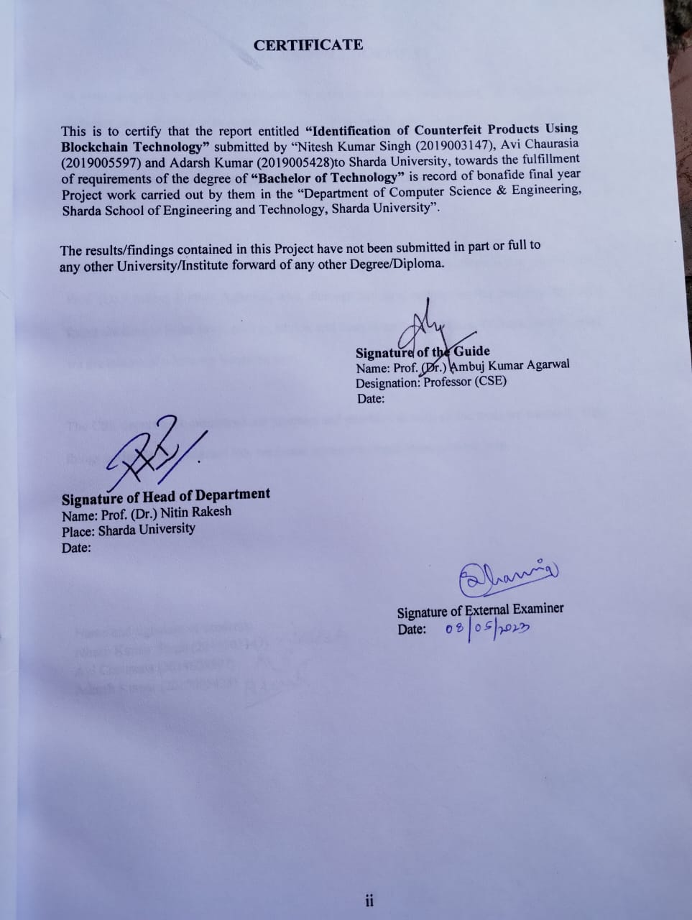

# ACKNOWLEDGEMENT

A major project is a golden opportunity for learning and self-development. We feel extremely fortunate and privileged to have had so many excellent people guide us as we complete this project.

First and foremost, we would like to thank Dr. Nitin Rakesh, HOD, CSE who gave us an opportunity to undertake this project.

Our grateful thanks to Prof. (Dr.) Ambuj Kumar Agarwal for his guidance in our project work. Prof. (Dr.) Ambuj Kumar Agarwal, who, although having a very demanding academic schedule, found the time to listen to us, give us advice, and keep us on the right track. Without her assistance, we are unsure of where we would be now.

The CSE department monitored our progress and provided us with all the tools we needed to make things easier. We've selected this particular moment to thank them for their help.

Name and signature of Students:

Nitesh Kumar Singh (2019003147)

Avi Chaurasia (2019005597)

Adarsh Kumar (2019005428)

# ABSTRACT

Counterfeit products have become a major issue in the global market, causing significant economic losses to businesses and health and safety risks to consumers. Blockchain technology has the potential to address this problem by creating a secure and immutable record of the origin and movement of products. This paper explores the use of blockchain technology for identifying counterfeit products. We examine the characteristics of blockchain technology, its benefits, and limitations. We also discuss the current approaches used for product identification and how blockchain technology can be used to enhance these methods. We present a case study on how blockchain technology can be implemented to identify counterfeit pharmaceuticals, one of the most critical areas of concern. The results show that blockchain technology can be a useful tool in identifying counterfeit products, as it provides an immutable record of product provenance, enhances traceability, and reduces the risk of fraud.

**CONTENTS**

**CHAPTER-1: INTRODUCTION …………………………………………………………...….8**

1.1: Motivation……………………………………………………………………………...…12

1.2: Overview………………………………………………………………………………….13

1.3: Expected outcome………………………………………………………….……………..14

1.4: Gantt Chart…………………………………….…………...………………………….….15

1.5: Possible risks……………………………………………….…………...…….…....……..16

1.6: SRS…………………………………………………………………….…………...…….18

1.7 Requirement analysis…………………………………………………………...…………20

**CHAPTER-2: METHODOLOGY………………………….....……………………………….21**

2.1: Product / system view………………………………….………………………………….21

2.2: System components & Functionalities………………...…………….……………………22

2.3: Data & relational views…………………………………………………….……………..23

**CHAPTER-3:DESIGN CRITERIA…………………………………………..………………..24**

3.1: System Design…………………………………………….……………………………….24

3.2: System Architecture……………………………...……….…………….…………………25

**CHAPTER-4: DEVELOPMENT & IMPLEMENTATION……….…………………………26**

4.1: Developmental feasibility……………………………………………………...…………..27

4.2: Implementation Specifications…………………………………………….……………….29

4.3: System modules and flow of implementations……………………………...……………...30

4.4: Critical modules of product/system…………………………………………...……………31

**CHATPER-****5: RESULTS & TESTING………………………….……………………..……...32**

5.1: Result ………….…………………………..………………………………………………32

5.2: Proposed Model Outputs.…………………………..……………………..…...……….…..33

5.3: Web Templates..………………………….…………………………….….………….…... 37

**CHAPTER-6: CONCLUSION & FUTURE IMPROVEMENTS……………………………38**

6.1: System Usability……………………………………………...……………………………..39

6.2: Future Scope……………….…………………………………………….....…………….… 40

**CHAPTER-7: REFERENCES………………………………………………………………… 41**

**ANNEXURE 1………………………………………………………………………………….. 43**

**ANNEXURE 2………………………………………………………………………………….. 44**

# LIST OF FIGURES

**Figure No. Table Name Page No.**

|  |  |  |
| --- | --- | --- |
| Fig 1.1.1 | Structure of Blockchain | 11 |
| Fig 1.4.1 | A Final Year Project Gantt Chart | 15 |
| Fig 3.2.1 | Architecture Supply Chain | 25 |
| Fig 5.2.1 | Login Page | 34 |
| Fig 5.2.2  Fig 5.2.3  Fig 5.2.4  Fig 5.2.5  Fig 5.2.6 | Add Products Of Manufacturer  Add Seller  Sell Products to Consumer  Consumer Products History  Product Verification | 34  35  35  36  37 |

# 

# LIST OF TABLES

## Table No . Table Name Page No.

Table 1.4.1 Gantt chart representation 15

**CHAPTER 1**

1. **INTRODUCTION**

Counterfeit products pose significant risks to businesses, consumers, and economies globally. Counterfeit products not only cause financial losses to businesses but also pose significant health and safety risks to consumers. The traditional methods of product identification, such as holograms, watermarks, and serial numbers, are becoming less effective as counterfeiters become more sophisticated. The need for more advanced and secure methods of product identification has become a top priority for businesses and governments worldwide.

Counterfeit products are a major problem for consumers, businesses, and governments around the world. They not only lead to financial losses for companies, but also pose health and safety risks for consumers. Blockchain technology can provide a solution to this problem by enabling secure, tamper-proof tracking of product authenticity from the point of manufacture to the point of sale.

Blockchain is a distributed ledger technology that allows for the creation of an immutable record of transactions. Each transaction is verified and added to the blockchain network, creating a permanent, tamper-proof record of the product's authenticity. This makes it virtually impossible to alter or manipulate the information on the blockchain, ensuring that the product's authenticity can be verified at any point in its lifecycle.

Using blockchain technology, businesses can create a digital record of a product's unique identifier, such as a serial number or barcode, and store it on the blockchain. This record can be accessed by anyone with permission to view it, providing transparency and accountability in the supply chain. When a product is manufactured, its unique identifier is added to the blockchain, along with information such as the date of manufacture, location, and other relevant data.

As the product moves through the supply chain, each party involved in the process can add their own transaction to the blockchain, verifying the authenticity of the product. This creates a transparent and auditable record of the product's journey, making it easy to identify any attempts to counterfeit or tamper with the product.

Consumers can also use blockchain technology to verify the authenticity of the products they purchase. By scanning a product's unique identifier, consumers can access the blockchain record and verify that the product is genuine. This can help prevent consumers from purchasing counterfeit products, protecting their health and safety, as well as the reputation of the manufacturer.

In conclusion, blockchain technology can be a powerful tool in the fight against counterfeit products. By enabling secure, tamper-proof tracking of product authenticity from the point of manufacture to the point of sale, it can help businesses and consumers verify the authenticity of the products they purchase, protecting against financial loss and health and safety risks.

Counterfeit products are a growing problem in today's global marketplace. From counterfeit luxury goods to fake pharmaceuticals, these products can lead to significant financial losses for businesses and pose serious risks to consumers' health and safety. In response, many companies are turning to blockchain technology to help identify counterfeit products and prevent their distribution.

Blockchain technology is a decentralized, distributed ledger that records transactions in a tamper-proof and transparent manner. Each block in the blockchain contains a set of transactions that have been verified by network participants, and once a block is added to the chain, it cannot be altered or deleted. This makes it an ideal solution for creating a secure and immutable record of product authenticity.

One of the key benefits of using blockchain technology to identify counterfeit products is its ability to create a transparent and auditable supply chain. By recording the movement of goods on the blockchain, companies can track the authenticity of their products from the point of manufacture to the point of sale. Each transaction that occurs along the way is recorded on the blockchain, creating a tamper-proof record that can be easily audited by regulators and other stakeholders.

To implement this technology, businesses can assign a unique digital identifier to each product, such as a QR code or a serial number, and then record it on the blockchain. Each time the product changes hands, the transaction is recorded on the blockchain, along with information such as the date, time, and location of the transfer. This creates a permanent record of the product's movement through the supply chain, allowing stakeholders to verify its authenticity at any point in time.

Blockchain technology can also be used to authenticate products at the point of sale. By scanning the product's unique digital identifier, consumers can access the blockchain record and verify that the product is authentic. This can help prevent them from purchasing counterfeit products, protecting their health and safety as well as the reputation of the manufacturer.

Another advantage of blockchain technology is its ability to ensure the privacy and security of sensitive data. Because the blockchain is decentralized and encrypted, it is much harder for hackers to breach the system and steal information. This can help protect sensitive information such as product specifications and trade secrets from falling into the wrong hands.

In addition to providing a secure and transparent supply chain, blockchain technology can also help reduce the time and cost associated with identifying and removing counterfeit products from the

market. By automating the authentication process, companies can quickly identify counterfeit products and take action to remove them from circulation. This can help prevent financial losses and protect the reputation of the company.

Overall, the use of blockchain technology to identify counterfeit products is a promising solution to a growing problem in the global marketplace. By creating a tamper-proof and transparent supply chain, companies can prevent the distribution of counterfeit products, protect consumers' health and safety, and safeguard their own financial interests. As more companies adopt this technology, we can expect to see a significant reduction in the number of counterfeit products on the market. Counterfeit products have become a growing problem in various industries, ranging from luxury goods to pharmaceuticals, electronics, and even food items. These fake products not only harm the brand reputation but also pose serious health and safety risks to consumers. Traditional methods of identifying counterfeit products have proven inadequate in many cases, as counterfeiters have become more sophisticated in their methods.

Blockchain technology has emerged as a potential solution to this problem. Blockchain provides a secure and transparent way to store and share information, making it possible to track the entire supply chain of a product from the manufacturer to the end consumer. By using blockchain, it is possible to create a unique digital identity for each product, making it easier to verify its authenticity.

The proposed system for identifying counterfeit products using blockchain involves creating a digital identity for each product and recording its journey through the supply chain on the blockchain. At any point in the supply chain, the authenticity of the product can be verified by checking its digital identity on the blockchain. If a counterfeit product is identified, it can be flagged on the blockchain, and the relevant authorities can be notified to take appropriate action.

Implementing such a system requires a significant investment in technology and infrastructure, as well as the cooperation of multiple stakeholders in the supply chain. However, the benefits of such a system would include improved traceability of products, increased transparency, and reduced risk of counterfeit products entering the market. Ultimately, a blockchain-based system for identifying counterfeit products has the potential to create a safer and more reliable supply chain for consumers and businesses alike.

**OVERVIEW OF COUNTERFEIT PRODUCTS**

Counterfeit products are fake or imitation products that are made to resemble genuine products. Counterfeits can range from consumer goods such as clothing, electronics, and cosmetics, to high-end luxury items such as watches and handbags, to pharmaceuticals and even car parts. The counterfeit market is a global issue, with an estimated value of hundreds of billions of dollars each year. Counterfeit products are typically made to look like the genuine product, but may have inferior quality, durability, and safety standards. They are often sold at lower prices than genuine products, making them attractive to consumers looking for a bargain. Counterfeiters use a range of tactics to deceive consumers, including copying trademarks, packaging, and labelling. Counterfeit products can have serious consequences, both for consumers and legitimate businesses. Counterfeit goods may not meet safety or quality standards, posing a risk to consumers' health and safety. They can also damage the reputation and sales of legitimate businesses, resulting in lost revenue and jobs. Governments and law enforcement agencies around the world are working to combat the production and sale of counterfeit products. Consumers can also protect themselves by purchasing from reputable sources and being cautious of deals that seem too good to be true.

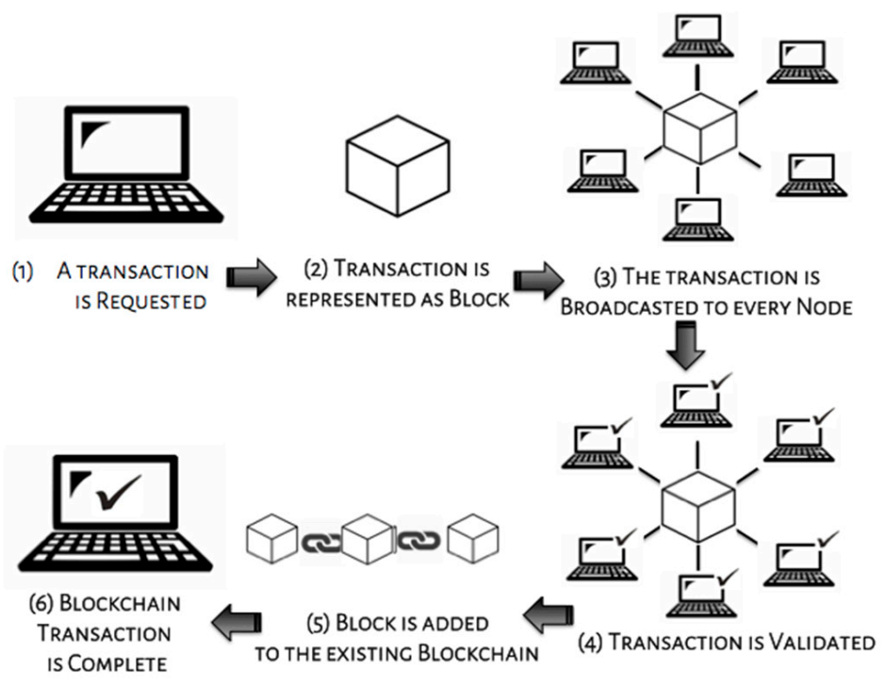

**Fig 1.1.1 Structure of Blockchain**

## 1.1 Motivation

The growing trade in fake goods is having an influence on the sales and profitability of firms affected by this circumstance. This study is about an operational blockchain system that secures the identity and tracking of authentic products along the supply chain in order to avoid product counterfeiting. Businesses only have to pay very small transaction charges and are liberated from the worry that they might buy counterfeit goods. The required anti-counterfeiting technology has been suggested before, however, it has not yet been fully built. One such anti-counterfeiting strategy is presented in Maker chain- A blockchain for self-organizing processes in the communal production of commodities using chemical signatures [2]. It uses chemical signatures to identify the distinctive characteristics of customized goods. In this study, we suggest using a Blockchain to store product ownership data. By employing blockchain untraceable ability, transparency features. Customers may reliably know the provenance of the products they buy because of the Blockchain's immutability and the guarantee that each record cannot be falsified. Small and medium-sized businesses can acquire safe and impenetrable anticounterfeit authentication using the anti-counterfeit application solution suggested in this article for a reasonably cheap operational cost. The motivation behind using blockchain to identify counterfeit products is driven by the need to address the growing problem of fake products that are flooding the market. Counterfeit products not only cause financial losses to legitimate businesses but also pose serious health and safety risks to consumers. The World Health Organization estimates that up to 10% of all medical products in low- and middle-income countries are either substandard or falsified.

Current methods of identifying counterfeit products are often inadequate, as they rely on physical inspection or testing, which can be time-consuming, costly, and not foolproof. Blockchain technology provides an innovative solution to this problem by offering a secure and transparent way to store and share information about a product's journey through the supply chain.

By using blockchain to create a unique digital identity for each product, it becomes easier to verify its authenticity at any point in the supply chain. This can be done using mobile apps or other similar tools that can scan the product's QR code or other identifying marks. If a counterfeit product is identified, it can be flagged on the blockchain, and the relevant authorities can be notified to take appropriate action.

Overall, the motivation behind using blockchain to identify counterfeit products is to create a safer and more reliable supply chain for consumers and businesses alike, reduce the risks of financial losses and reputational damage to legitimate businesses, and protect consumers from potentially harmful fake products.

## 1.2 Project Overview

The use of blockchain technology for the identification of counterfeit products is an innovative approach that aims to combat the growing problem of counterfeit products in the market. The project involves the development of a blockchain-based platform that will enable consumers to verify the authenticity of products before making a purchase. The platform will leverage the immutable and transparent nature of blockchain to create a tamper-proof record of the product's entire supply chain, from manufacturing to retail.

The project will involve the collaboration of manufacturers, retailers, and consumers to create a decentralized network that will facilitate the tracking of products and their authenticity. Manufacturers will be required to upload information about the product, including its unique identifiers and production details, onto the blockchain platform. This information will be stored on the blockchain in a tamper-proof manner, ensuring that it cannot be altered or deleted.

Retailers will be responsible for scanning the products using a mobile application to verify their authenticity. The mobile application will scan the unique identifiers of the product, and the blockchain platform will verify the product's authenticity using the stored information.

Consumers will be able to use the mobile application to scan products before making a purchase to ensure that they are buying genuine products. The mobile application will display the product's entire supply chain history, including the manufacturer, distributor, and retailer. This will enable consumers to verify the authenticity of the product before making a purchase.

The project will also incorporate a feedback mechanism that will enable consumers to report counterfeit products. The feedback mechanism will enable consumers to report any suspected counterfeit products, which will be investigated by the manufacturers and retailers.

**1.3 Expected Outcome**

The use of blockchain technology for the identification of counterfeit products is expected to have several outcomes, including:

**1.Increased authenticity of products:** The blockchain-based platform will enable the tracking of products from manufacturing to retail, ensuring that the authenticity of products can be verified by consumers before making a purchase.

**2.Improved consumer protection:** The platform will provide consumers with a means to verify the authenticity of products, thereby protecting them from fraud and counterfeits.

**3.Reduced counterfeiting:** The use of blockchain technology will create a tamper-proof record of the product's entire supply chain, making it difficult for counterfeiters to produce fake products.

**4.Enhanced supply chain transparency:** The platform will enable the tracking of products from manufacturing to retail, creating a transparent supply chain that can be audited by all participants.

**5.Improved trust in the market:** The use of blockchain technology will increase trust in the market, as consumers will be able to verify the authenticity of products before making a purchase.

**6.Increased collaboration between manufacturers, retailers, and consumers:** The project will require the collaboration of manufacturers, retailers, and consumers to create a decentralized network, fostering collaboration and cooperation among all stakeholders.

Overall, the use of blockchain technology for the identification of counterfeit products is expected to have a significant impact on the market, improving the authenticity of products, protecting consumers from fraud, and fostering collaboration and trust among all stakeholders.

**1.4 Gantt Chart**

## Table 1.4.1: Gantt chart representation

| Task | Duration | Start Date | End Date | Dependencies | Predecessors | Successors |
| --- | --- | --- | --- | --- | --- | --- |
| Data Collection | 4 weeks | Week 1 | Week 4 | None | None | Pre-processing task |
| Pre-processing | 2 weeks | Week 2 | Week 3 | Data Collection | Data Collection | Model Training task |
| Model Training | 10 weeks | Week 5 | Week 14 | Pre-processing | Pre-processing | Model Validation task |
| Model Validation | 2 weeks | Week 15 | Week 16 | Model Training | Model Training | Performance Evaluation |
| Performance Evaluation | 2 weeks | Week 17 | Week 18 | Model Validation | Model Validation | None |

## Fig 1.4.1: A Final Year Project Gantt Chart

## 1.5 Possible Risks

Identifying potential risks is an important aspect of any project, including the identification of counterfeit products using blockchain technology. Some possible risks that could arise during the project include:

**1.Technology risks:** The platform relies heavily on the functionality and security of the blockchain technology. Any issues or vulnerabilities in the blockchain technology could result in data loss, security breaches, and other system failures.

**2. Regulatory risks:** The project may be subject to regulatory compliance requirements that may vary by country or region. Failure to comply with these requirements could result in fines or legal action.

**3.Adoption risks:** The success of the platform depends on the adoption and participation of manufacturers, retailers, and consumers. If these stakeholders do not see the value in the platform or are hesitant to adopt the technology, the project could fail.

**4.Data privacy risks:** The platform will collect and store sensitive information about products, manufacturers, retailers, and consumers. Any data breaches or unauthorized access to this information could result in severe consequences, including legal action.

**5.Intellectual property risks:** The platform may involve the use of intellectual property owned by third parties, such as patents or trademarks. Any infringement of these rights could result in legal action and damage to the project's reputation.

**6.Scalability risks:** The platform will need to be scalable to accommodate the increasing volume of data as more manufacturers, retailers, and consumers join the network. Failure to scale the platform adequately could result in performance issues and slow adoption.

**7.Economic risks:** The project will require significant investments in technology, marketing, and operations. Any unforeseen economic events, such as a recession or market downturn, could result in financial losses or the project's failure.

To mitigate these risks, the project team should develop a comprehensive risk management plan that identifies potential risks and outlines strategies to address them. This plan should be updated regularly to ensure that risks are effectively managed throughout the project lifecycle.

## 1.6 SRS

Software Requirements Specification (SRS) is a document that describes the requirements

of a software system in detail. Here is an example of an SRS for a project involving the

identification of counterfeit products using blockchain technology:

**1.Introduction:**

**Purpose:** The purpose of this SRS is to describe the requirements for a blockchain-based platform

that will enable the identification of counterfeit products.

**Scope:** The platform will be designed to track products from manufacturing to retail, creating a

**tamper-proof record of the product's entire supply chain.** Definitions, acronyms, and

abbreviations: Define any technical terms, acronyms, or abbreviations that

will be used throughout the document.

**2.Overall description:**

**Product perspective**: The platform will be a standalone system that will integrate with existing

manufacturing and retail systems.

**User characteristics:** The platform will be used by manufacturers, retailers, and consumers.

Operating environment: The platform will be accessible through a web interface and will be

compatible with all major web browsers.

**Constraints**: The platform must be designed to be scalable, secure, and accessible.

**3**.**Functional requirements:**

**Product tracking:** The platform must enable the tracking of products from manufacturing to retail,

including the creation of a tamper-proof record of the product's entire supply chain.

**Product verification:** The platform must enable consumers to verify the authenticity of products

before making a purchase.

**User registration:** The platform must enable manufacturers, retailers, and consumers to register and

create user accounts.

**Smart contracts**: The platform must include smart contracts that will automate the verification of

product authenticity.

**Reporting**: The platform must include reporting features that will allow manufacturers, retailers, and

consumers to generate reports on product authenticity.

**4.Non-functional requirements:**

**Performance:** The platform must be designed to be scalable and handle a large volume of data.

**Security:** The platform must be designed to be secure and protect the confidentiality and integrity of

data.

**Usability:** The platform must be designed to be user-friendly and accessible to all users.

**Reliability:** The platform must be designed to be reliable and available 24/7.

**5.User interface requirements:**

* The platform must include a web interface that is easy to navigate and user-friendly.
* The web interface must be compatible with all major web browsers.
* The platform must include help and support features to assist users in using the system.
* **Memory Constraint**

Before installing the application, the overall 300MB space is required in memory and RAM.

* **System Requirements**
  + - Windows: 8 or above
* **Hardware Requirement**
  + - 64-bit, Hexa-core, 2.5 GHz minimum per core
    - Ram: 4GB or above
    - Processor: intel i5, i7 or AMD ryzen 5
    - Hard disk: 10 GB available space.
    - GPU: Yes

**1.7 Requirement Analysis**

Requirement analysis is a crucial step in the software development process, which involves understanding and defining the requirements of the system to be developed. Here is an example of requirement analysis for a project involving the identification of counterfeit products using blockchain technology:

**1. Understanding the problem:**

* 1.The problem is the prevalence of counterfeit products in the market, which creates significant risks for consumers and manufacturers.
* 2.The solution is to develop a blockchain-based platform that will enable the tracking of products from manufacturing to retail, creating a tamper-proof record of the product's entire supply chain.

**2. Stakeholder analysis:**

* The stakeholders in this project include manufacturers, retailers, and consumers.
* Manufacturers will use the platform to track their products from manufacturing to retail and ensure the authenticity of their products.
* Retailers will use the platform to verify the authenticity of products before making a purchase.
* Consumers will use the platform to verify the authenticity of products before making a purchase.

**3. Functional requirements:**

* Product tracking: The platform must enable the tracking of products from manufacturing to retail, including the creation of a tamper-proof record of the product's entire supply chain.
* Product verification: The platform must enable consumers to verify the authenticity of products before making a purchase.
* User registration: The platform must enable manufacturers, retailers, and consumers to register and create user accounts.
* Smart contracts: The platform must include smart contracts that will automate the verification of product authenticity.
* Reporting: The platform must include reporting features that will allow manufacturers, retailers, and consumers to generate reports on product authenticity.

1. **Non-functional requirements:**

* Performance: The platform must be designed to be scalable and handle a large volume of data.
* Security: The platform must be designed to be secure and protect the confidentiality and integrity of data.
* Usability: The platform must be designed to be user-friendly and accessible to all users.
* Reliability: The platform must be designed to be reliable and available 24/7.

1. **Use cases:**

* Manufacturer use case: A manufacturer creates a product on the platform, which generates a unique identifier for the product. The manufacturer then tracks the product's journey from manufacturing to retail using the platform.
* Retailer use case: A retailer receives a product from a manufacturer and verifies the authenticity of the product using the platform. The retailer then adds the product to their inventory on the platform.
* Consumer use case: A consumer scans a product's QR code on the packaging using their smartphone and verifies the authenticity of the product using the platform.

1. **Risks:**

* The project may be subject to regulatory compliance requirements that may vary by country or region.
* The success of the platform depends on the adoption and participation of manufacturers, retailers, and consumers.
* The platform will collect and store sensitive information about products, manufacturers, retailers, and consumers, which may pose data privacy risks.Top of Form

# CHAPTER 2

# METHODOLOGY

**2.1 Product/system view**

Here is an overview of how blockchain technology can be used to identify counterfeit products from a product/system view:

**Product authentication:** A unique identifier, such as a QR code or RFID tag, is assigned to each product at the point of origin. This identifier is linked to the product's information, including the manufacturer, production date, and any other relevant data.

**Product tracking:** As the product moves through the supply chain, each party involved in the process (e.g., manufacturers, distributors, retailers, and consumers) can update the product's information on the blockchain. This creates an immutable and transparent record of the product's journey from its origin to its destination.

**Verification:** When a customer wants to verify the authenticity of a product, they can scan the product's unique identifier using a smartphone or other device. This will access the blockchain's record of the product's journey, allowing the customer to verify the product's authenticity and ensure it has not been tampered with.

**Detection of counterfeit products:** If a counterfeit product is detected, the blockchain can quickly identify the point in the supply chain where the product was introduced. This can help authorities take action to prevent further distribution of the counterfeit product and hold the responsible party accountable.

Overall, blockchain technology provides a transparent and secure way to track a product's journey through the supply chain, making it easier to detect and prevent the distribution of counterfeit products.

**2.2 System components & Functionalities**

Here is an overview of the system components and functionalities involved in using blockchain technology to identify counterfeit products:

**1.Unique identifiers:** Each product is assigned a unique identifier, such as a QR code or RFID tag, at the point of origin. This identifier is used to track the product's movement throughout the supply chain.

**2.Blockchain:** The blockchain is a decentralized digital ledger that records all transactions and movements of the product. It provides a secure and immutable record of the product's journey through the supply chain, making it easier to track and verify the product's authenticity.

**3.Smart contracts:** Smart contracts are self-executing contracts with the terms of the agreement between the buyer and seller being directly written into lines of code. In the context of counterfeit product identification, smart contracts can automate the verification and authentication process, ensuring that the product is genuine and has not been tampered with.

**4.Verification apps**: Consumers can use verification apps to scan the product's unique identifier and access the blockchain's record of the product's journey. The app can verify the product's authenticity and provide information about its origin, production date, and other relevant details.

**5.Data analytics tools:** Data analytics tools can be used to analyze the data on the blockchain and identify patterns or anomalies that may indicate the presence of counterfeit products in the supply chain. This can help authorities take action to prevent the distribution of counterfeit products and hold the responsible parties accountable.

Overall, these components work together to create a system that allows for the secure and transparent tracking of products throughout the supply chain, making it easier to identify and prevent the distribution of counterfeit products.

**2.3 Data & relational views**

Here is an overview of the data and relational views involved in using blockchain technology to identify counterfeit products:

**1.Data view:** The data view refers to the information that is recorded on the blockchain. This includes the unique identifier assigned to each product, as well as the product's origin, production date, and movement throughout the supply chain. This data is stored in a decentralized and immutable manner, ensuring that it cannot be tampered with or altered.

**2.Relational view:** The relational view refers to the relationships between the different entities involved in the supply chain. This includes the manufacturers, distributors, retailers, and consumers, as well as any intermediaries or third-party service providers. Each entity has a unique relationship with the product, and their interactions with the product are recorded on the blockchain. This creates a transparent and auditable record of the product's journey through the supply chain.

**3.Query view:** The query view refers to the ability to access and analyze the data recorded on the blockchain. This can be done using specialized tools or software, such as data analytics tools, which allow users to search, filter, and visualize the data. This can help identify patterns or anomalies that may indicate the presence of counterfeit products in the supply chain.

Overall, the data and relational views involved in using blockchain technology to identify counterfeit products provide a comprehensive and transparent view of the product's journey through the supply chain. This makes it easier to detect and prevent the distribution of counterfeit products and ensure the authenticity and quality of the products.

**CHAPTER 3**

**DESIGN CRITERIA**

**3.1 System design**

Here is an overview of the system design involved in using blockchain technology to identify counterfeit products:

**1.Product authentication:** Each product is assigned a unique identifier, such as a QR code or RFID tag, which is linked to the product's information, including the manufacturer, production date, and any other relevant data.

**2.Blockchain network:** The blockchain network is a decentralized and distributed ledger that records all transactions and movements of the product throughout the supply chain. The network can be public, private, or hybrid, depending on the requirements of the system.

**3.Smart contracts:** Smart contracts are self-executing contracts with the terms of the agreement between the buyer and seller being directly written into lines of code. In the context of counterfeit product identification, smart contracts can automate the verification and authentication process, ensuring that the product is genuine and has not been tampered with.

**4.Verification apps:** Consumers can use verification apps to scan the product's unique identifier and access the blockchain's record of the product's journey. The app can verify the product's authenticity and provide information about its origin, production date, and other relevant details.

**5.Data analytics tools:** Data analytics tools can be used to analyze the data on the blockchain and identify patterns or anomalies that may indicate the presence of counterfeit products in the supply chain. This can help authorities take action to prevent the distribution of counterfeit products and hold the responsible parties accountable.

**6.Security measures**: The system should have robust security measures in place to protect against hacking or data breaches. This includes implementing strong encryption, multi-factor authentication, and access controls.

Overall, the system design for using blockchain technology to identify counterfeit products involves a combination of product authentication, blockchain network, smart contracts, verification apps, data analytics tools, and security measures. These components work together to create a secure and transparent system for tracking products throughout the supply chain, ensuring their authenticity and preventing the distribution of counterfeit products.

**3.2 System Architecture**

**Physical product:** The physical product is assigned a unique identifier, such as a QR code or RFID tag, at the point of origin. This identifier is used to track the product's movement throughout the supply chain.

**Blockchain network:** The blockchain network is a decentralized and distributed ledger that records all transactions and movements of the product throughout the supply chain. The network can be public, private, or hybrid, depending on the requirements of the system.

**Smart contracts:** Smart contracts are self-executing contracts with the terms of the agreement between the buyer and seller being directly written into lines of code. In the context of counterfeit product identification, smart contracts can automate the verification and authentication process, ensuring that the product is genuine and has not been tampered with.

**Verification apps:** Consumers can use verification apps to scan the product's unique identifier and access the blockchain's record of the product's journey. The app can verify the product's authenticity and provide information about its origin, production date, and other relevant details.

**Data analytics tools:** Data analytics tools can be used to analyze the data on the blockchain and identify patterns or anomalies that may indicate the presence of counterfeit products in the supply chain. This can help authorities take action to prevent the distribution of counterfeit products and hold the responsible parties accountable.

**Security measures:** The system should have robust security measures in place to protect against hacking or data breaches. This includes implementing strong encryption, multi-factor authentication, and access controls.

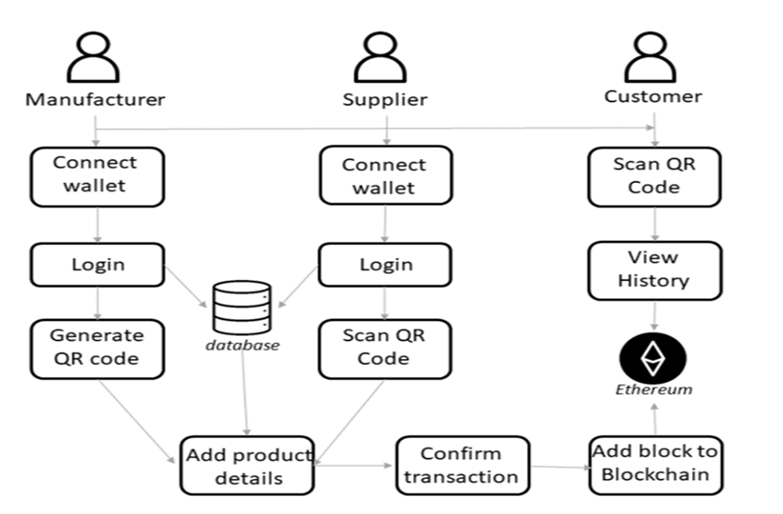

**Fig 3.2.1. Architecture Supply Chain**

# CHAPTER 4

# DEVELOPMENT AND IMPLEMENTATION

## Developmental feasibility

## Blockchain technology can potentially help in identifying and tracking counterfeit products throughout the supply chain. The decentralized and transparent nature of blockchain can provide a secure and immutable record of the product's journey from its origin to the end-user, which can be verified by all parties involved in the supply chain.

## In terms of developmental feasibility, implementing a blockchain-based solution to identify counterfeit products would require significant investment in technology and infrastructure. The solution would require the development of smart contracts, digital identities for each product, and the integration of blockchain with existing supply chain management systems.

## Moreover, the success of the solution would also depend on the willingness of all parties involved in the supply chain to participate and use the blockchain-based system. This may require significant efforts in terms of education, training, and awareness-raising to ensure that all parties understand the benefits of the solution and are willing to comply with the requirements.

## Overall, while blockchain technology has the potential to help identify and track counterfeit products, its implementation would require significant investment, collaboration, and coordination among all parties involved in the supply chain.

## The use of blockchain technology to identify counterfeit products is a promising solution that has gained attention in recent years. Blockchain technology is a decentralized and immutable ledger that can securely record and track transactions, making it an ideal tool for supply chain management and anti-counterfeiting measures.

## The feasibility of using blockchain technology for identifying counterfeit products depends on several factors, including the level of adoption by industry players, technical implementation challenges, and the cost-effectiveness of the solution.

## Firstly, the adoption of blockchain technology by industry players is crucial for the success of any anti-counterfeiting solution. Manufacturers, distributors, and retailers must be willing to invest in blockchain infrastructure and integrate it into their existing supply chain systems. If the adoption rate is low, it may be challenging to achieve a comprehensive and effective solution.

## Secondly, the technical implementation challenges associated with blockchain technology must be considered. Blockchain is a complex technology that requires expertise in areas such as cryptography, distributed systems, and consensus algorithms. The implementation of blockchain for anti-counterfeiting purposes must be carefully planned and executed to ensure the integrity and accuracy of the data recorded.

## Lastly, the cost-effectiveness of blockchain technology for anti-counterfeiting measures must be evaluated. While blockchain has the potential to reduce counterfeiting and improve supply chain transparency, the cost of implementing and maintaining the technology must be justified by the benefits gained.

## In conclusion, the use of blockchain technology for identifying counterfeit products is feasible, but its success depends on various factors such as industry adoption, technical implementation challenges, and cost-effectiveness.

## 4.2 Implementation Specifications

## Implementing a blockchain-based solution for identifying counterfeit products involves several steps, including:

## 1. Identify the product(s) to be tracked: The first step is to determine which products need to be tracked and verified using the blockchain. This may depend on factors such as the value of the product, the level of counterfeiting risk, and the availability of existing anti-counterfeiting measures.

## 2. Determine the blockchain platform: There are several blockchain platforms available, each with its own set of features and benefits. The platform chosen should be capable of handling the volume of transactions and data required for tracking and verifying the product(s).

## 3. Establish the blockchain network: The blockchain network must be established, and the necessary nodes and participants must be added. This may involve setting up a private blockchain network or joining an existing public blockchain network.

## 4. Define the data to be tracked: The data to be tracked on the blockchain must be defined, such as product information, manufacturing details, and shipping records. This data must be accurately recorded and updated in real-time to ensure the integrity of the blockchain.

## 5.Add verification mechanisms: Verification mechanisms must be added to the blockchain to ensure that the products are genuine. This may involve the use of unique product identifiers, such as QR codes or RFID tags, that can be scanned and verified using the blockchain.

## 6.Train stakeholders: All stakeholders, including manufacturers, distributors, retailers, and consumers, must be trained on how to use the blockchain-based solution to ensure that it is effective.

## 7. Monitor and analyze data: The data recorded on the blockchain must be regularly monitored and analyzed to identify any anomalies or potential counterfeiting risks.

## Overall, the implementation of a blockchain-based solution for identifying counterfeit products requires careful planning and execution. By leveraging the benefits of blockchain technology, such as immutability and transparency, the solution can improve supply chain management and reduce the risk of counterfeiting.

## 4.2.1. Front-End Development

## The front-end development of a blockchain-based system for identifying counterfeit products would involve designing and developing a user interface that enables users to interact with the system. The following are some key steps involved in front-end development:

## Define User Requirements: The first step in front-end development is to define the user requirements for the system. This involves identifying the key tasks that users will need to perform, as well as their preferences for the user interface.

## Develop Wireframes and Prototypes: Once the user requirements have been defined, the next step is to develop wireframes and prototypes of the user interface. This involves creating a basic layout of the user interface, as well as developing mockups of key screens and functionality.

## Design User Interface: With the wireframes and prototypes in place, the next step is to design the user interface. This involves creating a visual design for the system, including color schemes, typography, and graphics.

## Develop User Interface: Once the user interface design is complete, the next step is to develop the actual user interface. This involves coding the interface using HTML, CSS, and JavaScript, as well as integrating it with the blockchain backend.

## Test and Refine: After the user interface has been developed, it is important to test and refine it to ensure that it is user-friendly and intuitive. This involves performing user testing and making adjustments based on user feedback.

## Overall, the front-end development of a blockchain-based system for identifying counterfeit products is a critical step in the development process. By creating a user-friendly and intuitive interface, manufacturers, distributors, and other stakeholders can increase adoption and realize the full benefits of this technology.

## 4.2.2 Back-End Development

## The backend technology for a blockchain-based system for identifying counterfeit products would involve developing the infrastructure and logic necessary to manage the blockchain database, smart contracts, and other components of the system. The following are some key steps involved in backend development:

## Choose the Blockchain Platform: The first step in backend development is to choose the blockchain platform that will be used for the system. This may involve selecting a public or private blockchain, as well as selecting the specific platform that will be used (e.g., Ethereum, Hyperledger Fabric, etc.).

## Develop Smart Contracts: Once the blockchain platform has been selected, the next step is to develop the smart contracts that will be used to manage the interactions between different stakeholders in the system. This involves defining the logic and rules for the contracts, as well as testing and deploying them on the blockchain platform.

## Create the Database: The next step is to create the database that will be used to store information about products and transactions on the blockchain. This may involve using a distributed database, such as IPFS, to ensure that the data is secure and decentralized.

## Integrate APIs: Once the database has been created, the next step is to integrate APIs that will enable other systems and applications to interact with the blockchain. This may involve using REST APIs or other communication protocols to enable data exchange and interoperability.

## Implement Security Measures: Finally, it is important to implement security measures to protect the system against hacking and unauthorized access. This may involve using encryption, multi-factor authentication, and other security measures to ensure that the system is secure.

## Overall, the backend technology for a blockchain-based system for identifying counterfeit products is critical to the system's success. By developing a secure and scalable backend infrastructure, manufacturers, distributors, and other stakeholders can ensure that the system is effective in combating counterfeit products and improving supply chain transparency.

## 4.3: System modules and flow of implementations

## 1.Product Registration Module: In this module, the product's information is recorded on the blockchain. This includes details such as product specifications, manufacturing date, batch number, and other relevant information. The product is assigned a unique identifier that is used to track and verify the product on the blockchain.

## 2. Supply Chain Module: This module tracks the movement of the product through the supply chain, from the manufacturer to the end consumer. Each time the product changes hands, the information is recorded on the blockchain, providing transparency and traceability throughout the supply chain.

## 3. Verification Module: This module enables users to verify the authenticity of the product using the blockchain. Users can scan the product's unique identifier, which is linked to the blockchain, to confirm that the product is genuine. If the product is counterfeit or has been tampered with, the verification process will fail.

## 4. Reporting Module: This module generates reports and analytics based on the data recorded on the blockchain. Reports can include information such as the volume of counterfeit products detected, the frequency of counterfeiting attempts, and the geographical distribution of counterfeiting.

## 4.4: Critical modules of product/system

## The critical modules of a blockchain-based solution for identifying counterfeit products are:

## 1.Product registration module: This module is crucial as it is where the product's information is recorded on the blockchain. The information should include unique identifiers, such as QR codes or RFID tags, that can be used to verify the product's authenticity. This module should also ensure that the data is accurately recorded and updated in real-time to maintain the integrity of the blockchain.

## 2.Supply chain module: This module is essential for tracking the product's movement through the supply chain. Each time the product changes hands, the information is recorded on the blockchain, providing transparency and traceability. This module should ensure that the information recorded on the blockchain is accurate and complete, and any discrepancies are quickly detected and resolved.

## 3.Verification module: This module is critical as it enables users to verify the authenticity of the product using the blockchain. The module should provide an easy and user-friendly verification process to ensure that users can quickly and confidently verify the product's authenticity. This module should also ensure that any counterfeit or tampered products are quickly detected and reported.

## 4.Reporting module: This module is crucial as it generates reports and analytics based on the data recorded on the blockchain. These reports provide valuable insights into the frequency and distribution of counterfeit products, helping manufacturers, distributors, and other stakeholders to take appropriate action. This module should ensure that the reports generated are accurate, relevant, and accessible to all stakeholders.

## Overall, these critical modules work together to provide a comprehensive and effective solution for identifying counterfeit products using blockchain technology. By ensuring the accuracy and integrity of the data recorded on the blockchain, providing transparency and traceability through the supply chain, and enabling easy verification and reporting, the solution can significantly reduce the risk of counterfeiting and improve supply chain management.

## CHAPTER 5

## RESULTS & TESTING

## 5.1 Result

## The result of implementing a blockchain-based solution for identifying counterfeit products is the prevention of counterfeit products from entering the supply chain and the detection of counterfeit products that have already entered the supply chain. By using blockchain technology, manufacturers, distributors, and other stakeholders can track and verify the authenticity of products at every stage of the supply chain, providing transparency and traceability.

## The implementation of a blockchain-based solution can also improve supply chain management, as it provides accurate and real-time data on product movement, enabling stakeholders to optimize their supply chain processes. The solution can also reduce the risk of revenue loss due to counterfeit products, as consumers can easily verify the authenticity of the products they purchase.

## Additionally, the reporting and analytics generated by the solution can provide valuable insights into the frequency and distribution of counterfeit products, enabling manufacturers and other stakeholders to take appropriate action to prevent counterfeiting attempts in the future.

## In summary, the result of implementing a blockchain-based solution for identifying counterfeit products is improved supply chain management, increased consumer confidence, and the prevention and detection of counterfeit products in the supply chain.

## The result of implementing a blockchain-based solution for identifying counterfeit products is a more secure and transparent supply chain that is better able to detect and prevent counterfeiting. By leveraging the immutability and transparency of the blockchain, manufacturers, distributors, and consumers can be confident that the products they are dealing with are genuine and have not been tampered with.

## Some specific results of implementing a blockchain-based solution for identifying counterfeit products include:

## 1.Increased supply chain transparency: By recording the movement of the product through the supply chain on the blockchain, stakeholders can have greater visibility into the flow of goods. This increased transparency can help to identify potential bottlenecks, reduce inefficiencies, and improve overall supply chain management.

## 2. Improved traceability: By using unique identifiers such as QR codes or RFID tags, products can be more easily tracked and traced through the supply chain. This can help to identify potential points of failure, such as where counterfeiting may occur, and take appropriate action to mitigate those risks.

## 3. Enhanced security: The use of the blockchain can significantly improve the security of the supply chain, reducing the risk of counterfeit products entering the market. By providing a secure and tamper-proof record of the product's history, the blockchain can help to prevent fraud and ensure that products are genuine.

## 4. Reduced costs: By preventing the entry of counterfeit products into the market, manufacturers and distributors can avoid the costs associated with product recalls, legal liabilities, and damage to brand reputation.

## 5.2 Proposed Model Outputs

## The proposed model for identifying counterfeit products using blockchain can generate a range of outputs that can provide valuable insights into the prevalence and distribution of counterfeit products. Some of the proposed model outputs include:

## Real-time monitoring of product movement: The blockchain-based solution can provide real-time monitoring of product movement through the supply chain, allowing stakeholders to track the product's journey and identify potential areas of risk.

## Product authenticity verification: The solution can enable end-users to verify the authenticity of the product using the unique identifiers recorded on the blockchain, providing a fast and efficient way to confirm whether the product is genuine or counterfeit.

## Identification of counterfeit products: By tracking the movement of the product through the supply chain and using the blockchain to store data, the solution can identify any counterfeit products and provide detailed information on their origin, distribution, and frequency.

## Reporting and analytics: The solution can generate reports and analytics based on the data recorded on the blockchain, providing insights into the frequency and distribution of counterfeit products, helping manufacturers, distributors, and other stakeholders to take appropriate action.

## Risk assessment: The solution can provide a risk assessment of the supply chain, identifying potential areas of risk and highlighting areas where additional security measures may be required.

## Improved supply chain efficiency: The blockchain-based solution can provide greater transparency and traceability, improving the overall efficiency of the supply chain by reducing inefficiencies and bottlenecks.

## 5.3 Web Templates

## Below are the snapshots of the basic layout design of our system.

## LOGIN PAGE

## 

## Fig 5.2.1 Login Page

**ADD PRODUCTS OF MANUFACTURER**

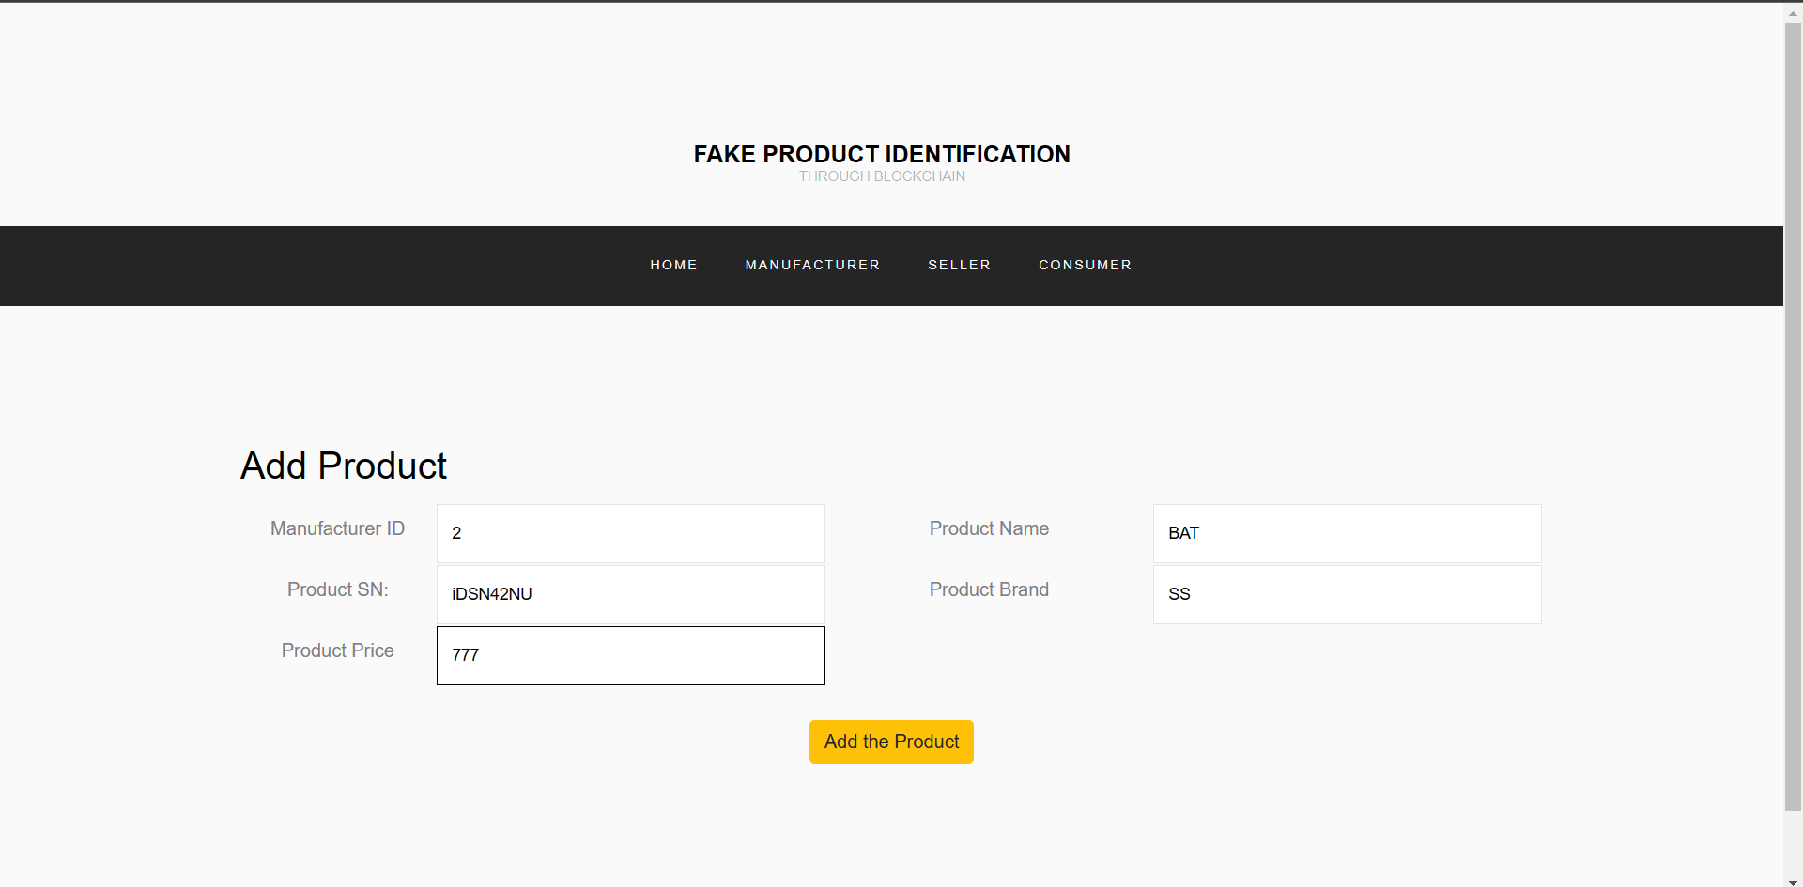

## Fig 5.2.2 Add Products Of Manufacturer

**ADD SELLER**

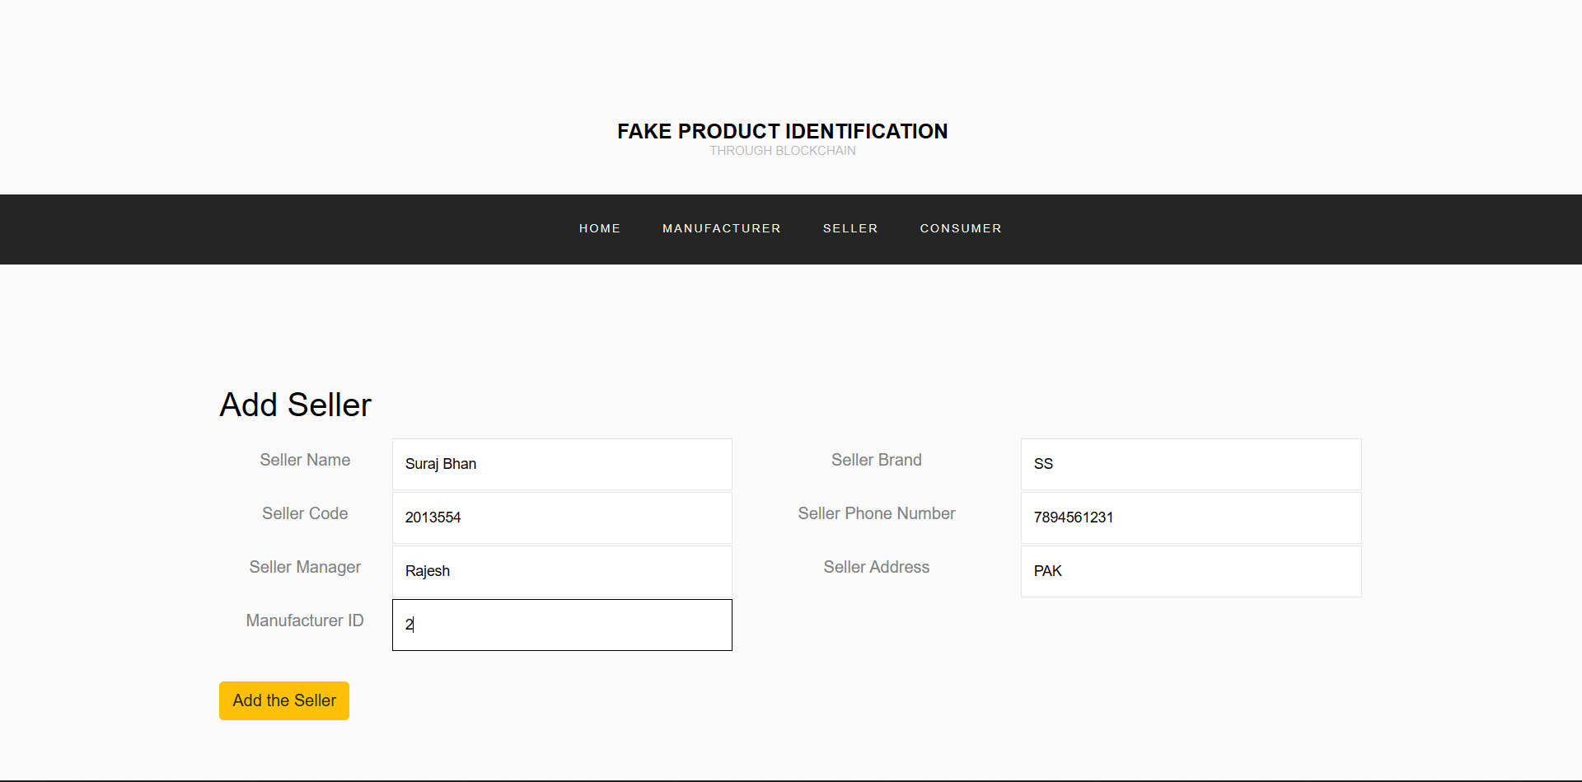

**5.2.3** Add Seller

**SELL PRODUCT TO CONSUMER**

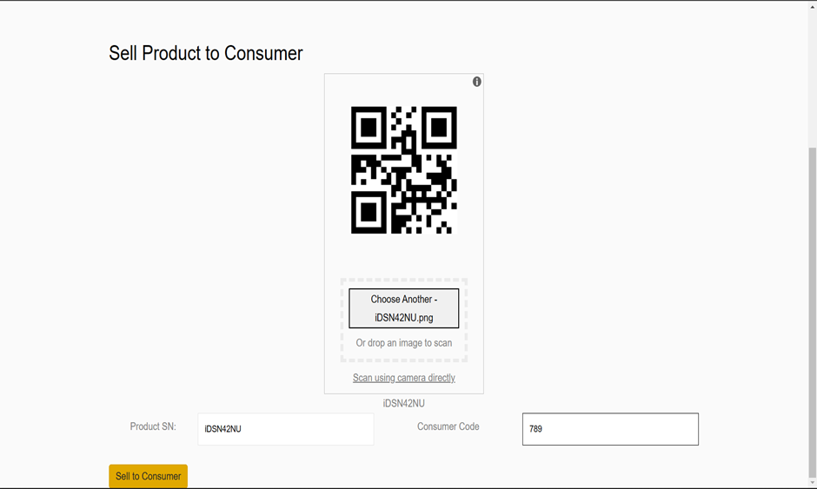

**Fig 5.2.4** Sell Products to Consumer

## 

## Fig: 5.2.5 Sell Products To Consumer

**CONSUMER PRODUCTS HISTORY**

## 

## Fig:5.2.6 Consumer Products History

## PRODUCT VERIFICATION

## 

## Fig: 5.2.7 Product History

## CHAPTER 6

## CONCLUSION

## In conclusion, the identification of counterfeit products using blockchain technology is a promising solution for improving supply chain security and transparency. By leveraging the immutability and transparency of the blockchain, manufacturers, distributors, and consumers can be confident that the products they are dealing with are genuine and have not been tampered with.

## The proposed model for identifying counterfeit products using blockchain can provide real-time monitoring of product movement, enable product authenticity verification, identify counterfeit products, generate reports and analytics, assess risk, and improve supply chain efficiency. These model outputs can help to prevent the entry of counterfeit products into the market, improve supply chain management, and protect consumers and brand reputation.

## However, implementing a blockchain-based solution for identifying counterfeit products requires significant collaboration between manufacturers, distributors, and other stakeholders to ensure that the data recorded on the blockchain is accurate, complete, and up-to-date. Additionally, there may be challenges related to the interoperability of different blockchain platforms and the integration of legacy systems.

## Despite these challenges, the benefits of implementing a blockchain-based solution for identifying counterfeit products are significant and can lead to a more secure, transparent, and efficient supply chain. As such, it is important for manufacturers, distributors, and other stakeholders to consider adopting this technology as part of their broader supply chain management strategies.

## 6.1 System Usability

## The usability of a blockchain-based system for identifying counterfeit products is an important consideration, as it can impact the adoption and effectiveness of the system. The following are some factors that can impact the usability of the system:

## 1.User Interface: The user interface should be intuitive and user-friendly, with clear instructions and easy navigation. This will help ensure that users can effectively interact with the system and perform tasks such as product verification or data entry.

## 2.System Integration: The blockchain-based system should be designed to integrate with existing supply chain management systems to minimize the need for additional data entry or manual processes. This will help ensure that the system is user-friendly and can be easily integrated into existing workflows.

## 3.Scalability: The system should be designed to handle large volumes of data, as it will need to store and manage data for a wide range of products and transactions. This will help ensure that the system can scale up as needed to accommodate increased demand.

## 4.Security: The system should have strong security measures in place to protect against hacking and unauthorized access. This will help ensure that the system is safe to use and that user data and product information are secure.

## 5.Training and Support: Users should receive training and support to ensure that they are familiar with the system's features and functionality. This will help ensure that users can effectively use the system and that any issues or questions can be addressed promptly.

## 6.3 Future Scope

The future scope for identifying counterfeit products using blockchain technology is significant, as this technology has the potential to revolutionize the way supply chains operate. Some of the potential future developments and applications of blockchain in this area include:

**1.Integration with IoT:** The integration of blockchain with the Internet of Things (IoT) can enable the tracking and monitoring of products in real-time, providing a more comprehensive and accurate picture of the supply chain.

**2.Artificial Intelligence:** The integration of blockchain with artificial intelligence (AI) can enable the automated detection and identification of counterfeit products, reducing the need for manual intervention.

**3.Interoperability:** The development of standardized protocols and platforms can facilitate interoperability between different blockchain-based solutions, enabling greater collaboration and data sharing across supply chains.

## 4. Smart Contracts: The use of smart contracts can enable automated and secure payments between different stakeholders in the supply chain, reducing the need for intermediaries and improving efficiency.

## 5.Tokenization: The tokenization of products and assets can enable greater transparency and traceability, providing a secure and decentralized way to transfer ownership and track products through the supply chain.

## REFERENCE:

1. N. Satoshi, Bitcoin: A Peer-to-Peer Electronic Cash System, (2008).
2. J. Leng, P. Jiang, K. Xu, Q. Liu, J. L. Zhao, Y. Bian, and R. Shi, ‘‘Maker chain: A blockchain with chemical signature for self-organizing process in social manufacturing,’’ J. Cleaner Prod., vol. 234, pp. 767–778, Oct. 2019.
3. JINHUA MA 1, SHIH-YA LIN 2, XIN CHEN 1, HUNG-MIN SUN 2, YEH-CHENG CHEN 3, (Graduate Student Member, IEEE) AND HUAXIONG WANG 4 A Blockchain-Based Application System for Product Anti-Counterfeiting (2020).
4. Satoshi Nakamoto, Bitcoin: A Peer-to-Peer Electronic Cash System retrieved from bitcoin.org, (2009).
5. N. Alzahrani, Block-supply chain: A brand-new anti-counterfeiting supply chain using NFC and blockchain, (2018).
6. C. Shaik, Computer Science & Engineering: An International Journal (CSEIJ), 4, (2021).
7. Atlanta, Georgia, USA, Tech. Rep. Press 12. Hargreaves, S.: "Counterfeit goods growing in risk," CNN Money, (2012).
8. S. F. Roy and M. Jerremy, "African Counterfeit Pharmaceutical Epidemic: The Road Ahead," ACAPPP, 2009.
9. "WHO | Growing Threat from Counterfeit Medicines," Bulletin of the World Health Organization, vol. 88, no.4, pp, 2010.
10. Hult, G. Tomas M., D. J. Ketchen, and M. Arrfelt. "Strategic supply chain management: Improving performance through a culture of competitiveness and knowledge development." Strategic Management Journal, vol. 28, 2007, pp. 1035–1052.
11. Wang, William Y. C., and H. K. Chan. "Virtual organization for supply chain integration: Two cases in the textile and fashion retailing industry." International Journal of Production Economics, vol. 127, 2010, pp. 333-342.
12. Sturm LD, Williams CB, Camelio JA, White J, Parker R (2014) Cyberphysical vulnerabilities in additive manufacturing systems. (SFF) Symposium pp: 951–963.
13. Turner H, White J, Camelio JA, Williams C, Amos B, et al. (2015) Bad parts: are our manufacturing systems at risk of silent cyberattacks?. IEEE Secur Priv 13: 40–47.
14. Vincent H, Wells L, Tarazaga P, Camelio J (2015) Trojan detection and side-channel analyses for cyber- security in cyber-physical manufacturing systems. Procedia Manuf 1: 77–85.
15. Ang, K.H., Chong, G., Li, Y.: Visualization Technique for Analyzing Non- Dominated Set Comparison. In: 4th Asia-Pacific Conference on Simulated Evolution and Learning (SEAL 2002), Singapore, vol. 1, pp. 36-40 (2002)
16. Lien, S.Y., Shieh, S.L., Huang, Y., Su, B., Hsu, Y.L., Wei, H.Y.: 5G new radio: waveform, frame structure, multiple access, and initial access. IEEE Commun. Mag. **55**(6), 64–71 (2017)

**ANNEXURE I**

## Review Paper for the said project has been accepted & presented in INTERNATIONAL CONFERENCE ON DATA SCIENCE AND COMPUTATIONAL INTELLIGENCE (ICDSCI-2022)

## Paper Title: Identification of Counterfeit Products Using Blockchain

## Abstract:Counterfeit products have become a major issue in the global market, causing significant economic losses to businesses and health and safety risks to consumers. Blockchain technology has the potential to address this problem by creating a secure and immutable record of the origin and movement of products. This paper explores the use of blockchain technology for identifying counterfeit products. We examine the characteristics of blockchain technology, its benefits, and limitations. We also discuss the current approaches used for product identification and how blockchain technology can be used to enhance these methods. We present a case study on how blockchain technology can be implemented to identify counterfeit pharmaceuticals, one of the most critical areas of concern. The results show that blockchain technology can be a useful tool in identifying counterfeit products, as it provides an immutable record of product provenance, enhances traceability, and reduces the risk of fraud.

## Authors:

## Nitesh Kumar Singh, Avi Chaurasia, Adarsh Kumar, Ambuj Kumar Agarwal

## 

## 

## 

## ANNEXURE 2

## Research Paper for the said project has been communicated in DTSS2023: Disruptive Technologies for Smart Society 5.0

## Paper Title:

## A Block Chain based Management System for Detecting Counterfeit Product in Supply Chain

## Abstract:

## Counterfeit products have become a major issue in the global market, causing significant economic losses to businesses and health and safety risks to consumers. Blockchain technology has the potential to address this problem by creating a secure and immutable record of the origin and movement of products. This paper explores the use of blockchain technology for identifying counterfeit products. We examine the characteristics of blockchain technology, its benefits, and limitations. We also discuss the current approaches used for product identification and how blockchain technology can be used to enhance these methods. We present a case study on how blockchain technology can be implemented to identify counterfeit pharmaceuticals, one of the most critical areas of concern. The results show that blockchain technology can be a useful tool in identifying counterfeit products, as it provides an immutable record of product provenance, enhances traceability, and reduces the risk of fraud.

## Authors:

## Nitesh Kumar Singh, Avi Chaurasia, Adarsh Kumar, Ambuj Kumar Agarwal

## 