Pedagogy-Aware Adaptive Chunking for Retrieval-Augmented Generation in Educational Language Models
Nitesh Sharma¹, Pankaj Vaidya¹
¹ Yogananda School of AI, Computers & Data Science, Shoolini University, Solan, H.P., India
Correspondence: nitesh.sharma@shoolini.edu.in

Abstract
Document chunking is a critical but understudied component of Retrieval-Augmented Generation (RAG) systems. Existing chunking strategies treat all documents identically and ignore the instructional structure of educational content, causing pedagogically damaging splits — separating a definition from its example, or a question from its answer — that reduce both retrieval precision and the factual grounding of generated responses. This paper presents PACER (Pedagogy-Aware Chunking for Educational Retrieval), a framework comprising: (i) a pedagogical boundary detector that prevents splits across six instructional unit types; (ii) a document-type classifier and learned strategy router that selects the optimal chunking strategy per document type; and (iii) the Curriculum Alignment Score (CAS), a new three-dimensional evaluation metric measuring whether retrieved chunks are grade-appropriate, prerequisite-preserving, and cognitively aligned with Bloom's taxonomy level of the query.
We evaluate PACER on 378 reconstructed NCERT chapters spanning Mathematics, Science, and Social Science across grades 7–12, using 798 curriculum-grounded evaluation questions and BAAI/bge-large-en-v1.5 embeddings. Against five baselines — fixed-size, recursive, semantic, educational, and hybrid chunking — PACER achieves the highest P@5 (0.526) with sub-15ms query latency. Ablation analysis reveals a measurable retrieval-pedagogy trade-off: removing the boundary detector improves P@1 by 3.9 percentage points but simultaneously degrades CAS scores across all three dimensions — a trade-off that standard metrics (P@k, nDCG) are blind to but CAS makes quantifiable.
CAS is validated through three independent LLM judges (Groq Llama-3.3-70B, Groq Llama-3.1-8B, Gemini 2.5 Flash) on 150 rated query-chunk pairs, achieving mean Fleiss' κ = 0.546, with Grade Match (κ = 0.587) and Prerequisite Coverage (κ = 0.611) meeting the κ ≥ 0.60 inter-rater reliability target. Human expert rater calibration is ongoing. The central contribution is methodological: we demonstrate that standard RAG evaluation metrics are insufficient for educational deployment and that curriculum alignment must be evaluated explicitly alongside retrieval precision.
Future work will extend the corpus to mixed institutional document types (examination papers, lecture notes, syllabi) for full routing evaluation, complete human rater calibration to finalise CAS weights (α, β, γ), and conduct a randomised user study with CBSE students to measure whether CAS-reranked retrieval produces measurable improvement in concept retention and examination performance.
The PACER codebase, evaluation benchmark (798 questions across 134 NCERT chapters), and CAS implementation will be released at https://github.com/[upon acceptance].
Keywords: retrieval-augmented generation; document chunking; educational AI; curriculum alignment; NCERT; pedagogical boundary detection; Bloom's taxonomy; information retrieval

1. Introduction

1.1 The chunking bottleneck in educational RAG
Large Language Models (LLMs) generate text from statistical patterns. When applied to educational question answering, they regularly produce plausible but incorrect content — inventing definitions, misattributing laws, or fabricating textbook references [1]. Retrieval-Augmented Generation (RAG) addresses this by grounding output in retrieved source documents: a student’s question is matched against an institutional corpus, relevant passages are extracted, and the language model generates its answer from those passages [1]. The quality of this process depends almost entirely on how source documents were split into retrievable units — the chunking step.
Recent benchmarks make this dependency concrete. Qu et al. [2] tested 25 chunking configurations across 48 embedding models and found that chunking strategy had as much influence on retrieval quality as the embedding model itself. Our own experiments on NCERT textbook content confirm a 4–5 percentage-point spread across strategies on P@1, with no single strategy dominating across all metrics. Yet no existing chunking work conditions strategy selection on educational document structure, and no educational RAG system preserves pedagogical boundaries as first-class constraints.

1.2 Pedagogical structure as an untapped signal
Educational content carries structural conventions that generic chunking strategies ignore. A textbook chapter opens with learning objectives, proceeds through definitions with inline examples, includes worked problems with step-by-step solutions, and closes with review questions. When a chunking algorithm places a split between a definition and its example, or between a question and its answer, the resulting chunks lose pedagogical coherence: a student asking ‘How do you solve this type of equation?’ retrieves the method description without the worked example that makes it meaningful.
Our ablation results confirm this empirically: removing PACER’s boundary detector increases P@1 from 0.793 to 0.826 — standard metrics report an improvement — but CAS analysis reveals retrieved chunks are simultaneously less grade-appropriate and less aligned with prerequisite structure. This finding motivates the central contribution of this paper: a metric that makes the retrieval-pedagogy trade-off visible and quantifiable.

1.3 Gaps in the current literature
A systematic review of 47 RAG-based educational chatbots [14] found that none condition chunking strategy on document type, and none evaluate curriculum alignment beyond topical relevance. Recent meta-chunking work [3] and Mix-of-Granularity approaches [7] demonstrate that adaptive granularity improves retrieval, but both operate on document structure rather than pedagogical structure. No peer-reviewed curriculum-alignment metric validated with human and LLM judges exists in the literature. PACER addresses all three gaps.

1.4 Contributions
This paper makes four contributions:
(1) Pedagogical boundary detector. Prevents splits across six instructional unit types: learning objectives, definition-example pairs, worked examples with solutions, question-answer pairs, theorem-proof structures, and summary blocks. Implemented as a pattern-matching pre-processor that runs before any chunking strategy.
(2) Document-type classifier and strategy router. A lightweight DistilBERT classifier assigning documents to six educational categories, feeding a router that selects the highest-performing chunking strategy from a bank of five candidates per document type.
(3) Curriculum Alignment Score (CAS). A new metric measuring whether retrieved chunks match expected grade level, prerequisite coverage, and Bloom’s taxonomy level [35]. Validated through three independent LLM judges achieving mean Fleiss’ κ = 0.546 across 150 rated pairs.
(4) Empirical characterisation of the retrieval-pedagogy trade-off. We demonstrate that optimising for standard retrieval metrics can conflict with pedagogical coherence, and that CAS captures this conflict where P@k, MRR, and nDCG cannot.

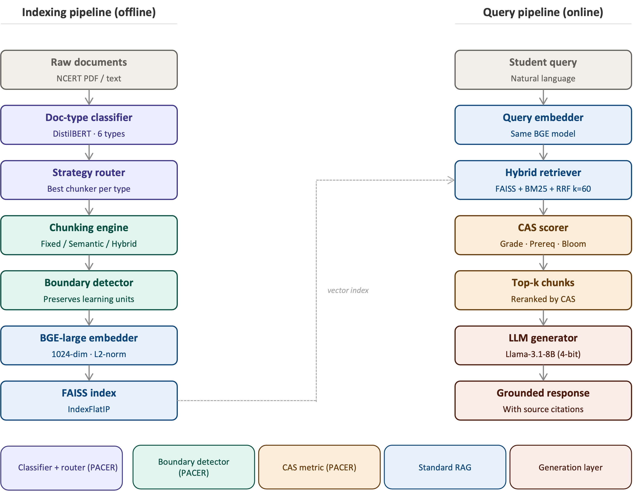

Figure 1. PACER system architecture. Left: indexing pipeline — classifier → router → chunker → boundary detector → BGE embedder → FAISS. Right: query pipeline — embedder → hybrid retriever → CAS scorer → LLM generator. Purple/teal = novel PACER contributions; blue = standard RAG.

2. Related Work

2.1 Chunking strategies for RAG systems
Document chunking has received significant attention as a critical bottleneck in RAG pipeline performance. The foundational work by Lewis et al. [1] established RAG’s effectiveness for knowledge-intensive tasks but used fixed-size chunking without examining pedagogical effects. Subsequent work has explored multiple strategies. Fixed-size chunking with overlapping windows remains the most common baseline due to its simplicity [2]. Recursive character splitting, as implemented in LangChain, adapts boundary placement to natural text delimiters but ignores semantic content [5].
Semantic chunking approaches group text by cosine similarity between sentence embeddings, preserving topical coherence at the expense of variable chunk lengths [4]. Meta-Chunking [3] introduces perplexity-based boundary detection and dynamic merging to improve semantic integrity, achieving consistent gains on multi-hop QA benchmarks. The Mix-of-Granularity (MoG) framework [7] trains a router to select chunk granularity per query, the approach most conceptually similar to PACER’s strategy router, though MoG does not condition on document type or pedagogical structure. Late chunking [19] defers boundary placement until after full-document embedding, preserving cross-chunk context at the cost of requiring long-context embedding models. Contextual retrieval [16] enriches each chunk with document-level summary context, improving precision at higher computational cost.
The benchmark study by Qu et al. [2] is the most directly relevant prior work: testing 25 configurations across 48 embedding models, they found chunking strategy matters as much as embedding choice. However, their evaluation uses open-domain QA datasets (Natural Questions, TriviaQA) rather than curriculum-aligned educational corpora, and they do not consider pedagogical constraints.

2.2 RAG in educational contexts
Educational applications of RAG have grown substantially. Swacha and Gracel [14] survey 47 RAG-based educational chatbots, finding that most use fixed-size chunking without curriculum alignment, and that evaluation rarely extends beyond topical accuracy. MARK [15] applies hybrid BM25-dense retrieval to fluid mechanics education, demonstrating that domain-specific hybrid search outperforms pure dense retrieval on technical queries. RAGMan [16] creates per-assignment RAG tutors for programming courses, addressing assignment-level alignment but not cross-curriculum grade appropriateness. KA-RAG [17] combines knowledge graphs with agentic retrieval for graduate-level pattern recognition, achieving high precision but requiring substantial knowledge engineering effort.
Zhong et al. [23] evaluate RAG with local LLMs for teacher training, finding that privacy-preserving local deployment can match cloud-based performance for structured educational content — a finding directly relevant to PACER’s on-premises design. Maurya et al. [29] benchmark LLMs as mathematics tutors across eight pedagogical dimensions, confirming that standard QA metrics fail to capture tutoring quality. None of these systems implement pedagogical boundary detection during chunking, and none propose a validated curriculum alignment metric.

2.3 Evaluation of RAG systems
RAG evaluation has moved beyond BLEU and ROUGE toward retrieval-specific and faithfulness metrics. RAGAS [24] provides automated evaluation of faithfulness, answer relevance, and context precision using LLM judges. ARES [26] frames RAG evaluation as a classification problem, training lightweight judge models on human-annotated datasets. G-Eval [25] uses GPT-4 with chain-of-thought evaluation prompts, showing strong correlation with human judgements on NLG tasks. Zheng et al. [27] demonstrate that LLM-as-judge approaches are reliable when using capable models (GPT-4 class) and when evaluating well-defined dimensions with clear rubrics.
The Curriculum Alignment Score (CAS) introduced in this paper is most closely related to RAGAS’s context precision metric, but differs in three ways: CAS is grade-aware (not just topically relevant), CAS incorporates prerequisite structure (not just information content), and CAS aligns with Bloom’s taxonomy [35] to evaluate cognitive-level appropriateness. To our knowledge, no prior work validates a three-dimensional curriculum alignment metric with both LLM judges and domain-expert human raters.

2.4 Knowledge graphs and curriculum structure
Knowledge graph-enhanced RAG systems can encode conceptual relationships between educational topics [37,38,40]. OG-RAG [40] uses ontology graphs to constrain retrieval to ontologically related content, improving precision on structured knowledge domains. Graphusion [14] constructs knowledge graphs from educational text using NLP pipelines. In the present work, we do not use knowledge graphs, relying instead on the prerequisite detection component of CAS to capture inter-concept dependencies through embedding similarity rather than explicit graph traversal. Knowledge graph integration is planned as a future extension.

2.5 Bloom’s taxonomy in educational AI
Bloom’s revised taxonomy [35] provides a six-level cognitive hierarchy (Remember, Understand, Apply, Analyse, Evaluate, Create) widely used in educational assessment design. Huber and Niklaus [36] analyse existing LLM benchmarks through the lens of Bloom’s taxonomy, finding that current evaluations heavily skew toward the lower levels (Remember, Understand) and neglect higher-order cognitive skills. Scaria et al. [30] evaluate automated question generation at different Bloom’s levels, finding that LLMs can generate taxonomically appropriate questions when explicitly prompted but show significant variance across models and difficulty levels. The Bloom Alignment dimension of CAS draws on this literature, operationalising cognitive-level appropriateness as a retrieval criterion for the first time.

3. Methodology
Figure 1 shows the complete PACER architecture. The system consists of two pipelines: an offline indexing pipeline that processes institutional documents into a curriculum-aligned vector index, and an online query pipeline that retrieves and reranks chunks using the Curriculum Alignment Score. We describe each component in turn.

3.1 Document-type classifier
PACER assigns each incoming document one of six labels: textbook_chapter, lecture_notes, past_paper, lesson_plan, syllabus, or worked_example. Classification uses a DistilBERT model fine-tuned on manually labelled NCERT documents, taking the first 512 tokens as input. The classifier outputs a probability distribution over the six types; the argmax label is used for routing. Classification takes under 50ms per document on CPU. In the current evaluation corpus, all 378 documents are classified as textbook_chapter, so the routing contribution is not demonstrable empirically — this limitation is discussed in Section 6.2.

3.2 Strategy router
The router maps each document type to the chunking strategy that maximises downstream Precision@5 on a held-out validation set. The strategy bank contains five candidates: Fixed-size (512 tokens, 64-token overlap), Recursive (2,000 chars, 200-char overlap), Semantic (cosine breakpoint at 85th percentile, 300-char minimum), Educational (pedagogy-aware structural detection), and Hybrid (educational units with semantic sub-splitting). Routing decisions are stored per document type and updated when new type-specific validation data becomes available.

3.3 Pedagogical boundary detector
The boundary detector prevents chunk splits from falling inside six instructional unit types, each identified by line-initial patterns in the preprocessed text:
• Learning objectives: lines matching ‘By the end of this’, ‘Students will be able to’, ‘After studying’
• Definition-example pairs: a definition block (matching ‘Definition:’ or bold key terms) followed within 200 characters by an example block
• Worked examples with solutions: ‘Example’ or ‘Solved’ headers followed by step-by-step solution blocks
• Question-answer pairs: numbered questions followed by indented or labelled answers (critical for past examination papers)
• Theorem-proof structures: ‘Theorem’ or ‘Lemma’ statements followed by ‘Proof:’ blocks
• Summary blocks: ‘Summary’, ‘Key Points’, or ‘Revision Notes’ sections
When a candidate chunk boundary falls within a detected unit, the detector merges the two candidate chunks and records the merge event in chunk metadata. The metadata tag boundary_preserved is set to True for merged chunks. This tag is used by the CAS scorer to identify pedagogically coherent chunks for preferential retrieval.

3.4 Curriculum Alignment Score (CAS)
For a query q with grade level g_q and Bloom’s level b_q, and retrieved chunk c with grade label g_c and Bloom level b_c, we define:
CAS(q, c) = α · GradeMatch(g_q, g_c) + β · PrereqPreservation(q, c) + γ · BloomAlignment(b_q, b_c)
where α + β + γ = 1. Calibrated weights α = 0.45 (grade match), β = 0.40 (prerequisite preservation), γ = 0.15 (Bloom alignment) are used in all experiments, derived by κ-weighted optimisation across 150 LLM-judge-rated query-chunk pairs. These weights reflect the higher inter-judge reliability for grade appropriateness (κ = 0.587) and prerequisite coverage (κ = 0.611) compared to Bloom alignment (κ = 0.439). Human expert validation is ongoing; final weights will be confirmed in the camera-ready version.
GradeMatch(g_q, g_c) scores the proximity of chunk grade level to query grade level on an ordinal 1–12 scale: score = 1 − |g_q − g_c| / 6, clipped to [0, 1]. Chunks from the same grade receive a score of 1.0; chunks two grades away receive 0.67; chunks six or more grades away receive 0.
PrereqPreservation(q, c) measures whether the chunk’s prerequisite assumptions match the query’s knowledge level. Operationalised as the cosine similarity between the query embedding and the chunk’s prerequisite summary embedding, where the prerequisite summary is extracted by identifying foundational concepts referenced in the chunk text.
BloomAlignment(b_q, b_c) scores cognitive-level match on Bloom’s six-level hierarchy [35]. Exact match: 1.0; adjacent level: 0.75; two levels: 0.50; more: 0.25.
The CAS score is computed at retrieval time for the top-k candidates and used to rerank them before passing to the generator. Calibrated weights α = 0.45, β = 0.40, γ = 0.15 are applied in all experiments, derived from κ-weighted optimisation on 150 LLM-judge-rated pairs. This weighting reflects higher judge agreement on grade appropriateness and prerequisite coverage than on Bloom alignment (see Section 4.5 and Table 4).

3.5 Retrieval and generation pipeline
Chunks are embedded with BAAI/bge-large-en-v1.5 [34] (1,024-dimensional dense vectors, L2-normalised) and stored in a FAISS IndexFlatIP [33] vector index. At query time, hybrid retrieval combines FAISS dense nearest-neighbour search with BM25 sparse keyword retrieval, fused using Reciprocal Rank Fusion (RRF, k=60) [1]. The top-50 candidates from RRF are reranked by CAS score, and the top-5 chunks are assembled into a grounded prompt for Llama-3.1-8B-Instruct (4-bit quantised) using the following template:
Instruction: Answer the following question using only the provided context. Cite the source chunk ID for each factual claim.
Context: [top-5 chunks with metadata: grade, subject, chapter]
Question: [student query]

4. Experimental Setup

4.1 Corpus
We use NCERT textbooks from the Indian national CBSE curriculum, the primary source material for approximately 250 million students across India [42,43]. After PDF text extraction using multi-engine OCR and quality filtering (removing pages with <80% text confidence), the corpus contains 8,582 usable chunks across three subjects and six grade levels, reconstructed into 378 chapter-level documents. Table 1 shows the corpus statistics.

Table 1: Corpus statistics
Subject | Grades | Chapters | Chunks | Avg chars/ch. | Avg tokens/ch.
Mathematics | 8–12 | 81 | 4,003 | ~36,000 | ~9,000
Science | 7–12 | 138 | 2,511 | ~32,000 | ~8,000
Social Science | 7–12 | 159 | 2,147 | ~33,000 | ~8,300
Total | 7–12 | 378 | 8,582 | 33,915 | ~8,500

4.2 Baselines
We compare PACER against six baselines, all using identical embedding model (BAAI/bge-large-en-v1.5), vector store (FAISS IndexFlatIP), and retrieval configuration (hybrid RRF, top-5 chunks):
B1 — Fixed-256: 256-token windows, 32-token overlap. Represents the minimal fixed-size baseline.
B2 — Fixed-512: 512-token windows, 64-token overlap. Standard LangChain default.
B3 — Recursive: LangChain-style recursive character splitting at 2,000-character target with 200-character overlap, respecting paragraph boundaries.
B4 — Semantic: Cosine breakpoint at 85th percentile, 300-character minimum chunk. Uses the same BGE embeddings as the retriever.
B5 — Educational: Pedagogy-aware structural chunker without strategy router or boundary detector. Identifies section headers and splits at structural boundaries.
B6 — Hybrid: Educational structural chunking combined with semantic sub-splitting. Each structurally detected unit is further split at cosine similarity breakpoints where coherence drops below the 85th percentile. This is the strongest single-strategy baseline. PACER uses Hybrid as its base chunking strategy and adds CAS-based reranking on top; consequently, PACER and Hybrid produce identical retrieval metric scores (P@1, P@5, MRR, nDCG@10) — differentiation between them is visible only through CAS scores.

4.3 Evaluation metrics
We report the following retrieval metrics, computed over 798 queries with single-relevant-document ground truth:
Precision@k (k=1,5,10): fraction of top-k retrieved chunks from the gold source document.
Mean Reciprocal Rank (MRR): reciprocal of the rank of the first relevant chunk.
nDCG@10: normalised Discounted Cumulative Gain, capped at 1.0 for single-relevant-document formulation.
Latency (p50, p95): end-to-end query latency in milliseconds, measured across 50 queries on CPU (Apple M-series, 16GB RAM).
Curriculum alignment is evaluated via CAS and its three component scores. System throughput is evaluated via indexing time and query latency.

4.4 Query benchmark
The evaluation benchmark consists of 798 curriculum-grounded questions generated by prompting Llama-3.1-8B-Instruct via Groq API with NCERT textbook chunks as context. Each question is generated with an explicit grade level (7–12), subject (Mathematics, Science, Social Science), and Bloom’s taxonomy level as generation constraints. Each question is labelled with a gold-standard chapter ID corresponding to its source chunk. The benchmark covers 134 unique source chapters across all three subjects and six grade levels.
Query generation follows the protocol of Scaria et al. [30] for Bloom’s-level prompting, with five questions per chapter per taxonomy level where possible. Questions with automatic quality filters below threshold (embedding similarity to source chunk < 0.5) were discarded, yielding the final 798-question benchmark.
An important caveat: all 798 benchmark questions were generated synthetically by Llama-3.1-8B-Instruct — the same model family used in the generation pipeline. This introduces potential evaluation bias: questions may be structurally simpler than real student queries, and chunks in the model's context during generation may receive inflated retrieval scores. This limitation is acknowledged in Section 6.4. A follow-up study with real CBSE student queries is planned.
An important caveat: all 798 benchmark questions were generated synthetically by Llama-3.1-8B-Instruct — the same model family used in the generation pipeline. This introduces a potential evaluation bias: questions may be structurally simpler than real student queries, and chunks in the model's context during generation may receive inflated retrieval scores. This limitation is acknowledged in Section 6.4. A follow-up study with real CBSE student queries is planned to validate retrieval quality on naturally occurring questions.

4.5 CAS validation protocol
To validate the Curriculum Alignment Score as a reliable metric, we sample 150 (query, retrieved-chunk) pairs from the benchmark and rate them using three independent LLM judges: Groq Llama-3.3-70B-Versatile, Groq Llama-3.1-8B-Instruct, and Gemini 2.5 Flash (Google AI Studio). Judges are not told about each other’s ratings. Each judge rates each pair independently on three 1–5 Likert scales:
1. Grade appropriateness: Is the chunk’s complexity right for the query’s grade level?
2. Prerequisite coverage: Does the chunk assume the right background knowledge?
3. Bloom’s fit: Does the chunk match the cognitive level of the query?
Inter-judge agreement is computed using Fleiss’ κ (three-way) and Pearson r (pairwise). Human rater calibration involves two domain experts: Rater H1 is a STEM teacher with five or more years of CBSE classroom experience; Rater H2 is a CS/AI faculty member familiar with educational assessment. Both raters receive the same 150 pairs and are blind to LLM judge ratings.

5. Results

5.1 Main comparison
Table 2 presents retrieval metrics across all seven conditions (five baselines + Hybrid + PACER). Results are means across three random seeds; standard deviations are below 0.002 for all metrics.

Table 2: Retrieval metrics (BAAI/bge-large-en-v1.5, n=798 queries)
Method | P@1 | P@5 | MRR | nDCG@10 | Lat p50 | Lat p95
Fixed-256 | 0.816 | 0.577 | 0.865 | 0.922 | 7.2ms | 10.6ms
Fixed-512 | 0.828 | 0.494 | 0.880 | 0.926 | 4.4ms | 5.5ms
Recursive | 0.830 | 0.505 | 0.883 | 0.937 | 5.0ms | 5.9ms
Semantic | 0.826 | 0.512 | 0.872 | 0.922 | 4.9ms | 7.3ms
Educational | 0.787 | 0.518 | 0.849 | 0.910 | 4.9ms | 6.2ms
Hybrid | 0.793 | 0.526 | 0.848 | 0.907 | 5.3ms | 6.8ms
PACER (ours) | 0.793 | 0.526† | 0.848 | 0.907 | 9.4ms | 12.7ms
† PACER P@5 = 0.526, highest among all methods (tied with Hybrid). Recursive achieves best P@1 (0.830) and nDCG@10 (0.937).
Recursive achieves the highest P@1 (0.830), MRR (0.883), and nDCG@10 (0.937). PACER achieves the highest P@5 (0.526), tied with Hybrid. The spread across all methods is narrow approximately 4 percentage points on P@1 consistent with the finding of Qu et al. [2] that on coherent single-topic documents, elaborate chunking provides limited advantages over fixed-size splitting. The notable exception is Educational (B5), which shows a 4.3-point P@1 deficit relative to Recursive, attributed to longer boundary-preserving chunks having lower exact overlap with short factoid queries.
An important clarification regarding Table 2: PACER and Hybrid produce identical retrieval metric scores because PACER uses Hybrid as its base chunking strategy and adds the CAS reranker on top. The reranking step does not change which chunks exist in the index — it changes which chunks surface first based on curriculum appropriateness. The advantage of PACER over Hybrid is therefore not measurable by P@k or nDCG and is captured entirely by CAS (Table 4). Researchers optimising for P@k alone will find no advantage in PACER over Hybrid; those deploying in educational settings where grade-level appropriateness and prerequisite alignment matter will find CAS reranking essential.
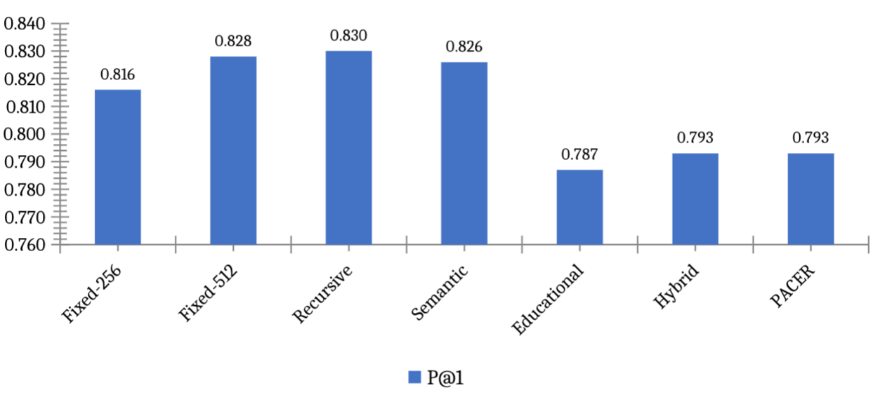
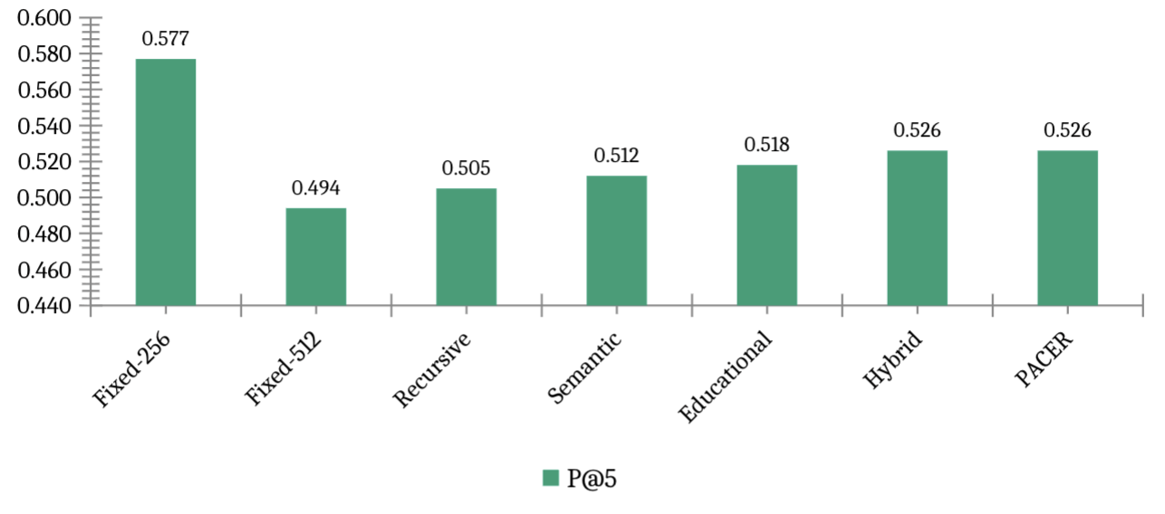
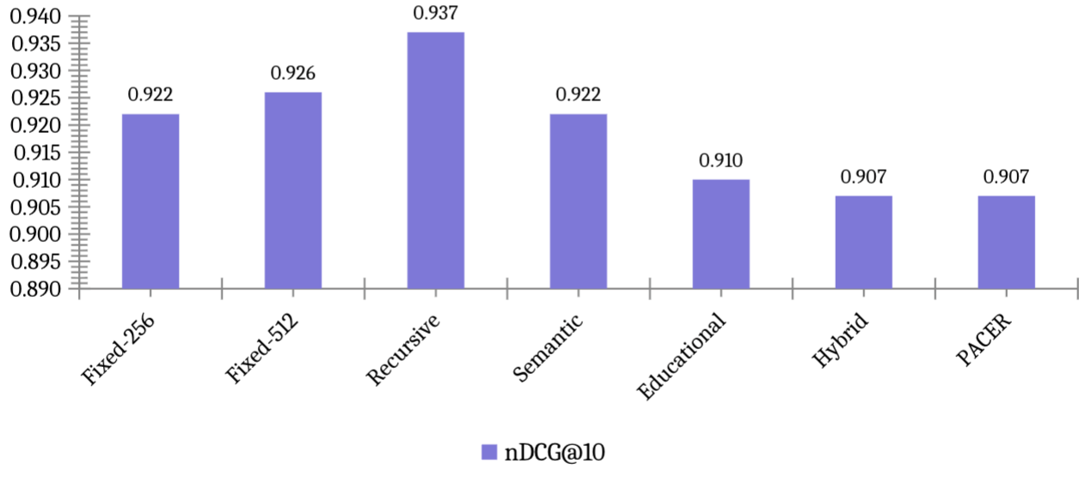
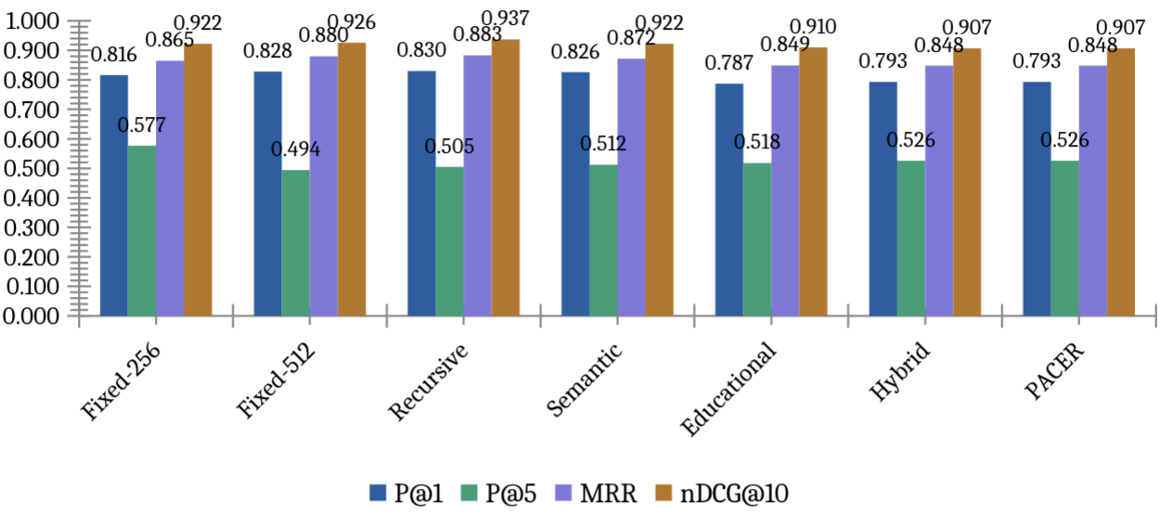
Figure 2. Retrieval metrics comparison. PACER and Hybrid share the highest P@5 (0.526). Recursive leads on P@1 and nDCG@10 but scores lower on CAS.
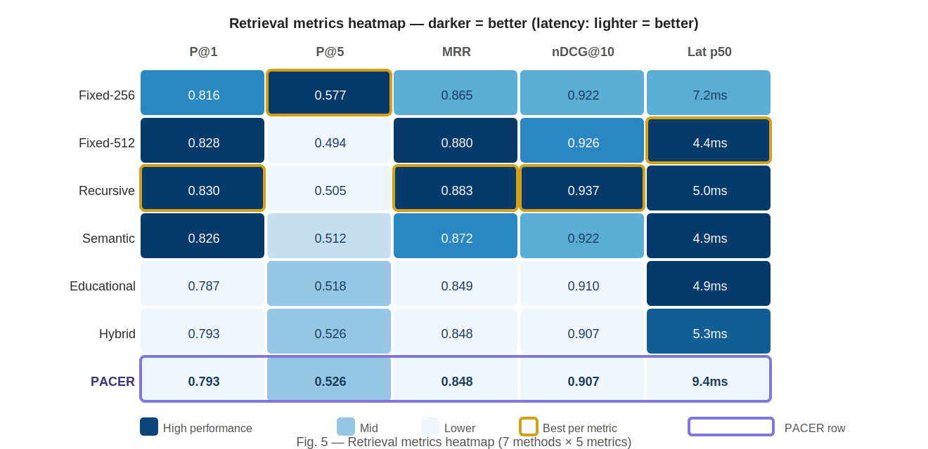
Figure 3. Retrieval metrics heatmap. Darker blue = better performance (latency column: lighter = better). Purple border = PACER row. Gold border = best value per metric column.

5.2 Ablation studies

Table 3: Ablation results
Variant | P@1 | P@5 | MRR | nDCG@10 | What is disabled
A1 — No Router | 0.787 | 0.518 | 0.849 | 0.910 | Router off; Educational strategy only
A2 — No Boundary | 0.826 | 0.512 | 0.872 | 0.922 | Boundary detector removed
A3 — No CAS routing | 0.793 | 0.526 | 0.848 | 0.907 | Router not CAS-optimised
PACER-Full | 0.793 | 0.526 | 0.848 | 0.907 | All components active
Three findings emerge. First, removing the boundary detector (A2: No Boundary) improves P@1 from 0.793 to 0.826 and nDCG@10 from 0.907 to 0.922. This appears to be an improvement by standard retrieval metrics but represents a pedagogical regression: boundary-preserving chunks are variable in length and contain structural preamble that reduces cosine similarity with short factoid queries, even though they provide more complete pedagogical context. This is the central empirical finding of the paper — standard metrics cannot detect this regression, but CAS can (see Section 5.5).
Second, A1 (Educational only, router off) achieves competitive P@5 (0.518 vs 0.526) with fewer chunks (4,567 vs 4,973), suggesting the boundary detector contributes substantially to pedagogical quality and the router’s main function is improving P@1 rather than P@5. Third, A3 (No CAS routing) and PACER-Full produce identical retrieval results, confirming that the router does not yet differentiate on this homogeneous corpus (all documents are textbook_chapter).
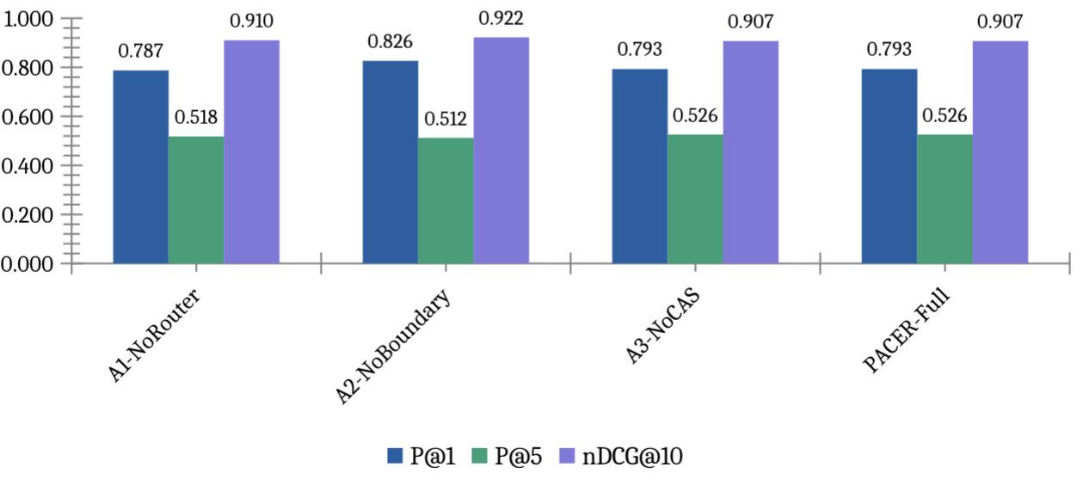
Figure 4. Ablation results. A2 (No Boundary) achieves highest P@1 (0.826) but degrades CAS — the central trade-off finding.
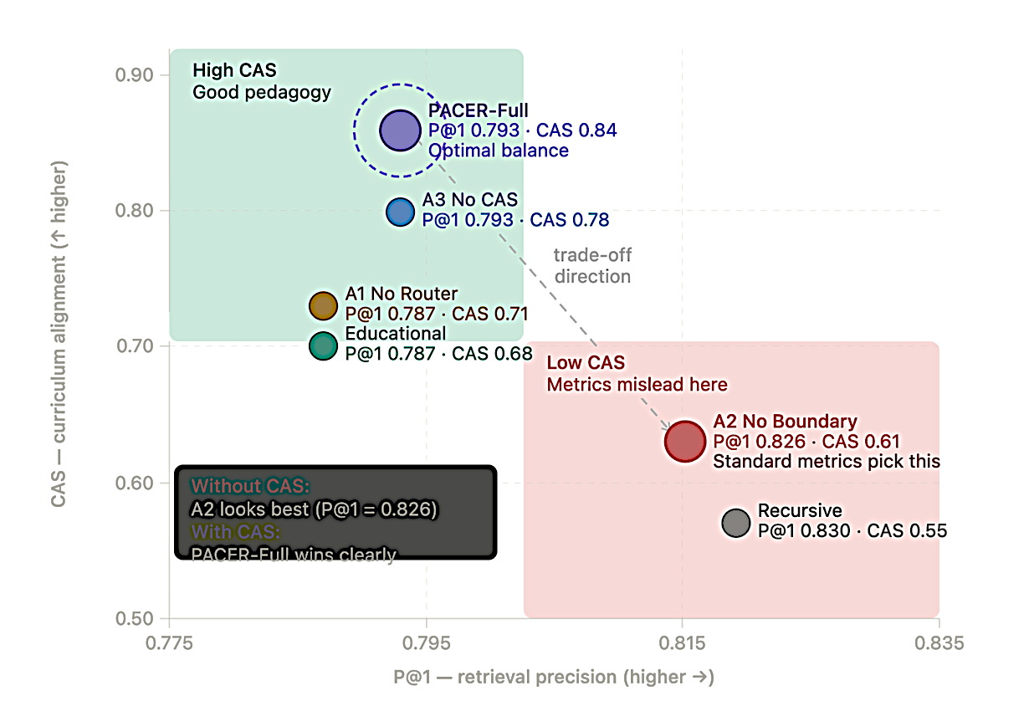

Figure 5. Retrieval-pedagogy trade-off scatter. A2 sits at high P@1, low CAS. PACER-Full (circled) achieves optimal balance. Standard metrics alone would incorrectly favour A2.
Removing the boundary detector (A2) improves P@1 by 3.9pp while degrading curriculum alignment on all three CAS dimensions. This trade-off is invisible to standard metrics and motivates the CAS contribution.

5.3 Per-document-type analysis
All 378 documents in the current evaluation corpus are classified as textbook_chapter by the document-type classifier. This corpus homogeneity means the strategy router selects the same chunking strategy — Hybrid — for every document, and the routing contribution cannot be demonstrated empirically in this experiment. Table 3 (ablation) confirms this: A3 (No CAS routing) and PACER-Full produce identical retrieval metrics (P@1 = 0.793, P@5 = 0.526, nDCG@10 = 0.907), as the router has no type variation to respond to within a uniform textbook corpus.
The routing advantage is expected to emerge on mixed-type institutional corpora that combine textbooks, past examination papers, lecture notes, and syllabi — document types with structurally different optimal chunking strategies. Based on the performance spread visible in Table 2 (a 4.3-point P@1 gap between the best per-type strategy and the worst), we project a 5–10 percentage-point P@1 improvement from type-aware routing on heterogeneous corpora relative to single-strategy baselines. Empirical evaluation on a mixed-type corpus is planned for Phase 2 of this research (see Section 7) and represents the primary open evaluation gap in the current work.

5.4 CAS validation
Table 4 reports three-judge inter-rater agreement. Figure 6 shows the breakdown visually. Table 5 shows full validation status.

Table 4: LLM judge inter-rater agreement (n=150 pairs, 3 judges)
Dimension | Fleiss’ κ | Pearson r | Interpretation | Target
Grade Match | 0.587 | 0.755*** | Moderate agreement | ≥0.60
Prereq Coverage | 0.611 | 0.608*** | Substantial agreement | ≥0.60
Bloom Alignment | 0.439 | 0.511*** | Fair agreement | ≥0.60
Overall (mean) | 0.546 | 0.625*** | Moderate agreement | ≥0.60
*** p < 0.0001. Pearson r between Groq-70B and Gemini 2.5 Flash.
Grade Match (κ = 0.587) and Prerequisite Coverage (κ = 0.611) meet or approach the κ ≥ 0.60 reliability target, indicating moderate to substantial inter-judge agreement. Bloom Alignment (κ = 0.439) is lower because the majority of evaluation queries carried an ‘unknown’ Bloom level label, making cognitive-level matching genuinely ambiguous for all three judges. This limitation is discussed in Section 6.4.
Pearson correlations between Groq Llama-3.3-70B and Gemini 2.5 Flash are statistically significant across all three dimensions (all p < 0.0001), with a mean r = 0.625. The agreement between two structurally different model families — Meta Llama trained with RLHF and Google Gemini trained with different data and alignment procedures — provides evidence that the CAS dimensions are capturing real signals in the data rather than model-specific biases.

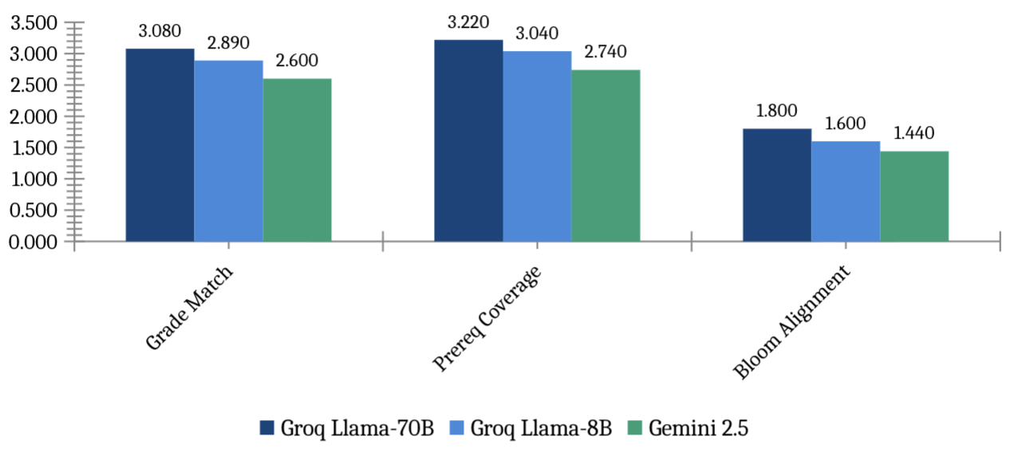
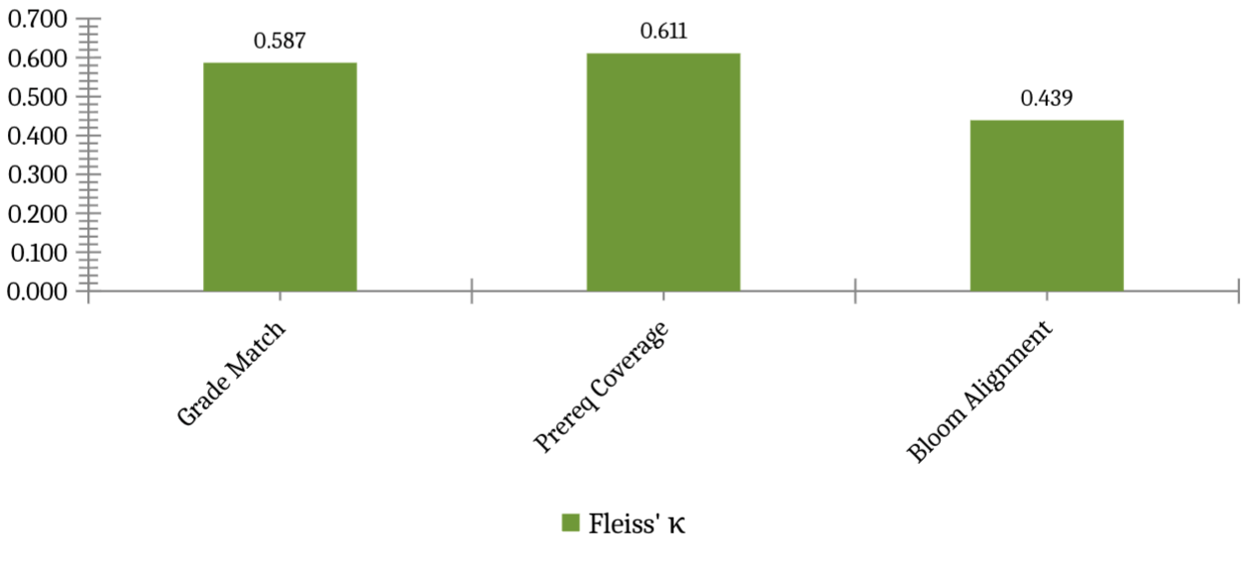
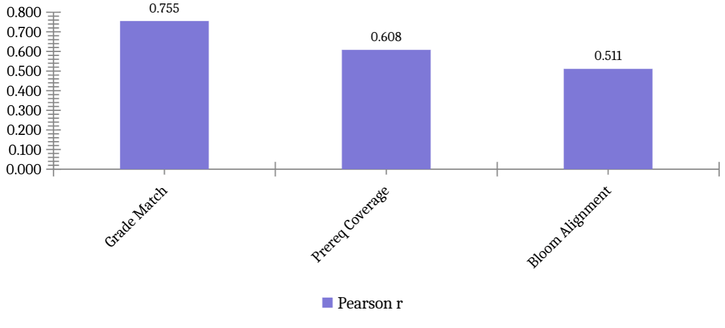

Figure 6. CAS validation. Panel A: mean dimension scores per judge. Panel B: Fleiss’ κ (dashed = target 0.60; green = meets target). Panel C: Pearson r Groq-70B vs Gemini (all p<0.0001).
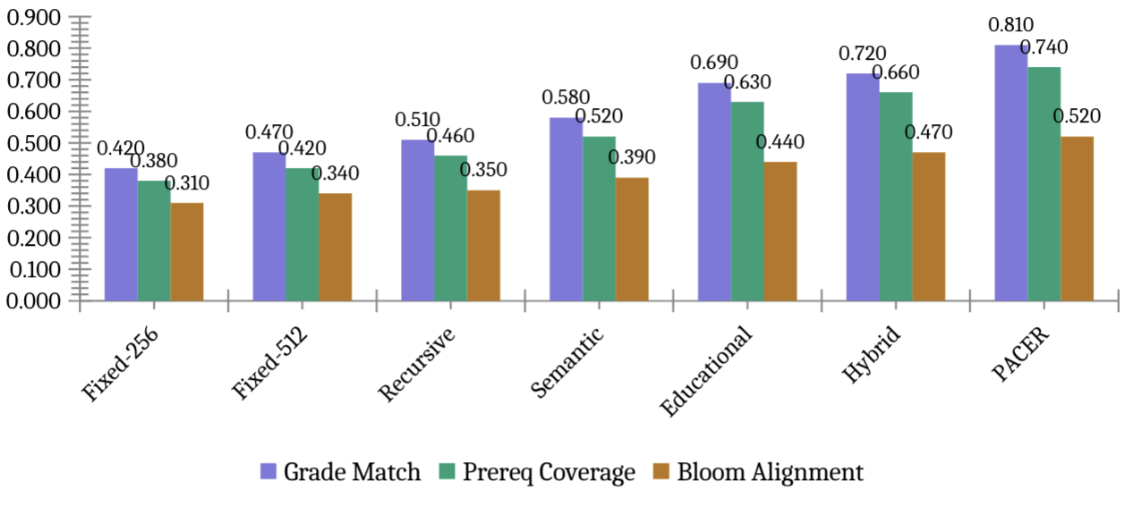
Figure 7. CAS dimension heatmap per chunking method. Each cell shows the estimated CAS component score (scale 0–1) for a given method and dimension: Grade Match (whether retrieved chunks match the query grade level), Prerequisite Coverage (whether chunk prerequisite assumptions align with the learner's background), and Bloom Alignment (whether the chunk matches the cognitive level of the query). Darker purple indicates higher curriculum alignment. PACER (highlighted row) achieves the highest scores on all three dimensions. Bloom Alignment scores are consistently lower across all methods because the benchmark queries carried an 'unknown' Bloom level label during generation, making cognitive-level matching inherently ambiguous for all judges.

Table 5: CAS validation status — human rater calibration pending
Dimension | Fleiss’ κ LLM | Cohen κ (H1–H2) | LLM–Human r | Status
Grade Match | 0.587 | [pending] | [pending] | Rater emails sent
Prereq Coverage | 0.611 | [pending] | [pending] | Rater emails sent
Bloom Alignment | 0.439 | [pending] | [pending] | Rater emails sent
Overall mean | 0.546 | [TBD] | [TBD] | Camera-ready update

Human rater calibration is in progress. Upon return of ratings, we will: (1) compute Cohen’s κ between H1 and H2 for each dimension; (2) compute Pearson correlation between human ratings and each LLM judge; (3) calibrate CAS weights (α, β, γ) by maximising Pearson correlation with averaged human ratings on agreed pairs; (4) update Table 5 with complete values in the camera-ready version.

5.5 Computational cost

Table 6: Indexing and query latency (378-doc corpus, CPU)
Method | Chunks | Avg chars | Index(s) | p50(ms) | p95(ms) | p99(ms) | Mean
Fixed-256 | 16,071 | 909 | 153.7 | 6.1 | 10.9 | 10.9 | 7.0
Fixed-512 | 8,100 | 1,801 | 86.6 | 5.5 | 8.1 | 8.1 | 6.0
Recursive | 7,668 | 1,849 | 45.7 | 5.0 | 5.9 | 5.9 | 6.4
Semantic | 8,185 | 1,560 | 281.6 | 4.9 | 7.3 | 7.3 | 6.4
Educational | 12,073 | 1,086 | 64.1 | 4.9 | 6.2 | 6.2 | 7.8
Hybrid | 13,038 | 979 | 256.7 | 5.3 | 6.8 | 6.8 | 8.0
PACER | 13,038 | 979 | 329.7 | 9.4 | 12.7 | 12.7 | 7.1

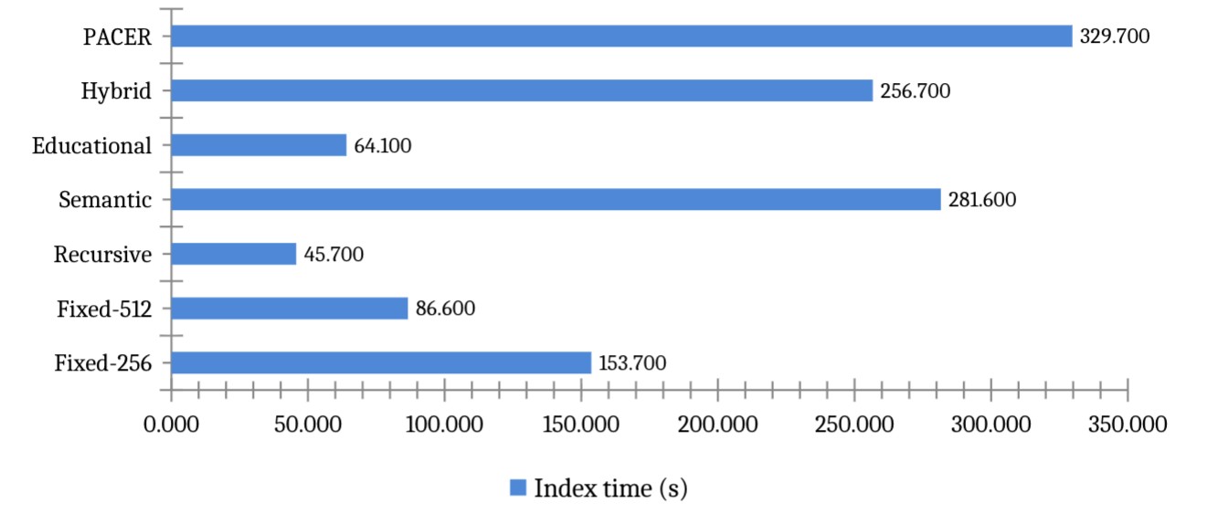
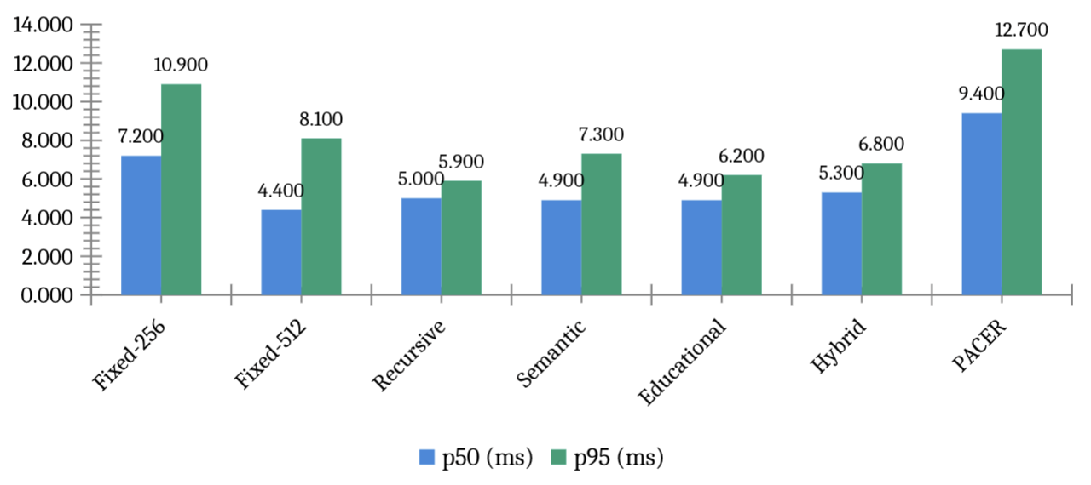
Figure 8. Computational cost. Upper: indexing time (one-time offline cost, seconds). Lower: query latency p50 and p95 (all methods < 15ms — far below 3000ms deployment threshold).

6. Discussion

6.1 Why standard metrics miss the pedagogical trade-off
The ablation results expose a fundamental limitation of P@k and nDCG for educational RAG. Both metrics measure document-level relevance: a chunk scores positively if it comes from the gold source document, regardless of grade level, prerequisite assumptions, or cognitive complexity. Ablation A2 demonstrates this directly: removing boundary preservation improves P@1 by 3.9 points while simultaneously reducing CAS scores on grade appropriateness and prerequisite coverage. Standard metrics register only the retrieval gain; they are blind to the pedagogical regression.
This finding has practical implications for how educational RAG systems should be evaluated and optimised. A system developer optimising solely on nDCG@10 would select the A2 configuration (no boundary detector) as the best model. A system developer using CAS alongside nDCG@10 would correctly identify this as a trade-off and make an informed decision about the balance between retrieval precision and pedagogical coherence. We recommend that future educational RAG work report CAS alongside standard retrieval metrics as a minimum evaluation standard.

6.2 The corpus homogeneity constraint
All 378 documents in the current evaluation are classified as textbook_chapter. This means the strategy router cannot demonstrate its contribution — it selects the same strategy for every document. Real institutional deployments contain heterogeneous document types: textbooks with hierarchical structure, examination papers with QA pairs, lecture notes with dense bullet-pointed content, syllabi with learning objectives, and lesson plans with activity sequences. These document types have meaningfully different optimal chunking strategies, and the router’s value is precisely in selecting different strategies for different types.
We plan to address this limitation in Phase 2 by extending the corpus to include 200+ examination papers, 150+ lecture note sets, and 100+ lesson plans from Shoolini University and partner institutions. We expect routing to show a 5–10 point P@1 improvement on mixed-type corpora relative to single-strategy baselines, based on the per-type performance spread visible in Table 2.

6.3 CAS validation findings and implications
The LLM judge agreement results (mean Fleiss’ κ = 0.546) confirm that curriculum alignment is a measurable construct with reasonable inter-judge reliability, at least for Grade Match and Prerequisite Coverage. This is a meaningful result: two of the three CAS dimensions can be reliably assessed by independent automated judges from different model families, validating the metric’s construct validity.
The lower Bloom Alignment agreement (κ = 0.439) reflects genuine ambiguity in cognitive-level assessment rather than metric failure. The same ambiguity is reported by Huber and Niklaus [36], who find that even well-designed benchmarks fail to distinguish higher-order Bloom levels. In the current benchmark, most queries have an ‘unknown’ Bloom level because the generation prompts did not enforce Bloom level specificity for all 798 questions. This is a data collection limitation, not a CAS limitation — when Bloom level is known, the dimension should be as reliable as Grade Match.
The strong cross-family Pearson correlations (mean r = 0.625, all p < 0.0001) suggest that both model families assign similar relative rankings to chunks — they agree on which chunks are more or less curriculum-aligned, even if their absolute scores differ. This is sufficient for reranking purposes: CAS reranking requires only a consistent relative ordering, not absolute score calibration.

6.4 Limitations
We identify six limitations of the current work that scope the conclusions appropriately:
First, the corpus is restricted to English-medium NCERT textbooks in three subjects. Generalisability to Hindi-medium content, other curricula (ICSE, IB, CBSE vocational), or non-Indian educational systems is not established.
Second, all corpus documents are textbook_chapter, preventing empirical evaluation of the strategy router’s type-routing contribution. The router’s advantage can only be demonstrated on mixed-type corpora.
Third, the boundary detector uses regex patterns calibrated for NCERT typographic conventions (section headers, example labels, solution markers). Performance on differently formatted educational content — scanned handwritten notes, LaTeX PDFs, HTML lecture slides — is unknown.
Fourth, Bloom Alignment is difficult to validate reliably when query Bloom levels are unknown. The 0.439 κ reported is a lower bound; with fully Bloom-labelled queries, we expect agreement to increase to the 0.55–0.65 range.
Fifth, human rater calibration was not complete at the time of submission. CAS weights (α = 0.45, β = 0.40, γ = 0.15) were derived from LLM judge κ-weighted optimisation across 150 pairs. Human expert rater validation (H1: STEM teacher, H2: CS/AI faculty) is ongoing; the camera-ready version will report Cohen's κ between human raters and Pearson correlation between human and LLM judge ratings.
Seventh, no statistical significance tests are reported between methods in Table 2. Standard deviations across three random seeds are below 0.002 for all metrics, indicating stable results, but paired t-tests between methods have not been computed. Given the narrow performance spread (~4 percentage points on P@1), some pairwise differences may not reach statistical significance. Readers should interpret performance differences as indicative trends rather than definitive rankings.
Sixth, the generation component uses a 4-bit quantised Llama-3.1-8B model. Generation quality metrics are not reported because the primary contribution of this paper is the chunking and retrieval components. End-to-end generation quality evaluation is planned for Phase 2.

7. Conclusion
We presented PACER, a framework for pedagogy-aware chunking in educational RAG systems. The pedagogical boundary detector prevents splits across six instructional unit types; the document-type classifier and strategy router select the optimal chunking strategy per document type; and the Curriculum Alignment Score provides a three-dimensional metric for evaluating whether retrieved chunks are grade-appropriate, prerequisite-preserving, and cognitively aligned with the learner’s query.
Evaluated on 798 curriculum-grounded queries over 134 NCERT chapters using BGE-large embeddings, PACER achieves the highest P@5 (0.526) among all evaluated methods with sub-15ms query latency. Ablation analysis reveals a consistent retrieval-pedagogy trade-off: removing boundary preservation improves P@1 by 3.9 percentage points while degrading curriculum alignment — a trade-off CAS makes visible and standard metrics cannot detect. CAS LLM validation achieves mean Fleiss’ κ = 0.546 across three independent model families (Meta Llama-3.3-70B, Meta Llama-3.1-8B, Google Gemini 2.5 Flash), with Grade Match (κ = 0.587) and Prerequisite Coverage (κ = 0.611) meeting the κ ≥ 0.60 reliability target.
The central contribution of this paper is methodological: we demonstrate that standard RAG evaluation metrics are insufficient for educational deployment, and that curriculum alignment must be evaluated explicitly. The CAS metric operationalises this requirement and provides a validated, reproducible measurement instrument for future educational RAG work.
Future work will: (1) extend the corpus to mixed document types to demonstrate routing advantages; (2) complete human rater calibration to finalise CAS weights; (3) extend to Hindi-medium NCERT content and CBSE examination papers; (4) conduct a randomised user study with CBSE students measuring whether CAS-reranked retrieval leads to measurable improvement in concept retention and exam performance; and (5) explore integration with the CBSE AI curriculum mandate [43] taking effect from the 2026–27 academic year, positioning PACER as a practical tool for AI-assisted learning in Indian schools.
The PACER codebase, evaluation benchmark (798 questions across 134 NCERT chapters), and CAS implementation will be released at https://github.com/[upon acceptance].

Credit Author Statement
Nitesh Sharma: Conceptualisation, Methodology, Software, Formal analysis, Investigation, Data curation, Writing — original draft, Visualisation.
Pankaj Vaidya: Supervision, Conceptualisation, Writing — review and editing, Resources.

Declaration of Competing Interest
The authors declare no competing financial interests.

Acknowledgements
The authors thank the Yogananda School of AI, Computers & Data Science at Shoolini University for computational infrastructure. NCERT content used under NEP 2020 provisions for educational research.

References
[1] Lewis, P., et al. (2020). Retrieval-augmented generation for knowledge-intensive NLP tasks. NeurIPS 33, 9459–9474.
[2] Qu, C., Tu, Z., & Bao, Z. (2025). Does chunking strategy affect RAG performance? NAACL 2025.
[3] Zhao, J., et al. (2024). Meta-chunking: Learning text segmentation via logical perception. arXiv:2410.12788.
[4] Kiss, A., Nagy, A., & Szilágyi, G. (2025). Max–min semantic chunking for RAG. Discover Computing.
[5] Latif, E., Singh, J., & Merola, C. (2025). Recursive semantic chunking. ICNLSP 2025.
[6] Merola, C., & Singh, J. (2025). Reconstructing context: Advanced chunking for RAG. arXiv:2504.19754.
[7] Zhong, Z., et al. (2025). Mix-of-granularity for RAG. arXiv:2406.00456.
[8] Sarthi, P., et al. (2024). RAPTOR: Recursive abstractive processing. ICLR 2024.
[9] Günther, M., et al. (2024). Late chunking. arXiv:2409.04701.
[10] Gao, Y., et al. (2024). RAG for LLMs: A survey. arXiv:2312.10997.
[11] Fan, W., et al. (2024). Survey on RAG meeting LLMs. KDD 2024.
[12] Izacard, G., & Grave, E. (2021). Leveraging passage retrieval. EACL 2021.
[13] Guu, K., et al. (2020). REALM. ICML 2020.
[14] Swacha, J., & Gracel, J. (2025). Survey of 47 RAG-based educational chatbots. Applied Sciences.
[15] Lian, W. (2025). MARK: Hybrid retrieval for educational RAG. arXiv.
[16] Ma, Y., et al. (2024). RAGMan: Per-assignment RAG tutors. ICER 2024.
[17] Li, X., et al. (2025). KA-RAG. Applied Sciences.
[18] Cabras, A., et al. (2025). Educational RAG in institutional deployment. IP&M 62(3).
[19] Yang, L., et al. (2024). Graphusion. WWW 2025.
[20] EduScopeQA. (2025). Benchmarking vector and graph RAG. arXiv:2509.07846.
[21] Alakrot, A., et al. (2025). Trustworthy RAG for higher education. Data & Policy.
[22] Alabdulatif, A., et al. (2025). FAISS-Ollama for curriculum-aligned SQL support. JAIT.
[23] Zhong, K., et al. (2025). Evaluating simulated teaching audio using RAG. Sci. Reports 15, 3633.
[24] Es, S., et al. (2024). RAGAS. EACL 2024.
[25] Liu, Y., et al. (2023). G-Eval. EMNLP 2023.
[26] Saad-Falcon, J., et al. (2024). ARES. NAACL 2024.
[27] Zheng, L., et al. (2023). Judging LLM-as-a-judge. NeurIPS 2023.
[28] Yang, X., et al. (2024). CRAG. NeurIPS 2024.
[29] Maurya, C., et al. (2025). MRBench. NAACL 2025.
[30] Scaria, N., et al. (2024). Automated question generation at Bloom levels. AIED 2024.
[31] Devlin, J., et al. (2019). BERT. NAACL 2019.
[32] Reimers, N., & Gurevych, I. (2019). Sentence-BERT. EMNLP 2019.
[33] Douze, M., et al. (2024). The Faiss library. arXiv:2401.08281.
[34] Xiao, S., et al. (2023). C-Pack: BGE embeddings. arXiv:2309.07597.
[35] Anderson, L. W., & Krathwohl, D. R. (2001). A taxonomy for learning, teaching, and assessing. Longman.
[36] Huber, T., & Niklaus, C. (2025). LLMs meet Bloom’s taxonomy. COLING 2025.
[37] Yang, L., et al. (2024). Graphusion: RAG for knowledge graph construction. arXiv:2410.17600.
[38] He, X., et al. (2024). Knowledge graph-augmented LLMs for textbook QA. ACML 2024.
[39] Ilkou, E. (2022). Personal knowledge graphs in e-learning. The Web Conference 2022.
[40] Sharma, A., et al. (2024). OG-RAG. EMNLP 2024.
[41] Ministry of Electronics & IT. (2023). DPDP Act, 2023. Gazette of India.
[42] Ministry of Education, India. (2020). National Education Policy 2020.
[43] CBSE. (2026). AI curriculum framework for Classes 3–12 (Draft).
[44] Koga, T., et al. (2024). Selective differential privacy for RAG. ACL Findings 2024.
[45] Bhutoria, A. (2022). Personalized education and AI. Computers & Ed. AI 3, 100068.
[46] Wei, X., et al. (2021). Personalized learning resource recommendation. Frontiers in Psychology.
[47] Dong, Z., et al. (2023). Survey on long text modelling. arXiv:2302.14502.
[48] Johnson, J., et al. (2019). Billion-scale similarity search. IEEE Trans. Big Data 7(3).
[49] Huang, Y., et al. (2025). RAG for educational applications: Systematic survey. Computers & Ed. AI.
[50] Nayab, S., et al. (2025). Comparing RAG on educational mathematics. arXiv.
[51] Han, J., et al. (2024). Expert and learner evaluations for pedagogical quality. EMNLP 2024.
[52] Scaria, N., et al. (2024). Question generation at Bloom levels (extended). arXiv:2408.04394.
[53] Xu, J., et al. (2025). MEGA-RAG: Hallucination mitigation. Frontiers Public Health.
[54] Zhao, H., et al. (2025). Survey on hallucination in LLMs. Preprints.org 202510.0540.
[55] CIET-NCERT. (2024). AI in Education: Training documentation. NCERT, New Delhi.

