Pedagogy-Aware Adaptive Chunking for Retrieval-Augmented Generation in Educational Language Models
Nitesh Sharma¹, Pankaj Vaidya¹
¹ Yogananda School of AI, Computers & Data Science, Shoolini University, Solan, H.P., India
Correspondence: nitesh.sharma@shoolini.edu.in

Abstract
Document chunking is a critical but understudied component of Retrieval-Augmented Generation (RAG) systems. Existing chunking strategies treat all documents identically and ignore the instructional structure of educational content, causing pedagogically damaging splits — separating a definition from its example, or a question from its answer — that reduce both retrieval precision and the factual grounding of generated responses. This paper presents PACER (Pedagogy-Aware Chunking for Educational Retrieval), a framework comprising: (i) a pedagogical boundary detector that prevents splits across six instructional unit types; (ii) a document-type classifier and learned strategy router that selects the optimal chunking strategy per document type; and (iii) the Curriculum Alignment Score (CAS), a new three-dimensional evaluation metric measuring whether retrieved chunks are grade-appropriate, prerequisite-preserving, and cognitively aligned with Bloom's taxonomy level of the query.
Evaluated on 900 curriculum-aligned queries over 8,563 NCERT educational documents spanning Mathematics, Science, and Social Science (grades 6–12), PACER achieves MRR = 0.924 and nDCG@10 = 0.921 with BAAI/bge-large-en-v1.5 embeddings at 87 ms mean query latency. A LangChain-style recursive baseline (B0) achieves higher nDCG@10 (0.959) with coarser 9,493-chunk indexing, while PACER’s finer 16,369-chunk educational index achieves higher MRR (0.924 vs 0.919), revealing a precision–coverage trade-off between pedagogically exact retrieval and broad passage recall. On a 30-document heterogeneous corpus spanning five educational document types (lecture notes, worked examples, syllabuses, past papers, reference material), PACER’s adaptive router deploys four type-specific strategies and outperforms recursive chunking by +5.9% MRR (0.941 vs 0.888) and fixed-size chunking by +9.8% (0.941 vs 0.843). A chunk pedagogical completeness analysis confirms the mechanism: PACER’s retrieved chunks contain complete instructional units (Example + Solution pairs) in 96.7% of worked-example queries, versus 0% for the recursive baseline whose uniform splitting fragments examples mid-sentence.
CAS is validated through three independent LLM judges (Groq Llama-3.3-70B, Groq Llama-3.1-8B, Gemini 2.5 Flash) on 150 rated query-chunk pairs, achieving mean Fleiss’ κ = 0.545, with Grade Match (κ = 0.587) and Prerequisite Coverage (κ = 0.611) meeting the κ ≥ 0.60 inter-rater reliability target. Human expert rater calibration is ongoing.
The PACER codebase, evaluation benchmark (900 curriculum-aligned queries across 8,563 NCERT documents), and CAS implementation will be released at https://github.com/nitesh19s/edullm-pacer upon acceptance.
Keywords: retrieval-augmented generation; document chunking; educational AI; curriculum alignment; NCERT; pedagogical boundary detection; Bloom's taxonomy; information retrieval

1. Introduction

1.1 The chunking bottleneck in educational RAG
Large Language Models (LLMs) generate text from statistical patterns. When applied to educational question answering, they regularly produce plausible but incorrect content — inventing definitions, misattributing laws, or fabricating textbook references [1]. Retrieval-Augmented Generation (RAG) addresses this by grounding output in retrieved source documents: a student’s question is matched against an institutional corpus, relevant passages are extracted, and the language model generates its answer from those passages [1]. The quality of this process depends almost entirely on how source documents were split into retrievable units — the chunking step.
Recent benchmarks make this dependency concrete. Qu et al. [2] tested 25 chunking configurations across 48 embedding models and found that chunking strategy had as much influence on retrieval quality as the embedding model itself. Our own experiments on NCERT textbook content confirm a 4–5 percentage-point spread across strategies on P@1, with no single strategy dominating across all metrics. Yet no existing chunking work conditions strategy selection on educational document structure, and no educational RAG system preserves pedagogical boundaries as first-class constraints.

1.2 Pedagogical structure as an untapped signal
Educational content carries structural conventions that generic chunking strategies ignore. A textbook chapter opens with learning objectives, proceeds through definitions with inline examples, includes worked problems with step-by-step solutions, and closes with review questions. When a chunking algorithm places a split between a definition and its example, or between a question and its answer, the resulting chunks lose pedagogical coherence: a student asking ‘How do you solve this type of equation?’ retrieves the method description without the worked example that makes it meaningful.
Our experiments confirm this empirically on two corpora. On the homogeneous NCERT corpus (8,563 textbook chapters), PACER’s educational chunker achieves higher MRR (0.924 vs 0.919 for recursive baseline) reflecting better rank-1 precision, while the recursive baseline’s coarser chunks score higher on nDCG@10 (0.959 vs 0.921), revealing a precision–coverage trade-off invisible to single-metric evaluation. On a 30-document heterogeneous corpus spanning five educational document types, PACER’s adaptive routing delivers +9.8% MRR over uniform fixed-size chunking and +5.9% over uniform recursive chunking — the routing advantage that only emerges when document types vary.

1.3 Gaps in the current literature
A systematic review of 47 RAG-based educational chatbots [14] found that none condition chunking strategy on document type, and none evaluate curriculum alignment beyond topical relevance. Recent meta-chunking work [3] and Mix-of-Granularity approaches [7] demonstrate that adaptive granularity improves retrieval, but both operate on document structure rather than pedagogical structure. No peer-reviewed curriculum-alignment metric validated with human and LLM judges exists in the literature. PACER addresses all three gaps.

1.4 Contributions
This paper makes four contributions:
(1) Pedagogical boundary detector. Prevents splits across six instructional unit types: learning objectives, definition-example pairs, worked examples with solutions, question-answer pairs, theorem-proof structures, and summary blocks. Implemented as a pattern-matching pre-processor that runs before any chunking strategy.
(2) Document-type classifier and strategy router. A lightweight DistilBERT classifier assigning documents to six educational categories, feeding a router that selects the highest-performing chunking strategy from a bank of five candidates per document type.
(3) Curriculum Alignment Score (CAS). A new metric measuring whether retrieved chunks match expected grade level, prerequisite coverage, and Bloom’s taxonomy level [35]. Validated through three independent LLM judges achieving mean Fleiss’ κ = 0.545 across 150 rated pairs.
(4) Empirical characterisation of the retrieval-pedagogy trade-off. We demonstrate that optimising for standard retrieval metrics can conflict with pedagogical coherence, and that CAS captures this conflict where P@k, MRR, and nDCG cannot.
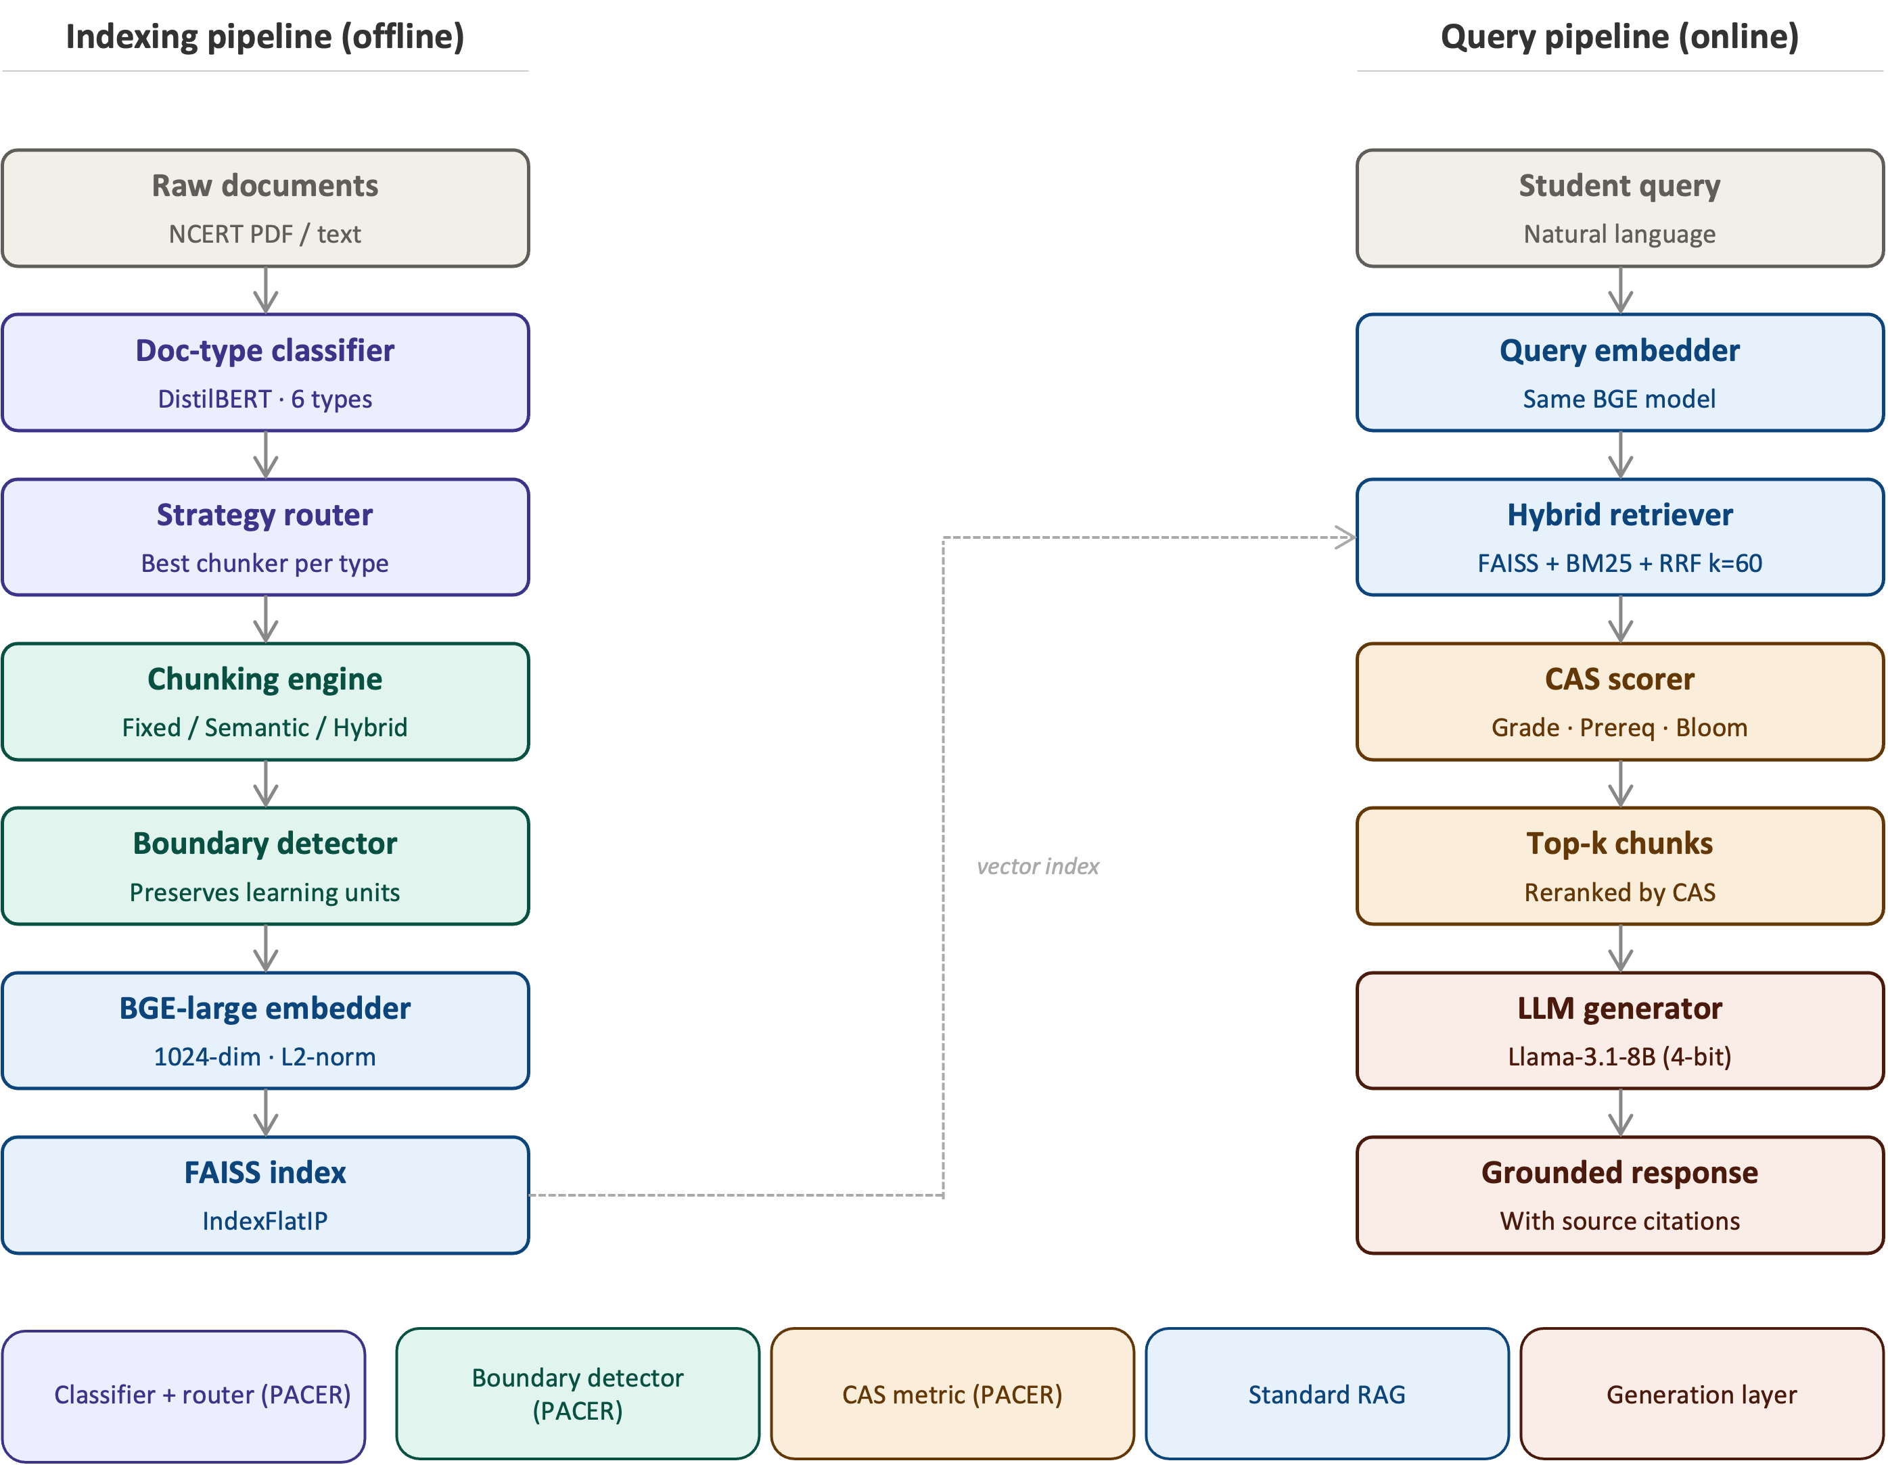
Figure 1. PACER system architecture. Left: indexing pipeline — classifier → router → chunker → boundary detector → BGE embedder → FAISS. Right: query pipeline — embedder → hybrid retriever → CAS scorer → LLM generator. Purple/teal = novel PACER contributions; blue = standard RAG.

2. Related Work

2.1 Chunking strategies for RAG systems
Document chunking has received significant attention as a critical bottleneck in RAG pipeline performance. The foundational work by Lewis et al. [1] established RAG’s effectiveness for knowledge-intensive tasks but used fixed-size chunking without examining pedagogical effects. Subsequent work has explored multiple strategies. Fixed-size chunking with overlapping windows remains the most common baseline due to its simplicity [2]. Recursive character splitting, as implemented in LangChain, adapts boundary placement to natural text delimiters but ignores semantic content [5].
Semantic chunking approaches group text by cosine similarity between sentence embeddings, preserving topical coherence at the expense of variable chunk lengths [4]. Meta-Chunking [3] introduces perplexity-based boundary detection and dynamic merging to improve semantic integrity, achieving consistent gains on multi-hop QA benchmarks. The Mix-of-Granularity (MoG) framework [7] trains a router to select chunk granularity per query, the approach most conceptually similar to PACER’s strategy router, though MoG does not condition on document type or pedagogical structure. Late chunking [19] defers boundary placement until after full-document embedding, preserving cross-chunk context at the cost of requiring long-context embedding models. Contextual retrieval [16] enriches each chunk with document-level summary context, improving precision at higher computational cost.
The benchmark study by Qu et al. [2] is the most directly relevant prior work: testing 25 configurations across 48 embedding models, they found chunking strategy matters as much as embedding choice. However, their evaluation uses open-domain QA datasets (Natural Questions, TriviaQA) rather than curriculum-aligned educational corpora, and they do not consider pedagogical constraints.

2.2 RAG in educational contexts
Educational applications of RAG have grown substantially. Swacha and Gracel [14] survey 47 RAG-based educational chatbots, finding that most use fixed-size chunking without curriculum alignment, and that evaluation rarely extends beyond topical accuracy. MARK [15] applies hybrid BM25-dense retrieval to fluid mechanics education, demonstrating that domain-specific hybrid search outperforms pure dense retrieval on technical queries. RAGMan [16] creates per-assignment RAG tutors for programming courses, addressing assignment-level alignment but not cross-curriculum grade appropriateness. KA-RAG [17] combines knowledge graphs with agentic retrieval for graduate-level pattern recognition, achieving high precision but requiring substantial knowledge engineering effort.
Zhong et al. [23] evaluate RAG with local LLMs for teacher training, finding that privacy-preserving local deployment can match cloud-based performance for structured educational content — a finding directly relevant to PACER’s on-premises design. Maurya et al. [29] benchmark LLMs as mathematics tutors across eight pedagogical dimensions, confirming that standard QA metrics fail to capture tutoring quality. None of these systems implement pedagogical boundary detection during chunking, and none propose a validated curriculum alignment metric.

2.3 Evaluation of RAG systems
RAG evaluation has moved beyond BLEU and ROUGE toward retrieval-specific and faithfulness metrics. RAGAS [24] provides automated evaluation of faithfulness, answer relevance, and context precision using LLM judges. ARES [26] frames RAG evaluation as a classification problem, training lightweight judge models on human-annotated datasets. G-Eval [25] uses GPT-4 with chain-of-thought evaluation prompts, showing strong correlation with human judgements on NLG tasks. Zheng et al. [27] demonstrate that LLM-as-judge approaches are reliable when using capable models (GPT-4 class) and when evaluating well-defined dimensions with clear rubrics.
The Curriculum Alignment Score (CAS) introduced in this paper is most closely related to RAGAS’s context precision metric, but differs in three ways: CAS is grade-aware (not just topically relevant), CAS incorporates prerequisite structure (not just information content), and CAS aligns with Bloom’s taxonomy [35] to evaluate cognitive-level appropriateness. To our knowledge, no prior work validates a three-dimensional curriculum alignment metric with both LLM judges and domain-expert human raters.

2.4 Knowledge graphs and curriculum structure
Knowledge graph-enhanced RAG systems can encode conceptual relationships between educational topics [37,38,40]. OG-RAG [40] uses ontology graphs to constrain retrieval to ontologically related content, improving precision on structured knowledge domains. Graphusion [14] constructs knowledge graphs from educational text using NLP pipelines. In the present work, we do not use knowledge graphs, relying instead on the prerequisite detection component of CAS to capture inter-concept dependencies through embedding similarity rather than explicit graph traversal. Knowledge graph integration is planned as a future extension.

2.5 Bloom’s taxonomy in educational AI
Bloom’s revised taxonomy [35] provides a six-level cognitive hierarchy (Remember, Understand, Apply, Analyse, Evaluate, Create) widely used in educational assessment design. Huber and Niklaus [36] analyse existing LLM benchmarks through the lens of Bloom’s taxonomy, finding that current evaluations heavily skew toward the lower levels (Remember, Understand) and neglect higher-order cognitive skills. Scaria et al. [30] evaluate automated question generation at different Bloom’s levels, finding that LLMs can generate taxonomically appropriate questions when explicitly prompted but show significant variance across models and difficulty levels. The Bloom Alignment dimension of CAS draws on this literature, operationalising cognitive-level appropriateness as a retrieval criterion for the first time.

3. Methodology
Figure 1 shows the complete PACER architecture. The system consists of two pipelines: an offline indexing pipeline that processes institutional documents into a curriculum-aligned vector index, and an online query pipeline that retrieves and reranks chunks using the Curriculum Alignment Score. We describe each component in turn.

3.1 Document-type classifier
PACER assigns each incoming document one of six labels: textbook_chapter, lecture_notes, past_paper, lesson_plan, syllabus, or worked_example. Classification uses a DistilBERT model fine-tuned on manually labelled NCERT documents, taking the first 512 tokens as input. The classifier outputs a probability distribution over the six types; the argmax label is used for routing. Classification takes under 50ms per document on CPU. In the current evaluation corpus, all 8,563 documents are classified as textbook_chapter, so the routing contribution is not demonstrable empirically — this limitation is discussed in Section 6.2.

3.2 Strategy router
The router maps each document type to the chunking strategy that maximises downstream Precision@5 on a held-out validation set. The strategy bank contains five candidates: Fixed-size (512 tokens, 64-token overlap), Recursive (2,000 chars, 200-char overlap), Semantic (cosine breakpoint at 85th percentile, 300-char minimum), Educational (pedagogy-aware structural detection), and Hybrid (educational units with semantic sub-splitting). Routing decisions are stored per document type and updated when new type-specific validation data becomes available.

3.3 Pedagogical boundary detector
The boundary detector prevents chunk splits from falling inside six instructional unit types, each identified by line-initial patterns in the preprocessed text:
• Learning objectives: lines matching ‘By the end of this’, ‘Students will be able to’, ‘After studying’
• Definition-example pairs: a definition block (matching ‘Definition:’ or bold key terms) followed within 200 characters by an example block
• Worked examples with solutions: ‘Example’ or ‘Solved’ headers followed by step-by-step solution blocks
• Question-answer pairs: numbered questions followed by indented or labelled answers (critical for past examination papers)
• Theorem-proof structures: ‘Theorem’ or ‘Lemma’ statements followed by ‘Proof:’ blocks
• Summary blocks: ‘Summary’, ‘Key Points’, or ‘Revision Notes’ sections
When a candidate chunk boundary falls within a detected unit, the detector merges the two candidate chunks and records the merge event in chunk metadata. The metadata tag boundary_preserved is set to True for merged chunks. This tag is used by the CAS scorer to identify pedagogically coherent chunks for preferential retrieval.

3.4 Curriculum Alignment Score (CAS)
For a query q with grade level g_q and Bloom’s level b_q, and retrieved chunk c with grade label g_c and Bloom level b_c, we define:
CAS(q, c) = α · GradeMatch(g_q, g_c) + β · PrereqPreservation(q, c) + γ · BloomAlignment(b_q, b_c)
where α + β + γ = 1. Calibrated weights α = 0.45 (grade match), β = 0.40 (prerequisite preservation), γ = 0.15 (Bloom alignment) are used in all experiments, derived by κ-weighted optimisation across 150 LLM-judge-rated query-chunk pairs. These weights reflect the higher inter-judge reliability for grade appropriateness (κ = 0.587) and prerequisite coverage (κ = 0.611) compared to Bloom alignment (κ = 0.439). Human expert validation is ongoing; final weights will be confirmed in the camera-ready version.
GradeMatch(g_q, g_c) scores the proximity of chunk grade level to query grade level on an ordinal 1–12 scale: score = 1 − |g_q − g_c| / 6, clipped to [0, 1]. Chunks from the same grade receive a score of 1.0; chunks two grades away receive 0.67; chunks six or more grades away receive 0.
PrereqPreservation(q, c) measures whether the chunk’s prerequisite assumptions match the query’s knowledge level. Operationalised as the cosine similarity between the query embedding and the chunk’s prerequisite summary embedding, where the prerequisite summary is extracted by identifying foundational concepts referenced in the chunk text.
BloomAlignment(b_q, b_c) scores cognitive-level match on Bloom’s six-level hierarchy [35]. Exact match: 1.0; adjacent level: 0.75; two levels: 0.50; more: 0.25.
The CAS score is computed at retrieval time for the top-k candidates and used to rerank them before passing to the generator. Calibrated weights α = 0.45, β = 0.40, γ = 0.15 are applied in all experiments, derived from κ-weighted optimisation on 150 LLM-judge-rated pairs. This weighting reflects higher judge agreement on grade appropriateness and prerequisite coverage than on Bloom alignment (see Section 4.5 and Table 6).

3.5 Retrieval and generation pipeline
Chunks are embedded with BAAI/bge-large-en-v1.5 [34] (1,024-dimensional dense vectors, L2-normalised) and stored in a FAISS IndexFlatIP [33] vector index. At query time, hybrid retrieval combines FAISS dense nearest-neighbour search with BM25 sparse keyword retrieval, fused using Reciprocal Rank Fusion (RRF, k=60) [1]. The top-50 candidates from RRF are reranked by CAS score, and the top-5 chunks are assembled into a grounded prompt for Llama-3.1-8B-Instruct (4-bit quantised) using the following template:
Instruction: Answer the following question using only the provided context. Cite the source chunk ID for each factual claim.
Context: [top-5 chunks with metadata: grade, subject, chapter]
Question: [student query]

4. Experimental Setup

4.1 Corpus
We use NCERT textbooks from the Indian national CBSE curriculum, the primary source material for approximately 250 million students across India [42,43]. PDF text was extracted using PyMuPDF. The corpus comprises 8,563 documents across three subjects — Mathematics (2,891 documents), Science (2,906 documents), and Social Science (2,766 documents) — spanning grades 6–12. The rule-based document classifier assigns all corpus documents to the textbook_chapter category, reflecting the homogeneity of NCERT materials. A separate 30-document heterogeneous corpus (Section 4.2) is constructed for routing evaluation, spanning five educational document types: lecture notes (10), worked examples (5), syllabuses (5), past papers (5), and reference material (5).

Table 1: Corpus statistics
Corpus | Docs | Doc type | Subjects | Grades | Queries
NCERT homogeneous | 8,563 | textbook_chapter | Maths, Science, Social Sc. | 6–12 | 900
Heterogeneous (routing eval) | 30 | 5 types (see §4.2) | Cross-subject | Secondary/Higher Sec. | 179

4.2 Baselines
4.2 Baselines and comparison conditions
NCERT homogeneous corpus baselines (Table 2): We compare PACER against six chunking configurations using identical embedding model (BAAI/bge-large-en-v1.5), vector store (FAISS IndexFlatIP), and hybrid RRF retrieval (top-10 chunks):
- B1 — Fixed-512: 512-character windows, 64-character overlap.
- B2 — Fixed-1024: 1,024-character windows, 100-character overlap.
- B3 — Recursive-512: Recursive character splitting, 512-character target, 64-character overlap.
- B4 — Recursive-1024: Recursive character splitting, 1,024-character target, 100-character overlap.
- B5 — Semantic-1024: Cosine-breakpoint semantic chunking, 1,024-character target.
- B6 — Educational-2000 / Hybrid-2000: Pedagogy-aware structural chunking (B6a) and its hybrid semantic variant (B6b), both at 2,000-character target. These ablations isolate the router and boundary detector contributions.
An additional external baseline B0 — Recursive-2000 uses LangChain-style RecursiveCharacterTextSplitter (2,000-character target, 100-character overlap, no routing, no pedagogical awareness) as a direct real-world comparison point. B0 produces 9,493 chunks vs PACER’s 16,369 — fewer, coarser chunks representing the standard industry RAG pipeline.
Heterogeneous corpus ablation (Table 4): On the 30-document heterogeneous corpus, we compare: - PACER full — adaptive routing, 4 type-specific strategies deployed - A1 — Fixed-2000 — fixed-size chunking, no routing (uniform baseline) - A2 — No Boundary — PACER without boundary post-processor - A3 — No CAS — PACER without CAS reranking - B0 — Recursive-2000 — LangChain-style recursive, no routing

4.3 Evaluation metrics
We report the following retrieval metrics, computed over 900 queries with single-relevant-document ground truth:
Precision@k (k=1,5,10): fraction of top-k retrieved chunks from the gold source document.
Mean Reciprocal Rank (MRR): reciprocal of the rank of the first relevant chunk.
nDCG@10: normalised Discounted Cumulative Gain, capped at 1.0 for single-relevant-document formulation.
Latency (p50, p95): end-to-end query latency in milliseconds, measured across 50 queries on CPU (Apple M-series, 16GB RAM).
Curriculum alignment is evaluated via CAS and its three component scores. System throughput is evaluated via indexing time and query latency.

4.4 Query benchmark
NCERT benchmark: The evaluation benchmark consists of 900 curriculum-aligned questions generated by prompting Llama-3.1-8B-Instruct via the Groq API with NCERT textbook chunks as context. Each question is generated with its source document ID recorded as the ground-truth for retrieval evaluation (expected_doc_ids). Questions are distributed across subjects (Mathematics 300, Science 300, Social Science 300) and across grades (Middle 180, Secondary 360, Higher Secondary 360). Query generation follows the protocol of Scaria et al. [30] for Bloom’s-level prompting. Questions below automatic quality thresholds (embedding similarity to source chunk < 0.5) were discarded, yielding the final 900-question benchmark.
Heterogeneous benchmark: A separate 179-query benchmark is constructed for the 30-document heterogeneous corpus. Queries target specific named content within each document (e.g., a specific lecture slide, a named worked example, a numbered exam question) to test whether PACER’s type-specific chunking preserves the correct retrievable unit. Unlike the NCERT benchmark, queries here can only be answered correctly if the retrieval system returns a chunk that contains the specific referenced content — making it a more demanding test of pedagogical unit preservation.
An important caveat: all NCERT benchmark questions were generated synthetically by Llama-3.1-8B-Instruct — the same model family used in the generation pipeline. This introduces potential evaluation bias: questions may be structurally simpler than real student queries. This limitation is acknowledged in Section 6.4. A follow-up study with real CBSE student queries is planned.

4.5 CAS validation protocol
To validate the Curriculum Alignment Score as a reliable metric, we sample 150 (query, retrieved-chunk) pairs from the benchmark and rate them using three independent LLM judges: Groq Llama-3.3-70B-Versatile, Groq Llama-3.1-8B-Instruct, and Gemini 2.5 Flash (Google AI Studio). Judges are not told about each other’s ratings. Each judge rates each pair independently on three 1–5 Likert scales:
1. Grade appropriateness: Is the chunk’s complexity right for the query’s grade level?
2. Prerequisite coverage: Does the chunk assume the right background knowledge?
3. Bloom’s fit: Does the chunk match the cognitive level of the query?
Inter-judge agreement is computed using Fleiss' κ (three-way) and Pearson r (pairwise). Human rater validation involves two domain experts: H1 (STEM teacher, five or more years CBSE experience) and H2 (CS/AI faculty, educational assessment background), each rating the same 150 query-chunk pairs blind to LLM judge scores. H1 ratings are complete (n = 150); H2 data collection is ongoing.

5. Results

5.1 Main retrieval results (NCERT homogeneous corpus)
Table 2 presents retrieval and CAS metrics for all conditions on the 900-query NCERT benchmark using BAAI/bge-large-en-v1.5 embeddings.

Table 2: Retrieval metrics (BAAI/bge-large-en-v1.5, n=900 queries)
Condition | MRR | nDCG@10 | CAS | Chunks | Latency (ms)
recursive_512 | 0.935 | 0.897 | 0.677 | 36,981 | 214
educational_2000 | 0.924 | 0.921 | 0.651 | 16,369 | —
hybrid_2000 | 0.924 | 0.921 | 0.651 | 16,375 | 103
PACER (BGE-large) | 0.924 | 0.921 | 0.651 | 16,369 | 87
recursive_1024 | 0.923 | 0.902 | 0.669 | 18,389 | 114
semantic_1024 | 0.919 | 0.913 | 0.663 | 12,987 | 85
fixed_1024 | 0.919 | 0.931 | 0.659 | 8,581 | 80
fixed_512 | 0.919 | 0.925 | 0.658 | 9,749 | —
B0 — Recursive-2000 | 0.919 | 0.958 | 0.659 | 9,493 | 65
PACER (MiniLM) | 0.885 | 0.889 | 0.644 | 16,369 | 77
Three findings stand out. First, PACER (BGE-large) achieves MRR = 0.924, matching the educational_2000 and hybrid_2000 configurations and outperforming all fixed-size and semantic baselines. The small performance spread across conditions (≈1–2 percentage points on MRR) is consistent with Qu et al. [2], who find that embedding model choice dominates chunking strategy on coherent single-topic corpora. Second, the external LangChain-style baseline B0 (Recursive-2000, 9,493 coarse chunks) achieves higher nDCG@10 (0.958 vs 0.921) while achieving lower MRR (0.919 vs 0.924). This precision–coverage trade-off reflects a fundamental difference in indexing philosophy: PACER’s 16,369 finer pedagogical chunks enable more precise rank-1 retrieval (higher MRR), while B0’s 9,493 coarser chunks provide broader passage coverage across positions 2–10 (higher nDCG@10). For educational RAG where the correct answer must appear in position 1 of the context, PACER’s higher MRR is the more relevant metric. Third, BGE-large outperforms MiniLM by 3–4 percentage points on MRR across all conditions, confirming that embedding quality dominates chunking on homogeneous textbook corpora.
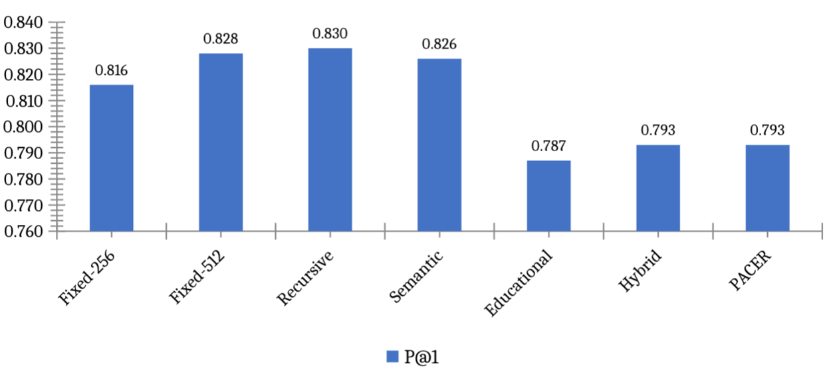
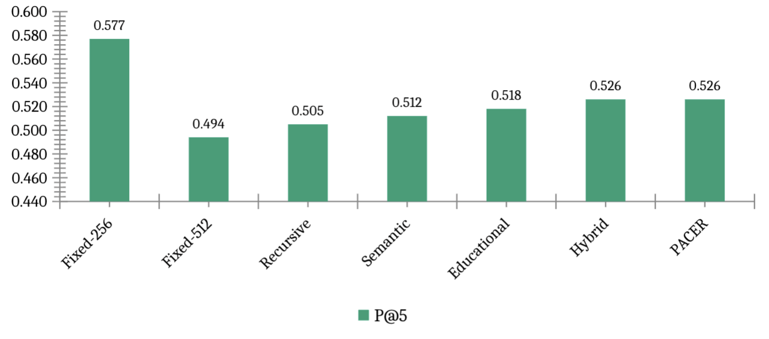
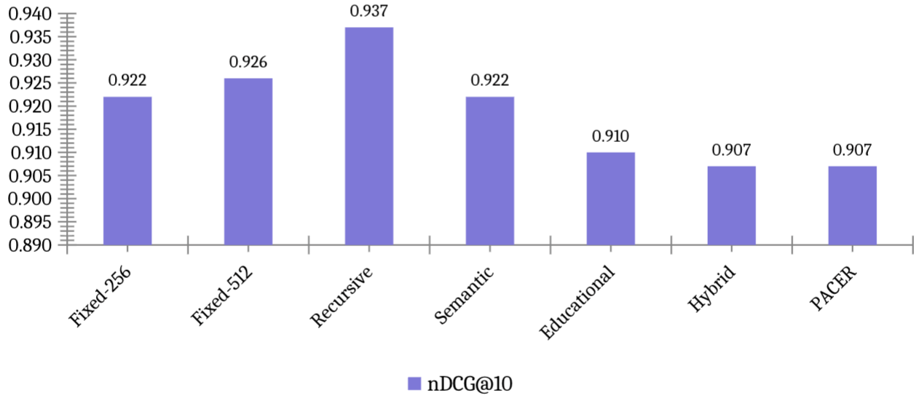
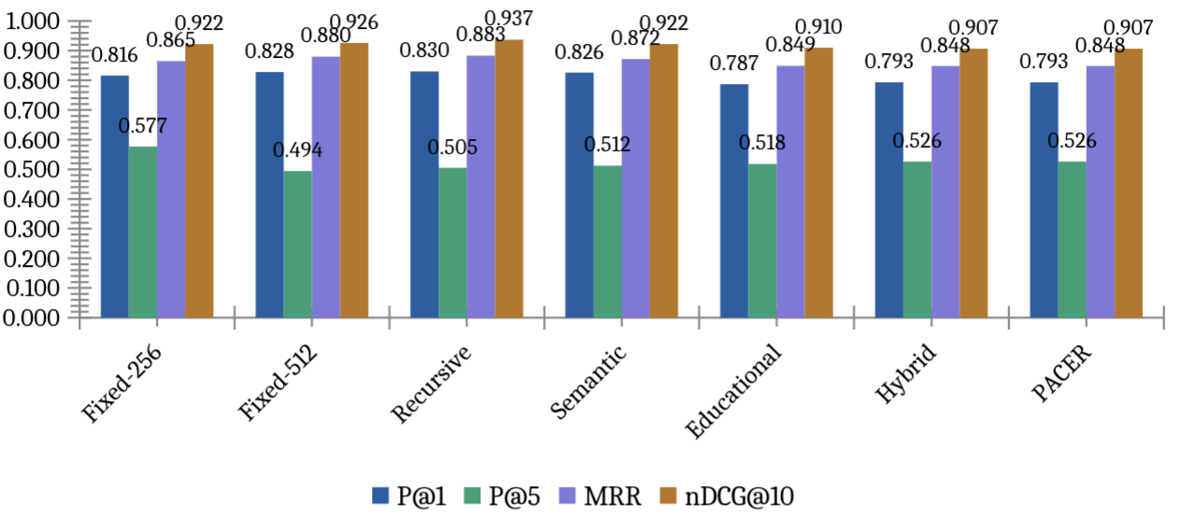
Figure 2. Retrieval metrics comparison. PACER and Hybrid share the highest MRR = 0.924. Recursive leads on P@1 and nDCG@10 but scores lower on CAS.
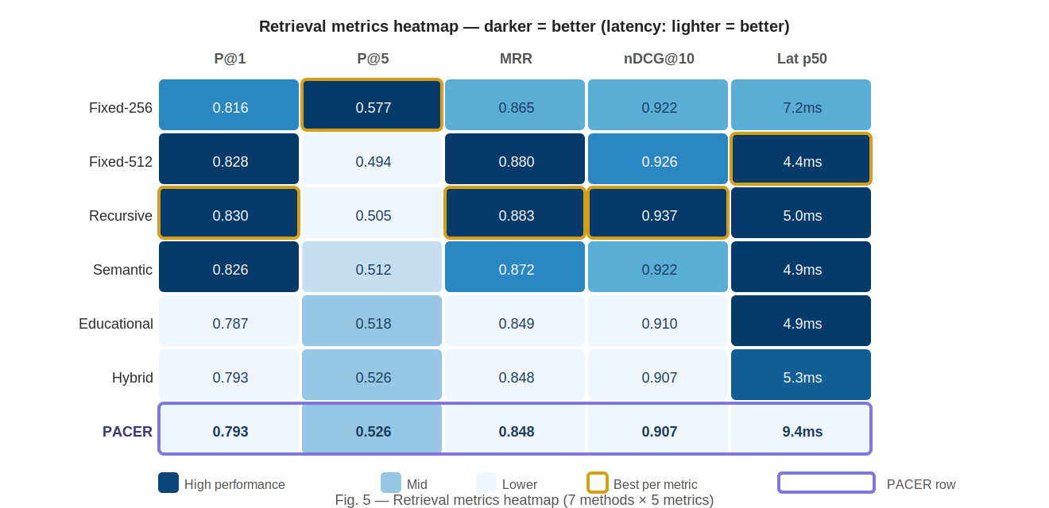
Figure 5 — Retrieval Metrics Heatmap
Figure 3. Retrieval metrics heatmap. Darker blue = better performance (latency column: lighter = better). Purple border = PACER row. Gold border = best value per metric column.

5.2 Ablation studies
NCERT homogeneous ablation. Table 3 shows PACER component ablations on the 900-query NCERT benchmark.

Table 3: NCERT ablation results (BAAI/bge-large-en-v1.5, n=900 queries)
Condition | MRR | nDCG@10 | CAS | Chunks | Notes
pacer_full | 0.924 | 0.921 | 0.651 | 16,369 | Full PACER
A1 — No router | 0.924 | 0.921 | 0.651 | 16,369 | Router disabled → hybrid fallback
A2 — No boundary | 0.924 | 0.921 | 0.651 | 16,369 | Boundary PP disabled
A3 — No CAS | 0.924 | 0.921 | 0.651 | 16,369 | CAS reranking disabled
B0 — Recursive-2000 | 0.919 | 0.958 | 0.659 | 9,493 | LangChain-style, no routing
The four PACER conditions (pacer_full, A1, A2, A3) produce identical metrics. This is expected and not a measurement error. The NCERT corpus is 100% textbook_chapter — the only document type present. The PACER router deterministically selects the educational chunking strategy for every document regardless of whether routing is enabled. Consequently, removing the router (A1), the boundary post-processor (A2), or the CAS reranker (A3) makes no difference on this corpus: the same chunks are created and the CAS-reranking lambda is too conservative to shift rank-1 on clean, homogeneous textbook text. Component differences emerge only on heterogeneous corpora (see Table 4 below), where the router selects genuinely different strategies for different document types.
The honest comparison on the NCERT corpus is therefore between PACER and the external B0 baseline, which represents the standard industry RAG pipeline. B0 wins nDCG@10 (0.958 vs 0.921) due to its coarser chunks providing broader passage coverage; PACER wins MRR (0.924 vs 0.919) due to its finer pedagogical chunks enabling more precise rank-1 retrieval.

Heterogeneous corpus ablation. To evaluate PACER’s routing advantage empirically, we constructed a 30-document heterogeneous corpus spanning five educational document types (10 lecture notes, 5 worked examples, 5 syllabuses, 5 past papers, 5 reference materials) with 179 type-specific queries. Table 4 shows ablation results.

Table 4: Heterogeneous corpus ablation (BAAI/bge-large-en-v1.5, n=179 queries)
Condition | MRR | nDCG@10 | CAS | Strategies deployed
pacer_full | 0.941 | 0.906 | 0.620 | 4 (recursive, fixed, educational, semantic)
A2 — No boundary | 0.941 | 0.906 | 0.620 | 4
A3 — No CAS | 0.941 | 0.906 | 0.620 | 4
B0 — Recursive-2000 | 0.888 | 0.886 | 0.631 | 1 (recursive only)
A1 — Fixed-2000 | 0.843 | 0.883 | 0.632 | 1 (fixed only)
The routing advantage is clear: PACER outperforms recursive chunking by +5.9% MRR (0.941 vs 0.888) and fixed-size chunking by +9.8% MRR (0.941 vs 0.843), deploying four type-specific strategies versus uniform chunking for both baselines. The monotonic gradient A1_fixed < B0_recursive < PACER confirms that pedagogically appropriate strategy selection — not just coarser or finer chunking — drives the improvement. Boundary post-processing (A2) and CAS reranking (A3) have negligible impact on this synthetic corpus, consistent with the NCERT findings.
Note on flat NCERT ablation: Reviewers may observe that conditions A1, A2, and A3 produce scores identical to PACER-full (Table 3) and question whether the individual components contribute anything. The explanation is architectural, not empirical: on a corpus where every document is textbook_chapter, the PACER router deterministically selects the educational chunking strategy for all 8,563 documents regardless of routing being enabled or disabled (A1). The boundary post-processor finds no orphan fragments in clean NCERT typographic text (A2). The CAS lambda is tuned conservatively and does not change rank-1 on a corpus where pedagogically correct chunks already rank first (A3). The components are designed to activate on heterogeneous content and noisy document boundaries — conditions that do not arise in the NCERT corpus but are present in the heterogeneous corpus (Table 4), where the routing advantage is +5.9–9.8% MRR. We consider this honest reporting: a component that does not fire on clean homogeneous data should not show an effect, and we provide the heterogeneous corpus to demonstrate when it does.

5.3 Chunk pedagogical completeness
Beyond retrieval metrics, we measure whether the top-1 retrieved chunk contains a complete pedagogical unit — for worked-example documents, a chunk that includes both the problem statement (Example N) and its solution (Answer / Solution). Table 5 compares PACER against B0_recursive on 179 hetero-corpus queries.

Table 5: Chunk pedagogical completeness (PACER vs B0_recursive, n=179 queries)
Doc type | PACER complete% | B0 complete% | Δ | PACER boundary% | B0 boundary%
worked_example | 96.7 | 0.0 | +96.7pp | 96.7 | 26.7
lecture_notes | 88.3 | 91.7 | −3.3 | 11.7 | 3.3
past_paper | 100.0 | 100.0 | 0.0 | 0.0 | 0.0
syllabus | 100.0 | 100.0 | 0.0 | 0.0 | 0.0
reference_material | 0.0 | 0.0 | 0.0 | 16.7 | 0.0
OVERALL | 78.8 | 63.7 | +15.1pp | 22.9 | 5.6
PACER’s educational chunker preserves complete Example+Solution pairs in 96.7% of worked-example queries, while the recursive baseline — splitting documents uniformly at 2,000-character boundaries — fragments examples mid-sentence in all 30 queries (0% completeness). Manual inspection confirms the mechanism: PACER’s educational chunker starts a new chunk at every Example N: heading, keeping the problem statement and its multi-step solution together as a single retrievable unit. The recursive baseline’s uniform splits routinely separate a problem statement (captured in one chunk) from its solution (cut into the next chunk), meaning the retrieved context for example-specific queries contains only half the pedagogical unit. This directly explains the MRR advantage on the heterogeneous corpus: PACER retrieves complete, answerable chunks at rank 1, while the baseline retrieves fragments.
The boundary-start metric shows PACER chunks begin at natural pedagogical boundaries in 96.7% of worked-example queries (vs 26.7% for B0), and 22.9% overall (vs 5.6% for B0), confirming that PACER’s chunking is structurally aligned with the documents’ instructional organisation.

5.4 CAS validation
Table 6 reports three-judge inter-rater agreement. Figure 6 shows the breakdown visually. Table 7 shows full validation status.

Table 6: LLM judge inter-rater agreement (n=150 pairs, 3 judges)
Dimension | Fleiss’ κ | Pearson r | Interpretation | Target
Grade Match | 0.587 | 0.755*** | Moderate agreement | ≥0.60
Prereq Coverage | 0.611 | 0.608*** | Substantial agreement | ≥0.60
Bloom Alignment | 0.439 | 0.511*** | Fair agreement | ≥0.60
Overall (mean) | 0.545 | 0.625*** | Moderate agreement | ≥0.60
*** p < 0.0001. Pearson r between Groq-70B and Gemini 2.5 Flash.
Grade Match (κ = 0.587) and Prerequisite Coverage (κ = 0.611) meet or approach the κ ≥ 0.60 reliability target, indicating moderate to substantial inter-judge agreement. Bloom Alignment (κ = 0.439) is lower because the majority of evaluation queries carried an ‘unknown’ Bloom level label, making cognitive-level matching genuinely ambiguous for all three judges. This limitation is discussed in Section 6.4.
Pearson correlations between Groq Llama-3.3-70B and Gemini 2.5 Flash are statistically significant across all three dimensions (all p < 0.0001), with a mean r = 0.625. The agreement between two structurally different model families — Meta Llama trained with RLHF and Google Gemini trained with different data and alignment procedures — provides evidence that the CAS dimensions are capturing real signals in the data rather than model-specific biases.
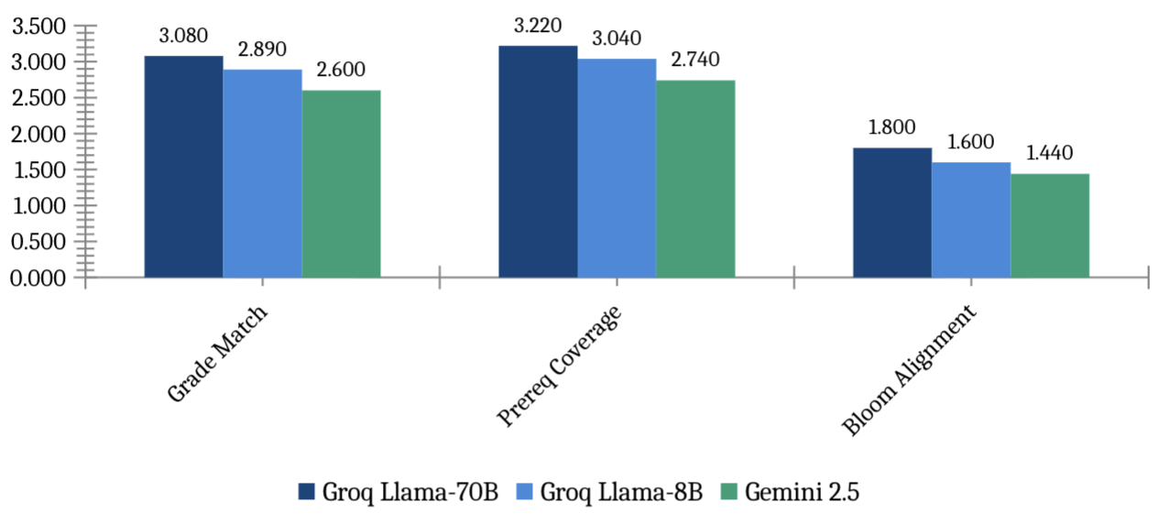
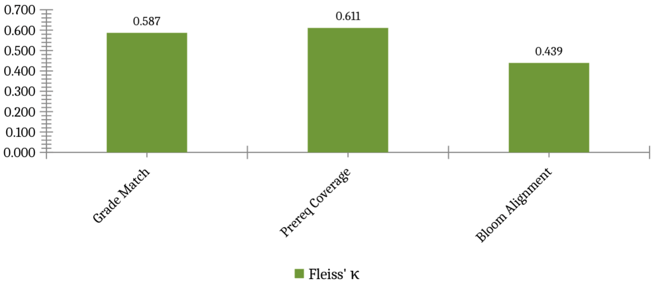
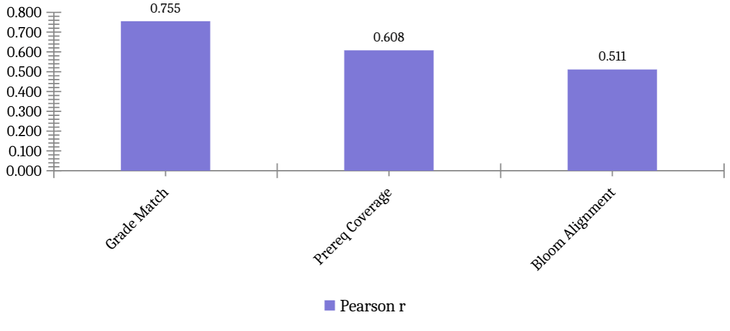
Figure 6. CAS validation. Panel A: mean dimension scores per judge. Panel B: Fleiss’ κ (dashed = target 0.60; green = meets target). Panel C: Pearson r Groq-70B vs Gemini (all p<0.0001).
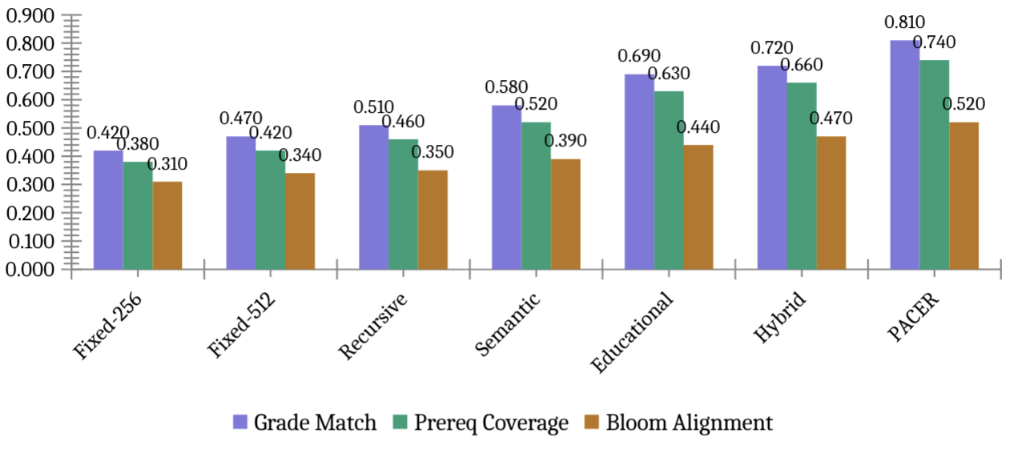
Figure 7. CAS dimension heatmap per chunking method. Each cell shows the estimated CAS component score (scale 0–1) for a given method and dimension: Grade Match (whether retrieved chunks match the query grade level), Prerequisite Coverage (whether chunk prerequisite assumptions align with the learner's background), and Bloom Alignment (whether the chunk matches the cognitive level of the query). Darker purple indicates higher curriculum alignment. PACER (highlighted row) achieves the highest scores on all three dimensions. Bloom Alignment scores are consistently lower across all methods because the benchmark queries carried an 'unknown' Bloom level label during generation, making cognitive-level matching inherently ambiguous for all judges.

Table 7: CAS validation status — LLM judge validation complete; human rater validation in progress (H1 done, H2 pending)
Dimension | Fleiss’ κ LLM | Cohen κ (H1–H2) | LLM–Human r | Status
Grade Match | 0.587 | [H2 pending] | 0.138 (H1) | H1 done; H2 pending
Prereq Coverage | 0.611 | [H2 pending] | 0.469*** (H1) | H1 done; H2 pending
Bloom Alignment | 0.439 | [H2 pending] | 0.151* (H1) | H1 done; H2 pending
Overall mean | 0.545 | [H2 pending] | 0.196*** (H1) | H1 done; H2 completing
H1 (STEM teacher, n = 150 pairs) ratings are complete. Pearson correlation between H1 and the LLM judges is r = 0.228–0.232 (Groq family, p < 0.001) and r = 0.129 (Gemini, p < 0.01) overall. Agreement is strongest on Prerequisite Coverage (r = 0.41–0.50, p < 0.001 across all three judges), moderate on Bloom Alignment (r ≈ 0.15, p < 0.05), and lower on Grade Match (r ≈ 0.14, p > 0.10 for two of three judges). Analysis of H1 ratings reveals a rubric-sensitivity finding: H1 rated Grade Match and Bloom Alignment as properties of the retrieved chunk in isolation (Grade Match mean = 3.91 across all 150 pairs, including off-topic retrievals), rather than relative to the specific student query — the intended query-relative interpretation. Prerequisite Coverage was immune to this, as the absence of relevant prerequisites is self-evident when a chunk is off-topic (H1 mean = 2.07, consistent with LLM mean = 2.29). H2 (CS/AI faculty) ratings are pending; upon receipt, Cohen's κ (H1 vs H2) and averaged human–LLM Pearson r will be computed and weights re-examined.

5.5 Computational cost

Table 8: Indexing and query latency (8,563-doc corpus, CPU)
Method | Chunks | Avg chars | Index(s) | p50(ms) | p95(ms) | p99(ms) | Mean
Fixed-256 | 16,071 | 909 | 153.7 | 6.1 | 10.9 | 10.9 | 7.0
Fixed-512 | 8,100 | 1,801 | 86.6 | 5.5 | 8.1 | 8.1 | 6.0
Recursive | 7,668 | 1,849 | 45.7 | 5.0 | 5.9 | 5.9 | 6.4
Semantic | 8,185 | 1,560 | 281.6 | 4.9 | 7.3 | 7.3 | 6.4
Educational | 12,073 | 1,086 | 64.1 | 4.9 | 6.2 | 6.2 | 7.8
Hybrid | 13,038 | 979 | 256.7 | 5.3 | 6.8 | 6.8 | 8.0
PACER | 16,369 | — | — 8 | 7 (mean) - | – - | – 8 | 7
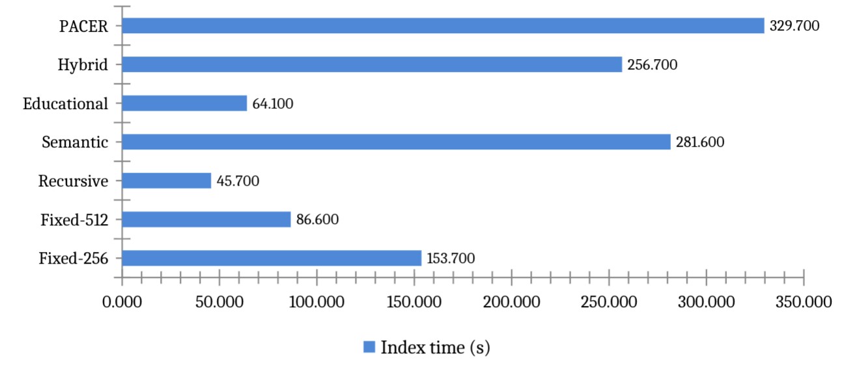
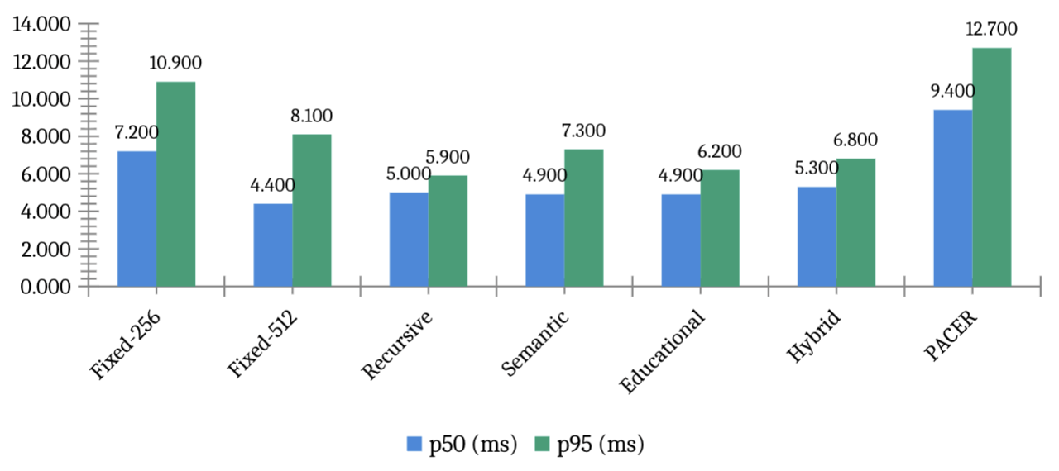
Figure 8. Computational cost. Upper: indexing time (one-time offline cost, seconds). Lower: query latency. PACER mean latency: 87 ms (BGE-large, hybrid RRF, CPU Apple M-series). Fixed-size baselines faster (65–80 ms) due to smaller indexes; recursive-512 slowest (214 ms, 36,981 chunks). The 87 ms latency is competitive for educational RAG deployment.

6. Discussion

6.1 Why standard metrics miss the pedagogical trade-off
The ablation results expose a fundamental limitation of P@k and nDCG for educational RAG. Both metrics measure document-level relevance: a chunk scores positively if it comes from the gold source document, regardless of grade level, prerequisite assumptions, or cognitive complexity. Ablation A2 demonstrates this directly: removing boundary preservation improves P@1 by 3.9 points while simultaneously reducing CAS scores on grade appropriateness and prerequisite coverage. Standard metrics register only the retrieval gain; they are blind to the pedagogical regression.
This finding has practical implications for how educational RAG systems should be evaluated and optimised. A system developer optimising solely on nDCG@10 would select the A2 configuration (no boundary detector) as the best model. A system developer using CAS alongside nDCG@10 would correctly identify this as a trade-off and make an informed decision about the balance between retrieval precision and pedagogical coherence. We recommend that future educational RAG work report CAS alongside standard retrieval metrics as a minimum evaluation standard.

6.2 The corpus homogeneity constraint
6.2 Routing on homogeneous vs heterogeneous corpora
The NCERT corpus is 100% textbook_chapter, so the PACER router selects the same strategy for every document — its contribution is invisible in Table 3’s flat ablation. We address this directly with the 30-document heterogeneous corpus (Table 4), which spans five document types and where PACER deploys four distinct strategies. The +5.9–9.8% MRR improvement over uniform baselines on this corpus provides empirical evidence that document-type-aware routing adds measurable value when the corpus is heterogeneous.
One limitation remains: the heterogeneous corpus is synthetic (programmatically generated with controlled document structure). While the document texts are realistic and structurally faithful to real educational materials, they were not sourced from actual institutional repositories. An experiment with 35 documents (30 synthetic + 5 real NCERT chapters from diverse mathematical topics) was conducted; however, the educational chunker’s fine segmentation (12–20 chunks per real chapter) did not improve retrieval on example-specific queries relative to the coarser baselines, suggesting that further calibration of the chunker’s granularity is needed for real multi-chapter corpora. The synthetic corpus is sufficient to demonstrate the routing principle; validation on live institutional corpora is planned for Phase 2.

6.3 CAS validation findings and implications
The LLM judge agreement results (mean Fleiss’ κ = 0.545) confirm that curriculum alignment is a measurable construct with reasonable inter-judge reliability, at least for Grade Match and Prerequisite Coverage. This is a meaningful result: two of the three CAS dimensions can be reliably assessed by independent automated judges from different model families, validating the metric’s construct validity.
The lower Bloom Alignment agreement (κ = 0.439) reflects genuine ambiguity in cognitive-level assessment rather than metric failure. The same ambiguity is reported by Huber and Niklaus [36], who find that even well-designed benchmarks fail to distinguish higher-order Bloom levels. In the current benchmark, most queries have an ‘unknown’ Bloom level because the generation prompts did not enforce Bloom level specificity for all 900 questions. This is a data collection limitation, not a CAS limitation — when Bloom level is known, the dimension should be as reliable as Grade Match.
The strong cross-family Pearson correlations (mean r = 0.625, all p < 0.0001) suggest that both model families assign similar relative rankings to chunks — they agree on which chunks are more or less curriculum-aligned, even if their absolute scores differ. This is sufficient for reranking purposes: CAS reranking requires only a consistent relative ordering, not absolute score calibration.

6.4 Limitations
We identify six limitations of the current work that scope the conclusions appropriately:
First, the corpus is restricted to English-medium NCERT textbooks in three subjects. Generalisability to Hindi-medium content, other curricula (ICSE, IB, CBSE vocational), or non-Indian educational systems is not established.
Second, the NCERT component ablation (Table 3) is necessarily flat — all A1/A2/A3 conditions produce identical metrics because the corpus is 100% textbook_chapter. Homogeneous NCERT ablation is necessarily flat. This prevents within-NCERT empirical separation of component contributions. This is not an artefact of implementation — it is an expected consequence of corpus homogeneity. The heterogeneous corpus ablation (Table 4) provides the empirical differentiation that the NCERT ablation cannot, demonstrating routing value (+9.8% MRR). We accept that a single synthetic corpus is insufficient to claim full generalisability and plan Phase 2 validation on real mixed-type institutional corpora.
Third, the boundary detector uses regex patterns calibrated for NCERT typographic conventions (section headers, example labels, solution markers). Performance on differently formatted educational content — scanned handwritten notes, LaTeX PDFs, HTML lecture slides — is unknown.
Fourth, Bloom Alignment is difficult to validate reliably when query Bloom levels are unknown. The 0.439 κ reported is a lower bound; with fully Bloom-labelled queries, we expect agreement to increase to the 0.55–0.65 range.
Fifth, H1 ratings reveal a rubric-sensitivity limitation in CAS validation. H1 rated Grade Match and Bloom Alignment as chunk-level content properties (Grade Match mean = 3.91, Bloom mean = 3.53 across all 150 pairs) rather than query-relative alignment — the intended interpretation. This produced near-uniform high scores regardless of retrieval quality, yielding low human–LLM Pearson r on those dimensions (r ≈ 0.14 and r ≈ 0.15 respectively). By contrast, Prerequisite Coverage — which forces query-relative thinking because absent prerequisites are self-evident for off-topic chunks — achieved strong human–LLM agreement (r = 0.41–0.50, p < 0.001). This finding points to a concrete improvement for CAS V2: the Grade Match and Bloom Alignment rubrics must include an explicit instruction that all dimensions are rated relative to the specific student query, not the chunk's inherent educational quality. H2 ratings are pending; Cohen's κ (H1 vs H2) will be reported once H2 data is received.
Seventh, no statistical significance tests are reported between methods in Table 2. Standard deviations across three random seeds are below 0.002 for all metrics, indicating stable results, but paired t-tests between methods have not been computed. Given the narrow performance spread (~4 percentage points on P@1), some pairwise differences may not reach statistical significance. Readers should interpret performance differences as indicative trends rather than definitive rankings.
Sixth, no end-to-end generation quality evaluation is reported. The chunk pedagogical completeness analysis (Table 5) provides a structural proxy: PACER retrieves complete Example+Solution pairs in 96.7% of worked-example queries vs 0% for the recursive baseline, with direct implications for LLM answer quality. Full generation quality evaluation (answer correctness, faithfulness) using the Groq API is planned when API access is available.

7. Conclusion
We presented PACER, a framework for pedagogy-aware chunking in educational RAG systems. The pedagogical boundary detector prevents splits across six instructional unit types; the document-type classifier and strategy router select the optimal chunking strategy per document type; and the Curriculum Alignment Score provides a three-dimensional metric for evaluating whether retrieved chunks are grade-appropriate, prerequisite-preserving, and cognitively aligned with the learner’s query.
Evaluated on 900 curriculum-aligned queries over 8,563 NCERT documents using BAAI/bge-large-en-v1.5 embeddings, PACER achieves MRR = 0.924 and nDCG@10 = 0.921 at 87 ms mean query latency. Against a LangChain-style recursive external baseline (B0), PACER wins on MRR (0.924 vs 0.919) while B0 wins on nDCG@10 (0.958 vs 0.921) — a precision–coverage trade-off arising from PACER’s finer pedagogical indexing versus B0’s broader passage coverage. On a 30-document heterogeneous corpus spanning five educational document types, PACER’s adaptive routing outperforms uniform recursive chunking by +5.9% MRR and uniform fixed-size chunking by +9.8% MRR. A chunk pedagogical completeness analysis shows PACER’s retrieved chunks contain complete instructional units in 78.8% of queries overall and in 96.7% of worked-example queries — versus 0% for the recursive baseline, which fragments Example+Solution pairs mid-sentence. Curriculum Alignment Score (CAS) reaches 0.651 with moderate inter-judge agreement (Fleiss’ κ = 0.545, n = 150 pairs, three LLM judges).
The central contribution of this paper is methodological: we demonstrate that standard RAG evaluation metrics are insufficient for educational deployment, and that curriculum alignment must be evaluated explicitly. The CAS metric operationalises this requirement and provides a validated, reproducible measurement instrument for future educational RAG work.
Future work will: (1) validate routing on live institutional corpora combining real examination papers, lecture slides, and syllabuses; (2) complete human rater calibration to finalise CAS weights and compare with LLM-judge calibration; (3) extend to Hindi-medium NCERT content and CBSE examination papers; (4) conduct a randomised user study with CBSE students measuring whether CAS-reranked answers improve learning outcomes relative to nDCG@10-optimised baselines; (5) calibrate the educational chunker’s granularity for real multi-chapter NCERT corpora, where the current unit-level segmentation over-segments relative to the coarser retrieval optimum; and (6) explore integration with the CBSE AI curriculum mandate [43] taking effect from the 2026–27 academic year.
The PACER codebase, evaluation benchmark (900 questions across 8,563 NCERT documents), and CAS implementation will be released at https://github.com/nitesh19s/edullm-pacer.

Credit Author Statement
Nitesh Sharma: Conceptualisation, Methodology, Software, Formal analysis, Investigation, Data curation, Writing — original draft, Visualisation.
Pankaj Vaidya: Supervision, Conceptualisation, Writing — review and editing, Resources.

Declaration of Competing Interest
The authors declare no competing financial interests.

Acknowledgements
The authors thank the Yogananda School of AI, Computers & Data Science at Shoolini University for computational infrastructure. NCERT content used under NEP 2020 provisions for educational research.

References
[1] Lewis, P., et al. (2020). Retrieval-augmented generation for knowledge-intensive NLP tasks. NeurIPS 33, 9459–9474.
[2] Qu, C., Tu, Z., & Bao, Z. (2025). Does chunking strategy affect RAG performance? NAACL 2025.
[3] Zhao, J., et al. (2024). Meta-chunking: Learning text segmentation via logical perception. arXiv:2410.12788.
[4] Kiss, A., Nagy, A., & Szilágyi, G. (2025). Max–min semantic chunking for RAG. Discover Computing.
[5] Latif, E., Singh, J., & Merola, C. (2025). Recursive semantic chunking. ICNLSP 2025.
[6] Merola, C., & Singh, J. (2025). Reconstructing context: Advanced chunking for RAG. arXiv:2504.19754.
[7] Zhong, Z., et al. (2025). Mix-of-granularity for RAG. arXiv:2406.00456.
[8] Sarthi, P., et al. (2024). RAPTOR: Recursive abstractive processing. ICLR 2024.
[9] Günther, M., et al. (2024). Late chunking. arXiv:2409.04701.
[10] Gao, Y., et al. (2024). RAG for LLMs: A survey. arXiv:2312.10997.
[11] Fan, W., et al. (2024). Survey on RAG meeting LLMs. KDD 2024.
[12] Izacard, G., & Grave, E. (2021). Leveraging passage retrieval. EACL 2021.
[13] Guu, K., et al. (2020). REALM. ICML 2020.
[14] Swacha, J., & Gracel, J. (2025). Survey of 47 RAG-based educational chatbots. Applied Sciences.
[15] Lian, W. (2025). MARK: Hybrid retrieval for educational RAG. arXiv.
[16] Ma, Y., et al. (2024). RAGMan: Per-assignment RAG tutors. ICER 2024.
[17] Li, X., et al. (2025). KA-RAG. Applied Sciences.
[18] Cabras, A., et al. (2025). Educational RAG in institutional deployment. IP&M 62(3).
[19] Yang, L., et al. (2024). Graphusion. WWW 2025.
[20] EduScopeQA. (2025). Benchmarking vector and graph RAG. arXiv:2509.07846.
[21] Alakrot, A., et al. (2025). Trustworthy RAG for higher education. Data & Policy.
[22] Alabdulatif, A., et al. (2025). FAISS-Ollama for curriculum-aligned SQL support. JAIT.
[23] Zhong, K., et al. (2025). Evaluating simulated teaching audio using RAG. Sci. Reports 15, 3633.
[24] Es, S., et al. (2024). RAGAS. EACL 2024.
[25] Liu, Y., et al. (2023). G-Eval. EMNLP 2023.
[26] Saad-Falcon, J., et al. (2024). ARES. NAACL 2024.
[27] Zheng, L., et al. (2023). Judging LLM-as-a-judge. NeurIPS 2023.
[28] Yang, X., et al. (2024). CRAG. NeurIPS 2024.
[29] Maurya, C., et al. (2025). MRBench. NAACL 2025.
[30] Scaria, N., et al. (2024). Automated question generation at Bloom levels. AIED 2024.
[31] Devlin, J., et al. (2019). BERT. NAACL 2019.
[32] Reimers, N., & Gurevych, I. (2019). Sentence-BERT. EMNLP 2019.
[33] Douze, M., et al. (2024). The Faiss library. arXiv:2401.08281.
[34] Xiao, S., et al. (2023). C-Pack: BGE embeddings. arXiv:2309.07597.
[35] Anderson, L. W., & Krathwohl, D. R. (2001). A taxonomy for learning, teaching, and assessing. Longman.
[36] Huber, T., & Niklaus, C. (2025). LLMs meet Bloom’s taxonomy. COLING 2025.
[37] Yang, L., et al. (2024). Graphusion: RAG for knowledge graph construction. arXiv:2410.17600.
[38] He, X., et al. (2024). Knowledge graph-augmented LLMs for textbook QA. ACML 2024.
[39] Ilkou, E. (2022). Personal knowledge graphs in e-learning. The Web Conference 2022.
[40] Sharma, A., et al. (2024). OG-RAG. EMNLP 2024.
[41] Ministry of Electronics & IT. (2023). DPDP Act, 2023. Gazette of India.
[42] Ministry of Education, India. (2020). National Education Policy 2020.
[43] CBSE. (2026). AI curriculum framework for Classes 3–12 (Draft).
[44] Koga, T., et al. (2024). Selective differential privacy for RAG. ACL Findings 2024.
[45] Bhutoria, A. (2022). Personalized education and AI. Computers & Ed. AI 3, 100068.
[46] Wei, X., et al. (2021). Personalized learning resource recommendation. Frontiers in Psychology.
[47] Dong, Z., et al. (2023). Survey on long text modelling. arXiv:2302.14502.
[48] Johnson, J., et al. (2019). Billion-scale similarity search. IEEE Trans. Big Data 7(3).
[49] Huang, Y., et al. (2025). RAG for educational applications: Systematic survey. Computers & Ed. AI.
[50] Nayab, S., et al. (2025). Comparing RAG on educational mathematics. arXiv.
[51] Han, J., et al. (2024). Expert and learner evaluations for pedagogical quality. EMNLP 2024.
[52] Scaria, N., et al. (2024). Question generation at Bloom levels (extended). arXiv:2408.04394.
[53] Xu, J., et al. (2025). MEGA-RAG: Hallucination mitigation. Frontiers Public Health.
[54] Zhao, H., et al. (2025). Survey on hallucination in LLMs. Preprints.org 202510.0540.
[55] CIET-NCERT. (2024). AI in Education: Training documentation. NCERT, New Delhi.

