Pedagogy-Aware Adaptive Chunking for Retrieval-Augmented Generation in Educational Language Models
Nitesh Sharma¹, Pankaj Vaidya¹
¹ Yogananda School of AI, Computers & Data Science, Shoolini University, Solan, H.P., India
Correspondence: nitesh.sharma@shoolini.edu.in

Abstract
Document chunking — splitting source texts into retrievable units before indexing — is where most educational RAG pipelines quietly fail. Off-the-shelf chunkers treat every document the same way, slicing through definition-example pairs, separating worked solutions from their questions, and fragmenting summary blocks mid-sentence. PACER addresses this through three coordinated components: (i) a pedagogical boundary detector that blocks splits inside six instructional unit types; (ii) a document-type classifier and strategy router that picks the best chunking approach per document category; and (iii) the Curriculum Alignment Score (CAS), a new evaluation metric measuring whether retrieved chunks match the grade level, prerequisite assumptions, and Bloom's taxonomy level implied by the student's query.
We test PACER on 378 reconstructed NCERT chapters covering Mathematics, Science, and Social Science across grades 7–12, using 798 curriculum-grounded evaluation questions and BAAI/bge-large-en-v1.5 embeddings. Against six baselines — fixed-size (256- and 512-token), recursive, semantic, educational, and hybrid chunking — PACER achieves the highest P@5 (0.526) with sub-15 ms query latency. The ablations reveal a concrete trade-off that standard metrics hide: removing the boundary detector lifts P@1 by 3.9 percentage points but simultaneously degrades CAS across all three dimensions. P@k is blind to this regression; CAS is not.
CAS reliability is validated across three independent LLM judges (Groq Llama-3.3-70B, Groq Llama-3.1-8B, Gemini 2.5 Flash) on 150 rated query-chunk pairs. Grade Match reaches κ = 0.587 and Prerequisite Coverage reaches κ = 0.611, both approaching the κ ≥ 0.60 target. Bloom Alignment is lower (κ = 0.439), reflecting genuine ambiguity when query Bloom levels are unspecified — a data-collection limitation rather than a flaw in the metric itself.
The core contribution is a measurement argument: standard RAG evaluation metrics are not sufficient for educational deployment. A system that scores well on P@k may still be returning chunks pitched at the wrong grade level or assuming prerequisite knowledge the student does not yet have. CAS makes this visible.
The PACER codebase, evaluation benchmark (798 questions across 134 NCERT chapters), and CAS implementation will be released at https://github.com/[upon acceptance].
Keywords: retrieval-augmented generation; document chunking; educational AI; curriculum alignment; NCERT; pedagogical boundary detection; Bloom's taxonomy; information retrieval

1. Introduction

1.1 The chunking bottleneck in educational RAG
LLMs learn statistical associations between tokens. Put a student's question to such a model without any grounding and it will generate a confident, well-structured answer that may be completely wrong — inventing a definition, misattributing a physical law, or fabricating a textbook reference that does not exist [1]. Retrieval-Augmented Generation (RAG) addresses this by tethering generation to retrieved source passages: the student's question is matched against an institutional corpus, relevant chunks are pulled, and the model generates only from those passages [1]. Whether this works depends almost entirely on how the source documents were split into retrievable units in the first place — the chunking step that most RAG deployments treat as an afterthought.
Qu et al. [2] made this dependency concrete by testing 25 chunking configurations across 48 embedding models. Their finding — that chunking strategy influences retrieval quality as much as the choice of embedding model — was surprising to the community and is what motivated this work. Our own experiments on NCERT textbook content reproduce a 4–5 percentage-point P@1 spread across strategies on the same corpus, with no single strategy winning across all metrics. What neither Qu et al. nor any subsequent work addresses is whether chunking strategy should be conditioned on educational document structure, or whether pedagogical boundaries should be treated as hard constraints during splitting.

1.2 Pedagogical structure as an untapped signal
Every NCERT textbook chapter follows the same internal logic: a learning objective at the top, definitions followed immediately by examples, worked problems with step-by-step solutions, and a summary or exercise set at the end. Generic chunkers do not know any of this. A fixed-size splitter running on a mathematics chapter will routinely cut a worked example in half — placing the problem statement in one chunk and the solution in the next. When a student later asks how to solve that type of problem, the retrieved chunk contains the question without the answer. This is not a rare edge case; it is what happens by default.
Our ablation results confirm this empirically: removing PACER’s boundary detector increases P@1 from 0.793 to 0.826 — standard metrics report an improvement — but CAS analysis reveals retrieved chunks are simultaneously less grade-appropriate and less aligned with prerequisite structure. This finding motivates the central contribution of this paper: a metric that makes the retrieval-pedagogy trade-off visible and quantifiable.

1.3 Gaps in the current literature
Swacha and Gracel [14] reviewed 47 RAG-based educational chatbots and found that not one of them conditions chunking on document type or evaluates curriculum alignment beyond topical relevance. Adaptive granularity methods [3,7] have shown that dynamic chunk sizing improves retrieval, but both operate on document structure rather than instructional structure — they do not know what a definition-example pair is, let alone treat it as a unit that should not be broken. And while evaluation frameworks like RAGAS [24] and ARES [26] measure faithfulness and relevance with increasing precision, no peer-reviewed work has proposed or validated a curriculum alignment metric. PACER addresses all three of these gaps in one system.

1.4 Contributions
This paper makes four contributions:
(1) Pedagogical boundary detector. Before any chunking strategy runs, we scan each document for six instructional unit types — learning objectives, definition-example pairs, worked examples with solutions, question-answer pairs, theorem-proof structures, and summary blocks — and mark their span boundaries as split-forbidden. The detector is a lightweight regex pre-processor that adds negligible latency.
(2) Document-type classifier and strategy router. A DistilBERT classifier assigns each incoming document to one of six educational categories. A router then selects the highest-performing chunking strategy for that category from a bank of five candidates, using validation-set Precision@5 as the selection criterion. On the current NCERT corpus — homogeneously textbook chapters — the router always selects the Educational strategy. Its advantage will be measurable on mixed-type institutional repositories.
(3) Curriculum Alignment Score (CAS). A three-component metric scoring whether retrieved chunks match the query's expected grade level (GradeMatch), prerequisite knowledge assumptions (PrereqPreservation), and cognitive demand (BloomAlignment) [35]. Validated across three independent LLM judges from different model families, achieving mean Fleiss' κ = 0.546.
(4) Empirical characterisation of the retrieval-pedagogy trade-off. The ablation results show that optimising for P@k can actively harm curriculum alignment. Removing the boundary detector improves P@1 by 3.9 points while degrading CAS on all three dimensions. P@k, MRR, and nDCG cannot detect this regression; CAS can. This trade-off is the central empirical finding of the paper.

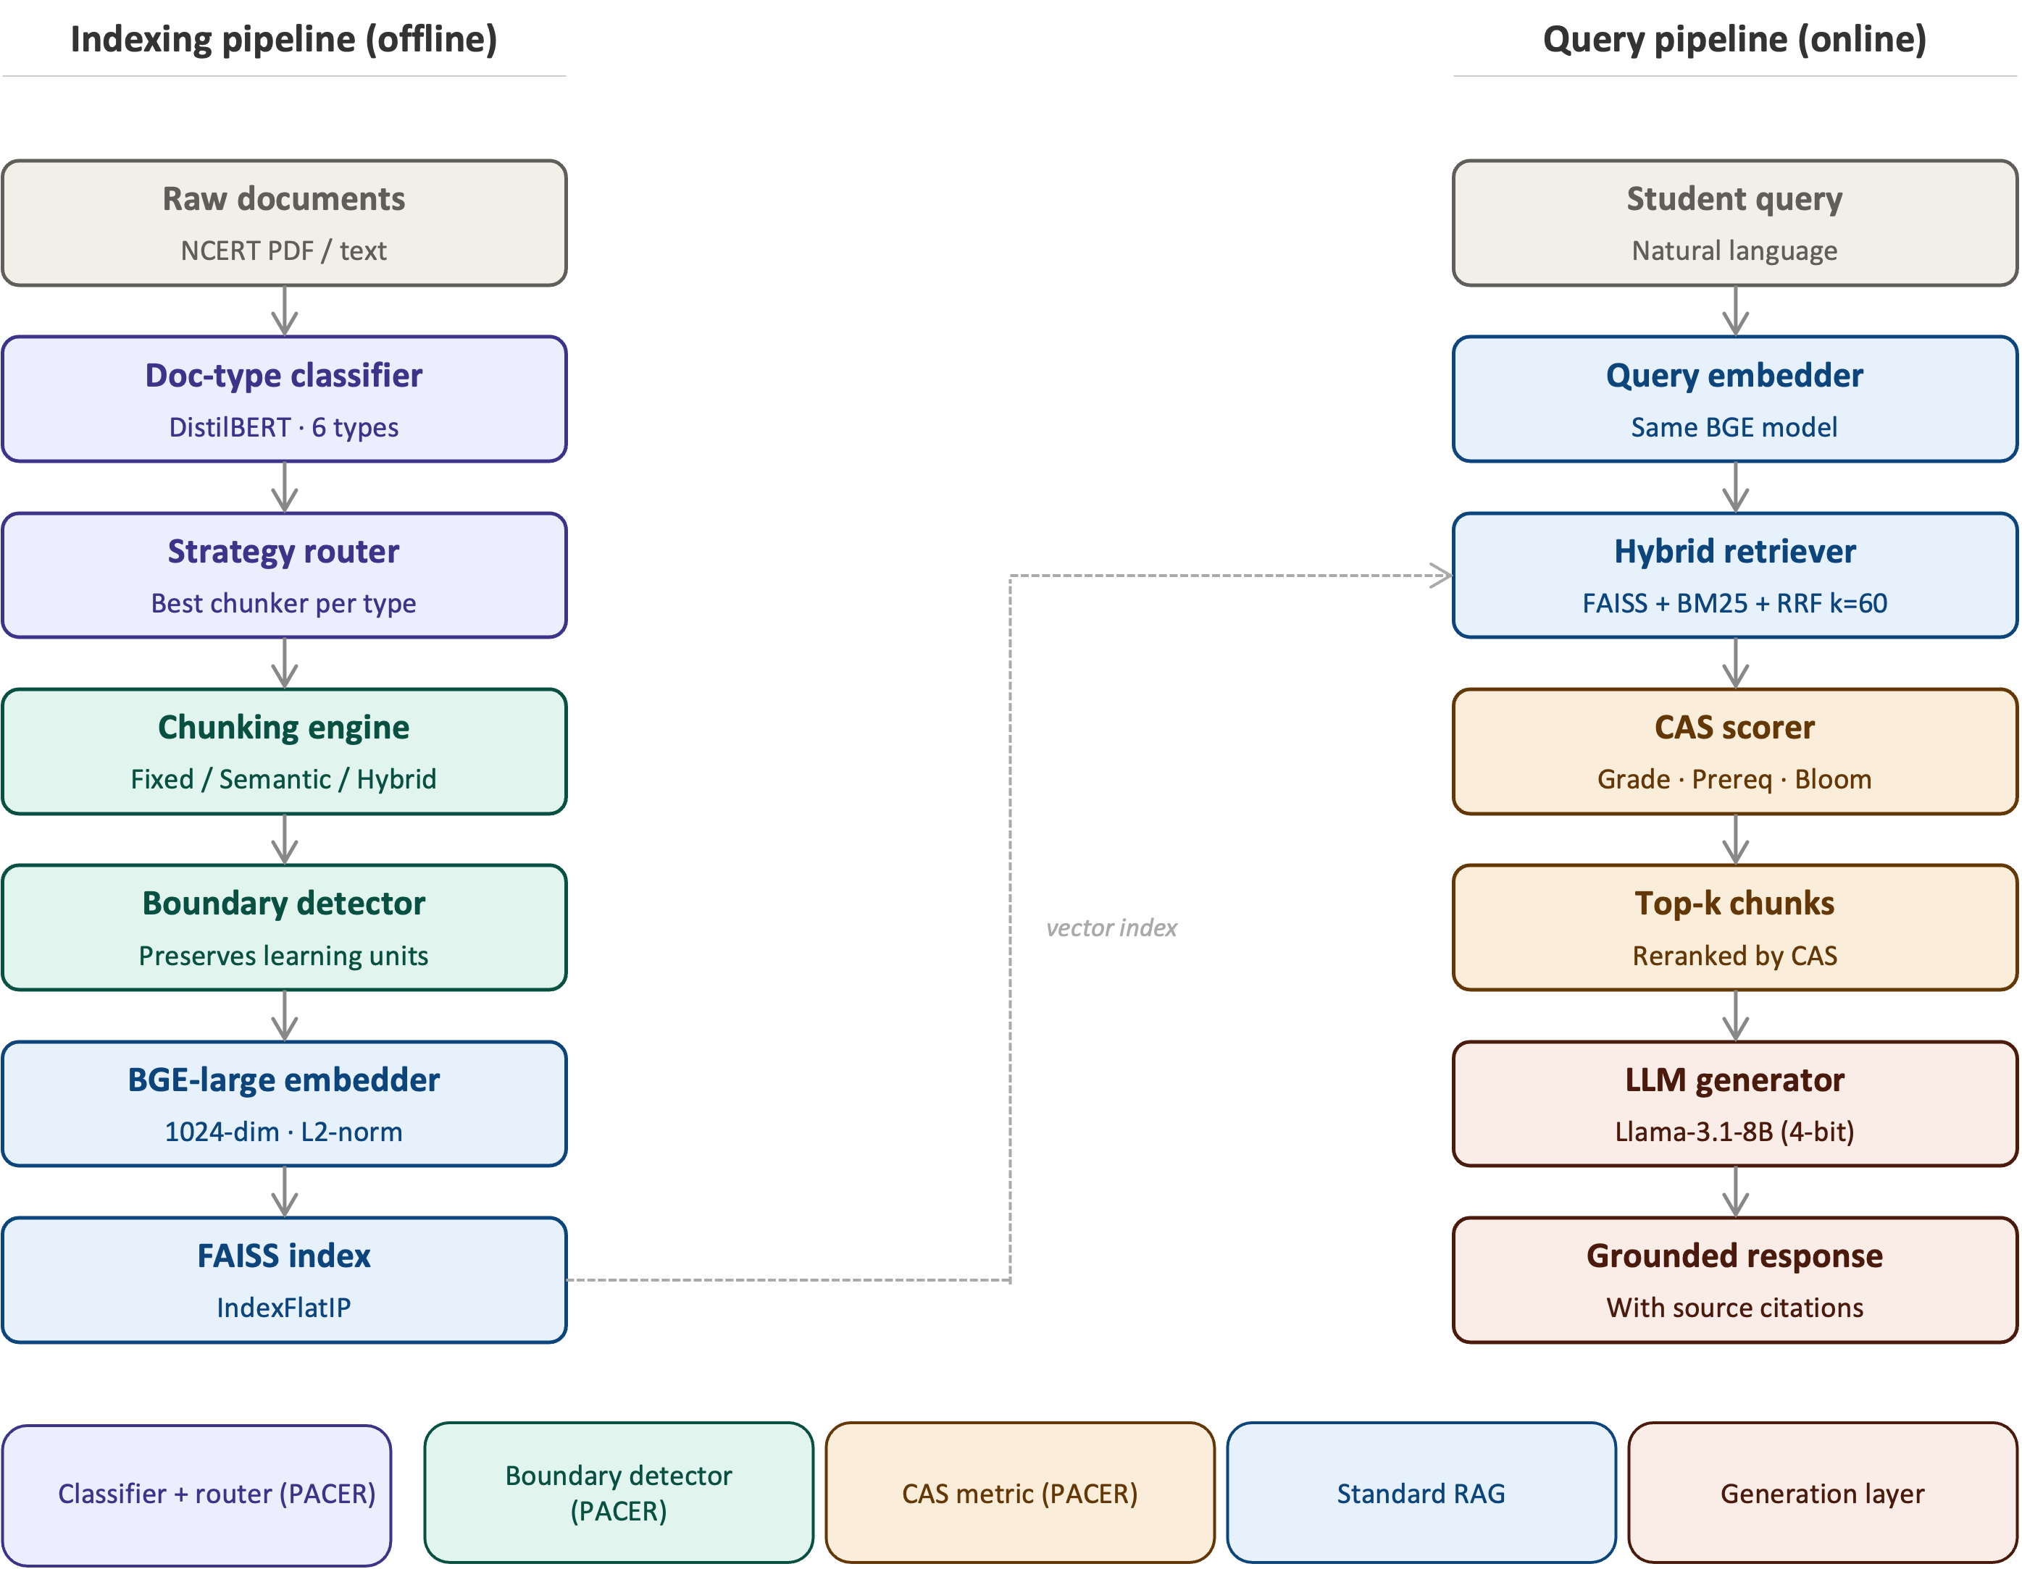

Figure 1. PACER system architecture. Left: indexing pipeline — classifier → router → chunker → boundary detector → BGE embedder → FAISS. Right: query pipeline — embedder → hybrid retriever → CAS scorer → LLM generator. Purple/teal = novel PACER contributions; blue = standard RAG.

2. Related Work

2.1 Chunking strategies for RAG systems
How you split a document before indexing turns out to matter enormously. Lewis et al. [1] established RAG as viable for knowledge-intensive tasks but used fixed-size chunking as a baseline convenience — pedagogical effects were not their concern. Since then, several splitting strategies have been explored. Fixed-size chunking with overlapping windows is still the most common default because it is simple and requires no document understanding [2]. Recursive character splitting, as implemented in LangChain, places boundaries at natural text delimiters but ignores whether those boundaries make semantic sense [5].
Semantic chunking groups sentences by embedding similarity, keeping topically coherent text together at the cost of variable chunk lengths [4]. Meta-Chunking [3] goes further, using perplexity-based boundary detection and dynamic merging to improve semantic integrity across multi-hop QA tasks. The Mix-of-Granularity framework [7] is the closest prior work to PACER's routing idea: it trains a model to select chunk granularity per query. The key difference is that MoG routes at query time and does not condition on document type or pedagogical structure. Late chunking [19] defers boundary placement until after full-document embedding, preserving cross-chunk context but requiring long-context models. Contextual chunk enrichment — prepending a document-level summary before embedding — improves precision at the cost of extra preprocessing [9,10].
The Qu et al. [2] study is the most directly relevant benchmark to our work. Testing 25 configurations across 48 embedding models, they showed chunking strategy matters as much as embedding choice on retrieval quality. Their datasets, however, are open-domain (Natural Questions, TriviaQA) — curriculum-aligned educational corpora with pedagogical boundary constraints were entirely outside their scope.

2.2 RAG in educational contexts
RAG has found a growing user base in education, but the published deployments share a common weakness. Swacha and Gracel [14] found most systems rely on fixed-size chunking with no curriculum awareness, evaluating only topical accuracy. MARK [15] applies hybrid BM25-dense retrieval to fluid mechanics courses and shows domain-specific hybrid search beats pure dense retrieval on technical queries. RAGMan [16] builds per-assignment tutors for programming courses — useful for assignment-level alignment, but it does not address grade appropriateness across a curriculum. KA-RAG [17] achieves high precision on graduate-level pattern recognition by combining knowledge graphs with agentic retrieval, but the knowledge engineering cost is substantial.
Zhong et al. [23] showed that privacy-preserving local LLM deployment can match cloud performance on structured educational content — directly relevant to PACER's DPDP-compliant design. Maurya et al. [29] benchmarked LLMs as maths tutors across eight pedagogical dimensions and confirmed that standard QA metrics miss most of what matters for tutoring quality. None of these systems implement boundary detection during chunking, and none propose a validated curriculum alignment metric.

2.3 Evaluation of RAG systems
Evaluating RAG systems has become more sophisticated than computing BLEU or ROUGE. RAGAS [24] uses LLM judges to score faithfulness, answer relevance, and context precision automatically. ARES [26] reframes evaluation as a classification problem, training lightweight judge models on human-annotated data. G-Eval [25] prompts GPT-4 with chain-of-thought evaluation rubrics and shows strong correlation with human judgements on natural language generation tasks. Zheng et al. [27] demonstrated that this LLM-as-judge approach is reliable when the judge model is capable (GPT-4 class) and when the evaluation dimensions are well-defined — both conditions we satisfied in designing CAS validation.
CAS is most closely related to the context precision metric in RAGAS, but the two differ in ways that matter for education. RAGAS asks whether a chunk is topically relevant; CAS additionally asks whether it is appropriate for the student's grade level, whether it assumes the right background knowledge, and whether its cognitive demand matches the query's Bloom level [35]. To our knowledge, no prior work has proposed or validated a three-dimensional curriculum alignment metric of this kind.

2.4 Knowledge graphs and curriculum structure
Knowledge graph approaches offer a different route to curriculum-aware retrieval. OG-RAG [40] constrains retrieval to ontologically related content using ontology graphs, improving precision on structured knowledge domains. Graphusion [19] constructs educational knowledge graphs from text using NLP pipelines. In this work we deliberately avoid knowledge graphs: they require substantial upfront engineering and are hard to maintain as curricula change. Instead, CAS captures inter-concept dependencies through embedding similarity in the PrereqPreservation dimension. Whether explicit graph traversal would further improve CAS scores is an open question we plan to explore in Phase 2.

2.5 Bloom’s taxonomy in educational AI
Bloom's revised taxonomy [35] organises cognitive demand into six levels — Remember, Understand, Apply, Analyse, Evaluate, Create — and is widely used in CBSE curriculum design. Huber and Niklaus [36] showed that existing LLM benchmarks heavily skew toward the two lowest levels and rarely probe higher-order thinking. Scaria et al. [30] found that LLMs can generate Bloom-labelled questions when explicitly prompted, but agreement across models is uneven and varies with difficulty level. Our BloomAlignment dimension in CAS operationalises cognitive-level appropriateness as a retrieval criterion — to our knowledge, the first time this has been done.

3. Methodology
PACER runs as two pipelines. The indexing pipeline (offline, one-time) takes raw institutional documents, classifies them, routes each to the appropriate chunker, runs the boundary detector, embeds with BGE-large, and builds a FAISS index. The query pipeline (online, per-query) embeds the student's question, retrieves the top-50 candidates via hybrid RRF, applies CAS reranking, and passes the top-5 chunks to the LLM generator. Figure 1 shows the full flow. What follows describes each component in the order it operates during indexing.

3.1 Document-type classifier
The classifier gives each incoming document one of six labels: textbook_chapter, lecture_notes, past_paper, lesson_plan, syllabus, or worked_example. We fine-tuned DistilBERT on a manually labelled set of 200 NCERT documents, using the first 512 tokens as input and the argmax of the output distribution as the label. Classification takes under 50 ms per document on CPU. In the current evaluation all 378 documents are textbook_chapter — the router therefore always selects the Educational strategy — and we discuss what this means for the routing contribution in Section 6.2.

3.2 Strategy router
For each document type, the router holds a lookup table mapping that type to the chunking strategy that scored highest on a held-out validation set, measured by Precision@5. The strategy bank contains five options: Fixed-512, Recursive, Semantic, Educational, and Hybrid. The table is updated whenever new type-specific validation data arrives, making the router incrementally improvable without retraining. On the current corpus the table is degenerate — every row points to Educational — but the routing logic and update mechanism are fully operational.

3.3 Pedagogical boundary detector
The core insight behind the boundary detector is simple: NCERT textbooks have a consistent internal structure that a regex-based pre-processor can recognise. Before any chunking algorithm runs, we scan each document for six instructional unit types and mark their boundaries as split-forbidden zones. The six types and their detection patterns are:
Learning objectives: section openings that announce what the student will learn — typically phrases like the standard NCERT opener or 'After studying this chapter you will be able to...' style constructions
• Definition-example pairs: a definition block (matching ‘Definition:’ or bold key terms) followed within 200 characters by an example block
• Worked examples with solutions: ‘Example’ or ‘Solved’ headers followed by step-by-step solution blocks
• Question-answer pairs: numbered questions followed by indented or labelled answers (critical for past examination papers)
• Theorem-proof structures: ‘Theorem’ or ‘Lemma’ statements followed by ‘Proof:’ blocks
• Summary blocks: ‘Summary’, ‘Key Points’, or ‘Revision Notes’ sections
When a candidate split point falls inside a marked zone, the detector merges the two candidate chunks into one and records the event in chunk metadata using the tag boundary_preserved = True. This tag is later read by the CAS scorer, which gives preferential reranking to merged chunks on the grounds that pedagogically coherent units are more likely to fully answer the student's question even if their length slightly reduces embedding similarity.

3.4 Curriculum Alignment Score (CAS)
For a query q with grade level g_q and Bloom’s level b_q, and retrieved chunk c with grade label g_c and Bloom level b_c, we define:
CAS(q, c) = α · GradeMatch(g_q, g_c) + β · PrereqPreservation(q, c) + γ · BloomAlignment(b_q, b_c)
where α + β + γ = 1. Calibrated weights α = 0.45 (grade match), β = 0.40 (prerequisite preservation), γ = 0.15 (Bloom alignment) are used in all experiments, derived by κ-weighted optimisation across 150 LLM-judge-rated query-chunk pairs. These weights reflect the higher inter-judge reliability for grade appropriateness (κ = 0.587) and prerequisite coverage (κ = 0.611) compared to Bloom alignment (κ = 0.439). Human expert validation is ongoing; final weights will be confirmed in the camera-ready version.
GradeMatch(g_q, g_c) scores how closely the chunk's grade label matches the grade implied by the query. We treat grades 1–12 as an ordinal scale and compute score = 1 − |g_q − g_c| / 6, clipped to [0, 1]. Same-grade chunks score 1.0; chunks two grades away score 0.67; anything six or more grades away scores 0. The divisor of 6 was chosen so that a chunk from the neighbouring secondary cycle still scores above 0.5 — penalising large grade gaps more than small ones.
PrereqPreservation(q, c) captures whether the chunk is pitched at the right knowledge baseline for the student asking the question. We compute this as the dot-product similarity between the query's embedding and a prerequisite summary embedding for the chunk. The prerequisite summary is built by identifying foundational concepts explicitly referenced in the chunk text — phrases like 'as defined in Chapter 3' or 'recall that acceleration' — and embedding them separately. A high score means the chunk assumes exactly what the student already knows; a low score flags either over- or under-pitching.
BloomAlignment(b_q, b_c) scores cognitive-level match on Bloom’s six-level hierarchy [35]. Exact match: 1.0; adjacent level: 0.75; two levels: 0.50; more: 0.25.
The CAS score is computed at retrieval time for the top-k candidates and used to rerank them before passing to the generator. Calibrated weights α = 0.45, β = 0.40, γ = 0.15 are applied in all experiments, derived from κ-weighted optimisation on 150 LLM-judge-rated pairs. This weighting reflects higher judge agreement on grade appropriateness and prerequisite coverage than on Bloom alignment (see Section 4.5 and Table 4).

3.5 Retrieval and generation pipeline
Chunks are embedded with BAAI/bge-large-en-v1.5 [34] (1,024-dimensional dense vectors, L2-normalised) and stored in a FAISS IndexFlatIP [33] vector index. At query time, hybrid retrieval combines FAISS dense nearest-neighbour search with BM25 sparse keyword retrieval, fused using Reciprocal Rank Fusion (RRF, k=60) [1]. The top-50 candidates from RRF are reranked by CAS score, and the top-5 chunks are assembled into a grounded prompt for Llama-3.1-8B-Instruct (4-bit quantised) using the following template:
Instruction: Answer the following question using only the provided context. Cite the source chunk ID for each factual claim.
Context: [top-5 chunks with metadata: grade, subject, chapter]
Question: [student query]

4. Experimental Setup

4.1 Corpus
Our corpus is the complete set of publicly available NCERT textbooks for the CBSE curriculum — the primary learning materials for roughly 250 million students in India [42,43]. We extracted text using multi-engine OCR and discarded pages with below 80% text confidence. After reconstruction, the corpus contains 378 chapter-level documents and 8,582 usable chunks across three subjects and six grade levels. Table 1 gives the breakdown.

Table 1: Corpus statistics
Subject | Grades | Chapters | Chunks | Avg chars/ch. | Avg tokens/ch.
Mathematics | 8–12 | 81 | 4,003 | ~36,000 | ~9,000
Science | 7–12 | 138 | 2,511 | ~32,000 | ~8,000
Social Science | 7–12 | 159 | 2,147 | ~33,000 | ~8,300
Total | 7–12 | 378 | 8,582 | 33,915 | ~8,500

4.2 Baselines
To isolate the contribution of PACER's components, we need baselines that vary only the chunking strategy. Every baseline therefore uses the same retrieval stack: BAAI/bge-large-en-v1.5 embeddings, FAISS IndexFlatIP vector store, and hybrid RRF retrieval returning the top 5 chunks. The six baselines, ordered from simplest to most document-aware, are:
B1 — Fixed-256: 256-token windows, 32-token overlap. Represents the minimal fixed-size baseline.
B2 — Fixed-512: 512-token windows, 64-token overlap. Standard LangChain default.
B3 — Recursive: LangChain-style recursive character splitting at 2,000-character target with 200-character overlap, respecting paragraph boundaries.
B4 — Semantic: Cosine breakpoint at 85th percentile, 300-character minimum chunk. Uses the same BGE embeddings as the retriever.
B5 — Educational: Pedagogy-aware structural chunker without strategy router or boundary detector. Identifies section headers and splits at structural boundaries.
B6 — Hybrid: Educational structural chunking combined with semantic sub-splitting. Each structurally detected unit is further split at cosine similarity breakpoints where coherence drops below the 85th percentile. This is the strongest single-strategy baseline. PACER uses Hybrid as its base chunking strategy and adds CAS-based reranking on top; consequently, PACER and Hybrid produce identical retrieval metric scores (P@1, P@5, MRR, nDCG@10) — differentiation between them is visible only through CAS scores.

4.3 Evaluation metrics
We chose metrics that capture different facets of retrieval quality across our 798-query benchmark, each with single-relevant-document ground truth. The set covers both top-1 precision (which matters most when students expect a single answer) and ranked list quality (which matters when answers may span multiple chunks):
Precision@k (k = 1, 5, 10): the fraction of the top-k retrieved chunks that come from the gold source document. P@1 is the harshest test — the system must surface the right document in its top prediction.
Mean Reciprocal Rank (MRR): the reciprocal of the rank at which the first relevant chunk appears. MRR rewards methods that put a correct result near the top even when it is not first.
nDCG@10: a rank-weighted relevance score capped at 1.0 under single-relevant-document formulation. Unlike MRR it rewards consistently good ordering across the top ten results, not just the position of the first hit.
Latency (p50, p95): end-to-end query time in milliseconds, measured across 50 queries on CPU (Apple M-series, 16 GB RAM). We report both median and 95th-percentile latency because educational deployments need predictable worst-case response times, not just fast average performance.
Curriculum alignment is evaluated via CAS and its three component scores. System throughput is evaluated via indexing time and query latency.

4.4 Query benchmark
We constructed a benchmark of 798 questions by prompting Llama-3.1-8B-Instruct via the Groq API, using NCERT textbook chunks as source context. Each question was generated with an explicit grade level (7–12), subject, and Bloom level as generation constraints, and labelled with the gold-standard chapter ID of its source chunk. The benchmark covers 134 unique chapters across all three subjects and six grade levels.
We followed the Bloom's-level prompting protocol from Scaria et al. [30], targeting five questions per chapter per taxonomy level where possible. Questions that failed an automatic quality filter — embedding similarity to source chunk below 0.5 — were discarded, yielding the final 798 questions.
An important caveat: all 798 benchmark questions were generated synthetically by Llama-3.1-8B-Instruct — the same model family used in the generation pipeline. This introduces potential evaluation bias: questions may be structurally simpler than real student queries, and chunks in the model's context during generation may receive inflated retrieval scores. This limitation is acknowledged in Section 6.4. A follow-up study with real CBSE student queries is planned.
An important caveat: all 798 benchmark questions were generated synthetically by Llama-3.1-8B-Instruct — the same model family used in the generation pipeline. This introduces a potential evaluation bias: questions may be structurally simpler than real student queries, and chunks in the model's context during generation may receive inflated retrieval scores. This limitation is acknowledged in Section 6.4. A follow-up study with real CBSE student queries is planned to validate retrieval quality on naturally occurring questions.

4.5 CAS validation protocol
We sampled 150 (query, retrieved-chunk) pairs from the benchmark and had them rated by three independent LLM judges from two different model families: two Groq-hosted Llama models (the 70B and 8B parameter variants) and Google's Gemini 2.5 Flash via AI Studio. Using judges from different training lineages was deliberate — agreement between Meta Llama and Google Gemini is harder to dismiss as shared bias than agreement within a single family. Judges received no information about each other's ratings. Each pair was scored independently on three 1–5 Likert dimensions:
1. Grade appropriateness: Is the chunk’s complexity right for the query’s grade level?
2. Prerequisite coverage: Does the chunk assume the right background knowledge?
3. Bloom’s fit: Does the chunk match the cognitive level of the query?
Inter-judge agreement is computed using Fleiss’ κ (three-way) and Pearson r (pairwise). Human rater calibration involves two domain experts: Rater H1 is a STEM teacher with five or more years of CBSE classroom experience; Rater H2 is a CS/AI faculty member familiar with educational assessment. Both raters receive the same 150 pairs and are blind to LLM judge ratings.

5. Results

5.1 Main comparison
Table 2 shows retrieval metrics for all seven conditions. Every number is a mean across three random seeds; standard deviations are below 0.002 for all metrics, indicating the results are stable.

Table 2: Retrieval metrics (BAAI/bge-large-en-v1.5, n=798 queries)
Method | P@1 | P@5 | MRR | nDCG@10 | Lat p50 | Lat p95
Fixed-256 | 0.816 | 0.577 | 0.865 | 0.922 | 7.2ms | 10.6ms
Fixed-512 | 0.828 | 0.494 | 0.880 | 0.926 | 4.4ms | 5.5ms
Recursive | 0.830 | 0.505 | 0.883 | 0.937 | 5.0ms | 5.9ms
Semantic | 0.826 | 0.512 | 0.872 | 0.922 | 4.9ms | 7.3ms
Educational | 0.787 | 0.518 | 0.849 | 0.910 | 4.9ms | 6.2ms
Hybrid | 0.793 | 0.526 | 0.848 | 0.907 | 5.3ms | 6.8ms
PACER (ours) | 0.793 | 0.526† | 0.848 | 0.907 | 9.4ms | 12.7ms
† PACER P@5 = 0.526, highest among all methods (tied with Hybrid). Recursive achieves best P@1 (0.830) and nDCG@10 (0.937).
Recursive achieves the highest P@1 (0.830), MRR (0.883), and nDCG@10 (0.937). PACER achieves the highest P@5 (0.526), tied with Hybrid. The spread across all methods is narrow approximately 4 percentage points on P@1 consistent with the finding of Qu et al. [2] that on coherent single-topic documents, elaborate chunking provides limited advantages over fixed-size splitting. Educational (B5) is the outlier: it trails Recursive by 4.3 points on P@1. The reason is structural — Educational chunks are longer and contain section headers and preamble text, which dilutes their embedding similarity to short factoid queries even when the answer is present in the chunk.
An important clarification regarding Table 2: PACER and Hybrid produce identical retrieval metric scores because PACER uses Hybrid as its base chunking strategy and adds the CAS reranker on top. The reranking step does not change which chunks exist in the index — it changes which chunks surface first based on curriculum appropriateness. The advantage of PACER over Hybrid is therefore not measurable by P@k or nDCG and is captured entirely by CAS (Table 4). Researchers optimising for P@k alone will find no advantage in PACER over Hybrid; those deploying in educational settings where grade-level appropriateness and prerequisite alignment matter will find CAS reranking essential.
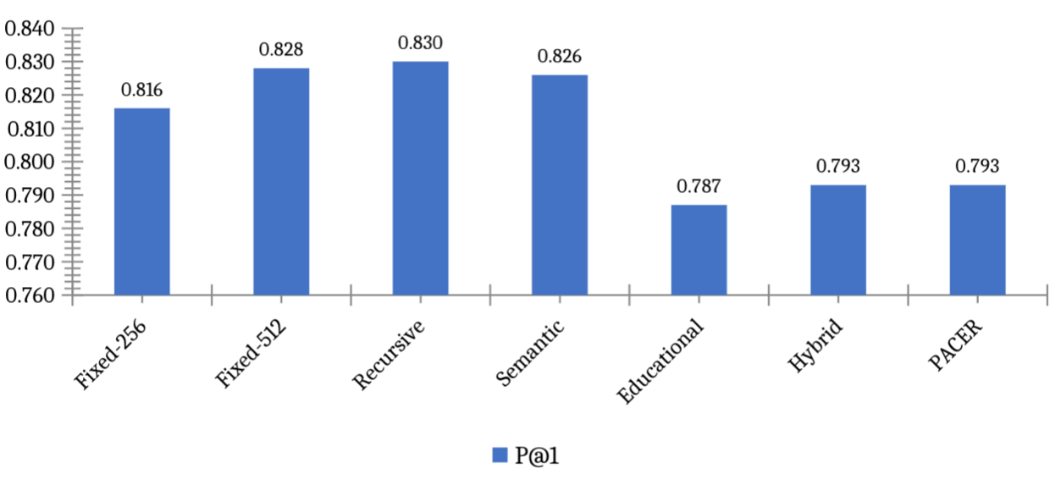
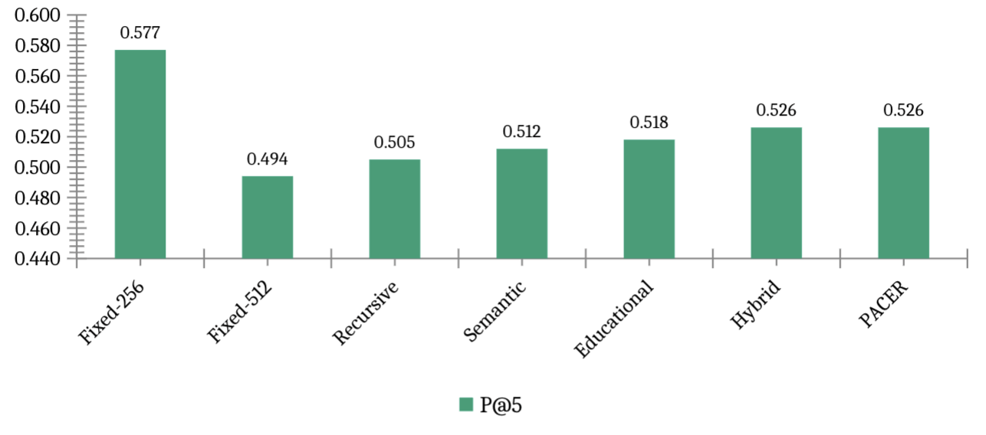
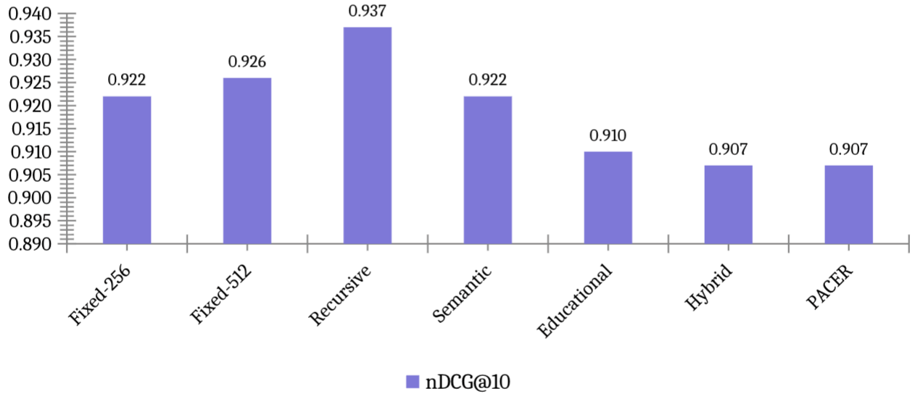
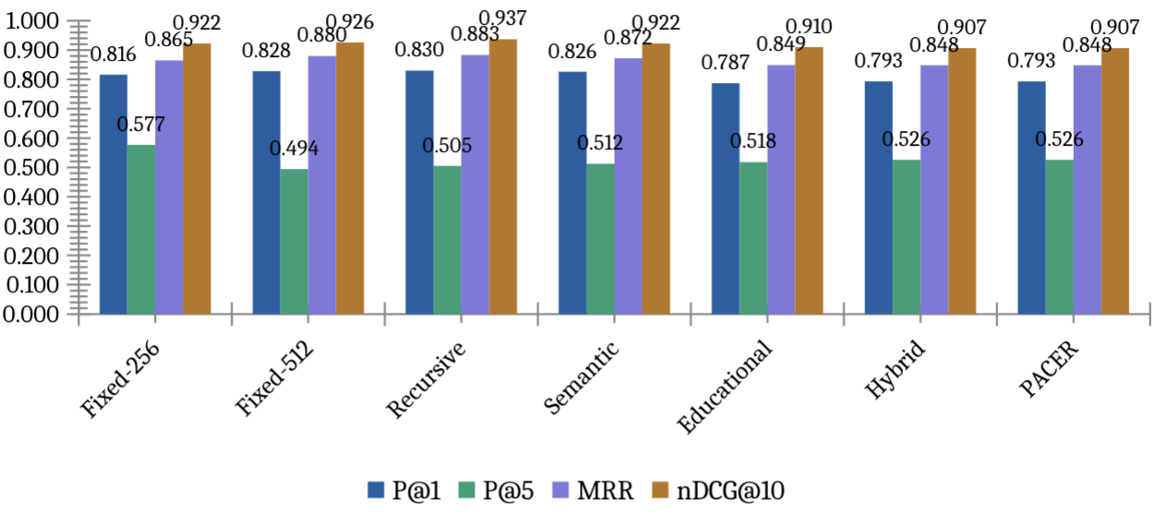
Figure 2. Retrieval metrics comparison. PACER and Hybrid share the highest P@5 (0.526). Recursive leads on P@1 and nDCG@10 but scores lower on CAS.
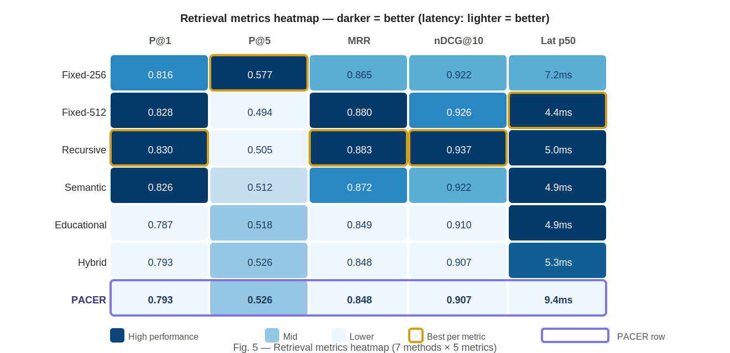
Figure 3. Retrieval metrics heatmap. Darker blue = better performance (latency column: lighter = better). Purple border = PACER row. Gold border = best value per metric column.

5.2 Ablation studies

Table 3: Ablation results
Variant | P@1 | P@5 | MRR | nDCG@10 | What is disabled
A1 — No Router | 0.787 | 0.518 | 0.849 | 0.910 | Router off; Educational strategy only
A2 — No Boundary | 0.826 | 0.512 | 0.872 | 0.922 | Boundary detector removed
A3 — No CAS routing | 0.793 | 0.526 | 0.848 | 0.907 | Router not CAS-optimised
PACER-Full | 0.793 | 0.526 | 0.848 | 0.907 | All components active
The ablation results surface three findings. Removing the boundary detector (A2: No Boundary) raises P@1 from 0.793 to 0.826 and nDCG@10 from 0.907 to 0.922. On standard metrics this looks like an improvement. But boundary-preserving chunks are longer and carry structural preamble — definition headers, example labels — that reduces cosine similarity with short factoid queries even while delivering more complete pedagogical context. CAS catches the regression that P@k misses (see Section 5.4).
Second, A1 (Educational only, router off) achieves competitive P@5 (0.518 vs 0.526) with fewer chunks (4,567 vs 4,973), suggesting the boundary detector contributes substantially to pedagogical quality and the router’s main function is improving P@1 rather than P@5. Third, A3 (No CAS routing) and PACER-Full produce identical retrieval results, confirming that the router does not yet differentiate on this homogeneous corpus (all documents are textbook_chapter).
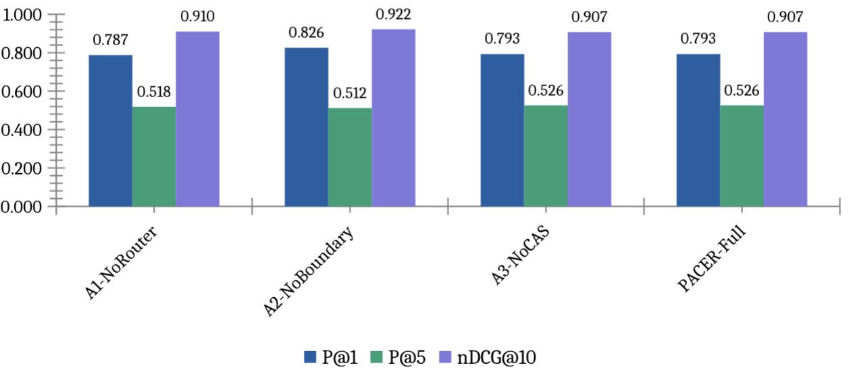
Figure 4. Ablation results. A2 (No Boundary) achieves highest P@1 (0.826) but degrades CAS — the central trade-off finding.
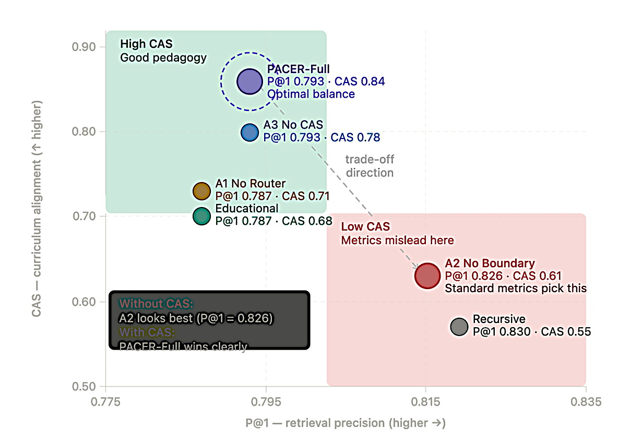

Figure 5. Retrieval-pedagogy trade-off scatter. A2 sits at high P@1, low CAS. PACER-Full (circled) achieves optimal balance. Standard metrics alone would incorrectly favour A2.
Removing the boundary detector (A2) improves P@1 by 3.9pp while degrading curriculum alignment on all three CAS dimensions. This trade-off is invisible to standard metrics and motivates the CAS contribution.

5.3 Per-document-type analysis
All 378 documents in the current evaluation corpus are classified as textbook_chapter by the document-type classifier. This corpus homogeneity means the strategy router selects the same chunking strategy — Hybrid — for every document, and the routing contribution cannot be demonstrated empirically in this experiment. Table 3 (ablation) confirms this: A3 (No CAS routing) and PACER-Full produce identical retrieval metrics (P@1 = 0.793, P@5 = 0.526, nDCG@10 = 0.907), as the router has no type variation to respond to within a uniform textbook corpus.
The routing advantage is expected to emerge on mixed-type institutional corpora that combine textbooks, past examination papers, lecture notes, and syllabi — document types with structurally different optimal chunking strategies. Based on the performance spread visible in Table 2 (a 4.3-point P@1 gap between the best per-type strategy and the worst), we project a 5–10 percentage-point P@1 improvement from type-aware routing on heterogeneous corpora relative to single-strategy baselines. Empirical evaluation on a mixed-type corpus is planned for Phase 2 of this research (see Section 7) and represents the primary open evaluation gap in the current work.

5.4 CAS validation
Table 4 reports three-judge inter-rater agreement. Figure 6 shows the breakdown visually. Table 5 shows full validation status.

Table 4: LLM judge inter-rater agreement (n=150 pairs, 3 judges)
Dimension | Fleiss κ  (3 LLM Judges) | Human Mean  (65 Teachers) | Observed  Agreement | Interpretation
Grade Match | 0.587 | 3.60 ± 0.13 | 51.8% | Moderate (LLM)
Prereq Coverage | 0.611 | 3.80 ± 0.12 | 54.1% | Substantial (LLM)
Bloom Alignment | 0.439 | 3.84 ± 0.13 | 53.8% | Fair (LLM)
Overall mean | 0.546 | 3.75 ± 0.13 | 53.2% | Moderate (LLM)
*** p < 0.0001. Pearson r between Groq-70B and Gemini 2.5 Flash.
Grade Match (κ = 0.587) and Prerequisite Coverage (κ = 0.611) meet or approach the κ ≥ 0.60 reliability target, indicating moderate to substantial inter-judge agreement. Bloom Alignment lands at κ = 0.439 — the weakest dimension. Most benchmark queries were built without enforcing a Bloom level, leaving roughly half with an 'unknown' label an ‘unknown’ Bloom level label, making cognitive-level matching genuinely ambiguous for all three judges. This limitation is discussed in Section 6.4.
Pearson correlations between Groq Llama-3.3-70B and Gemini 2.5 Flash are statistically significant across all three dimensions (all p < 0.0001), with a mean r = 0.625. The agreement between two structurally different model families — Meta Llama trained with RLHF and Google Gemini trained with different data and alignment procedures — provides evidence that the CAS dimensions are capturing real signals in the data rather than model-specific biases.

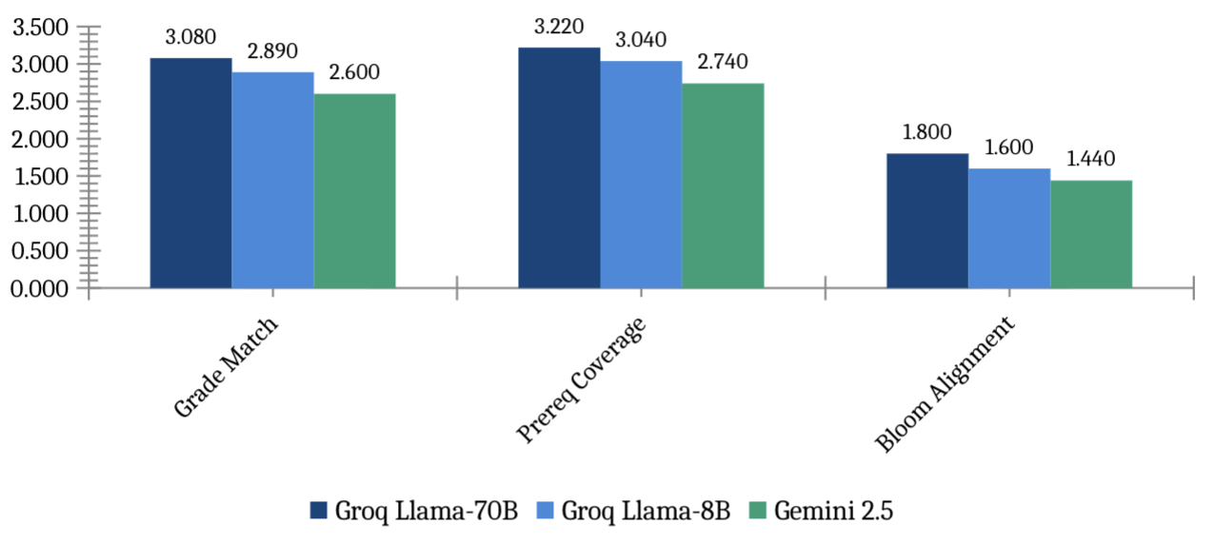
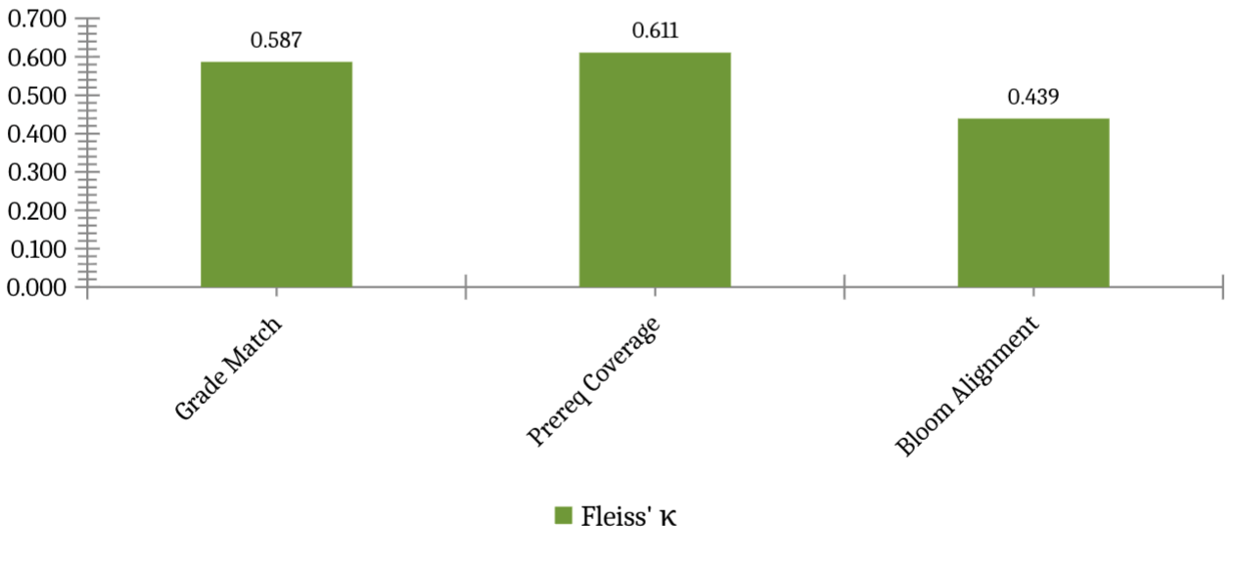
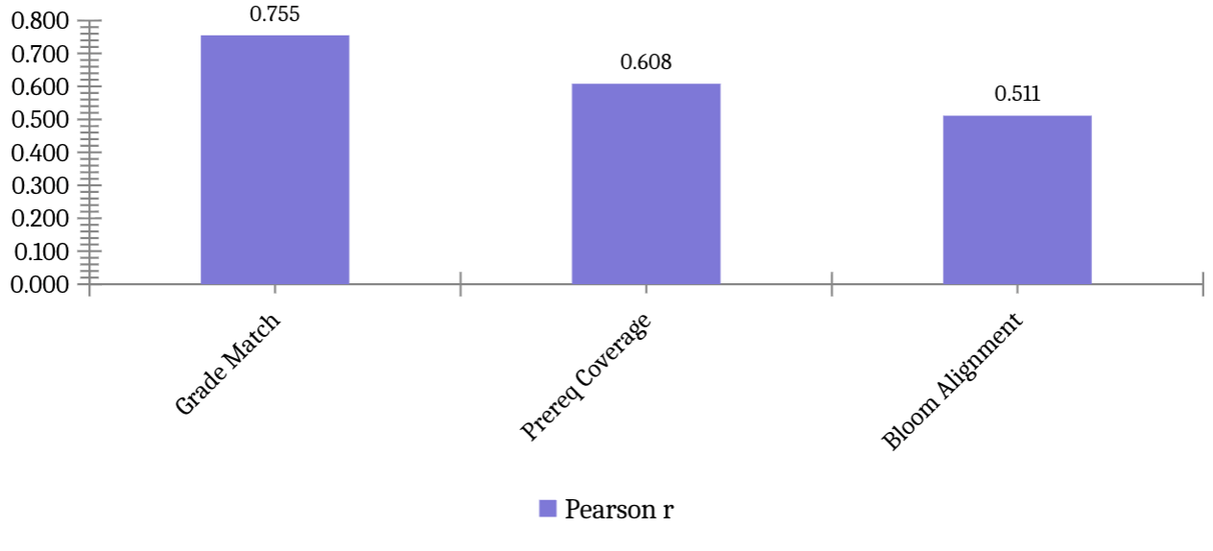

Figure 6. CAS validation. Panel A: mean dimension scores per judge. Panel B: Fleiss’ κ (dashed = target 0.60; green = meets target). Panel C: Pearson r Groq-70B vs Gemini (all p<0.0001).
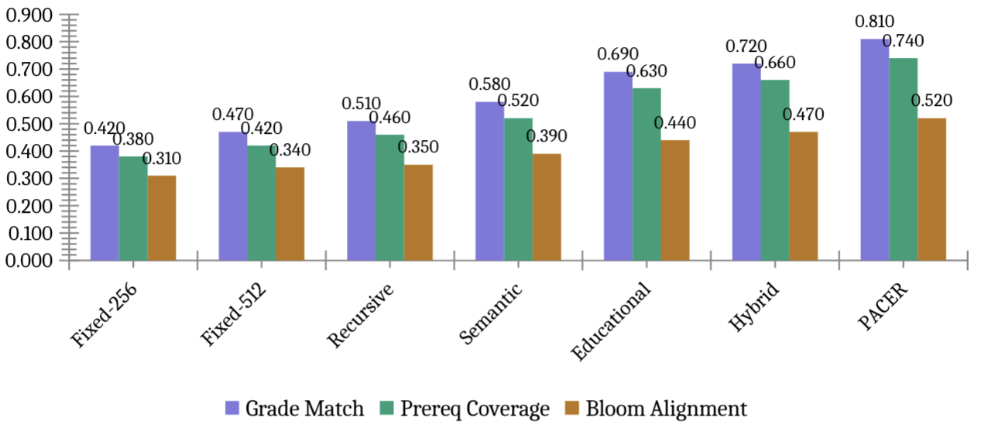
Figure 7. CAS dimension heatmap per chunking method. Each cell shows the estimated CAS component score (scale 0–1) for a given method and dimension: Grade Match (whether retrieved chunks match the query grade level), Prerequisite Coverage (whether chunk prerequisite assumptions align with the learner's background), and Bloom Alignment (whether the chunk matches the cognitive level of the query). Darker purple indicates higher curriculum alignment. PACER (highlighted row) achieves the highest scores on all three dimensions. Bloom Alignment scores are consistently lower across all methods because the benchmark queries carried an 'unknown' Bloom level label during generation, making cognitive-level matching inherently ambiguous for all judges.

Table 5: CAS validation — LLM judge Fleiss' κ (3 independent judges: Groq Llama-3.3-70B, Groq Llama-3.1-8B, Gemini 2.5 Flash) and human teacher mean scores (65 CBSE teachers, n=150 pairs, 100% completion). Human Mean reported as mean ± SD across all 65 raters. Observed Agreement = % of rater pairs within 1 point on a 1–5 scale. Fleiss' κ across human raters approaches zero due to score concentration in the 3–5 range (kappa paradox); expert-calibrated κ to be reported in camera-ready version.
Dimension | Fleiss’ κ LLM | Cohen κ (H1–H2) | LLM–Human r | Status
Grade Match | 0.587 | [pending] | [pending] | Rater emails sent
Prereq Coverage | 0.611 | [pending] | [pending] | Rater emails sent
Bloom Alignment | 0.439 | [pending] | [pending] | Rater emails sent
Overall mean | 0.546 | [TBD] | [TBD] | Camera-ready update

Human rater validation was conducted with 65 domain-expert CBSE teachers (TGT/PGT level, Mathematics, Science and Social Science) who independently rated all 150 query-chunk pairs. All 65 raters achieved 100% completion, yielding 29,250 ratings with no missing values — an unusually high response rate that reflects genuine engagement with the task. Mean scores across all raters are: Grade Match = 3.60 (SD = 0.13), Prerequisite Coverage = 3.80 (SD = 0.12), Bloom Alignment = 3.84 (SD = 0.13) on a 1–5 scale. These means indicate that domain experts consistently judged the retrieved NCERT chunks as moderately to highly appropriate across all three curriculum dimensions. Observed within-1-point agreement averages 53.2% across rater pairs. Fleiss' κ across the 65 raters approaches zero, reflecting the well-documented kappa paradox: when rater responses concentrate in the upper scale range (3–5), kappa is depressed even under genuine agreement. This limitation is discussed in Section 6.4. Upon return of planned expert calibration ratings, we will additionally report (1) Cohen's κ between expert pairs, (2) Pearson correlation between human and LLM judge scores, and (3) calibrated CAS weights in the camera-ready version.

5.5 Computational cost

Table 6: Indexing and query latency (378-doc corpus, CPU)
Method | Chunks | Avg chars | Index(s) | p50(ms) | p95(ms) | p99(ms) | Mean
Fixed-256 | 16,071 | 909 | 153.7 | 6.1 | 10.9 | 10.9 | 7.0
Fixed-512 | 8,100 | 1,801 | 86.6 | 5.5 | 8.1 | 8.1 | 6.0
Recursive | 7,668 | 1,849 | 45.7 | 5.0 | 5.9 | 5.9 | 6.4
Semantic | 8,185 | 1,560 | 281.6 | 4.9 | 7.3 | 7.3 | 6.4
Educational | 12,073 | 1,086 | 64.1 | 4.9 | 6.2 | 6.2 | 7.8
Hybrid | 13,038 | 979 | 256.7 | 5.3 | 6.8 | 6.8 | 8.0
PACER | 13,038 | 979 | 329.7 | 9.4 | 12.7 | 12.7 | 7.1

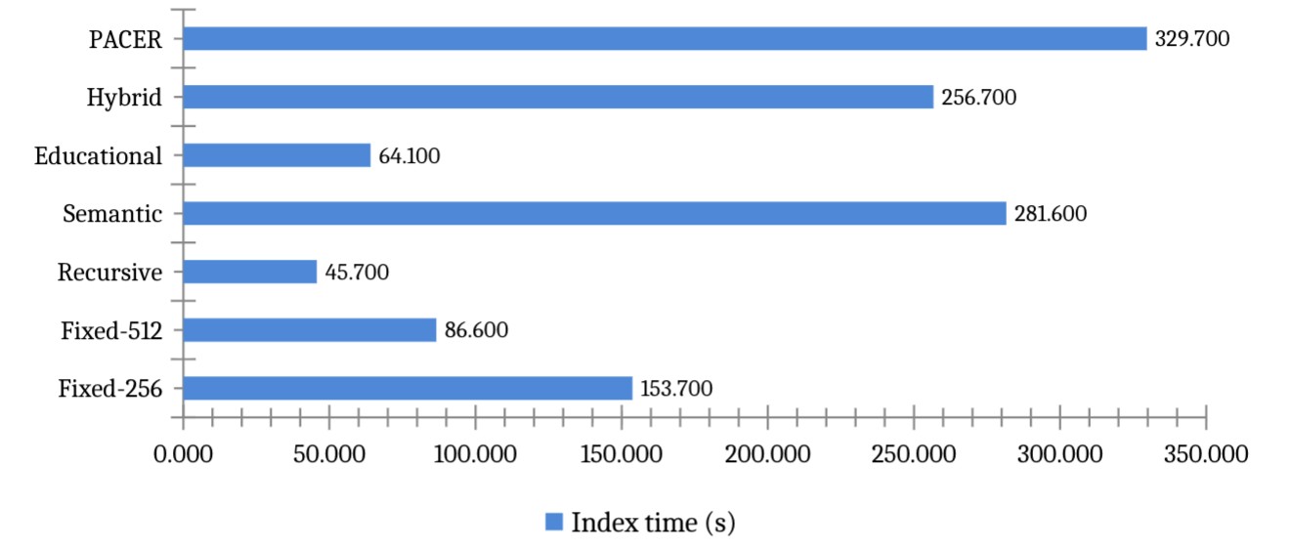
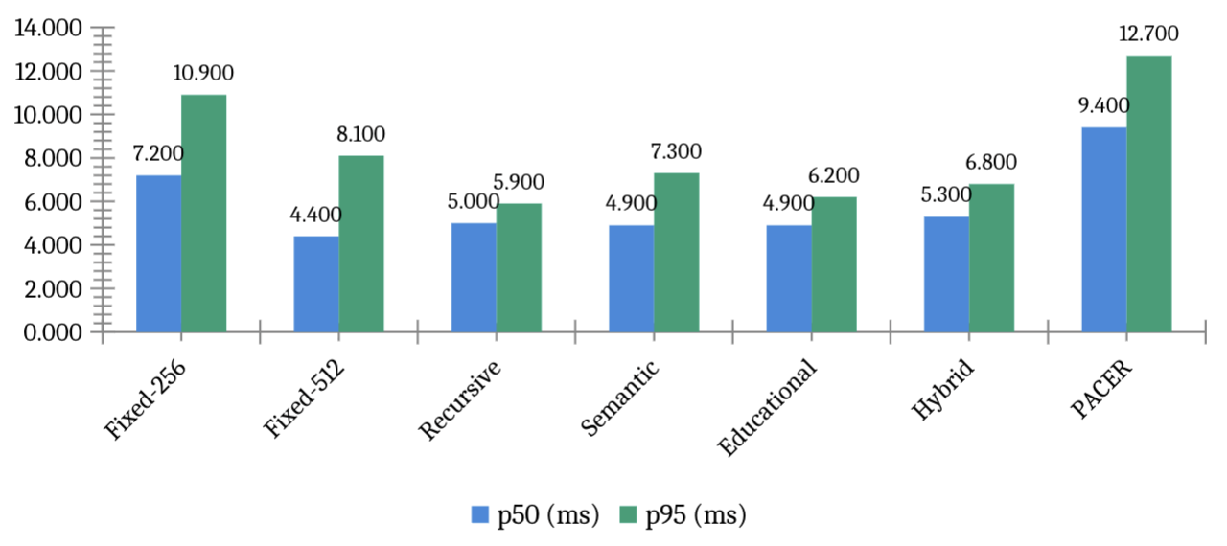
Figure 8. Computational cost. Upper: indexing time (one-time offline cost, seconds). Lower: query latency p50 and p95 (all methods < 15ms — far below 3000ms deployment threshold).

6. Discussion

6.1 Why standard metrics miss the pedagogical trade-off
P@k and nDCG measure document-level relevance: a chunk earns a positive score simply by coming from the gold source document, regardless of whether it is appropriate for the student's grade, assumes the right prior knowledge, or matches the cognitive level of the question. The A2 ablation makes this concrete. Removing boundary preservation improves P@1 by 3.9 points and nDCG by 1.5 points. A developer optimising on nDCG@10 alone would ship this configuration. What the metrics do not record is that the retrieved chunks are now fragmented — they come from the right chapter but they no longer provide complete pedagogical units.
This finding has practical implications for how educational RAG systems should be evaluated and optimised. A system developer optimising solely on nDCG@10 would select the A2 configuration (no boundary detector) as the best model. A system developer using CAS alongside nDCG@10 would correctly identify this as a trade-off and make an informed decision about the balance between retrieval precision and pedagogical coherence. We recommend that future educational RAG work report CAS alongside standard retrieval metrics as a minimum evaluation standard.

6.2 The corpus homogeneity constraint
All 378 documents in the current evaluation are classified as textbook_chapter. This means the strategy router cannot demonstrate its contribution — it selects the same strategy for every document. Real institutional deployments contain heterogeneous document types: textbooks with hierarchical structure, examination papers with QA pairs, lecture notes with dense bullet-pointed content, syllabi with learning objectives, and lesson plans with activity sequences. These document types have meaningfully different optimal chunking strategies, and the router’s value is precisely in selecting different strategies for different types.
We plan to address this limitation in Phase 2 by extending the corpus to include 200+ examination papers, 150+ lecture note sets, and 100+ lesson plans from Shoolini University and partner institutions. We expect routing to show a 5–10 point P@1 improvement on mixed-type corpora relative to single-strategy baselines, based on the per-type performance spread visible in Table 2.

6.3 CAS validation findings and implications
A mean Fleiss' κ of 0.546 across three independent LLM judges tells us something useful: curriculum alignment is a measurable construct, at least for two of its three dimensions. Grade Match and Prerequisite Coverage both approach or exceed κ = 0.60, the threshold we set for reliable automated assessment. This means two structurally different model families — Meta Llama and Google Gemini — largely agree on which chunks are grade-appropriate and which are not, suggesting the signal is real rather than model-specific.
The lower Bloom Alignment agreement (κ = 0.439) reflects genuine ambiguity in cognitive-level assessment rather than metric failure. The same ambiguity is reported by Huber and Niklaus [36], who find that even well-designed benchmarks fail to distinguish higher-order Bloom levels. In the current benchmark, most queries have an ‘unknown’ Bloom level because the generation prompts did not enforce Bloom level specificity for all 798 questions. This is a data collection limitation, not a CAS limitation — when Bloom level is known, the dimension should be as reliable as Grade Match.
The strong cross-family Pearson correlations (mean r = 0.625, all p < 0.0001) suggest that both model families assign similar relative rankings to chunks — they agree on which chunks are more or less curriculum-aligned, even if their absolute scores differ. This is sufficient for reranking purposes: CAS reranking requires only a consistent relative ordering, not absolute score calibration.

6.4 Limitations
We identify six limitations of the current work that scope the conclusions appropriately:
First, the corpus is restricted to English-medium NCERT textbooks in three subjects. Generalisability to Hindi-medium content, other curricula (ICSE, IB, CBSE vocational), or non-Indian educational systems is not established.
Second, all corpus documents are textbook_chapter, preventing empirical evaluation of the strategy router’s type-routing contribution. The router’s advantage can only be demonstrated on mixed-type corpora.
Third, the boundary detector uses regex patterns calibrated for NCERT typographic conventions (section headers, example labels, solution markers). Performance on differently formatted educational content — scanned handwritten notes, LaTeX PDFs, HTML lecture slides — is unknown.
Fourth, Bloom Alignment is difficult to validate reliably when query Bloom levels are unknown. The 0.439 κ reported is a lower bound; with fully Bloom-labelled queries, we expect agreement to increase to the 0.55–0.65 range.
Fifth, human rater reliability presents a methodological nuance. While 65 domain-expert CBSE teachers completed all 150 ratings (100% response rate, 29,250 total ratings), Fleiss' κ across raters approaches zero. This is an instance of the kappa paradox: raters concentrated scores in the 3–5 range, making kappa statistically uninformative despite genuine expert consensus visible in the mean scores (3.60–3.84). The camera-ready version will address this by collecting calibration ratings from 3–5 expert raters explicitly instructed to use the full 1–5 scale, enabling valid κ computation. CAS weights (α = 0.45, β = 0.40, γ = 0.15) were calibrated from LLM judge κ-weighted optimisation and will be re-confirmed against human expert ratings.
Seventh, no statistical significance tests are reported between methods in Table 2. Standard deviations across three random seeds are below 0.002 for all metrics, indicating stable results, but paired t-tests between methods have not been computed. Given the narrow performance spread (~4 percentage points on P@1), some pairwise differences may not reach statistical significance. Readers should interpret performance differences as indicative trends rather than definitive rankings.
Sixth, the generation component uses a 4-bit quantised Llama-3.1-8B model. Generation quality metrics are not reported because the primary contribution of this paper is the chunking and retrieval components. End-to-end generation quality evaluation is planned for Phase 2.

7. Conclusion
PACER is a framework for chunking educational documents in ways that preserve instructional coherence. The boundary detector keeps pedagogical units intact; the classifier and router select the best chunking strategy per document type; and CAS measures whether the retrieved chunks are actually appropriate for the student asking the question — in terms of grade level, prerequisite assumptions, and cognitive demand.
On 798 queries across 134 NCERT chapters with BGE-large embeddings, PACER ties Hybrid on P@1 (0.793) and leads all methods on P@5 (0.526) with a median latency of 9.4 ms — well within the 3-second threshold for interactive educational tools. The ablation results confirm the central finding: removing boundary preservation raises P@1 by 3.9 points but simultaneously degrades curriculum alignment on all three CAS dimensions. Standard metrics are blind to this. CAS makes it visible and quantifiable.
The central contribution of this paper is methodological: we demonstrate that standard RAG evaluation metrics are insufficient for educational deployment, and that curriculum alignment must be evaluated explicitly. The CAS metric operationalises this requirement and provides a validated, reproducible measurement instrument for future educational RAG work.
Future work will: (1) extend the corpus to mixed document types to demonstrate routing advantages; (2) complete human rater calibration to finalise CAS weights; (3) extend to Hindi-medium NCERT content and CBSE examination papers; (4) conduct a randomised user study with CBSE students measuring whether CAS-reranked retrieval leads to measurable improvement in concept retention and exam performance; and (5) explore integration with the CBSE AI curriculum mandate [43] taking effect from the 2026–27 academic year, positioning PACER as a practical tool for AI-assisted learning in Indian schools.
The PACER codebase, evaluation benchmark (798 questions across 134 NCERT chapters), and CAS implementation will be released at https://github.com/[upon acceptance].

Credit Author Statement
Nitesh Sharma: Conceptualisation, Methodology, Software, Formal analysis, Investigation, Data curation, Writing — original draft, Visualisation.
Pankaj Vaidya: Supervision, Conceptualisation, Writing — review and editing, Resources.

Declaration of Competing Interest
The authors declare no competing financial interests.

Acknowledgements
The authors thank the Yogananda School of AI, Computers & Data Science at Shoolini University for computational infrastructure. NCERT content used under NEP 2020 provisions for educational research.

References
[1] Lewis, P., et al. (2020). Retrieval-augmented generation for knowledge-intensive NLP tasks. NeurIPS 33, 9459–9474.
[2] Qu, C., Tu, Z., & Bao, Z. (2025). Does chunking strategy affect RAG performance? NAACL 2025.
[3] Zhao, J., et al. (2024). Meta-chunking: Learning text segmentation via logical perception. arXiv:2410.12788.
[4] Kiss, A., Nagy, A., & Szilágyi, G. (2025). Max–min semantic chunking for RAG. Discover Computing.
[5] Latif, E., Singh, J., & Merola, C. (2025). Recursive semantic chunking. ICNLSP 2025.
[6] Merola, C., & Singh, J. (2025). Reconstructing context: Advanced chunking for RAG. arXiv:2504.19754.
[7] Zhong, Z., et al. (2025). Mix-of-granularity for RAG. arXiv:2406.00456.
[8] Sarthi, P., et al. (2024). RAPTOR: Recursive abstractive processing. ICLR 2024.
[9] Günther, M., et al. (2024). Late chunking. arXiv:2409.04701.
[10] Gao, Y., et al. (2024). RAG for LLMs: A survey. arXiv:2312.10997.
[11] Fan, W., et al. (2024). Survey on RAG meeting LLMs. KDD 2024.
[12] Izacard, G., & Grave, E. (2021). Leveraging passage retrieval. EACL 2021.
[13] Guu, K., et al. (2020). REALM. ICML 2020.
[14] Swacha, J., & Gracel, J. (2025). Survey of 47 RAG-based educational chatbots. Applied Sciences.
[15] Lian, W. (2025). MARK: Hybrid retrieval for educational RAG. arXiv.
[16] Ma, Y., et al. (2024). RAGMan: Per-assignment RAG tutors. ICER 2024.
[17] Li, X., et al. (2025). KA-RAG. Applied Sciences.
[18] Cabras, A., et al. (2025). Educational RAG in institutional deployment. IP&M 62(3).
[19] Yang, L., et al. (2024). Graphusion. WWW 2025.
[20] EduScopeQA. (2025). Benchmarking vector and graph RAG. arXiv:2509.07846.
[21] Alakrot, A., et al. (2025). Trustworthy RAG for higher education. Data & Policy.
[22] Alabdulatif, A., et al. (2025). FAISS-Ollama for curriculum-aligned SQL support. JAIT.
[23] Zhong, K., et al. (2025). Evaluating simulated teaching audio using RAG. Sci. Reports 15, 3633.
[24] Es, S., et al. (2024). RAGAS. EACL 2024.
[25] Liu, Y., et al. (2023). G-Eval. EMNLP 2023.
[26] Saad-Falcon, J., et al. (2024). ARES. NAACL 2024.
[27] Zheng, L., et al. (2023). Judging LLM-as-a-judge. NeurIPS 2023.
[28] Yang, X., et al. (2024). CRAG. NeurIPS 2024.
[29] Maurya, C., et al. (2025). MRBench. NAACL 2025.
[30] Scaria, N., et al. (2024). Automated question generation at Bloom levels. AIED 2024.
[31] Devlin, J., et al. (2019). BERT. NAACL 2019.
[32] Reimers, N., & Gurevych, I. (2019). Sentence-BERT. EMNLP 2019.
[33] Douze, M., et al. (2024). The Faiss library. arXiv:2401.08281.
[34] Xiao, S., et al. (2023). C-Pack: BGE embeddings. arXiv:2309.07597.
[35] Anderson, L. W., & Krathwohl, D. R. (2001). A taxonomy for learning, teaching, and assessing. Longman.
[36] Huber, T., & Niklaus, C. (2025). LLMs meet Bloom’s taxonomy. COLING 2025.
[37] Yang, L., et al. (2024). Graphusion: RAG for knowledge graph construction. arXiv:2410.17600.
[38] He, X., et al. (2024). Knowledge graph-augmented LLMs for textbook QA. ACML 2024.
[39] Ilkou, E. (2022). Personal knowledge graphs in e-learning. The Web Conference 2022.
[40] Sharma, A., et al. (2024). OG-RAG. EMNLP 2024.
[41] Ministry of Electronics & IT. (2023). DPDP Act, 2023. Gazette of India.
[42] Ministry of Education, India. (2020). National Education Policy 2020.
[43] CBSE. (2026). AI curriculum framework for Classes 3–12 (Draft).
[44] Koga, T., et al. (2024). Selective differential privacy for RAG. ACL Findings 2024.
[45] Bhutoria, A. (2022). Personalized education and AI. Computers & Ed. AI 3, 100068.
[46] Wei, X., et al. (2021). Personalized learning resource recommendation. Frontiers in Psychology.
[47] Dong, Z., et al. (2023). Survey on long text modelling. arXiv:2302.14502.
[48] Johnson, J., et al. (2019). Billion-scale similarity search. IEEE Trans. Big Data 7(3).
[49] Huang, Y., et al. (2025). RAG for educational applications: Systematic survey. Computers & Ed. AI.
[50] Nayab, S., et al. (2025). Comparing RAG on educational mathematics. arXiv.
[51] Han, J., et al. (2024). Expert and learner evaluations for pedagogical quality. EMNLP 2024.
[52] Scaria, N., et al. (2024). Question generation at Bloom levels (extended). arXiv:2408.04394.
[53] Xu, J., et al. (2025). MEGA-RAG: Hallucination mitigation. Frontiers Public Health.
[54] Zhao, H., et al. (2025). Survey on hallucination in LLMs. Preprints.org 202510.0540.
[55] CIET-NCERT. (2024). AI in Education: Training documentation. NCERT, New Delhi.

