**Experiment Title-1**

**Student Name: Nitesh Sharma UID: 20BCS1600**

**Branch: CSE Section/Group-ON20BCS_NTPP_WM_702 {B}**

**Semester: 5th Date of Performance: 4/8/2022**

**Subject Name: java lab Subject Code: 20CSP-321**

**Subject Teacher: Reshma mam**

**1. Aim/Overview of the practical:** Given the following table containing information about employees of an organization, develop a small java application, which accepts employee id from the command prompt and displays the following details as output:

**2. Task to be done/ Which logistics used:** To perform searching on table.

**4. Steps for experiment/practical/Code:**

**import java.util.Arrays;**

**import java.util.*;**

**class Main {**

**public static void main(String[] args) {**

**Scanner sc=new Scanner(System.in);**

**String[] empAssoc = {"EmpNo", "EmpName", "JoinDate", "DesignationCode", "Department", "Basic", "HRA", "IT"};**

**String[][] empTable = new String[][] {**

**{"1001", "Ashish", "01/04/2009", "e", "R&D", "20000", "8000", "3000"},**

**{"1002", "Sushma", "23/08/2012", "c", "PM", "30000", "12000", "9000"},**

**{"1003", "Rahul", "12/11/2008", "k", "Acct", "10000", "8000", "1000"},**

**{"1004", "Chahat", "29/01/2013", "r", "FrontDesk", "12000", "6000", "2000"},**

**{"1005", "Ranjan", "16/07/2005", "m", "Engg", "50000", "20000", "20000"},**

**{"1006", "Suman", "1/1/2000", "e", "Manufacturing", "23000", "9000", "4400"},**

**{"1007", "Tanmay", "12/06/2006", "c", "PM", "29000", "12000", "10000"}**

**};**

**String[] daAssoc = {"DesignationCode", "Designation", "DA"};**

**String[][] daTable = new String[][] {**

**{"e", "Engineer", "20000"},**

**{"c", "Consultant", "32000"},**

**{"k", "Clerk", "12000"},**

**{"r", "Receptionist", "15000"},**

**{"m", "Manager", "40000"}**

**};**

**System.out.println("enter Empno: ");**

**int a= sc.nextInt();**

**int f=0;**

**for(int i=0;i<7;i++){**

**int num=Integer.parseInt(empTable[i][0]);**

**if(num==a){**

**f=1;**

**int sal=0;**

**String ans="";**

**if(empTable[i][3]=="e"){**

**sal+=20000;**

**ans= daTable[0][1];**

**}**

**if(empTable[i][3]=="c"){**

**sal+=32000;**

**ans= daTable[1][1];**

**}**

**if(empTable[i][3]=="k"){**

**sal+=12000;**

**ans= daTable[2][1];**

**}**

**if(empTable[i][3]=="r"){**

**sal+=15000;**

**ans= daTable[3][1];**

**}**

**if(empTable[i][3]=="m"){**

**sal+=40000;**

**ans= daTable[4][1];**

**}**

**sal+=Integer.parseInt(empTable[i][5]);**

**sal+=Integer.parseInt(empTable[i][6]);**

**sal-=Integer.parseInt(empTable[i][7]);**

**System.out.println("Emp No. Emp Name Department Designation Salary");**

**System.out.println(a+" "+empTable[i][1]+" "+empTable[i][4]+" "+ans+" "+sal);**

**}**

**}**

**if(f==0){**

**System.out.println("There is no employee with empid :"+a);**

**}**

**}**

**}**

**5. Screenshot of code with output:**

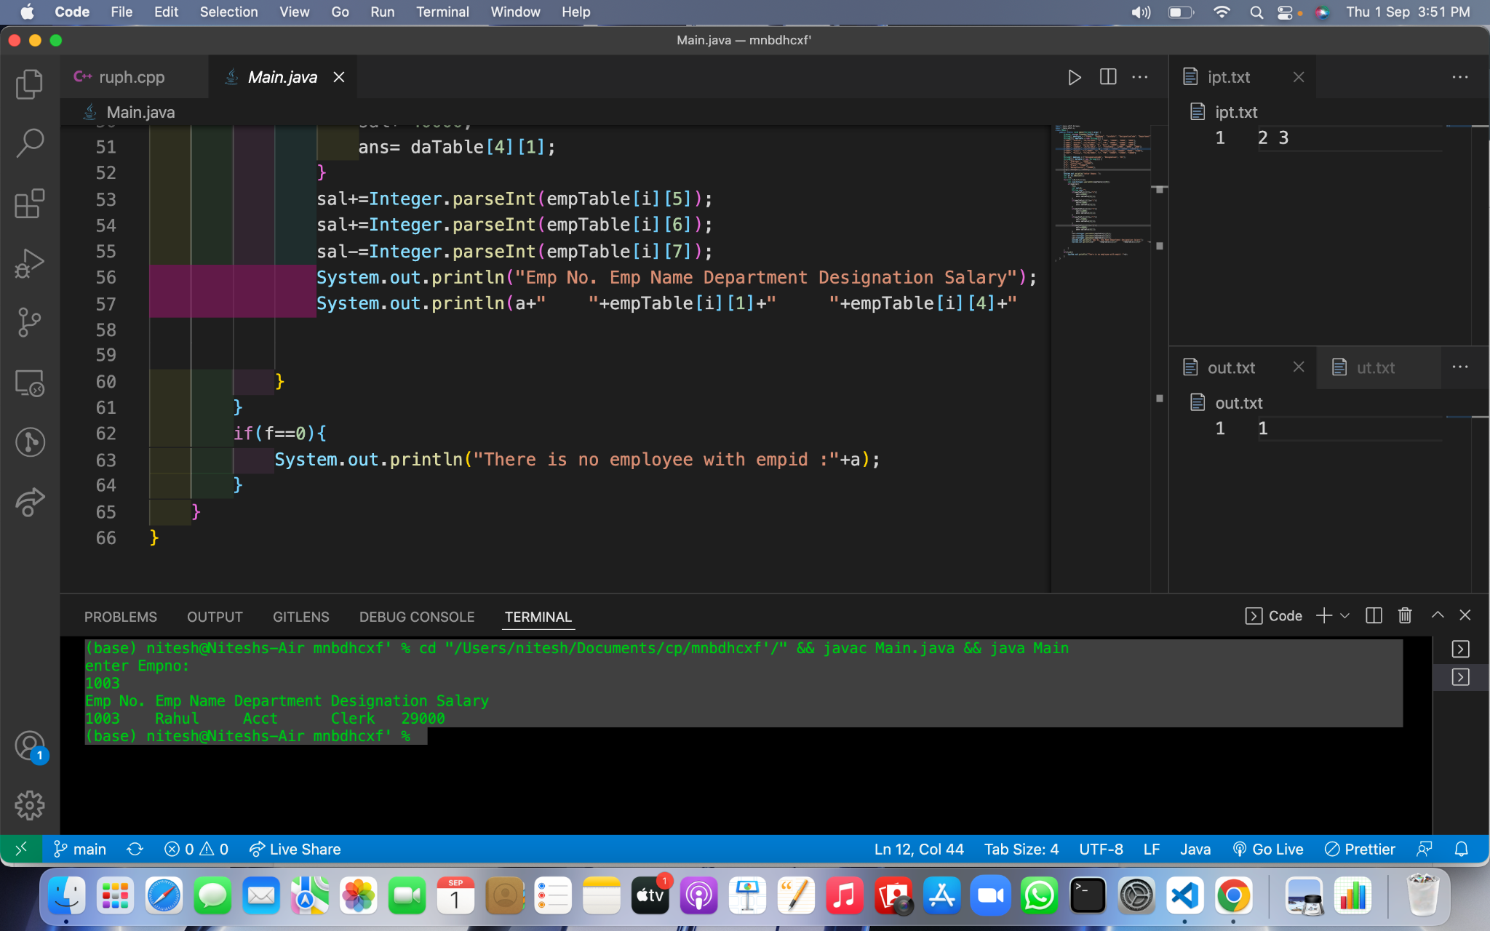

**Learning outcomes (What I have learnt):**

**1.We have learnt about the basic syntax of java**

**2.We have learnt about the tables and searching technique in java.**

**Evaluation Grid (To be created as per the SOP and Assessment guidelines by the faculty):**

| Sr. No. | Parameters | Marks Obtained | Maximum Marks |
| --- | --- | --- | --- |
| 1. |  |  |  |
| 2. |  |  |  |
| 3. |  |  |  |
|  |  |  |  |