**Experiment Title-2.1**

**Student Name: Nitesh Sharma UID: 20BCS1600**

**Branch: CSE Section/Group-ON20BCS_NTPP_WM_702 {B}**

**Semester: 5th Date of Performance: 15/9/2022**

**Subject Name: java lab Subject Code: 20CSP-321**

**Subject Teacher: Reshma mam**

**1. Aim/Overview of the practical:**

Write a program to collect and store all the cards to assist the users in finding all the cards in a given

symbol.

This card game consists of N number of cards. Get N number of cards details from the user and store

the values in Card object with the attributes symbol and number.

Store all the cards in a map with a symbol as its key and list of cards as its value. Map is used here to

easily group all the cards based on their symbol.

Once all the details are captured print all the distinct symbols in alphabetical order from the Map. For

Each symbol prints all the card details, number of cards and their sum respectively.

**2. Task to be done/ Which logistics used:** Collect and group cards

**4. Steps for experiment/practical/Code:**

**import java.util.*;**

**public class unittwo {**

**public static void main(String[] args){**

**Scanner input = new Scanner(System.in);**

**List<Integer> valueList = new ArrayList<Integer>();**

**TreeMap<String, List<Integer>> mapObj = new TreeMap<String, List<Integer>>();**

**int totalCards, index, value, sum = 0, count = 0;**

**System.out.println("ENTER NUMBER OF CARDS : ");**

**totalCards = input.nextInt();**

**String symbol;**

**for(index = 1; index <= totalCards; index++){**

**System.out.println("ENTER CARD" + " " + index);**

**symbol = input.next();**

**value = input.nextInt();**

**if(mapObj.containsKey(symbol)){**

**valueList = mapObj.get(symbol);**

**valueList.add(value);**

**}else{**

**valueList = new ArrayList<Integer>();**

**valueList.add(value);**

**mapObj.put(symbol, valueList);**

**}**

**}**

**System.out.println("DISTINCT SYMBOLS ARE :");**

**for(Map.Entry getData : mapObj.entrySet()){**

**System.out.print(getData.getKey() + " ");**

**}**

**System.out.println();**

**for(Map.Entry getData : mapObj.entrySet()){**

**System.out.println("CARDS IN " + getData.getKey() + " SYMBOL :");**

**ArrayList<Integer> temp = (ArrayList<Integer>) getData.getValue();**

**Iterator itr= temp.iterator();**

**while(itr.hasNext())**

**{**

**count++;**

**int val = (int) itr.next();**

**System.out.print(getData.getKey());**

**System.out.println(" " + val);**

**sum += val;**

**}**

**System.out.println("NUMBER OF CARDS : " + count);**

**System.out.println("SUM OF NUMBERS : " + sum);**

**sum = 0;**

**}**

**}**

**}**

**5. Screenshot of code with output:**

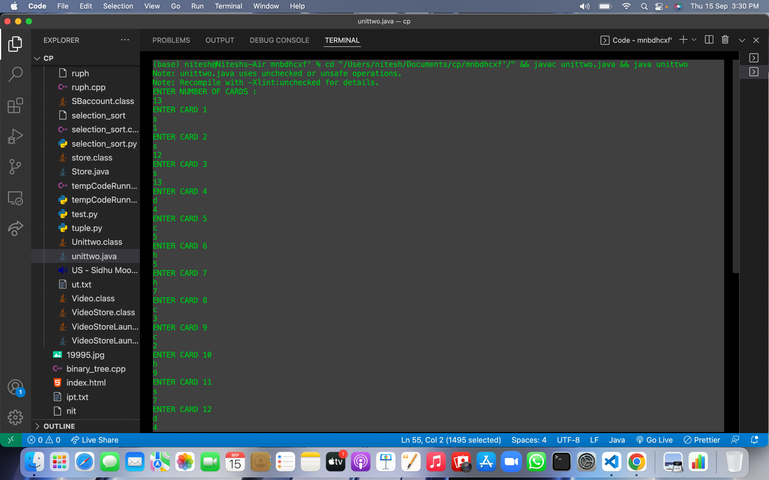

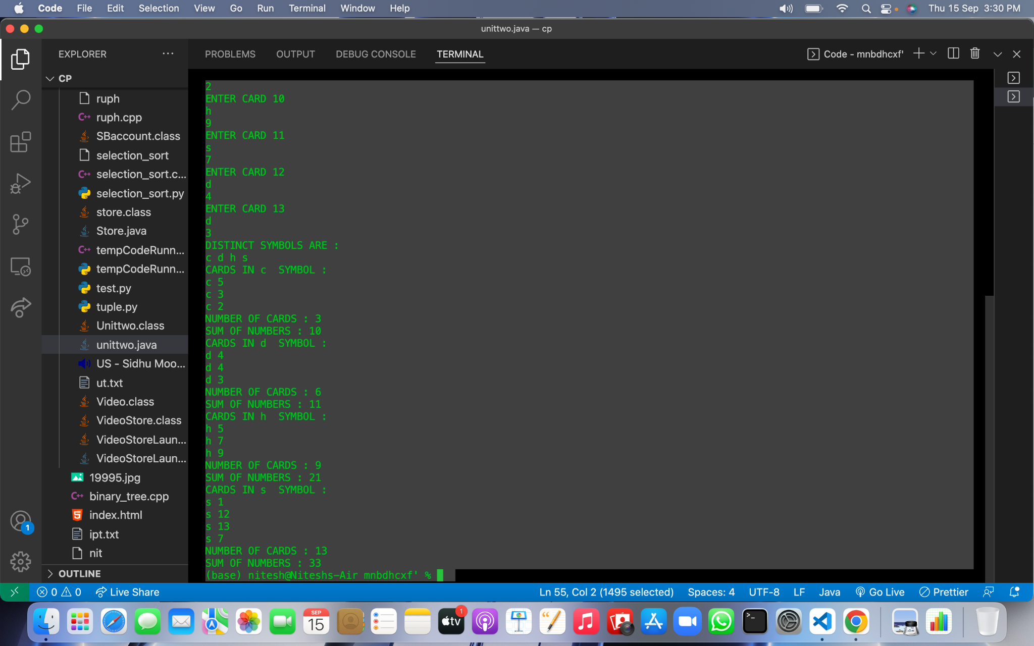

**Learning outcomes (What I have learnt):**

**1.We have learnt about the basic syntax of java**

**2.We have learnt about the lists and maps used in java.**

**Evaluation Grid (To be created as per the SOP and Assessment guidelines by the faculty):**

| Sr. No. | Parameters | Marks Obtained | Maximum Marks |
| --- | --- | --- | --- |
| 1. |  |  |  |
| 2. |  |  |  |
| 3. |  |  |  |
|  |  |  |  |