**Experiment Title-2.2**

**Student Name: Nitesh Sharma UID: 20BCS1600**

**Branch: CSE Section/Group-ON20BCS_NTPP_WM_702 {B}**

**Semester: 5th Date of Performance: 7/10/2022**

**Subject Name: java lab Subject Code: 20CSP-321**

**Subject Teacher: Reshma mam**

**1. Aim/Overview of the practical:**

Playing cards during travel is a fun filled experience. For this game they wanted to collect all four

unique symbols. Can you help these guys to collect unique symbols from a set of cards?

Create Card class with attributes symbol and number. From our main method collect each card

details (symbol and number) from the user.

Collect all these cards in a set, since set is used to store unique values or objects.

Once we collect all four different symbols display the first occurrence of card details in alphabetical

order.

**2. Task to be done/ Which logistics used:** Collect and group cards

**4. Steps for experiment/practical/Code:**

**package sem6;**

**import java.util.*;**

**class Data implements Comparable<Data> {**

**char c;**

**int num;**

**Data(char c,int num) {**

**this.c=c; this.num=num;**

**}**

**public int compareTo(Data o) {**

**if (this.c < o.c)**

**return -1;**

**else if (this.c > o.c)**

**return 1;**

**else**

**return 1;**

**}**

**public int hashCode() {**

**return String.valueOf(c).hashCode();**

**}**

**public boolean equals(Object obj){**

**if (obj instanceof Data) {**

**Data card = (Data) obj;**

**return (card.c == this.c);**

**}**

**else {**

**return false;**

**}**

**}**

**}**

**public class unittwo {**

**public static void main(String[] args) {**

**// TODO Auto-generated method stub**

**Scanner sc=new Scanner(System.in);**

**HashSet<Data> set=new HashSet<>();**

**int count=0;**

**while(count!=4){**

**char c=sc.next().charAt(0);**

**int n=Integer.parseInt(sc.next());**

**Data obj=new Data(c,n);**

**if(set.add(obj)) {**

**count++;**

**}**

**}**

**System.out.println("Result:");**

**for(Data temp:set) {**

**System.out.println(temp.c+" " +temp.num);**

**}**

**}**

**}**

**5. Screenshot of code with output:**

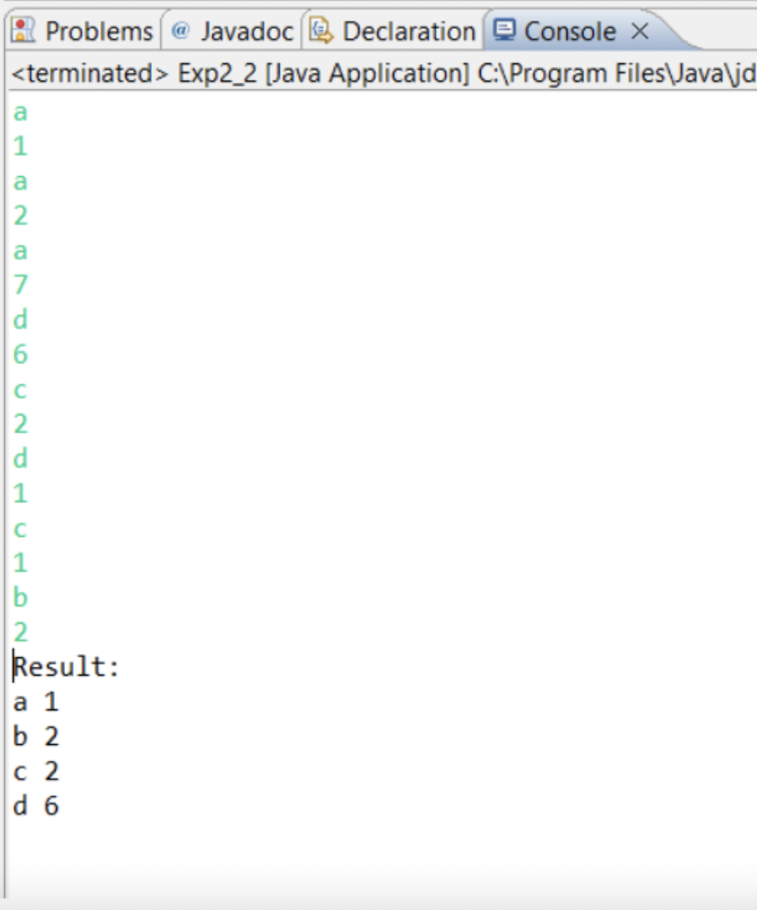

**Learning outcomes (What I have learnt):**

**1.We have learnt about the basic syntax of java**

**2.We have learnt about the lists and maps used in java.**

**Evaluation Grid (To be created as per the SOP and Assessment guidelines by the faculty):**

| Sr. No. | Parameters | Marks Obtained | Maximum Marks |
| --- | --- | --- | --- |
| 1. |  |  |  |
| 2. |  |  |  |
| 3. |  |  |  |
|  |  |  |  |