**Experiment Title-2_3**

**Student Name: Nitesh Sharma UID: 20BCS1600**

**Branch: CSE Section/Group-ON20BCS_NTPP_WM_702 {B}**

**Semester: 5th Date of Performance: 11/10/2022**

**Subject Name: java lab Subject Code: 20CSP-321**

**Subject Teacher: Reshma mam**

**1. Aim/Overview of the practical:** Write a Program to perform the basic operations like insert, delete, display and search in list. List contains String object items where these operations are to be performed.

**2. Task to be done/ Which logistics used:** To store and perform searching on list of strings.

**4. Steps for experiment/practical/Code:**

**import java.util.*;**

**import java.io.*;**

**import java.util.ArrayList;**

**import java.util.List;**

**class more{**

**public static void main(String[] args) throws IOException{**

**int index;**

**BufferedReader sc = new BufferedReader(**

**new InputStreamReader(System.in));**

**List<String> items = new ArrayList<>();**

**int ch=-1;**

**while (ch != 5)**

**{**

**System.out.println("1. Insert");**

**System.out.println("2. Search");**

**System.out.println("3. Delete");**

**System.out.println("4. Display");**

**System.out.println("5. Exit");**

**System.out.println("Enter your choice: ");**

**ch = Integer.parseInt(sc.readLine());**

**switch (ch)**

**{**

**case 1:**

**System.out.println("Enter the item to be inserted: ");**

**String name = sc.readLine();**

**items.add(name);**

**System.out.println("Inserted successfully");**

**break;**

**case 2:**

**System.out.println("Enter the item to search: ");**

**name= sc.readLine();**

**int f=0;**

**for(String str: items) {**

**if (str.contains(name)) {**

**System.out.println("Item found ....");**

**f=1;**

**}**

**}**

**if(f==0){**

**System.out.println("Item not found in the list.");**

**}**

**break;**

**case 3:**

**System.out.println("Enter the item to delete: ");**

**name= sc.readLine();**

**int g=0;**

**for(String str: items) {**

**if (str.contains(name)) {**

**items.remove(name);**

**System.out.println("Item removed successfully.....");**

**g=1;**

**}**

**}**

**if(g==0){**

**System.out.println("Item not found in the list.");**

**}**

**break;**

**case 4:**

**System.out.println("The Items in the list are: ");**

**for (int i = 0; i < items.size(); i++)**

**{**

**System.out.print(items.get(i)+" ");**

**}**

**break;**

**case 5:**

**break;**

**}**

**}**

**}**

**}**

**5. Screenshot of code with output:**

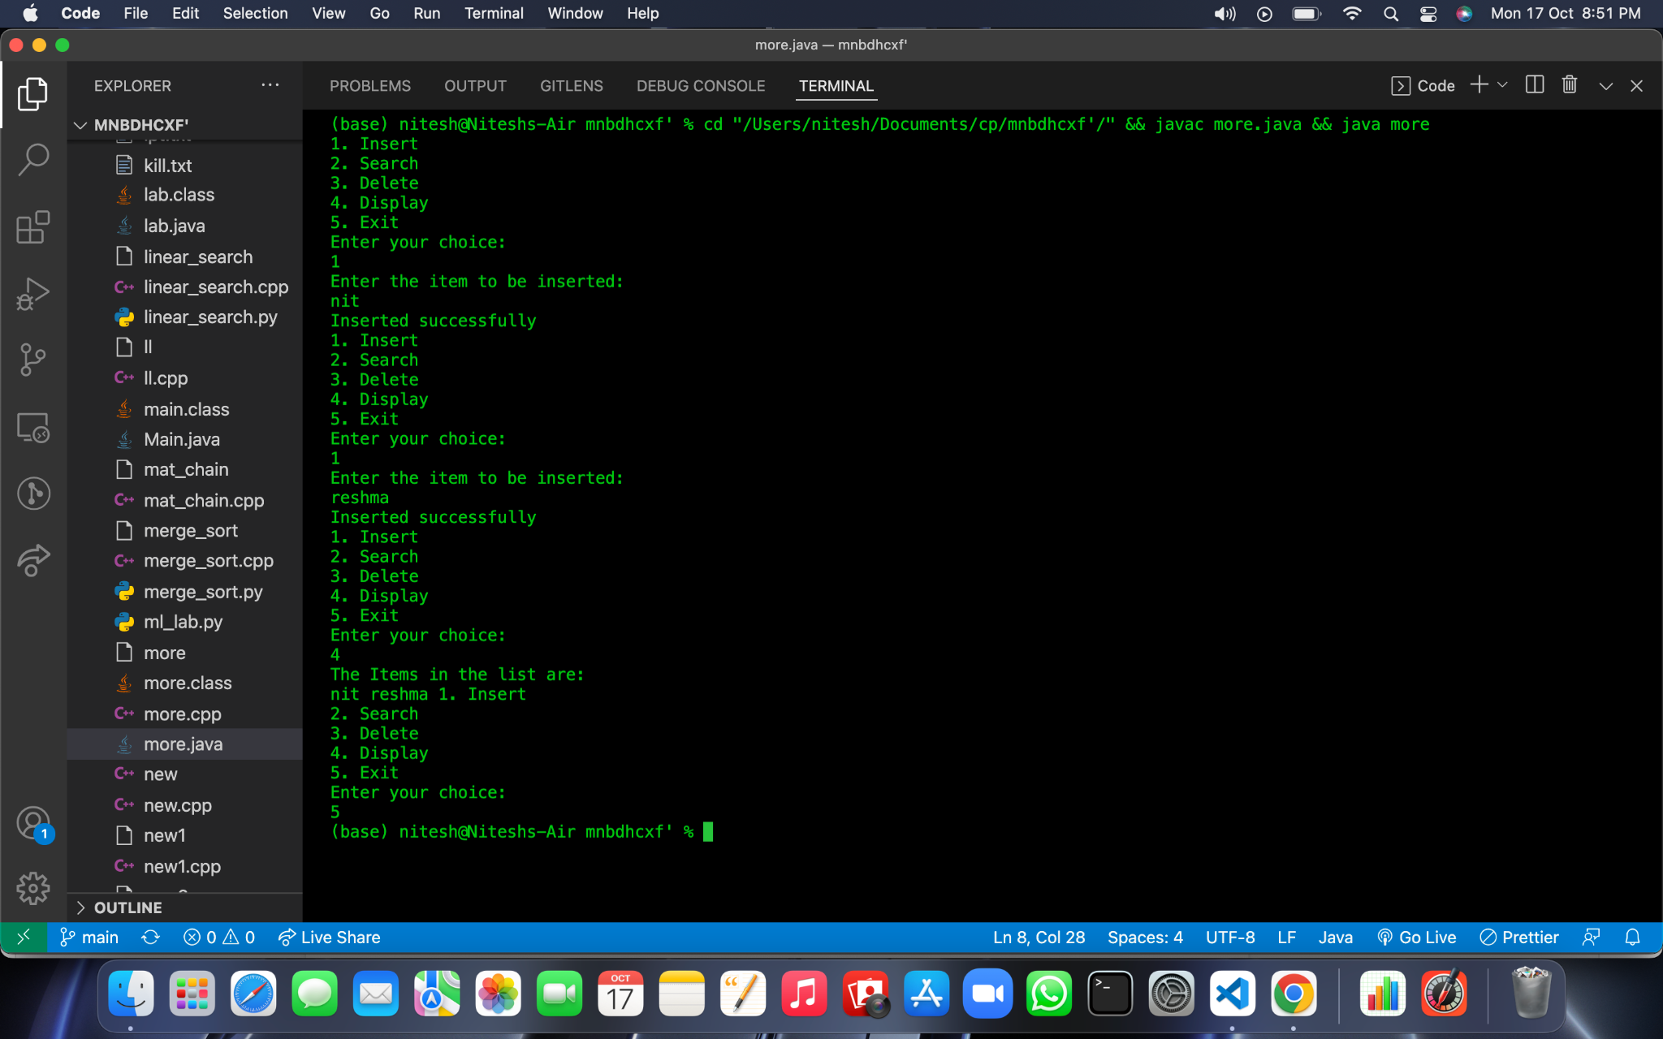

**Learning outcomes (What I have learnt):**

**1.We have learnt about the basic syntax of java**

**2.We have learnt about the inheritance concept of java.**

**Evaluation Grid (To be created as per the SOP and Assessment guidelines by the faculty):**

| Sr. No. | Parameters | Marks Obtained | Maximum Marks |
| --- | --- | --- | --- |
| 1. |  |  |  |
| 2. |  |  |  |
| 3. |  |  |  |
|  |  |  |  |