**Experiment Title-2**

**Student Name: Nitesh Sharma UID: 20BCS1600**

**Branch: CSE Section/Group-ON20BCS_NTPP_WM_702 {B}**

**Semester: 5th Date of Performance: 11/8/2022**

**Subject Name: java lab Subject Code: 20CSP-321**

**Subject Teacher: Reshma mam**

**1. Aim/Overview of the practical:** The goal of this project is to design and implement a simple inventory control system for a small video rental store. Define at least two classes: a class Video to model a video and a class VideoStore to model the actual store.

**2. Task to be done/ Which logistics used:** To design and implement a simple inventory control system for a small video rental store.

**4. Steps for experiment/practical/Code:**

**import java.util.*;**

**class Video{**

**String title;**

**boolean[] flag = new boolean[10];**

**int[] user_rating=new int[10];**

**void being_checkedout(int i) {**

**if(flag[i] == true)**

**flag[i] = false;**

**}**

**void being_returned(int j) {**

**if(flag[j] == false)**

**flag[j] = true;**

**}**

**void receive_a_rating(int n, int no) {**

**user_rating[n] = no;**

**}**

**}**

**class VideoStore extends Video{**

**Video obj = new Video();**

**String[] videos = new String[10];**

**int[] rate = new int[10];**

**int i = 0;**

**void addVideo(String title) {**

**videos[i++]=title;**

**}**

**void checkOut(String nm) {**

**int j, index = 0;**

**for(j = 0; j < 3; j++) {**

**if(videos[j].equals(nm)) {**

**index = j;**

**}**

**}**

**being_checkedout(index);**

**}**

**void returnVideo(String nm) {**

**int j, index = 0;**

**for(j = 0; j < 3; j++) {**

**if(videos[j].equals(nm)) {**

**index=j;**

**}**

**}**

**being_returned(index);**

**}**

**void receiveRating(int n, int no) {**

**rate[n]=no;**

**receive_a_rating(n, no);**

**}**

**void listInventory( int num) {**

**int i;**

**for(i = 0; i < num+1; i++) {**

**if(flag[i]==true)**

**System.out.println(videos[i]+" "+flag[i]);**

**}**

**}**

**}**

**class Store extends VideoStore {**

**public static void main(String[] args){**

**VideoStore o = new VideoStore();**

**Scanner sc=new Scanner(System.in);**

**Arrays.fill(o.flag, true);**

**System.out.println("enter number of videos :");**

**int n=sc.nextInt();**

**System.out.println("enter name of movies :");**

**for(int i=0;i<n+1;i++){**

**String s;**

**s=sc.nextLine();**

**o.addVideo(s);**

**}**

**for(int i=0;i<n;i++){**

**System.out.println("enter rating for "+i+"th movie :");**

**int g=sc.nextInt();**

**o.receiveRating(i, g);**

**}**

**o.checkOut("The Matrix");**

**o.checkOut("Godfather II");**

**o.checkOut("Star War Episode IV: A New Hope");**

**o.returnVideo("The Matrix");**

**o.returnVideo("Godfather II");**

**o.returnVideo("Star War Episode IV: A New Hope");**

**o.checkOut("Godfather II");**

**o.listInventory(n);**

**}**

**}**

**5. Screenshot of code with output:**

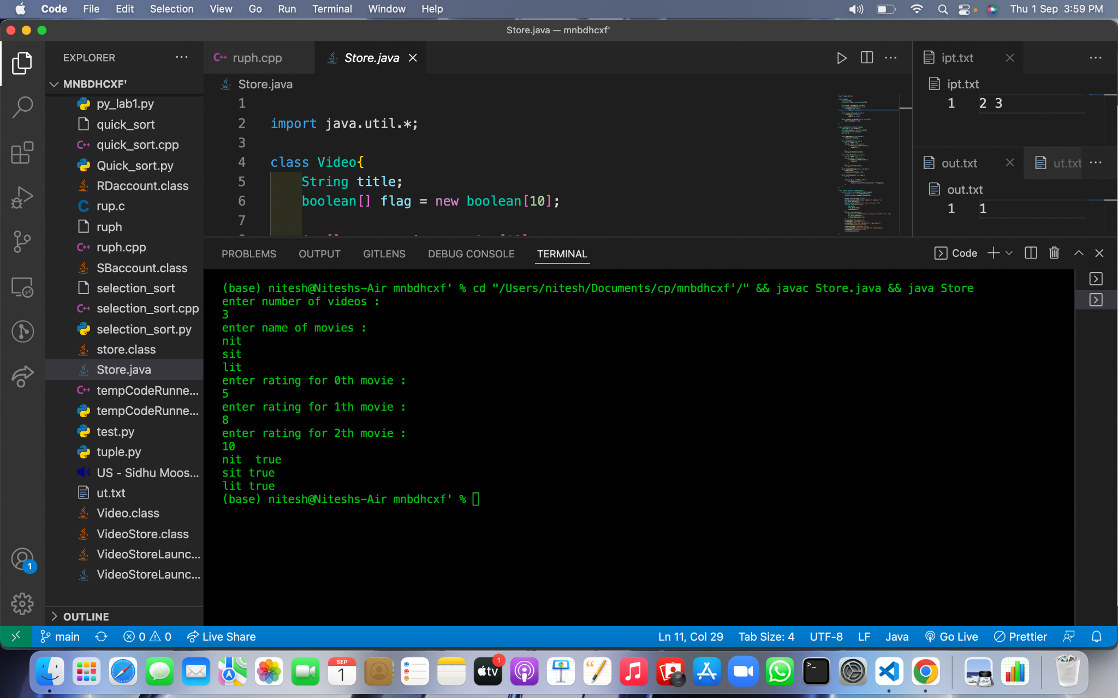

**Learning outcomes (What I have learnt):**

**1.We have learnt about the basic syntax of java**

**2.We have learnt about inheritance in java.**

**Evaluation Grid (To be created as per the SOP and Assessment guidelines by the faculty):**

| Sr. No. | Parameters | Marks Obtained | Maximum Marks |
| --- | --- | --- | --- |
| 1. |  |  |  |
| 2. |  |  |  |
| 3. |  |  |  |
|  |  |  |  |