**Experiment Title-3.1**

**Student Name: Nitesh Sharma UID: 20BCS1600**

**Branch: CSE Section/Group-ON20BCS_NTPP_WM_702 {B}**

**Semester: 5th Date of Performance: 21/10/2022**

**Subject Name: java lab Subject Code: 20CSP-321**

**Subject Teacher: Reshma mam**

**1. Aim/Overview of the practical:**

**Given a string , find its largest palindromic substring.**

**2. Task to be done/ Which logistics used:** To find the largest palindromic substring.

**4. Steps for experiment/practical/Code:**

**import java.io.*;**

**import java.util.*;**

**import java.text.*;**

**import java.math.*;**

**import java.util.regex.*;**

**public class Solution {**

**public static void main(String[] args) {**

**/* Enter your code here. Read input from STDIN. Print output to STDOUT. Your class should be named Solution. */**

**Scanner scan = new Scanner(System.in);**

**String s = scan.nextLine();**

**long x=s.chars().distinct().count();**

**if(x==1){**

**System.out.println(s);**

**}else{**

**isPal(s);**

**}**

**}**

**public static void isPal(String s) {**

**HashSet<String> pals = new HashSet<>();**

**int count=0;**

**int max = -1;**

**String maxs = "";**

**for(int i=0;i<s.length();i++) {**

**for(int j=0;i-j>=0 && j+i<s.length();j++) {**

**if(s.charAt(i-j)==s.charAt(i+j)) {**

**String temp = s.substring(i-j, i+j+1);**

**if(!pals.contains(temp)) {**

**pals.add(temp);**

**if(maxs==""){**

**maxs=temp;**

**max=temp.length();**

**}else{**

**if(max<temp.length()){**

**maxs=temp;**

**max=temp.length();**

**}**

**}**

**count++;**

**}**

**}else{**

**break;**

**}**

**}**

**}**

**for(int i=0;i<s.length();i++) {**

**for(int j=0;i-j>=0 && j+i+1<s.length();j++) {**

**if(s.charAt(i-j)==s.charAt(i+j+1)) {**

**String temp = s.substring(i-j, i+j+2);**

**if(!pals.contains(temp)) {**

**pals.add(temp);**

**if(maxs==""){**

**maxs=temp;**

**max=temp.length();**

**}else{**

**if(max<temp.length()){**

**maxs=temp;**

**max=temp.length();**

**}**

**}**

**count++;**

**}**

**}else{**

**break;**

**}**

**}**

**}**

**System.out.println(maxs);**

**//return count;**

**}**

**}**

**5. Screenshot of code with output:**

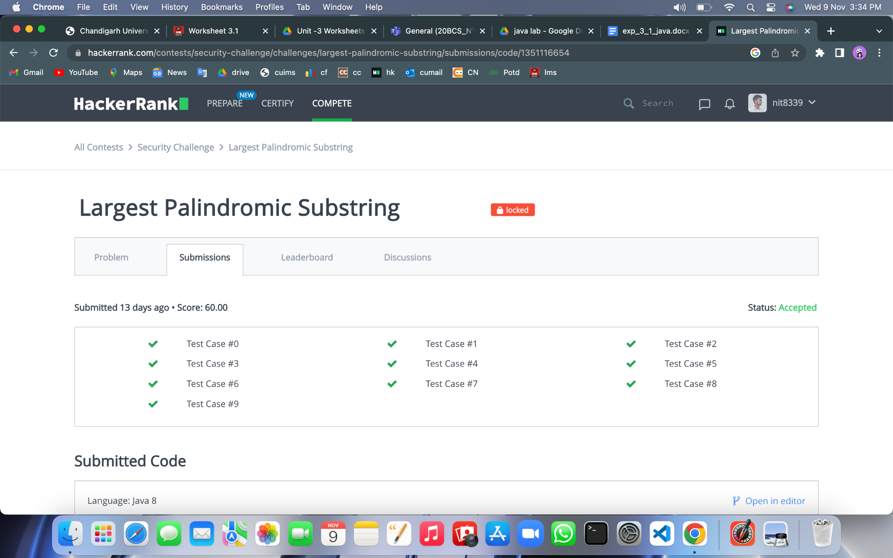

**Learning outcomes (What I have learnt):**

**1.We have learnt about the basic syntax of java**

**2.We have learnt about the inheritance concept of java.**

**Evaluation Grid (To be created as per the SOP and Assessment guidelines by the faculty):**

| Sr. No. | Parameters | Marks Obtained | Maximum Marks |
| --- | --- | --- | --- |
| 1. |  |  |  |
| 2. |  |  |  |
| 3. |  |  |  |
|  |  |  |  |